Logger32 Helpfile

**Table of contents**

[Introduction](#_topic_Introduction) 6

[Welcome and History](#_topic_WelcomeandHistory) 9

[General Features](#_topic_GeneralFeatures) 14

[Copyrights and License](#_topic_CopyrightsandLicense) 19

[How to Use Help](#_topic_HowtoUseHelp) 22

[Links and Reflectors](#_topic_LinksandReflectors) 27

[Helpfile Changes](#_topic_HelpfileChanges) 31

[Installation](#_topic_Installation) 43

[System Requirements](#_topic_SystemRequirements) 45

[Installation Procedures](#_topic_InstallationProcedures) 48

[Initial Setup](#_topic_InitialSetup) 51

[Setup Callsign](#_topic_SetupCallsign) 55

[Setup User Lat and Long](#_topic_SetupUserLatandLong) 58

[Transferring Logs from Logger 16 and Other Programs](#_topic_TransferringLogsfromLogger16andO) 61

[Transferring Logger32 to Another Computer](#_topic_TransferringLogger32toAnotherCom) 67

[Setup Bands and Modes](#_topic_SetupBandsandModes) 70

[Setup Date, Time and Frequency Formats](#_topic_SetupDateTimeandFrequencyFormats) 78

[Setup CD ROM](#_topic_SetupCDROM) 81

[Convert Logger16 Notes to Logger32](#_topic_ConvertLogger16NotestoLogger32) 85

[Setting up a Second Logger32 INI File](#_topic_SettingupaSecondLogger32INIFile) 88

[Uninstall Procedures](#_topic_UninstallProcedures) 92

[Updating Logger32](#_topic_UpdatingLogger32) 95

[Logbook Windows](#_topic_LogbookWindows) 103

[Logbook Entry Window](#_topic_LogbookEntryWindow) 105

[Logbook Page Window](#_topic_LogbookPageWindow) 130

[Backing up Logger32 Files and Databases](#_topic_BackingupLogger32FilesandDatabas) 146

[Changing Logbooks](#_topic_ChangingLogbooks) 152

[Changing Operator](#_topic_ChangingOperator) 155

[Reformat QSO Numbers](#_topic_ReformatQSONumbers) 158

[Notes and Comments Window](#_topic_NotesandCommentsWindow) 161

[Importing Logs](#_topic_ImportingLogs) 166

[Exporting Logs](#_topic_ExportingLogs) 171

[Exporting Files](#_topic_ExportingFiles) 179

[Grid Appearance Setup](#_topic_GridAppearanceSetup) 184

[Grid Layout Setup](#_topic_GridLayoutSetup) 188

[Callsign Lookup](#_topic_CallsignLookup) 193

[Flag QSOs for QSLing](#_topic_FlagQSOsforQSLing) 202

[QSL File Creation](#_topic_QSLFileCreation) 205

[Logbook Informational Entries](#_topic_LogbookInformationalEntries) 211

[Using Logbooks](#_topic_UsingLogbooks) 215

[LoTW Configuration](#_topic_LoTWConfiguration) 220

[Satellite LoTW](#_topic_SatelliteLoTW) 222

[Logbook Synchronization](#_topic_LogbookSynchronization) 225

[eQSL Synchronization](#_topic_eQSLSynchronization) 227

[LoTW Synchronization](#_topic_LoTWSynchronization) 232

[LoTW Synchronization From Club Log](#_topic_LoTWSynchronizationFromClubLog) 242

[QSL Synchronization](#_topic_QSLSynchronization) 247

[IOTA Synchronization](#_topic_IOTASynchronization) 250

[Previous QSOs Window](#_topic_PreviousQSOsWindow) 258

[Worked Confirmed Window](#_topic_WorkedConfirmedWindow) 264

[Telnet Cluster Window](#_topic_TelnetClusterWindow) 272

[Using the Local Host Panel with CW Skimmer](#_topic_UsingtheLocalHostPanelwithCWSkim) 287

[Tracking Window](#_topic_TrackingWindow) 292

[Tracking Window](#_topic_TrackingWindow1) 294

[Background Maps](#_topic_BackgroundMaps) 310

[Sound Card Data Window](#_topic_SoundCardDataWindow) 317

[Sound Card Data Window](#_topic_SoundCardDataWindow1) 319

[Sound Card Data Window FAQs](#_topic_SoundCardDataWindowFAQs) 345

[Communicating with PSK, MFSK and QPSK](#_topic_CommunicatingwithPSKMFSKandQPSK) 353

[Communicating with RTTY](#_topic_CommunicatingwithRTTY) 378

[Callibrating the Sound Card](#_topic_CallibratingtheSoundCard) 405

[Transmitting a Clean Signal with PSK, MFSK, QPSK and RTTY](#_topic_TransmittingaCleanSignalwithPSKM) 413

[Support for a Second Sound Card](#_topic_SupportforaSecondSoundCard) 418

[Sound Card Transmitter Audio Setup](#_topic_SoundCardTransmitterAudioSetup) 422

[MultiRX](#_topic_MultiRX) 427

[G3YYD 2Tone RTTY Engine](#_topic_G3YYD2ToneRTTYEngine) 435

[GRITTY Decode engine for RTTY](#_topic_GRITTYDecodeengineforRTTY) 443

[MACROs Hot Keys and Programmable Buttons](#_topic_MACROsHotKeysandProgrammableButt) 449

[MACROS](#_topic_MACROS) 451

[HotKeys](#_topic_HotKeys) 466

[Programmable Buttons](#_topic_ProgrammableButtons) 472

[DX Spots Window](#_topic_DXSpotsWindow) 479

[DX Spots Window](#_topic_DXSpotsWindow1) 481

[Adjust DX Spots for Audio Frequency](#_topic_AdjustDXSpotsforAudioFrequency) 513

[The Bandmap](#_topic_TheBandmap) 518

[Pseudo DX Spots](#_topic_PseudoDXSpots) 531

[CW Machine Window](#_topic_CWMachineWindow) 534

[Data Terminal Window](#_topic_DataTerminalWindow) 553

[Digital Voice Keyer (DVK)](#_topic_DigitalVoiceKeyerDVK) 559

[NCDXF Beacons Window](#_topic_NCDXFBeaconsWindow) 567

[Additional Information Windows](#_topic_AdditionalInformationWindows) 571

[Award Tables](#_topic_AwardTables) 576

[Award Tracking](#_topic_AwardTracking) 595

[Award Tracking](#_topic_AwardTracking1) 597

[ARRL Scraper](#_topic_ARRLScraper) 612

[Generic QSOs WIndow](#_topic_GenericQSOsWIndow) 618

[Database Updates](#_topic_DatabaseUpdates) 623

[Database Maintenance](#_topic_DatabaseMaintenance) 625

[User Editable Databases](#_topic_UserEditableDatabases) 634

[Club Log Exceptions](#_topic_ClubLogExceptions) 638

[IOTA Database](#_topic_IOTADatabase) 642

[DXCC Validation](#_topic_DXCCValidation) 645

[Printing](#_topic_Printing) 650

[Using External Print Programs](#_topic_UsingExternalPrintPrograms) 652

[Printing Award Tables](#_topic_PrintingAwardTables) 657

[Menu Bars](#_topic_MenuBars) 661

[Main Menu](#_topic_MainMenu) 663

[Setup Menu](#_topic_SetupMenu) 673

[Tool Bar](#_topic_ToolBar) 685

[Status Bar](#_topic_StatusBar) 689

[Status Panels](#_topic_StatusPanels) 691

[Starndard TIme Zones](#_topic_StarndardTImeZones) 700

[Misc.](#_topic_Misc) 705

[Snap Windows to Size](#_topic_SnapWindowstoSize) 708

[Atomic Clock](#_topic_AtomicClock) 713

[Conversion Utility](#_topic_ConversionUtility) 717

[Using Logger32 as a Contest Log](#_topic_UsingLogger32asaContestLog) 720

[Contest Serial Numbers](#_topic_ContestSerialNumbers) 723

[The F11 Key Explained](#_topic_TheF11KeyExplained) 726

[Scrolling Using a Wheel Mouse](#_topic_ScrollingUsingaWheelMouse) 729

[Finding Lost Windows](#_topic_FindingLostWindows) 732

[Multi-Language Support](#_topic_MultiLanguageSupport) 736

[Multi-Language Support](#_topic_MultiLanguageSupport1) 738

[Creating Language DLLs](#_topic_CreatingLanguageDLLs) 743

[Grid Squares](#_topic_GridSquares1) 752

[Grid Square Calculator](#_topic_GridSquareCalculator1) 754

[Maidenhead Locator System](#_topic_MaidenheadLocatorSystem1) 757

[External Interfaces](#_topic_ExternalInterfaces) 760

[Using the Logger32 External Interface](#_topic_UsingtheLogger32ExternalInterfac) 762

[The TCP Server](#_topic_TheTCPServer) 771

[The UDP Bandmap](#_topic_TheUDPBandmap) 782

[UDP Broadcast of DX Spots](#_topic_UDPBroadcastofDXSpots) 805

[Support for Ham CAP](#_topic_SupportforHamCAP) 814

[Utilities](#_topic_Utilities1) 819

[Computer Setup](#_topic_ComputerSetup) 825

[Computer Suggestions](#_topic_ComputerSuggestions) 827

[Computer Tuneup](#_topic_ComputerTuneup) 839

[Screen Control Operation](#_topic_ScreenControlOperation) 844

[Shared Serial and Parallel Ports](#_topic_SharedSerialandParallelPorts) 854

[Dual Monitors](#_topic_DualMonitors) 868

[Radio Control Setup](#_topic_RadioControlSetup) 872

[Setup Radio Control](#_topic_SetupRadioControl) 874

[Radio Control Panel (RCP)](#_topic_RadioControlPanelRCP) 883

[Radio Debug Window](#_topic_RadioDebugWindow) 908

[Direct Control of Radios](#_topic_DirectControlofRadios) 912

[Interfacing a Radio to the PC Sound Card](#_topic_InterfacingaRadiotothePCSoundCar) 922

[Interfacing a Radio for PC Control](#_topic_InterfacingaRadioforPCControl) 930

[Single Operator Two Radios (SO2R) Support](#_topic_SingleOperatorTwoRadiosSO2RSuppo) 935

[Setting up to Use Two Radios](#_topic_SettinguptoUseTwoRadios) 949

[Single Operator Two VFOs (SO2V) Support](#_topic_SingleOperatorTwoVFOsSO2VSupport) 953

[Griffin PowerMate](#_topic_GriffinPowerMate) 957

[Hardware Setup](#_topic_HardwareSetup) 966

[Antennas](#_topic_Antennas) 968

[Setup Antenna Selector](#_topic_SetupAntennaSelector) 970

[Automatic Antenna Switch](#_topic_AutomaticAntennaSwitch) 978

[Virtual SteppIR Controller (VSC)](#_topic_VirtualSteppIRControllerVSC) 982

[Virtual UltraBeam Controller (VUC)](#_topic_VirtualUltraBeamControllerVUC) 991

[Rotators](#_topic_Rotators) 995

[Setup Antenna Rotator](#_topic_SetupAntennaRotator) 997

[Hygain E-Z Rotator](#_topic_HygainEZRotator) 1012

[EA4TX ARS Support](#_topic_EA4TXARSSupport) 1015

[TNCs](#_topic_TNCs) 1019

[KAM Plus](#_topic_KAMPlus) 1021

[PK232-HK232](#_topic_PK232HK232) 1031

[AGW Packet Engine](#_topic_AGWPacketEngine) 1035

[Radios](#_topic_Radios) 1043

[Configuring Push to Talk](#_topic_ConfiguringPushtoTalk) 1045

[Software Controlled Radios](#_topic_SoftwareControlledRadios) 1051

[Interfacing Logger32 to a microHam Keyer and FT-1000MP](#_topic_InterfacingLogger32toamicroHamKe) 1054

[The Echo Port](#_topic_TheEchoPort) 1064

[The Slave Port](#_topic_TheSlavePort) 1069

[Elecraft](#_topic_Elecraft) 1077

[Elecraft K2 K3](#_topic_ElecraftK2K3) 1079

[ICOM](#_topic_ICOM1) 1091

[ICOM General](#_topic_ICOMGeneral) 1093

[ICOM IC-706 Mk II](#_topic_ICOMIC706MkII) 1099

[ICOM IC-706](#_topic_ICOMIC706) 1102

[ICOM IC-735](#_topic_ICOMIC735) 1104

[ICOM IC-746](#_topic_ICOMIC746) 1107

[ICOM IC-7300](#_topic_ICOMIC7300) 1110

[ICOM IC-7610](#_topic_ICOMIC7610) 1116

[JRC JST-245](#_topic_JRCJST245) 1122

[Kachina 505](#_topic_Kachina505) 1125

[Kenwood](#_topic_Kenwood) 1128

[Kenwood General](#_topic_KenwoodGeneral) 1130

[Kenwood TS-440](#_topic_KenwoodTS440) 1135

[Kenwood TS-570, TS-60, TS870 and TS-2000](#_topic_KenwoodTS570TS60TS870andTS2000) 1138

[Kenwood TS-50, TS-60, TS-840, TS-940, TS950SD and TS-950DX](#_topic_KenwoodTS50TS60TS840TS940TS950SD) 1143

[Kenwood TS-480/TS-590](#_topic_KenwoodTS480TS590) 1146

[Power SDR](#_topic_PowerSDR) 1163

[Yaesu](#_topic_Yaesu) 1170

[Yaesu General](#_topic_YaesuGeneral) 1172

[Yaesu FT-100](#_topic_YaesuFT100) 1177

[Yaesu FT-817](#_topic_YaesuFT817) 1182

[Yaesu FT-920](#_topic_YaesuFT920) 1185

[Yaesu FT-990](#_topic_YaesuFT990) 1191

[Yaesu FT-1000MP](#_topic_YaesuFT1000MP) 1195

[Yaesu FTDX-5000](#_topic_YaesuFTDX5000) 1198

[TEN-TEC](#_topic_TENTEC) 1202

[TEN-TEC OMNI V, VI and VI+](#_topic_TENTECOMNIVVIandVI)  1204

[TEN-TEC OMNI VII](#_topic_TENTECOMNIVII) 1208

[TEN-TEC ORION](#_topic_TENTECORION) 1212

[TEN-TEC Paragon 585](#_topic_TENTECParagon585) 1216

[TEN-TEC Paragon II](#_topic_TENTECParagonII) 1219

[Alpha 87A Linear](#_topic_Alpha87ALinear) 1223

[Using Transverters with Logger32](#_topic_UsingTransverterswithLogger32) 1229

[Support for microHam Control Commands](#_topic_SupportformicroHamControlCommand) 1232

[Open Two Radio Switching Protocol (OTRSP)](#_topic_OpenTwoRadioSwitchingProtocolOTR) 1238

[Tips, Tricks and Troubleshooting](#_topic_TipsTricksandTroubleshooting) 1243

[Tips, Tricks and Troubleshooting](#_topic_TipsTricksandTroubleshooting1) 1245

[Frequently Asked Questions (FAQs)](#_topic_FrequentlyAskedQuestionsFAQs) 1260

[Appendices](#_topic_Appendices) 1265

[Abbreviations](#_topic_Abbreviations) 1267

[Glossary](#_topic_Glossary) 1277

**Introduction**

*Created with the Personal Edition of HelpNDoc:* [*Easily create EBooks*](http://www.helpndoc.com/feature-tour)

**Welcome and History**

# Geoff Anderson G3NPA and Hew Lines VA7HU

## Version 3.50.388 Beta 1

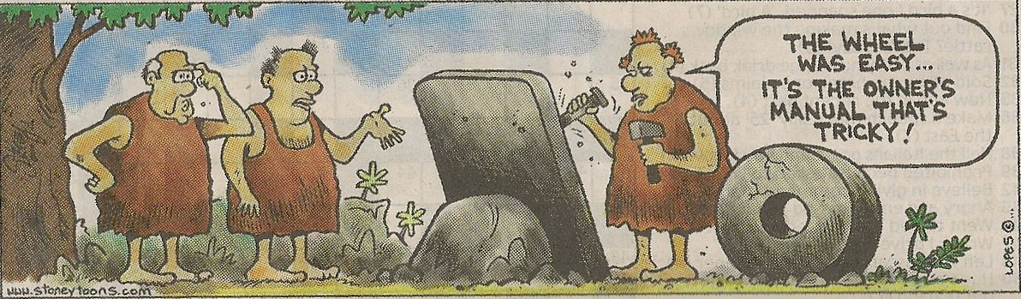

WAH\_1

## 1.0 GENERAL

Welcome to Logger32, a 32-bit logging program written by Bob Furzer, K4CY. Bob is also the author of [Zakanaka](#Zakanaka), and a 16-bit version of Logger.

Logger32 runs under Windows Vista, Windows 7 and Windows 8 operating systems provided that the program is NOT installed in the "Program Files" folder on the computer and the [UAC](#UAC) is turned off. For all functions to perform, Logger32.exe should be run with Administrator privilege. Although no longer supported by Microsoft, efforts are made to maintain a reasonable backwards compatibility for Windows 95/98, Windows 2000, Windows ME, Windows NT and Windows XP operating systems (these program names are all copyright by Microsoft Corporation.)

At the present time. Logger32 is free.

Logger32 software and Helpfile copyright information can be found in the [Copyrights and License](#_topic_CopyrightsandLicense) section.

## 2.0 ACKNOWLEDGMENTS

Thanks and acknowledgments are given to:

* + John Shelton K1XN for his approval allowing the integration of the GoList QSL Manager Database with this program. The GOLIST can be found at the [GOLIST link](#Link:_GOLIST), or via e-mail at [support@golist.net](mailto:support@golist.net).
  + Makoto Mori JE3HHT for his permission to include his [RTTY](#RTTY) data engine MMTTY and his [RTTY](#RTTY) and [PSK](#PSK31/63/125) data engine MMVARI within the Soundcard Data window software. Further information on [MMTTY](#MMTTY) can be found at the [MMTTY link](#Link:_MMTTY) and MMVARI at the [MMVARI Link](#Link:_MMVARI).
  + Aki Yoshida JA1NLX and Hal Kojima JE4IVN for their considerable assistance during the development of the radio control software for use under the Japanese versions of Microsoft Windows.
  + Alex Shovkoplyas VE3NEA (Afreet Software Inc.) for the support given during the integration of his HamCAP propagation prediction freeware. HamCAP can be downloaded from the [Ham CAP link](#Link:_HamCap).
  + Roger Hedin SM3GSJ for his invaluable assistance with the Azimuthal map projection code.
  + The [RSGB](#RSGB) [IOTA](#IOTA) committee for supporting the downloading of their "activity" [XML](#XML) files for use with Logger32.
  + The 425DX organization for allowing the use of their DX News and Calendar.
  + Robert Chalmas HB9BZA for supporting Logger32 in allowing users to download and use his [LoTW](#LoTW) database.
  + Rene Schmidt DF9GR and Richard Desaulniers VE2DX for their assistance and testing during the integration of the support for the GS232B Az/Az rotator protocol .
  + The many who provided valuable feedback and information on specific topics throughout the project.

## 3.0 HISTORY

Like Zakanaka, Logger32 and these Help files are the product of an experiment. Bob Furzer, K4CY, decided that he would enlist the assistance of other amateurs in creating the package. Work started on the project in early July 2001, and the following volunteers coordinated via the Internet to assist in the development of the program and to create the Helpfile:

Someday we will meet each other in person, but for the moment, we hope that we have continued the helping-ham tradition that was passed to us by Bob. Each topic of the Helpfile has the name of the original author(s) at the upper left, but all team members contributed over the course of development.

### 3.1 Development Team

|  |
| --- |
| Bob Furzer K4CY |
| Geoff Anderson, G3NPA |
| Charlie Sutton, W1MCP |
| Mike Mace, VK3SU |
| Jim Hargrave, W5IFP |
| Hew Lines VA7HU |
| Aki Yoshida JA1NLX |
| Bud Hippisley W2RU |
| Rick Ellison N2AMG |
| Rick WIlliams VE7TK |

### 3.2 Beta Test Team

|  |  |
| --- | --- |
| Bob Furzer K4CY | Geoff Anderson G3NPA |
| Hew Lines VA7HU | Charlie Sutton W1MCP |
| Jim Hargrave W5IFP | Mike Mace VK3SU |
| Ramon Paradell EA3EJI | Marek Niedzielski SP7DQR |
| Jan Buitenhuis PA4JJ | Alec Otulak SP2EWQ |
| Jim Pickett K5LAD | Javier Bermejo EA1AUS |
| Ian Morrison VE3EP | Villi Sigurjonsson TF3VS |
| Bud Hippisley W2RU | Randolf Schmitz DL6KAI |
| Dave Lavelli IK2AGX | Hans-Juergen Barthen DL5DI |
| Jim Steel M0ZAK | Janis Majdic S51J |
| Arne Andersson SM5CNQ | Jorge Enrique Knull LU4YAO |
| Constantin Semyonov UA1AKE | Haruo (Hal) Kojima JE4IVN |
| Yukito Fukui JI1ANI | Dragan Acimovic YZ1EW |
| Franck F8ADY | Luca Civinini IK5PWC |
| Polde Kobal S57TUB | Rick Ellison N2AMG |
| Joseph Jiang BD4EPV | Gerry Hohn VE6LB |
| Gary Hinson ZL2IFB | Bob Harrison G4UJS |
| Aki Yoshida JA1NLX | Dan Atchison N3ND |
| Rick Williams VE7TK |  |

### 3.3 Translators

|  |  |  |  |
| --- | --- | --- | --- |
| **Author** | **Language** | **DLL** | **Document** |
| Geoff Anderson G3NPA | English (Britain) | Language DLL | Helpfile Topics |
| Aki Yoshida JA1NLX | Japanese | Language DLL | Helpfile Topics |
| Jan Buitenhuis PA4JJ | Dutch | Language DLL |  |
| Villi Sigurjonsson TF3VS | Icelandic | Language DLL |  |
| Dragan Acimovic YZ1EW |  |  |  |
| Luca Civinini IK5PWC |  |  |  |
| Polde Kobal S57TUB | Slovenian | Language DLL |  |
| Luciano Fusari I5FLN | Italian | Language DLL |  |
| Alexander Schwinn DL5VZ |  |  |  |
| Marek Niedzielski SP7DQR | Polish | Language DLL | Helpfile Topics |
| Javier Bermejo EA1AUS | Spanish | Language DLL | Helpfile Topics |
| Constantin Semyonov UA1AKE | Russian | Language DLL |  |
| Franck Kerdoncuff F8ADY | French | Language DLL |  |
| Joseph Jiang BD4EPV | Chinese | Language DLL |  |
| Zdenek Habala, OK2PAD | Czech | Language DLL | Helpfile Topics |
| Alexander Schwinn DL5VZ | German | Language DLL |  |
| Vangelis Gkekas SV2BFN | Greek | Language DLL |  |
| Papp Dénes HA6FQ | Hungarian | Language DLL |  |
| Jozef Hacaj OM3JH | Slovak | Language DLL |  |

### 3.4 Contributors

### 3.4.1 Database maintenance

Geoff Anderson G3NPA IOTA database

Bud Hippisley W2RU             Country database

### 3.4.2 Group Moderators

Prasad Rajagopal VU2PTT Logger32.net

Bud Hippisley W2RU           Hamlogger

Geoff Anderson G3NPA L32Team

Geoff Anderson G3NPA L32Beta

### 3.4.3 Help file

Hew Lines VA7HU Editor

### 3.4.4 SK Contributors

The following amateurs each contributed greatly to the Logger32 development and testing and have left their legacy for us to carry on.

Antonio (Toni) Perez, EA1NK (SK 18 Jan 2006)

Jose (Joe) Valdes, YV5LIX (SK Aves-2006 DXpedition)

Ray McClure, W8CNL (SK 25 Jun 2008)

Eike Barthels DM3ML (SK 25 Sep 2011)

Javier Bermejo EA1AUS

Geoff Anderson G3NPA (SK 10 Mar 2018)

*Created with the Personal Edition of HelpNDoc:* [*Free help authoring tool*](http://www.helpndoc.com/help-authoring-tool)

**General Features**

# Geoff Anderson G3NPA

## 1.0 GENERAL

LOGGER32 has been developed to be a highly user-configurable, general purpose amateur radio logbook with computer control support for many radios and antenna rotators. It is **NOT** a contesting log, although there is no real reason why it could not be used as such, and does not contain some features that might be found in software specifically designed for this activity. The functionality that it **DOES** provide includes:

* 1. Logger32 maintains [ADIF](#ADIF) compatibility at the current release level within the constraints of development lag between the [latest](links%20and%20reflectors.htm#links:%20adif) [ADIF](#ADIF) [release](links%20and%20reflectors.htm#links:%20adif) and Logger32 version release;
  2. [Logbook Page window](#_topic_LogbookPageWindow) and Previous QSOs windows that each have up to 47 columns, all user configurable, including [IOTA](#IOTA), grid squares, satellite names, Ten-Ten and other items;
  3. Many windows that contain columns displayed in user configurable order;
  4. A Worked/Confirmed window that can display information in multiple ways;  
     ;
  5. Multiple user-definable Logbook Entry window entry items;
  6. The capability to log more than 1.5M QSOs;
  7. Fully editable Country, County, and IOTA databases;
  8. The display of sunrise/sunset times, short path distance, long and short path beam headings, and local time for the distant station:
  9. Comprehensive statistics tables for awards and QSLs;  
     .
  10. Real time satellite tracking using Keplarian elements from a local file or collected from a [web site](#Link:_Keplerian_Elements);
  11. Grayline display on maps with selectable terminator;
  12. DX spot displays with input from multiple sources;
  13. User-definable worked/confirmed color schemes for incoming spots;
  14. Support for many radios including a debug window;
  15. User-selectable frequency display in [KHz](#KHz) or [MHz](#MHz) down to 1 [Hz](#Hz) resolution;
  16. User-selectable date and time formats;
  17. CDROM support;
  18. On-line support for the use of QRZ.com and GoList;
  19. A facility to synchronize your computer's clock to an atomic standard;
  20. Re-sizable windows and the capability to retrieve lost windows when screen resolution is modified;
  21. Support for multiple .INI files for different set-ups (normal, contest, etc.);
  22. Configurable fonts, including background, and foreground colors;
  23. Auto log-on scripts for telnet and cluster access;
  24. Definable telnet and cluster shortcuts and scripts;
  25. The capability to personalize your own bandplan;
  26. Prefix statistics available for up to 50 bands and 48 modes;
  27. A list of previously worked callsigns that automatically appears under the Callsign Entry edit box;
  28. User-definable column widths in many windows and tables;
  29. Support for a parallel port antenna selector that can operate automatically with your bandplan;
  30. Many windows that can be sorted on any visible column.
  31. The capability to output Log data in [ADIF](#ADIF), [UQF](#UQF), or [CSV](#CSV) formats;
  32. Support for both multiple user (One log for the family or Club station) and multiple logs (e.g. one for the main, one for contesting);
  33. User-selectable fields to copy data from previous QSO details to a new logbook entry;
  34. A Logbook percentage full indicator;
  35. A Grid Square Calculator;
  36. Support for Club Log, [eQSL](#eQSL) and Logbook of The World ([LoTW](#LoTW));
  37. Functional information buttons in the Logbook Entry Window;
  38. The capability to export QSOs flagged for QSLing;
  39. The highlighting of QSLs waiting to be sent in the log;
  40. The capability to send DX spots to a VHF cluster or Telnet;
  41. The Integration of [MMTTY](#MMTTY) and [MMVARI](#MMVARI) for digital operations, including three independent, simultaneous receive channels in PSK31 and a selectable waterfall or spectral signal display;
  42. Selectable colors for receive and transmit windows;
  43. Selectable frequency markers;
  44. Built-in macros for use with a selectable number of programmable "buttons";
  45. The capability to capture a callsign and name with a click;
  46. The capability to add QSO number;
  47. Programmable default [Rx](#Rx) (initial receive) frequencies;
  48. Independent [AFC](#AFC) and squelch settings for each [Rx](#Rx) window;
  49. Selectable waterfall and spectrum display characteristics (color, brightness, smoothing);
  50. An [IMD](#IMD) indication;
  51. A slash-zero display option;
  52. The capability to operate [RTTY](#RTTY) (including 23 [Hz](#Hz).) using the [MMTTY](#MMTTY) module;
  53. Calibrating the sound card timing;
  54. Operate split using audio tones or radio control;
  55. The capability to save operating parameters in [RTTY](#RTTY) mode in a "Profile";
  56. [SO2R](#SO2R) compatibility;
  57. A built-in CW keyer (but NO decoder) with programmable buttons and a limited range of macros;
  58. Support for automatic control of your antenna rotator;
  59. A contest serial number counter for up to 999,999 contacts;
  60. User-selectable highlighting of states for Worked, Confirmed, QSL Send, QSL awaiting printing and general editing;
  61. Single button compression and saving of backup log files;
  62. A built-in Digital Voice Keyer ([DVK](#DVK));
  63. A built-in Data Terminal with programmable buttons and a range of macros;
  64. A simple conversion utility (Deg. [C](#C) -> [F](#F). etc.);
  65. DX Cluster spots that can be displayed on a map;
  66. Selective filtering of DX spots;
  67. Synchronization of the log to download [LoTW](#LoTW) and/or [eQSL](#eQSL) records;
  68. Sending and receiving cluster "Announce" and "Talk" messages using a separate window;
  69. Support for HamCap - a propagation prediction tool written by VE3ENA;
  70. Support for a second [CAT](#CAT) controlled radio;
  71. Support for on-line Hamcall lookup.

 With Logger32 the answer is probably "Yes." Now what is the question?

*Created with the Personal Edition of HelpNDoc:* [*Easily create Web Help sites*](http://www.helpndoc.com/feature-tour)

**Copyrights and License**

# Bob Furzer K4CY

## 1.0 GENERAL

## Copyright 2002-2019 Robert C. Furzer. All rights reserved.

Authorization to use this software is limited to radio amateurs who agree to strictly comply with the following operating practices:

* + Any questions or comments pertaining to Logger32 should be addressed to the [Hamlogger Reflector](#Links:_Hamlogger_Reflector), and **NOT** to Bob Furzer directly
  + Always use your full callsign when calling another station
  + Never respond to calling operators who do not use full callsigns
  + Do not spell your name or QTH unless specifically asked to do so
  + Do not call the operator of the station you are in contact with 'Sir', 'Your Highness', 'Doctor', 'Monk' or any other title (real or imaginary)
  + Do not end your transmissions with 'QSL', 'Roger', 'Over', or 'Over Over'
  + Do not begin your transmissions with 'QSL', 'Roger', or 'Roger Roger'
  + Do not operate (or condone those that do) on DX list or DX net operations
  + Know the callsign of the station you are calling before you call
  + Do not operate on SSB with wider than 2.8 KHz bandwidth filters (or condone those that do)
  + Do not use external devices to unnecessarily distort the audio
  + Do not precede an exchange of signal reports with "Please copy ...," "When last heard...," or any other superfluous colloquial phrase

I took the time and effort to write the software. Many others have taken the time and effort to debug the software and write the documentation. At the very least, you can make the effort to comply with the terms of the use of this software. If you chose not to operate in accordance with the requirements listed above, please do not use this software.

In general, Logger32 is free for use in amateur radio, but is not licensed for reproduction on CDs or web sites other than those selected by Bob Furzer.  Authorization to reproduce this software (on CD, Internet or any other form or media) is explicitly prohibited. Please don't waste my time or yours by asking. The answer is 'NO.'

The [IOTA](#IOTA) database is copyright of the [RSGB](#RSGB), and is not part of the Logger32 release software. The IOTA and IOTA Island databases now included with Logger32 are sample databases derived from public (non-copyright) sources, from public domain (non-copyright) sources, and extensive contributions from individual amateurs. The validity and accuracy of the Logger32 databases are unknown and have not been validated with the RSGB. Individual users of Logger32 are free to modify the Logger32 IOTA databases as they see fit.

*Created with the Personal Edition of HelpNDoc:* [*Single source CHM, PDF, DOC and HTML Help creation*](http://www.helpndoc.com/help-authoring-tool)

**How to Use Help**

# Geoff Anderson G3NPA and Hew Lines VA7HU

## 1.0 GENERAL

The Helpfile contains a few features that you should know about.

There is also a section of Tips Tricks and Troubleshooting that may save you time in solving problems (for example: Everything stopped working--Is Logger32 on top of an error message?)

## 2.0 HYPERLINKS

There are hyperlinks throughout the text, in three colors.

* + Those in purple jump to a definition in the [Glossary](#_topic_Glossary) or [Abbreviations](#_topic_Abbreviations) and you can also get to the [Glossary](#_topic_Glossary) or [Abbreviations](#_topic_Abbreviations) by using the Contents tab.
  + The hyperlinks in green jump to various sections of the Helpfile that go into more detail about the subject of the link.
  + The hyperlinks in blue will attempt to link to a World Wide Web site to provide external resources that may help you with hardware and other issues relevant to using Logger32 and implementing digital modes on your computer-radio system. They can also open your default e-mail application to send an e-mail message to the highlighted e-mail address.
  + In all cases, once you have jumped to a new location, you can use the [Back button](#3.2._Back_Button) on the Navigation bar to return to the previous location.
  + You can use Help in two ways:  
    - The Table of Contents can be found under the [Contents tab](#4.1_Contents_Tab) on the Navigation bar. Use the Table of Contents to navigate to a specific section or topic.
    - The [Index](#4.2_Index_Tab), [Search](#4.3_Search_Tab) and [Favorites](#4.4_Favorites_Tab) tabs allow the user to search for specific sections, topics or individual words and phrases within the Helpfile.

## 3.0 NAVIGATION BAR

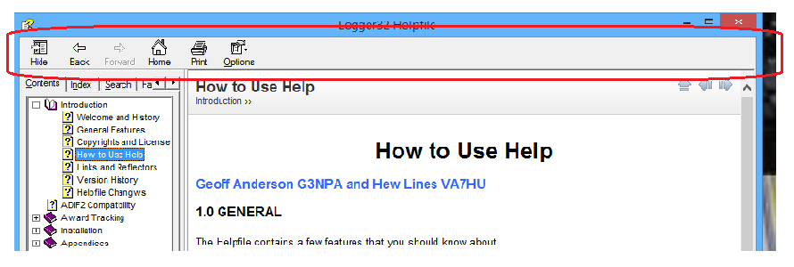

HTUH\_1

The Navigation Bar consists of six buttons that enable quick movement within and between all sections of the Helpfile.

### 3.1 Show/Hide Button

The Show/Hide button controls the display of the [Functions panel](#4.0_FUNCTIONS_PANEL) on the left side of the Helpfile window.

### 3.2. Back Button

As you navigate through the Helpfile, the <**Back**> button will take you back one step to the previous topic that you were viewing. When you first open the Helpfile or return to the first topic that was first displayed, the <**Back**> button will be disabled (you are back where you started).

### 3.3 Forward Button

The <**Forward**> button will be disabled until you have used the <**Back**> button to return to a previously selected topic. When you have used the <**Back**> button, the <**Forward**> button will be enabled, allowing you to return to the previous topic.

### 3.4 Home Button

The <**Home**> button will always take you back to the beginning of the Helpfile (the [Welcome and History](#_topic_WelcomeandHistory) topic).

### 3.5 Print Button

The <**Print**> button provides access to printing functionality available within the Helpfile in two ways.

If the Content tab is selected and the Table of Contents is displayed, selecting the <**Print**> button will display a "Print Topics" dialog box that will allow the user to:

* + Print the Selected Topic only; or,
  + Print the Selected Topic and all Subtopics of the selected one.

**Note**: The second option will not start each subtopic on a new page but will print the complete text of all topics as a single document.

If any of the other tabs are selected, the system Print dialog box will be displayed.

### 3.6 Options Button

The <**Options**> button allows the user to configure much of the functionality available within the Helpfile.

## 4.0 FUNCTIONS PANEL

The Helpfile is structured like a book and includes a Table of Contents, a number of Sections, with each section containing one or more Topics, as well as a document Index. In addition stepping through the topics sequentially, the Favorites panel provides the user with additional functionality to navigate the Helpfile in a number of ways through four tabbed panels:

**Note**: If you select a Section icon on the Functions Panel (a purple closed book), the Title page for that section will be displayed and will only contain the Title of that section. The remainder of the page will be blank.

### 4.1 Contents Tab

The Contents tab displays the Helpfile Table of Contents. Simply selecting any of the Section or Topic names or icons will take you directly to that Section or Topic.

### 4.2 Index Tab

The Index tab will display a list of "Keywords" or phrases that can be used to search through the Helpfile. Every topic in the document has been assigned one or more "Keywords" or phrases by the developers. During Helpfile development, these words or phrases were identified as being "important" in some context within the content of the topic, and in fact are probably assigned to more than one topic.

When you first select the Index tab, a complete list of all keywords in the document is displayed, in alphabetical order. You could, if you wanted to, simply scroll up and down in the list and try to find the desired word. However, you could also type the word you are looking for in the edit box above the list and an smaller list containing only the topics that contain the word or phrase in the edit box will be displayed. You will notice that the list changes with each letter entered, eventually reaching the exact word or phrase entered, or the closest match to it.

Selecting the <**Display**> button at the bottom of the list will then display a small "Topics Found" dialog box with a list of all topics in the Helpfile that contain the word or phrase in the edit box. You can then jump to a topic by left-clicking on the topic name and selecting the <**Display**> button, or double-clicking the topic name in the list.

### 4.3 Search Tab

The Search tab displays a panel that provides the tools to search the entire Helpfile for any word or phrase, not just a specific Keyword. Enter the word or phrase into the edit box at the top of the panel, select the <**List Topics**> button and a complete list of all topics that contain the entered data will be displayed. If necessary (the list is too large), you can configure the list using the three check boxes at the bottom of the panel and select the <**List Topics**> button again

Selecting the <**Display**> button at the bottom of the list will then display a small "Topics Found" dialog box with a list of all topics in the Helpfile that contain the word or phrase in the edit box. You can then jump to a topic by left-clicking on the topic name and selecting the <**Display**> button, or double-clicking the topic name in the list.

### 4.4 Favorites Tab

The Favorites tab provides the user with the capability to identify favorite sections and topics and add or remove them from a list, They can be quickly displayed from the Favorites list by selecting a topic and then the <**Display**> button or double-clicking on a topic name in the list.

*Created with the Personal Edition of HelpNDoc:* [*Easily create EPub books*](http://www.helpndoc.com/feature-tour)

**Links and Reflectors**

###### Hew Lines VA7HU

## 1.0 GENERAL

The following links to the Internet may provide you with more specific or additional detail on topics related to Logger32:

### 2.0 LINKS

The official Logger32 website, including all supporting software and documentation is located at [www.logger32.net](http://www.logger32.net./).

For details on the current version of the Amateur Data Interchange Format used to exchange data between various logging programs, visit [www.adif.org.uk/adif](http://www.adif.org.uk/adif).

For on-line callsign lookup you have three choices:

* 1. [www.qrz.com/](http://www.qrz.com/);
  2. [www.golist.net/](http://www.golist.net/); or,
  3. [www.hamqth.com/](http://www.hamqth.com/).

For information on the ARRL Logbook of the World program, see [www.arrl.org/lotw](http://www.arrl.org/lotw/#top).

Jeff, AC6V, has a great list of world-wide DX clusters at [www.ac6v.com/dxcluster](http://www.ac6v.com/dxcluster.htm).

In addition to the Telnet site predefined in the Satellite Tracking Window, another source for Keplerian elements can be found at [www.amsat.org/](http://www.amsat.org/amsat/keps/menu.html)

A site that has lots of good information on time zones around the world is [www.timeanddate.com/worldclock](http://www.timeanddate.com/worldclock/full.html).

For information on converting Excel spreadsheet data to [ADIF](#ADIF) logfile format, see [www.storm.ca/~ve3iay/spreadsh.html](http://www.storm.ca/~ve3iay/spreadsh.html).

For information on the NCDXF DX Beacon Project, go to [www.ncdxf.org/beacons.html](http://www.ncdxf.org/beacons.html).

For information on Multi Language Support [DLL](#DLL)s, go to [http://support.microsoft.com/](http://support.microsoft.com/default.aspx?scid=kb;EN-US;q232625).

For information on Locale IDs ([LCID](#LCID)), go to [http://support.microsoft.com/](http://support.microsoft.com/default.aspx?scid=kb;EN-US;221435).

For help with Time Zone configuration on Windows OS using Regional Settings see  <http://support.Microsoft.com/kb/928388>,

\*\*\*\*\*\*\*\*\*\*\* For information on Resource file translators, see <http://www.yare-vb.com>.

The HamCap propagation prediction software can be obtained at <http://www.dxatlas.com/HamCap/>.

The following [URL](#URL) provides a good overview of [RTTY](#RTTY). It is good for the beginner as well as seasoned [RTTY](#RTTY) operators:<http://www.aa5au.com/rtty/getting-started-on-rtty/>

A list of various contest times and rules can be found on the web at [www.sk3bg.se/contest/](http://www.sk3bg.se/contest/).

The MMTTY web site is <http://hamsoft.ca/pages/mmtty.php>.

The MMVARI web site is [http://hamsoft.ca/pages/mmvari.php.](http://hamsoft.ca/pages/mmvari.php)

West Mountain Radio, the distributor of Rigblaster, has lots of information at this url: <http://www.westmountainradio.com/>.

Here is a link to a number of interface designs to go between the sound card output (speaker or headphone out) and the microphone or audio input at the transceiver. In addition to the interface between the sound card output and transceiver audio input, this excellent site has schematics for interfaces that allow us to operate the PTT line of the radio from a COM port on the computer, yet keep the two components completely isolated by using an optoisolator.  There are designs for switching PTT using the RTS or DTR line, and the diagrams give the pinout on the computer DB-9 or DB-25 for each line. http://www.qsl.net/wm2u/interface.html.

The magnetic variation for any specific QTH, can be determined from information available at: <http://www.geo-orbit.org/sizepgs/magmapsp.html>.

For a good introduction to PSK31 and QPSK, see NB6Z's excellent discussion at <http://myplace.frontier.com/~nb6z/frame.htm>.

.

For information on the WinKey Interface, the manual is downloadable from <http://k1el.tripod.com/products.html>.

The National Institute of Standards and Technology maintains a list of time servers on their web page: [http://tf.nist.gov/tf-cgi/servers.cgi#](http://tf.nist.gov/tf-cgi/servers.cgi).

The WM2U page has radio-specific interface designs for sound-card-output-to-radio audio connections, and also for PTT connections.  Ground loop solutions are also addressed. [www.qsl.net/wm2u/interface.html.](http://www.qsl.net/wm2u/interface.html)

These interfaces and interface kits provide various combinations of plug compatibility, sound card output voltage reduction and isolation, PTT isolation, and other features. [www.westmountainradio.com/](http://www.westmountainradio.com/), [www.buxcommco.com/buxcat.html](http://www.buxcomm.com/catalog/) and [www.mfjenterprises.com/](http://www.mfjenterprises.com/).

\*\*\*\*\* Logger32 comes with a generic map for use in the tracking window. For those of you who like to play, take a look at www.satscape.co.uk/ under Maps.

\*\*\*\*\* The Ten-Tec Programmers Reference Manual can be found at  www.rfsquared.com/updates/588/588

Information on IOTA activity can be found at: [http://www.rsgbiota.org](http://www.rsgbiota.org/).

CwGet is NOT part of the Logger32 distributed package and the user must obtain their own copy of this program. One source is <http://www.dxsoft.com/en/products/cwget/>.

Detailed information on the SteppIR antenna controllers can be found at <http://www.steppir.com/manuals>.

Support for the Griffin PowerMate can be found at <http://griffintechnology.com/support/powermate>.

Information and details regarding Club Log can be found at [https://secure.clublog.org/lotw](https://secure.clublog.org/lotw/)

Information on DX Spot Clusters can be found at the following url's:

[http://www.g4bki.com/clusters.htm;,](http://www.g4bki.com/clusters.htm)

[http://www.bcdxc.org/ve7cc/default.htm#prog;, and](http://www.bcdxc.org/ve7cc/default.htm#prog)

[http://www.dxcluster.info/telnet/index.php.](http://www.dxcluster.info/telnet/index.php)

## 3.0 REFLECTORS

The following reflector will allow you to participate in on-line discussions related to the Logger programs, both 16 and 32 bit versions <https://groups.io/g/hamlogger>

*Created with the Personal Edition of HelpNDoc:* [*Easily create CHM Help documents*](http://www.helpndoc.com/feature-tour)

**Helpfile Changes**

# Hew Lines VA7HU

|  |  |  |  |
| --- | --- | --- | --- |
| **Date** | **Version** | **Type of Release** | **Revisions** |
| 5 Jun 2019 | 3.50.388B1 | Beta Release | The following topics have been modified  [Welcome and History](#_topic_WelcomeandHistory)  [Helpfile changes](#_topic_HelpfileChanges)  [Status Panels](#_topic_StatusPanels)  [The UDP Bandmap](#_topic_TheUDPBandmap) |
| 28 May 2019 | 3.50.387B1 | Beta Release | The following topics have been modified  [Welcome and History](#_topic_WelcomeandHistory)  [Helpfile changes](#_topic_HelpfileChanges)  [The UDP Bandmap](#_topic_TheUDPBandmap)  [ICOM General](#_topic_ICOMGeneral)  [Kenwood General](#_topic_KenwoodGeneral)  [Yaesu General](#_topic_YaesuGeneral) |
| 6 May 2019 | 3.50.385B1 | Beta Release | The following topics have been modified  [Welcome and History](#_topic_WelcomeandHistory)  [Helpfile changes](#_topic_HelpfileChanges)  [The UDP Bandmap](#_topic_TheUDPBandmap) |
| 22 Apr 2019 | 3.50.383B1 | Beta Release | The following topics have been modified  [Welcome and History](#_topic_WelcomeandHistory)  [Helpfile changes](#_topic_HelpfileChanges)  [Status Panels](#_topic_StatusPanels)  [Using the Logger32 External Interface](#_topic_UsingtheLogger32ExternalInterfac) |
| 15 Apr 2019 | 3.50.382B1 | Beta Release | The following topics have been modified  [Welcome and History](#_topic_WelcomeandHistory)  [Helpfile changes](#_topic_HelpfileChanges)  [DX Spots Window](#_topic_DXSpotsWindow1)  [Exporting Logs](#_topic_ExportingLogs)  [Kenwood TS-480/TS-590](#_topic_KenwoodTS480TS590)  [Setup Menu](#_topic_SetupMenu)  [The UDP Band Map](#_topic_TheUDPBandmap)  [The TCP Server](#_topic_TheTCPServer) |
| 11 Feb 2019 | 3.50.380B1 | Beta Release | The following topics have been modified  Helpfile changes  [DX Spots Window](#_topic_DXSpotsWindow1)  [ICOM IC-7300](#_topic_ICOMIC7300)  [Logbook Page Window](#_topic_LogbookPageWindow)  [The UDP Bandmap](#_topic_TheUDPBandmap) |
| 02 Jan 2019 | 3.50.377B1 | Beta Release | The following topics have been modified  Helpfile changes  [Copyrights and License](#_topic_CopyrightsandLicense)  [Status Panels](#_topic_StatusPanels) |
| 30 Dec 2018 | 3.50.373B2 | Beta Release | The following topics have been modified  Welcome and History  Helpfile changes  MACROs - Broken Links Fixed |
| 27 Dec 2018 | 3.50.373B1 | Beta Release | The following topics have been modified  Welcome and History  Helpfile changes  [The UDP Bandmap](#_topic_TheUDPBandmap)  [CW Machine Window](#_topic_CWMachineWindow) - Broken Links Fixed |
| 10 Dec2018 | 3.50.371B1 | Beta Release | Broken  Welcome and History  Helpfile changes  [The UDP Bandmap](#_topic_TheUDPBandmap) |
| 17 Sep 2018 | 3.50.366B1 | Beta Release | The following topics have been modified  Welcome and History  Helpfile changes  The CW Machine Window  Logbook Entry Window  MACROs, Hotkeys and Programmable Buttons  Radio Control Panel  The UDP Bandmap |
| 16 Aug 2018 | 3.50.362B1 | Beta Release | The following topics have been modified  Welcome and History  Helpfile changes  Links and Reflectors  The Setup Menu  The UDP Bandmap |
| 17 Jul 2018 | 3.50.358B1 | Beta Release | The Following Topic has been added  The Slave Port  The following topics have been modified  Welcome and History  Helpfile changes  The Echo Port  UDP Broadcast of DX Spots  Setup Menu  Status Bar |
| 28 Jun 2018 | 3.50.357B1 | Beta Release | The Following Section has been added  External Interfaces  The Following Topic has been added  UDP Broadcast of DX Spots  The following topics have been modified  Welcome and History  Helpfile changes  DX Spots Window  The UDP Bandmap |
| 24 May 2018 | 3.50.356B1 | Beta Release | The following topics have been modified  Welcome and History  Helpfile changes  Award Tables |
| 16 May 2018 | 3.50.355B2 | Beta Release | The following topics have been modified  Welcome and History  Helpfile changes  MACROs, Hot Keys and Programmable Buttons  Radio Control Panel |
| 14 May 2018 | 3.50.355B1 | Beta Release | The following topics have been modified  Welcome and History  Helpfile changes  Award Tables  The UDP Bandmap |
| 2 May 2018 | 3.50.354B2 | Beta Release | The following topics have been modified  Welcome and History  Helpfile changes  Logbook Window  The F11 Key Explained |
| 22 Apr 2018 | 3.50.354B1 | Beta Release | The following topics have been modified  Welcome and History  Helpfile changes  Data Terminal Window  MACROs, Hot Keys and Programmable Buttons  Setup Antenna Selector |
| 21 Mar 2018 | 3.50.350B1 | Beta Release | The following topics have been modified  Welcome and History  Helpfile changes  Tips Tricks and Troubleshooting |
| 30 Jan 2018 | 3.50.347B1 | Beta Release | The following topics have been modified  Welcome and History  Helpfile changes  Logbook Entry Window |
| 6 Jan 2018 | 3.50.345B1 | Beta Release | The following topics have been modified  Welcome and History  Helpfile changes  Copyrights and License  The UDP Bandmap |
| 7 Dec 2017 | 3.50.342B1 | Beta Release | The following topics have been modified  Welcome and History  Helpfile changes  Award Tracking |
| 3 Dec 2017 | 3.50.341B1 | Beta Release | The following topics have been modified  Welcome and History  Helpfile changes  Award Tracking  DX Spots Window  The UDP Bandmap |
| 18 Nov 2017 | 3.50.340B1 | Beta Release | The following topics have been modified  Welcome and History  Helpfile changes  Setup Menu  Club Log Exceptions |
| 9 Nov 2017 | 3.50.339B1 | Beta Release | The following topics have been modified  Welcome and History  Helpfile changes  Status Panels  The TCP Server  The H2S Bandmap title changed to UDP Bandmap with changes |
| 29 Oct 2017 | 3.50.336B1 | Beta Release | The topic H2S Bandmap has been added  The following topics have been modified  Welcome and History  Helpfile changes  DX Spots Window  IOTA Synchronization  Main Menu  Status Panels |
| 08 Sep 2017 | 3.50.334B1 | Beta Release | The following topics have been modified  Welcome and History  Helpfile changes  Exporting Logs  Updating Logger32 |
| 29 Aug 2017 | 3.50.332B1 | Beta Release | The following topics have been modified  Welcome and History  Helpfile changes  CW Machine Window  Data Terminal Window  Hot Keys  Links and Reflectors  Radio Control Panel |
| 14 Aug 2017 | 3.50.329B1 | Beta Release | The following topics have been modified  Welcome and History  Helpfile changes  Additional Information Windows  Award Tables  Logbook Entry Window  Tips, Tricks and Troubleshooting |
| 31 Jul 2017 | 3.50.328B1 | Beta Release | The following topics have been modified  Welcome and History  Helpfile changes  eQSL Synchronization  Main Menu  Logbook Page Window |
| 6 Jul 2017 | 3.50.324B1 | Beta Release | The following topics have been modified  Welcome and History  Helpfile changes  The TCP Server  Status Panels |
| 16 Jun 2017 | 3.50.321B1  The Rainbow Version | Beta Release | The following topic has been added  The TCP Server  The following topics have been modified  Welcome and History  Helpfile changes  DX Spots Window  Logbook Entry Window  Logbook Page Window  Status Panels  The Bandmap |
| 31 May 2017 | 3.50.319B1 | Beta Release | The following topics have been modified  Welcome and History  Helpfile changes  DX Spots Window  Logbook Entry Window  The Bandmap |
| 14 May 2017 | 3.50.315B3 | Beta Release | The following topics have been modified  Welcome and History  Helpfile changes  Communicating with PSK, MFSK and QPSK  Communicating with RTTY  GRITTY Decode Engine for RTTY  LoTW Synchronization from Club Log  Sound Card Data Window |
| 12 May 2017 | 3.50.315B2 | Beta Release | The following topic has been added  LoTW Synchronization from Club Log  The following topics have been modified  Welcome and History  Helpfile changes  Links and Reflectors |
| 11 May 2017 | 3.50.315B1 | Beta Release | The following topics have been modified  Welcome and History  Helpfile changes  Additional Information Windows  Communicationg with PSK, MFSK and QPSK  DX Spots Window  Exporting Files  Exporting Logs  Logbook Entry Window  Logbook Page Window  MACROs, Hot Keys and Programmable Buttons  Setup Bands and Modes  Sound Card Data Window  Status Bar  The Bandmap  The Tracking Window  Tips Tricks and Troubleshooting  Worked Confirmed Window |
| 4 Apr 2017 | 3.50.313B1 | Beta Release | The following topic has been removed  Version History  The following topics have been modified  Welcome and History  Helpfile changes  Cumminicating with RTTY  The Bandmap  Setup Menu  DX Spots Widow |
| 9 Mar 2017 | 3.50.311B1 | Beta Release | Beta Release The following Sections have been modified  Welcome and History  Helpfile changes  DX Spots Window |
| 2 Mar 2017 | 3.50.309B2 | Beta Release | Beta Release The following Sections have been modified  Welcome and History  Helpfile changes  IOTA Synchronization  Using the Logger32 External Interface |
| 26 Feb 2017 | 3.50.309B1 | Beta Release | Beta Release The following Sections have been modified  Welcome and History  Helpfile changes  DX Spots Window  IOTA Synchronization  The Bandmap |
| 9 Feb 2017 | 3.50.306B1 | Beta Release | The following Sections have been modified  Welcome and History  Helpfile changes  DX Spots Window |
| 30 Jan 2017 | 3.50.305B1 | Beta Release | The following Sections have been modified  Welcome and History  Helpfile changes  DX Spots Window |
| 18 Jan 2017 | 3.50.300B1 | Beta Release | The following Sections have been modified  Welcome and History  Helpfile changes  DX Spots Window |
| 4 Jan 2017 | 3.50.298B1 | Beta Release | The following Sections have been modified  Welcome and History  Helpfile changes  Copyrights and License  The Bandmap  The CW Machine |
| 18 Dec 2016 | 3.50.296B1 | Beta Release | The following Sections have been modified  Welcome and History  Helpfile changes  Virtual UltraBeam Controller |
| 24 Oct 2016 | 3.50.291B4 | Beta Release | The following Sections have been modified  Welcome and History  Helpfile changes  Tips, Tricks and Troubleshooting |
| 21 Oct 2016 | 3.50.291B3 | Beta Release | The following Sections have been modified  Welcome and History  Helpfile changes  Tips, Tricks and Troubleshooting |
| 18 Oct 2016 | 3.50.291B2 | Beta Release | The following Sections have been modified  Welcome and History  Helpfile changes  Tips, Tricks and Troubleshooting |
| 15 Oct 2016 | 3.50.291B1 | Beta Release | The following Sections have been modified  Welcome and History  Helpfile changes  How to Use Help  Tips, Tricks and Troubleshooting |
| 20 Sep 2016 | 3.50.285B1 | Beta Release | The following Sections have been modified  Welcome and History  Helpfile changes  Using the Logger32 External Interface  Configuring Push to Talk  Radio Debug Window  Single Operator Two Radios (SO2R) Support  Yaesu General |
| 12 Sep 2016 | 3.50.284B1 | Beta Release | The following Section has been added  Transferring Logger32 to Another Computer  The following Sections have been modified  Welcome and History  Helpfile changes  Sound Card Data Window  DX Spots WIndow  Award Tables |
| 1 Sep 2016 | 3.50.282B3 | Beta Release | The following Sections have been modified  Welcome and History  Helpfile changes  Sound Card Data Window |
| 1 Sep 2016 | 3.50.282B2 | Beta Release | The following Sections have been modified  Welcome and History  Helpfile changes  Radio Control Panel  Sound Card Data Window  Communicating with PSK, MFSK and QPSK  Communicating with RTTY |
| 31 Aug 2016 | 3.50.282B1 | Beta Release | The following Sections have been modified  Welcome and History  Helpfile changes  Radio Control Panel |
| 28 Aug 2016 | 3.50.281B1 | Beta Release | The following Sections have been modified  Welcome and History  Helpfile changes  DX Spots Window |
| 26 Aug 2016 | 3.50.280B2 | Beta Release | The following Section has been added  GRITTY  The following Sections have been modified  Welcome and History  Helpfile changes  Exporting Logs  DX Spots Window  Logbook Entry Window |
| 25 Aug 2016 | 3.50.280B1 | Beta Release | The following Sections have been modified  Welcome and History  Helpfile changes  Logbook Entry Window  MACROs  Sound Card Data Window  Adjust DX Spots for Audio Frequency  Communicating with PSK, MFSK and QPSK  Communicating with RTTY  G3YYD 2Tone RTTY Engine |
| 24 Aug 2016 | 3.50.279B2 | Beta Release | The following Sections have been modified  Welcome and History  Helpfile changes  Database Maintenance  Logbook Entry Window |
| 18 Aug 2016 | 3.50.279B1 | Beta Release | The following Sections have been modified  Welcome and History  Helpfile changes  mputer Suggestions  Setup Antenna Rotator |
| 11 Aug 2016 | 3.50.277B1 | Beta Release | Welcome and History  Helpfile changes  DX Spots Window  Main Menu |
| 11 July 2016 | 3.50.274B1 | Beta Release | The following Sections have been modified  IOTA Synchronization  The following General Changes have been made  Welcome and History  Helpfile changes  Minor typo and editorial changes |
| 8 July 2016 | 3.50.272B1 | Beta Release | The following Section has been added  Logbook Synchronization  The following Topic has been added  IOTA Synchronization  The following topics have been moved  eQSL Synchronization  LoTW Synchronization  QSL Synchronization |
| 7 July 2016 | 3.50.271B1 | Beta Release | **The following sections have been modifed**  Welcome and History  Helpfile Changes  Logbook Page Window  Exporting Logs  Sound Card Data Window  DX Spots Window  Adjust DX Spots for Audio Frequency  Elecraft K2/K3 |
| 29 May 2016 | 3.50.265B1 | Beta Release | **The following sections have been modifed**  Welcome and History  Helpfile Changes  Exporting Logs  DX Spots Window |
| 11 May 2016 | 3.50.264B1 | Beta Release | **The following sections have been modifed**  Welcome and History  Direct Control of Radios  Elekraft K2 and K3  Exporting Logs |
| 23 Mar 2016 | 3.50.255B1 | Beta Release | **The following sections have been modifed**  Welcome and History  Helpfile Changes  MACROS  CW Machine  Kenwood General  Kenwood TS-570  Kenwood TS-590  Kenwood TS-950  Radio Control Panel |
| 24 Feb 2016 | 3.50.251B3 | Beta Release | **The following sections have been modifed**  Welcome and History  Helpfile Changes  DX Spots Window |
| 11 Dec 2015 | 3.50.222 | Update Release | **The following sections have been modifed**  Welcome and History  Helpfile Changes  Multi-Language Support  Screen Control Operations |
| 21 Oct 2014 | 3.50.0 | Full Release | **Full Release**  **The following section has been removed**  IOTA Marathon  **The following section has been added**  G3YYD 2Tone RTTY Engine  **The following sections have been modified**  Welcome and History  Version History  Help File Changes  Setup Antenna Rotator  Updating Logger32  Logbook Entry Window  Telnet CLuster Window  The Bandmap  Sound Card Data WIndow  Communicating with PSK31 and PSK63  Communicating with RTTY  MACROs Hot Keys and Progammable Buttons  Multi RX  Radio Control Panel  Power SDR  Status Bars  Previous QSOs window  DX Spots window  CW Machine  Award Tables |
| 10 Apr 2014 | 3.49.0 | Full Release | **Full Release**  **The following sections have been added**  DXCC Validation  Computer Suggestions  Dual Monitors  Support for microHam Control Commands  Open Two Radio Switching Protocol  **The following sections have been modified**  Welcome and History  Version History  Help File Changes  Setup Radio Control  Setup Antenna Rotator  Logbook Entry Window  Backing up Logger32 Files and Databases  LOTW Synchronization  MACROs Hot Keys and Progammable Buttons  Printing Awards Tables  Setup Menu  Status Bars  Database Maintenance  Radio Control Panel  Elecraft K2 K3 and KX3  ICOM General  Yaesu FTDX-5000  Automatic Antenna Switch |
| 9 Oct 2013 | 3.48.0 | Full Release | **Full Release**  **The following section has been added**  Griffin PowerMate  **The following sections have been modified**  Welcome and History  Version History  Help File Changes  System Requirements  DX Spots Window  MACROs, Hot Keys and Programmable Buttons  CW Machine  The Bandmap |

*Created with the Personal Edition of HelpNDoc:* [*Full-featured EBook editor*](http://www.helpndoc.com/create-epub-ebooks)

**Installation**

*Created with the Personal Edition of HelpNDoc:* [*Full-featured multi-format Help generator*](http://www.helpndoc.com/help-authoring-tool)

**System Requirements**

# Hal Miller, KB1ZQ and Jim Hargrave, W5IFP

## 1.0 GENERAL

Logger32 is a 32 bit application that runs on both 32 and 64 bit operating systems. It has been tested and should run on the following operating systems:

* + Windows NT; (See Note)
  + Windows 2000; (See Note)
  + Windows XP; (See Note)
  + Windows Vista (See Note);
  + Windows 7 (See Note); and,
  + Windows 8 (See Note).
  + Windows 10; (See Note)

**Note**: Logger32 will run under Vista and Windows 7, 8 & 10 if the [UAC](#UAC) is turned off and Logger32 is NOT installed in C:\program files\Logger32 as in older Operating Systems. C:\Logger32 is the current default directory, but it can be installed in other directories, such as C:\Ham Radio\Logger32.

Earlier versions of Logger32 may still work on the Win NT, Win95, Win98/98SE, 2000, Win ME & XP operating systems, but no further development will be afforded these [OS](#_topic_Abbreviations). As technology advances, some Logger32 functions no longer work with these obsolete operating systems.

The program, and all of its attendant files and databases, requires approximately 100 [Mb](#Mb) of disk space.

## 2.0 WINDOWS 7 and 8

### 2.1 The following are some suggestions for Window 8 & 10 users.

* + Run as Administrator;
  + Set "Logger32.exe" to run in compatibility mode: "Administrator" or "XP";
  + Add "?Logger32.exe" and"C:\Logger32\" directory as exceptions in your Anti-virus  Potentially Unsafe Programs (PUP); and,
  + Turn "[UAC](#UAC)" OFF.

### 2.2 Specific suggestions for Windows 8 users:

* 1. With Windows Explorer, navigate to the Logger32 directory;
  2. Locate the file "Logger32.exe";
  3. Right click and choose properties;
  4. Click on the "compatibility".tab;
  5. Check: "Run this program as an administrator". and,
  6. Click OK.

*Created with the Personal Edition of HelpNDoc:* [*Single source CHM, PDF, DOC and HTML Help creation*](http://www.helpndoc.com/help-authoring-tool)

**Installation Procedures**

Jim Hargrave W5IFP

Please review the [System Requirements](#_topic_SystemRequirements) topic in this help file before you install Logger32. Pay particular attention to the suggestions for running Logger32 on Vista, Win7 and Win 8.

Once you have verified that your equipment and operating system is compatible, download the latest full installation package from the [Logger32 website.](#Links:_Logger32_Website)

Unpack the package into a temporary directory and review the "Read.me" file before proceeding.

Run Setup.exe. The setup program will create all the necessary folders and install all files in the correct location. The default directory is C:\Logger32

Once all the files are in place, open Logger32 by clicking on the Logger32 Icon on the desktop or double clicking on Logger32.exe in the Logger32 directory. Once the program opens it will ask you for your Callsign. Enter your callsign and agree with the conditions as prompted.

Once Logger32 is operational proceed to the [Initial Setup](#_topic_InitialSetup) topic for detailed procedures to configure the basic elements of Logger32.

*Created with the Personal Edition of HelpNDoc:* [*Easily create HTML Help documents*](http://www.helpndoc.com/feature-tour)

**Initial Setup**

# Geoff Anderson G3NPA

## 1.0 GENERAL

In order for Logger32 to operate correctly, there is some basic set-up information that it requires. This section is designed to help you through this stage so you can be up and running in the shortest possible time. It is recommended that before you progress too far that the latest version of Internet Explorer be installed on your computer.

For some good ideas on how to setup your version of Logger32, take a look at the collection of Logger32 systems that Aki, JA1NLX has on his website at <http://www.asahi-net.or.jp/~yy7a-ysd/ScreenshotNew.htm>.

The basic steps are:

* 1. [Enter the operator callsign;](#2.0_-_CALLSIGN_SETUP)
  2. [Set your preferred window configuration](#3.0_WINDOW_SETUP) and window sizes;
  3. [Set the latitude and longitude](#4.0_LATITUDE_AND_LONGITUDE_SETUP) of your location;
  4. [Set your computer clock](#5.0_COMPUTER_CLOCK_SETUP);
  5. Set your preferred [frequency](#6.0_FREQUENCY_DISPLAY_SETUP), [date and time format](#_topic_SetupDateTimeandFrequencyFormats); and,
  6. Consider [additional functional window setups](#7.0_ADDITIONAL_SETUP_CONSIDERATIONS);
  7. [Import your existing log](#8.0_IMPORT_YOUR_LOG_DATA).

## 2.0 - CALLSIGN SETUP

When Logger32 is run for the first time you will be presented with the dialog box displayed below.

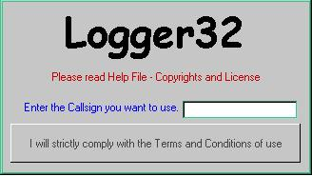

IS\_1

Enter your callsign IN CAPITALS and then click on the bar containing the words "I will strictly comply with the Terms and Conditions of use".

## 3.0 WINDOW SETUP

On opening Logger32 for the first time, it will default to a main window and eight smaller child windows. Adjust the main window to your preferred size and then position and size the eight individual child windows within the main window. Child windows may be turned off by using the "X" in the top right of each window and turned on again using the Toolbar buttons in the second panel of the Toolbar.

## 4.0 LATITUDE AND LONGITUDE SETUP

In order for some of the Logger32 features to work correctly (Beam heading and distance, and Grid Squares) you must enter the latitude and longitude of your location using the [Setup User Latitude/Longitude dialog box](#_topic_SetupUserLatandLong).

## 5.0 COMPUTER CLOCK SETUP

Logger32 records times in [UTC](#UTC) so it is important to ensure that your PC is set up correctly.

* 1. Double-click on the clock/time in the Windows system tray to display the computer Date/Time Properties;
  2. Select the appropriate Time Zone for your location and check the small box alongside the words "Automatically adjust clock for daylight saving changes" and then click on "Apply" followed by "OK";
  3. Reboot the computer to ensure that the operating system is correctly set and then call up the Date/Time Properties once again;
  4. Set the date and time to your LOCAL time. Click on "Apply" followed by "OK", or synchronize the computer clock to an atomic standard as described in section Atomic Clock;  
       
     **Note**: If you maintain your computer on [GMT](#GMT) throughout the year, you must set your computer time to use [GMT] Casablanca, Monrovia, **NOT** [GMT] Greenwich Mean Time London. The latter setting automatically adjusts for Daylight Saving Time.
  5. Logger32 displays [UTC](#UTC) time in the bottom left-hand corner of the Lower Status Bar. If this time is not correct then check to make sure you have all the above settings correct; and,
  6. As a final check, place the mouse over the time pane in Logger32 (see below) to display the PC time. Note that in the example below, the two times are the same because the PC used was set to [GMT](#GMT) and no [DST](#DST) was being applied in January! If you are using any other Time Zone and/or [DST](#DST) is being applied, then these times will be different.

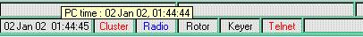

IS\_2

You should not need to change your computer clock again (apart from any small corrections necessary resulting from drift) even when daylight saving times apply.

**Special notice**: Logger32 relies on knowing how you have set your computer time in order to calculate the actual ([GMT](#GMT)) time.  If your computer clock is set to [GMT](#GMT) and the time zone to GMT Casablanca, then there is no need for concern.  However if you use your regional settings (including any daylight saving time if applicable), then you are advised to make sure that the operating system is up to date with regard to the time zone information. In the Spring of 2007, the daylight saving times for a number of places round the world changed and users are encouraged to read the [Microsoft Help and Support Notes](#Links:_Microsoft_Help_for_TIme_Zones) and to update their systems as appropriate.

## 6.0 FREQUENCY DISPLAY SETUP

Logger32 has the ability to display and log frequency in either [MHz](#MHz) or [kHz](#KHz) to a maximum resolution of 1 [Hz](#Hz). From the Logger32 [Main Menu](#_topic_MainMenu), select the [Setup | Frequency](#6.0_SETUP_MENU_ITEM) menu items and select the frequency display format of your choice.

## 7.0 ADDITIONAL SETUP CONSIDERATIONS

You can now start to log your contacts but you may wish to refer to other topics on how to set up the Logbook Page window, the Logbook Entry window, the Previous QSOs windows and the Bandplan before doing so. If you will be using either a Telnet or a VHF packet cluster to gather DX spot information, and/or you are using a CAT interface to your transceiver then you may wish to refer to these sections also.

## 8.0 IMPORT YOUR LOG DATA

Import log data from other logging programs as described in the section [Transferring Logs From Other Programs](#_topic_TransferringLogsfromLogger16andO).

*Created with the Personal Edition of HelpNDoc:* [*Generate EPub eBooks with ease*](http://www.helpndoc.com/create-epub-ebooks)

**Setup Callsign**

# Geoff Anderson G3NPA

When Logger32 is run for the first time or if you right-click on any of the edit boxes in the [Logbook Entry window](#_topic_LogbookEntryWindow) and select "Change Operator" from the popup menu, the Current Operator dialog box will be displayed. Simply enter a new callsign into the edit box, or using the drop-down list, select a previously entered callsign and click the <**Apply**> button.

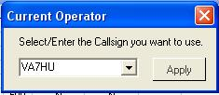

SCS\_1

*Created with the Personal Edition of HelpNDoc:* [*Free CHM Help documentation generator*](http://www.helpndoc.com)

**Setup User Lat and Long**

# Geoff Anderson G3NPA

In order to set up or change the Latitude and Longitude of your station, right-click on any edit box in the [Logbook Entry window](#_topic_LogbookEntryWindow) and select the Setup | My QTH Lat/Long menu item to display the Setup Latitude/Longitude dialog box.

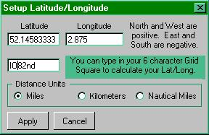

SLL\_1

Enter your Latitude and Longitude in degrees and decimal degrees, choose the units in which you want distance to be displayed and click the <**Apply**> button. Note that North and West are positive values while East and South are negative values.

If you don't know your Lat/Long but you know your six-figure Grid Square reference, then you can use this instead. Note that this method of entry can introduce small errors and it is far better to use known good Lat/Long values.

**Note**: In the above example the Grid Square information has been used and this has produced the Lat/Long figures in the appropriate boxes. Using the entry of the Lat/Long figures on its own does NOT automatically generate the Grid Square reference. You can use the [Grid Square Calculator](#_topic_GridSquareCalculator1) to do this.

If you prefer to enter Latitude and Longitude in degrees minutes and seconds, then right-click on either of the two panes to display the Lat/Long Entry dialog box. Enter Latitude in the format (N or S) DD MM SS.S and Longitude in the format (E or W) DDD MM SS.S

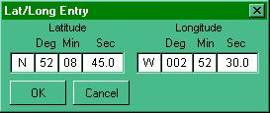

SLL\_2

**Note**: The [ADIF](#ADIF) specifies DISTANCE will be recorded in Km. and this is what is output to the ADI file. However, the Logbook, will show either Miles, [NM](#NM) or [Km](#KM) depending on the user setting found in the Setup Latitude/Longitude dialog box ([SLL\_1](#SLL_1)). The values shown in the logbook will re-calculate automatically if the basic distance unit is changed.

*Created with the Personal Edition of HelpNDoc:* [*News and information about help authoring tools and software*](http://www.helpauthoringsoftware.com)

**Transferring Logs from Logger 16 and Other Programs**

# Geoff Anderson G3NPA  and  B. Charles Sutton W1MCP

## 1.0 TRANSFER LOGGER16 LOGBOOKS

In order to Import your existing Logger16 logbook into Logger32 without problems, you need to complete each of the following steps:

### 1.1 Save the Existing Logbook.

Load Logger16 and select the Print menu button to open the Print/Backup Options dialog box.

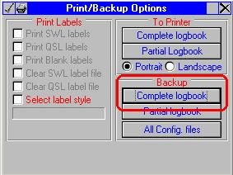

TLFL\_1

From the Backup panel, select Complete Logbook and then select [ADIF](#ADIF) format.

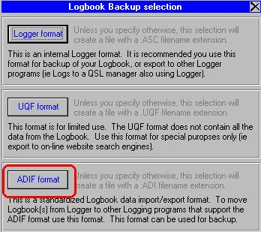

TLFL\_2

You are now given the opportunity to give a name to the file you are creating. It is suggested that you name the file YOURCALL.ADI. When ready, select the <**OK**> button. If this file already exists then either select the <**NO**> button and start again OR select <**YES**> button to overwrite the file.

You are now returned to the Print/Backup Options window, where you should select the <**OK**> button to actually save the file.

You should see a counter increasing rapidly as the file is saved.  Please note two things at this point:

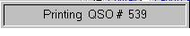

TLFL\_3

* + Your existing log in Logger16 will not have been effected by this export, and
  + The file YOURCALL.ADI just created will be found in the Logger16 directory.

If you have valued contacts already within the Logger32 logbook and you need to retain these, it is recommended that you also export these to an [ADIF](#ADIF) file, for import again. IN the [Logger32 Main menu](#_topic_MainMenu), select the Use [Tools | Export Logs | ADIF file menu ite](#3.0_TOOLS_MENU_ITEM)ms and follow the prompts.

### 1.2 Make any Corrections Necessary to the ADIF File

It is important to note that if you have used some digital modes in Logger16 or another log program, your program may not have used a correct [ADIF](#ADIF) mode format. Although the log file created in Step 1 will load, you may find that the new statistics created in Logger32 do not match up with what you observed in Logger16 or another program. As an example of this, you may have used the term [PSK](#PSK31/63/125) instead of the full and correct identification of [PSK31](#PSK31/63/125) and if this is the case, it is advisable to correct the problem now before you go on.

If you need to correct a Logger16 log file, please read the section [Using Conversion.exe](#1.7_Use_of_Conversion.Exe) and then continue the correction of your log file.

You can correct your file by loading the "YOURCALL.ADI" file into Notepad or WordPad and performing a search and replace function throughout the file to correct this problem.

**Note**:  When making changes to the .ADI file you must follow the correct format.

Before the actual mode text is the field identifier and the field length, for example:  <MODE:3>PSK You CANNOT simply change PSK to PSK31, you would have to search on 3>PSK and replace it with 5>PSK31.  In this example the word MODE identifies this field as the MODE field, the number 3 identifies the length of the text following the > delimiter, PSK = 3 characters.  If you omit changing the 3 to a 5, any ADIF compliant program will ONLY read the three characters following the > delimiter, in effect you would negate the text change.

Once you have made the necessary changes you are ready to go to the next step.

### 1.3 Make Sure that the Logger32 Logbook is Empty

It is quite possible that in your eagerness to see how Logger32 works you have entered some data into the logbook. Before you load your logs into Logger32 you are strongly advised to make sure that any log previously created is removed.  Open Windows Explorer and select the Logger32 folder. Look for and delete the eight (8) files named Logbook32.isd, .isf, .isl and .ism and Stats32.isd, .isf, .isl and .ism.

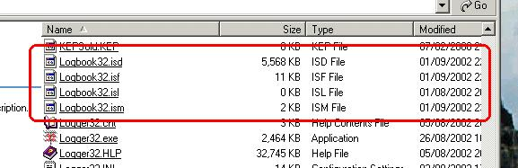

TLFL\_4

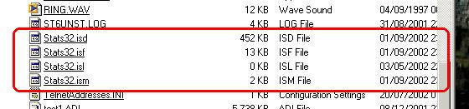

TLFL\_5

### 1.4 Make Sure You Have Entered Your Callsign into the Current User Area

Your callsign should have been configured during the first opening of Logger32. However it is advisable at this stage to check that the callsign configured is the one you want to use. Open Logger32 and make sure that the [Logbook Entry window](#_topic_LogbookEntryWindow) is visible. If it is not visible, then click on the fourth icon from the left on the Tool Bar. Right-click on the grey area in the middle of this window (NOT in one of the edit boxes) and you will bring up the appropriate menu. Select Change Operator and enter your callsign here.

If, in Logger16 you have different logs based on different callsigns you've had in the past, or used to separate mobile or portable calls, then you should CHANGE the Logger 32 callsign to match the log you will be importing.  Unlike Logger16 in which you would have to load and maintain multiple log books for different callsigns, Logger32 takes advantage of the [ADIF](#ADIF) field OPERATOR, and therefore only uses one Logbook.  The operator field should be used to identify the operator at the time of the QSO.  Logger32 will automatically enter the callsign for the current operator when importing [ADIF](#ADIF) log files.

### 1.5 Load the Logbook Data into Logger32

With Logger32 running, from the [Logger32 Main menu](#_topic_MainMenu) select the [File | Import Logs | ADIF](#2.0_FILE_MENU_ITEM) menu items.  Locate your (possibly modified) "YOURCALL.ADI" file and select the <**Open**> button. You will now be presented with the Import ADIF Log dialog box shown below and as this section is specifically for the loading of Logger16 logs; it is recommended that all the check boxes are left blank. Click the <**Start**> button. You will now receive a message to the effect that if imported QSOs have no operator field, they will default to the current user: YOURCALL. Select the <**OK**> button and the file will load.

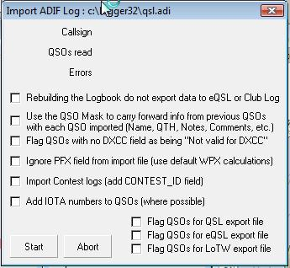

TLFL\_6

At the end of the loading process you will receive an information window advising the number of QSOs loaded and the number that could not be loaded for some reason. If there are log entries that were not accepted by Logger32, then the file BAD.ADI (located in the /Logger32 subdirectory) will contain those records that were problematic. These can be edited and re-loaded in the same way. The filename must be changed from BAD.ADI to something else. Logger32 will not import a file named BAD.ADI.

If you saved an [ADIF](#ADIF) file from Logger32 in Step 1.1, repeat the load process for this file to make the new log complete.

### 1.6 Perform a Recalculation

If you have carried out all the steps described above, then this step should not be necessary. However, just to make sure that all the log databases are set up correctly and the statistics that come from them are right, it is recommended that you perform a "recalculation."  Use the [Logger32 Main menu](#_topic_MainMenu) [Tools | Database Maintenance | Recalculate statistics](#3.0_TOOLS_MENU_ITEM) menu items and then click on the "Recalculate" button in the Recalc Stats dialog box. This step WILL be required if you have deleted some QSOs for any reason after previously loading them into Logger32

Should you find that your statistics do not match up with those generated by Logger16, look again at the point specifically raised in Step 1.2. The quickest way to do this is to look at the logbook and sort it on MODE (click on the title) and then scroll through the log looking for errors in the mode description. Return your logbook to normal by clicking on the title for QSO# or date.

Points to Note About the Transfer of Logger16 Files

* 1. It has already been pointed out above that some fields exported from Logger16 might not conform to the correct [ADIF](#ADIF) specification. In addition to this, Logger16 did not have separate fields for Name, QTH and Notes, and such items were probably recorded in the Comment field. The Logger32 import routine cannot sort this out for you and this has to be a manual editing labor of love if you require your log to look correctly or you could try using [CONVERSION.EXE](#1.7_Use_of_Conversion.Exe).
  2. There is a minor bug in Logger16 when exporting a PARTIAL log in that it will not output QSO data for the final date selected. It will output all QSOs up to the date but not for the final date itself. In order to overcome this problem, select a final date as one day AFTER the selection required. In other words, if you require QSOs between 1 Jan 2000 and 31 Dec 2001, enter the start date as 01012000 and the end date as 01022002. This "bug" is NOT present if you export the whole log.

### 1.7 Use of Conversion.Exe

This application is only to be used to convert Logger16 ADI files to Logger32 ADI files.

In an attempt to assist with the problems described in "points to Note" (1) above, a small routine has been included with Logger32 which will look at the "Comments" and "Mode" fields from Logger16. This routine cannot fix every situation that could arise from your Logger16 ADIF file so it is far from perfect.

The routine does three things:

* + It will assume that the first word in the Comments field is a NAME and generate a name field with this word in it.  (This has been selected as if one was using [Zakanaka](#Zakanaka) with Logger16, Zakanaka would place a name as the first item in the Comments field);
  + Any words in the original Comments field can be either placed in a new QTH or new Comments field OR discarded at the user's option; and,
  + An attempt will be made to convert the old MODE field to a standard [ADIF](#ADIF) mode /sub mode name. For example, PSK will become PSK31, BPSK will become PSK31 with the submode of BPSK and QPSK will become PSK31 with a submode of QPSK.

The routine can be run from any directory folder and it is self-explanatory in its use. The user has the option to select how the program deals with other information in the Comments field.

On running the program you will be presented with the Conversion Tool dialog box shown below. Select your options and click on the start button. Note that the text box is to be left blank and will display the callsigns being converted as the utility runs.

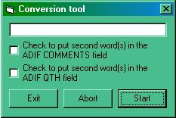

TLFL\_7

The output file will be called CONVERTED.ADI and will be found in the directory where you ran CONVERSION.EXE.

PLEASE NOTE:

* + You may still have some small editing to do following the use of this conversion program. If you only use SSB and/or CW modes, then it will not be necessary to run this routine at all.
  + The converter routine is **ONLY** intended to be used with Logger16 ADI files.  NO attempt has been made to deal with [ADIF](#ADIF) files from other sources.

## 2.0 TRANSFER LOGBOOKS FROM OTHER SOURCES

If you wish to transfer a logbook for another source, the basics of steps 1.1 to 1.6 above will still apply. The only difference will be the method by which you obtain the [ADIF](#ADIF) file format from your current software. You are advised to consult the help file of that software for guidance on how to export your log in [ADIF](#ADIF) format.

It should be noted that some [ADIF](#ADIF) formats contain [WPX](#WPX) information in the [PFX](#Pfx) field and this will cause Logger32 to produce incorrect information. The ADI file loader can ignore this field (if present) and it is recommended that this box be checked before loading if you are in doubt. Logger32 will then replace the field with the correct [DXCC](#DXCC) prefix automatically.  Should you find that you have prefixes like WB2 or 9K2 in the [PFX](#Pfx) field, then this is incorrect and the log files will have to be reloaded. Delete ALL the log files (4) AND the Stats files (4) [noted in [Step 1.3](#1.3_Make_Sure_that_the_Logger32_Logbook_is_Empty) above] and start again.

The ADI file loader has the ability to load contest logs and to mark them with the name of the contest. If this option is required, check the "Import Contest Log" box and you will be asked to supply the contest name. The contest name given will be automatically loaded into the Contest\_ID field for each record in the logbook.

*Created with the Personal Edition of HelpNDoc:* [*Free EPub producer*](http://www.helpndoc.com/create-epub-ebooks)

**Transferring Logger32 to Another Computer**

# Jim Hargrave, W5IFP

## 1.0 GENERAL

This section covers transferring Logger32 files to another computer. This process should result in a copy of Logger32 with the same basic setup and child windows in the same screen location. Also the Logbook should be intact.

The assumption is made that the new installation uses the same monitor or equivalent and the same screen resolution. The same fonts must also be available on the new computer if special fonts are used. Logger32 defaults to “Arial”. Latest versions will provide a warning if it finds fonts in the Logger32 config file that are not installed on the computer, giving an option to convert to Arial.

Logger32 initial installation defaults to folder “C:\Logger32”. If the existing installation is in a different folder, then the same folder(s) should be established on the new computer, otherwise you will have some path errors.

## 2.0 PROCEDURE FOR COPYING FILES

* 1. Open Logger32 and make a backup of your [Logbook and User files](#_topic_BackingupLogger32FilesandDatabas). (First 2 Icons on the Tool Bar)
  2. Download the latest full install from [Logger32.net](#Links:_Logger32_Website).
  3. Install Logger32 on the new computer and allow it to autoupdate to the most recent version.
  4. Close Logger32.
  5. Copy the 2 backup files saved in step 1 to a temp folder on the new computer.
  6. Unpack the 2 zip files and copy all the files to the new Logger32 folder.
  7. Open Logger32 and it should look like the old installation.

You may have to make adjustments due to screen size and resolution.

*Created with the Personal Edition of HelpNDoc:* [*Free EPub and documentation generator*](http://www.helpndoc.com)

**Setup Bands and Modes**

Geoff Anderson G3NPA and Aki Yoshida JA1NLX

## 1.0 GENERAL

The purpose of the Bands and Modes table is to address the difficulties associated with correctly identifying (from a DX spot) the mode a spotted station is operating and the mode into whih to place your radio. Although the program is provided with a default Bandplan that may be adequate for some users, the capability is provided for users to define their own band segment allocations (a Bandplan) for up to 200 entries.

## 2.0 CONFIGURE BANDS AND MODES

To modify, or delete a default setting or to add a new segment, on the Logger32 [Main menu](#_topic_MainMenu) select the [Tools |Setup Bands and Modes](#3.0_TOOLS_MENU_ITEM) menu items to open the Edit Bands & Modes dialog box.

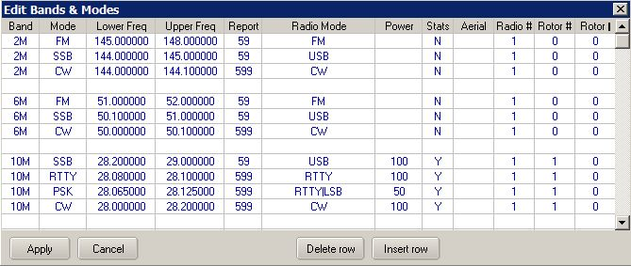

SBM\_1

See [www.adif.org.uk/adif](http://www.adif.org.uk/adif). for complete ADIF Definitions and Details

* + **Band** for this segment - Must be a valid [ADIF](#ADIF) Band;
  + **Mode** for this segment - Must be a valid [ADIF](#ADIF) Mode definition. **Note**: that PSK31, PSK63 etc are not ADIF Modes but ADIF Submodes.
  + **Lower (sub-band) Freq** for this segment - Frequency in MHz (e.g. for 40M [CW](#CW) it would be 7.000};
  + **Upper (sub-band) Freq** for this segment -Frequency in MHz (e.g. for 20M [SSB](#SSB) it would be 14.350):  
      
    **Note**: Trailing zeros will be automatically inserted for both Lower and Upper entries;
  + The order in which the segments are entered is also very important. Take a 20M example;  
    - 20M SSB 14.150 14.350 59 USB 100 Y
    - 20M RTTY 14.080 14.120 RTTY 50 Y
    - 20M PSK 14.065 14.075 USB 50 Y
    - 20M CW 14.000 14.350 CW 100 Y

The lower sub band entries **MUST** be in descending order (the higher frequency must be above the lower frequency).  In this example, the lower sub band edges are (in descending order) 14.150, 14.080, 14.065, and 14.000.

To add the [SSTV](#SSTV) sub band to 20M (in the example above), you would need to add a new line to the table. Place the cursor on the line above 20M SSB 14.150... and click <Insert Row>. You can now enter data in the additional line to the table so the entries now read:

* + - 20M SSTV 14.220 14.230 599 USB 100 Y
    - 20M SSB 14.150 14.350 59 USB 100 Y
    - 20M RTTY 14.080 14.120 RTTY 50 Y
    - 20M PSK 14.065 14.075 USB 50 Y
    - 20M CW 14.000 14.350 CW 100 Y

Click on <OK> to bring the new change into effect.

By adding this new line, you have done the following:

* + - Added [SSTV](#SSTV) as a valid mode to Logger32;
    - When the receiver is tuned to a frequency in the [SSTV](#SSTV) sub-band the Logbook Mode will default to [SSTV](#SSTV);
    - When clicking on a DX Spot on a frequency between 14.220 and 14.230 the radio will go to the frequency and the radio mode will be set to [USB](#USB).  The Logbook Mode will default to [SSTV](#SSTV).

How does this work?  If you are tuning the radio across the 20M band (with auto poll on, and Logbook Mode controlled by the radio) starting from the bottom of 20M (14.000), the Mode in the Logbook will show [CW](#CW), regardless of what mode the radio is switched to.  As you tune upward past:

* + - 14.065 the Logbook mode will change to [PSK](#PSK31/63/125);
    - 14.075 the Logbook mode will change to [CW](#CW);
    - 14.080, and the Logbook mode will change to [RTTY](#RTTY);
    - 14.120 and the Logbook mode will change to [CW](#CW);
    - 14.150, and the Logbook mode will change to [SSB](#SSB).

Also, take the case of a DX Spot on 14.066.  Clicking on the DX Spot will put the radio on 14.066 [USB](#USB), and the Logbook to 14.066, 20M [PSK](#PSK31/63/125).

* + **Report** - Default report for this segment (e.g. 59, 595 and 599).
  + **Radio Mode** - The mode to place the radio into for this segment.

The table below shows acceptable bandplan mode names for specific equipment. Any others are invalid. However, not ALL radio equipment will accept ALL of these for mode changing when clicking on a DX spot.

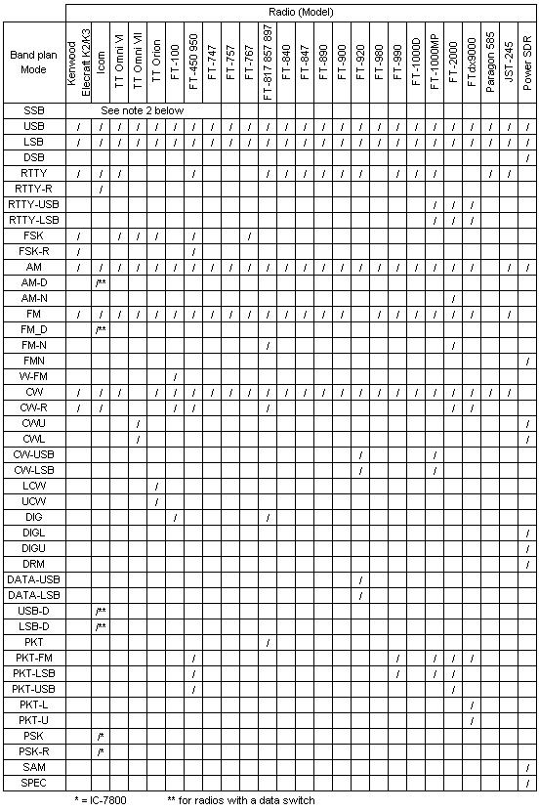

SBM\_2

**Notes**:

* + 1. The use of an invalid Bandplan Mode for a particular radio will put that radio in [USB](#USB) or [LSB](#LSB) depending on the frequency.
    2. All radios will accept and work correctly if one uses the simple [SSB](#SSB), [CW](#CW), [RTTY](#RTTY), [AM](#AM), [FM](#FM) mode descriptions in the Bandplan. It is only some of the more obscure mode settings that may give rise to problems. However if you choose to use these descriptions, then by default [SSB](#SSB) will select [USB](#USB) or [LSB](#LSB) according to frequency. If the frequency is below 14.0 [MHz](#MHz) then the radio will be switched to [LSB](#LSB). If above, the radio will be switched to [USB](#USB).  [CW](#CW) will default to CW-USB and [RTTY](#CW) will default to [RTTY-L](#RTTY-L).
    3. For [DIG](#DIG) mode on the FT-100 to work properly (in combination with Logger32); menu item #34 ([AFSK](#AFSK) mode) on the FT-100 should be configured as [PKT-LSB](#PKT-LSB) or [RTTY-LSB](#RTTY-LSB). In addition, it is recommended that in order to have narrow band (CW filter) reception in [DIG](#DIG) mode, set the preset audio freq in Logger32 (see Soundcard Data Window Settings | Preset audio freq) to 1700 [Hz](#Hz) and set menu #39 on the FT-100 to the same frequency. With this setup, the CW filter is centered on 1700 [Hz](#Hz) when enabled.
    4. Code has been added to to support SO2R radio mode. Please refer to the SO2R topic Additional facility added to the band/mode table for more information.
    5. Some ICOM radios have a DATA setting. This mode is used in conjunction with the AUX connector on the rear of the radio when receiving and transmitting Digital information. When the DATA mode is set, the radio shifts the Audio input and output to the rear Auxiliary connector. This function usually mutes the microphone so it will not interfere with the TNC/Soundcard data during transmit and a constant audio output level is provided to the AUX connector. See the ICOM General section of this help file.

**Power** - TX power to be logged for this sub band

**Stats** - An indicator to show if stats are to be calculated/displayed in the Worked/Confirmed window. If ALL band/mode slots are left blank or are marked "N," only a single small grey square will be displayed in the Worked/Confirmed window. See [Column Order in the Worked/Confirmed Window](#2.0_COLUMN_ORDER_IN_WORKED_CONFIRMED_WINDOW ) below.

**Aerial** - The Antenna Number to be used by automatic antenna switches.

**Note**: A different antenna may be selected for Radio #1 and Radio #2 for the same band segment. Example: Radio #1 uses antenna #1 and Radio #2 uses antenna #2 for the same band segment. To automate this antenna switch over the entry in the Aerial column would be "1|2" (without the quotes).

**Radio #** - The Radio to be used for this particular segment. It was originally intended that this would allow automatic switching from clicking on DX spots for those who have a second radio for the VHF/UHF bands - but if you are so inclined it could be used for similar switching between an SSB only setup and a CW only setup. The combinations are almost limitless. Also see the sections on connecting a radio to your computer in Interfacing a Radio for PC Control and Setting up to use Two Radios.

Certain radios do not automatically switch their selected antenna if the band is changed by [CAT](#CAT) command (like they do if the band is manually changed), so the following has been implemented in the BandPlan:

Selection in the Radio # column (column 10) includes both Radio # and Radio Ant.  Similar to the format implemented in the Radio Mode column (column 6) the format is   x, xy|z or x y|z.  Where x (in the range of 1 or 2) is the default radio to use, y (in the range of 0 to 9) is the ant port on radio 1 and z (I the range of 0 to 9) is the ant port on radio 2.  If no ant is to be selected, use 0 as the antenna port number.

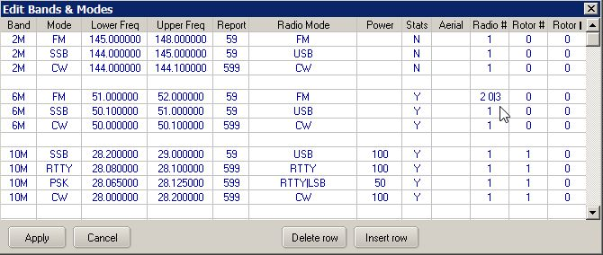

SBM\_4

Some examples:

* + - "2"  This sets radio 2 as the default and no switching is done of either radio 1 or radio2 internal aerial ports.
    - "2 0|0"  Same as above.
    - "17|8"  This sets radio 1 as the default radio using internal aerial port 7.  If radio 2 is selected (say for SO2R operation) then radio 2 ant 8 is selected.
    - "1 7|8" is the same as above
    - '2 0|3"  This sets radio 2 as the default radio with internal antenna 3 selected.  Switching to radio one does not issue any aerial selection command to radio 1.

**Operational Note**:  As Logger32 does not read the Radio Antenna, reverting back to the previously selected Radio|Antenna (by menu selection) will not revert the Radio to the previously selected Antenna.

**Programming Note**:  ICOM radio code has been tested (minimal).  FT-2000 and FT-9000 code has been programmed but is untested.  Other radios that may have Radio Antenna by CAT command are unknown and have not been coded.

**Set up Note**:  The radio configuration menu AUTOMATIC RADIO CHANGE option must be checked for this feature to work.

**Rotor #** - This column is used to set the rotor number used for the particular band/frequency segment. If no Rotor is present or not used on a particular segment, then insert a 0 in this column.

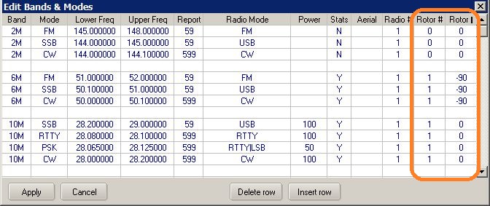

SBM\_5

**Rotor \*** - This column is used to compensate for beam antennas mounted crosswise to the main beam. As an example, if the user has a 6-meter beam mounted 90 degrees clockwise from the main beam, The chart should reflect -90 in the Rotor column. This will allow Logger32 to compensate the antenna direction and point the 6-meter beam to the true heading of the partner station.

If no compensation is needed, then enter a 0 in this column.

Rotor fixed compensation for mast slippages and magnetic variations are covered in the Setup Antenna Rotator section.

## 2.0 COLUMN ORDER IN WORKED CONFIRMED WINDOW

Depending on your individual operating preferences, you may choose to have a simple Bandplan, or a very complex one.  The choice is yours.

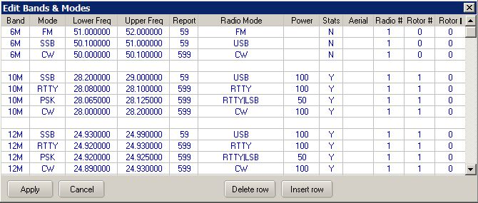

SBM\_5A

A Worked/Confirmed window for the Bandplan above might look like that below.  **Note** that various options with this window are checked. See the [Worked/Confirmed window](#_topic_WorkedConfirmedWindow) topic for detail.

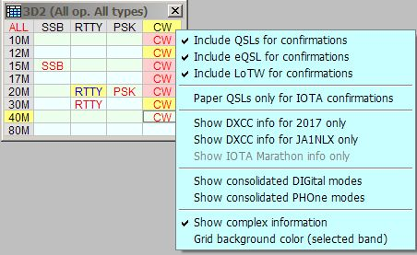

SBM\_3

**Note**: The order in which the modes appear in the Worked/Confirmed window, from left to right, will be the same as the Mode order in the Bandplan from top to bottom (for those modes that are marked "Y" in the Stats column. If you compare the left to right order of the modes in the above picture with the Bandplan example shown below, you will see that they match the top to bottom order of the modes marked "Y" in the 10M section.

In order to produce all the stats for each band and mode, it is only really necessary to mark one "Y" in each band for one mode. If you carefully select which of these you mark with a "Y", then it is possible to change the order of appearance of these modes in the Worked/Confirmed window. For example, if the Stats column in the top line of the table below were changed to "N", then the worked confirmed window would display the modes in the order [PSK31](#PSK31/63/125), [RTTY](#RTTY), [CW](#CW), [SSB](#SSB) (the [SSB](#SSB) coming from the top line of the 12M entry).

*Created with the Personal Edition of HelpNDoc:* [*Easy CHM and documentation editor*](http://www.helpndoc.com)

**Setup Date, Time and Frequency Formats**

Hew Lines VA7HU

Logger32 provides the capability for the user to select the display format of the Date, Time and Radio Frequencies from a pre-defined list of formats. These formats are selected by first selecting the [Logger32 Setup Menu](#_topic_SetupMenu), then selecting the [Date Format](#3.0_DATE_FORMAT_MENU_ITEM), [Time Format](#4.0_TIME_FORMAT_MENU_ITEM) or [Frequency](#8.0_FREQUENCY_MENU_ITEM) menu items respectively.

*Created with the Personal Edition of HelpNDoc:* [*Free Qt Help documentation generator*](http://www.helpndoc.com)

**Setup CD ROM**

# Geoff Anderson G3NPA, Hal Miller KB1ZQ and Art Petteway WB4MNK

## 1.0 SETUP

To set up the CD ROM drive functionality, from the Logger32 [Setup menu](#_topic_SetupMenu) select the [CD Rom](#6.0_CD_ROM_MENU_ITEM) menu item and select the appropriate CD ROM as shown below:

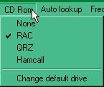

SC\_1

For information on how to use the lookup facility, please refer to the [Callsign Lookup](#_topic_CallsignLookup) topic.

If you wish to change the default drive, then click on the "Change default drive" menu item to display the window shown below:

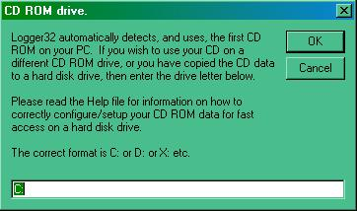

SC\_2

## 2.0 INSTALLATION ON HARD DISK DRIVE

It is possible to run without the actual CD in a drive if the data on the CD ROM has been copied onto a Hard Disk. If you wish to do this, here are the steps you should take. In the examples given below, it is assumed that the drive used will be C: but this can be any HD drive letter.

Copy the contents of the CD ROM data folder from the CD ROM into a folder called

* + C:\Data for RAC;
  + C:\Callbk for QRZ; or
  + C:\ham0\HamCall for HamCall

**Note**: The HamCall CD can install the Database on the HD.  Insert the HamCall CD into the CD drive and the HamCall main menu will appear. Click on "Copy Database to Hard Drive" this will install the HamCall data onto the Hard Disk.

Locate the correct DLL from the CD ROM and copy it into your Logger32 directory.

* + raccd32a.dll for RAC;
  + qrz32.dll for QRZ: or
  + Hamcal32.dll for HamCall.

Select the "[Change default drive](#SC_1)" option from the Logger32 [Setup menu](#_topic_SetupMenu) [CD ROM menu item](#6.0_CD_ROM_MENU_ITEM) and enter the appropriate drive letter. The callsign lookup will now be much quicker.

*Created with the Personal Edition of HelpNDoc:* [*Single source CHM, PDF, DOC and HTML Help creation*](http://www.helpndoc.com/help-authoring-tool)

**Convert Logger16 Notes to Logger32**

# Geoff Anderson G3NPA

A small routine has been included with the Logger32 package to enable users to extract the Notes that they may have generated in Logger16 and to copy them into a working log in Logger32. Please make sure that you have loaded your basic log data BEFORE running this utility.

The conversion is almost self explanatory. Run the program ConvertNotesToLogger32.exe and use the browse facility to determine the source and destination.

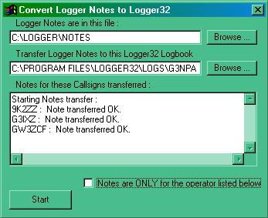

CLNL\_1

If you are using your log for multi operator and wish the notes to be associated with just one operator, then check the "Notes are ONLY for the operator listed below" to open up a small edit box in which you can type the callsign required.

When everything is set up, select the <**Start**> button and you will see the Notes being transferred. In the above example, all the notes were transferred OK. If a callsign for which an original note was attached is NOT present in the log selected, an error message will be generated.

*Created with the Personal Edition of HelpNDoc:* [*Easily create EPub books*](http://www.helpndoc.com/feature-tour)

**Setting up a Second Logger32 INI File**

Geoff Anderson G3NPA and Jim Hargrave W5IFP

## 1.0 GENERAL

Logger32 has the ability to use the configuration defined by the default Logger32.INI file, or to select custom configurations. An example of this might be a preferred standard layout for day-to-day use and to have a different arrangement for contesting, a second operator or a second radio.

The command line to run Logge32 with a different INI file is: C:\path\Logger32.Exe (Filename[.ini]), where filename[.INI] is the name of the ini file to load. The .INI extension is optional.

## 2.0 CREATING A SECOND SET UP

* 1. Open Windows Explorer and right-click on the Logger32.EXE file and create a shortcut on the desktop;
  2. Right-click on the new desktop shortcut and select "Properties";

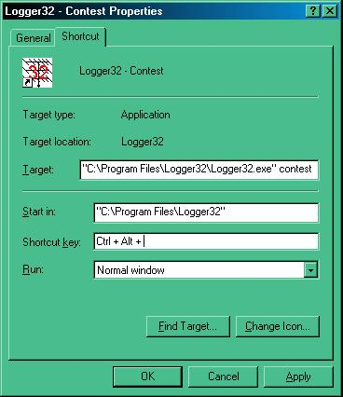

SUSLI\_1

* 1. In the "Target" edit box Add the new filename. ( in this case - contest);
  2. Select the <**OK**> button; and,
  3. Right-click on the desktop shortcut, select the "Rename" menu item and call it "Logger32 - Contest".

When you left-click on this shortcut Logger32 will run and automatically create two new files in the Logger32 directory - in this case, Contest.INI and ContestBandMode.db. These two files may then be modified to make your new configuration as required.

On opening the [Sound Card Data window](#_topic_SoundCardDataWindow1), the [CW Machine](#_topic_CWMachineWindow) or the [Data Terminal window](#_topic_DataTerminalWindow) for the first time, Logger32 will also create the appropriate .INI files for these windows.

The example above is for a contest set-up, but other configurations could be achieved. Examples might be a configuration for a different operator or different radios. The options are endless.

### 3.0 THE HELP MENU ITEM

The [Help menu](#8.0_HELP_MENU_ITEM) item of the Logger32 [Main menu](#_topic_MainMenu) allows you to determine the configuration file being used. Normally this will be the default configuration but if you have set up and are using a different file then it will be identified here. In the example shown below, the contest configuration (as described above) has been loaded.

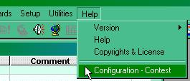.

SUSLI\_2

*Created with the Personal Edition of HelpNDoc:* [*iPhone web sites made easy*](http://www.helpndoc.com/feature-tour/iphone-website-generation)

**Uninstall Procedures**

# Hal Miller K1BZQ

It is recommended that you first [Export your logs](#_topic_ExportingLogs) in .ADI ([ADIF](#ADIF)) format to prevent the loss of your logged contacts, then uninstall Logger32 using Add/Remove Programs function from the Windows Control Panel.

*Created with the Personal Edition of HelpNDoc:* [*Single source CHM, PDF, DOC and HTML Help creation*](http://www.helpndoc.com/help-authoring-tool)

**Updating Logger32**

# Jim Hargrave W5IFP and Aki Yoshida JA1NLX

## 1.0 GENERAL

This is a simplified guide for updating Logger32. It is not considered all-inclusive, but will provide some basic procedures to follow. It is assumed that you have already downloaded the required files needed for either the update or the full installation. If not, go to the [Logger32 web site](#Links:_Logger32_Website) and follow the instructions given for the file or files you need.

Before attempting to update or load a completely new install, **ALWAYS**:

* + Make a backup of all your user and logbook files; and,
  + Export your log files to an [ADI](#ADIF) file.

There are three basic processes for updating Logger32:

* 1. Files update;
  2. Complete installation; and,
  3. Automatic update starting with version 3.46.

## 2.0  PROCEDURE FOR UPDATING LOGGER32 VERSIONS 3.0 AND LATER

This procedure applies when you are updating Logger32 from the immediately preceding release.

Download and unzip "lgr32upgrade(nnn).zip" into a temporary directory (not the Logger32 default directory) and follow any special instructions in the "Read.me" file. The generic Update Procedure is to:

* 1. Backup your logs and user files;
  2. [Export your logbook](#_topic_ExportingLogs) in [ADIF](#_topic_Abbreviations) format;
  3. Stop Logger32;
  4. Unzip the contents of the Upgrade.zip file to your Logger32 directory;
  5. If you wish to update the Country and [IOTA](#IOTA) databases, unzip the contents of the Databases.zip file to your Logger32 directory;
  6. Run Logger32 and verify that you have the correct version running; and,
  7. If you installed new databases in step 4, recalculate your statistics.

## 3.0  PROCEDURE FOR UPDATING VERSIONS OF LOGGER32 PRIOR TO 3.0 OR ACCOMPLISHING A COMPLETE INSTALLATION

Accomplishing a complete installation will always insure you have the latest operating files.

1. Open your current version of Logger32 and make a [Backup of both the Logbook and User files](#_topic_BackingupLogger32FilesandDatabas);
2. Export your Logbook to a .ADI ([ADIF](#ADIF)) file. (**Ensure you use the ADIF (.adi) format);**
3. Close Logger32. If you are doing a Complete Installation, go to Step 5;
4. Delete the four Logbook files in the Logger32 directory. (**Mandatory Step**) (Logbook32.ISF, Logbook32.ISD, Logbook32.ISL, Logbook32.ISM)

**Note**: If you have deliberately renamed your logbook files they will not be named Logbbook32.ISF, Logbook32.ISD, etc. as in the previous example. Many have renamed their files to reflect their own calls so you may see files like W5IFP.ISF, W5IFP.ISF, etc.

1. Download the latest "lgr32full(nnn).zip" file.
2. Unzip the file into a temporary folder and run "Setup" from the temporary folder. You can install Logger32 to the default or a new directory of your choice and rebuild the setup files, or you may also direct Logger32 to install in your current Logger32 directory, which will leave most of your setup files intact. Follow any special instructions in the "Read.me" file.
3. Open Logger32 and make sure it is working OK.  [Enter your callsign](#_topic_SetupCallsign) and accept the conditions (if applicable). It will open with an empty logbook.
4. [Import the ADIF logbook](#_topic_ImportingLogs) file saved in step 2 above. This may cause some errors, which will appear in the "Bad.adi" file, which saves in the default directory where the other Logger32 files are stored. Most of the reported errors have been an incompatibility between the state and county designations in the logbook file. You will need to edit and rename the Bad.adi file and use it to import the remaining records.

## 4.0 AUTOMATED UPDATE

Starting with Logger32 version 3.46, an automated update has been incorporated. This can be setup for automatic notification or accomplished manually. The following captures are sample updates.

**Note**: For this function to operate, you must have an Internet connection available.

To Initiate the update process, using the Logger32 [Setup menu](#_topic_SetupMenu), select the [Updates](#14.0_UPDATES_MENU_ITEM) menu item. This provides three options:

* 1. **Enable auto updates**. When this line is checked, Logger32 will automatically check for updates and advise when they are ready each time the program is opened. A pop-up message will advise if an update is available;

**Note**: The Auto Update determination is initiated 10 seconds after Logger32 is loaded.

* 1. **Look for updates now**. Clicking on this line will force the system to check for possible updates.
  2. **Read release notes**. Clicking on this option will open the file "auto-update release notes.txt". This file contains a list of changes included in each auto-update release.

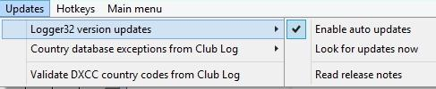

UPD\_1

If no updates are available the following notice will be displayed:

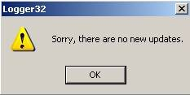

UPD\_2

If new updates are available you will get a notice similar to the following.

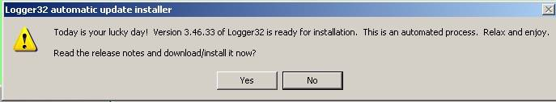

UPD\_3

Select the <**Yes**> button and a dialog box similar to the following will appear. Read the release notice in the top pane. A check box offers the option to make backups prior to the update process

**Note**: If you select to save your backups to an Internet depository such as GOOGLE Drive you may have trouble completing the update download.You will need to allow time for the cloud system to synchronize the files before making another backup. If you have trouble with the backup process, it is suggested that you specify a path/file on your local drive and then upload this backup file to your Internet depository manually.

If you continue to experience problems making backups during Auto Update, it is suggested you initiate backups manually before starting the Auto Update process.

**Note**: The Release notes will be saved in the "\Release Notes\" folder in the Logger32 directory.

Select the <**Install now**> button and you can watch the update process in the lower pane. From this point on, it is a fully automated process. You will see the progress bar move to the right and then Logger32 will close and automatically re-open with the update installed.

**Note**: During the update the progress bar followed by a spinning "Pin wheel" will reflect activity.

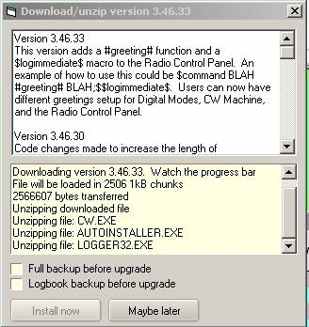

UPD\_4

**Note**: Following are some suggestions for Window 7 & 8 users.

### 4.1 Failure of the Autoupdate Process

If you are experiencing difficulty with the Auto Update file down load, try some of the following:

* + Run as Administrator
  + Set Logger32.exe and Logger32autoinstaller.exe to run in compatibility mode:"Administrator: or "XP:
  + Set "Logger32.exe", Logger32autoinstaller.exe, and C:\Logger32 as exceptions in your Anti-virus.
  + Turn "[UAC](#UAC)" OFF.

Specific process for Windows 8 users:

* 1. Close Logger32;
  2. With Windows Explorer, navigate to the Logger32 directory. Locate the files Logger32.exe and Logger32autoinstaller.exe;
  3. Right-click and choose properties;
  4. Click on tab "compatibility";
  5. Check: "Run this program as an administrator";
  6. Click OK. Set both of the files listed in step 2 above.
  7. Open Logger32 update.

**4.1.1**. If you are still having trouble with the autoupdate completing. There is a couple of things you can do to help yourself. Below is the sequence of events, which hopefully will assist you in determining what part of the process is failing.

Built into Logger32 is additional debugging capability which by default is disabled.  Click VIEW and check the option ENABLE ERROR TRAPPING.  If the error is generated within Logger32 (and not the auto installer), the exact line of code that fails is identified.  Depending on you configuration, this option may also alert you of other setup problems you were unaware of.  Who knows, maybe even more Logger32 bugs will be found.

**4.1.2 Autoupdate process.**

When Logger32 attempts to install an update, there is a review of the last few steps before it closes:

* 1. It looks in the \updatefiles folder for a newer version of QRX.EXE (the annoying pinwheel you see when updating). If there is a newer version, it replaces the existing one and deletes the copy from the \updates folder.
  2. Starts QRX.EXE.

### 4.2 Additional Information on the Autoupdate Process

### 4.2.1 When Doing an Autoupdate

When doing an autoupdate, Logger32 accomplishes the following steps:

* + Copies the files from the \Logger32\updatefiles to the \Logger32\Rollback\ folder. The files will allow the user to roll back Logger32 to the previous version in case of trouble with the update;
  + Downloads the update file and unzips the files into a folder \Logger32\updatefiles; and
  + Closes Logger32 and copy the files from the \updatefiles\ to the \Logger32 folder and restarts Logger32.

**Note**: You can do these steps manually if the autoupdate fails.

There have been occasions where the PC configuration, security settings, AV and malware software have interrupted the process at a point where the \Logger32\updateFiles directory is empty.  What you can do if the \Logger32\updateFiles directory is empty is find the file “zipfile.zip” The files needed are in \Logger32\updates\zipfiles.zip

We need to do two things:

* 1. Copy the update files to the \Logger32 directory; and
  2. Copy the update files to the \Logger32\updateFiles folder so the next auto-update makes a valid \Logger32\Rollback folder.

Another option would be to delete the \updates folder in the \Logger32 folder. After deleting the \updates folder, be sure to close Windows Explorer. The Autoupdate should now run.

### 4.2.2 Rollback to Previous Version

If Logger32 does not work properly after an update and you want to rollback to the previous version then click Tools. Click Rollback to previous version.Select the listed version you want to rollback to and click "Rollback". Automatic rollback will run and copy files in the corresponding Rollback folder in Logger32 folder. The list of options is now limited to the most recent 10 versions.

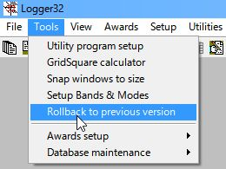

UPD\_4A

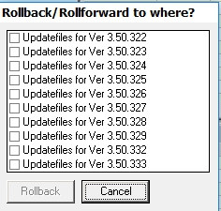

UPD\_4A\_1

If Logger32 does not start at all after an update then find the file "Logger32Rollback.exe" in the Logger32 folder and run it..

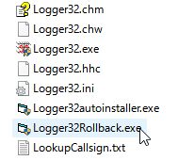

UPD\_4B

**Note**: Logger32Rollback.exe should be always run as an administrator.

### 4.2.3 If Things Work as Expected

If things work as expected, here's what actually happens. After the backup is completed (if the user so desires):

* 1. The file QRX.exe (the pinwheel) is copied from the \updatefiles folder to the Logger32 folder and is executed - The pinwheel starts.  So, QRX.EXE must pass antivirus/malware/security checking;
  2. The file “autoinstaller.exe” is copied from the \updatefiles folder to the Logger32 folder and is saved there as Logger32autoinstaller.exe (note the name change) and is executed - First thing it does is wait until Logger32 finishes shutting down, waits a few more seconds to be on the safe side, then copies all the files from the \updatefiles folder into the Logger32 folder and starts the new Logger32 version.  So, autoinstaller.exe and Logger32autoinstaller.exe must pass antivirus/malware/security checking; and,
  3. Eventually, when Logger32 is finished loading it stops QRX.exe.  If the update fails, QRX.exe will stop itself after 15 seconds.

**Note**: When attempting an auto-update, notice that when the pinwheel appears, the PC beeps every 5 seconds?  This beep tells you that the autoinstaller checked and there is still a copy of Logger32 (or the CW machine) running.  The auto installer tries again to close Logger32 (or the CW Machine) and utility programs which use Logger32 external interface.

The autoinstaller looks at all the windows that are open on the PC.  If any one of the windows has Logger32 in the title bar, it thinks that's Logger32 and tries to close it. This includes the Windows Explorer if it has the \Logger32\ folder open. If it finds Logger32 or the CW module and cannot close it, an error pane will advise the user.

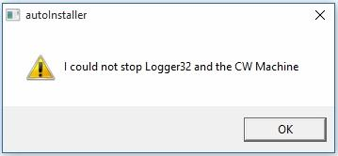

UPD\_5

*Created with the Personal Edition of HelpNDoc:* [*Easily create EPub books*](http://www.helpndoc.com/feature-tour)

**Logbook Windows**

*Created with the Personal Edition of HelpNDoc:* [*Full-featured EPub generator*](http://www.helpndoc.com/create-epub-ebooks)

**Logbook Entry Window**

# Geoff Anderson G3NPA, Jim Hargrave W5IFP and Aki Yoshida JA1NLX

## 1.0 BASIC SETUP

As the name implies, this is the window through which the main entries are made to the logbook. It is quite complex and highly configurable so you are well advised to take time to study this section to fully understand what facilities are available from here. The picture shown below is the most basic Logbook Entry Window.

The top line shows the Frequency, Mode and Band that will be logged. The Frequency will be derived from your radio if you have [CAT](#CAT) control and it is set up and activated. If you do not have computer control, then the frequency can be set manually. The Mode and Band will be derived from your Bandplan or, if desired, they also can be set manually. Below the top line are edit boxes for Callsign, RST Sent, RST Received, Name and QTH. You MUST enter a callsign at the very least before you can transfer anything to the log.

To change between edit boxes use the <**TAB**> key on the keyboard. Conversely the <**Up Arrow**> key will act as a Back-Tab <**Shift+TAB**> key combination. To transfer the QSO information to the logbook, use the key combination <**Ctrl+L**>\_or the <**Enter**> key.  If you wish to clear the whole entry window for any reason, use the <**F11**> key (if the focus is in the Logbook Entry window) ([see the Helpfile topic The F11 Key Explained](#_topic_TheF11KeyExplained)), the key combinations <**Ctr-C**>\_or <**Alt+W**> or a left-click on the left side of the Logbook Entry window about 1/4 inch to the left of the entry fields. As a rule of thumb - click over Call, Sent, Rcvd, Name, Cmnt/QTH/Addr or bottom left user field caption.

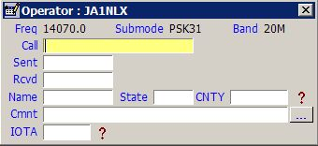

LBEW\_1

As soon as you enter a callsign prefix that is recognized, the following will occur:

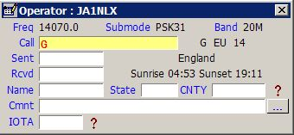

LBEW\_2

**Note**: that the Country name, Sunrise and Sunset times, Short and Long Path beam headings and the Short Path distance are all calculated and displayed. If it should happen that you have many edit boxes visible, then some or all of this latter information may not be visible here. However, the same information is displayed on the Upper Status Bar at the bottom of the main window, so the information is still available.

Continuing with the Callsign entry, once you have typed sufficient information AND there are matching callsigns already in your log, Logger32 will display those callsigns (Callsign Preview). If the one you require is in the list presented, then selecting that callsign will place it in the Call edit box of the Logbook Entry window. If not, just continue to type in the remaining letters. See the example below:

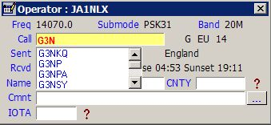

LBEW\_3

If you do not see this type of presentation, then right-click in the Callsign edit box, select the" Setup" menu item from the pop-up menu and check "Show callsign preview" menu item from the menu list displayed.

Right-click in any edit box to show menu. Many examples are described later.

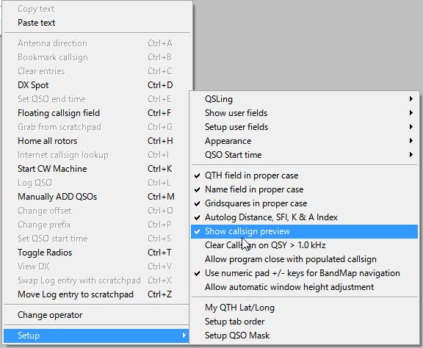

LBEW\_3A

**Note**:  It is preferred that you enter a callsign in the format:  Callsign / Prefix modifier. For example W4xxx/1 (a W4 portable in area 1) or G3xxx/FR/T (A G prefix operating on Tromelin Island).

Logger32 will accept a number of different callsign formats BUT occasionally, especially where the prefix modifier is complex (like FR\T or KH0\M), the determined location, Zone etc., can be incorrect if other formats are used.

Logger32 has, in fact, seven more edit boxes that you can configure for use. To do this, right-click on any of the visible edit boxes to produce a pop-up menu. Select the Setup | Show user fields | Show all user fields menu items. This will activate all the user-definable edit boxes. If you only require one or a special combination of panes, then these may be selected using the Show User field # menu items.

**Note:** If the additional User FIelds have been configured, then the assigned Field Name will be displayed in the menu items in place of the Field #.

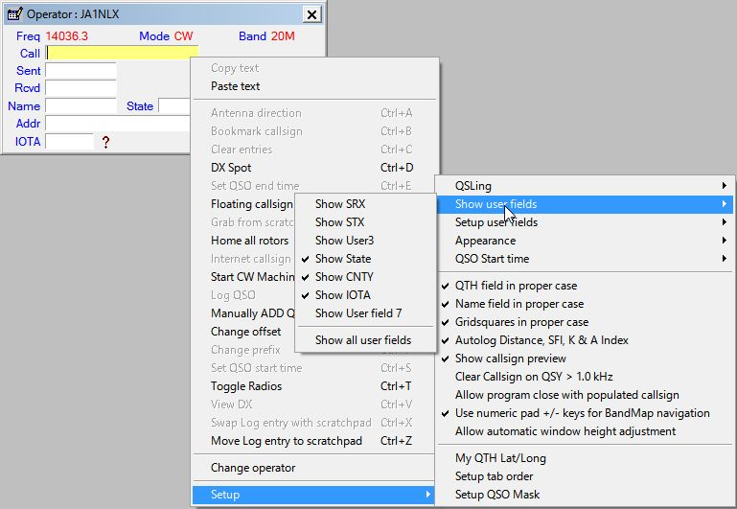

 LBEW\_4

**Note**: Auto-logging of Distance does not require an internet connection. However, auto-logging of SFI, A\_Index, and K\_Index only occurs after at least one instance of a WWV or WCY report has been received via a connection to a DX Cluster node -- whether automatically originated by the node or from an SH/WWV or SH/WCY command sent to the cluster.

Logger32 will use the most recent SFI A and K numbers received until Logger32 has been closed -- even after the your connection to the Cluster drops or is deliberately disconnected.

With all edit boxes visible the Logbook Entry window will look like this:

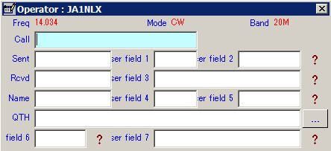

LBEW\_7

Take note of the location of the seven user edit boxes and their numbering. Each one of these boxes can be set up to accept ANY [ADIF](#ADIF) type entry. Right-click on any of the edit boxes, select the "Setup | Setup user fields" menu items and pick the field of your choice. In the example below, USER 5 was selected.

Enter the label required, select the [ADIF](#ADIF) field type and in this case the <**Show Help**> button. Make other selections to suit. Be aware that the list of ADIF fields available from the pull-down list will change. Once one of the ADIF definitions has been used the same definition will NOT appear in the list again thus preventing its use in a second edit box. To restore the definition to the list you must remove it from the edit box that is using it.

For further information on the use of the "CW Machine Free field" option in the lower section of the setup window below, please see the [CW Machine Window](#_topic_CWMachineWindow) topic.

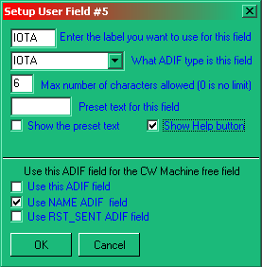

LBEW\_8

The settings above for User 5 are shown below. The "?" mark is the Help button and a selecting this will reveal information about your [IOTA](#IOTA) contacts.

* + A LEFT-click will show information about the Island Group; and,  
      
    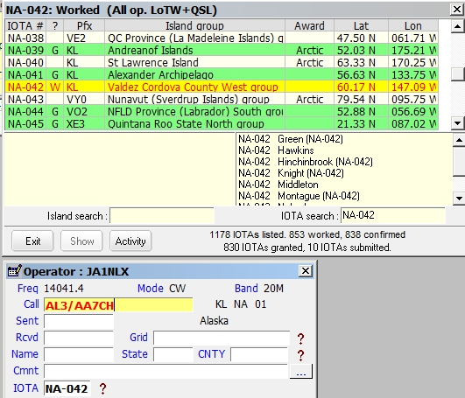  
      
    LBEW\_8A
  + A RIGHT-click will open a generic window showing contacts with the [IOTA](#IOTA) Island.  
      
    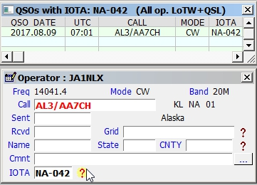  
      
    LBEW\_8B

**Note**: The RIGHT-click feature also applies to the STATE and [CNTY](#CNTY) fields

**Note**: Only fields 2,3,5,6 and 7 can have a "?" Help button associated with them.

The settings for User 3 are shown below. The "?" mark is the Help button and a selecting this will reveal information about your [Grid Square contacts.  You have an option to show Grid Square information for this year only. (2017 onlly in LBEW\_8D).](#IOTA)

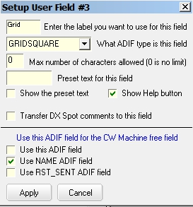

LBEW\_8C

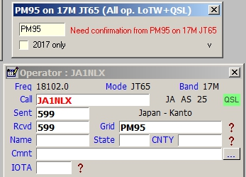

LBEW\_8D

If you want to see this window as soon as you enter a Grid Square in Logbook Entry Window, then click "V" (LBEW\_8D) and check "Show/hide this window....." option.

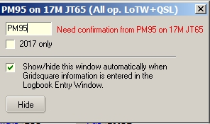

LBEW\_8E

It is possible to edit boxes to display Upper Case only provided that the field definition is one of the USER # [ADIF](#ADIF) fields. The option to do this will ONLY appear if the ADIF field of USER 1,2 or 3 is being used.

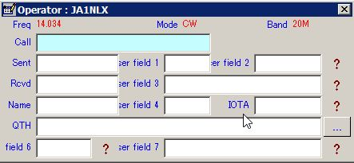

LBEW\_9

If you wish to limit the number of characters that can be entered into a field or have something preset in a field, then complete the appropriate parts in the setup window for that field.

Shown below is an example for the Logbook Entry window.

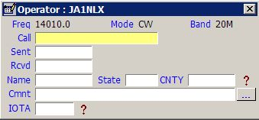

LBEW\_10

**Note**: The button next to Cmnt field will cause the fields on this line to toggle between Comment, QTH and Address.

A new feature has been added whereby you can now add preset text to the Comment field. See the menu item "Setup user fields".

Selecting the "Setup Comments" menu item will display the Setup Comments field dialog box.

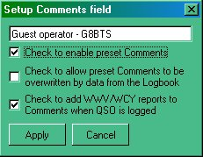

LBEW\_12

Here you have the option to set a comment you may wish to add to the Comments column. Note that there are three selectable options:

* + If you want the phrase to appear, then you must check the "Check to enable" box;
  + If you would like to add the WWV/WCY reports received from a cluster, then check the bottom check box.

For example: with both of the above options selected, the Comments field in the log will fill as shown.

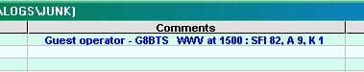

LBEW\_13

* + If you want comments for a specific callsign already in the log to override the this comment, then click the middle check box. This assumes of course that you have selected to copy over the comments from the previous QSO using the QSO mask.

There is a potential for conflict with this option however. If the user has Comments checked in the QSO Mask, each successive QSO will append the WWV/WCY report for each QSO. The error message shown below will be generated if this conflict exists.

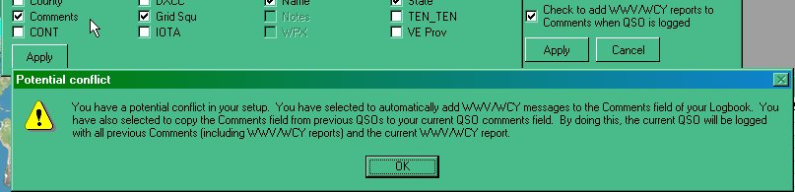

LBEW\_14

In addition to that above, an automated feature has been introduced to record the A and K indices, the SFI and the distance to the QSO partner (in Km). Right-click on the Logbook Entry window and select the Setup | Autolog Distance SFI K and A Index menu items.

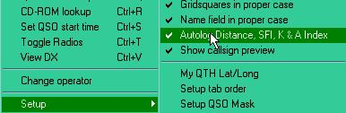

LBEW\_15

With this option checked, QSOs are automatically logged with data from the WWV/WCY and Distance panels on the Lower Status bar.

**Notes**:

* + It is not necessary to have SFI, DISTANCE A and/or K\_INDEX user fields on the Logbook Entry Window;
  + It is not necessary to have SFI, DISTANCE A and/or K\_INDEX user fields visible on the Logbook Entry Window;
  + If the user has entered SFI, DISTANCE A and/or K\_INDEX into user fields on the Logbook Entry Window, the field(s) will not be overwritten; and
  + If there is no data in the right side of the Lower Status bar from WWV or WCY, then nothing will be written to the SFI and/or A/K\_INDEX fields.

### 2.0 QUICK QSY

Logger32 has the ability to accept an input frequency in the "Call" edit box of the Logbook Entry window. This input frequency must be in the format of the frequency recorded in the log. In the "Call" edit box, simply enter the frequency and press <**Enter**>. If you have a radio with a [CAT](#CAT) interface, it will QSY to the frequency you have just entered.

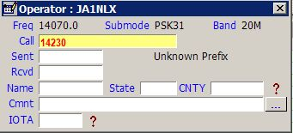

LBEW\_16

In the example above, the <**TAB**> or <**Enter**> key has not been pressed. As soon as one of them is, the "Call" edit box will clear and the radio will go to the entered frequency.

The current Received frequency can also be changed by using the scroll wheel on the mouse. Place the cursor anywhere in the Logbook Entry window and rotate the scroll wheel. One direction will increase the frequency while a rotation in the other direction will decrease the frequency. The step size for each scroll wheel click can be selected from a menu item list by right-clicking on the actual frequency displayed alongside the word "Freq". Depending on the polling interval of your computer/transceiver interface, the speed of the frequency change may be somewhat slow. The change may not be immediate as if you were turning the radio's tuning knob.

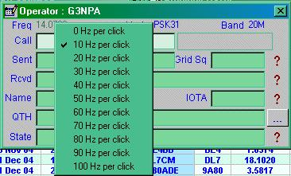

LBEW\_17

## 3.0 OTHER SETUP MENU ITEMS

To access menu items right-click in any edit box and select Setup menu item.

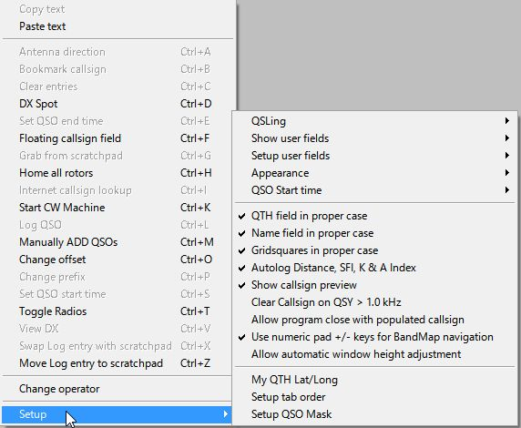

LBEW\_17A

### 3.1 Appearance

To access menu items right-click in any edit box and select Setup menu item.



LBEW\_17A

The general appearance of the Logbook Entry window can be adjusted to suit individual tastes.You can change a whole range of items such as Background, Highlight and Font colors as required - for both the Data and the Field names.

### 3.2 Entry Window Tab Order

Following the entry of a Callsign, you can arrange to <**Tab**> through the Logbook Entry window in any order you wish.

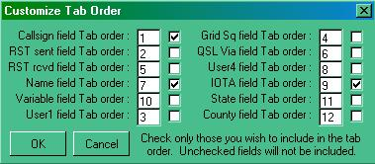

LBEW\_18

In the left-hand edit box, enter the order number for each field to fall and if you require that field to be included in the tab sequence, place a check mark in the check box. In the example above only three fields have been selected in the order Callsign, Name and User 5 (which you have defined as the IOTA number). Having completed your selection, select the <OK> button.

Note that your bandplan can set the default RST sent (normally 599) and the RST received field will default to 599 if nothing is entered. In the above case, Having entered a callsign, a single <**Tab**> will take you to "Name" having filled in the two reports of 599 on its way.

### 3.3 QSO Mask

Logger32 has the ability to look at your logbook and extract information from the last QSO you had with someone and display this in the Logbook Entry window. For example, if you had worked Bob K4CY previously and you had correctly recorded his name in the Name field, then the next time you enter his callsign, this information can be retrieved and put in the Logbook Entry window automatically. Select those items that you wish to be carried forward. In the example below, Name, QSL Via, QTH and State will all be transferred from the previous contact record to the new one. Now you know how Bob is so quick on coming back with your name if you work him twice!

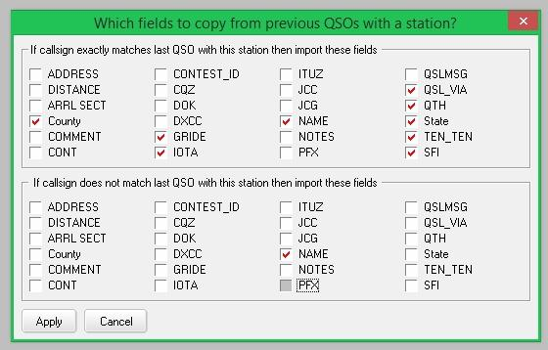

LBEW\_19

### 3.4 GridSquares in Proper Case

If this option is checked, then captured or directly input information will appear in the form "IO82nd".  If unchecked, the format will remain as typed (or captured).

### 3.5 Name Field in Proper Case

If this option is checked, then captured or directly input, information will have the first letter of the name capitalized and the remainder in lower case, i.e., Geoff.  If unchecked, the format will remain as typed (or captured).

### 3.6 QTH Field in Proper Case

If this option is checked, then captured or directly input information will have the initial letter of the name capitalized and the remainder in lower case, i.e., London. If umchecked, the format will remain as typed (or captured).

### 3.7 QSO Start time

A QSO is transferred from the Logbook Entry window into the logbook following an <**Enter**> key or <**Ctrl+L**> key combination. This action also automatically sets the QSO end time. Two options to automatically set the Start Time are available:

### 3.7.1 When Callsign Field Loses Focus

If this option is selected, the QSO Start Time will be taken to be the moment you enter the <**TAB**> key to move away from the Call edit box to add further information into the Logbook Entry window. The <**Ctrl+S**> key combination will override the Start Time even if it is used before the first time the callsign field loses focus

### 3.7.2 When QSO Entered into Log

If this option is selected, then the Start Time will be the same as the End Time. Even with this option selected the <**Ctrl+S**> key combination will still record the Start Time if pressed.

**Note**: Both the Start and End times can be recorded automatically if the $starttime$ and $endtime$ MACROs are used in the shortcut key definitions in the MMTTY and MMVari windows. These macros are NOT available for use in the [CW Machine](#_topic_CWMachineWindow).

## 3.8 Clear Callsign On QSY

With this option selected, a callsign in the Call edit box will be cleared when tuning the receiver away from the current frequency by more than +/- 1[KHz](#KHz). You can set the QSY frequency threshold to something other than the default 1KHz by adding the following to the [Globals] section of the Logger32.INI file.

**[Globals**]

**...**

**Allowable QSY Frequency=2.4** (or 2.5 or whatever in KHz).

The QRZ and other lookup windows are closed when the Call edit box cleared following a QSY.

## 3.9 Allow program close with populated callsign

If this option is checked then it allows Logger32 to be closed without clearing the Logbook Entry window.

## 3.10 Use numeric pad +/- keys for Bandmap navigation

If this option is checked then it will allow to navigate through DX Spots on the Bandmap

## 3.11 Allow automatic window height adjustment

If User field 6 and 7 are not visible and this option is not checked then you see like this.

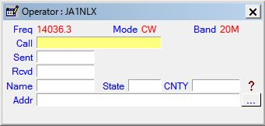

LBEW\_19A

If User field 6 and 7 are not visible and this option is checked then you see like this.

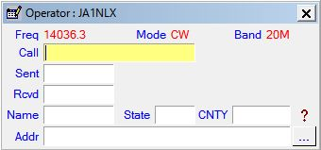

LBEW\_19B

## 4.0 OTHER MENU ITEMS

* + <**Ctrl+F**> will open the [Floating Callsign form](#11.0_FLOATING_CALLSIGN_FORM);
  + <**Ctrl+K**> will open the [CW Machine](#_topic_CWMachineWindow) with focus in the Logbook Entry window.
  + <**Ctrl+X**> swaps the selected [Scratchpad](#10.0_SCRATCHPAD) record with the Log entry.
  + <**Ctrl+Z**> will open the [Scratchpad](#10.0_SCRATCHPAD) (if not already open) and toggle the Log entry to the Scratchpad.
  + **Change operator:** The Logger32 logbook is designed to be used by one or more operators. If you wish to change the operator who is using the log at the time, select this option and change the callsign.

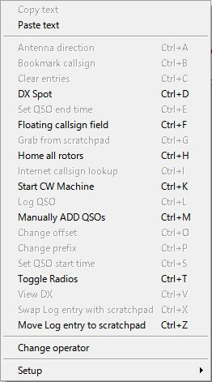

LBEW\_20

### 4.1 Note For Control + Letter Functions

You will see from the above menu that there are a number of functions that can be accessed using shortcut keys. All are reasonably self-explanatory, except perhaps the one that is grayed out in the above example.  Antenna direction is gray because in this case the antenna rotator function is not set up and/or the [COM](#COM) port is not activated.  The "Change Offset " will only show in black typeface if a prefix for a country with several time zones is entered (USA, Russia, etc.) and the station being worked is not in their own area. For example, enter the prefix W1 and note that this shows time and distance based on the station being in Concorde, NH. If this station was actually in California, the time and other information shown would be incorrect, so press the <**Ctrl+O**> key combination and a small window will appear allowing you to highlight the appropriate area - in this case W6.  Right-click on W6 and then the <Select> button. The calculated times, distances, etc., will now be based on San Francisco.

The <**Ctrl+T**>, <**Ctrl+A**> keystroke combinations may be intercepted globally depending on the options set in the Radio Configuration and Rotator Setup windows. Other Ctrl codes need the focus to be in the Logbook Entry window before they become effective.

The <**Ctrl+D**> key combination will allow you to forward a DX spot to a DX cluster. If the Logger32 Main menu option Setup | DX Spots | Prompt for Comments menu items are selected, then you will see the following dialog box.

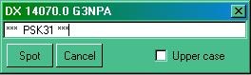

LBEW\_21

All of the report to the cluster is preformed, the header showing the frequency and callsign of the spot.  Anything typed into the edit box will appear as a comment. Click on the <**Spot**> button to send.

You must be connected to a cluster before this facility will work. The appropriate Cluster port and frequency format is selected from the Logger32 Setup Menu | DX Spots menu item.

A DX spot report is normally based on the callsign currently entered in the Logbook Entry window. However, if no callsign is entered, then Logger32 will assume that you wish to send a spot for the last entered callsign that is recognized in the log.

## 5.0 Band Mode Selection Setup

If you right or left-click on any of the titles Frequency, Band or Mode in the Logbook Entry window you can do several things.

### 5.1 Manual Entry

If you have no computer interface or you wish to manually enter details of Frequency, Band, Mode and/or Sub Mode, remove the check marks from Band from BandPlan and Mode from BandPlan (or Mode from Radio). You will now have complete manual control over what appears in the Logbook Entry window. Enter the details required and select the <**OK**> button.

The "Current frequency format is;" is dependent on your frequency resolution settings from the Logger32 Setup menu.

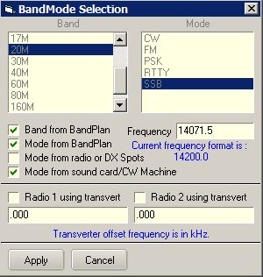

LBEW\_22

### 5.2 Automatic Entry

If you wish to automate some or all of these functions and you have a computer interface to your radio, then place check marks in "Band from BandPlan" and "Mode from BandPlan" or "Mode from Radio" to suit your needs.

### 5.2.1 The Band from Bandplan

The "Band" details as recorded in the log will be determined from the information contained in the [Band Mode table](#BandMode_Table). If the table is set up correctly, a frequency of, for example, 14.070 [MHz](#MHz) will give a band of 20M.

### 5.2.2 Mode from Bandplan

The operational Mode as recorded in your log will be determined from the information contained in the [BandMode table](#BandMode_Table). For example, a frequency of 14.070 [MHz](#MHz) might show an operational mode of [PSK](#PSK31/63/125). **Note**: The actual mode of the radio can be different and in this case could well be set to [USB](#USB).

In the above two cases, the Mode and/or Band will change automatically as you tune through the bands.

### 5.2.3 Mode from Radio or DX Spots

If "Mode from Radio or DX Spots" is checked and you are using a [CAT](#CAT) interface, then the mode displayed in the Logbook Entry window will be the mode of the radio (and not necessarily the actual mode of operation).

**Note**: This option better supports the mode sent in the comments field by DX Skimmer nodes such as on the Reverse Beacon Network. Reverse beacon DX Spots with mode in the comments field will decode want/need/worked/confirmed information based on that mode and not the Bandplan mode. As an example of how this would work. Say for example you have your Bandplan setup with 20M [CW](#CW) from 14000 to 14350 and [RTTY](#RTTY) from 14080 to 14100. A DX Spot on 14080.1 is assumed to be RTTY and want/need/worked/confirmed calculations are based on the mode being RTTY. Reverse Beacon clusters that aggregate DX Spots are now adding the mode to the comments field. So, the same DX Spot from a Reverse Beacon may have the frequency as 14080.1 but the comments field showing the mode as [CW](#CW). In this case the new code will calculate want/need/worked/confirmed based on the mode being CW.

An additional benefit of knowing the actual mode rather than relying on the often inaccurate Bandplan, is setting the radio to the correct mode when clicking on the DX Spot. Again, using the same example of a DX Spot on 14080.1. If the user is configured to set the operating mode from the radio, clicking the DX Spot would set the radio to [RTTY](#RTTY) (or whatever the radio mode is to operate RTTY - maybe [FSK](#FSK)) and set the operating mode to RTTY. Clicking on the same spot from a Reverse Beacon with mode in the comments field would switch the radio to CW (or whatever the radio mode is for CW - maybe [CW-R](#CW-R)) and set the operating mode to CW.

### 5.2.4 Mode from Sound Card/CW Machine

If the "Mode from Sound card/CW Machine" is checked then the "in use" mode of the soundcard (when open) will substitute the mode as derived from the [Bandplan](#_topic_SetupBandsandModes). This allows for a digital contester to operate anywhere in the band and the mode entered into the log will be dependant on the soundcard mode in use.

See the [Logbook Page Window](#_topic_LogbookPageWindow) for typical examples.

If the [UDP Bandmap](#_topic_TheUDPBandmap) option of ALLOW WSJT/JTDX TO SET LOGGER32 FREQUENCY/MODE and the MODE FROM SOUND CARD/CW MACHINE option are selected and the [CW Machine Window](#_topic_CWMachineWindow) is open, then the FT8 mode from WSJT/JTDX UDP messages will not override the CW Mode in the [Logbook Entry Window](#_topic_LogbookEntryWindow). On closing the CW Machine, the mode in the Logbook Entry Window will revert to FT8 (or whatever) when Logger32 receives the next Status Out UDP message from WSJT/JTDX.

## 6.0 PHONE/DIGITAL MODE SETUP

If you like to operate on digital and/or phone modes, there are further options available.

First there is the option of setting which modes get collectively summed for awards under the general "digital" and/or "phone" banners.

There is also the option of selecting what mode you want recorded in the logbook if you have selected the "[Mode from Radio](#6.2.3_Mode_from_Radio_or_DX_Spots)" option described above.

To set any of these, from the Logger32 Main menu, select the "Tools | Database Maintenance | Setup Phone/Digital Digital Modes" menu items to display the following dialog box.

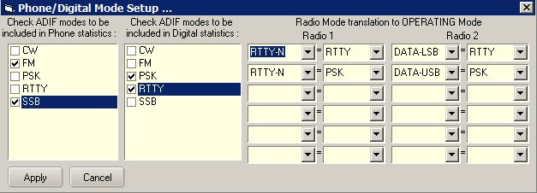

LBEW\_23

The grouping of the modes is achieved by simply checking the desired modes in one or both of the two left-hand lists. Note that the order and content of these lists are dependent on the [BandMode Table](#BandMode_Table). If a mode you wish to include does not appear here, then it is not in your BandMode table, and it needs to be.

The right-hand side of this table is associated with the "[Mode from Radio](#6.2.3_Mode_from_Radio_or_DX_Spots)" option. Here you can effectively translate the actual radio mode selected to the mode name desired for logging. If you like to use the radio mode of [DATA-USB](#DATA-USB) for your [PSK31](#PSK31/63/125) contacts, or you only operate [SSTV](#SSTV) via an [SSB](#SSB) mode, then this is the place to select what you desire. Radio mode on the left; Logged mode on the right.

## 7.0 LoTW/OQRS USER INDICATOR

Provided that the user has already downloaded the [LoTW](#LoTW) User file and generated a database, the Logbook Entry window will show a check mark if the callsign entered (either manually or from clicking on a DX spot) is found in that database. Tooltips iare displayed when the mouse is moved over the check mark. Tooltips are displayed depending on your setting. If the LoTW user file from Club Log is downloaded then it shows both, LoTW user info and OQRS user info, or either info. Details are described in the [DX Spot Window](#_topic_DXSpotsWindow1) topic.

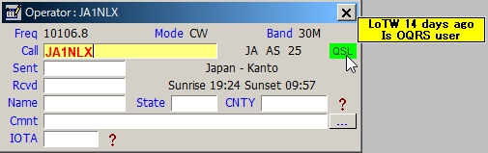

LBEW\_24

**Note**: This check mark can also be setup to indicate that the callsign entered is a user of other lists. eQSL, etc. See Load LotW User File in the DX Spot Window topic for instructions on loading other lists.

## 8.0 Split Operation

When split operation has been initiated by clicking on a DX Spot with the qualifying Split syntax in the comments, the Logbook Entry window will display the dialog box shown below. Clicking on the SPLIT OPERATION indicator will cancel Split operation.

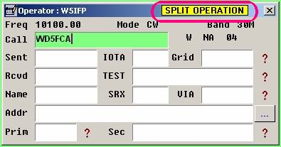

LBEW\_25

To enable the visual indication, see the Radio Control Panel topic.

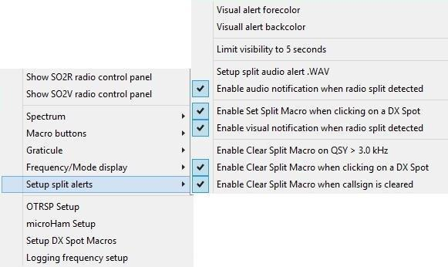

LBEW\_26

## 9.0 SCRATCHPAD

### 9.1. General

Scratchpad is a tool to save interesting QSO information, just like making notes on paper. It also provides a function to copy the saved information into the Logbook Entry window or swap it between the Scratchpad and Logbook Entry window.

## 9.2. Setup

If you want to use the Scratchpad then you need to configure it first.

Press the <**Ctrl+Z**> key combination to display the Scratchpad window:

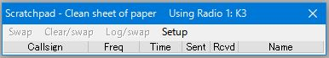

LBEW\_27

Select the Setup menu item to display the Setup drop-down menu items:

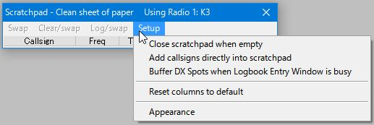

LBEW\_28

If you want to enter the callsign (with other data) directly into the Scratchpad then you must select the option "Add callsigns directly into scratchpad".

If you want to save DX spots then you must select the option "Buffer DX Spots when Logbook Entry Window is busy".

Select the Appearance menu item to change the appearance of the Scratchpad. This is the default Setup table.

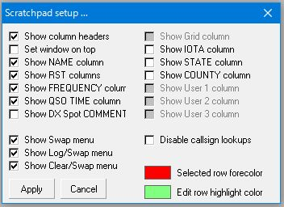

LBEW\_29

You can display only the columns you need. You may also change the Selected Row forecolor and Row highlight color. Click the <**Apply**> button to finish the setup. See section [9.6](#9.6._Tips) Tips for more setup tips

The following is an example of my setting and Scratchpad appearance. I recommend that the Set window on top option be checked.

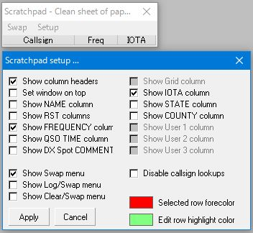

LBEW\_30

## 9.3. Writing a QSO into Scratchpad

There are various ways to enter information into the Scratchpad.

### 9.3.1. Writing Information Directly into Scratchpad

You can enter information directly into the Scratchpad. You can add information with callsign and other fields except Freq, QSO time and DX Spot comments directly into the Scratchpad.

Type a callsign, e.g. Test1 in the callsign edit box. If you want to enter other columns, e.g. IOTA, then select the <**TAB**> key to move the focus. Type IOTA reference number and Select hit the <**Enter**> key to finish. The frequency displayed in Logbook Entry window will be entered in the Freq edit box.

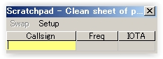

LBEW\_31

Enter a callsign, e.g. Test1 in the callsign edit box. If you want to enter other columns, e.g. [IOTA](#IOTA), then select an arrow key or the <**TAB**> key. Select the <**Enter**> key to finish. The frequency displayed in Logbook Entry window will be entered in the Freq edit box.

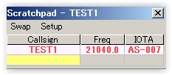

LBEW\_32

If you want to enter information for another QSO, e.g. Test2 then type callsign in the box with yellow backcolor and select the <**Enter**> key.

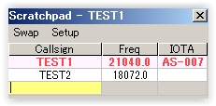

LBEW\_33

### 9.3.2. Enter QSO Information When You Click on a DX Spot

You can save information of a DX spot QSO when the Logbook Entry window is busy. Simply click any DX spot in the [DX Spots window](#_topic_DXSpotsWindow1) or [Bandmap](#_topic_TheBandmap). The Callsign, Frequency and Comment info (Split and/or Mode) are saved.

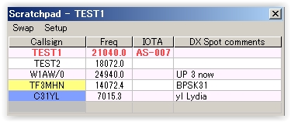

LBEW\_34

**Note:** Callsigns are highlighted with same color as in [DX Spots Window](#_topic_DXSpotsWindow1) and [Bandmap](#_topic_TheBandmap).

### 9.3.3 Writing a QSO in Logbook Entry window

The current QSO in the Logbook Entry window is saved into the Scratchpad by using the (**Ctrl+Z**) key combination.

## 9.4. Transferring a QSO Into the Logbook Entry Window

There are various ways to transfer a QSO into the Logbook Entry window or to swap QSOs between the Scratchpad and Logbook Entry window.

### 9.4.1 Selecting a QSO in Scratchpad

Click the QSO you want to transfer/swap. The QSO will be highlighted with the configured color. (see [9.2 Setup](#9.2._Setup)) If the Logbook Entry window is empty then this QSO is copied into Logbook Entry window.

### 9.4.2 With the Focus in the Logbook Entry Window You Have Following Choices:

* + - <**Ctrl+X**>: This is same as Swap below; and,
    - <**Ctrl+G**>: This is same as Log/Swap below

### 9.4.3 With the Focus in the Scratchpad You Have Following Choices:

* + - <**Ctrl+S**>: This is the same as Swap below;
    - Selecting menu items if the item is displayed in menu bar;
    - Swap: Swap the QSO between the selected QSO in Scratchpad and Logbook Entry window;
    - Clear/Swap: Clear the current QSO in Logbook Entry window and copy the selected QSO from the Scratchpad into Logbook Entry window;
    - Log/Swap: Log the current QSO in the Logbook Entry window and copy the selected QSO from Scratchpad into the Logbook Entry window; and,
    - Right click on the QSO and select one of following items:  
      * Swap callsign xxx: This is the same as Swap above;
      * Clear & Swap callsign xxx: This is the same as Clear/Swap above; and,
      * Log & Swap callsign xxx:This is the same as Log/Swap above.

### 9.5. Editing QSOs in Scratchpad

**Note**: More options are checked in the setup table for following examples.

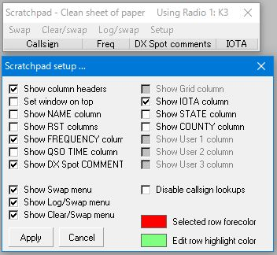

LBEW\_34A

You can edit any QSO data except Freq, QSO time and DX spot comment. Right click the edit box you want to edit. In this case I want to edit IOTA with TEST2 QSO.

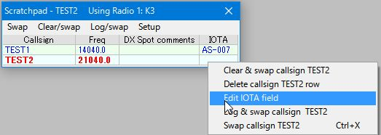

LBEW\_35

Click Edit IOTA field and enter as-007.

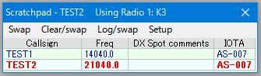

LBEW\_36

If you want to edit other fields, e.g. Test2 then select to that field (TEST2).

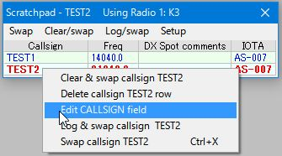

LBEW\_36A

Click Edit CALLSIGN field and type TEST3. Hit the <Enter> key.

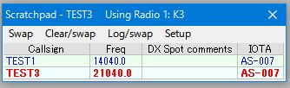

LBEW\_37

### 9.6. Tips

### 9.6.1 QSO Time

There are options to setup QSO Start time. Right click on Logbook Entry Window and click Setup.

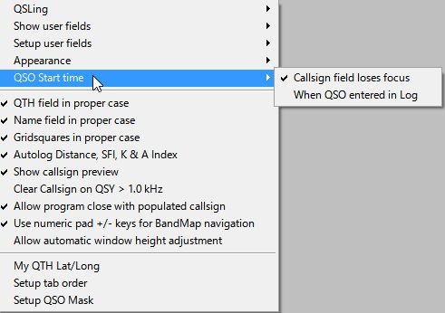

LBEW\_39

If "Callsign field loses focus" is checked then you have another option to set QSO Start time in Scratchpad. Right click on any row in the Scratchpad Window. Click "Set XXX QSO start time " (XXX is the callsign) Elapsed time is displayed in QSO Time column.

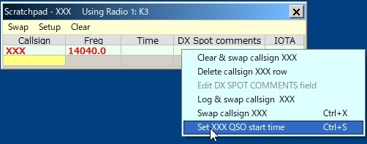

LBEW\_39A

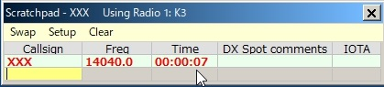

LBEW\_39B

If "When QSO entered in Log" is checked then logged TIME\_ON is always same as TIME\_OFF　regardless Scratchpad operation.

### 9.6.2 When You Close Logger32

You may receive the following warning message. You must close the Scratchpad first then close Logger32.

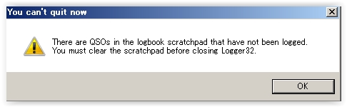

LBEW\_40

### 9.6.3 Grid Appearance

To change the column order and width of the grids:

* + Drag the mouse on the border between columns to change column width; and,
  + Drag the mouse on a column to another column to change the order.

To change the text position displayed in each column, right-click the column header and select your desired option.

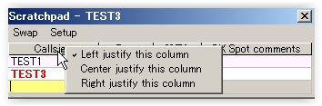

LBEW\_41

### 9.6.4 Manual Entry Field Background Color in Scratchpad

This is the same as the Data field background and Data field background (focus) in the Logbook Entry window. In my case White for Data field background and Yellow for Data field background. The manual entry field background color is like this.

Manual entry field (Callsign);

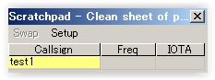

LBEW\_42

Moving focus to IOTA field; and,

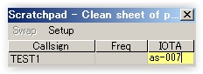

LBEW\_43

When Scratchpad loses focus.

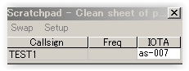

LBEW\_44

## 10.0 FLOATING CALLSIGN FORM

Logger32 ver 3.49.229 and later has a Floating Callsign form. This form will display the current callsign that is posted in the Logbook Entry window "CALL" edit box. This window can be positioned anywhere on the screen(s) for handy reference for the current callsign being worked or checked for propagation. It can be positioned near the top of the [Sound Card Data window](#_topic_SoundCardDataWindow1) or [CW Machine window](#_topic_CWMachineWindow) for quick reference. It is especially useful for users with 2 monitors.

To open the Floating Callsign form, place the focus in the Logbook Entry Window and enter the <**Ctrl+F**> key combination. You can also activate the Floating Callsign form with a right-click and select "Floating callsign field".

The following is a sample Floating Callsign form placed at the top of the screen just below the "Logger32" Title on the main MDI Form.

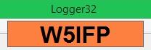

LBEW\_45

**Note**: The Floating Callsign window will be blank if there are no entries in the Logbook Entry CALL field.

The Floating Callsign window can be configured to the user's preference. A right-click on the window will bring up the configuration menus.

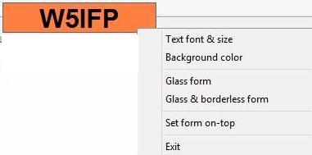

LBEW\_46

* 1. Text font & size: You can select "Text font and size". Vertical size of the form is adjusted automatically based on the Font size. The Floating form can be sized horizontally by dragging the sides with the mouse;
  2. Background color: You can select the desired background color when in a normal display mode. In the Glass form, the background is clear. (Transparent); and,
  3. Glass form: This option makes the form transparent displaying the Callsign with a border and no background color.

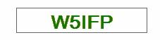

LBEW\_47

* 1. Glass & Borderless form: This option shows only the Callsign and is a little tricky to maneuver. In order to see this option, you must have a call in the Logbook Entry window CALL field. To get to the menu options, you must right click on one of the callsign letters or numbers. To reposition the form, you must Left click and drag the box with the mouse pointer positioned on one of the letters or number since it does not have a visible perimeter border.

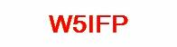

LBEW\_48

If you lose track of the Floating Callsign form, you can find it in the usual way. From the [Logger32 Main menu](#_topic_MainMenu), select the [View | Find lost windows](#4.0_VIEW_MENU_ITEM) menu items. When the Currently open dialog box is displayed, check the "Floating" check box and then the <**Find**> button. This will disable the Glass mode and position the window in the Upper Left hand corner of the screen.

You can also find the FLoating Callsign form (if it gets lost, or the rubber band in your mouse is loose) by typing the <**Ctrl+F**> key combination a second time in the Logbook Entry Window, [CW Machine](#_topic_CWMachineWindow), or [Sound Card Data Window](#_topic_SoundCardDataWindow1). This will disable the GLASS option, making the form more visible.

*Created with the Personal Edition of HelpNDoc:* [*Easily create Help documents*](http://www.helpndoc.com/feature-tour)

**Logbook Page Window**

# B. Charles Sutton W1MCP, Jim Hargrave W5IFP and Aki Yoshida JA1NLX

## 1.0 GENERAL

The Logbook Page holds all the information pertaining to your individual QSOs.

One of the biggest changes in Logger32 is how it handles multiple operators. In prior versions of Logger, if you wanted to keep separate logs for separate callsigns you were required to have multiple logs. In Logger32, you can still have multiple logs, but you may not find it necessary. Tracking is based on setting the operator callsign for individual contacts as they are entered. You do not need to change the operator callsign with each QSO you enter, but you must change it for the first QSO entered with a different callsign.  This allows you to maintain everything in one single log. Logger32 checks the operator of each QSO to determine if it should be included when generating statistical and award tracking information. You can also export the entire logbook or a portion based on a single operator.

You change the current operator callsign by right-clicking in the [Logbook Entry window](#5.1_Change_Operator) and selecting the "Change operator" menu item  If you prefer to use different logs, you still have the option to create multiple logs as before. From the Logger32 [Main menu](#_topic_MainMenu), select the [File | Change Logbook](#2.0_FILE_MENU_ITEM) menu items. A dialog box will appear requesting additional information. You must supply a filename (which must be unique), and the path for storing the file. After switching logs, you must run a recalculation to reset the statistics files to match the current log. You can do this from the Logger32 [Main menu](#_topic_MainMenu) by selecting the [Tools | Database maintenance | Recalculate statistics](#3.0_TOOLS_MENU_ITEM) menu items.

If you choose to maintain multiple log files, you can change them from the Logger32 [Main menu](#_topic_MainMenu) by selecting the [File | Change Logbook](#2.0_FILE_MENU_ITEM) menu items.

**Note**: Because of the way tracking and stats are handled, you can only have one instance of a log name per computer. Just ensure each log has a different name.

## 2.0 LOGGER32 TRACKS THREE DIFFERENT QSL TYPES, PAPER, LoTW & eQSL

You are able to track QSLs that you have sent, received and those that have been verified for [DXCC](#DXCC). When you right click on an entry in the Logbook Page window, Logger32 will highlight that QSO and open a [menu list](#LBPW_3). Select the "Set/show award credits" menu item and this will open the [Award Status dialog box](#Award_Status_dialog_box), where you can check/set the appropriate status of the highlighted QSO. See [Award Tracking](#_topic_AwardTracking1) topic for details.

**Note**: When viewing your Award Statistics, if you have selected "All QSL types" at the bottom of the chart, Logger32 treats these fields as one. A "Y" in any one of the three QSL Received fields will count that QSO as a confirmed contact. You can also select individual QSL status by changing the QSL filter.

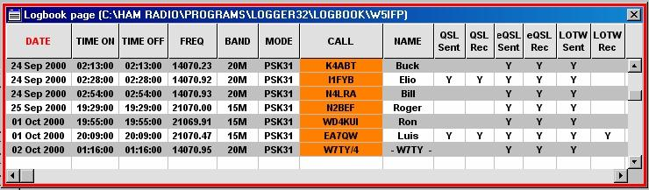

LBPW\_1

## 3.0 LOGBOOK FIELD NAMES CAN BE CHANGED

When more than one word is used to define a field, the user can check the "Show Logbook Page Window column headers as Multi-line" check box. This will allow the names to fit in more narrow columns. If the column is made narrower, the words in the name will wrap to two or three lines depending on the name and column width.

**Note**: Header names with an underscore will not word wrap. As in the LBPW\_1B example below. "QSL\_SENT" is changed to two words "QSL Sent" By making the header two words the headers will now word wrap when Multi-line format is selected.

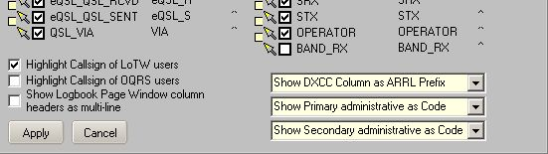

LBPW\_1A

Below is an example of Multi-Line column headers:

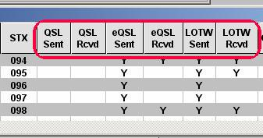

LBPW\_1B

4.0 LOGBOOK COLUMNS CAN BE SORTED

By clicking on a column heading, Logger32 will display your QSOs in ascending order sorted on that column.  When you select a column sort, that column's header will be displayed in red ([Date column](#LBPW_1) in the example above LBPW\_1).  When you select a column to sort, Logger32 will only display QSOs with data in the sorted field. For example, if you sort on [IOTA](#IOTA), then only QSOs with an IOTA entry will be displayed.

**Note**: If you should sort on a field that does not contain data, Logger32 will display the following error message, cancel the sort request, and return you to the Logbook Page.

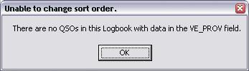

LBPW\_2.

If you choose to display more fields than can be displayed in the window you will see a scrollbar at the bottom of the window. Once your log exceeds the number of lines that can be displayed in the window, you will notice a scrollbar on the right side of the window. The sort you have selected is maintained when scrolling through the logbook.

## 5.0 CHANGING LOGBOOK GRID APPEARANCE

You can change the appearance of the grid such as displaying the grid lines, changing the row height and column width, alternating grid background colors and much more. Refer to the [Grid Appearance Setup](#_topic_GridAppearanceSetup) topic for complete details.

## 6.0 SET QSO END TIME

This option will change the End Time of the highlighted QSO to match the current time.

## 7.0 MODIFYING QSO INFORMATION.

You can change the data in any cell by left-clicking in that cell and simply typing in the correct information. After you have made the change, you must save the change by one of the following actions:

* + <**Tab**> key - Saves the change and moves to the next cell. Remains in "edit" mode
  + <**Enter**> key - Saves the change and return focus to the [Logbook Entry window](#_topic_LogbookEntryWindow).
  + <**Up**> or <**Down**> arrow keys - Saves the change and returns focus to the [Logbook Entry window](#_topic_LogbookEntryWindow).
  + Mouse Pointer - Position the pointer in another cell and left-click. Remains in "edit" mode.

The following describes the use of additional keys and their action in the "Edit" mode:

* + <**Esc**> key - Edit is cancelled and the focus is moved back to the [Logbook Entry window](#_topic_LogbookEntryWindow).
  + <**Page Up**> or <**Page Down**> keys - Edit is canceled and the Logbook is moved Up or Down one page. As you are no longer in "Edit" mode, further use of the arrows has no effect.
  + <**Ctrl+End**> and <**Ctrl+Home**> key combinations - Change the cell being edited to the rightmost or leftmost cell.
  + <**Left**> or <**Right**> arrow keys - Changes the cell being edited to the left or right.

**Note**: Some fields cannot be edited directly in the Logbook cells. Examples are: "COUNTRY" and "ADMIN SUBDIVISION". If you attempt to edit one of these fields, an error message will be displayed displaying the correct procedure for editing.

When entering QSOs from the [Logbook Entry window](#_topic_LogbookEntryWindow) or the [Add QSO window](#Add_QSO_Window), the mode field is limited to those modes defined in your [BandMode table](#BandMode_Table). However, you can change the mode field for any QSO in the Logbook Page window by left-clicking in the mode field and changing the text to any valid ADIF mode

## 8.0 QUICK EDIT

A right-click on any Logbook Page column header will open a Quick Edit dialog box. This dialog box allows you to make several changes to the columns and headers.

The left section allows the column headers to be moved, re-named and formatted. Clicking on the <**Apply changes to this column**> button will save the changes. You can also select the column to the left or right for further editing without closing the window.

The right section accommodates DXCC and Multi-line header selection. Clicking on the <**Apply changes to this Form**> button will save the appropriate changes.

The <**Move this column to the left**> (or right) buttons are dynamic and the change will be executed immediately.

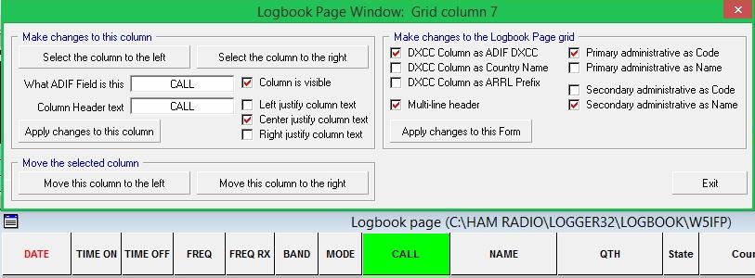

LBPW\_2A

## 9.0 LOGBOOK OPTIONS

### 9.1 Setting up the Grid and Choosing the Fields to Display

When you right-click anywhere inside the Logbook Page window a pop-up menu will appear allowing you to modify the Grid. These changes will apply only to the Logbook Page window.

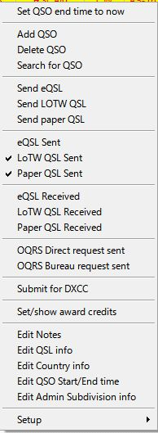

LBPW\_3

### 9.2 Changing Cell Color

Choosing Cell text color (edit) and Cell background color (edit) will change the color of the cell you have chosen to edit.  Notice QSO #1, the font color has changed to red and the cell background has changed to light blue.

### 9.3 Changing Column Header Names

Choosing the Grid layout will allow you to change the column header names, the justification of the columns and the order in which the columns are displayed.  Please refer to the [Grid Layout Setup](#_topic_GridLayoutSetup) topic for complete details.

## 10.0 ADDING OR DELETING A QSO

To add a QSO, right-click anywhere in the Logbook Page window and select Add QSO.  The Add QSOs manually dialog box will be displayed.

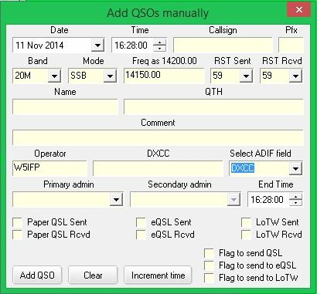

LBPW\_5

**Note**: Logger32 determines the [DXCC](#DXCC) Country based on current callsign allocations. No adjustment to DXCC Country is made based on certain date ranges.

For example, in the 1970s many Russian and German callsigns were assigned differently than they are today. While this window is functional, if you have a large number of older QSOs to enter, you should probably use a program specifically written for the purpose (ask for advice on currently recommended software the Hamlogger reflector) that will create an [ADIF](#ADIF) file that can be imported into Logger32.

If you have just a few new records, you can change the [ADIF](#ADIF) field to [DXCC](#DXCC) as shown below and enter the correct DXCC based on the date of your QSO. If you leave this field blank, Logger32 will assign the most current designation based on the callsign prefix.

## 11.0 NAVIGATION

The following steps define the ways to navigate through the Logbook Page records. With the mouse pointer on the Logbook Page window and the grid showing QSOs. A Mouse-click on a row with QSO data will select that QSO:

* + **Mouse left-click**: The row is set for editing;
  + **Mouse right-click**: A menu of options is presented; and,
  + **Mouse scroll**: Moves through the logbook QSO by QSO. Holding down the <**Shift**> key, and rotating the mouse wheel, moves through the logbook a full page at a time.

The <**Home**>, <**End**>, <**Page Up**> and <**Page Down**> keys move the logbook as expected.

Arrow keys have no effect on the grid (It's a Microsoft thing).

### 11.1 Field Data

11.1.1 Date Field

This field will default to the current date. You can change the date by highlighting any of the three sections (month, day or year) and increase or decrease the field by using the <**+**> and <**-**> keys on the numeric pad or by using the <**Up**> and <**Down**> arrow keys. You can also select a date by clicking on the arrow to the right of the date and accessing the calendar.

### 11.1.2 Time Field

This field works very similar to the date field.

### 11.1.3 Band and Mode Fields

As you enter data here, you will notice the frequency will change to approximately the middle of that section of the band. The frequency can then be manually changed. If you enter a mode that has a submode associated (like [SSTV](#SSTV)), the submode field will become visible to the right of the End Time field.

**Note**: When entering the Mode, the drop-down list is populated with all of the valid ADIF modes, you are no longer restricted to those modes defined in the [BandMode](#BandMode_Table) table.

### 11.1.4 Address and Select ADIF Fields

These fields operate together. When you change the Select ADIF Field, the name on the field immediately to its left will change to match your choice. This allows you access to every field in your logbook. As you change fields, any data you entered in a previous field is retained and will be added to your QSO entry.

**11.1.5 Other Fields**

Several fields are "sticky" in that they remember the last data entered. This should make adding several QSOs much easier, especially if there are several on the same day or band.

* + Placing a check in QSL Sent or QSL Rcvd will update the corresponding ADIF fields.
  + Placing a check in Flag QSO for QSL, eQSL or LOTW will flag the QSOs to be included in your next corresponding log export.
  + The <**Clear**> button will clear any data from the non-sticky fields.

The Exit window will close the Add QSOs manually dialog box.  If there is data in the fields, it will not be logged.

If you try to enter a QSO with the same time as a QSO already in your logbook, a pop-up message will alert you. Select the <**OK**> button and either change the time or select the red <**Increment time**> button to the right of the <**Clear**> button. This will increment the time and log the QSO.

To delete a QSO, right-click in the appropriate row and select Delete QSO.  A confirmation message will be displayed.  Select the <Yes> button to delete the QSO or the <No> button if you made an error.

To search for a QSO, right-click anywhere within the Logbook Page window and select Search for QSO.  A Search the Logbook dialog box will open and you can choose from many of the fields to conduct your search, some are shown here:

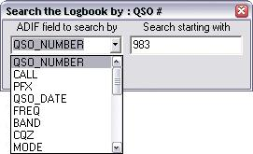

LBPW\_6

Depending on what field you choose to search, the Logbook Page will react differently.  For example, if you choose to search by QSO number beginning with 983 as in the image above, the log will sort by QSO number and then position itself at QSO #983.  One thing to note is that when sorting, only QSOs with matching data will appear in the log. For example, if you sort by IOTA starting with NA-001, the log will first sort by IOTA, then position itself at NA-001 and only those QSOs with an IOTA entry will display in the log. Once you have selected your search criteria, you can move the Search the Logbook dialog box out of your way while you are working with the log. The Logbook Page and the Search dialog box interact and you can make changes to your search routine from either window.

**Example**: You can choose another sort routine by clicking on a header in the Logbook Page while leaving the QSO search dialog box open. A corresponding change will be reflected in the QSO Search dialog box.

Once you close the Search the Logbook dialog box, the Logbook Page reverts back to the condition it was in before you invoked the search.

## 12.0 FLAGGING QSO RECORDS

Right-clicking on any QSO will bring up Logbook Options menu (see [LBPW\_3](#LBPW_3) above) where in the center of the window are 4 options:

* + **Send QSL**  - This option will flag the QSO so that it is included with the next QSL Record export;
  + **Send eQSL**  - This option will flag the QSO so that it is included with the next eQSL Record export;
  + **Send LoTW**  - This option will flag the QSO so that it is included with the next LoTW Record export; and,
  + **QSL Sent**  - This option will set the field QSL\_Sent to Yes.

## 13.0 HIGHLIGHTING THE STATUS OF QSO RECORDS

You can set-up different highlight colors to visually help identify the status of a QSO. Highlights include Worked, Confirmed, QSL sent, and QSLs flagged for printing.

* + **eQSL Sent**: Clicking on this option will set the eQSL Sent field to Yes.
  + **LoTW QSL Sen**t: Clicking on this option will set the LoTW Sent field to Yes.
  + **Paper QSL Sent**: Clicking on this option will set the QSL Sent field to Yes and also add the current date to the QSL Sent Date field.
  + **eQSL Received**: Clicking on this option will set the eQSL Received field to Yes.
  + **LoTW QSL Received**: Clicking on this option will set the LoTW QSL Received field to Yes.
  + **Paper QSL Received**: Clicking on this option will set the QSL Received field to Yes and also add the current date to the QSL Received Date field.
  + **eQSL Verified**: Clicking on this option will set the eQSL Received field to Verified.LoTW QSL  
    Verified: Clicking on this option will set the LoTW QSL Received field to Verified.
  + **Paper QSL Verified**: Clicking on this option will set the QSL Received field to Verified.

## 14.0 EDIT NOTES

Any notes associated with the callsign will be displayed along with the QSO date. To enter a note for this particular QSO, type the information in the text box and choose the <**Apply**> button.

## 15.0 EDIT QSL INFO

The Edit QSL Info dialog box will appear as shown here:

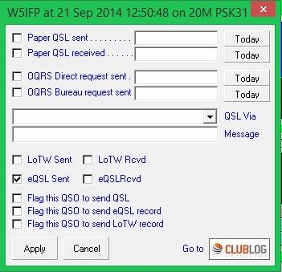

LBPW\_4

You can change the data that is displayed, add a QSL manager (or bureau) or add a QSL message.  The message section here will appear in the ADIF QSL\_Message field. Many QSL printing programs will print any data entered in this field on your QSL card or label.

The QSL Via drop-down list includes the following options:

* + Bureau
  + Direct
  + OQRS direct request sent
  + OQRS bureau request sent
  + OQRS direct request received
  + OQRS bureau request received
  + Manager direct
  + Manager by bureau
  + QSL service
  + eMail request Auto QSL

You can either manually enter data in the field; choose an option from the drop-down box, or a combination of the two. For example, you could select "Manager direct - " from the drop-down box and then type in CA1LL after it.

The new auto-update of Logger32 attempts to provide easier and smoother access to OQRS (which is essentially a closed system). The [Edit QSL Info dialog box](#Edit_QSL_Info_Dialog_Box) has four new OQRS related options under the QSL\_VIA drop down list.  Also, clicking the Club Log logo will take you directly to the Club Log search page for the station you selected in the Logbook Page Window. There you can query your QSOs with the station, and by the click of a button, go to ClubLog's OQRS pages.  If you have selected a QSO in your logbook with a station in your logbook that does not have logs at Club Log, you will be taken to the Club Log page that lists all on-line DXpedition logs.

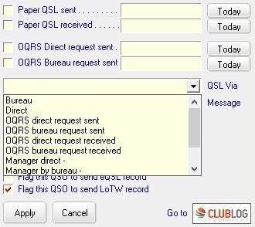

LBPW\_4A

## 16.0 EDIT COUNTRY INFO

This option will display a grid, as shown below, and allow you to choose a different country for the QSO.

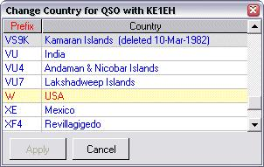

LBPW\_8

## 17.0 EDIT QSO Start/End time

This option will display Edit QSO Start/End time window as shown below. If you wish then “End time=Start time” box may be checked.

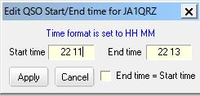

LBPW\_8A

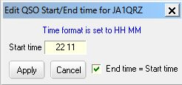

LBPW\_8B

## 18.0 EDIT ADMIN SUBDIVIION INFO

This option will display a grid, as shown below, and allow you to choose a different Administrative Subdivision for the QSO.

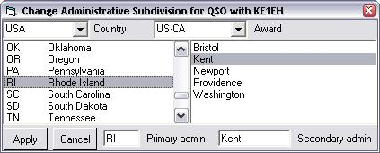

LBPW\_9

## 19.0 SETUP

* + 1. Right click on Logbook Page Window. Click Setup to show setup menu.

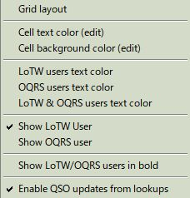

LBPW\_9A

### 19.1 Grid Layout

Allows you to change the column header names, the justification of the columns and the order in which the columns are displayed. Refer to the [Grid Layout Setup](#_topic_GridLayoutSetup) topic for complete details. Choosing cell text color (edit) and cell background color (edit) will change the color of the cell you have chosen to edit. Notice QSO #1, the font color has changed to red and the cell background has changed to light blue.

**19.2 Cell text color (edit) and Cell background color (edit)**

Allows to change text color and cell background color in edit mode.

**19.3 LoTW users text color, OQRS users text color and LoTW & OQRS users text color**

Allows to change text color for LoTW users, OQRS users and LoTW/OQRS users.

**19.4 Show LoTW user, Show OQRS user and Show LoTW/OQRS users in bold**

Allows to enable//disable to show each user in bold.

## 19.5 Enable QSO updates from lookups

Allows user to update data from lookups if needed after QSO. Following additional settings are needed. Details about lookups is explained in the section “[Callsign lookup](#_topic_CallsignLookup)” in this Help.

### 19.5.1 Using Auto Internet Callsign Lookup

If you use “Auto Internet Callsign lookup (external)” or “Auto Internet Callsign lookup (internal)” in Logger32 then:

**a)** in the Setup/Auto lookup menu check “Auto Internet callsign lookup (external)” or “Auto Internet callsign lookup (internal)

### 

LBPW\_9B

**b)** In the Lookup window menu click ”Transfer” and check “Transfer selected fields on autolookup”

### 

LBPW\_9C

**c)** If you use “Auto Internet callsign lookup” with L32Lookup by N2AMG then run L32Lookup.

**d)** Left click on any QSO in the Logbook Page window.  Lookup window now opens.  Click on the menu “Update QSO”. The QSO on the Logbook Page will be updated with any filed data which are pre-selected in the Transfer menu.

### 

LBPW\_9D

### 19.5.2 Using Another External Lookup

If you use another external lookup utility like Lookup\_QRZ\_XML, Lookup\_HamQTH\_ADIF or Lookup\_HamQTH\_XML by JA1NLX then:

**a)** Run this utility.

**b)** Left click on any QSO in the Logbook Page window. Click “Update QSO” button. The QSO on the Logbook Page will be updated with following fields data.any filed data.

Name, IOTA, Grid, State, CNTY and QSL\_VIA.

**c)** If you want to overwrite then check “Overwrite”

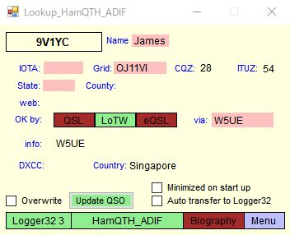

LBPW\_9E

### 20.0 DELETING LOGBOOKS

If you have any old or unwanted logbooks that you wish to delete you must first open Logger32 and then open a logbook you wish to keep. Finally, close Logger32.

Open Windows Explorer and browse to the Logger32 directory.Manually delete the four files associated with the logbook you wish to delete. The four files have the extensions: .isd, .isf, .isl and .ism.  Note that if you close Logger32 with the logbook that you wish to delete in the open or active state, Logger32 will re-create that logbook the next time you start the program, although the new logbook will be blank with no logged entries.

### 21.0 ADIF Field Definitions

**Note**: the Logbook in Logger32 has one field for mode, however it is neither ADIF MODE nor ADIF SUBMODE field. Typical examples are shown below.

CW is one of the ADIF MODEs. If radio is in CW mode and “Mode from BandPlan” is checked then Logbook entry window shows “Mode CW” This QSO is logged in Logbook with mode=CW.

SSB is one of the ADIF MODEs. LSB and USB are ADIF SUBMODEs of the ADIF MODE SSB. If radio is in LSB mode and “Mode from BandPlan” is checked then the Logbook entry window shows “Mode SSB” This QSO is logged in Logbook with mode=SSB”

PSK is one of the ADIF MODEs. PSK31, PSK63 etc are ADIF SUBMODEs of the ADIF MODE PSK. If the radio is in the mode for PSK31 and “Mode from soundcard/CW machine” is checked then Logbook entry window shows “Submode PSK31” This QSO is logged in Logbook with mode=PSK31.

If you prefer to log this QSO with mode=PSK then “Mode from BandPlan” should be checked and

“Mode from soundcard/CW machine” should be unchecked.

RTTY is one of the ADIF MODEs. If the radio is the mode for RTTY then Logbook entry window shows “Mode RTTY” This QSO is logged in Logbook with mode=RTTY.

You may have different result depending on option checked in BandMode Selection table in Logbook entry window.

Below is a table of the [ADIF](#ADIF) fields used in your Logbook, along with the type of data, a description of the field's intended use, and any special features within Logger32.

The file "ADIFModes.txt" located in your Logger32 root directory contains the current list of valid ADIF MODEs and SUBMODEs. This file is used by Logger32 to calculate statistics by Mode and Submode correctly.

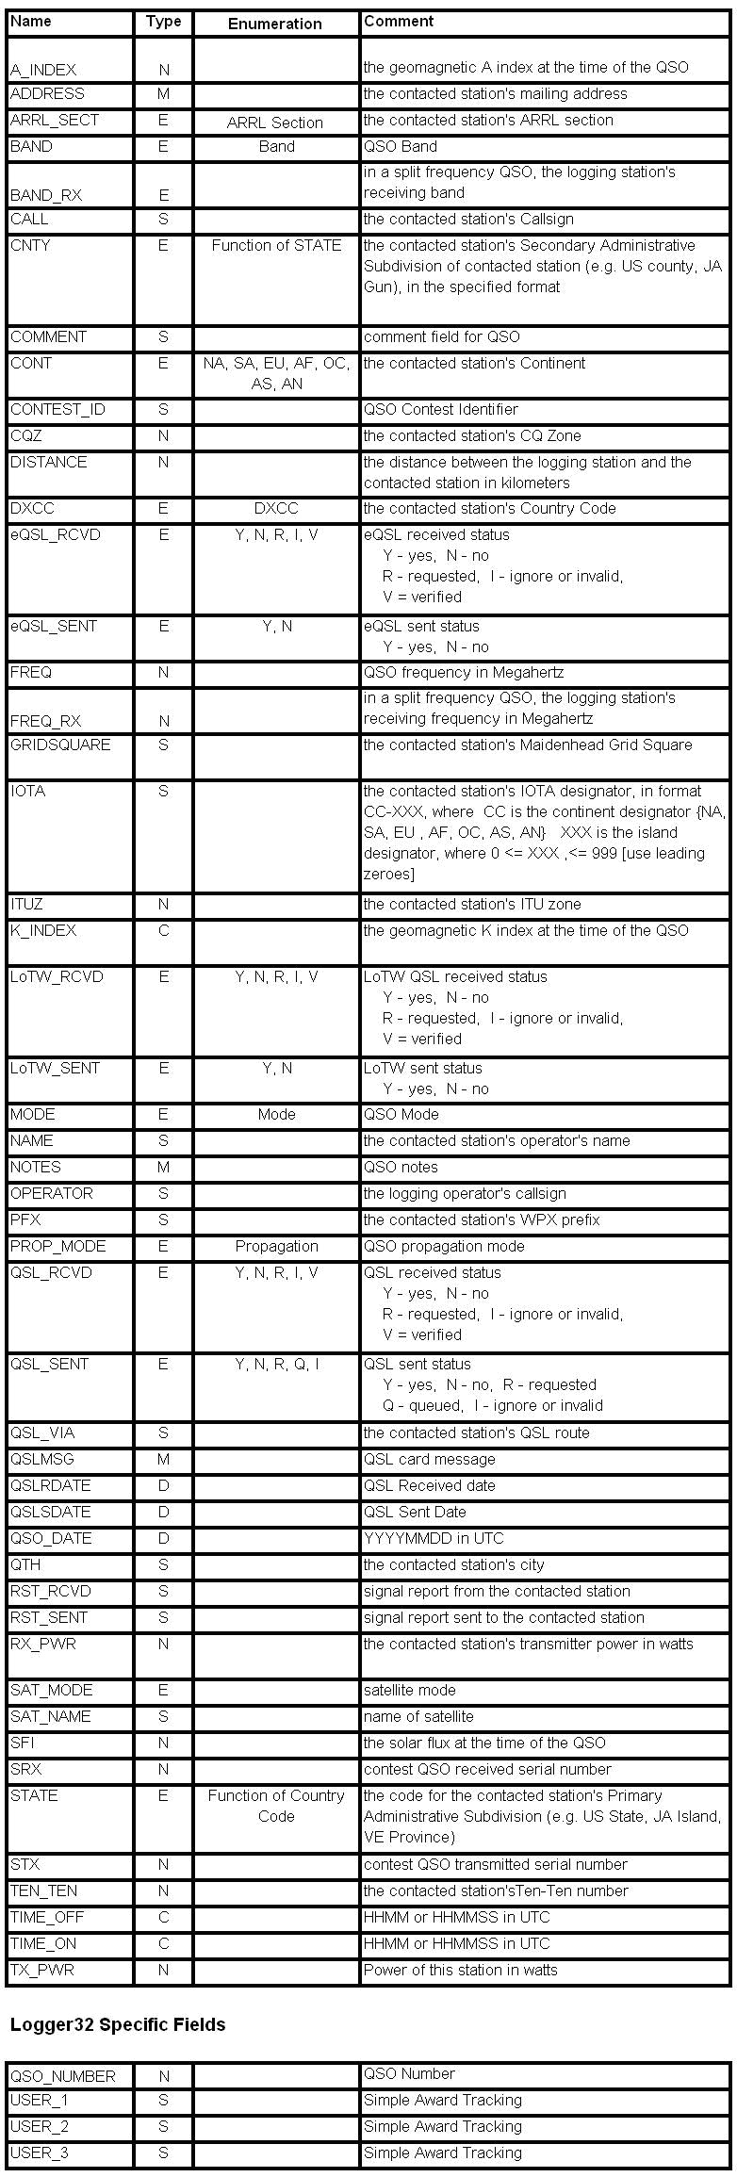

LBPW\_7

*Created with the Personal Edition of HelpNDoc:* [*Create HTML Help, DOC, PDF and print manuals from 1 single source*](http://www.helpndoc.com/help-authoring-tool)

**Backing up Logger32 Files and Databases**

# B. Charles Sutton W1MCP, Jim Hargrave W5IFP and Geoff Anderson G3NPA

## 1.0 GENERAL

It is **STRONGLY** recommended that you backup your files **OFTEN**.

Note: **If you select to save your backups to an Internet depository such as GOOGLE Drive, you will need to allow time for the cloud system to synchronize the files before making another backup**.

If you continue to have trouble making backups, it is suggested that you specify a path/file on your local drive and then upload this backup file to your Internet depository manually.

There are three Backup options in Logger32:

* + User files:
  + Database and Logs; and,
  + Current logbook only.

These are all accessed from the Logger32 toolbar.

* + Database and Log backups are saved to filenames filename\_FULL/<logbook name>\_001 to filename\_FULL/<logbook name>\_010 and contain versions of both databases and logbook; and,
  + Current Logbook only backups are triggered by the "Schedule" menu option of the Backup databases and logbook dialog box (see section 6.0 Automatic Backup Selection), and are saved to logbook name\_PART\_001.ZIP to logbook name\_PART\_010, ZIP and contain versions of the logbook only.

When the backup count of either backup file set exceeds 10, the first backup is deleted, backups 002 to 010 are renumbered 001 to 009 and the newest backup is numbered 010. Backup 010 will always be the latest backup version.

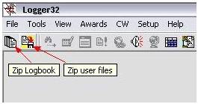

BULFD\_1

## 2.0  ZIP LOGBOOK

This option will compress your active logbook files into ZIP format.  Only one logbook can be backed up at a time. If you have several logbooks you will need to perform this backup once per logbook. Clicking on the Zip Logbook icon will display the Backup databases and logbook dialog box.

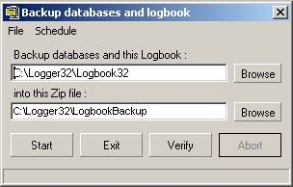

BULFD\_2

In the first edit box, enter the path and name of the logbook you wish to backup (without the .ISD extension) or use the "browse" Backing up Logger Files and Databases <**Browse**> button to locate it.

**Note**: If you have not renamed your log it will have the default name of "Logbook32.isd".

In the second edit box, enter the path and name of the ZIP file you wish to create.

**Note**: If you select the A: drive, Logger32 will automatically span multiple floppy disks if necessary.

Select the appropriate button to:

* + <**Start**> to begin the backup;
  + <**Exit**> to close the dialog box without backing up the logbook;
  + <**Verify**> to check that the archive was created error-free; and.
  + <**Abort**> to abort a backup in progress.

The Status bar at the bottom of the dialog box will display the status of the backup and any instructions necessary.

## 3.0  ZIP USER FILES

This option will compress your User Files into the ZIP format. User Files include all non-logbook files that you may have modified while using Logger32.  Examples include:

* + All .ini files containing your preferred setup(s);
  + Country databases (and support files);
  + IOTA databases; and.
  + Other non-logbook files.

The number of files backed up during this operation will depend on how you use Logger32.  As an example, my current version contains 32 files.

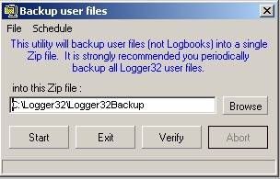

BULFD\_3

In the first line, provide the path and name of the ZIP file you wish to create. **Note**::If you select the A: drive, Logger32 will automatically span multiple floppy disks if necessary.

Select the appropriate button to:

* + <Start> the backup;
  + <Exit> to close the dialog box without backing up the logbook;
  + <Verify> to check that the archive was created error-free; and,
  + <Abort> to abort a backup in progress.

The Status bar at the bottom of the dialog box will show the status of the backup and any instructions necessary.

## 4.0 DO IT YOURSELF

You can also copy your entire Logger32 directory to another drive, networked computer, or burn a copy to a CD. Logger32 does not store any configuration settings in the registry at all.

## 5.0 RESTORING YOUR FILES

If you need to restore your backed up files, you will need a program such as WinZip or PKUnzip, or any of the other programs capable of reading a ZIP file.  Simply extract the files back into the Logger32 directory.

## 6.0 AUTOMATIC BACKUP SELECTION

From version 3.30 onwards, options have been built in to allow the user to automate backups. Access to these is gained by selecting ""Schedule" menu item in either of the two backup windows described above to produce the drop-down menu list.

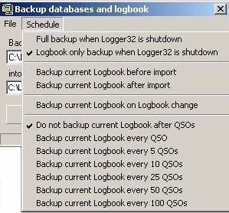

BULFD\_4

The menu list is divided into four sections.

### 6.1. Backup on Logger32 Shutdown

The first section determines what action is to be taken when shutting down Logger32:

Full backup will backup the active log and the databases into the database zip file and the user files into the user zip file.

Logbook only backup will backup the active logbook only and these get placed into the Logbook zip file.

**Note**: The user can choose a common name for both databases and user zip files, or can name them differently.

### 6.2. Backup Before or After Import

The second section allows for a backup before or after the import of additional log data.

### 6.3 Backup on Logbook Change

The third section allows for a backup before when changing a Logbook. The status of the auto backup when changing logbooks is shown in the header line.

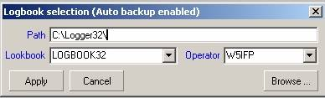

BULFD\_5

### 6.4 Backup after Logging QSOs

The final section provides the option to backup after "n" QSOs where "n" = 1, 5, 10, 25, 50 or 100 contacts. Only one of the seven options in this section can be selected at any one time.

*Created with the Personal Edition of HelpNDoc:* [*Create cross-platform Qt Help files*](http://www.helpndoc.com/feature-tour/create-help-files-for-the-qt-help-framework)

**Changing Logbooks**

# Geoff Anderson G3NPA

## 1.0 GENERAL

Logger32 supports multiple logs. This functionality is most useful should you wish to maintain separate logs for contesting. This has the advantage that the stats produced during the contest will apply ONLY to that contest even if the Operator is the same as in other logs. You can select a Logbook that already exists, or create a New Logbook by selecting the Logger32 [Main menu](#_topic_MainMenu) [File | Change Logbook](#2.0_FILE_MENU_ITEM) menu item to display the Logbook selection dialog box. The Logbook selection dialog box will display the Path, Logbook Name and Operator for the current Logbook open in Logger32.

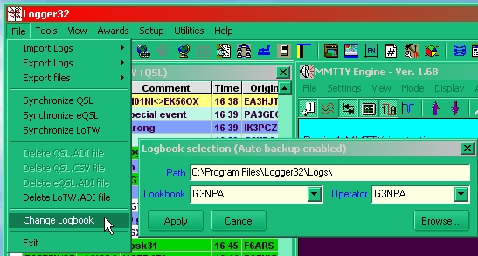

CL\_1

## 2.0 SELECT AN EXISTING LOGBOOK

There are two ways to select an existing logbook:

### 2.1 Using the Default Logbook Path

* + Select a Logbook and Operator from the appropriate combo box lists; and,
  + Select the <**Apply**> button.

### 2.2 Using the <Browse> button

Select the <**Browse**> button to display the SELECT LOGBOOK TO USE dialog box. When opened, the Title Bar of the dialog box will display the path and Logbook name of the current Logbook open in Logger32, and the Directory and Logbook Name will be highlighted in the selection panels. Select the Directory and Logbook Name of the logbook you wish to open and select the <**Apply**> button to open the logbook.

### 3.0 CREATE A NEW LOGBOOK

To create a new Logbook, you must use the Logbook Path option.

* + Use the default Path or enter a new Path in the Path edit box;
  + Enter a new Logbook Name into the Logbook edit box;
  + Select an Operator or enter a new Operator into the Operator edit box; and,
  + Select the <**Apply**> button.

The new Logbook will now be your current Logger32 Logbook. Logbook Page window and Statistics will be empty. If you wish, you can import [ADIF](#ADIF) file or just start to use it.

*Created with the Personal Edition of HelpNDoc:* [*Full-featured EBook editor*](http://www.helpndoc.com/create-epub-ebooks)

**Changing Operator**

# Geoff Anderson G3NPA

If you right-click on the [Logbook Entry window](#5.1_Change_Operator) and select "Change operator" from the [popup menu](#Setup_Menu), the Current Operator dialog box will be displayed. Simply enter a new callsign into the edit box, or using the drop-down arrow, select a previously entered callsign and click the <**Apply**> button.

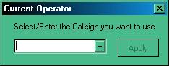

CO\_1

*Created with the Personal Edition of HelpNDoc:* [*Easily create iPhone documentation*](http://www.helpndoc.com/feature-tour/iphone-website-generation)

**Reformat QSO Numbers**

# Hew Lines VA7HU

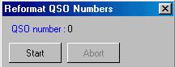

RQN\_1

Selecting the Logger32 [Main menu](#_topic_MainMenu) [Tools menu item](#3.0_TOOLS_MENU_ITEM) will allow you to re-number the QSOs in your logbook

If you have manually entered any QSOs in your logbook with dates and/or times in the past, if you sort on date, the display will show QSO numbers out of sequence. This function will re-number your QSOs in the correct order.

*Created with the Personal Edition of HelpNDoc:* [*Free HTML Help documentation generator*](http://www.helpndoc.com)

**Notes and Comments Window**

# Geoff Anderson G3NPA

## 1.0 GENERAL

In Logger32 there are two log columns in which additional information connected with a QSO may be kept: [Comments](#2.0_COMMENTS); and [Notes](#3.0_NOTES).

There is a subtle difference in the way these two functions work and a considerable difference in the way information is displayed. In summary, the use of "Comments" is quick and easy, but not so easy to retrieve the information. The use of "Notes" is perhaps a little more time consuming, but the presentation of the information is done on a callsign basis. Both methods may be used for a log entry.

## 2.0 COMMENTS

Comments are entered into the logbook via the Cmnt field in the [Logbook Entry window](#_topic_LogbookEntryWindow). To use this functionality you will have to ensure that the Comments column in the logbook is visible (see [Grid Layout Setup](#_topic_GridLayoutSetup)). The  Comments field of the [Logbook Entry window](#_topic_LogbookEntryWindow) provides the capability for you to select data from the Comment, QTH or Address fields of the Logbook.

Select the  button to the right of the edit box to toggle the field so that the title Cmnt appears to the left of the edit box and enter the comment text. Any text entered will be stored in the Comment field of the logbook when the QSO is logged.

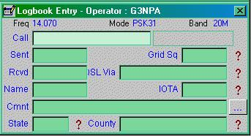

NACW\_1

## 3.0 NOTES

Notes are entered into the logbook via the Notes window that is opened by selecting the Notes icon on the [Logger32 Toolbar](#_topic_ToolBar).

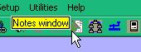

NACW\_3

If there is no callsign entered in the [Logbook Entry window](#_topic_LogbookEntryWindow) or the particular callsign does not have any notes associated with it, then the Notes window will be blank.  If a callsign is entered into the [Logbook Entry Window](#_topic_LogbookEntryWindow) and there are notes associated with that call somewhere in the logbook, then the Notes window will fill with the appropriate details.

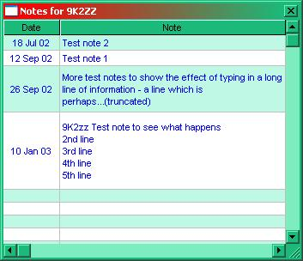

NACW\_4

The Notes window will only display 100 characters of text. Should the text be longer than 100 characters then the display will be cut short and the word "(truncated)" will be added.

A left click on any of the notes in the table will highlight that entry in the [Logbook Page window](#_topic_LogbookPageWindow) and the "Notes for" dialog for that contact will contain the complete text.

In the example given below you can see that the text for 26 Sept 02 is truncated but is displayed in full in the "Notes for" window.

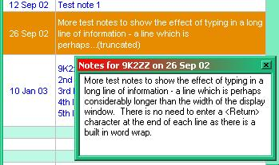

NACW\_8

To enter a Note you must have the Notes window visible and have a callsign into the [Logbook Entry window](#_topic_LogbookEntryWindow). Right click on the Notes window to bring up menu shown below.

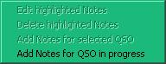

NACW\_5

If you are just adding a Note, click on "Add Notes for current QSO" and type your text into the small window that will appear. Once you have completed this task, exit from the text window and return the focus back to the [Logbook Entry window](#_topic_LogbookEntryWindow). You may then continue with entering whatever further QSO data you wish before logging the contact using the <**Enter**> key.

You may also edit or delete a Note from the Notes window by right clicking on the required entry. This will bring up a menu with the Edit and Delete menu items not greyed out. Selecting the Delete menu item will immediately remove the Note. Selecting the Edit menu item will bring up a new window containing the original Note where you can enter any additional text or modify the existing text.

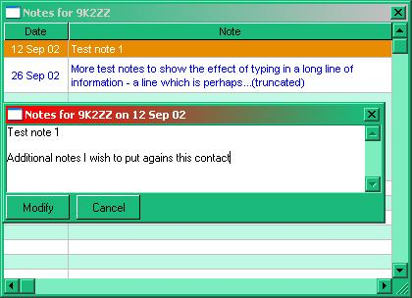

NACW\_6

To save the Note and end the session, select the <**Modify**> button.

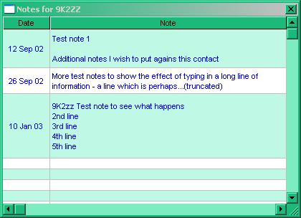

NACW\_7

*Created with the Personal Edition of HelpNDoc:* [*Free Qt Help documentation generator*](http://www.helpndoc.com)

**Importing Logs**

# B. Charles Sutton W1MCP and Jim Hargrave W5IFP

## 1.0 GENERAL

For specific instructions on transferring your logs from Logger16 to Logger32, please refer to the topic: [Transferring Logs from Logger16 and Other Programs](#_topic_TransferringLogsfromLogger16andO).

Logger32 accepts one form of input file known as [ADIF](#ADIF). Logger32 follows the ADIF standards and will import those files that also follow the standards. There are some programs that do not follow the standards and you will have to modify them before they can be correctly imported into Logger32.  Logger32 will identify all QSO records that are not formatted correctly and the problem.

Here is a small sample of an ADIF file:

<CALL:5>KE1EH <QSO\_DATE:8:D>20000402 <TIME\_ON:6>000016 <MODE:3>SSB <BAND:3>10M <RST\_SENT:2>59 <EOR>

While there are many other fields that can be included in an ADIF record, this will give you an idea of what the file should look like.

One of the ADIF fields is the operator field. This field is used to identify the callsign of the operator that made the QSO. You can use this field to keep track of the different callsigns you may have had. If you wish to use this kind of tracking, it will be easier if you have one ADIF log for each different callsign.

Logger32 will allow you to display QSO data and statistics based on an individual operator, or for all operators.

Before importing your ADIF log, be sure the [Logbook Entry window](#_topic_LogbookEntryWindow) is displaying the correct operator callsign. If it isn't, change it accordingly. While importing your logs, Logger32 will search for the operator field and apply it to each QSO, if the field is not present in your ADIF file, Logger32 will use the operator currently configured.  Before the import starts, a dialog box will remind you of this and show the current operator callsign that will be used as the default.

From the Logger32 [Main menu](#_topic_MainMenu), select the [File | Import Logs | ADIF (.adi) file](#2.0_FILE_MENU_ITEM) menu items.

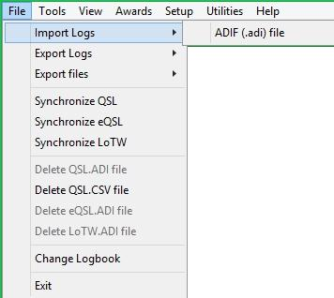

IL\_1

Logger32 will prompt you for the file you wish to import.  (**Note**: Logger32 will only look for files with the .adi extension). Select the file you wish to import and then the <**Open**> button.

The Import ADIF Log dialog box will open and provide you with a few options at this point.

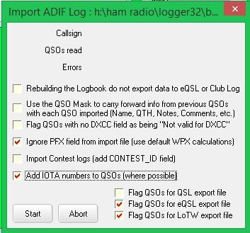

IL\_2

Several users have experienced difficulty with the Logbook after importing data that may not have conformed to the ADIF specifications. It is a **VERY GOOD idea to backup your logs before importing ANY data.**

## 2.0 IMPORT OPTIONS

### 2.1 Rebuilding the Logbook. do not export data to eQSL or Club Log

This option should be checked if you are importing a backup log file where the QSOs have already been uploaded to these facilities. This will avoid sending large numbers of unnecessary duplicate QSOs.

**Note**: There is no interaction between this option and the FLAG QSOs for QSL/eQSL/LoTW options.  However, if the you are rebuilding a logbook, it would be assumed that the ADIF backup file already has all appropriate flags set.

### 2.2 Use the QSO Mask to carry forward info from previous QSOs

If this option is checked, information that you have entered in the first QSO with a callsign, will be copied into all successive QSO records during the import.

### 2.3 Flag QSOs with no DXCC field as being "Not valid for DXCC"

This option is primarily to be used when initially importing logs to Logger32 from other logging programs that use [DXCC](#DXCC) field of 000 to indicate a QSO not valid for DXCC. Contest logs frequently do not fill out the DXCC field, and for those logs, this option should be unchecked. When Logger32 encounters these records it will add them to the logbook with DXCC set to 0 and will also append \*\* before the call sign (for example \*\*CA1LL). The two asterisks preceding the call sign tells Logger32 that this QSO is not accepted for DXCC and it will not be included in the DXCC Award statistics.

### 2.4 Ignore PFX field from import file (use default WPX calculations)

If this option is checked, Logger32 will ignore any data in the [ADIF](#ADIF) [PFX](#Pfx) field and calculate it's own PFX data. This option was added to correct many ADIF files that incorrectly populate the PFX field with the call prefix rather than the WPX prefix.

### 2.5 Import Contest Logs (add CONTEST\_ID field)

If this option is checked, Logger32 will prompt you for the Contest name and add that data to the ADIF CONTEST\_ID field. This option is very helpful in the event you are importing many records from a contest log saving you from having to manually add the Contest ID for each record.

### 2.6 ADD IOTA numbers to QSOs (where possible)

If this option is checked [IOTA](#IOTA) numbers will be added to the record, where these are found in the database or previous QSOs already in the logbook.

### 2.7 Flag QSOs to QSL

Checking here will flag each imported QSO to be included with a QSL export.

### 2.8 Flag QSOs to eQSL

Checking here will flag each imported QSO to be included with an [eQSL](#eQSL) export.

### 2.9 Flag QSOs to LoTW

Checking here will flag each imported QSO to be included with a [LoTW](#LoTW) export.

More information on these three exports is included in the [Exporting Files](#_topic_ExportingFiles) topic.

Selecting the <**Start**> button will start the import and the <**Stop**> button will stop the import. (Note: Any QSOs that were added before pressing Stop will remain in the logbook.

## 3.0 WARNING AND ERROR MESSAGES

**Note**: Prior to loading the ADIF file - Logger32 will display the following warning:

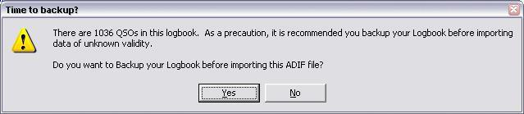

IL\_3

After Logger32 has completed the import, a popup window will open showing you the total imported QSOs and any errors that were found.

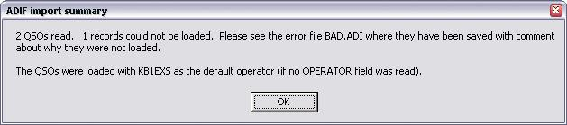

IL\_4

In this example, you can see that one QSO was found to be bad and could not be imported. Logger32 will generate a file named BAD.ADI in the Logger32 folder. You should open this file in a text editor (such as Notepad) and make any corrections needed. Save the file with a different name, and then import the newly created .ADI file.  Here is an example of the error reporting:

Error in the <QSO\_DATE:x> field ....

<CALL:5>CA1LL <QSO\_DATE:8:D>04052002 <TIME\_ON:6>230814 <MODE:3>SSB <EOR>

The ADIF standard requires the date to be in the format of YYYYMMDD, and as you can see, this record does not comply.

*Created with the Personal Edition of HelpNDoc:* [*Free Web Help generator*](http://www.helpndoc.com)

**Exporting Logs**

# B. Charles Sutton W1MCP, Jim Hargrave W5IFP and Aki Yoshida JA1NLX

## 1.0 GENERAL

Logger32 gives you the option to export your logs in three different formats. To export your log:

From the Logger32 [Main menu](#_topic_MainMenu) select the [Files | Export Logs](#2.0_FILE_MENU_ITEM) menu items, then choose the output format of your choice.

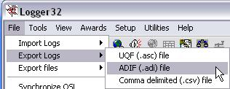

EL\_1

Logger32 will prompt you for the filename you wish to receive your exported QSO records. You can choose an existing file (doing this will overwrite all data in that file), or you can create a new file.

## 2.0 OUTPUT FORMATS

### 2.1 ADIF

Logger32 follows all the standards for exporting [ADIF](#ADIF) files, here is an example of a portion of an ADIF record:

<CALL:5>KE1EH <QSO\_DATE:8:D>20000402 <TIME\_ON:6>000016 <MODE:3>SSB <BAND:3>10M <RST\_SENT:2>59 <EOR>

After selecting the ADIF format the Export log dialog box will open with additional options:

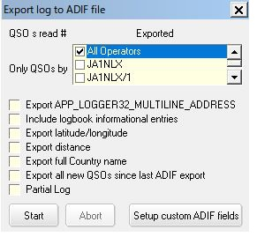

EL\_2

Select the appropriate operator(s) you wish to receive your exported QSO records, or choose "All Operators". Logger32 will allow you to select more than one operator.

**2.1.1 Include logbook informational entries**:

With this option checked, the export will include logbook entries, which were entered for information regarding propagation, SWL, etc.

**2.1.2 Export full Country name**:

If this option is checked - Logger32 will export an additional field with the full country name.

**2.1.3 Export Latitude/Longitude**:

With this option checked, Logger32 will export Latitude & Longitude data for each record using the <APP\_LOGGER32\_LAT:x> and <APP\_LOGGER32\_LNG:x> fields.

**2.1.4 Setup Personal ADIF fields.**

**2.1.4.1 Export These Fixed ADIF Fields:**

This option allows the operator to export ADIF fields or Personal defined fields. The fields must be in ADIF\_FORMAT. The desired text can be in any format. Following is an example of using this feature. Each field entered will be appended to each record exported.

**Note**: Logger32 only supports the ADIF fields listed in the Logbook setup chart. Non-standard ADIF fields can be exported, but will be ignored upon import.

Some logging facilities, notably the logger in QRZ.com as one, may require the ADIF field, STATION\_CALLSIGN as part of each record within the file.  This can be accomplished using a fixed field. This might also be useful for Field Day where all contacts are made under a single club callsign or special events where several operators participate using a club callsign.

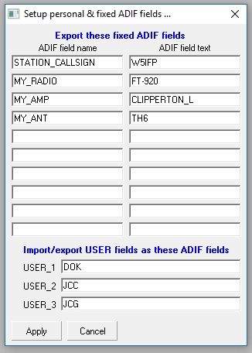

EL\_2A

The following is an excerpt of the ADIF file using the above sample.

……. <STATION\_CALLSIGN:5> W5IFP<MY\_RADIO:6>FT-920 <MY\_AMP:12>Clipperton L <MY\_ANT:4>TH-6 <EOR>

**2.1.4.2 Import/Export USER Fields as These ADIF fields**

This option allows the operator to export/import USER fields as user defined ADIF fields. Following is an exported ADIF example of using this feature. USER field data are “a”, “b” and “c” for USER\_1, USER\_2 and USER\_3 fields in this case.

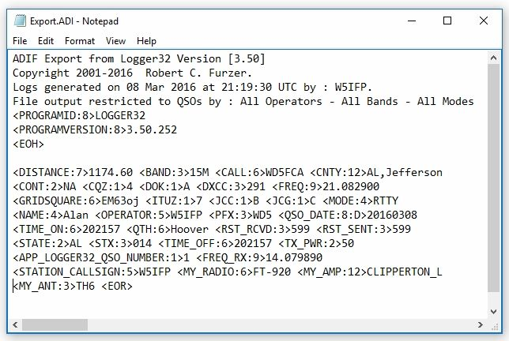

EL\_2B

### 2.1.5 Export all new QSOs since last ADIF export

The option is intended for those who periodically export new QSOs from their logbook to send to QSL Managers, or wherever.  The option is disabled to start.  Export your logbook, add new QSO, now the option will allow you to export only the new QSO.

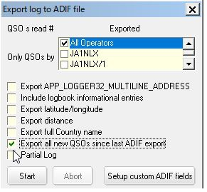

**EL\_2C**

**2.1.6 Partial Log**: [See Below](#3.0._PARTIAL_LOG)

When you click the <**Start**> button, Logger32 will begin exporting your QSOs. You can click the <**Abort**> button any time after this point to stop the export.

## 2.2 Comma Delimited (csv)

The first four lines of the [CSV](#CSV) file have details about the data it contains, the sixth line shows the field headers, and the following lines contain the QSO records. Here is an example of a portion of a CSV record:

"KE1EH","RI,KENT","","NA","","03","","291","28.305000","","","06","","","SSB","Rusty"

CSV files can be easily imported into many other programs, including Microsoft Excel. You may have to delete the first four header lines to do so in some programs.

After selecting the CSV format, the Export log dialog box will open with additional options:

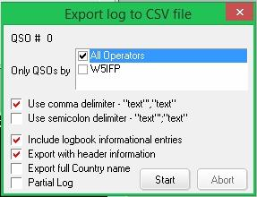

EL\_3

Select the appropriate operator(s) you wish to export QSO records for, or choose "All Operators". Logger32 will allow you to select more than one operator.

**Include logbook informational entries**: With this option checked, the export will include logbook entries which were entered for information regarding propagation, SWL, etc.

**Export full Country name**: If this option is checked - Logger32 will export an additional field with the full country name.

**Export with header information**: With this option checked, Logger32 will export the data file wth field Header information.

**Partial Log**: [See Below](#3.0._PARTIAL_LOG)

When you click the <**Start**> button, Logger32 will begin exporting your QSOs. You can click the <**Abort**> button any time after this point to stop the export.

## 2.3 UQF (asc)

This format is for limited and specific use. Only select fields are exported from the Logbook; here is an example:

CA1LL 040901 0514 80 CW 599

After selecting the [UQF](#UQF) format the Export Log dialog box will open with additional options:

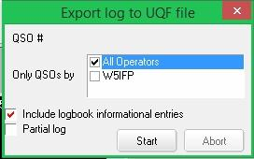

EL\_4

Select the appropriate operator(s) you wish to export QSO records for, or choose "All Operators". Logger32 will allow you to select more than one operator.

**Include logbook informational entries**: With this option checked, the export will include logbook entries which were entered for information regarding propagation, SWL, etc.

**Partial Log**: [See Below](#3.0._PARTIAL_LOG)

When you click the <**Start**> button, Logger32 will begin exporting your QSOs. You can click the <**Abort**> button any time after this point to stop the export.

## 3.0. PARTIAL LOG

Selecting this option will expand the dialog boxes shown above providing additional options allowing a partial log export based on start and end dates, specific bands and specific modes, specific callsigns and country numbers, start QSO number and end QSO numbers.The band and mode options allow multiple selections. You should run “Reformat QSO number” when you use QSO number option.

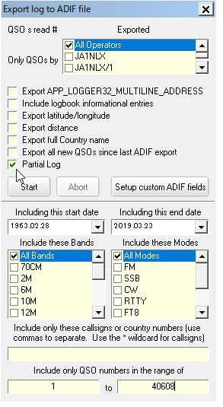

EL\_5

## 4.0 ADIF FIELD CHANGES

### 4.1 Country Field

Changes to the Country field in L32 version 3.x and up: Prior to the adoption of [ADIF](#ADIF) version 2, when you asked Logger32 to export the full country name, Logger32 would add an additional field named

APP\_LOGGER32\_COUNTRY. ADIF version 2 now allows for a full country name field, "COUNTRY", and Logger32 will now export the full country name into that field. Please be aware that if you have other software, such as a log printing program, that is expecting to find the APP\_LOGGER32\_COUNTRY field, you will need to change it to COUNTRY.

### 4.2 County (CNTY) Field

Changes to the CNTY field in L32 version 3.x and up: Logger32 allows the user considerable flexibility in setup/usage of the Primary/Secondary Admin Subdivisions. For ADIF 2.x compatibility, ADIF export/import of the CNTY field will apply to Countries that have ADIF defined Secondary Admin Subdivisions. Countries that have no ADIF defined Secondary Admin Subdivisions will be exported/Imported as APP\_LOGGER32\_CNTY.

### 4.3 State (STATE) Field

Changes to the STATE field in L32 version 3.x and up: STATE fields that are defined by ADIF (Primary Admin Subdivision) are exported/imported as <STATE:x> whereas others are exported/imported as APP\_LOGGER32\_STATE:x>

### 4.4 Mode and Sub Mode Field

When it exports mode,

a) if mode is ADIF MODE then ADIF MODE is written as <MODE>.

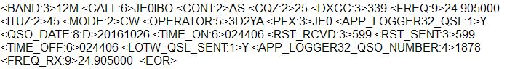

EL\_6

b) If mode is ADIF SUBMODE then corresponding ADIF MODE is written as <MODE> and ADIF SUBMODE is written as <SUBMODE>

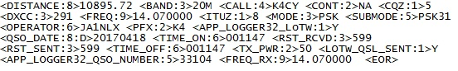

EL\_7

*Created with the Personal Edition of HelpNDoc:* [*Free CHM Help documentation generator*](http://www.helpndoc.com)

**Exporting Files**

# B. Charles Sutton W1MCP, Jim Hargrave W5IFP and Aki Yoshida JA1NLX

## 1.0 GENERAL

From the Logger 32 [Main menu](#_topic_MainMenu), select the [Tools | Export Files](#3.0_TOOLS_MENU_ITEM) option, then choose QSL, eQSL, LOTW or DXCC.

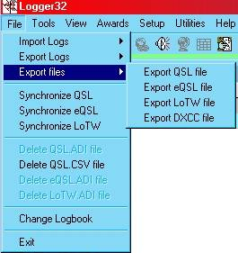

EF\_1

The Export records dialog box will open. Select the appropriate operator(s) you wish to export QSO records for, or choose "All Operators". Logger32 will allow you to select more than one operator.

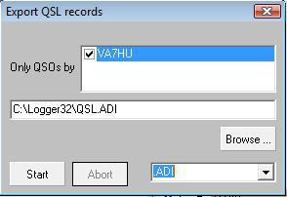

EF\_2

With the exception of DXCC files, you have the option to export an [ADIF](#ADIF) or [CSV](#CSV) file. You may also choose a CSV file with no header record. The header record contains the ADIF field names.

Select the <**Start**> button and you will be prompted for the filename you wish to use. You can choose an existing file (doing this will overwrite all data in that file), or you can create a new file.

**Note**: Once you have made a file export, Logger32 will remember the last filename/path used. This will facilitate the use of third party software for processing the QSL actions

## 2.0 FLAG OPTIONS

For QSL, eQL and LoTW files, once your QSO records have been exported, for you will be prompted for the QSL Flag options. The action taken depends on the type of export you chose.

**Note**: Only QSO records with the appropriate flag set will be exported. To see if a particular record is flagged, right-click on the record in the Logbook. You will see all three types listed, if there is a check mark before the file type, it is flagged for export.

### 2.1 eQSL records

If you choose yes to have these records flagged as having been sent, Logger32 will remove the export flag from all the records that were successfully exported.

### 2.2 QSL records

If you choose yes to have these records flagged as having been sent, Logger32 will:

* + Rremove the export flag from all the records that were successfully exported;
  + Set the QSL\_Sent field's flag to Y; and,
  + Add the current date to the QSLSDATE field.

### 2.3 LOTW records

If you choose yes to have these records flagged as having been sent, Logger32 will remove the export flag from all the records that were successfully exported.

### 2.4 CSV Records

The [CSV](#CSV) file will export two QSO dates for user discretion in QSL printing:

* + QSO\_DATE field (in YYYMMDD format) which meets the [ADIF](#ADIF) specification, and
  + APP\_LOGGER32\_QSO\_DATE in user-defined date format.

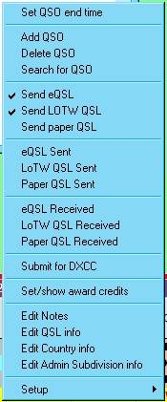

EF\_3

## 3.0 ADIF COUNTRY FIELD

Changes to the Country field in L32 version 3.x and up: Prior to the adoption of [ADIF](#ADIF) version 2, when you asked Logger32 to export the full country name, Logger32 would add an additional field named.

APP\_LOGGER32\_COUNTRY. ADIF version 2 now allows for a full country name field, "COUNTRY", and Logger32 will now export the full country name into that field. Please be aware that if you have other software, such as a log printing program, that is expecting to find the APP\_LOGGER32\_COUNTRY field, you will need to change it to COUNTRY.

Changes to the [CNTY](#CNTY) field in L32 version 3.x and up: Logger32 allows the user considerable flexibility in setup/usage of the Primary/Secondary Admin Subdivisions. For ADIF 2.x compatibility, ADIF export/import of the CNTY field will apply to countries that have ADIF defined Secondary Admin Subdivisions. Countries that have no ADIF defined Secondary Admin Subdivisions will be exported/Imported as APP\_LOGGER32\_CNTY.

Changes to the CNTY field in L32 version 3.x and up: STATE fields that are defined by ADIF (Primary Admin Subdivision) are exported/imported as <STATE:x> others are exported/imported as APP\_LOGGER32\_STATE:x>

## 4.0 ADIF MODE AND SUBMODE FIELDS

When it exports mode,

a) if mode is ADIF MODE then ADIF MODE is written as <MODE>.



EF\_4

b) If mode is ADIF SUBMODE then corresponding ADIF MODE is written as <MODE> and ADIF SUBMODE is written as <SUBMODE>



EF\_5

**Note**: Currently, eQSL does not sot support SUBMODE. eQSL exports (both the ADIF export and the eQSL dump file for the N2AMG gateway) put MODE/SUBMODE back in the original format.

*Created with the Personal Edition of HelpNDoc:* [*Single source CHM, PDF, DOC and HTML Help creation*](http://www.helpndoc.com/help-authoring-tool)

**Grid Appearance Setup**

# B. Charles Sutton W1MCP

## 1.0 GENERAL

Four windows in Logger32 are setup in a grid format. They are the:

* + [Logbook Page](#_topic_LogbookPageWindow);
  + [Previous QSOs](#_topic_PreviousQSOsWindow);
  + [Worked/Confirmed](#_topic_WorkedConfirmedWindow); and,
  + [DX Spots](#_topic_DXSpotsWindow1) windows.

Any changes in the Grid appearance will affect all four windows equally.

You access the Grid appearance menu by selecting the [View | Grid appearance](#4.0_VIEW_MENU_ITEM) menu items from the Logger32 [Main menu](#_topic_MainMenu).

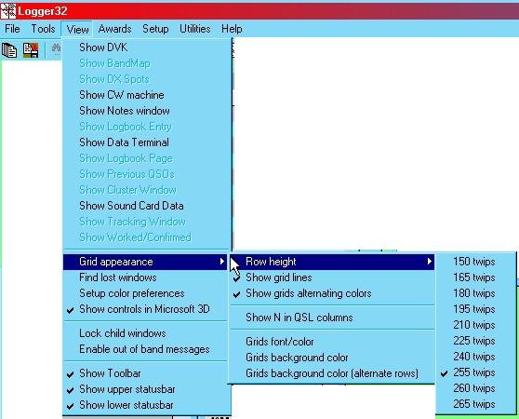

GAS\_1

### 1.1 Row Height

This menu item provides eight choices ranging from 150 to 255 pixels (twips) in height. The following examples show how you could customize the Grid appearance:

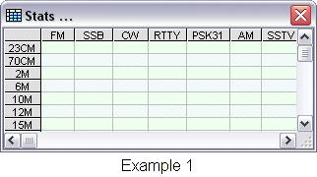 G

GAS\_2

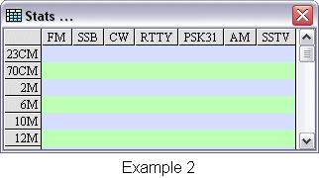

GAS\_3

### 1.2 Show grid lines

This menu item will toggle the gridlines (thin lines separating the rows and columns) on and off.  Example 1 shows gridlines on and Example 2 shows them off.

### 1.3 Show grids alternating colors

This menu item will display every the rows of data in alternating colors as shown in Example 2.

### 1.4 Show N in QSL columns

When this option is checked, the logbook will default to "N" in the six QSL columns when making a log entry. If unchecked, the six QSL columns will default to blank.

### 1.5 Grids background color

This menu item has two effects:

* + If you are not choosing to show your grid with alternating colors, this will be the background color of every row in your grid; and,
  + If you have chosen to display the grid with alternating colors, this will be the primary background color.

### 1.6 Grids background color (alternating rows)

If you have chosen to display the grid with alternating colors, this will be the secondary background color.

### 1.7 Grids font/color

This option will allow you to choose the font, size and color for the data displayed in the grid.  Example 1 is using the Arial font in 8pt type and Example 2 the Times New Roman Font in 9pt type.

### 1.8 Column Width

You can change a column's width by placing your mouse cursor in the header row between two columns, directly over the grid line (for example between FM and SSB in the examples above), the mouse cursor will change shape to two opposing arrowheads.Simply click and hold the left mouse button and drag the column to the width of your choice.  This will only change the width of the single column and will not affect columns in other grid windows.

*Created with the Personal Edition of HelpNDoc:* [*Free HTML Help documentation generator*](http://www.helpndoc.com)

**Grid Layout Setup**

# B. Charles Sutton W1MCP

## 1.0 GENERAL

The Grid Layouot of each of the following wondows can be set individually;

* + Logbook Page - Right-click on the [Logbook Page window](#9.1_Setting_up_the_Grid_and_Choosing_the_Fields_to_Display) and select the Setup | Grid Layout menu items from the pop-up menu;
  + Previous QSOs - Right-click on the Previous QSos window and select the Grid Layout menu item from the pop-up menu, or
  + Additional Information - Right-click on the Additional Information window and select the Grid Layout pop-up menu.

To open the Show column layout dialog box, This examplpe is from the Logbook Page window

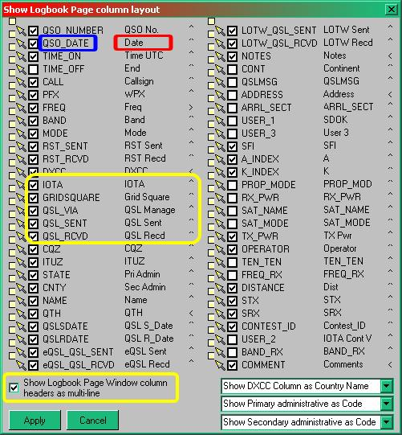

GLS\_1

## 2.0 DISPLAYING FIELDS

This is a complete list of all the fields you can display with half of the fields in the left column and the other half in the right column and corresponds to the rows from in the selected window (left to right).

The columns in dialog box are the:

* + Move Field indicators (small box and yellow arrow);
  + display field checkbox (white box with check mark);
  + [ADIF](#ADIF) Field Name;
  + Grid Column Header; and
  + Text Justification indicator (< ^ >)

To display a field from this list on the appropraite window, click on the white box to the left of the ADIF field name.  In this example some of the fields are checked and it is these fields that are displayed in the LogBook Page window.

### 2.1 ADIF Field Name

The first text column shows the ADIF field name. In the example above, the text in blue (QSO\_DATE) is an ADIF field name and cannot be changed. When importing and exporting data, these field names allow Logger32 to identify parts of your data.  Refer to the Logbook Page Window for a [list of all the ADIF fields](#19.0_ADIF_Field_Definitions) you have available along with the type of data expected in each field, and to see what fields Logger32 will automatically fill in for you.

### 2.2 Grid Column Header

The next text column shows the Grid Column Header. This is the heading at the top of each column in your window. In the example above, the text in red (Date) is a Grid Column Header and can be changed. In the example above, the column header will be displayed as Date rather then the longer QSO\_DATE. Other examples include Time On and Time Off, which were also changed from their ADIF counterpart. Please keep in mind that while you can change a column header to anything you like, it should represent the data Logger32 is expecting there. For example, you could change the QSLMSG column header to ABC Club # and you could enter ID Numbers for contacts you make with the ABC Club, BUT, when you export your logs that field will be labeled QSLMSG and other programs reading that label will expect to find a QSL Message in that field. If you have a special need for a unique data field, it is suggested you use the Notes or Comments field. If you have a special need for unique data that you would like to track in a Simple Award, it is suggested you use the USER\_1, USER\_2, and/or USER\_3 fields. If you refer to the first example at the top of this page, you will see how customizing the Grid Column Headers can look.

**Note**:  Even though you are able to change the names of the column headers, the correct ADIF field will be used during any export function. The three USER fields mentioned above will be exported in your ADIF exports as <APP\_LOGGER32\_USER\_1:9>some data.

### 2.3 Text Algnment Indicator

The last column shows a symbol that represents the alignment of the data in that column.  "<" indicates left-justified, "^" indicates centered and ">" indicates right-justified.  To change the alignment of a column, right-click on the symbol and choose from the three options or simply overtype the symbol. In the screenshot shown above there are examples of each type of justification option.

### 2.4 Multi-Line Display

The logbook column header can display in a multi-line format. The setup selection enclosed in the yellow line above will be displayed as shown below IF the multi-line option is selected AND the column width in the log is set as appropriate.

**Note**: Header names with an underscore will not word wrap. As in the [example above](#Show_column_layout_dialog_box): "QSL\_SENT" is changed to "QSL Sent" and GRIDSQUARE is changed to two words: "GRID Square". With these changes the headers will now word wrap when multi-line format is selected.

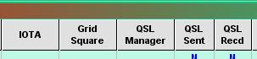

GLS\_2

## 3.0 REARANGING COLUMNS

Rearranging the order in which the columns will be displayed is a little tricky and may take a few attempts to get the hang of it. The top left header is the first column displayed in your page and the bottom right header is the last column displayed. To move a column left, click on the yellow arrow to the left of the field name you wish to move and hold the mouse button down.  Drag that arrow to the appropriate small white box and release the mouse.  Notice that the white boxes are positioned offset between two field names, releasing the mouse will move that field to a position between those two fields.  For example, if you wanted to move the BAND\_RX field to a position after the ADDRESS field, you would left-click and hold on the arrow to the left of BAND\_RX (shown above in red), then drag the field to the box between ADDRESS and AGE (shown above in green) and release the mouse.

**Note**:  If you make a mistake, choose <**Cancel**> and the changes will not be applied as changes are only applied when you select <**OK**>.  Bear in mind that if you make 5 changes, and then select <**Cancel**>, all five changes will be lost.

## 4.0 FIELD DISPLAY OPTIONS

There are three choices at the bottom of the window that allow you to control how some data will appear in your Logbook:

* + The first box gives you three choices for how the data is shown in the DXCC column:

Show DXCC Column as ADIF DXCC #;

Show DXCC Column as Country Name; and,

Show DXCC Column as ARRL Prefix

* + The second box gives you two options for displaying the Primary Administrative field, either byName or by Code;
  + The third box gives you two options for displaying the Secondary Administrative field, either by Name or by Code; and
  + Regardless of your choices above, all ADIF file exports will contain the code.

*Created with the Personal Edition of HelpNDoc:* [*Easily create iPhone documentation*](http://www.helpndoc.com/feature-tour/iphone-website-generation)

**Callsign Lookup**

# Geoff Anderson G3NPA, Jim Hargrave W5IFP and Rick Ellison N2AMG

## 1.0 GENERAL

Logger32 offers the user several ways in which to look up information about the QSO partner by:

* + [Using a call book CDROM](#2.0_Using_a_Local_CDROM) in a local drive to establish QTH information
  + [Using an internet-based call book](#3.0_Using_an_Internet_Database ) to establish QTH information
  + [Using a local database to establish QSL Manager](#6.0_GoList) information.
  + [Using a user- specified URL to return ADI formatted data](#7.0_Generic_On-Line_Lookup.).

Logger32 supports the QRZ Hamcall and RAC CDROMS, contains a sample QSL manager database from GoList, and supports internet access to QRZ.com, Hamcall.net and GoList.net. Information from these sources can be obtained either manually or automatically and the data obtained from the call book databases can be used in a variety of ways to automatically update the [Logbook Entry window](#_topic_LogbookEntryWindow).

**Note**: QRZ.com-XML Feed,Hamcall.net, and GoList.net are all subscription services requiring passwords. Details of these services can be obtained from those sites (see [Links and Reflectors](#_topic_LinksandReflectors))

**IMPORTANT NOTES:**

You should be able to send eMail by clicking on an eMail address (if shown) in the Callsign lookup dialog box.

If the Lookup returns a URL it will be shown as a functional website link (blue text with underscore).

Logger32 does NOT provide Internet lookup capability to QRZ.com or Hamcall.net. Those wishing to access these services must use third party (non Logger32) modules.

Since its inception, Logger32 has accessed QRZ.com through an external module (not part of Logger32 but written by the same author) called QRZLookup.exe. and the collected information has been forwarded to a routine within Logger32 to display the results. Data was provided by QRZ.com in a high throughput proprietary format that was free from advertising. The policies of QRZ.com have changed and the direct data feed for Logger32 is no longer available. The QRZLookup.exe module no longer works, and has been removed from the distribution package. This file together with QRZ.txt, is no longer used and can be deleted from the default Logger32 directory. However the display window remains as part of Logger32 and can be filled with data via the external interface.

From release 3.35.0 forward, Logger32 provide Internet lookup service from HamQTH. Setup for this capability is covered in paragraph 8 below.

2.0 Using a Local CDROM

### 2.1 Manual Method

Using the Logger32 [Setup menu](#_topic_SetupMenu), select the CDRom menu item and the appropriate CDROM type.

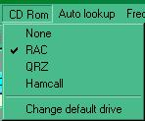

CSL\_1

Initially Logger32 expects the CDROM to be in the first CDROM drive on the computer. If necessary, you can set the default drive for the CDROM to any drive letter from the above menu. For details on how to set up CDROM data on a HDD for faster access, please refer to the [Setup CDROM topic](#_topic_SetupCDROM).

To display the data, on the Logger32 [Toolbar](#_topic_ToolBar) select the CD ROM Lookup icon to open the Callsign Lookup dialog box:

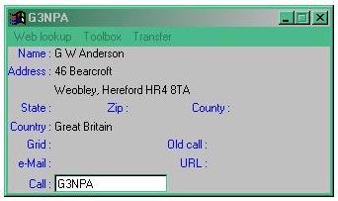

CSL\_2

Enter the callsign into the Call edit box and press the <**Enter**> key, if the call is found on the CD ROM, the data for that callsign will be displayed.

All similar windows have Toolbox and Transfer menu options. The Toolbox menu item enables the selection of data and label font/color and background color. The Transfer menu item is described in section [5.0 Automatic transfer of QTH data to Log Input Window](#5.0_Automatic_transfer_of_QTH_data_to_Log_Input_Window).

### 2.2 Automatic method

Logger32 can be configured to do an automatic lookup from the CDROM by selecting the Logger32 [Setup menu](#_topic_SetupMenu) Auto Lookup | Auto CD-ROM Lookup menu items.

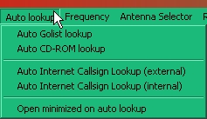

CSL\_3

Entering a callsign in the [Logbook Entry window](#_topic_LogbookEntryWindow) and on leaving the Call edit box the [Callsign Lookup dialog box](#Callsign_Lookup_Dialog_Box) will automatically open and display data for that callsign.

## 3.0 Using an Internet Database

Logger32 provides capability to do callsign lookups from internet-based databases by use of external modules written for specific sites. These external modules are available on the [Logger32 web site](#Links:_Logger32_Website) on the Support page.

Current lookup modules are available for:the QRZ XML Lookup Database, QRZ Web Interface, and Hamcall.net.

The QRZ XML Lookup Database Module is included and configured when Logger32 is installed and requires a subscription to QRZ.com.

Sample source code of a non-functional (it doesn't go anywhere or retrieve any data) external internet Callsign Lookup module is available at the [Logger32 website](#Links:_Logger32_Website) on the Support page. Programmers can use this as a skeleton to access whatever database they choose.

### 3.1 Installing Internet Based Lookup Modules

To install a third-party lookup module:

* 1. Download the Lookup module from the internet;
  2. Unzip the files in the downloaded zip file into the Logger32 directory;
  3. On the Logger32 Tool bar, select the Internet callsign lookup icon;

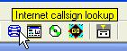

CSL\_15

* 1. From the menu of the Online lookup dialog box, select the Toolbox menu item;

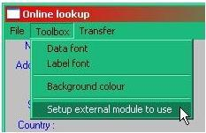

CSL\_13

5. Select the Setup external module to use menu item to open the Setup Internet callsign lookup dialog box. Logger32 provides the capability to configure up to five different lookup modules. The "Use" radio button needs to be selected to enable the lookup you want to use.

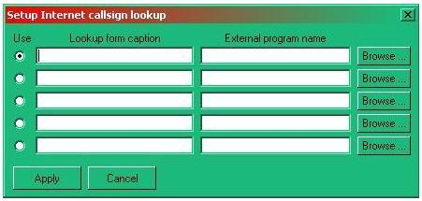

CSL\_14

6. Select the <**Browse**> button and search for the file you downloaded and unzipped in the Logger32 directory. This will save the path information to the Lookup application you are installing in the External program name edit box;

7. In the "Lookup form caption" edit box, enter the name you want to call the lookup module. This name will appear on the top of the Callsign Lookup dialog box.

8.Select the <**Apply**> button to save the new configuration.

### 3.2 Using an Internet Database

### 3.2.1 Manual method

To access the Callsign Lookup dialog box manually, on the Logger32 Toolbar Select the Internet Callsign Lookup icon to produce the Callsign Lookup dialog box. Enter the callsign and press the <**Enter**> key. The lookup module will open, retrieve the data and display it in the Callsign Lookup dialog box. If the data is not retrieved, there will be indication on the top of the window saying the information can't be found. Note: You MUST be connected to the internet for this to work.

### 3.2.2 Automatic method

If you wish an automated lookup from the web, then in addition to the settings detailed above, also check the Logger32 [Setup menu](#_topic_SetupMenu) Auto Lookup | Auto Internet Callsign Lookup (external) menu items.

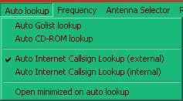

CSL\_6

Entering a callsign in the [Logbook Entry window](#_topic_LogbookEntryWindow) and leaving the Call edit box will automatically display the Callsign Lookup dialog box and fill it with data for that callsign.

## 4.0 Minimized display

If you wish to run the QSL information windows in a minimized state rather than have them clutter up the screen, then select the Logger32 [Setup menu](#_topic_SetupMenu) Auto lookup | Open minimized menu items.

## 5.0 Automatic transfer of QTH data to Log Input Window

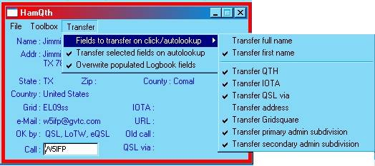

CSL\_7

Logger32 can be set up to automatically transfer information directly into the [Logbook Entry window](#_topic_LogbookEntryWindow). In the Callsign Lookup dialog box, click on the Transfer menu item and set the desired option(s).

**Note**: QRZ, Hamcall and the CDROM lookups have their own dialog boxes and therefore different options may be set up for each.

If no automatic transfer options are selected, then you can click on individual fields of the display to transfer just one particular piece of information.

Transferring of more precise position data (like US county or Gridsquare information) from a Callsign lookup dialog box to the [Logbook Entry window](#_topic_LogbookEntryWindow) will update the heading/distance information.

## 6.0 GoList

Like the CDROM and QRZ.com lookup for obtaining individual QTH data, Logger32 also has the ability to search for QSL manager information using the GoList database. There is a built-in database that was current when Logger32 was first released, However you are reminded that this will quickly go out of date.

Subscribers have unlimited lookups for a year. More information may be found on the GoList web site or (assuming that you are already connected to the Internet) click on Web lookup to collect from the GoList database.

### 6.1 GoList - Manual

To obtain the QSL manager information, enter the station callsign into the [Logbook Entry window](#_topic_LogbookEntryWindow), then select the GoList icon.

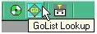

CSL\_8

Alternatively, click on the icon first, enter the callsign and either press the <**Enter**>key to get the information from the local source.

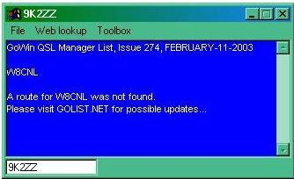

CSL\_9

### 6.2 GoList - Automatic

While the button that used to perform the on-line 'GoList' lookup still looks the same, the functionality has changed. The on-line 'GoList' lookup functionality has been removed. The 'Golist' local database lookup is as before, and those users who wish to do on-line 'GoList' lookups can invoke a local lookup and click the menu to do an on-line lookup.

## 7.0 Generic On-Line Lookup.

The original GoList auto lookup facility has been changed to a more general generic lookup facility. The use of the facility is very much the same as the other lookup options described above except that the user can set up their desired URL

The button that was previously used for on-line 'GoList' lookup now invokes a generic on-line query. The user programs their URL, and waits to receive an [ADIF](#ADIF) formatted reply.

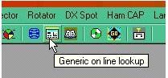

CSL\_10

Logger32 defaults to HamQTH.

HamQTH.com has now added an ADIF lookup that Logger32 can access directly (the button between the Internet lookup [QRZ.com] and [CD ROM Lookup] is used to access this capability.

To access HamQTH directly from Logger32, you must first register with HamQTH:

Go to <http://hamqth.com/login.php> and click on the register link to register with HamQTH . You must provide a USERNAME and PASSWORD.

Next, open the internal lookup window.and select the "Toolbox | Change lookup URL" menu items.

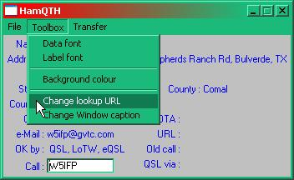

CSL\_11

and set the URL to:

http://hamqth.com/adif.php?u=USERNAME&p=PASSWORD&callsign=CALLSIGN&prg=LOGGER32.

**Note**: Substitute your HamQTH username for USERNAME and substitute your password for PASSWORD. The URL will should look something like this (example username is BWANA, and example password is MAKUBA):

http://hamqth.com/adif.php?u=BWANA&p=MAKUBA&callsign=CALLSIGN&prg=LOGGER32

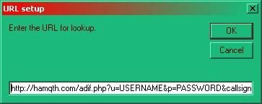

CSL\_11A

It is envisaged that initial implementations will be for simple QSL Manager data retrieval, so the window presented is adequate.  If and when more complex sets of data are returned, the capabilities of the window will be enhanced to include user-defined field mapping. Replies must be in ADI format.

To change the window caption, select the Toolbox | Change Window caption menu items.

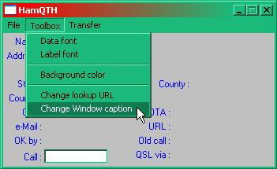

CSL\_11B

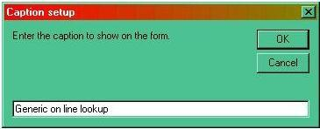

CSL\_12

As well as defining the window title, the same words are used for the icon tooltip (see [CSL\_10](#CSL_10) above)

*Created with the Personal Edition of HelpNDoc:* [*Easy to use tool to create HTML Help files and Help web sites*](http://www.helpndoc.com/help-authoring-tool)

**Flag QSOs for QSLing**

# Geoff Anderson G3NPA

## 1.0 GENERAL

If you wish to automatically flag your QSOs for QSLing, then this may be setup using the [Setup menu](#Setup_Menu) from the [Logbook Entry window](#_topic_LogbookEntryWindow).

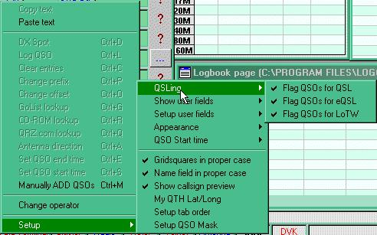

FQFQ\_1

If you have the Logger32 [Setup menu](#_topic_SetupMenu) "Highlight |/Highlight|QSL to be printed" menu item selected then you will immediately see this reflected in the log once any QSO is entered. However this flag applies to all three QSL options. If you have more than one Flag option selected, individual options are not immediately recognizable. However, a left-click on a QSO in the Logbook Page window will indicate the flag status for each option.

## 2.0 FLAG QSOs FOR QSL

If this menu item is selected. any QSO entered into the [Logbook Entry Window](#_topic_LogbookEntryWindow) will be flagged for export to the [QSL file](#2.2_QSL_records).

## 3.0 FLAG QSOs FPR eQSL

If this menu item is selected, any QSO entered into the [Logbook Entry window](#_topic_LogbookEntryWindow) will be flagged for export to the [eQSL file](#2.1_eQSL_records).

## 4.0 FLAG QSOs FOR LoTW

If this menu item is selected, any QSO entered into the [Logbook Entry window](#_topic_LogbookEntryWindow) will be flagged for export to the [LoTW file](#2.3_LOTW_records).

*Created with the Personal Edition of HelpNDoc:* [*Full-featured multi-format Help generator*](http://www.helpndoc.com/help-authoring-tool)

**QSL File Creation**

# Geoff Anderson G3NPA

## 1.0 GENERAL

QSL Files can be created by selecting the Logger32 [Main meu](#_topic_MainMenu) [Files | Export Files](#2.0_FILE_MENU_ITEM) menu items.

## 2.0 eQSL FILES

The [eQSL](#eQSL) file is a standard [ADIF](#ADIF) (.adi) file and is created by selecting the Logger32 [Main menu](#_topic_MainMenu) [Files | Export Files | Export eQSL file](#2.0_FILE_MENU_ITEM) menu items.

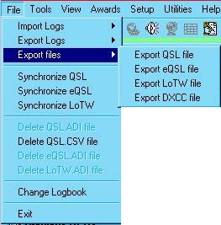

QFC\_1

to open the Export eQSL records dialog box.

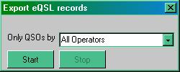

QFC\_2

Select the appropriate operator(s) and the <**Start**> button.

**Note**: If there are no appropriate QSOs flagged in the log, a message to that effect will be displayed and the operation will terminate.

Either select a file name from those presented OR type in a new file name and select the <**OK**> button;

Respond to the appropriate prompt to either:

* + Create a new file;
  + Replace or Append to the existing file; or,
  + Cancel the file creation activity.

If you do not "Cancel", at the end of file creation you will be presented with a message that "nnn QSOs have been copied into the eQSL file. Do you want to flag these QSOs as having been sent to eQSL Yes/No?". Answer this prompt appropriately.

Logger32 will now have created the eQSL file ready for uploading to eQSL.

## 3.0 LoTW FILES

The [LoTW](#LoTW) file is a standard [ADIF](#ADIF) (.adi) file. To save an LoTW file select the Logger32 [Main menu](#_topic_MainMenu) [Files | Export Files | Export LoTW file](#2.0_FILE_MENU_ITEM) menu items.



QFC\_3

to open the Export LoTW records dialog Box

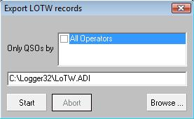

QFC\_4

Select an Operator from the Operator combo box and select the <**Start**> button.

Either select a file name from those presented OR type in a new file name and select the <**OK**> button.

Select one of the three options to replace the file, to append to the existing file or Cancel.

You are then advised that XX QSOs have been copied into the LoTW file. Do you want to flag these QSO as having been sent to the LoTW Yes/No?

I you select the <**Yes**> button the LoTW file will be created.

If there are no appropriate QSOs flagged in the log, a message to that effect will be displayed.

## 4.0 QSL FILES

To save a QSL file, select the Logger32 [Main menu](#_topic_MainMenu) [Files | Export Files | Export QSL file](#2.0_FILE_MENU_ITEM) menu items.

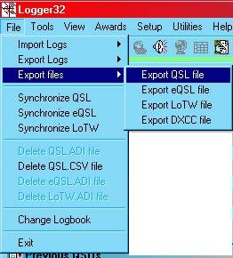

QFC\_5

to display the Export QSL records dialog box.

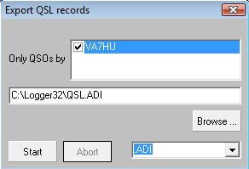

QFC\_6

Select an Operator from the Operator combo box and the type of file you wish to produce from the drop-down list. there are three types are available;

* + [ADI](#ADIF),
  + [CSV](#CSV) or
  + CSV without header lines.

The CSV type file is useful if you wish to import the data into a spreadsheet like Excel and the CSV without header can be used as a Mail Merge source in Microsoft Word for the generation of QSL labels.

Select the <**Start**> button.

Either select a file name from those presented OR type in a new file name and select the <**OK**> button.

Select one of the three options to replace the file, to append to the existing file or Cancel

You are then advised that nnn QSOs have been copied into the QSL file. Do you want to flag these QSOs as having been sent to QSL Yes/No?

If yoou select the <**Yes**> button, Logger32 will create the appropriate file.

If there are no appropriate QSOs flagged in the log, a message to that effect will be displayed.

## 5.0 DXCC FILES

For additional details on use and export of the [DXCC](#DXCC) files see the [Flagging and exporting QSL Award files](#3.2_Flagging_and_Exporting_QSL_Award_files.) section In the [Award Tracking Topic](#_topic_AwardTracking1).

To create a DXCC file. select the Logger32 [Main menu](#_topic_MainMenu) [Files | Export Files | Export DXCC file menu](#2.0_FILE_MENU_ITEM) items.

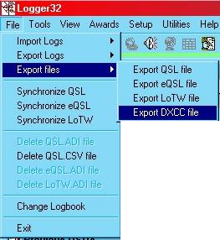

QFC\_7

to display the Export DXCCC records dialog box

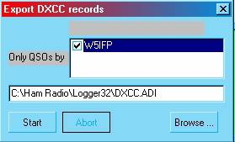

QFC\_8

\

Select an Operator from the Operator combo box and either select a file name from those presented OR type in a new file name from the file name edit box.

Select the <**Start**> button to displpay the File Exists message.

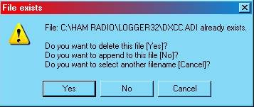

QFC\_9

Select one of the three options to replace the file, to append to the existing file or Cancel

You will be advised that nnn QSOs have been copied into the DXCC file. And you will be presented with two questions to check as appropriate.

* + Check to delete the DXCC Export flags.
  + Check to flag these QSOs as having been submitted for DXCC credit.

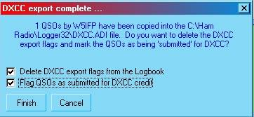

QFC\_10

Select the <**Finish**> button and Logger32 will create the DXCC file.

If there are no appropriate QSOs flagged in the log, a message to that effect will be displayed.

*Created with the Personal Edition of HelpNDoc:* [*Generate Kindle eBooks with ease*](http://www.helpndoc.com/feature-tour/create-ebooks-for-amazon-kindle)

**Logbook Informational Entries**

# Bud Hippisley W2RU

Beginning with Logger32 version 2.4, logging of information other than completed contacts is possible. These "pseudo-contacts" are created by terminating any character string in the [Logbook Entry window](#_topic_LogbookEntryWindow) or [Logbook Page window](#_topic_LogbookPageWindow) Call field with a single "equal sign" (=).  When used in conjunction with a display of the [Previous QSOs window](#_topic_PreviousQSOsWindow), information entries can be a very helpful tool. Here are some examples of uses for this feature:

* + To log periods of calling CQ or unsuccessfully calling a DX station. You might do this, for instance, to keep track of when you were on the air in case you are in the habit of receiving spurious TVI complaints from your neighbors. Simply enter "CQ= in the Callsign field of the [Logbook Entry window](#_topic_LogbookEntryWindow), along with your frequency, output power, antenna used, time on and time off, or any other information you wish to retain in other fields.  (You could do the same thing without the "=" but that would mess up your DXCC records by crediting you with an apparent contact with some country you didn't actually contact!)
  + To keep a record of a contact with a station you suspect may have been a "pirate". If you're proved wrong and eventually a valid QSL comes through, so much the better, but in the meantime you can continue to show award statistics for that band-country as if you had never worked the questionable station because "=" entries do not result in changes to the various awards databases.
  + To collect information about a station before you actually succeed in working it. It is not uncommon on the low bands to try for many nights to work a DXpedition before getting through, and many operators try to improve their chances by recording the exact times of each day's openings to the DXpedition, the frequencies used by the group, etc. See the example below for one way to use these entries when DXing.
  + To keep a record of changes to your station or antenna farm. Simply enter your own call (or H0SE or another call of your choice) followed by the = and type in the Comments and other fields as appropriate.
  + To temporarily log a callsign you're unsure of, until you confirm the actual call.
  + To keep a record of WWV propagation numbers without creating false USA contacts.

Once entered, these information entries become a part of your log, just like real contacts. Just like real contacts, they can be deleted and edited, and they will form part of the printout of your total log or station record. If you don't want them to print, you can always use Excel or another program to remove them.

**Note** that information entries (=) are not the same as the "not valid for DXCC credit" (\*\*) entries. The latter are real contacts that for one reason or another (maritime mobile operation, date of QSO, failure to gain ARRL DXCC Desk credit, etc.) should not be submitted to ARRL for DXCC or WAS credit but retain their validity in all other respects. They may well be eligible for submission against any of the other awards tracked by Logger32. In contrast, the magic of "=" entries is that they do not contribute to the statistics for any of the awards tracked by Logger32.  Because of that, it is possible to store or park, for future reference, awards information (CQ Zone, USA State or County, IOTA number, Grid Square, et al.) for a given station in any or all of the relevant awards fields for these logbook entries without the stored information altering the calculated award statistics in any way whatsoever.

Because the = is a lower case symbol that can be typed with one finger and because it is adjacent to the <Backspace> key on virtually all PC keyboards, it is easy with a very slight motion of a single finger to alternate the contents of the Logbook Entry Call field between, say, "FT5XO" and "FT5XO=".  Doing this causes the contents of the Previous QSOs window to instantly switch from real QSOs with FT5XO to information entries for that station, and back again.  Here's how you might use this in practice:

The figure below shows a section of W2RU's log for the last week of the March, 2005 FT5XO DXpedition.  Note that FT5XO has been typed into the Call field of the Logbook Entry window. In response, the Previous QSOs window lists all the contacts W2RU made with "FT5XO" through March 26.  Also notice that the drop down window beneath the Callsign field in the [Logbook Entry window](#_topic_LogbookEntryWindow) is indicating by the presence of the "FT5XO=" character string that W2RU?s logbook contains one or more information entries for FT5XO.

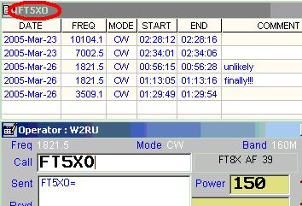

LIW\_1

Now add an "=: after the call in the [Logbook Entry window](#_topic_LogbookEntryWindow) Callsign field.  Observe in the following figure that the [Previous QSOs window](#_topic_PreviousQSOsWindow) now contains only information and incomplete QSO entries from the W2RU log.  By viewing this pane W2RU can see, for instance, what hours FT5XO was audible at his QTH on previous days, what receiving antennas worked best, and even when W7LR, who was very close to the antipode for FT5XO, succeeded in working them.

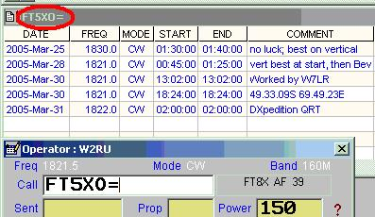

LIW\_2

Once you become accustomed to having this feature available in Logger32, you will probably find many more uses for it than have been suggested here.

*Created with the Personal Edition of HelpNDoc:* [*Write EPub books for the iPad*](http://www.helpndoc.com/create-epub-ebooks)

**Using Logbooks**

# Geoff Anderson G3NPA

## 1.0 GENERAL

The logbook in Logger32 is a multi-user and/or a multi-log system that can be used or set up in an almost endless variety different ways. It should be made clear at this stage that the logbook databases are written for a single user only but the user name can change. The use of the term multi user does NOT imply multi concurrent use where several users can access the database at the same time. It is simply one user at a time.

The Log can be set up as a single logbook with a single or multiple users. For example one can have one log file named "General Log" (or possibly just a single callsign) with just one operator entering details as might be the case for the basic at home use or the same logbook with entries from multiple operators as might be the case for a Club logbook where the operator name would change according to who is using the log at the time.

Or a Log can be set up as a multiple series of logbooks for either a single user or multiple users. For example a single operator may wish to keep separate logs for contests or for contacts made over some specific period of time. So one might generate logs with the names "IOTA\_2011" or possibly "QSOs 2010-11". These could also be multi-operator logs if required.

The basic set up for the recording of data is very flexible.

It is very easy to swap between logbooks using the Logger32 [Manu menu](#_topic_MainMenu) [File | Change Logbook](#2.0_FILE_MENU_ITEM) menu items, but remember always to ensure that you are using the appropriate "Operator" when recording data.

It should be noted that there is only ONE set of Stats files generated no matter how many logs are in use. Should there be a need to delete the Stats files for ANY reason then ALL logbooks in use will need to have the "Recalc Statistics" function run on them if you need to see any awards details for any one of them.

## 2.0  ADVANTAGES AND DISADVANTAGES

As is always the case with anything that is designed to try to satisfy as many users as possible, there will advantages and disadvantages in the logbook system selected.

### 2.1 Single Logbook

In the case of the single logbook/single operator then everything is straight forward and there should not be any obvious problems when checking awards stats. Along the base of every award window is a series of combo boxes that allow for the selection of various filters to be use when displaying the data from the logbook. One of these boxes is for the selection of the "Operator". In the case of the single log/single operator, then this choice is obvious (and restricted).

In the case of single logbook/multiple operator then the choice of "Operator" filter becomes important. If "All Operators" is selected then the stats produced (for whatever awards table is on view) will be for the whole log. If a specified operator is selected in the filters then the award table will show the stats pertinent to that one operator selection. So taking an actual example for DXCC.

The log in the example has entries from three operators - G3NPA, G4ZA and GQ3NPA. Using the Operator filter of All, G3NPA, G4ZA and GQ3NPA you can see below the different results

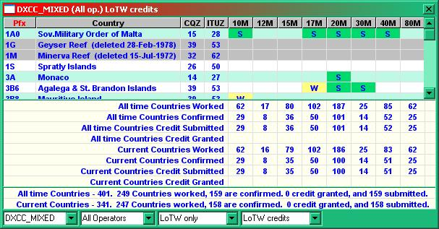

UL\_1

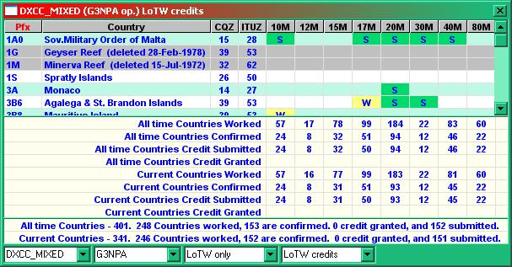

UL\_2

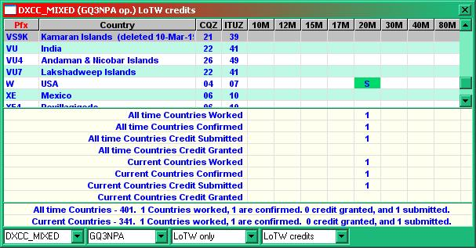

UL\_4

The advantage of this is that information for each operator may be found quickly and the whole logbook is scanned.

The disadvantage of this method is that there is no inbuilt way that stats ranging over a date range can be produced by a simple click of the mouse.

### 2.2 Multiple logbooks

If the user wants to be able to determine stats over a specified period of time then the best initial approach is to set up logbooks for each time period giving each an appropriate name such as "Log 2000-2001" or for a new callsign signifying the change of callsign. This approach will give stats over the required date range only.

The disadvantage of this is the fact that this same date range will also apply to stats like DXCC which have no time limitations (unless the user wants it that way).

### 2.3 Suggestions

It is possible to generate time related multiple logs from a single/multiple user log if required. When saving an ADIF copy of a log there is an option to output a partial log created by a specified operator over a selectable date range with the additional filter option for band and mode.

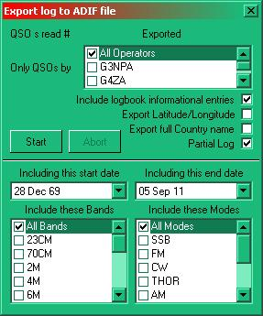

UL\_5

It is therefore possible to extract highly specific QSO data which might be for a particular year or for a favorite contest etc into individual files/logs. These files may be re-entered into separately named logbooks and the stats for that logbook displayed.

## 3.0 OTHER CONSIDERATIONS

Don't be afraid of generating more logbooks as the need arises for to do so can be a VERY useful tool from the trying out of actions that you may wish to perform on your logbook that you are not too sure about, to the testing or confirmation of some strange happening that you may wish to report. If you are worried about what might happen to your precious log if you perform a synchronization with [LotW](#LoTW) then simply try it out first using a test logbook created just for this purpose.

The generation of a new and blank log is easy. Simply use the Logger32 [Main menu](#_topic_MainMenu) [File | Change Logbook](#2.0_FILE_MENU_ITEM) menu items and create a new log with a new (and unique) name such as Testlog or whatever might be appropriate. Please note that it is highly recommended that when generating these logs you do so into a folder which is specifically for test logs, thus separating them from your main log. It is also a foregone assumption that you will have made appropriate backups from your main logbook.

Into this new log you can now load whatever you like. For example, you could load a copy of the [ADIF](#ADIF) file generated from your working log, thus making a copy for test purposes. Into this copy log you can now load whatever you like or work on it to test out what you may wish to do to the main log to see what happens. If disaster strikes then NOTHING is lost for you still have your original log available just a couple of mouse clicks away simply by changing logs back to the original.

The test log can also be used to check out the action of Logger32. Into an empty test log one can enter a series of dummy QSOs on different frequencies/bands/modes/operators etc or take part of a known good log and test away in the knowledge that whatever you do the main log will not be effected in any way.

These "test" logs will of course generate four files for each logbook, each bearing the name you gave to the log in the first place plus the extensions of .ISD, .ISM, .ISL and .ISM. If no longer required these can be deleted at any time. If you have done as recommended above, these will be in a separate folder away from your main logs.

This ranges from simply seeing what happens if you perform some action like the loading of more data or perhaps the syncing of the log to [LotW](#LoTW)

## 4.0 CONCLUSIONS

It can be seen that Logger32 is very comprehensive and flexible but it can also be complex. The complexity of the log system is entirely dependent on the user and it is for him/her to have carefully considered how they wish logger32 to function in this regard. The beauty of the system however is that however one starts and then wishes to continue it is almost always possible to make the changes (with a bit of careful thought)..

*Created with the Personal Edition of HelpNDoc:* [*Free Qt Help documentation generator*](http://www.helpndoc.com)

**LoTW Configuration**

*Created with the Personal Edition of HelpNDoc:* [*Easily create EBooks*](http://www.helpndoc.com/feature-tour)

**Satellite LoTW**

# Grant Mitchell  N4GM

If you are entering a Satellite QSO there are some additional fields that should be filled in for LoTW.  You can use the [Grid Layout Setup](#_topic_GridLayoutSetup) to select and add these fields (columns) to your logbook page.

SAT\_MODE, SAT\_NAME, PROP\_MODE, BAND\_RX, FREQ\_RX

All entries in these fields must be in CAPITAL letters.  This is required by LoTW and their TQSL file conversion program.

LoTW uses the BAND information field to match satellite QSOs so you must enter the TRANSMIT frequency and band in the FREQ and BAND columns. This is important as most satellite QSOs are crossband.  Use the FREQ\_RX and BAND\_RX columns to enter the RECEIVE information.

Here is an example of a correctly filled-in logbook page for satellite QSOs

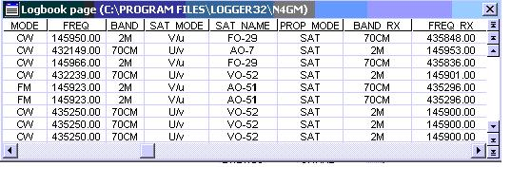

SL\_1

*Created with the Personal Edition of HelpNDoc:* [*Free help authoring environment*](http://www.helpndoc.com/help-authoring-tool)

**Logbook Synchronization**

*Created with the Personal Edition of HelpNDoc:* [*Free PDF documentation generator*](http://www.helpndoc.com)

**eQSL Synchronization**

# Geoff Anderson G3NPA

1.0 DOWNLOADING FROM eQSL

Go to [https://www.eqsl.cc/QSLCard/DownloadADIF.cfm to download files from eQSL.](https://www.eqsl.cc/QSLCard/DownloadADIF.cfm)

Either method will take you to this page:

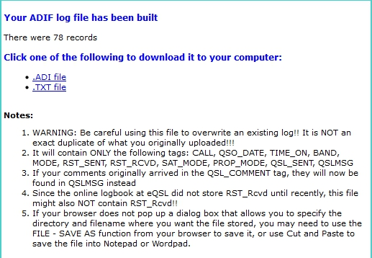

ES\_1

The file will look like this:

ADIF 3 Export from eQSL.cc

For JA1NLX

Generated on Thursday, July 20, 2017 at 22:35:42 PM UTC

<PROGRAMID:20>eQSL.cc DownloadADIF

<ADIF\_Ver:5>3.0.4

<EOH>

<CALL:4>NX5M<QSO\_DATE:8:D>19981212<TIME\_ON:4>0025<BAND:3>10m<MODE:2>CW<RST\_SENT:3>599<QSL\_SENT:1>Y<QSL\_SENT\_VIA:1>E<QSLMSG:7>Thanks!<EOR>

<CALL:5>F6IRG<QSO\_DATE:8:D>19991107<TIME\_ON:4>0841<BAND:3>10m<MODE:3>PSK<SUBMODE:5>PSK31<RST\_SENT:3>599<QSL\_SENT:1>Y<QSL\_SENT\_VIA:1>E<QSLMSG:7>Thanks!<EOR>

## 2.0 SYNCHRONIZING LOGGER32

In Logger32 [Main menu](#_topic_MainMenu) select the [File| Synchronize to eQSL menu](#2.0_FILE_MENU_ITEM) items and select the required file.

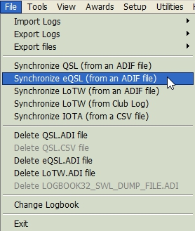

ES\_2

When the file has been loaded,the eQSL Synch dialog box.will be displayed. Select the <**Start**> button and you're off. All eQSL matches will be changed from a blank in the eQSL\_RCVD column of the logbook to a Y.

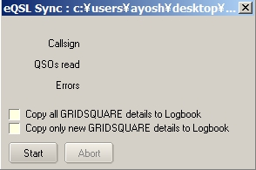

 ES\_3

A valid eQSL ADIF file must have <PROGRAMID:20> field in the header (or it will be rejected). A search +/- 10 minutes of the QSO TIME\_ON is done. If a QSO with the same callsign, same band, and same mode is found, and the eQSL\_SENT field is Y, then it is assumed this is the correct QSO and the eQSL\_RCVD field is set to Y.

As a reminder (as with the LoTW\_SENT and LoTW\_RCVD fields), the eQSL\_SENT and eQSL\_RCVD fields used in Logger32 are non-standard ADIF fields and probably will not be recognized by other software.

**Notes**:

QSL don't seem to do any validation on the GRIDSQUARE, IOTA and STATE, CNTY fields, but Logger32 checks these fields for validity during synchronization (and puts the invalid ones in the BAD.ADI file).

If Logger produces a BAD.ADI file, then check:

* + 1) The DATE/TIMES of the QSOs.  It MUST be within +/- 10 minutes of what appears in your log - the fields in the format:
  + <QSO\_DATE:8>20031023   <TIME\_ON:6>004956
  + 2) IOTA field should be of the format xx-nnn. I suspect that the ADIF file received is without the dash, for example <IOTA:6>NA-033
  + 3) Grid information must be of the format XXnn or XXnnxx. For example <GRIDSQUARE:6>FM72nd or <GRIDSQUARE:4>FM72

eQSL sync looks for a QSO in the logbook that matches (Call, Band, Mode and Time). To allow for clock variations, if it does not find an exact time match, it searches the logbook for a matching QSO with a Time within +/- 30 minutes of the Time listed in the eQSL sync file.

*Created with the Personal Edition of HelpNDoc:* [*Create help files for the Qt Help Framework*](http://www.helpndoc.com/feature-tour/create-help-files-for-the-qt-help-framework)

**LoTW Synchronization**

# Andy McLellan VE9DX and Geoff Anderson G3NPA

## 1.0 DOWNLOADING FROM LoTW

You should go to the [LoTW page](#Link:_LoTW) and log in with your callsign and password.  This will log you into your Home Page. There are 6 boxes across the top so click on "Your QSOs". On the left side is the QSOs Menu. Click on "Download Report".

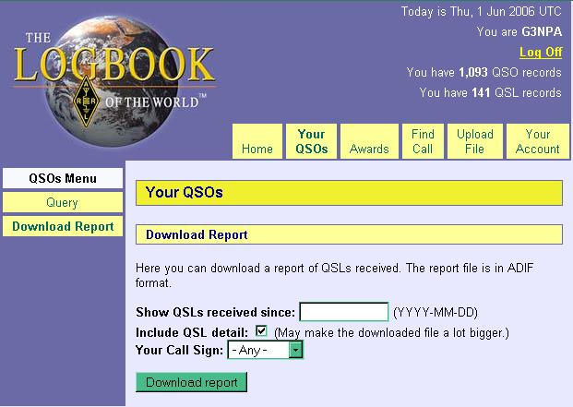

LOTW\_1

Since you will want all of your LoTW records (if it?s your first time), make sure the date area is blank.

Put a check mark in the box for "Include QSL detail".  It will make the file a little larger but Logger32 requires this data in the file.

Select the <**Download report**> button.

If given the option, point the "save to" wherever you want to save the file. The file created will be titled lotwreport.adi.

Example of lotwreport.adi file

ARRL Logbook of the World Status Report

Generated at 2006-06-03 09:39:39

for g3npa

Query:

   QSL ONLY: YES

  QSL SINCE: 2006-01-01 00:00:00

<PROGRAMID:4>LoTW

<APP\_LoTW\_LASTQSL:19>2006-05-26 12:21:43

<APP\_LoTW\_NUMREC:2>17

<eoh>

<APP\_LoTW\_OWNCALL:5>G3NPA

<STATION\_CALLSIGN:5>G3NPA

<CALL:9>FJ/SM7DKF

<BAND:3>17M

<MODE:3>SSB

<QSO\_DATE:8>20060517

<TIME\_ON:6>223731

<QSL\_RCVD:1>Y

<QSLRDATE:8>20060522

---------------------------------------------------See note 2 below

<DXCC:3>213

<CQZ:1>8

<ITUZ:2>11

<IOTA:6>NA-146

<GRIDSQUARE:6>FK87ov

<eor>

<APP\_LoTW\_OWNCALL:5>G3NPA

<STATION\_CALLSIGN:5>G3NPA

<CALL:8>GW3KHZ/P

<BAND:3>40M

<MODE:2>CW

<QSO\_DATE:8>20060513

<TIME\_ON:6>082116

<QSL\_RCVD:1>Y

<QSLRDATE:8>20060517

---------------------------------------------------See note 2 below

<DXCC:3>294

<IOTA:6>EU-106

<eor>

**Notes**:

* 1. All digital contacts will show as [RTTY](#RTTY).  ([PSK31](#PSK31/63/125), [PSK63](#PSK31/63/125), [MFSK](#MFSK), [HELL](#HELL), [MT63](#MT63) etc) but Logger32 import will ignore this field - so the local log will not be changed as a result of this strange anomaly.
  2. If you do not check the "Include QSL detail" option when calling for a downloaded report from LoTW, then all of the data below this line will be omitted. Logger32 will detect this short form. A warning will be given when trying to use the short form report:

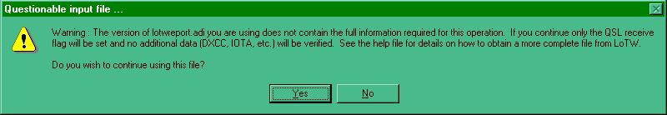

LOTW\_2

* 1. LoTW "basic" & "detail" sync files now work with the first sync option (Update LoTW\_SENT & LoTW\_RCVD). All other options still require the LoTW detail file.

## 2.0 SYNCHRONIZING LoTW TO LOGGER32

Select the Logger32 [Main menu](#_topic_MainMenu) [File | Synchronize LoTW](#2.0_FILE_MENU_ITEM) menu items

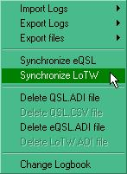

LOTW\_3

and Select the required file. When the file is loaded, the LoTW Synch dialog box will be displayed.

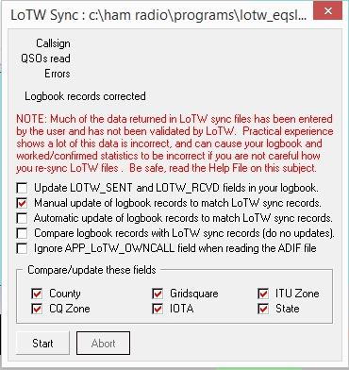

LOTW\_4

The LoTW file downloaded will contain QSL details and may also contain one or all of the following data fields:

<Gridsquare>, <State>, <DXCC>, <CNTY>, <ITUZ>, <IOTA>, <CQZ>.

The user has the option to select which fields to update by checking the appropriate box for the appropriate field in the lower portion of the dialog box. Fields unchecked will be ignored for comparison and will not be updated. These selections are enabled for the "[Manual update](#2.1.3_Manual_update_of_the_log)", "[Automatic update](#2.1.4_Automatic_update_of_the_logbook)" and "[Compare Logbook records](#2.1.1_Compare_logbook_records_with_LoTW_(do_not_update) )". The Manual update option is automatic as long as all user selected elements match.

The update will stop and present user an edit window when a mismatch is encountered

Fields not selected will be grayed out and not checked for a match.

Where possible, Logger32 will make use of this data but please take due note of the warnings given in the Sync dialog box. There are a number of fields in the downloaded file that have NOT been verified by LoTW.  People usually know where they live but very often they use the wrong abbreviation for the US State or the incorrect format for an [IOTA](#IOTA) or Gridsquare reference.  If YOU don't check these fields, then it is possible that this incorrect data will be transferred to your log.  It is because of this that Logger32 includes an option to simply compare records without altering the log.

When ready, select the option required and the <**Start**> button. [**Note** - only one option is selectable at a time].

It is important to appreciate that Logger32 will maintain a record of what has changed. The same file names are used each time a sync process is initiated so you are asked if you want to append to the existing file (if there is one) or overwrite the file.

2.1 Options Available

### 2.1.1 Compare logbook records with LoTW (do not update)

This is really the first step for the faint of heart. You can run a complete comparison between the log and what is contained in the lotwreport.adi and the results will be available in the LoTW mismatch.txt file to be found in the default Logger32 directory.

\*\*\*\* NO RECORDS WILL BE UPDATED during this exercise.\*\*\*\*

The indication of how many records have been read (or otherwise)

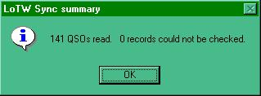

LOTW\_5

The indication of errors stored in the LoTW mismatch .txt file

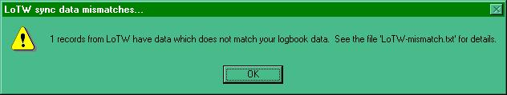

LOTW\_6

This gives the option to append data to an existing file or to wipe the existing file before recording.

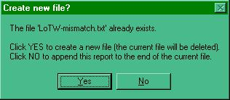

LOTW\_7

Here is an example of a LoTW-mismatch.txt file:

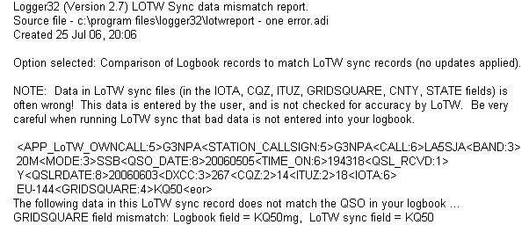

LOTW\_8

### 2.1.2 Update LOTW\_SENT and LOTW\_RCVD fields in the logbook

If the object of your synchronization is simply to update the QSL status, then use this option.  Both the QSL\_SENT and QSL\_RCVD status will be made to correspond to the data contained in the lotwreport.adi file

### 2.1.3 Manual update of the log

This option allows for the user to update their log one QSO at a time. On selecting the option, Logger32 presents a mismatch comparison window showing what is in the log and what is in the lotwreport.adi file for that QSO. An example is shown below:

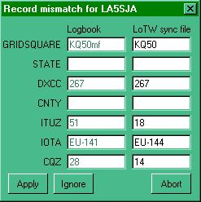

LOTW\_9

At this point the user can ignore any changes and skip to the next record by clicking on the <**Ignore**> button.  If the user is prepared to accept the LoTW information as presented then selecting the <**Apply**> button will update the log and move on to the next record.

Should the user not agree with one or more of the LoTW fields then these can be edited and when satisfied, selecting the <**Apply**> button will update the log.

When using the manual update option:

* + If there are no notable differences between the logbook entry and the LoTW sync file, then the LOTW\_SENT and LOTW\_RCVD fields are updated.
  + If there are differences between the logbook entry and the LoTW sync file found, then the LoTW manual update window (shown above) is displayed.  There are now two options:
    - Ignore -- the Logbook is NOT updated (no change made to any fields - including LOTW\_SENT and LOTW\_RCVD).
    - Apply -- Logbook is updated.   LoTW sent/received fields are set appropriately.

### 2.1.4 Automatic update of the logbook

For those who are brave enough, the log can be updated automatically. All records will be made to match the data received from LoTW and the QSL records will be updated

**Warning**: Be very careful using this option. The data that is being placed into your log will NOT have been checked/verified by LoTW or Logger32. This data has been entered by the originator and could be incorrect. You are strongly advised to generate a LOTW-mismatch.txt file and study that first. Once you are fully satisfied that the LoTW data is OK, then use this option.

## 3.0 CORRECTING IOTA ERRORS

Many are the times when additional information in the lotwreport.adi is in an incorrect format (see General Notes below) and this applies particularly to IOTA codes.

Logger32 gives the operator the option to correct these when using the manual mode. If the automatic sync mode is selected then Logger32 will do its best to repair the most common errors in the IOTA information on import. For example:

* + NA26 will be changed to NA-026
  + NA026 will be changed to NA-026
  + NA-26 will be changed to NA-026

Of course, If NA26 or NA-26 was supposed to be NA-260, then it will pass the validity test, but still be wrong.

## 4.0 GRIDAQUARE INFORMATION

Gridsquare data can be in either 4 or 6 character format.

In the automatic synchronization mode, Logger32 will NOT change a locally recorded 6-character reference back to a 4-character reference should one come from LoTW. If a 6-character reference comes from LoTW and only 4 characters are in the local log, then the reference will be updated.

In the manual update mode, if a 4-figure reference is supplied by LoTW, then it is up to the user to make sure that the LoTW side of the table is corrected/edited before applying the data.

## 5.0 A SETUP SUGGESTION

The LoTW sync option can generate two files: BAD.adi and LOTW-mismatch.txt.  If you want quick access to these files then try the following.

Using the Logger32 Main menu Tools|Utility program menu items, set up two shortcuts for viewing the BAD.adi and/or LOTW-mismatch.txt files in the Utilities menu as below:

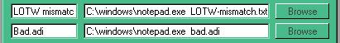

LOTW\_10

6.0 GENERAL NOTES

If Logger32 produces a BAD.adi file, then check:

* + The DATE/TIMES of the QSOs.  They MUST be within +/- 10 minutes of what appears in your log - the fields in the format <QSO\_DATE:8>20031023   <TIME\_ON:6>004956;
  + IOTA field should be of the format xx-nnn, example: <IOTA:6>NA-033. Quite often, the IOTA ADIF field received is without the dash or the leading zero, or a combination of both; and,
  + Grid information must be of the format XXnn or XXnnxx, example: <GRIDSQUARE:6>FM72nd or <GRIDSQUARE:4>FM72.

LoTW sync now look -/+ 10 minutes for a QSO that matches (Call, Band and Mode). LoTW first does a check for an exact match, then browses the logbook -/+ 10 minutes.  eQSL does not do an exact match check, it starts - 10 minutes and looks thru the log for 20 minutes for a match.

If you happen to have more than one log registered with LoTW, then, if you are not selective, LoTW will download QSLs for ALL registered callsigns into the one lotwreport.adi file. During import, the LoTW record

APP\_LOTW\_OWNCALL is checked against the OPERATOR field in the logbook and will only update those records that match. It may be, therefore, that you have to run the lotwreport.adi file into Logger32 several times, depending on how you have set up your log(s), if you wish to capture all the data contained in it.

As a reminder, the LOTW\_SENT and LOTW\_RCVD fields used in Logger32 are correct ADIF fields but probably will not be recognized by other software, as these are program specific (as defined by the ADIF specification).

## 7.0 EASY CHECKING FOR LoTW - Jim Pickett K5LAD

I use the ARRL Logbook of the World service regularly, sometimes daily, so I made it easier for pulling up my LoTW downloads and looking them over before I synchronize the file into my Logger32. For ease in getting to these, I placed them in the [Utilities Menu](#7.0_UTILITIES_MENU_ITEM) located conveniently on the Logger32 [Main menu](#_topic_MainMenu).

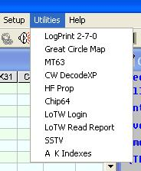

LOTW\_11

These two items are listed above as LoTW Login and LoTW Read Report.

Obviously, before this can work you must have already submitted your request to ARRL and received and implemented the password received on the postcard into their TQSL program. It is assumed that this has all been done and you have successfully downloaded some of your QSLed QSOs at least one time.

To make this work in the Utilities Menu, go to the Logger32 [Main menu](#_topic_MainMenu) Tools | [Utility Program Setup](#7.0_UTILITIES_MENU_ITEM) menu item.  You may already have one or several entries in this list but Logger32 will allow you to have up to twenty choices.  My setup list looks like this:

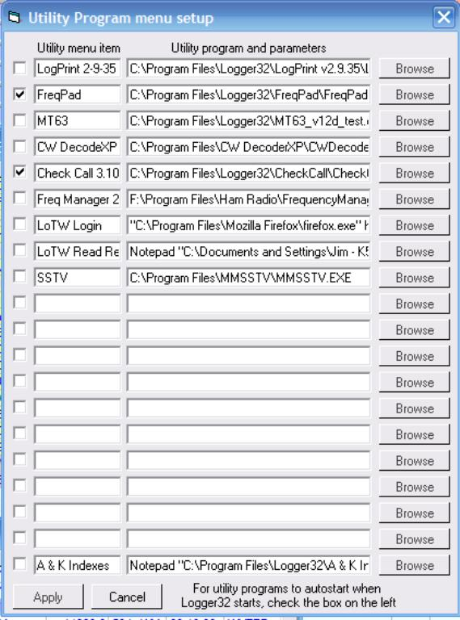

LOTW\_12

and note that I have used positions 7 and 8.

Enter the menu item in the left-hand box - in this case it is LoTW Login. The following line was entered in the larger right-hand box labeled "Utility program and parameters".  The information is specific to my computer and my LoTW login. I am using Firefox as my browser and it is located in the Program Files\Mozilla Firefox folder on drive C: but you should enter the location and filename for your own browser. Also, the line following the https:// entry is the information required for accessing LoTW from the ARRL website but you would, of course, use your own call and password. Note also that there should be a space between .exe? and https:// and when you enter it in the box it will be on all one line.

"C:\Program Files\Mozilla Firefox\firefox.exe" https://p1k.arrl.org/lotwuser/qsos?login=K5LAD&password=your password here

Choosing the LoTW Login entry from the Utilities Menu should go to the ARRL website and pull up and save a file called "lotwreport.adi" to the default file destination location. In my case, I save downloaded files to my Desktop.

I like to look over my downloaded file before synchronization to see what new entries I have received since the last time I downloaded QSOs. To save me having to close or hide Logger32 and go to the Desktop to read this file, I created this second Utilities Menu item located at line eight. The entry in the left-hand box is LoTW Read Report

To read the file I use Notepad and since I download the lotwreport.adi to my Desktop I show in the following entry how I get to my Desktop. I am using XP Home so the entry shown is true for my particular setup. If you?re using a different operating system you will want to use the entries that take you to your Desktop, or wherever your downloaded file saves.

Enter: Notepad "C:\Documents and Settings\Jim Pickett - K5LAD\Desktop\LoTWReport.adi"

Note here that there are some spaces before and after the hyphen and before and after the "and" in Documents and Settings. Your setup will be different and you will need to find the route to your Desktop.

There are different ways to access your Desktop and it will depend on your operating system as to how this is done. For instance, with Windows 98 the Desktop is typically accessed via:  C:\Windows\Desktop . For Windows 2000 PRO and Windows XP it will depend on how you are logged into your computer. Your login will create a folder for you under that login name and that folder will hold several folders specifically for you under that name, including your Desktop. That login folder will be found in folder on your C: drive called "Documents and Settings"  In the Enter: example above, you'll see that my login shows as "Jim Pickett = K5LAD"  so when a lotwreport.adi file is received from ARRL and placed on my Desktop, it is accessed as in the example.

After you are satisfied with the contents of the lotwreport.adi file you have downloaded, you are ready to add this information to your logbook. This is the process of synchronization and that is accomplished by clicking on the File menu item of the Main menu and choosing "Synchronize LoTW"  The open file window will open and allow you to choose where your copy of lotwreport.adi is located.  Go to Synchronizing LoTW to Logger32 for information on this process

*Created with the Personal Edition of HelpNDoc:* [*Free EPub producer*](http://www.helpndoc.com/create-epub-ebooks)

**LoTW Synchronization From Club Log**

# Aki Yoshida JA1NLX

## 1.0 GENERAL

Logger32 provides a feature which synchronizes LoTW Credit Granted status with the status on the Club Log database. You should be a user of Club Log and LoTW to use this feature.

## 2.0 PREPARATION

1) Upload your all QSOs to LoTW.

2) Go to <https://secure.clublog.org/lotw/> and select “**Download confirmed QSOs from LoTW**”. Details are not explained here. Please read the guide provided by Club Log in the link above.

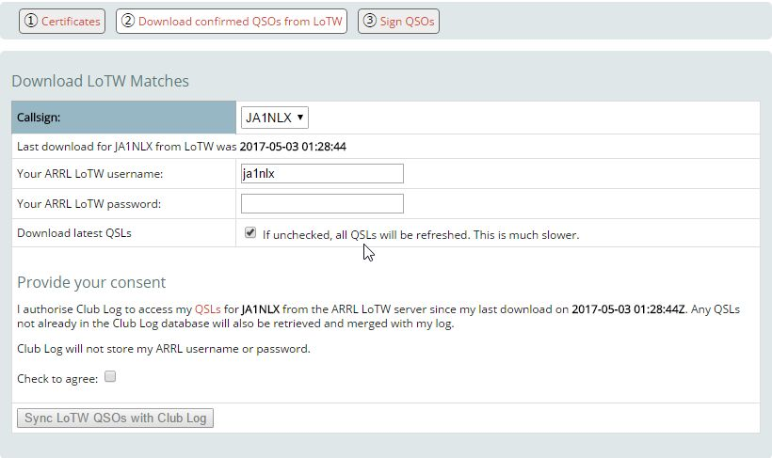

LOTWCL\_1

## 3.0 SYNCHRONIZE LOTW FROM CLUB LOG

Click File and Synchronize LoTW (from Club Log.)

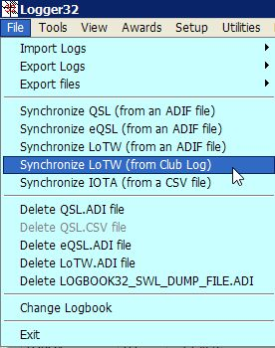

LOTWCL\_2

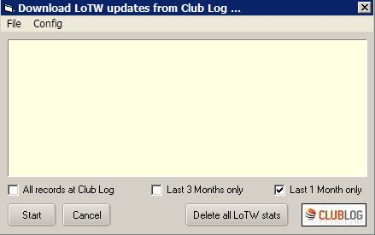

LOTWCL\_3

Select the Config menu option and enter the Callsign, Password and eMail address for Club Log and Click Apply.

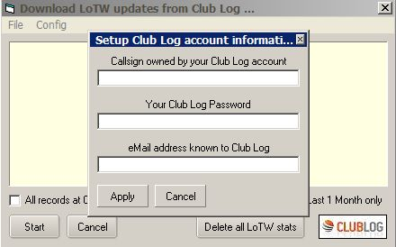

LOTWCL\_4

Club Log has only very recently (May 2017) introduced the capability of reporting QSOs that have been credited for DXCC by LoTW. While Club Log may know of QSOs that are eligible for LoTW credit, it can not definitively say what of these QSOs loaded to Club Log prior to May 2017 have credit granted. To update all your QSOs on Club Log, you need to UNcheck the option shown in LOTWCL\_1. This will refresh all your LoTW credits in the Club Log databases. It's slower than normal, but it will ensure you get the most current LoTW credits. You need only do this once.

If you want to synchronize Logbook by confirmed QSOs for last 1 month then check Last 1 month only.

If you want to synchronize Logbook by confirmed QSOs for last 3 months then check Last 3 months only.

If you want to synchronize Logbook by all confirmed QSOs at Club Log then check All records at Club Log.

Click Start to synchronize.

## 4.0 NOTES

It may take a long time to complete update when Logger32 need to update for many QSOs. (just after deleting all LoTW Credit Granted status) However once it updated then it is faster next time.

Downloaded QSOs records are saved as “LoTW records from ClubLog.txt” (JSON format) in the Logger32 folder. Sample below.

["VE7AHA","2013-12-31 23:41:41","12","CW","C"],["W9WI","2013-12-29 22:38:06","15","CW","C"],["3W1T","2013-12-27 00:36:35","10","CW","C"],["YB4IR\/8","2013-12-25 22:19:21","20","CW","C"],["YF1AR\/8","2013-12-23 11:39:13","20","SSB","C"],["YB4IR\/8","2013-12-23 03:18:01","15","CW","C"],["YF1AR\/8","2013-12-22 05:51:26","15","SSB","C"],["YB4IR\/8","2013-12-21 23:25:48","17","CW","C"],["ZM90DX","2013-12-18 02:42:55","12","CW","G"],["RW110RAEM","2013-12-10 07:49:41","12","CW","C"],["V63XG","2013-12-10 07:34:17","15","CW","C"],["T32RC","2013-12-09 08:53:15","30","CW","C"],["V63XG","2013-12-09 07:18:09","20","CW","C"],["J69DS","2013-11-29 22:57:36","15","RTTY","C"],["C6AUM","2013-11-29 12:28:09","40","CW","C"],

*Created with the Personal Edition of HelpNDoc:* [*Free iPhone documentation generator*](http://www.helpndoc.com/feature-tour/iphone-website-generation)

**QSL Synchronization**

# Geoff Anderson G3NPA

## 1.0 General

This option was designed for those operators who use a QSL manager to deal with their paper confirmations. It is anticipated that the operator will keep the QSL Manager updated with [ADIF](#ADIF) files, which update the remote. The operator can do this by simply outputting a partial log from a specified date (the last one in the Manager's version of the log) to the present. The QSL Manager is therefore kept up to date without overwriting any details he may have already input.

One now assumes that the QSL Manager makes appropriate updates to the QSL fields and in the due process of time will return a complete version of the log in ADI format to the operator. This can take the form of an ADI file of the complete log as held by the Manager

This utility will use the Manager's log and use it to synchronize the original (master) log held by the operator. It is important to appreciate that the Manager's log should NOT be use to REPLACE the operator's log as it is more than likely that the operator will have logged more QSOs since the last update he sent to his Manager.

The QSL sync function will synchronize the 4 ADIF fields QSL\_SENT, QSL\_RCVD, QSLSDATE and QSLRDATE.

## 2.0 QSL Synchronizing

To use the facility select the Logger32 Main menu Files | Synchronize QSL menu items.

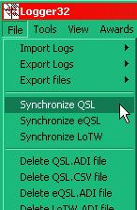

QSLS\_1

After selecting the QSL file to synchronize, the QSL Sync dialog box will be displayed.

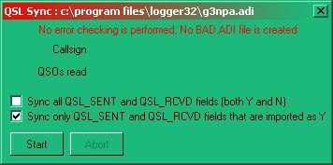

QSLS\_2

**Note**: There is NO error checking or the creation of a BAD.ADI when using this option.

*Created with the Personal Edition of HelpNDoc:* [*What is a Help Authoring tool?*](http://www.helpauthoringsoftware.com)

**IOTA Synchronization**

# Aki Yoshida JA1NLX

## 1.0 GENERAL

Logger32 provides a feature which synchronizes [IOTA](#IOTA) Credit Granted flags with the status on RSGB/IOTA database.

## 2.0 DOWNLOAD YOUR QSOs FOR IOTA

If you are registered then go to <https://www.iota-world.org/en/> and log in. Click My IOTA Tab. Click the Link “Download (CSV)” to download the file, myqsos.csv anywhere you like..

The myqsos.csv file consists of the following data:

* + IOTA reference number;
  + Callsign;
  + [UTC](#UTC);
  + Count for;
  + Status:

This is either of “QSL”, “Contest”, “Accepted Operation” or “Not submitted”

If your credit application is accepted by QSL card then it is “QSL”;

If your credit application is accepted by IOTA Contest Log then it is “Contest”;

If your credit is accepted by ClubLog then it is “Accepted Operation”.

If you only add QSO manually or by ClubLog QSO matches then it is “Not submitted”; and

* + No Header:  
      
     Accepted: credited, and  
      
     Active: not credited yet.

This is a part of myqsos.csv.

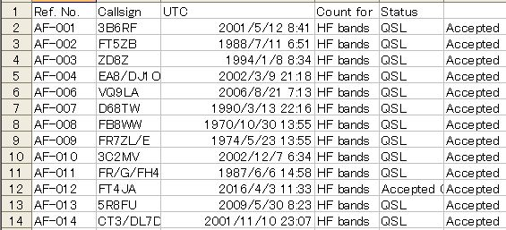

ISY\_1

**Note:**　If you have any of IOTA credited prior to August 2007 then YOUR myqsos.csv may be different. There may be many records with “00000000” as UTC. You see 2 extra columns, Freq and Mode, “Method” instead of “Status” header and “Status” instead of blank header. It looks like below.

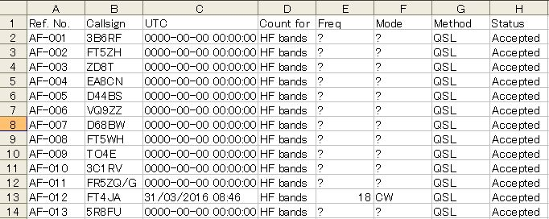

ISY\_1A

You may notice following QSO at the end of the file. The most right column shows "Active". These are "Pending QSO"s (not credited yet) and Logger32 does not update flag for these QSO.

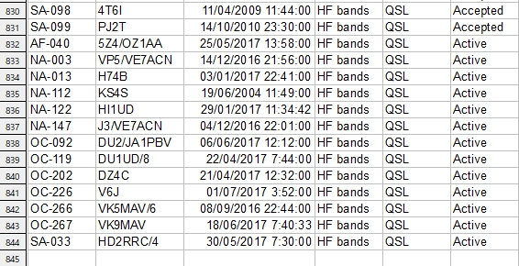

ISY\_1B

## 3.0 SYNCHRONIZE IOTA

Click File and Synchronize IOTA (from a CSV file).

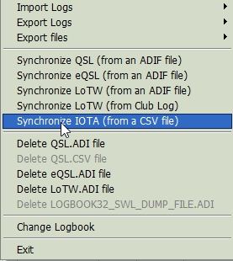

ISY\_2

You must select myqsos.csv which you downloaded in step 2.0.

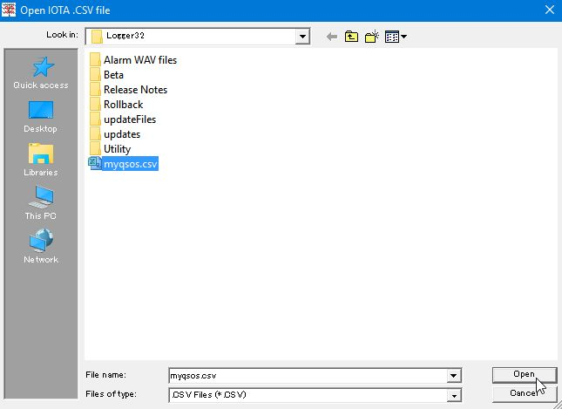

ISY\_2A

Click “Open”.

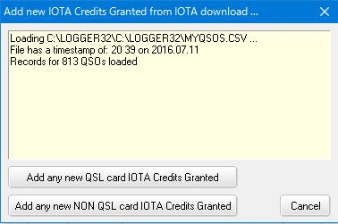

ISY\_3

Logger32 check if the file format is one like ISY\_1 or ISY\_1A and if UTC data is correctly formated. Otherwise it shows like this:

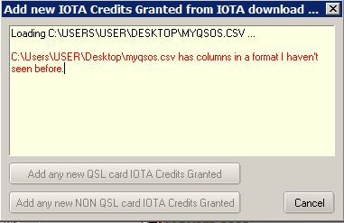

ISY\_3A

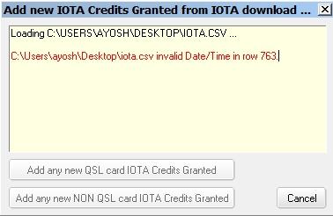

ISY\_3B

In either case you must click "Cancel" and edit myqsos.csv.

Click “Add any new QSL card IOTA Credits Granted” Only QSO with “QSL” status will update Logbook.

Click “Add any new NON QSL card IOTA Credits Granted”. QSO with “Contest” or “Accepted Operation” status will update Logbook.

**Note:** QSO with “Active” status do not update Logbook.

If Logger32 can not find matched QSO then you are now presented with a list of QSOs in your logbook that match the home call of the station you worked.

If a record in the myqsos.csv has date and time information and Logger32 can not find a matched QSO in the Logbook then following list is presented. Logger32 looks +/- 30 minutes either side of the reported QSO time and checks dates as dd/mm/yyyy and mm/dd/yyyy.

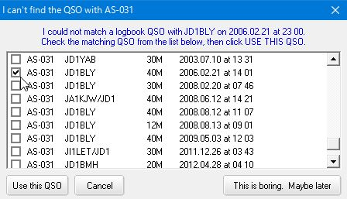

ISY\_4

If a record in the myqsos.csv has no date and time information then following list is presented.

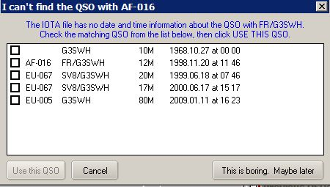

ISY\_4A

In either case select a proper QSO and click “Use this QSO”.

These mapping are saved as <logbook name>\_IOTA\_QSO\_MAP.txt in the Logger32 folder.

If the QSO is updated successfully you see a message like this for each QSO.

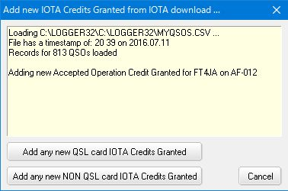

ISY\_5

If Logger32 does not find any QSO to be updated then you see a message like this.

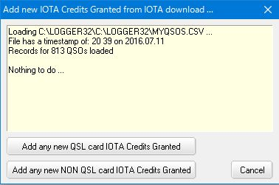

ISY-6

**Note**: You will be surprised to see lots of errors “Can’t find the QSO.....” It is unbelievable. I do not know who really made such a mistake.

Most of these are un-matched with Date/UTC and the rest are un-matched with callsign. (JA1NLX/3D2 or 3D2/JA1NLX). Logger32 does not change anything in Logbook except the Credit Granted flag even if it does not find any matched QSO. It only creates a mapping table.

*Created with the Personal Edition of HelpNDoc:* [*Free Qt Help documentation generator*](http://www.helpndoc.com)

**Previous QSOs Window**

B. Charles Sutton W1MCP and Jim Hargrave W5IFP

## 1.0 GENERAL

When you enter a full callsign in the [Logbook Entry window](#_topic_LogbookEntryWindow), or click on a record in the [Logbook Page window](#_topic_LogbookPageWindow), Logger32 queries your logbook and locates any previous QSOs you've had, then displays them in the Previous QSOs window. Logger32 will display up to 500 matching entries from your logbook. If you sort the window in ascending order, Logger32 will display the first 500 matching records in your logbook. If you sort in descending order, Logger32 will display the last 500 matching records in your logbook.

**Note**: If the number of QSOs exceeds the lines displayed in the Previous QSOs Window, the total number of QSOs will appear in the header line. You can increase the window size or scroll to see the remaining Previous QSOs.

### 1.1 Setting up the Grid and Choosing the Fields to Display

When you right-click click on any blank line in the Previous QSOs window a popup menu will appear allowing you to make changes that will apply only to the Previous QSOs window.

To select your desired format, right-click and select the Grid Layout menu item and you will be presented with the [Show column layout dialog box](#Show_column_layout_dialog_box) that will allow you to change the column header names, the justification of the columns and the order in which the columns are displayed. Please refer to the [Grid Layout Setup](#_topic_GridLayoutSetup) topic for complete details.

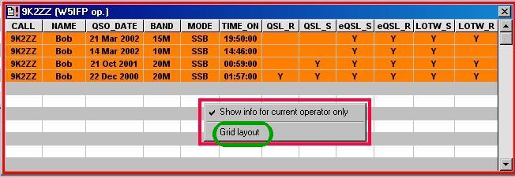

PQW\_1

## 2.0 CHANGING THE QSO RECORDS DISPLAYED IN THE WINDOW

By default, Logger32 will display all the matching QSO records found in the logbook. If you wish to display only those records found that match the current operator, right-click on any blank line in the grid and select the "Show info for current operator only" menu item.

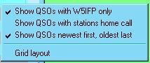

PQW\_2

By checking the menu item "Show QSOs with stations home call", Logger32 will display all QSO records with the entered callsign regardless of call area modifier. Below is an example of this feature.

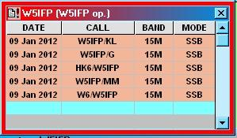

PQW\_8

## 3.0 SORTING THE QSOs

The Previous QSOs window can be sorted in ascending or descending Date order by clicking on the Date column header. You can also right-click on any blank line and check the menu item "Show QSOs newest first, oldest last". To show the oldest first, simply uncheck the line.

## 4.0 SELECTING A QSO

Left-clicking on any QSO in the Previous QSOs Window will highlight that QSO and will also highlight the same QSO in the [Logbook Page window](#_topic_LogbookPageWindow).

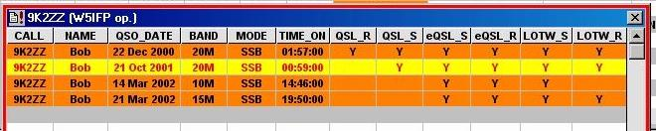

PQW\_3

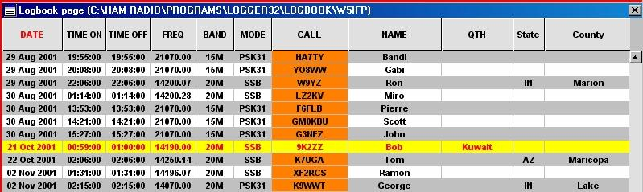

PQW\_4

## 5.0 CHANGING THE APPEARANCE OF THE PREVIOUS QSOs GRID

You can change the appearance of the grid such as displaying the grid lines, changing the row height and column width, alternating grid background colors and much more. Please refer to the topic [Grid Appearance Setup](#_topic_GridAppearanceSetup) for complete details.

* + Choosing Grid font (highlight) will change the color of the font when you highlight a row as shown above in red.
  + Choosing Grid background (highlight) will change the background color of a row when you highlight it as shown above in yellow.

## 6.0 QUICK QSL DIALOG BOX

Right-clicking on a QSO in the Previous QSO Window will open the Quick QSL dialog box.

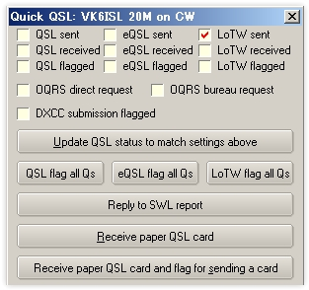

PQW\_5

The top half of the menu allows you to make several changes to the selected QSO. For the twelve options, you will see a check mark displayed for any of the fields set to Y(es) or (V)erified in the logbook. Fields marked as N(o) or are blank in the logbook will not have a checkmark. You can change any of these twelve fields and the logbook will be updated to match. After making changes be sure to select the <**Update QSL status to match settings above**> button or the <**Ctrl+U**> keys from the [Logbook Entry window](#_topic_LogbookEntryWindow), otherwise your changes will not be saved.

The lower half of the menu allows two quick changes. When used, these options will update the logbook and close the window.

## 7.0 RECEIVE PAPER QSL

Selecting the <**Receive paper QSL card**> button or the <**Ctrl+R**> keys from the [Logbook Entry window](#_topic_LogbookEntryWindow) will change the "QSL Received" field to Y and will also add the current date to the QSLRDATE field.

## 8. RECEIVE PAPER QSL AND FLAG FOR SENDING A CARD

Selecting the <**Receive paper QSL card and flag for sending a card**> button or the <**Ctrl+S**> keys from the [Logbook Entry window](#_topic_LogbookEntryWindow) will do the same as above and will also flag the record in your logbook to send a paper QSL. The next time you export a QSL file, this QSO will be included.

**Note** that any information in the logbook QSL received fields will be overwritten when using the two Quick QSL features.

Closing the window without clicking on the Update line or one of the Quick QSL lines will simply cancel selections and close the window.

## 9. RECEIVE PAPER SWL CARD AN D FLAG FOR SENDING A CARD

When you receive a QSL card from a Short Wave Listener (SWL), enter the callsign of the station you were heard working into the [Logbook Entry window](#_topic_LogbookEntryWindow). In the Previous QSO window, right click on the monitored QSO as indicated on the SWL Card and select the <**Reply to SWL report**> button.

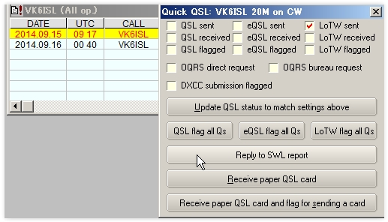

PQW\_6

You will be presented a new pane. Enter the number listed on the SWL card and select the <**Send**> button.

The SWL record will be placed in a separate [ADIF](#ADIF) file in your Logger32 directory. Look for the file: "< yourcallsign >\_ SWL \_dump\_file. Adi". You can use this file with your printer program to make labels or QSL Cards.

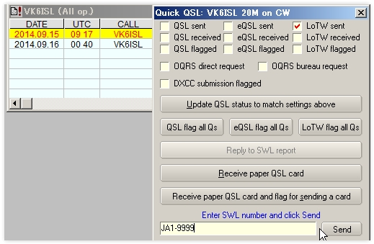

PQW\_7

## 10. QSL, eQSL and LoTW FLAG ALL Qs

The <**QSL flag all Qs**> button  will change the "Send paper QSL" field to Y unless "Paper QSL sent" field is checked for all QSOs displayed in Previous QSOs window.

The <**eQSL flag all Qs**> button will change the ?Send eQSL? field to Y unless "eQSL sent" field is checked for all QSOs displayed in Previous QSOs window.

The <**LoTW flag all Qs**> button will change the "Send LoTW QSL" field to Y unless "LoTW QSL sent" is checked for all QSOs displayed in Previous QSOs window.

*Created with the Personal Edition of HelpNDoc:* [*Free CHM Help documentation generator*](http://www.helpndoc.com)

**Worked Confirmed Window**

# Geoff Anderson G3NPA and Aki Yoshida JA1NLX

## 1.0 GENERAL

The Worked/Confirmed window is designed to show a summary of the [Band/Mode](#BandMode_Table) combinations worked for a specific prefix. Additionally, it will show specific summary information for the callsign entered in the [Logbook Entry window](#_topic_LogbookEntryWindow), if that callsign has been entered into the log previously. Some elements of the way this information is displayed are configurable by the user.

An empty window is shown here:

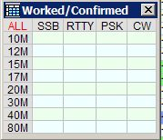

WCW\_1

The bands and modes displayed are derived from your [BandPlan](#_topic_SetupBandsandModes) and whether you have the Stats column marked with a "Y". The more bands and modes you have so marked, the larger will be the table shown above.

The table becomes active as soon as a recognized prefix is entered into the "Call" edit box of the [Logbook Entry window](#_topic_LogbookEntryWindow). The table will remain blank if the particular country has not been logged before, but if the prefix has been recorded previously, then the appropriate [Band/Mode](#BandMode_Table) combinations will be activated, as shown in the example below.

**Note**: The Worked/Confirmed window title bar will change and include that of the prefix entered, the Operator and the type of QSLs to be included for confirmations (see below)

**Note**: The current Band/Mode cell is indicated by the boarder with clear line. (See 40M CW below)

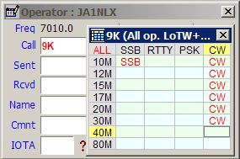

WCW\_2

## 2.0  WORKED/CONFIRMED WINDOW MENU

A right mouse click with the cursor anywhere on the Worked/Confirmed window will produce the following set of menu options:

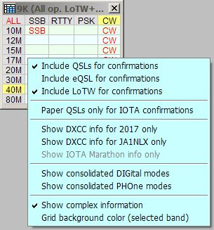

WCW\_3

### 2.1 Include QSL/eQSL/LotW for Confirmations

This menu item allows the user to select what QSO confirmed information is displayed. This will also affect the colors displayed in the [DX Spots window](#_topic_DXSpotsWindow1).

An example showing the changes that can be observed when selecting different "Include for confirmation" options.

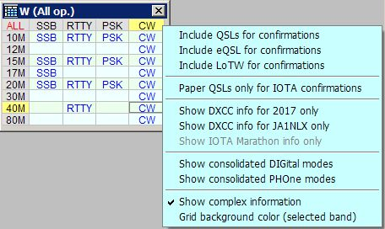

WCW\_13

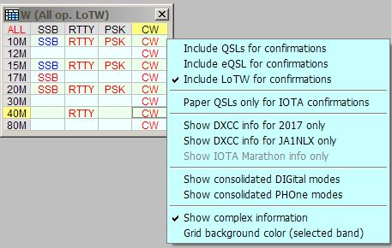

WCW\_13A

### 2.2 Paper QSL's for IOTA Confirmations

This menu item has an effect on the highlight colours in the [DX Spots window](#_topic_DXSpotsWindow1) rather than the Worked/Confirmed table.

As an example If a specific [IOTA](#IOTA) group has been worked and a confirmation for that QSO is been made via [LotW](#LoTW) then the QSO will be highlighted as needing a paper confirmation.

### 2.3 Show DXCC for [year] Only

Selecting this menu item will cause the Worked/Confirmed table and the [DX Spots window](#_topic_DXSpotsWindow1) to display information based on the QSOs recorded within the current year rather than the whole log book. The year is derived from the computer system time/date and therefore will update automatically on the 1st January each year. When selected, the upper left hand cell in the table will change from ALL to the current year.

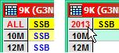

WCW\_14

This configuration allows the user to track [DXCC](#DXCC) performance by calendar year. This status will be based on the current logbook in use and operator selection. When this line is checked, the DXCC status for the current year will be reflected in the Logger32 Child windows listed below:

* + Worked Confirmed Window (including [Generic QSOs Window](#_topic_GenericQSOsWIndow));
  + DXCC Award Window (including [Generic QSOs Window](#_topic_GenericQSOsWIndow));
  + DXCC Challenge Window (including [Generic QSOs Window](#_topic_GenericQSOsWIndow));
  + [DX Spots Window](#_topic_DXSpotsWindow1) (including QSOB4 column);
  + DX Activity window; and,
  + [Bandmap](#_topic_TheBandmap) Windows.

Panel number 2 of the Upper Status bar reflects the status of the callsign in the [Log Entry window](#_topic_LogbookEntryWindow).

### 2.4 Show Info for [current operator] Only

The Worked/Confirmed table can display the status for the whole log and all operators or just for the current operator. Logger32 displays this status in the title bar of the Worked/Confirmed Table and the Previously Worked Table as shown below.

In addition the title bar also displays the "Include QSLs for confirmations" options selected. In the examples below all the QSL options have been selected.

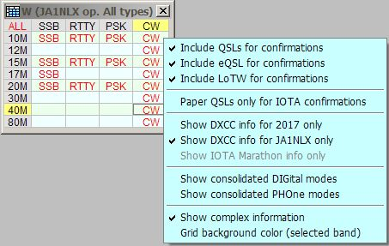

WCW\_4

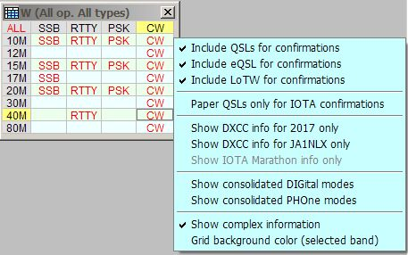

WCW\_5

### 2.5 Show Consolidated DIGital/PHOne Modes

For those users who might prefer to display the consolidated details for phone and or digital modes this may be achieved by selecting the appropriate menu options as shown above. The screen shot below shows the effect of selecting both options. This table uses the mode definitions as set up in the Logger32 [Main menu](#_topic_MainMenu) [Tools | Database maintenance | Setup phone/digital modes](#3.0_TOOLS_MENU_ITEM) menu item.

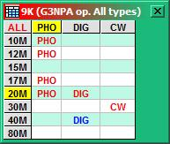

WCW\_6

### 2.6 Show Complex Information

The data in the Worked/Confirmed window can be selected to display either a simplified format or one that is more complex. Right-click anywhere within the window and uncheck "Show Complex Information" to obtain the simple format.

**Complex format**

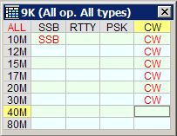

WCW\_7

**Simple format**

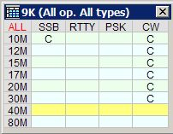

WCW\_8

In the simple presentation only "W" and "C" indications are given and the only the band in use at the time is shown.

The text and background colors in the complex version of the table as shown above have the following meanings:

* + Red text - Band/Mode worked AND confirmed; and,
  + Blue text - Band/Mode worked but NOT confirmed

Once the full callsign of your QSO partner has been entered in the [Loghbook Entry window](#_topic_LogbookEntryWindow), further information may be available if you have worked that station before and you have set the "Complex" mode of display.

The background colors in the individual Band/Mode combinations now indicate specific details for the particular callsign entered. In the example below, the red background indicates that 9K2ZZ has confirmed QSOs on 20M CW, 17M CW, 15M CW , and the light yellow background that he has been worked on 30M CW, 12M CW and 20M RTTY. The entry which is not highlighted indicates that the prefix 3D2 has been worked in this Band/Mode combination, but it was not with 3D2AG. The specific colors for these highlights may be selected form the Logger32 [Setup menu](#_topic_SetupMenu), Highlight menu option.

The background colors and the display of the modes in the individual band/mode fields have two meanings:

* 1. The background colour indicates those band mode combinations recorded in the log as worked or confirmed for the particular callsign. This is NOT operator dependent.
  2. The infill of the mode shows the band/mode combinations worked for the PREFIX - by the current operator.

Additionally, the highlight markers in the Column/Row headers shows the current Band/Mode as determined from the radio frequency and the [BandMmode table](#BandMode_Table).

**Note**: It is advisable to perform a logbook recalculation occasionally to ensure that this table is correct.

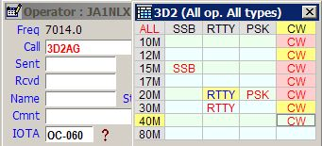

WCW\_9

## 3.0 ADDITIONAL INFORMATION

Left clicking on any grid of the Worked/Confirmed Window will display the [Additional Information dialog box](#_topic_AdditionalInformationWindows), listing all log entries for the Band/Mode selected. For example, clicking on the 17M CW in WCW\_9 above would display the following details from the logbook.

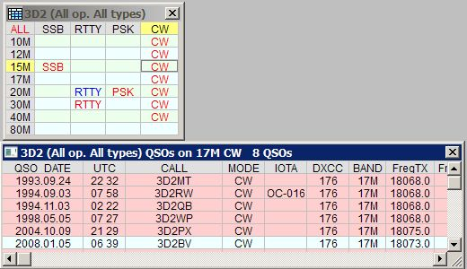

WCW\_11

Observe that this action shows ALL the stations logged with the prefix 3D2.

Left-clicking on an empty grid in the Worked/Confirmed window will display a Mixed-Mode listing of all logbook entries for the selected band, regardless of mode. If you do not have an empty grid space in the Worked /Confirmed window, then the click on the empty gray rectangle in the upper left-hand corner of the table to achieve the same result, as below:

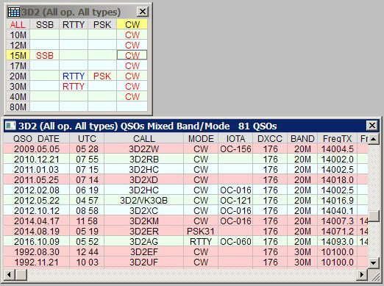

WCW\_12

Both of the above generic window screenshots display the total number of QSOs in the title bar that meets the particular criteria. If the total number is less than the number of visible lines in the table, then this area in the title bar will be blank.

**Note**: Right-clicking on the [Additional Information dialog box](#_topic_AdditionalInformationWindows) will display the [Grid Layout Setup](#_topic_GridLayoutSetup) window, allowing you to customize the display in the same way as the [Logbook Entry](#_topic_LogbookEntryWindow) and [Previous QSO](#_topic_PreviousQSOsWindow) windows. Left-clicking on any of the QSOs in this window will bring up the [Previous QSO window](#_topic_PreviousQSOsWindow) and the [Logbook Page window](#_topic_LogbookPageWindow) with appropriate data and will highlight the QSO in the Logbook.

*Created with the Personal Edition of HelpNDoc:* [*Easy CHM and documentation editor*](http://www.helpndoc.com)

**Telnet Cluster Window**

# Hal Miller KB1ZQ, Geoff Anderson G3NPA and Mike Davies G0WZY

## 1.0 GENERAL

The Cluster window consists of five (5) tab panels, the:

* + [TNC](#2.0_TNC_PANEL) panel;
  + [Telnet](#3.0_TELNET_PANEL) panel;
  + [Messages](#4.0_MESSAGES_PANEL) panel;
  + [AGWpe](#5.0_AGWpe_PANEL  ) panel; and,
  + [Local Host](#6.0 LOCAL_HOST_PANEL) panel.

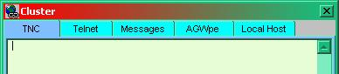

TCW\_1

Right-clicking on any of the tabs displays the Cluster Tab pop-up menu.

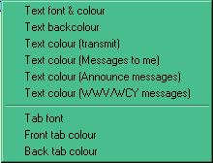

TCW\_2

This menu allows the operator to select various font and color values. The selected fonts and colors are the same for all tab panels.

* + Text font sets the font parameters for all tab panels;
  + Text back color sets the background color for all tab panels;
  + Text color (transmit) sets the color to be used for transmitted text;
  + Text color (Messages to me) sets the color to be used for received text to "operator" in all tab panels;
  + Text Color (Announce messages) sets the color of received "Announce" text:
  + Text color (WWV/WCY messages) sets the color of received WWV/WCY messages;
  + Tab font sets the font color of all tabs;
  + Front tab color sets the color of the active tab; and,
  + Back tab color sets the color of the non-active tabs.

## 2.0 TNC PANEL

The TNC panel is selected by the TNC tab and provides a connection to a serial port and is intended to use a [TNC](#TNC) to receive packet radio spots from a VHF packet cluster station. It can also be used to connect to another computer (serial to serial) to receive spots from a second packet cluster station.

Right-clicking on the TNC panel displays a pop-up menu allowing the operator to both configure and operate the TNC panel. This menu is divided into six sections that each contain a set of menu items. [Section five](#2.5_Section_Five) displays up to ten packet cluster shortcuts that are manually entered by the user using the "Cluster shortcuts" menu item of section six. If no cluster shortcuts are defined, there will be no menu items displayed in [section four](#2.4_Section_Four).

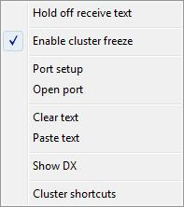

TCW\_3

### 2.1 Section One

**Hold off receive text**

This is a toggled menu item. When checked, the display of received text stops. When cleared, the display of received text starts.

### 2.2 Section Two

**Enable Cluster Freeze**

This menu item enables the [Cluster Freeze function](#3.1_Freezing_Spots), stopping Telnet Cluster display activity temporarily while the mouse the cursor.

### 2.3 Section Three

**2.3.1 Port setup**

This menu item displays the Comport Setup dialog box, allowing the user to set the serial port parameters.

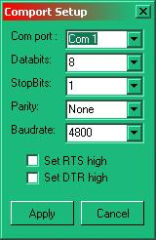

TCW\_4

**2.3.2 Open port / Close port**

This is a toggled menu item that allows the user to open or close the serial port configured for the panel. The text of the menu item changes with the state of the port. If the port is currently closed, the text will display "Open port". If the port is open, the text will display "Close port".

### 2.4 Section Four

**2.4.1 Clear text**

Clears all text from the TNC panel.

**2.4.2 Paste text**

Pastes any text in the Windows clipboard into the TNC panel at the current cursor position.

### 2.5 Section Five

**Show DX**

In this example this menu item has been adapted by the user using the Cluster shortcuts menu (below) to display the last ten DX spots received.

### 2.6 Section Six

**2.6.1 Cluster shortcuts**

This menu item displays the Cluster shortcuts dialog box that enables the user to enter up to ten packet cluster commands. Each entry consists of plain text in the left column that will be displayed as the menu item of section four and, in the right column, the packet cluster command to be sent to the packet cluster station for that menu item.

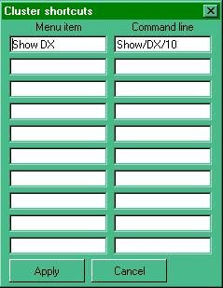

TCW\_5

The Cluster shortcuts dialog box support multi-line commands. Simply add the text " crl f'' in the command string (note the space before and after crlf). Like this:

Command1 crlf command2 crlf command3

or

SH/DX/10 crlf SH/WWV/5

**2.6.2 Using MACROs**

The MACROs $call$ and $band$ are supported in the Cluster window. See details in [Setup Telnet shortcuts](#3.7.3_Setup_telnet_shortcuts) below.

## 3.0 TELNET PANEL

The Telnet panel provides a connection to a DX cluster via the Internet. The data it receives is the source for the [DXSpots window](#_topic_DXSpotsWindow1) information.

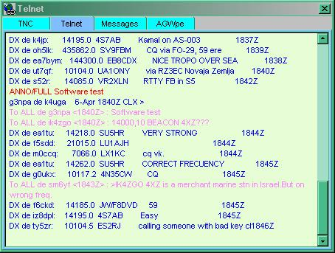

TCW\_6

Left-double-clicking on any line that starts "DX de..." will act in exactly the same way as doing the same in the [DX Spots window](#_topic_DXSpotsWindow1). Left-clicking on any other lines will do nothing.

### 3.1 Freezing Spots

From version 3.45.0 onward the 'feel' of the Telnet window, TNC, AGWpe and Local Host tabs of the Cluster Window has been changed. Receiving text is no longer being suppressed while typing a message in the lower part of the window.

Mouse wheel activation, or a single left click, now freezes incoming spots for 10 seconds. This should be enough time for the user to browse the history and/or double-click on a line. Following a double-click, the freeze on activity in the Telnet pane is cancelled. During this freeze time, incoming spots are still being decoded and displayed on the [DX Spots window](#_topic_DXSpotsWindow1).

Those using a mouse configuration where Windows does not see mouse wheel events cannot simply scroll the wheel one click to freeze the selected pane on the Cluster window. However they can now make a single left mouse click instead.

During the period that the software holds off incoming spots, the Cluster window header line changes to display the fact that a "Freeze" is in operation. The series of dots following the word "Freeze" will display a count down to the freeze being released automatically if no further action is taken.

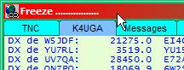

TCW\_20

Right-clicking on the Telnet panel displays a pop-up menu allowing the operator to both configure and operate the Telnet panel. This menu is divided into seven sections that each contain a set of menu items. [Section five](#3.6_Section_Five) displays up to ten packet cluster shortcuts that are manually entered by the user using the "Cluster shortcuts" menu item of [section six](#3.7_Section_Six). If no cluster shortcuts are defined, there will be no menu items displayed in [section four](#3.5_Section Four  ).

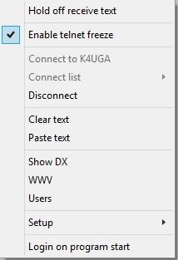

TCW\_7

### 3.2 Section One

**Hold off receive text**

This is a toggled menu item. When checked, the display of received text stops. When cleared, the display of received text starts.

### 3.3 Section Two

**Enable telnet freeze**

When checked the display is frozen until the timer expires when the mouse pointer is positioned within the pane. Incoming spots are buffered and the screen updated when the freeze time expires.

### 3.4 Section Three

### 3.4.1 Connect to

This is a toggled menu item. If there is not a current Telnet connection then this menu item is enabled and provides the capability to connect to the call sign defined by the "Set as defaults shortcut" button of the [Setup Remote Hosts](#3.7.2_Setup_Remote_hosts) section of the Telnet Setup menu. If the Telnet panel is currently connected, this menu item is disabled.

### 3.4.2 Connect list

This is a toggled menu item. If there is not a current Telnet connection then this menu item is enabled and, when clicked, displays a drop-down list of possible connections defined by the user using the [Setup remote hosts](#3.7.2_Setup_Remote_hosts) menu item of the Telnet Setup menu. . If the Telnet panel is currently connected, this menu item is disabled.

### 3.4.3 Disconnect

This is a toggled menu item. If there is not a current Telnet connection then this menu item is disabled, if there is a current Telnet connection, then this menu item is enabled, and when clicked, will disconnect.

## 3.5 Section Four

### 3.5.1 Clear text

Clears all text from the Telnet panel.

### 3.5.2 Paste text

Pastes any text in the Windows clipboard into the Telnet panel at the current cursor position.

### 3.6 Section Five

* + Show DX
  + Show WCY
  + Show WWV

In this example the user, using the [Setup Telnet shortcuts](#3.7.3_Setup_telnet_shortcuts) menu item of the Telnet Setup menu, has adapted these menu items.

### 3.7 Section Six

This menu item allows the user to setup the telnet scripts, remote host addresses and shortcuts.

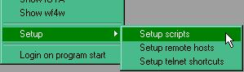

TCW\_8

### 3.7.1 Setup Scripts

Selecting this menu item displays the Setup telnet script dialog box. This box enables the user to identify to Logger32 the prompts that are sent by the default Telnet host, and to define responses to each of those prompts. This effectively enables an automatic login process to the default host.

Prompts sent by the host are detailed in the left-hand columns, and the Logger32 responses to each of those prompts are detailed in the right-hand column.

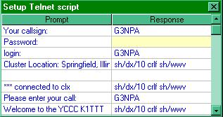

TCW\_9

**Note**: A script may contain more than one command per line by the addition of "crlf" between commands like this:

Command1 crlf command2 crlf command3

or

SH/DX10 crlf SH/WWV/5

### 3.7.2 Setup Remote hosts

This menu item displays the Telnet Setup dialog box that enables the user to define a list of remote host shortcuts that appear when the Connect List menu item of the Telnet panel pop-up menu is displayed. One of the entries in this list may also be designated as the default host and will appear in the "Connect to" menu item of the Telnet panel pop-up menu. For links to DX cluster lists, see the section [Links and Reflectors](#Link:_DX_Packet_Clusters).

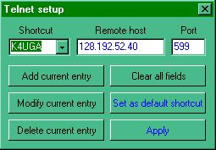

TCW\_10

**Add current entry**

Enters the current entry to the list of stored hosts

**Modify current entry**

Enables the current entry to be edited

**Delete current entry**

Deletes the current entry

**Clear all fields**

Clears all fields allowing new entries to be made

**Set as default shortcut**

Sets the current entry as the default "Connect to" host.

### 3.7.3 Setup telnet shortcuts

This menu item displays the Telnet shortcuts dialog box that permits the user to enter up to ten telnet commands. Each entry consists of plain text in the left column that will be displayed as the menu item of Section five and, in the right column, the telnet command to be sent to the telnet station for that menu item.

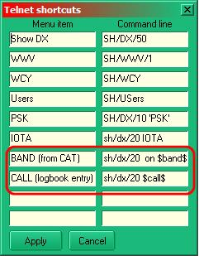

TCW\_11

The use of the macros $call$ and $band$ are supported in the Telnet window.

The callsign and band substitutions are based on the current call and radio frequency as shown in the [Logbook Entry window](#_topic_LogbookEntryWindow). The user can click on a DX spot and select one of the macro menu items and show all spots for that callsign or band.

Examples are shown in TCW-11 above.

The user can assign any name to these shortcuts and they will appear in the main menu of the Telnet window.

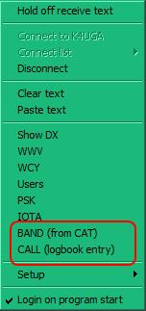

TCW\_19

As with scripts, shortcuts also support multi-line commands. Simply add " crlf " in thecommand text string (note the space before and after the letters crlf). Like this:

command1 crlf command2 crlf command3

or

SH/DX/10 crlf SH/WWV/5

### 3.8 Section Seven

### 3.8.1 Login on Program Start

 If checked, the Telnet session will automatically log on to the default telnet cluster when Logger32 is started.

### 3.8.2 Automatic Re-connect

A first attempt to provide some reasonably intelligent Telnet auto-reconnect has been added to Logger32 but note that this facility will ONLY work IF you have the "Login at program start" option checked.

The logic is thus: If you have Login on program start checked AND the Login completed without error then an internal flag OKtoReconnect is raised.

When Telnet sees an error code 10053 it does one of two things:

* + If OKtoReconnect is raised then the error message is suppressed and the reconnect process starts (and continues trying every minute). This should take less than two minutes from the time the Internet connection is re-established; or,
  + if OKtoReconnect is not raised, then the 10035 message is displayed and the Telnet port is closed. If (and only if) a successful connection to a Telnet cluster was automatically initiated on start of Logger32 then if/when Logger32 receives an error 10053 (a generic 'lost connection' message) on the Telnet port then it will ping the telnet cluster every minute.

If/when the Telnet cluster is detected, then an auto-connect is attempted.

If the above occurs then the Telnet window will clear and the reconnection progress messages shown below will be displayed.

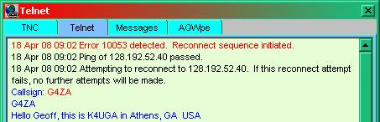

TCW\_15

## 4.0 MESSAGES PANEL

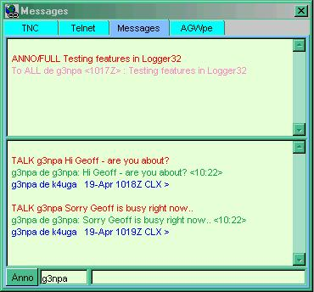

TCW\_12

The Messages panel displays "Announce" messages in the upper portion of the panel, while the lower portion displays talk messages that are addressed to you, (as defined in MYCALLSIGNS on the [DX Spots window](#_topic_DXSpotsWindow1)).

If you need to capture anything from either of the windows then click, hold and drag the cursor to highlight the required text and then release the mouse button. The highlight will then disappear but the text will have been stored on the Windows Clipboard and it can be pasted where desired.

Talk messages are messages sent directly to you from another user of the same cluster. For example, you and a friend are watching for a band opening on 6 meters. If one of you sees the opening he can send a talk message to the other direct without other users on the cluster seeing it.

At the bottom of the window are two fields: one small [bottom left] and other somewhat larger [bottom right]: the small field is used for talk messages and will contain the call sign of the person to which you wish to communicate. (See below). The larger field is for text (message) entry.

### 4.1 To send an Announce Message

To send an Announce message, type your message (in the larger text field - bottom right), and click the <**Anno**> button.  Text (if any) in the smaller field is ignored.

### 4.2 To send a Talk Message

In the small field, type the call sign of the station you want to talk to. This will remain for the Logger32 session unless edited, so talking to someone becomes just a matter of typing in the message and pressing the <**Enter**> key. The message will be sent via the Cluster or Telnet, depending on which you have selected. This should be reasonably intuitive to use.

If someone talks to you, you will see it in the lower half of the window. Instead of typing in the callsign as mentioned above, click the mouse anywhere on the received line of text, and it will magically populate the smaller text field with the call sign of the station that sent you the talk message, ready for you to reply.

Right-clicking on the Messages window brings up a pop-up menu that allows the user to select where the messages are being received from, Telnet, Cluster and / or AGWpe.

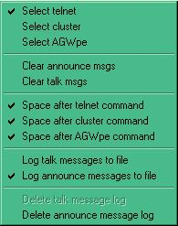

TCW\_13

### 4.3 To Clear Messages

The Clear announce messages and Clear talk messages menu items clear the panel of text.

The Space after telnet, cluster or AGWpe command menu items allow you to insert an unseen space in the command line depending on the command structure required for their connection.

Talk and Announce messages can be logged to a file if required by checking the appropriate menu option. The files used for this logging are called "TalkMessages.txt" and "AnnounceMessages.txt" and will  be placed in the default Logger32 directory. A delete file option is also available.

**Note**: No facility is provided to open/read these files from within Logger32. It is suggested that the user create a desktop shortcut for this purpose.

5.0 AGWpe PANEL

The AGWpe panel allows for the use of this mode to connect to a cluster, see the [AGWpe Packet Engine](#_topic_AGWPacketEngine) topic for details. The right-click options are similar to the Telnet Panel options.

## 6.0 LOCAL HOST PANEL

The 'Local Host panel is intended to add a simple (see definition of simple below) TCP Socket to allow the user to connect to 127.0.0.1 on the local machine for connection to a VE7CC Cluster, CW Skimmer, or whatever may come along.

This panel can also be used as a second Telnet panel.  In this role it provides some additional capabilities, notably "de-duping" the spot stream coming from Telnet DX clusters that provide Reverse Beacon Network (RBN).

**Note**: Definition of simple as used above: No error recovery/reconnect, single address/port choice, single prompt/reply message only.

Information received via this source will appear in the [DX Spots window](#_topic_DXSpotsWindow1) in the same way as data collected via the telnet panel.

Right clicking on the Local Host panel displays a pop-up menu allowing the operator to both configure and operate the Local Host panel as shown below. See section [3.0 Telnet Panel](#3.0_TELNET_PANEL) above for more detailed information.

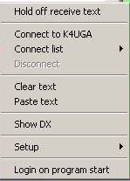

TCW\_16

### 6.1 Section One

**Hold off receive text**

This is a toggled menu item. When checked, the display of received text stops. When cleared, the display of received text starts.

### 6.2 Section Two

### 6.2.1 Connect to

This menu item will show the name of the Telnet address as detailed in the shortcut name mentioned in the set-up window (see below). The option provides the capability to connect to the address selected.

### 6.2.2 Connect list

This menu item will display a small pop-up list of all configured Telnet addresses.

### 6.2.3 Disconnect

If there is not a current connection then this menu item will be disabled. If there is a current connection, then this menu item is enabled, and when clicked, will cause a disconnect.

## 6.3 Section Three

### 6.3.1 Clear text

Clears all text from the Telnet panel.

### 6.3.2 Paste text

Pastes any text in the Windows clipboard into the Telnet panel at the current cursor position.

### 6.4 Section Four

In this example the user, using the Setup Telnet shortcuts menu item of the Telnet Setup menu, has adapted the Show DX command.

### 6.5 Section Five

### 6.5.1 Setup

Here the user may set up the host address, port number and the shortcut name that will appear in the menu. In addition the reply to a specified log in prompt may be entered.

The screenshot below shows the default conditions

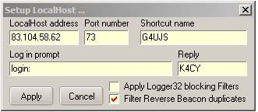

TCW\_17

### 6.5.2 Apply Logger32 blocking Filters

An option in the Telnet Local host menu allows for the main Telnet blocking filters to be used or not as desired for this window as can be seen in the screenshot above.

The Local Host can be used to connect to a regular Telnet Cluster. So, it is possible to connect to K4UGA as (say) G3NPA under the Telnet tab, and simultaneously connect to K4UGA as (say) G3NPA-1 under the Local Host tab.

Don't forget to set the Telnet and Local Host Callsigns to match - Right Click on the [DX Spots Window](#_topic_DXSpotsWindow1), Setup | Callsigns - so that direct messages addressed to these callsigns ring the bells.

With this new option off (do not apply Logger32 blocking filters to the Local Host DX Spots), you can now apply Logger32 DX Spot blocking filters to the (say) G3NPA connection, and DX Cluster specific filters to (say) G3NPA-1. For example, on (say) G3NPA, block all bands except 6M and all originating Continents except Europe. On the (say) G3NPA-1 connection you can set the K4UGA filters to block all 6M DX Spots.

**Note** - that the font for entries in the [DX Spots window](#_topic_DXSpotsWindow1) can be color coded so it is obvious for which source the information originates and there are NO double entries in the DXspot table.

For the adventurous, this adds a whole new dimension to DX Spot blocking/filtering.

### 6.5.3 Filter Reverse beacon duplicates

Checking this line will enable the following criteria: If the DX Spot has "-#" in the DX Spot originators callsign, Logger32 will check the last 100 dx spots to see if the callsign has been spotted within 1kHz.  If it has, it is filtered.

### 6.6 Section Six

**Login at program start**

If checked the Telnet session will automatically log on to the default telnet cluster.

### 6.7 Using the Local Host panel with CWSkimmer/VE7CC

See the [separate section](#_topic_UsingtheLocalHostPanelwithCWSkim).

## 7.0 Using the Telnet Window to Telnet to Other Computers

# Mike Davies G0WZY

The Telnet panel provides a connection to a DX cluster via the Internet. This works 100% and is the primary use of this window.

It can be used to Telnet to other computers (example: on your own LAN) but in this case Logger32 has to work harder, and there are implications and issues arising that need to be explained here.

Logger32 does not provide a full-blown Telnet terminal, and the remote host may complain about this in several ways.

* + The first way the remote host may complain is by outputting some 'garbage' before the initial prompt. The prompt may also become scrambled. This is the remote host trying to negotiate with Logger32 about how the Telnet link will be used. Logger32 responds in every case with WON'T and DON'T;
  + Then, after you have logged in, you may get messages from the remote host such as:  
    - unknown terminal "network"; or
    - WARNING: terminal is not fully functional.

This is a direct consequence of the Telnet negotiation. Because of this, some programs may not run and behave as you might normally expect; or

* + If your login to the remote system involves entering a password, then, because Logger32 echoes keyed input in a different color, Logger32 will echo this password in a readable form. This may be a problem or security issue for some people.

So if there are these limitations, why would you want to use the Telnet window of Logger32 in this way? The PC on your LAN may be a node in the DXCluster, or it may have radios connected to it that you can remotely use to start a packet radio session with your local DXCluster. Logger32 will allow you to do that.

Logger32 does not provide a full function Telnet terminal. Remember that and you will not be disappointed.

The following screenshot shows some of these problems.

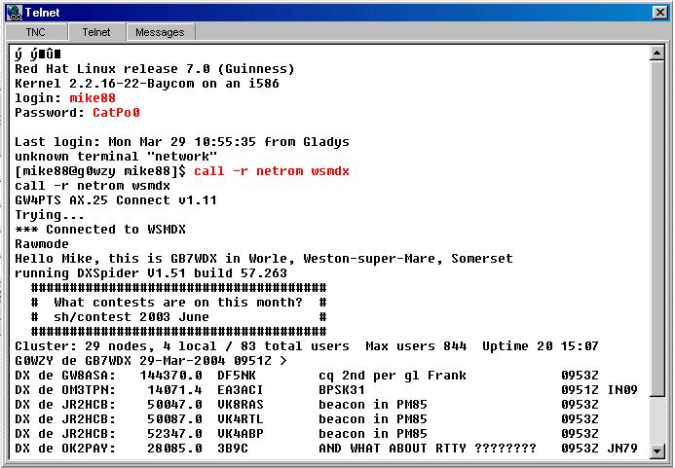

TCW\_14

*Created with the Personal Edition of HelpNDoc:* [*Free help authoring environment*](http://www.helpndoc.com/help-authoring-tool)

**Using the Local Host Panel with CW Skimmer**

# Geoff.Anderson G3NPA

## 1.0 GENERAL

For the purposes of this section it is assumed that you have already got CW Skimmer loaded and running to your satisfaction according to the details available with the program and have read the appropriate paragraphs in the [Telnet Cluster Window](#_topic_TelnetClusterWindow) topic.

You will need to use a virtual port splitter to feed the radio frequency information to CW Skimmer as well as Logger32 in order to obtain useful frequency information. In my own case I use the secondary [CAT](#CAT) port available in the microHAM router software to drive CW Skimmer but I suspect that the same end result may be achieved by using software such as VSP Manager or the like. See <http://k5fr.com/ddutilwiki/index.php?title=VSP_Manager>.

If you want to see the output from CW Skimmer in the [DX Sopts window](#_topic_DXSpotsWindow1) then you have to ensure that CW Skimmer is set to enable the Telnet server using port 7300. In CW Skimmer use option View | Settings | Telnet and check "Enable Telnet Server" as shown below.

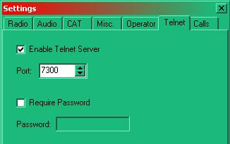

LHP\_1

In addition, in Logger32 right click on the [Local Host panel](#6.0 LOCAL_HOST_PANEL) of the [Telnet Cluster window](#_topic_TelnetClusterWindow) and select the setup menu item.

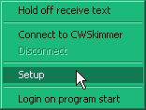

LHP\_2

Ensure that the Local Host will look at the correct address and port when a connection command is given.

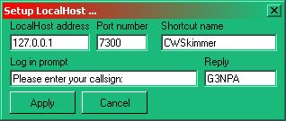

LHP\_3

A screenshot of Local Host running with CW Skimmer is shown below. Note that in this case my copy of Skimmer is set up using my second callsign of G4ZA just to show a distinction in the dxspot table.

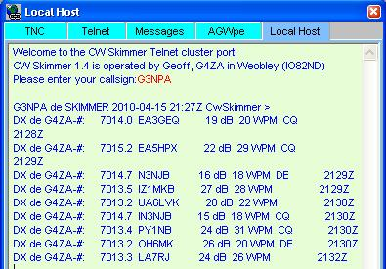

LHP\_4

Here is the resulting appearance of the [DX Spots window](#_topic_DXSpotsWindow1).

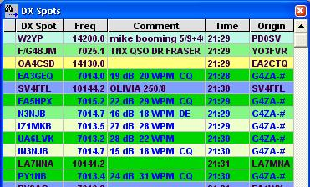

LHP\_5

**Note**: Spots originating from the Local Host show with a blue text whilst those from the normal telnet cluster show with black text. In addition all spots from CW Skimmer show the origin as being from G4ZA-#. For information, the blue text colour mentioned above is set from the right click menu from the [DX Spots window](#_topic_DXSpotsWindow1) Setup | Appearance | Local Host spots colour.

DO NOT ATTEMPT TO START/STOP CWSKIMMER AUTOMATICALLY FROM WITHIN LOGGER32. DO NOT ATTEMPT TO AUTOCONNECT TO CW SKIMMER.

While Logger32 can start CW Skimmer, it can not auto login or stop CW Skimmer.

If you try to connect with CW Skimmer/VE7CC or indeed any site/software that isn't running at the time then you will receive the error message below. Use the "logon at program start" option with caution.

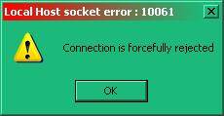

LHP\_6

## 2.0 Local Host & VE7CC

Again it is assumed that you have already got the VE7CC software loaded and running to your satisfaction according to the details supplied with that program.

If you want the output of the VE7CC program to display its data in the Logger32 [DX Spots window](#_topic_DXSpotsWindow1) then you must ensure that VE7CC is set to act as a server.

Using the VE7CC menu items Configuration | Ports/Logging program, enable Telnet using port 7300 as shown below.

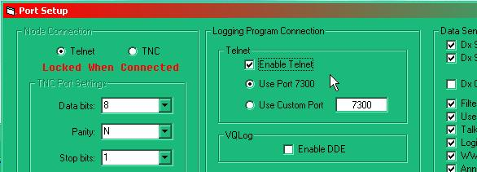

LHP\_7

Then connect via the local host using an address of 127.0.0.1 port 7300. Right-click on the [Local Host panel](#6.0 LOCAL_HOST_PANEL), select "Connect to" and see the response from the VE7CC software.

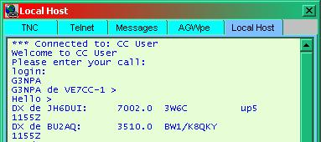

LHP\_8

The screenshot below shows the Logger32 dxspot table. The entries with a black text come from the Logger32 Telnet connection to K4UGA (in this instance) while the entries using a blue text have come from the VE7CC program

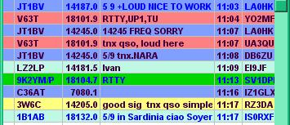

LHP\_9

**Note**:

1. If any DX spot blocking filters have been set in Logger32 then these will apply also to the data coming from VE7CC.
2. Not all spots received from each source will be displayed in the [DX Spots window](#_topic_DXSpotsWindow1) as Logger32 will attempt to prevent unnecessary spot duplication.

*Created with the Personal Edition of HelpNDoc:* [*Create HTML Help, DOC, PDF and print manuals from 1 single source*](http://www.helpndoc.com/help-authoring-tool)

**Tracking Window**

*Created with the Personal Edition of HelpNDoc:* [*Easy EBook and documentation generator*](http://www.helpndoc.com)

**Tracking Window**

# Geoff Anderson G3NPA and Aki Yoshida JA1NLX

## 1.0 GENERAL

The Tracking window displays maps of the world on five tab panels, overlaid with additional data. The five panels are:

* + [Grayline](#3.0_GRAYLINE_PANEL) - Displays the current grayline position;
  + [Satellite](#4.0_SATELLITE_PANEL) - Displays selected satellite orbit data;
  + [DX Spots](#6.0._DX_SPOTS_PANEL) - Displays DX spot information;
  + [IOTA](#7.0_IOTA_SPOT_PANEL) - Displays IOTA spot information: and,
  + [View DX](#8.0_View_DX_Panel) - Displays prefix or IOTA group locations

The tabs that switch the display between the five panels can be set to user preferences. A right-click on any one of the tabs will display the menu below.

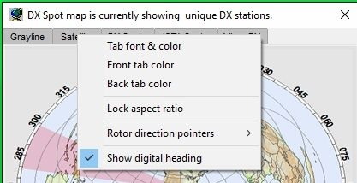

TW\_1

See the [Grayline](#3.0_GRAYLINE_PANEL), [Satellite](#4.0_SATELLITE_PANEL), [DX Spots,](#6.0._DX_SPOTS_PANEL) [IOTA](#7.0_IOTA_SPOT_PANEL) or [View DX](#8.0_View_DX_Panel) panel sections for more detail.

The active and non-active tab colors can be selected as well as the font and text color.

The aspect ratio of any of the maps can be locked to a standard format by checking the menu option. Note that this is a general option and therefore applies to all maps in the Tracking window.

The rotor direction pointer colors and line widths can be set up here. (See the Tracking Window paragraphs in the Setup Antenna Rotor topic and Background Maps paragraphs below for more information).

**Note**: For accurate rotor operation, the map display MUST be in "Azimuthal Equidistant" projection and have the "Lock aspect ratio" menu item checked.

Selecting the “Show digital heading” will open a floating window showing the antenna heading. See the [Rotor Setup](#_topic_SetupAntennaRotator) topic for details.

## 2.0 BACKGROUND MAPS

There are three basic options as to the type of map (and/or its source) to be used:

* 1. Computer-generated Miller projection;
  2. Computer-generated Azimuth Equidistant projection (Great Circle); and,
  3. User-supplied Miller projection.

For 1 and 2 above, there are various options that can be selected before generating the maps. Option 3 ONLY applies to the use of Miller projection maps.

The reader is advised to consult the topic [Background Maps](#_topic_BackgroundMaps) for more detail and to view some examples.

**Note**: The Great Circle maps do not automatically change their perspective if the user changes their QTH settings in Logger32. They must be re-drawn.

Great Circle versions of the maps in the Tracking window (except for the Satellite window) will have the capability of displaying information for the control of computer-controlled rotors. Two pointers are provided:

* 1. The setting of the desired antenna position; and,
  2. Te actual position.

An example is given below:

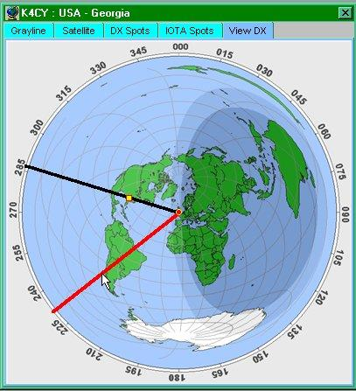

TW\_2

In this particular example, the red line will control the desired direction (in conjunction with a mouse click) and the black line will be the actual antenna bearing (in real time). More information on this can be found in the [Setup Antenna Rotator topic](#_topic_SetupAntennaRotator).

## 3.0 GRAYLINE PANEL

The Grayline panel overlays the world map with three distinct shaded areas defining:

* + Day;
  + Night: and,
  + A selectable transition area between day and night (the Grayline).

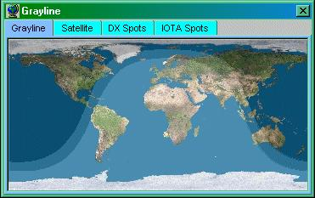

TW\_3

A right-click on this window will display a pop-up menu allowing the operator to:

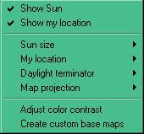

TW\_4

* + Show or hide the sun;
  + Show or hide your QTH marker;
  + Select the size of the sun displayed on the map from one of three sizes;
  + Set up color(s) and size of the QTH location marker;
  + Select the size of the Grayline.;

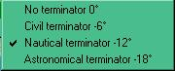

TW\_5

* + Select the type of projection to use as the background map. Please see the topic [Background Maps](#_topic_BackgroundMaps);
  + Select the contrast to be displayed between the three areas; and,

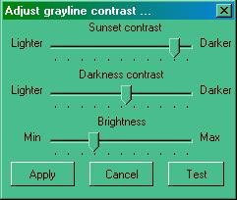  
  
TW\_6

* + Create Custom base maps.

The screen capture of the grayline panel displayed above ([TW\_3](#TW_3)) is showing the daylight terminator set to nautical (-12 degrees). It also uses an external Miller map projection.

## 4.0 SATELLITE PANEL

The Satellite Panel overlays the world map with the optional display of the position, and the predicted track to next Acquisition of Signal (AOS) or Loss of Signal (LOS) of a selected satellite as well as optional details.

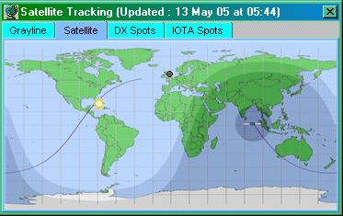

TW\_7

The satellite to be displayed is selected from the drop-down list in the Satellite Data dialog box that will appear when the "Satellite" tab is selected.

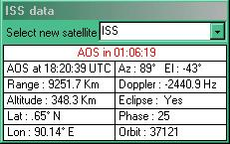

TW\_8

**Note** 1: If this dialog box does not appear, then right-click on the satellite map and check "[Show Satellite details](#TW_9)".

**Note** **2**: The information in this panel will ONLY be correct if you have ensured that:

* + Your [QTH Lat/Long are set properly](#_topic_SetupUserLatandLong);
  + The [Keplerian elements are up to date](#4.7_Load_Keplarian_elements): and,
  + The [computer clock is set correctly](#_topic_StarndardTImeZones).

The satellites given in the [Select new satellite drop-down list](#Satellite_Data_dialog_box) are derived from the import of one or more sets of Keplerian elements described later.

The remaining sections of the data panel show:

* + The time in hours, minutes, and seconds remaining until the next [AOS](#AOS) or [LOS](#LOS) [when the satellite reaches AOS, a new track is drawn from AOS to LOS and the time indicator on the top row changes to show the time remaining to LOS. Once LOS is reached, a new track will be drawn to the next AOS]
  + The azimuth and elevation of the satellite ([Lat and Long must be set correctly](#_topic_SetupUserLatandLong))
  + The Lat/Long of the satellite
  + Additional information such as the range, Doppler shift, eclipse state, phase and orbit number

Right-clicking on the satellite map will display the pop-up menu shown below:

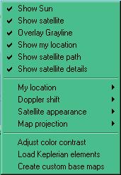

TW\_9

### 4.1 Show Sun/Overlay grayline/Show my location/Show satellite/Show satellite path

Select this menu item to display each item on the map.

### 4.2 Show Satellite details

Select this menu item to display the [Satellite Data dialog box](#Satellite_Data_dialog_box).

### 4.3 My Location

Select this menu item to select the preferred colors and/or size of the QTH marker

### 4.4 Doppler shift

Select this menu item to change the Doppler shift value displayed in the [Satellite Data dialog box](#Satellite_Data_dialog_box). This value can be based on frequencies in the 10M, 2M, 70 or 23 cm bands.

### 4.5 Satellite Appearance

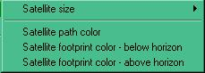

TW\_10

### 4.5.1 Satellite size

Display the satellite in one of three sizes.

### 4.5.2 Satellite path color

Select the preferred color for the satellite path.

### 4.5.3 Satellite footprint color

Set different footprint colors depending on the position of the satellite. The footprint will show the satellite above the horizon when your QTH is contained within the footprint area.

### 4.6 Adjust color contrast

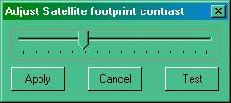

TW\_11

**Note**: The contrast settings for the grayline, the footprint contrast and the colors of the underlying map all contribute to how well or otherwise these colors/settings actually display on your screen. It is recommended that you stick to a darker range of colors for the footprint.

### 4.7 Load Keplarian elements

[See below](#5.0_LOAD_KEPLARIAN_ELEMENTS).

### 4.8 Map projection/Create custom base map

See the topic [Background Maps](#_topic_BackgroundMaps).

## 5.0 LOAD KEPLARIAN ELEMENTS

Right-click on the Satellite map and select the Load Keplerian elements menu item to display the Load Keplarian elements dialog box.

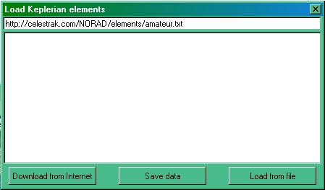

TW\_12

From here you can load elements from the web or from a file you may already have on your computer. Note that the files MUST have the extension of .TXT.

If you download from the Internet, you can change the default location and file before selecting the <**Download from Internet**> button. The file contents will appear in the display portion of the window.

If you wish to load a file from the computer, select the <**Load from file**> button and you will be presented with the Windows FIle Open dialog box. Make your selection and select the <**Open**> button. The file contents will appear in the display portion of the window.

Select the <**Save data**> button and you will be advised on how many satellite elements have been loaded and you will be given the choice to save these to memory. To save the file, select the <**Yes**> button and the data will be saved in a file called KEPS.TXT in the default Logger32 directory.

Logger32 will accept a maximum of 100 element sets.

[The correspondence below is supplied for information. Thanks are given to both Eddie and Thom in allowing this to be reproduced here. The source was the Hamlogger reflector 8th April 2005]

On Fri, 08 Apr 2005 18:55:10 +0000, WI8W wrote:

> For those that do not know...

>

> when updating keps be aware that some websites that carry the updated

> keps are no longer allowed to distribute updated elements under the

> order of the US Government.  It's a security issue from what I undestand.(sic)

>

> I used to get my keps from www.celestrak.com but they are one that is

> not allowed to provide updates.  I was directed by that site to

> www.space-track.org.  This is the official site for keps that is

> authorized to distribute them.  You have to sign up for a free account.

> I assume that they actually do some slight background checking before

> they OK the account.  Mine (sic) application took 3 days to be approved.

>

Further, you can get your account at space track then go to Dr. Kelso's

www.celestrak.com site, click on the "current data" box, then click on the

"Space Track TLE Retriever" line and use this application to automatically

login to Space Track and retrieve current keps. The TLE Retriever will

reformat the keps to a .txt file that Logger32 can directly load. Works

very well here.

--

Eddie, WB4MLE

Before these predictions will be correct for your location, you MUST ensure that your own latitude and longitude have been entered into Logger32. See the topic [Setup User Lat and Long](#_topic_SetupUserLatandLong).

## 6.0. DX SPOTS PANEL

Incoming DX Spots are displayed on the DX Spots Map. The square markers are the spots and the round marker is your home location. The colors and sizes of both types of marker can be defined by the user.

The background map may be changed by right-clicking on the DX Spots map and selecting the [Create custom base maps menu item](#TW_9)..

Left-clicking on a map marker is the same as left-clicking on an entry in the [DX Spots window](#_topic_DXSpotsWindow1), i.e., the radio will QSY. Mouseover Hints are provided.

### 6.1 Operation

When spots are being received, the DX Spot map will become populated.

A Hint box will be displayed as the cursor is passed over each spot. This Hint shows the:

* + Callsign of the station making the report;
  + Callsign of the station heard;
  + Frequency;
  + Prefix;
  + Country name;
  + Zone;
  + Continent;
  + Worked/Confirmed status; and,
  + Time duration of the spot.

**Note**: Some of this information depends on the settings in the [Band/Mode table](#BandMode_Table) and the content of your log.

Currently the maximum number of spots on the map is 99. Any new spots will be displayed, removing older spots.

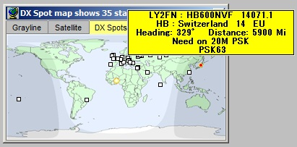

TW\_15

Right-clicking anywhere on the map will produce the setup menu shown below:

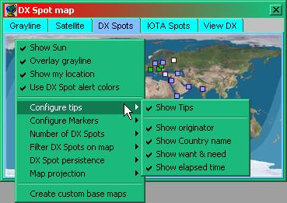

TW\_16

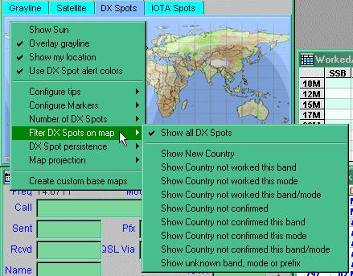

TW\_17

### 6.2 Show Sun

Check to display the position of the sun.

### 6.3 Overlay Grayline

Check to turn on the grayline.

### 6.4 Show my location

Check to display your location (colored circle).

### 6.5 Use DX Spot alert colors

Check to use the colors set up in the Worked/Confirmed color selection.

**Note**: If this is left un-checked, then the marker color will be determined by the setting under "Marker fixed color" in the [Configure Markers](#6.7_Configure Markers) option.

### 6.6 Configure tips

Select the Show tips menu item to show the mouseover tooltips on the DX Spots map. Once checked you can then select any combination of:

* + Show heading;
  + Show originator;
  + Show comments;
  + Show elapsed time;
  + Show country name; and
  + Show want & need.

### 6.7 Configure Markers

Select the colors for the various markers and borders and a size to be used by all markers. A range of four marker sizes is available.

**Note**: The fixed marker color is used to display DX Spots which do not meet any of the colored background criteria.

.

### 6.8 Filter DX Spots on map

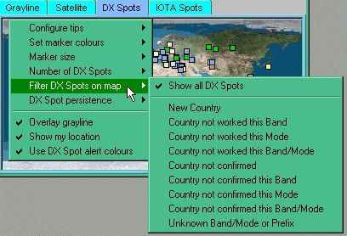

TW\_18

The user can selectively display spots as listedon the pop-up menu.

**Note 1:** If you want to display all spots but NOT ones where you have the country/band/mode fully confirmed, then check all the selections rather than "show all DX spots".

**Note 2:** If you have selected "Show all DX Spots", fully confirmed country/band/mode spots will show. The default color for these particular spots will be the default set under the "Set marker color" menu option. In order to distinguish between these particular spots and others, then it is suggested that you set the default marker color to one that you do not use in the "Worked/Confirmed" range.

### 6.9 Overlay Grayline

Check to turn on the grayline.

### 6.10 DX Spot persistence

Select the preferred time for the displayed spots to remain visible.

### 6.11 Show my location

Check to display your location (colored circle).

### 6.12 Use DX Spot alert colors

Check to use the colors set up in the Worked/Confirmed color selection.

## 7.0 IOTA SPOT PANEL

Incoming [IOTA](#IOTA) Spots are displayed on the IOTA Spots Map. The square markers are the spots and the round marker is your home location. The colors and sizes of both types of marker can be defined by the user.

The background map may be changed by right-clicking on the IOTA Spot Map itself.

Left-clicking on a map marker is the same as left-clicking on an entry in the [DX Spots window](#_topic_DXSpotsWindow1), i.e., the radio will QSY. Mouseover hints are provided. There is one major difference however. Clicking on an IOTA spot (from the map) will populate the IOTA edit box in the [Logbook Entry Window](#_topic_LogbookEntryWindow) if it is in use. Clicking on the DX Spot (from the DX Spot map) WILL NOT fill in the IOTA edit box.

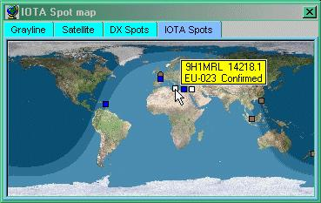

TW\_19

### 7.1 Operation

When spots are being received, the IOTA Spot map will become populated from either information collected from the comments fields in the incoming data OR from the received callsign IF the prefix is also uniquely an IOTA reference.

A note of caution: Logger32 does its best to extract the IOTA information from the DX spots, but there will be occasions where this will fail OR it will pick up erroneous information. It is up to the operator to make sure that logged data is correct.

A mouseover Hint will be displayed as the cursor is passed over each spot. This Hint displays the:

* + Callsign of the person making the report;
  + Callsign of the station heard;
  + Frequency;
  + Prefix;
  + Country name;
  + Zone;
  + Continent;
  + IOTA Island name; and
  + Whether it is a station required for the log.

Right-clicking anywhere on the map will produce the setup menu as shown below:

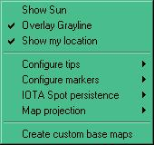

TW\_20

### 7.2 Show Sun

Check to show the position of the sun.

### 7.3 Overlay Grayline

Check to turn on the grayline.

### 7.4 Show my location

Check to display your location (colored circle).

### 7.5 Configure Tips

Select the Show tips menu item to show the mouseover Hints on the DX Spots map. Once checked you can then select any combination of:

* + Show heading;
  + Show originator;
  + Show comments;
  + Show elapsed time;
  + Show country name; and,
  + Show want and need.

### 7.6 Configure Markers

Select the colors for the various markers and a size to be used by all markers. A range of four marker sizes is available.

The Set marker colors menu item allows the user to set the marker colors based on Worked, Confirmed, Submitted and Granted.

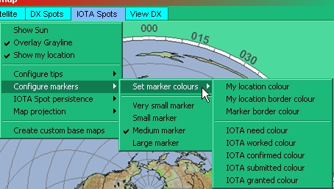

TW\_24

7.7 IOTA Spot persistence

Select the preferred time for the displayed spots to remain visible.

### 7.8 Map Projection

See the topic "Background Maps.

### 7.9 Important Note on IOTA Tooltips

Logger32 does its best to retrieve the IOTA information from the DX spot comment field, but this is not always in the correct format. Logger32 will correct for many of the common mistakes and when it does so, it will place a "?" into the tooltip in order to draw the operator's attention to the fact that the data may not be correct.

## 8.0 VIEWS DX PANEL

The View DX Panel is designed to display information, which is already available on the computer (the DX Spot Panel displays information derived from some outside source). Currently it will show one of two things on the map, the location of:

* + An entered prefix (or full callsign); and,
  + The center of a specified IOTA Group.

To use either of these capabilities it is not necessary to have the Tracking window loaded (it will load automatically). If the Tracking window is loaded, the tab will automatically switch to the View DX tab.

Like all other maps in the Tracking Window you can select one of two forms of presentation. Refer to the topic Background Maps.

### 8.1 To Display the Location of a Prefix

The View DX tab of the Tracking window has a "real time" feel based on what is entered into the [Logbook Entry window](#_topic_LogbookEntryWindow) Callsign field, provided that the tab is already open. Simply enter a callsign or prefix into the [Logbook Entry window](#_topic_LogbookEntryWindow) and the location will show up immediately on the selected map.

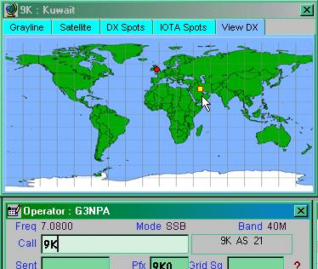

TW\_21

An additional shortcut, the <**Ctrl+V>** keys has been added to the Logbook Entry window menu. If a callsign is entered, selecting the <**Ctrl+V**> keys will show the location of the station on the View tab of the Tracking window. If you are not displaying the View DX map at the time, Logger32 will bring up the correct display.

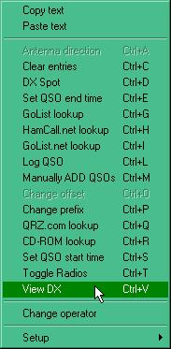

TW\_22

### 8.2 To Display the Location of a Specified IOTA Group

From the IOTA search list (see Additional Information), simply highlight the island group you wish to view. If the map doesn't immediately appear, then try right-clicking on the <**Show**> button.

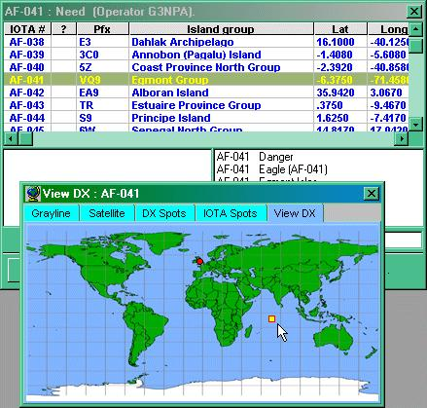

TW\_23

*Created with the Personal Edition of HelpNDoc:* [*News and information about help authoring tools and software*](http://www.helpauthoringsoftware.com)

**Background Maps**

# Geoff Anderson G3NPA

## 1.0 GENERAL

Logger32 can now support the display of information on two types of world map projections, the:

* + [Miller cylindrical](#1.1_Miller_Cylindrical_Projection); and,
  + [Azimuthal Equidistant](#1.2_Azimuthal_Equidistant_Projection).

The following information applies to most of the background maps in Logger32, including the four maps in the [Tracking window](#_topic_TrackingWindow1), the [NCDXF map](#_topic_NCDXFBeaconsWindow) and the IOTA map. The map in the HamCap window is not included.

## 1.1 Miller Cylindrical Projection

This form of projection gives the mapping of latitude and longitude as parallel horizontal or vertical lines, evenly or equally spaced in each direction.

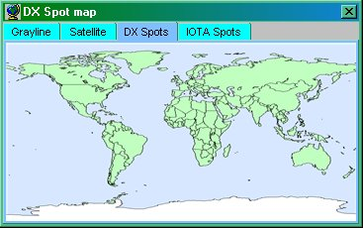

BM\_1

1.2 Azimuthal Equidistant Projection

This form of projection is perhaps better known in the amateur world as Great Circle mapping. Your QTH should appear in the center of a circular map with radial distances correctly scaled. The azimuth angles show the Great Circle bearing to the point of interest.

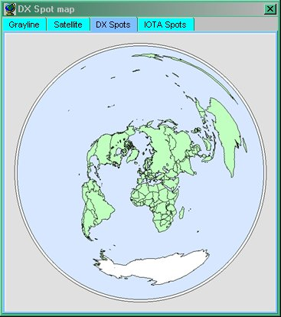

BM\_2

The examples given above show the basic default mapping based on a QTH close to London. It should be noted that the Great Circle maps do not automatically change their perspective if the user changes their QTH settings in Logger32. They must be redrawn by re-creating the map.

## 2.0 CREATE NEW MAPS

By right-clicking on any of the maps you will obtain a set-up menu shown below. Note that each menu is slightly different from one another but all allow for the selection of map type, and options for the grayline, your QTH, sun position, etc.

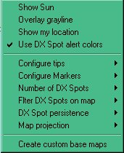

BM\_3

### 2.1 Base Map Projection

It is this menu item that will allow the selection of the Base type of map you wish to display. Logger32 will remember how you configure your map set-up for each of the available map windows, so you can have Miller maps for some and Great Circle maps for the rest.  In addition, the overlaying of the grayline and other items are all available for each map.

### 2.2 Customize Base Maps

Having selected your map preference, you can then customise it. You can alter the land, sea, background and the compass (if azimuthal projection) colors, show the meridian lines and or introduce a topographical overlay. You can even use an external map if you prefer for Miller projection maps only. Select the [Create custom base map](#2.0_CREATE_NEW_MAPS) menu item to display the set-up panel as shown below.

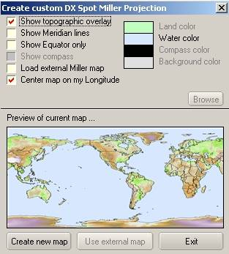

BM\_4

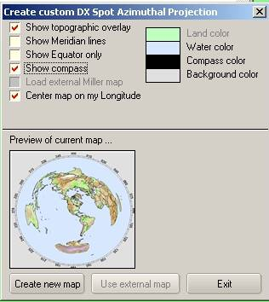

BM\_5

Select your desired options and the <**Create new map**> button.  To select color preferences, click on the appropriate color in the setup window (Land, Water, Compass, Background) to raise a standard color palette and select the colors you desire.

If you are going to generate a map with the topographical overlay, then this does take some time to produce. Please be patient. Progress is shown on the progress bar located to the top right of the main window.

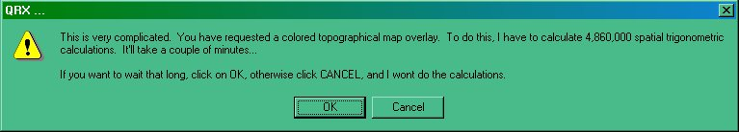

BM\_6

## 3.0 USING OTHER MAPS

If you wish to use a pre-prepared map in Miller projection, then select the "Load external Miller map" check box and the <**Use external map**> button. Maps should be linear in both latitude and longitude and be in a .bmp format. The original map (map.bmp) provided with earlier versions of Logger32 can be used this way. Please note that this only applies to the Miller projection. There is NO provision for the use of such maps for conversion to the Great Circle projection.

[Technically the file can be a bitmap (.bmp) file, icon (.ico) file, cursor (.cur) file, run-length encoded (.rle) file, metafile (.wmf) file, enhanced metafile (.emf), GIF (.gif) file or a JPEG (.jpg) file.  In practice, the file will probably be a .bmp, .gif or a .jpg file. The map can be of any size (Logger32 will shrink/expand the file as necessary). As with aerials, bigger is better (resolution is lost trying to stretch a very small picture). The map must be a Miller cylindrical projection (It must be a projection that has equidistant latitudes from the equator to the poles).].

Some example maps are shown below:

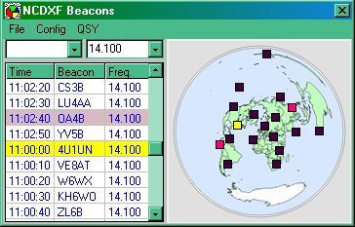

BM\_7 - NCDXF Beacons shown on the default Great Circle map

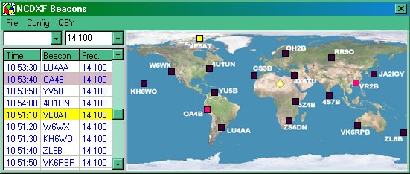

BM\_8 - NCDXF beacons shown on an external Miller map

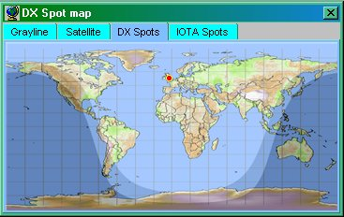

BM\_9 - DX Spots map set up using the Miller projection with topographical, Lat/Long QTH and Grayline overlays.

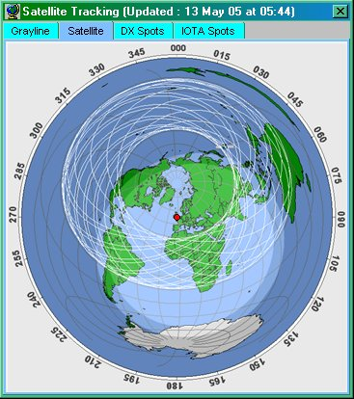

BM\_10 - Satellite tracking set up on a Great Circle projection ( Azimuthal) using self-selected colours for sea and land with Lat/Long, grayline and QTH overlays AND the Hubble spacecraft orbits. (The spacecraft is at an Az angle of 030 degrees close to Japan.)

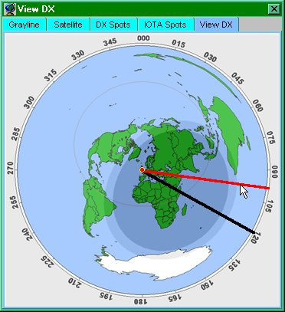

BM\_11 - DX View set up on a Great Circle projection with compass bearings using self selected colors for the sea and land with just the equator overlay. The red and black lines radiating from the center are the actual angle (black) and the desired antenna angle (red).

*Created with the Personal Edition of HelpNDoc:* [*Free EPub producer*](http://www.helpndoc.com/create-epub-ebooks)

**Sound Card Data Window**

*Created with the Personal Edition of HelpNDoc:* [*Free EPub producer*](http://www.helpndoc.com/create-epub-ebooks)

**Sound Card Data Window**

# Jim Hargrave W5IFP

## 1.0 GENERAL

In Logger32, it is the Sound Card Data window that provides the functionality previously found in [Zakanaka](#Zakanaka). The Sound Card Data window is the interface that provides [PSK31](#PSK31/63/125), [PSK63,](#PSK31/63/125) [PSK125](#PSK31/63/125) and [RTTY](#RTTY) capabilities through an interface to the computer sound card and a radio connected to Logger32 through a serial (Com) port.

Logger32 is an extremely efficient way of operating PSK31, PSK63, PSK125 and RTTY.

Two engines provide the Sound Card Data window digital modes:

* + The MMVari engine, written by Makoto Mori, JE3HHT that supports PSK and RTTY; and,
  + The MMTTY engine, also written by Makoto Mori, JE3HHT. This RTTY engine supports a number of baud rates, shift widths, and mark/space selections.

References to PSK31, PSK63 and PSK125 apply to the MMVARI data engine.

References to RTTY can apply to either the MMVARI and MMTTY data engines.

## 2.0 SOUND CARD SELECTION

Logger32 allows for separate hardware selection of the received and transmitted signals. Each Sound Card program, MMTTY and MMVARI have an independent selection process described below. You will also find additional information in the [SO2R support](#_topic_SingleOperatorTwoRadiosSO2RSuppo), [SO2V support](#_topic_SingleOperatorTwoVFOsSO2VSupport), [Support for a second Sound Card](#_topic_SupportforaSecondSoundCard). and [Calibrating the Sound Card](#_topic_CallibratingtheSoundCard) topics.

### 2.1 MMTTY Sound Card Selection

Open the Sound Card module in the MMTTY mode and click on the MMTTY setup icon. It's the little wrench symbol (ninth from the left) on the upper task bar.

Click on the "Sound Card" Tab. (MMTTY Version 1.66g and later) and make your selection for the Receive and Transmit audio sources. The following example is a typical setup.

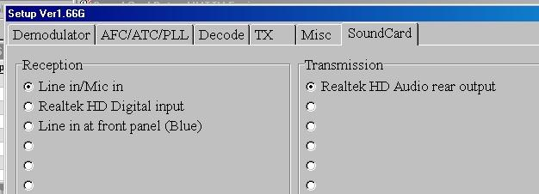

SCDW\_46

After you have selected the Receive and Transmit audio sources. Select on the "Misc" tab and select the audio channel to be used. In the example below the left channel has been selected.

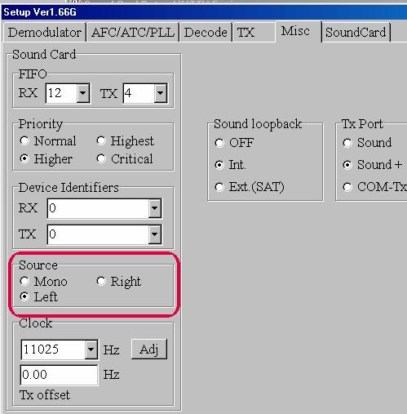

SCDW\_47

After making the above selections, select the <**OK**> button at the bottom of the setup window. In order to permanently save these setting for the next time, on the Sound Card Data Window menu, select the Mode | MMTTY Engine | Save current profile settings menu items.

If you have [SO2R](#_topic_SingleOperatorTwoRadiosSO2RSuppo) or [SO2V](#_topic_SingleOperatorTwoVFOsSO2VSupport) setup on your system, then you need to select the Sound Card Data window menu SO2R or SO2V menu items and open the SO2R/SO2V second MMTTY program. Repeat the above Sound Card setup process for the SO2R/SO2V application.

### 2.2 MMVARI Sound Card Selection

Open the Sound Card module in the MMVARI mode. On the Sound Card Data window menu, select the Settings | MMVARI settings | Sound Card setup menu items. Make your selection of Sound Card sources for Input and Output audio signals and select the <**Apply**> button.

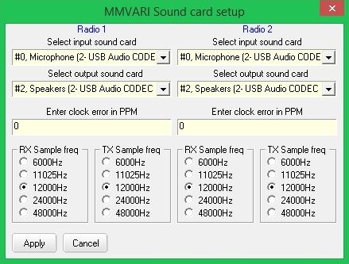

SCDW\_48

Now select the Settings | MMVARI settings | SO2R/SO2V audio channel menu items and select the audio channel for Radio #1. If you are setup for SO2R or SO2V, then the opposite audio channel will be automatically selected when the Radio #2 or sub-receiver is active. If you setup different sound cards for each radio, then the system will select the appropriate sound card when you switch radios.

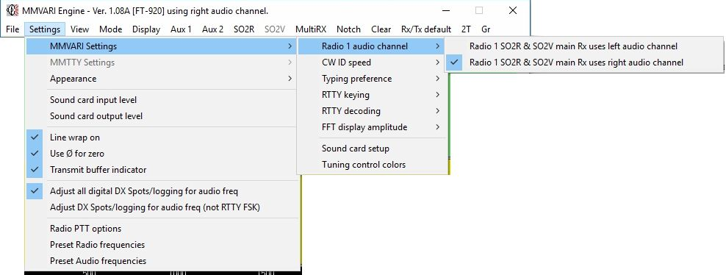

SCDW\_49

The above MMVARI selections will automatically be saved when you exit the respective setup child window.

Now the last step in the Sound Card selection process is to set the volume controls. This can be accomplished in either the MMVARI or MMTTY mode. From the Sound Card Data window menu, select the "Settings | Sound Card input Level" menu items. This will open up the appropriate system volume controls. To avoid distortion and over modulation, it is suggested these setting be around the 50% level as a good starting point.

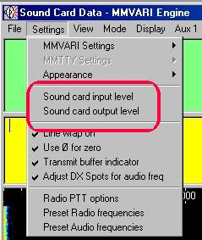

SCDW-50

While operating in the MMVARI mode, you can see the Sound Card currently in use by placing the mouse cursor over the Audio box in the lower status line (Second pane from left). The selected Sound Card will display in a pop-up Hint while in Receive or Transmit mode.

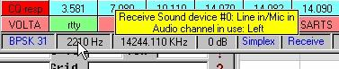

SCDW\_51

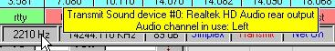

SCDW\_52

The Sound Card Data window provides the capability for:

* + One-click entry of callsigns for use in logging and in macros;
  + Presentation of frequency information in the Sound Card Data window (requires a radio that communicates with Logger32 via the serial port); and,
  + Automatic entry of data from the RX screen to Logger32.

There are several ways of using Logger32 and the Sound Card Data window. The choice will determine what features are available:

* + Communication may be set up between the radio and the computer. This lets Logger32 control the radio, display the radio frequency, and do a number of special functions;
  + The Sound Card Data window has the capability to operate in [PSK31](#PSK31/63/125), [PSK63](#PSK31/63/125) and [RTTY](#RTTY); and,
  + In RTTY mode, it is possible to operate [AFSK](#AFSK) or [FSK](#FSK).  FSK has certain advantages, but some advanced features are only available using AFSK

The Sound Card Data Window provides PSK31/PSK63/[PSK125](#PSK31/63/125), [BPSK](#BPSK31/63/125), and RTTY capabilities to the operator with minimal hardware.

Most program settings made from the Sound Card Data window menu remain the same in all modes: when you set a feature in one mode, it remains in that setting for other modes. Screen operations (like fonts, colors, etc.) also work this way. However, this is not true for the Macro buttons. Macro buttons are the same for PSK31, PSK63 and PSK125 modes, but you can have an entirely different set of buttons for RTTY. See the topic [Programmable Buttons](#_topic_ProgrammableButtons) for more information.

## 3.0 DX SPOT OFFSET

Logger32 has the option of automatically computing the correct offset for DX Spots when they are selected in the [DX Spots window](#_topic_DXSpotsWindow1). This feature works when radio control is active and the Sound Card Data window is open. When the operator clicks on a DX Spot, Logger32 will make a series of checks. It looks at the spot frequency and compares it to the [Band Plan](#_topic_SetupBandsandModes). If the sound card is open and the spot is determined to be a digital mode then the system will command the radio to the spot frequency plus/minus the appropriate offset. This function will position the signal at the user-defined default frequency and will be reflected on the waterfall or spectrum display.

A detailed description of this function can be found in the DX Spots window topic.

To activate the automatic offset feature, select the Sound Card Data window menu Settings menu item and place a check mark on the Adjust DX Spots for audio freq sub-menu item.

**Note**: This option will place the Spot frequency at the user defined Audio preset. DX Spot sent by Logger32 will use this frequency. The exact frequency will be posted in the lower status bar, 3rd pane. When this option is selected Logger32 assumes the DX Spot frequency is the actual MARK RF Frequency.

## 4.0 SOUND CARD FEATURES

The following screen captures have most of the Sound Card Data window features implemented. New users may want to look this over to get an idea of where the controls and displays are located.

The Sound Card Data window consists of eight sections:

* + The Title bar;
  + The Main Menu;
  + The RX window;
  + The Splitter bar;
  + The TX window;
  + The Radio Frequency Display;
  + The Tuning window;
  + The Programmable Buttons; and,
  + The Status bar.

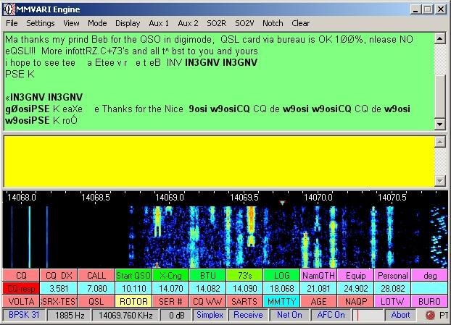

SCDW\_1

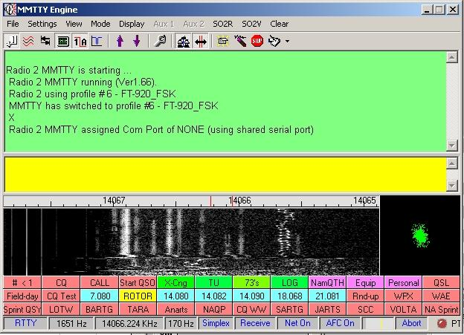

SCDW\_43

The two Auxiliary windows consist of the:

* + Title bar;
  + Menu bar;
  + RX window; and,
  + Status bar

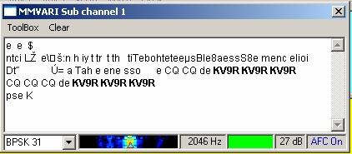

SCDW\_2

The Sound Card Data window main menu bar provides access to the following functionality:

* + File
    - Send a text file
    - Open receive text file
    - Close receive text file
    - Exit
  + Settings
    - MMVARI Settings
    - MMTTY Settings
    - RTTY Settings
    - Appearance
    - Sound Card Input level
    - Sound Card Output level
    - Line wrap on
    - Use 0 for zero
    - Transmit buffer indicator
    - Adjust all digital DX spots/logging for audio freq
    - Adjust DX spots/logging for audio freq (not RTTY FSK)
    - Radio PTT options
    - Preset Radio frequencies
    - Preset Audio frequencies
  + View
    - Show Status bar
    - Show RTTY toolbar (MMTTY only)
    - Show RTTY XY Scope (MMTTY only)
    - Show Radio debug window
    - Frequency display
    - Macro buttons
    - RX window options
  + Mode
    - MMVari Engine
      * GMSK     (MBCS)
      * FSK        (MBCS)
      * FSK-W    (MBCS)
      * BPSK31  (MBCS)
      * BPSK63  (MBCS)
      * BPSK125 (MBCS)
      * BPSK 250 (MBCS)
      * BPSK31
      * BPSK63
      * BPSK125
      * BPSK 250
      * RTTY-L
      * RTTY-U
      * MFSK-L 4
      * MFSK-L 8
      * MFSK-L 11
      * MFSK-L 16
      * MFSK-L 22
      * MFSK-L 32
      * MFSK-L 64
      * MFSK-U 4
      * MFSK-U 8
      * MFSK-U11
      * MFSK-U 16
      * MFSK-U 22
      * MFSK-U 32
      * MFSK-U 64
      * QPSK-L 31
      * QPSK-L 63
      * QPSK-L 125
      * QPSK-U 31
      * QPSK-U 63
      * QPSK-U 125
    - MMTTY Engine
      * Standard RTTY
      * Fluttered signals
      * Fluttered signals (FIR)
      * Multi-path
      * (RTTY User Profiles)
      * 23 Hz RTTY
  + Display
    - Spectrum
    - Waterfall
  + Aux 1 (MMVARI only)
  + Aux 2 (MMVARI only)
  + SO2R  
    SO2V
  + Multi RX
  + Notch (MMVARI only)
  + Clear
    - Clear RX
    - Clear TX
    - Clear both
  + Rx/Tx default
    - 1000Hz/1000Hz
    - 1100Hz/1100Hz
    - 1200Hz/1200Hz
    - 1300Hz/1300Hz
    - 1400Hz/1400Hz
    - 1500Hz/1500Hz
    - 1600Hz/1600Hz
    - 1700Hz/1700Hz
    - 1800Hz/1800Hz
    - 1900Hz/1900Hz
  + 2T

The Notch Filter is available in all MMVari modes. When you click on the Notch menu item, it will place a highlighted box with the letter "N" within the frequency ribbon display on the Waterfall or Spectrum display. This box represents the frequency where the Notch filter is active. You can move the position of the box by placing the cursor over the box and dragging while holding the mouse's left button down. This allows you to null out strong adjacent signals. Note on the following picture the effectiveness of nulling out a strong [PSK](#PSK31/63/125) signal.

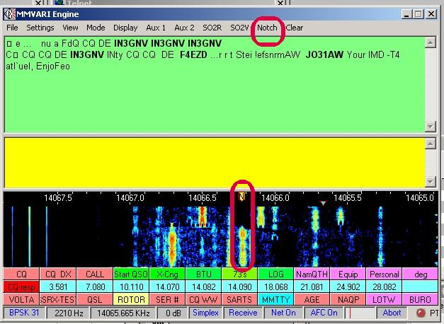

SCDW\_4

The Aux 1 and Aux 2 Menu Bars provide access to the following functionality:

* + MMVari Engine
    - Text Font/Color
    - Background Color
    - Mouseover Highlight Color
    - Show Bold Callsigns
    - Enable mouseover highlight
  + Clear

## 5.0 THE STATUS BAR - AN INFORMATION CONTROL MECHANISM

The Status bar of the Sound Card Data window is located at the bottom of the window. It is the command and control center of this window, providing access to information and commands that you will use actively during digital operations.

The panes in the Status Bar not only give information, but those with captions in blue or red are controls that act as switches to change modes or perform actions (for example, to switch between receive and transmit).

### 5.1 Mode

The first pane indicates the digital mode currently selected. A mouse-click in this panel will cycle through Logger32's modes. A left-click will toggle the mode in one direction and a right-click will toggle the mode in the opposite direction.

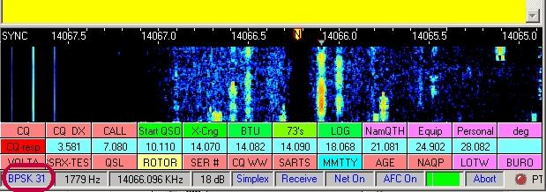

SCDW\_5

The Scroll Lock is enabled by checking “Enable Scroll Lock Function” in the Rx window options.

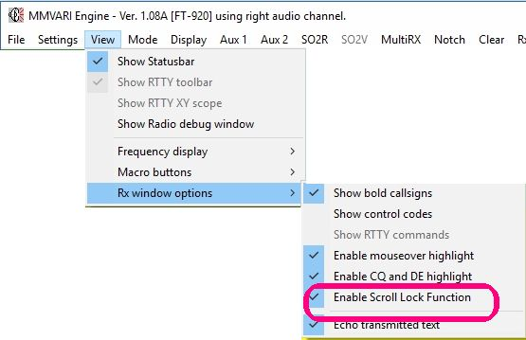

SCDW\_53A

The mode can also be set from the Sound Card Data window menu Mode menu item. The following screen captures display the various modes available.

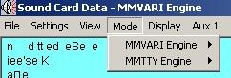

SCDW\_6

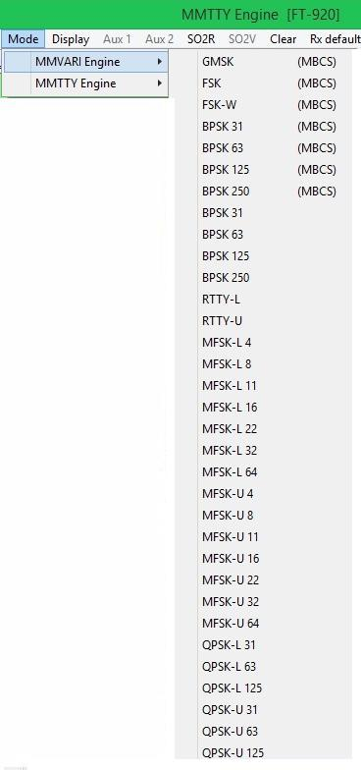

SCDW\_7

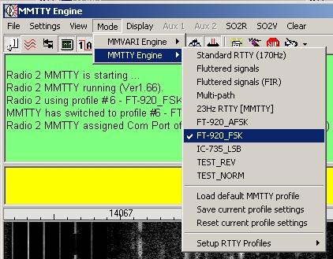

SCDW\_8

### 5.2 Audio frequency

The second pane indicates the audio frequency at the tuned position of the main window.

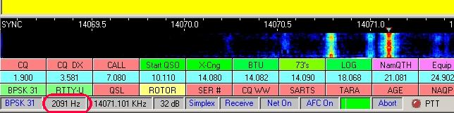

### 5.3 Operating Frequency

The third pane will show your actual operating frequency, which is your radio frequency plus ([USB](#_topic_Abbreviations)) or minus ([LSB](#LSB)) the receive audio frequency. To display this frequency your radio must be connected to Logger32 using a computer-radio communication, and you must be running Logger32.  See [Interfacing a Radio for PC Control](#_topic_InterfacingaRadioforPCControl) for information on connecting your radio to Logger32. Next, select the Display frequency from radio menu item from the View menu item of the Sound Card Data window menu.

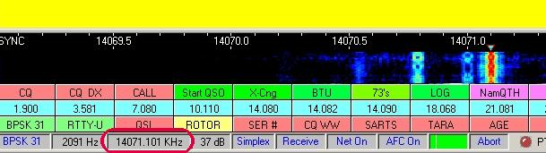

SCDW\_11

**Note**:  Logger32 may or may not reflect a change in frequency that you have set using your [RIT](#RIT) or the Clarifier control on the radio. You should check this so you know how it works. Turn the RIT or the clarifier and see if the frequency pane shows a change.

You may elect to display the actual RF frequency without the audio offset. The audio offset can be enabled or disabled by right clicking on the Operating Frequency pane in the lower status bar,

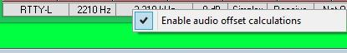

SCDW\_11A

### 5.4 IMD

The fourth pane has two different uses, depending on which digital engine is being used.

* + MMVari Engine: The fourth pane indicates Signal to Noise of the signal being decoded.

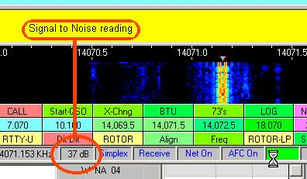

SCDW\_13

* + MMTTY Engine: The fourth pane shows the [RTTY](#RTTY) frequency shift being used.

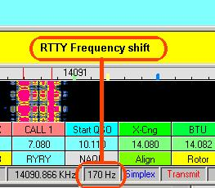

SCDW\_14

### 5.5 Simplex/Split

The fifth pane shows Simplex or Split operation. When you have computer-radio communication using a serial port, Logger32 can operate split frequency by changing the frequency of the radio as it goes between receive and transmit. This pane tells you if you are in simplex or split mode, and allows you to set the direction and amount of transmit split from your receive frequency.

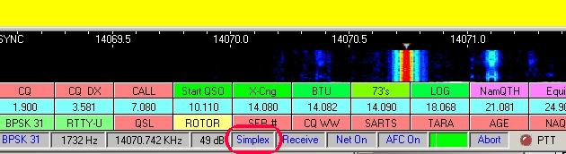

SCDW\_15

### 5.6 Receive/Transmit

The sixth pane indicates that Logger32 is either in Receive or Transmit modes. The RX/TX mode can be toggled with a mouse-click on this pane. RX/TX can also be toggled with the pause/break key on your keyboard.

A right-click in this pane will activate the "Tune" function. See the topic Sound Card Transmitter Audio Setup for detailed procedures.

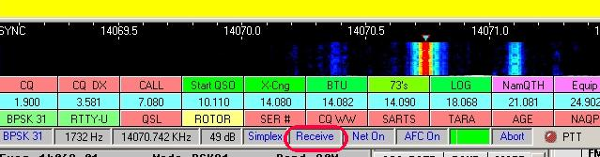

SCDW\_16

### 5.7 Net On/Off

The seventh pane indicates Net is on or off.  Net can be toggled on/off by a mouse-click on this pane. (NET On will set the transmitted audio frequency to the receive audio frequency. Net Off will cause you to transmit at the last frequency at which you transmitted. If you have not gone to transmit since you started Logger32, you will transmit at the default TX audio frequency. When you transmit, the waterfall display of your transmit signal will be on the frequency where you are actually transmitting.

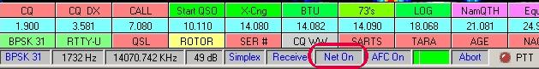

SCDW\_17

### 5.8 AFC On/Off

The eighth pane indicates [AFC](#AFC) status, On or Off.  [PSK31](#PSK31/63/125) and [PSK63](#PSK31/63/125) are quite difficult to tune in manually. You will usually want the AFC on, at least to tune in a station.

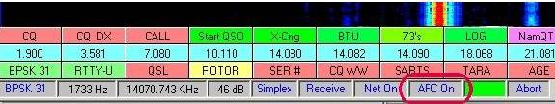

SCDW\_18

The user can adjust the MMVARI AFC capture level and width for both the Sound Card Data Window and the SO2R/SO2V MMVARI Window. Right click on the AFC pane on the status bar of the window. Check the desired level and width.

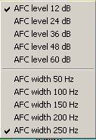

SCDW\_18A

You can adjust the MMVARI AFC capture level and width for both the Sound Card Data Window and the SO2R/SO2V MMVARI Window. Right click on the AFC pane on the status bar of the window. Check the desired level and width.

### 5.9 Signal Levels and Squelch Settings

The ninth panel indicates Signal levels and Squelch settings. The yellow line indicates the squelch threshold setting. To change the squelch setting, position the cursor on the yellow line, hold the left mouse button down and drag the line to the position desired. You can also position the cursor at the level desired and left-click the mouse button. The program will only decode signals above the squelch threshold.

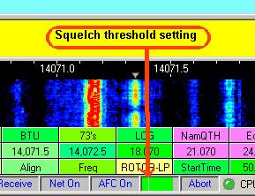

SCDW\_20

### 5.10 Abort

A mouse click in the tenth pane clears the transmit buffers. If Logger32 is transmitting it switches from transmit to receive as quickly as possible.

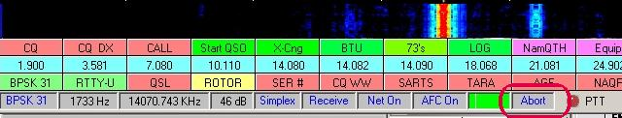

SCDW\_21

### 5.11 PTT Indicator Lights

A red [PTT](#PTT) LED indicates PTT is off and Logger32 is in the receive mode.

A green PTT LED indicates PTT is on and Logger32 is in the transmit mode.

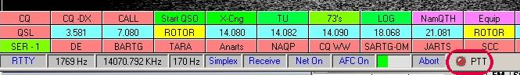

SCDW\_22

## 6.0 BASIC OPERATION

The following sections describe how to do basic Sound Card Data window operations.

### 6.1 Switching the Radio Between Receive and Transmit

* + Use the Receive/Transmit pane in the Status bar (this is the sixth box along the bottom);

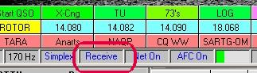

SCDW\_23

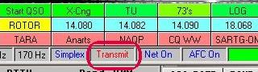

SCDW\_44

* + Use Macros and Hot Keys;
  + Use the <**Pause/Break**> key; or,
  + Use the <**Esc**> key.

### 6.2 Pausing the RX Window

### 6.2.1 Keyboard<Insert> Key

You can pause the display of received data in the RX Window by pressing the <**Ins**> or <**Insert**> key on the keyboard.  You can then scroll back and forth in the RX Window, using the scroll keys. The pause is cancelled by typing the <**Ins**> key again. Logger32 continues to receive data while the RX Window is paused, and the text that arrived while the display was paused will appear at the bottom of the RX window when you press the <**Ins**> key a second time.

Be careful with the pause function. When you use the pause function, the background turns white.  If you are using a white font, the whole RX Window will turn white and you won't be able to see the letters. You can adjust the RX window background color for pause by selecting the Sound Card Data window menu items "Settings|Appearance|Rx window pause background".

### 6.2.2 Mouse scroll wheel

If the RX window is full of text, and some text has scrolled off, you can pause the RX window by placing the Mouse cursor anywhere in the RX window and rotate the scroll wheel. This function will suppress incoming data, allowing the user to scroll the existing text without interruption by incoming text.  While scrolling, this pause function is visually indicated by the word “Freeze…” in the upper left hand corner of the header. Data will continue to be decoded, but will not print. Freeze mode will time-out and self-cancel if no further scrolling is detected. If the cursor is moved away from the receive pane, freeze mode is immediately canceled and incoming text printing is resumed.

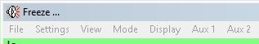

SCDW\_53

The “Freeze” function is enabled by opening “View | Rx window options” and checking “Enable receive Freeze”.

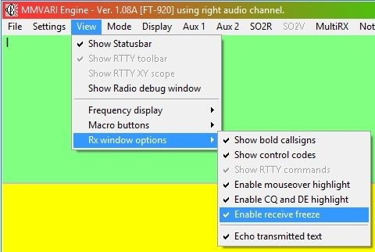

SCDW\_53A

### 6.3 Cut and Paste

You can cut and paste data from the Sound Card Data window. You can copy text into the Logger32 windows, a browser, or a word processor.  For those familiar with Windows, this is the Clipboard function.

* + Left-click and drag the mouse across some text in the RX window (this will momentarily highlight the text), then release the left mouse button;
  + Right-click and select Copy or Cut.  Be careful as some people often forget this right-click step; and,
  + Move to the window where you want to paste (probably the TX window), press the right mouse key and select Paste.

### 6.4 Resizing the TX Window

Move the cursor slowly over the separation line between the TX window and the RX Window and when the cursor changes shape into a double-arrow, hold down the left mouse button to resize the window to your operating preference.

### 6.5 Operating On the Other Station's Frequency (Net Operation)

Turn Net on and you will transmit on the other station's frequency. If you turn Net off, you will transmit where you last transmitted. See the topic on [Audio Split Frequency Operation](#8.0_AUDIO_SPLIT_FREQUENCY_OPERATION) for more details. Operation of the Net On/Off is slightly different in the MMVARI engine. See [5.7 Net On/Off](#5.7_Net_On/Off) for details.

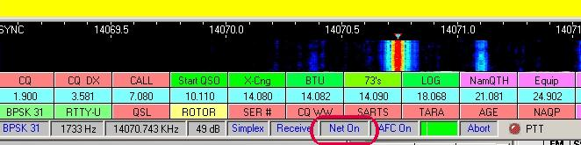

SCDW\_24

### 6.6 Using the Sound Card Data Window With or Without Radio-Computer Communication

The Sound Card Data window will work without any direct radio interface. You can operate [PSK31](#PSK31/63/125) or [RTTY](#RTTY) as long as you have a way to operate the transmit/receive switching and get tones to and from the computer soundcard.  All the functions that are discussed here also work with radio-computer communication.  Here are some functions that you have:

* + Display of your audio frequency;
  + Split operation using audio frequency;
  + Data capture for use by Macros and logging;
  + Automatic data entry into the Logbook Entry window: and,
  + CD callsign lookup.

## 7.0 LOGGING FROM THE SOUND CARD

Logger 32 has enhanced logging procedures for PSK and RTTY modes. Many of the normal QSO exchange data can be logged directly from the Receive Text window.

They can be automatically transferred to the Logbook Entry window by clicking on the appropriate words or numbers in the received text window.

**Note**: In order for all these entries to work, you must configure the [Logbook Entry window](#_topic_LogbookEntryWindow) to accommodate the desired entries by adding the data fields to the "user defined fields." This is accomplished by right-clicking in the [Logbook Entry window](#_topic_LogbookEntryWindow) and selecting the [Setup](#Setup_Menu) menu item. Then, select each field you want to display by placing a check mark by each field to be shown. Set up the user fields by selecting the appropriate title and [ADIF field](#19.0_ADIF_Field_Definitions). Specific details of setting up the user fields are provided elsewhere in the Help file.

The following sample text shows the fields that can be automatically transferred to the [Logbook Entry window](#_topic_LogbookEntryWindow) by mouse clicks.

de W5ifp Jim Bulverde TX  Grid EL09ss  RST 599 10-10# 10530  IOTA  NA-067 SRX# 219 QSL via WD5FCA

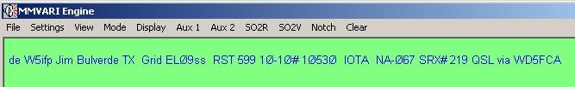

SCDW\_45

As in the examples below, Logger32 does not always display the full list of options. It determines which selections are to be displayed based on the word/number that is highlighted by the right-click.

### 7.1 The Fields

### 7.1.1 Callsign

Left-click on the callsign of the station you are in contact with or desire to contact. This is a fixed field and does not require user setup.

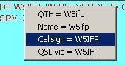

SCDW\_25

To facilitate callsign identification, the you can opt to have the callsigns displayed in bold characters in the received text. To set this option, Select the Sound Card Data window menu items "View | Rx window options" and place a check mark on the first line "Show bold callsigns".

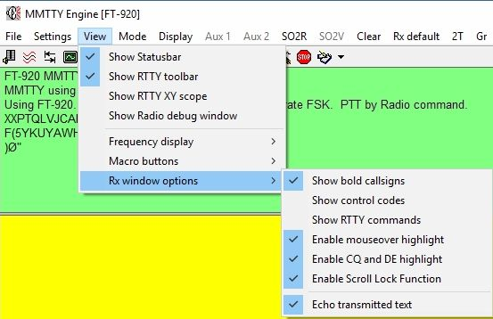

SCDW\_26

### 7.1.2 Name

Right-click on the name and the following window will appear.  Select "name" then left-click. This is a fixed field.

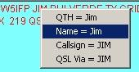

SCDW\_27

### 7.1.3 QTH

Right-click on the QTH and select QTH, then left-click. This is a fixed field.

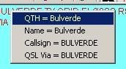

SCDW\_28

### 7.1.4 Grid Square

Right-click on the Grid Square and select Grid Square, then left-click. This field requires user setup with the [ADIF definition](#19.0_ADIF_Field_Definitions) of GRID SQUARE

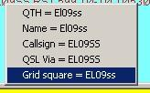

SCDW\_29

### 7.1.5 Your RST Signal Report

Right-click on the numeric signal report, select RST, then left-click. This is a fixed field.

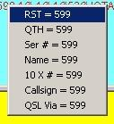

SCDW\_30

### 7.1.6 Ten\_Ten Number

Right-click on the Ten\_Ten #, select 10X#, then left-click. This field requires user setup with the [ADIF definition of TEN\_TEN](#19.0_ADIF_Field_Definitions)

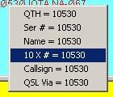

SCDW\_31

### 7.1.7 IOTA island designation

Right-click on the [IOTA](#IOTA) number, select IOTA, then left-click. This field requires user setup with the [ADIF definition of IOTA](#19.0_ADIF_Field_Definitions)

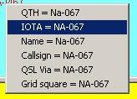

SCDW\_32

### 7.1.8 Contest QSO Report Number

Right-click on the QSO contest report number, select QSO number, then left-click. This field requires user setup with the [ADIF definition of SRX](#19.0_ADIF_Field_Definitions)

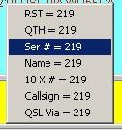

SCDW\_33

### 7.1.9 QSL Manager

Right-click on the QSL manager's callsign  Select QSL Via and left-click. This field requires user setup with the [ADIF definition of QSL\_VIA](#19.0_ADIF_Field_Definitions)

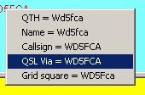

SCDW\_34

### 7.1.10 Other Fields

In addition to the above more common fields, there is also a provision to transfer data for the three User defined fields: USER\_1, USER\_2, and USER\_3. These will appear in the drop-down menu listing using their user assigned name.

As an example; if USER\_1 is setup in the Logbook Entry window for "DOK" information, a right-click on the data in the Sound Card Data window will have the DOK listed as one of the options to select for transfer to the DOK field in the Logbook Entry window. For this data to transfer, you must have the USER\_x fields setup in the [Logbook Entry window](#_topic_LogbookEntryWindow).

Due to the flexibility and multiple uses available for these three fields, no example is given.

### 7.2 How This Works

Each time you click on the above elements they will automatically appear in the [Logbook Entry window](#_topic_LogbookEntryWindow). Here is a sample of the log entry showing all the above entries:

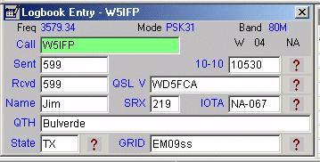

SCDW\_35

When you complete the QSO, you can automatically log the data into the main logbook by using Macros within the Sound Card Data window. You can include $log$ in your signoff Macro or you can also have a dedicated Macro for that purpose. Here is an example of the $log$ included in the signoff Macro:

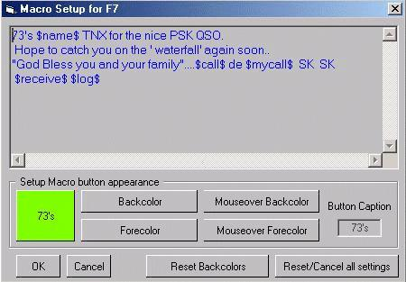

SCDW\_36

The following is an example of a dedicated $logimmediate$ Macro.This Macro will log the QSO with the current time of the computer.

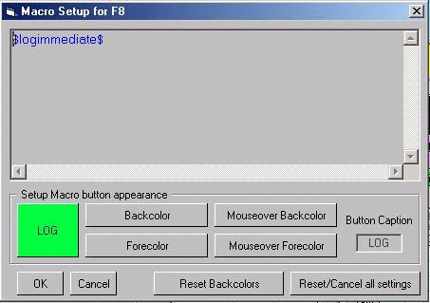

SCDW\_37

## 8.0 AUDIO SPLIT FREQUENCY OPERATION

Even though you do not have computer-radio communication over a serial port, the Sound Card Data window can operate split frequency on transmit and receive by using different tones for each frequency. This is only possible in [PSK](#PSK31/63/125) mode. Audio split-frequency operation is fully described in the Receiving PSK31 topic, in the section called Operating Split Frequency Using Different Audio Tones.

If you have computer control, look at the section later in this topic called [Operating Split Frequency with Computer Control](#9.0_USING_LOGGER32_WITH_COMPUTER-RADIO_COMMUNICATION).

## 9.0 USING LOGGER32 WITH COMPUTER-RADIO COMMUNICATION

You must configure computer-radio communication through Logger32 as described in the topic [Interfacing a Radio for PC Control](#_topic_InterfacingaRadioforPCControl).

Here are various functions that are enabled with radio-computer communication:

* + Display of frequency from the radio;
  + Frequency control of the radio using the $align$ Macro; and,
  + Split frequency operation.

### 9.1 Display of Frequency from the Radio

The Sound Card Data window can display the radio frequency, the actual transmitted frequency and the tone frequency.

The frequency displayed on the radio will be at the left end of Sound Card Data window's frequency bar (A).

The Sound Card Data window uses the radio frequency (A) along with the audio tone frequency (B) to display the actual frequency (C) you will receive/transmit.

That is, if your radio frequency is 14.070 (A), radio in LSB, and you are listening to a 1500 Hz (B) tone, the Sound Card Data window will display the actual transmitted frequency of 14068.5 kHz (C).

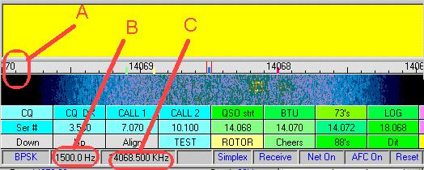

SCDW\_38

To turn this feature on, select the Sound Card Data window menu "View | Frequency Display | Display frequency from radio" menu items. You must do this to get the frequency display on screen in the third pane from the left in the Status bar, but once you do it, you can leave it on forever. If frequency information is unavailable, the Sound Card Data window will display nothing. Select the Soound Card Data window "View | Frequency Display | Display Audio Frequencies" menu items if you would rather see the audio frequencies of the tones.

### 9.2 Align

There are situations in which you might want to retune your radio after you have begun to copy a station, but you would not want to lose the station. Here are some situations:

* + You want to transmit a high tone to reduce the chance that you will transmit distortion, but the station you want to receive is low in your receive/transmit range, at the current radio frequency setting (see [Transmitting a Clean Signal with PSK..](#_topic_TransmittingaCleanSignalwithPSKM).);
  + You have a narrow receive filter in your radio, but it is not centered at the place where the station you want to receive is being received;
  + You want to quickly move the station you are listening to near the edge of the receive range, so you can use your radio's passband tuning to get rid of QRM.

The align function will help out, in both [PSK](#PSK31/63/125) and [RTTY](#RTTY) modes.

Your radio can be retuned with a mouse-click. To use the align (frequency change) function, set up the following:

* + You must have computer communication with your radio;
  + Select the Sound Card Data window menu "Settings | Default main Rx Frequency" menu items and set it to an appropriate value (this will stay the same most of the time). This can be a high tone or the center of the narrow filter passband. It is best if both these situations are true, and you may have to tune your passband tuning control to make it so;
  + Select the Sound Card Data window View | Frequency Display | Display Frequency from Radio menu items;

Here is how the align operation works:

* + Leave the [AFC](#5.8_AFC_On/Off) on so Logger32 can retune following the frequency change
  + Left-click on a signal to receive it in the main RX window
  + Right-click on the same signal to invoke the align function, so that signal will be received at the preset Default Main RX Frequency

Instead of a right-clicking, you can use the $align$ Macro in a programmable button.

Logger32 will move the main passband to the default RX frequency, and will also reset your radio frequency the proper amount so that the signal is now at the default RX frequency. You should still be copying the signal.

Here is an example:

* + Set your default RX frequency to 2000 Hz., which is high within the range of your narrow filter, so if you overmodulate, you will probably not generate harmonics since they fall outside your transmit passband
  + The radio is currently tuned to 14.070 MHz
  + Left-click to receive someone at 14.0705 MHz. This means that you will be transmitting a 500 Hz. tone, which is quite low, and may cause distortion
  + Use align function (right-click or Macro)
  + Logger32 will retune the radio to 14.068 MHz., which is now the low end of the Sound Card Data Window frequency display
  + You are still receiving and transmitting at 14.0705 MHz
  + The station is now at 2000 Hz. in your RX and TX transceiver range, which is pretty high, and not subject to as much distortion as the 500 Hz. tone

It is possible to tune your radio using this feature: click anywhere in the display and that spot will move to the Default Main RX Frequency. If you click higher in frequency than your Default Main RX Frequency your radio will tune up in frequency; if you click lower in frequency than your Default RX Frequency, your radio will tune down.

Many people find that it is difficult to right-click just the right place on the received signal. The $align$ Macro takes care of that problem.  Instead of retuning where you click, it moves the current signal that is being received to the default RX frequency. Just dedicate a programmable button to contain the text $align$ only and when you select that button, it will be is as if you right-clicked in the correct place.

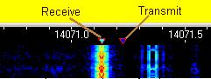

SCDW\_39

### 9.3 Operating Split Frequency with Computer Control

There are two ways that Logger32 can operate split frequency:

* + Using different audio tones for transmit and receive and,
  + Changing your radio frequency as it switches between transmit and receive.

The audio frequency method is described in Receiving PSK31, and only works in that mode.

Here is how you can operate split with computer control, for [PSK31](#PSK31/63/125), [PSK63](#PSK31/63/125) or [RTTY](#RTTY):

* + You must have computer-radio communication
  + On the Status bar in the Simplex panel, the Simplex/Split status is displayed. It probably says Simplex

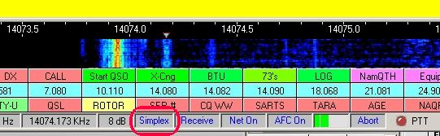

SCDW\_40

* + Left-click on the Simplex panel and the Simplex/Split dialog box will pop-up

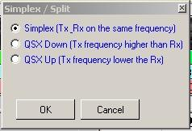

SCDW\_41

* + Select QSX Down if you want to transmit higher than your receive frequency, or QSX Up if you want to transmit lower than your receive frequency. This choice will depend which way the other station tells you he is listening. It does not matter if you are in USB or LSB. QSX Down will always take you higher in frequency when you transmit
  + After you make your selection, the Simplex / Split dialog box will appear

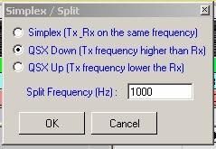

SCDW\_42

* + Enter a frequency in Hz in this window. If you want to transmit 1 kHz from your receive frequency, enter 1000;

**Note**: Some radios have a frequency resolution limitation using [CAT](#CAT) commands. If you select a frequency-offset that is smaller than the radio supports you will get an error message that the radio did not respond to the QSY command. If that happens, try using a higher offset frequency.

* + Select the <**OK**> button;
  + The Simplex Status panel will now display the word Split, instead of Simplex;
  + Make your calls, and, we hope, work the rare DX station who is listening split; and
  + When you are finished, click the Simplex Status panel, select Simplex and you will be back to regular operation.

You can also use a Macro to do this, but it is no easier unless you integrate it with some other commands.The Macro is $qsx$, and is described in the topic [MACROs](#_topic_MACROS).

There is a $simplex$ Macro as well, to undo $qsx$.

9.4 MMTTY Failure to invoke:

On some systems, MMTTY will not open in the [Sound Card Data window](#_topic_SoundCardDataWindow1). If you are getting an error message like: “Failure to invoke MMTTY.EXE”, then you need to accomplish the following procedure;

Close Logger32 and open Windows Explorer.

Navigate to the Logger32 directory.

Open the config file “Logger32.INI” in Notepad or similar text editor.

Search for: [Globals]

Add the following new line below the [Globals] header:

Enable MMTTY Retries=True

Save the Logger32.INI file and then re-open Logger32.

Open the sound card. MMTTY should now open properly.

*Created with the Personal Edition of HelpNDoc:* [*Produce Kindle eBooks easily*](http://www.helpndoc.com/feature-tour/create-ebooks-for-amazon-kindle)

**Sound Card Data Window FAQs**

# Jim Hargrave W5IFP

### I previously used Zakanaka, what do I have to do to use Logger32?

Logger32 now uses the MMVARI data engine for all [PSK](#PSK31/63/125) modes.

Many of the Macros in Logger32 are the same as those in [Zakanaka](#Zakanaka). You can copy your macros from the Zakanaka.ini file and paste them into the appropriate area of the MMVARISoundCardMacros.ini file. Be sure to back-up your MMVARISoundCardMacros.ini file before attempting this. Also, check the [Soundcard Data window topic](#_topic_SoundCardDataWindow1) for a list of macros that are the same. There are several other user settings within the Zakanaka ini file that are also used in the MMVARISoundCardMacros.ini file. With a little cut and paste work, the most significant parts of one's original settings can be transferred to work from within Logger32 without the need to type them all in again. This procedure is not for the faint of heart and if you have any doubts or concerns, just set up the Sound Card Data window as though it was all new.

It is recommended that the following procedure be adopted should you wish you utilize your favored settings:

* 1. Make backup copies of the Logger32 AND Mmtty.ini files to be found in your default Logger32 directory. Do the same with your Zakanaka.ini;
  2. Delete the Mmtty.ini file from your default Logger32 directory;
  3. Copy the Mmtty.ini file from your default Zakanaka directory to your default Logger32 directory.

**Now for the more complex part:**

* 1. Open the MMVARISoundCardMacros.ini file in your default Logger32 directory using Notepad or WordPad;
  2. At the same time, open the Zakanaka.ini file from your default Zakanaka directory in Notepad or WordPad and arrange for BOTH sets of open files to be visible on the screen at the same time;
  3. Using cut and paste, transfer the following sections from the original Zakanaka.ini to the new MMVARISoundCardMacros.ini, removing the original contents, of course:  
     + [Waterfall Color]
     + [RTTY Macro]
     + [RTTY]
     + [Macro]
     + [Markers]

**Note**: Some of the Zakanaka macros have not been included in Logger32. Also, some of the original Zakanaka macros have been renamed in Logger32. For a complete list, see the topics [MACROS](#_topic_MACROS).

This will set up the most significant of your settings but it will NOT be all of them.  DO NOT attempt to transfer everything over from the original Zakanaka.ini file to the new Logger32.ini file unless you are absolutely certain of what you are doing as, in a number of instances, the parameters are held under different names or in different named sections.

### I previously used the PSKCORE Engine, what do I have to do to use the PSK Macros in the MMVARI Engine

Most of the macros in the Logger32 PSKCORE data engine are the same as those used in the MMVARI data engine. You can copy your MACROs  from the SoundCardMacros.ini file and paste them into the appropriate area of the MMVARISoundCardMacros.ini file. Be sure to backup your MMVARISoundCardMacros.ini file before attempting this. Also, check the [Soundcard Data window](#_topic_SoundCardDataWindow1) topic for a list of macros that work with MMVARI.

With a little cut and paste work, the Macros can be transferred to work with MMVARI without the need to type them all in again. This procedure is not for the faint of heart and if you have any doubts or have concerns, just set up the Sound Card Data window as though it was all new:

* 1. Make backup copies of the MMVARISoundCardMacros.ini file to be found in your default Logger32 directory;

**Now for the more complex part:**

* 1. Open the MMVARISoundCardMacros.ini file in your default Logger32 directory using Notepad or WordPad;
  2. At the same time, open the SoundCardMacros.ini file from your default Zakanaka directory in Notepad or WordPad, and arrange for BOTH sets of open files to be visible on the screen at the same time;
  3. Using cut and paste, transfer the entire [MACRO] section from the original SoundCardMacros.ini to the MMVariSoundCardMacros.ini file;
  4. Now change the title of the section from [MACRO] to [MMVARI bpsk 31]; and,
  5. You can make a duplicate set of Macros for PSK63 and PSK125 by following the same procedure (Step 4) and renaming it to [MMVARI bpsk 63] and [MMVARI bpsk 125].

The same approach can be used to transfer your [RTTY](#RTTY) macros from the SoundCardMacros.ini file to the MMVARISoundCardMacros.ini file. Copy the section titled [RTTY MACRO] and rename it [MMVARI RTTY-U]. A duplicate set can be copied and renamed to  [MMVARI RTTY-L].

**Windows ME users**:  The COM port's [DTR](#DTR) signal becomes active as soon as the computer is switched on. This means that if one is using the [PTT](#PTT) line (DTR) to control a rig, the rig will go straight into the transmit mode at this stage. To resolve this issue see the Microsoft Knowledgebase article Q285894 at:

<http://support.microsoft.com/default.aspx?scid=kb;EN-US;q285894>

### Right-Click Auto Fill Data is not showing up in the Log:

The Sound Card receive window has the ability to auto fill data in the [Logbook Entry Window](#_topic_LogbookEntryWindow).  By simply right-clicking text in the receive window, you are presented with a list of fields to choose from, and the selected data is sent to that field (see the [Sound Card Data window](#7.0_LOGGING_FROM_THE_SOUND_CARD) topic for detailed instructions on this feature).  For this feature to work, the field you are selecting data for in the right-click list, must be one of the fields in the [Logbook Entry Window](#_topic_LogbookEntryWindow) for the data to properly transfer.

### Logger32 does not seem to work with my sound card, which is built onto my motherboard.

Several hams have found that some on-board sound cards do not work with Logger32.  You can turn off the sound card with the System configuration of Windows (Start, Settings, Control Panel, System) and then install a new sound card board that is not part of the motherboard. In the U.S., surplus outlets sell usable boards for $20 to $50.  Do not assume that your board does not work until you have checked the mixer settings.

### Macros do not work properly or consistently.

* + Are the Macros typed with $ before and after?  Example:  $mycall$;
  + Check the spelling of the longer Macros, like $upperorlower$; and,
  + If a Macro using $receive$ fails to transmit text before going to receive, add three carriage returns to the beginning of the Macro.

### Special characters do not appear when I enter <Alt+ASCII code>.

* + The characters MUST be entered on the NUMERIC keyboard, not the alphabetic keyboard;
  + The <**Alt**> key must be held down while you enter the entire four-digit [ASCII](#ASCII) code; and,
  + See the topics [MACROS](#_topic_MACROS) and [Programmable Buttons](#_topic_ProgrammableButtons)  for information on this subject.

### When I type, I lose the mouse cursor.

Go to your mouse control software panel and see if you have "Hide cursor when typing" checked and uncheck it.

### Logger32 does not show any signals on the spectrum display.

* + Go to [Sound Card Data window](#_topic_SoundCardDataWindow1) menu and select the Settings|Sound card input level, and make sure that you have not muted a control or set it too low. The word "you" in this sentence includes any software that takes control of the audio; and,
  + Check to see that your dog did not disconnect the connection from your rig's audio out to the computer.

### The XY display does not appear in RTTY mode.

* + Turn XY on;
  + Click View|Show RTTY XY Scope;
  + Check the Main Menu View Menu item "Find Lost Windows";

### I lost a display that I used to have.

From the [Sound Card Data window](#_topic_SoundCardDataWindow1) menu, select the View menu item.

### The waterfall display is missing or very hard to see.

Make sure that your Windows colors setting is set to something greater than 16 colors (Start, Control Panel, Display, Settings, Colors).

### The tuning display shows no signals.

Check your audio interface from the radio. Also, from the [Sound Card Data window](#_topic_SoundCardDataWindow1) menu, seletc the "Settings|Sound Card input level" menu items and ensure the input line is not muted, or increase the gain setting.

### The align (frequency change) or QSY feature (right mouse click on the target signal) no longer works

You may be using a Kenwood radio in which this feature only works with one of the VFOs.  Switch VFOs and try again.

I suddenly have distorted audio on PSK31/PSK63/PSK125 or on phone.

* + Disconnect the microphone from your radio when you operate [PSK31/PSK63/PSK125](#PSK31/63/125);
  + Disconnect your computer sound card from the audio input to the radio when you operate phone; and,
  + See the topic [Transmitting a Clean Signal with PSK ...](#_topic_TransmittingaCleanSignalwithPSKM)  for a discussion of problems you can have when transmitting with high or low tones.

### Sometimes my transmit audio is weaker than at other times.

* + Your radio has a transmit as well as a receive passband. If your transmit audio begins to roll off at 2500 Hz, then you will find your transmitted signal to be weaker if you transmit and receive at 2800 Hz from the carrier frequency (because your radio's audio at that frequency is weaker), even though you may be able to copy a signal at that distance from the carrier frequency; and,
  + See the topic [Transmitting a Clean Signal with PSK ...](#_topic_TransmittingaCleanSignalwithPSKM)  for a discussion of problems you can have when transmitting with high or low tones.

### When I use VOX, the VOX line does not drop at the end of transmission, it cycles on and off.

Go into the audio mixer and turn off any unused inputs to the sound card. If you are using line input, mute the microphone input or turn it down to zero. The problem with this solution is that it may turn off your speaker sound.

### When I try to get Logger32 to copy a signal, it jumps to a stronger signal nearby.

This is the action of the [AFC](#AFC). You can [turn off AFC](#5.8_AFC_On/Off) in the Statusbar. You may have to turn it on occasionally if you lose copy.

### When the other station turns it over, Logger32 changes frequency.

This is the action of the [AFC](#AFC). You can [turn off AFC](#5.8_AFC_On/Off) in the Statusbar. You may have to turn it on occasionally if you lose copy.

### I lost one of the windows (tuning display or Aux Window).

* + If you changed screen resolution, it might be off your screen. Go back to the old screen resolution, gather your windows to the middle of your screen, and then reconfigure back to the new resolution;
  + Some windows may be hidden behind other windows. If a window disappears, move other windows to see if it is hidden behind them; and,
  + If all else fails, use the [Find Lost window](#_topic_FindingLostWindows) utility.

### When I press the <Ins> or <Insert> key to pause the RX Window, all the text disappears and I just see white.

The <**Ins**> key pauses the incoming RX text, but it turns the background white (no choice is allowed). This means that if you normally view RX as white letters on some background, now you are going to see white letters on a white background. This creates a visual challenge not to be overcome by ordinary mortal human beings. Try another font color besides white by using the [Sound Card Data window](#_topic_SoundCardDataWindow1) Settings|Appearance menu item.

### My RX or TX screen shows no text.

Did you set the font color to be the same as the screen color, so they cannot be distinguished from each other?  Go to Toolbox and fix it.

### My Waterfall display has problems, sometimes after working properly for a while.

Some Waterfall problems appear to be related to the use of power management (Windows automatically turns off the screen after a period of non-use) or screen savers.  Try turning off power management (see the topic [Computer Tuneup](#_topic_ComputerTuneup)) and/or the screen saver. The fact that things work well for a while suggests that only when the Windows considers using these features does a problem make itself known.

### There are problems with the screen print (slow, characters appear out of order, wrong characters print) or other video problems.

There are problems with some video cards and Windows.  Try using less hardware acceleration (try one position lower at a time) by doing the following:

* + Click Windows Start, Control Panel, Display, Settings, Advanced, Performance Tab, and move the Hardware Acceleration slider to the left one position.  According to W0EB, this may improve the performance of all your digital programs; and,
  + If you cannot change the Waterfall colors, then it is very likely that the Display Performance Hardware Acceleration is too high. Logger32 uses a lot of processor power, and display acceleration may have to be reduced markedly.

### I can run PSK31/PSK63/PSK125, but Logger32 gets slow or freezes in RTTY mode.

* + You may be running out of computer resources with the extra load from the MMTTY engine;
  + Try running only the programs you need or just Logger32 by itself;
  + Try eliminating the XY Scope Tuning Window; and,
  + Check the topic [Computer Tuneup](#_topic_ComputerTuneup).

### Everything appears in lowercase or UPPERCASE in PSK31.

Go to the [Sound Card data window](#_topic_SoundCardDataWindow1) menu and select the Settings|MMVARI Settings|Typing preferences menu items. Choose whether you want all UPPERCASE, all lowercase, or if you want the shift key to work (as typed).

### I cannot find my transmitted text in the RX window. It transmits, and disappears from the TX window.

Did you set the RX Window font color (TX) to the same color as the TX background?

From the Sound Card Data window menu, go to "Settings|Appearance|Rx window TX color" and fix it.

Also check the [Sound Card Data window](#_topic_SoundCardDataWindow1) menu item "View|RX window options|Echo transmitted text".

### I received a Soundcard Error 12 message

 Here is a list of conditions that can trigger this Windows message:

* + Input buffers overflowed;
  + Timed out waiting for input buffers;
  + Output buffers Underflowed-Timed out waiting for output buffers;
  + Function isn't supported;
  + Error value out of range;
  + Invalid flag passed;
  + Invalid parameter passed;
  + Card doesn't support 16bit, 8000Hz, Mono format (0); and,
  + Go to Settings on the [Sound Card Data window](#_topic_SoundCardDataWindow1) menu and change the way the figure zero prints to the screen. Your display may not be able to print with a slash.

### I have a problem setting the "back" colors for a macro key.

Reset the back colors with the key at the bottom, then try again.

### Logger32 prints everything except the figure zero (0).

Go to Settings on the [Sound Card Data window](#_topic_SoundCardDataWindow1) menu and change the way the figure zero prints to the screen. Your display may not be able to print with a slash.

### When I run MMTTY.EXE from the Logger32 directory I get error messages.

Yes, you will, as not all the MMTTY files have been loaded into this directory. If you are running MMTTY just to change some RTTY parameters, just ignore the error messages and select the <**return**> key until you reach the expected MMTTY opening screen.

### I installed Logger32 and use a COM port for T/R (PTT) switching. When I boot up the computer, the T/R switch is closed (transmit position) until I run Logger32.

* + There is a patch to fix this for some operating systems. Go to the [Hamlogger reflector](#Links:_Hamlogger_Reflector) and there is a link to download this free file.
  + W0MN solves this problem by turning the radio off and on;
  + VE3TFZ solves this problem with a Rigblaster by not connecting the [DTR](#DTR) line, and using only [RTS](#RTS) and ground for [PTT](#PTT);
  + VE3TFZ also suggests that you can remove a diode in the OR circuit that connects the DTR to the RTS line, but you must do some logic level measurements first to confirm which line is actually high;
  + West Mountain Radio, the distributor of Rigblaster, has further information and a possible cure on their [web page](#Link:_West_Mountain_Radio); and
  + Try removing the PTT connection from RTS during Logger32 startup, and reconnect it after Logger32 is loaded.

### If I connect the radio directly to the computer, things operate, but my audio levels are not right.But when I try to connect through my commercially made interface, the interface does not work.

If your radio interface gets its DC power from the computer over the [RTS](#RTS), [DSR](#DSR), or [DTR](#DTR) lines, it may not work properly with Logger32. You should try to provide power from the radio or from an external power source.

### There are extra carriage returns in my transmit buffer after I use a Macro.

* + Carriage returns in a macro are seen as if they were text.  They are transmitted when the buffer sent.  To get rid of them, end the macro with the macro command $cleartxbuffer$.  This will clear only the transmit buffer; and,
  + The other way to eliminate the carriage returns is not to use them in the macro, but just run everything together on one line.

### Logger32 is so broken, I have given up hope.  I want to start over, but I want the new Logger32 to know what the old one knew (preferences, macros, and so forth).

If Logger32 will open and run, we suggest you [back up your user files and logbook](#_topic_BackingupLogger32FilesandDatabas). These are the first and second icons on the toolbar.

Most of your settings and preferences are kept in a file named Logger32.ini. Copy this file to another directory. Then delete this file in your main Logger32 directory. Reinstall a new copy of Logger32. Logger32 will now start up in  default condition. Once you get it going you can then copy your old Logger32.ini back into the main directory and it will then have all your original settings. A current copy of Logger32 can be downloaded from [Logger32 web site](#Links:_Logger32_Website).

MACROs are kept in their respective SoundCardMacros.ini files. Normally these will be OK.

*Created with the Personal Edition of HelpNDoc:* [*Create cross-platform Qt Help files*](http://www.helpndoc.com/feature-tour/create-help-files-for-the-qt-help-framework)

**Communicating with PSK, MFSK and QPSK**

# Andrew J. O'Brien, K3UK and Jim Hargrave W5IFP

## 1.0 THE ART OF CONVERSATION IN PSK

The Logger32 [Sound Card Data window](#_topic_SoundCardDataWindow1) provides for [PSK](#PSK31/63/125) communications by using the MMVARI data engine and this section outlines general operating procedures.

**Note**: All operational references to PSK31 equally apply to PSK63 and PSK125.

From its beginning, PSK31 has been known as a conversational digital mode. This distinguishes it from the automated [PACTOR](#PACTOR) stations or the rapid-fire [RTTY](#RTTY) contest/DX operations. Many stations that you have PSK31 QSOs with will ask you a few questions about yourself and your setup. They may also comment on your signal and offer assistance to get your transmitted signal "just right."

While it is perfectly acceptable to have quick QSOs, you are encouraged to develop the art of digital conversations.

The art of a digital conversation does not differ much from the art of a rag chew on voice modes. It requires you to try and make the conversation interesting. In addition to your name, QTH, weather, and how long you have been on PSK, try to stimulate the conversation by asking questions about the other station's QTH, occupation, hobbies other than amateur radio, family, and so forth.

At first, operating a digital mode can be intimidating, especially to the slow typist. However, you will soon realize that Logger32 allows you to time your responses while listening to the other station and typing ahead. Typing ahead saves time and also saves your rig's finals since PSK31 is 100% duty cycle.

Logger32 allows you to program 36 buttons that also aid in the art of conversation. You will find, however, that over-use of pre-programmed macros is frowned upon by some. It's seen as too impersonal. Do not have long brag macros that describe everything in your shack including the manufacturer of the carpeting in your room!

By all means, use Macros for the obvious (name, QTH, antenna/rig, and a "return" Macro, i.e., one that automatically puts out his call and your call (example: pd5dx de kb2eoq).  A couple of basic Macros to use at each exchange will give enough time for even the slowest typist to type comfortably in real conversation mode. Here are some examples. The word in brackets is the Macro name.

* + Macro 1 [return]$call$ de $mycall$
  + Macro 2 [FB Name] ..FB $name$
  + Macro 3 [solid] Solid copy that time
  + Macro 4 [fair] Fair copy that time. Some garbled characters.

The above will give you about 15-20 seconds of delay time. You can then comfortably "hunt and peck," and even pause for a few seconds of thinking time without feeling like you are too slow.

Here are two different Macros that take care of transmit/receive switching along with some of the typing:

* + Macro 5            $transmit$ $call$ de $mycall$
  + Macro 6            BTU $name$  $call$ de $mycall$ K $receive$

### 1.1 Other Conversation Tips

Do not worry about typing errors or spelling mistakes. Yes, you can backspace and delete the error before it is transmitted (if you are fast enough) but it is really not necessary. Most hams will be able to figure out your original meaning. If you do backspace, remember that backspace is a PSK character, and you can even erase after the letter has been transmitted and the other station's display will backspace and erase the character.

When in conversation with hams for whom English is not their native tongue, avoid use of slang, colloquialisms, and other speech habits that obscure your meaning. "How's things with you?" will not mean as much as "How are you today?"   Likewise, " the handle here is Dave, just got home from the salt mine," is not as clear as "My name is Dave, I have just gotten home from work."  "QRX while I go to the bog, I need a wicked slash," will not have much meaning to non-British hams!

## 2.0 A DISCUSSION OF RST

RST is the standard READABILITY-SIGNAL STRENGTH-TONE system used by amateurs worldwide.

### 2.1 Readability

* 1. Unreadable
  2. Barely readable, occasional words distinguishable.
  3. Readable with considerable difficulty.
  4. Readable with practically no difficulty.
  5. Perfectly readable

### 2.2 Signal Strength

* 1. Faint signals, barely perceptible.
  2. Very weak signals.
  3. Weak signals.
  4. Fair signals.
  5. Fairly good signals.
  6. Good signals.
  7. Moderately strong signals.
  8. Strong signals.
  9. Extremely strong signals.

### 2.3 Tone

* 1. Sixty cycle AC or less, very rough and broad.
  2. Very rough AC, very harsh and broad.
  3. Rough AC tone, rectified but not filtered.
  4. Rough note, some trace of filtering.
  5. Filtered rectified AC but strongly ripple-modulated.
  6. Filtered tone, definite trace of ripple modulation.
  7. Near pure tone, trace of ripple modulation.
  8. Near perfect tone, slight trace of modulation.
  9. Perfect tone, no trace of ripple or modulation of any kind.

### 1.3 RST and PSK ?

Since PSK's debut on the ham bands, there has been much debate about the usefulness of the RST system.  Some have argued for a new system that includes the percentage of text copied perfectly and the IMD readings.  However, you will find that the majority of PSKers still use the RST system, and will give you your RST that can be clicked to put it in the log:

* + **Readability** is often a subjective measure of the printed text;
  + **Signal Strength** is often from a rig's S-meter, but sometimes from the subjective indications that can be viewed on the PSK Waterfall; and,
  + **Tone** is almost always reported as a "9" but some PSKers have suggested that the 9-step system can be used to indicate the quality/cleanliness of the transmitted PSK signal.

Another issue to deal with is the measurement of signal readability and strength.  Logger32 uses a panoramic display.  You may have realized by now that the usual method of using Logger32 is to set the transceiver bandwidth as wide as possible and select a signal with the mouse and cursor. You let Logger32's [DSP](#DSP) do the work of filtering. But when you look at the S-meter on the radio, you are not looking at the signal strength of the station you are working; you are looking at the signal strength of the strongest station in that 2000+ Hz. bandwidth. Your QSO partner may be far weaker than the S-meter indication.

The answer to this problem, for many PSKers, is to look at S-meter readings on an empty band and learn what different strength signals look like on the waterfall.Then you can estimate from the waterfall display what RST to give the other station. Of course, remember that strong signals in that broad bandwidth can desense your radio, and that will change the appearance of the display. You might want to look over the table above and make your judgments based on the subjective R and S levels descriptions in the table. As for T, well....................

## 3.0 RECEIVING PSK31

# Randy Tipton, WA5UFH and Jim Hargrave W5IFP

**Note**: All operational references to PSK31 equally apply to PSK63 and PSK125.

### 3.1 Popular RF transmitting frequencies for PSK31 QSOs

1838.150

3580.150

7035.15 for region 1 and region 3, and 7080.15 for region 2 \*

10140.150

14070.150 <--- Very active frequency for PSK

18100.150

21080.150

24920.150

28120.150

\* The 7 MHz. band is much wider in region 2 (the Americas), and the IARU bandplan reflects this.

The plan for PSK31 activity has been to concentrate activity starting from the bottom edge of the IARU RTTY bandplan, expanding upwards as activity increased.  The exception is in the 10-meter band, in order to give hams with less than full privileges a chance to meet.

The recommendation is to begin 150 Hz above the bottom frequency.  Keep in mind that all you need is about 100 Hz. for channel separation.

Receiving and displaying PSK31 signals involves several software options.  The best way to get familiar with the receiving options is to read this topic, thoroughly.  Then, while receiving live PSK31 transmissions, change the options to become familiar with their use.

### 3.2 Purpose of the RX Window

The Main Receive window has three purposes, to:

* 1. Display received PSK31 text.
  2. Echo transmitted text after it has been sent; and,
  3. Provide an area for the user to capture callsign, signal report, and name.

### 3.3 The Settings Menu

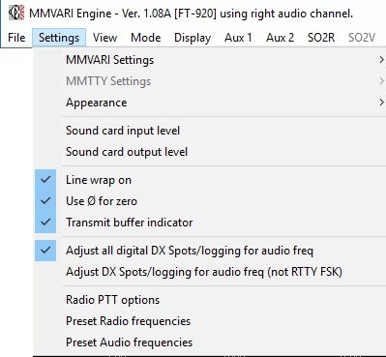

CWPAP\_1

**3.3.1** The following are user-selected options for the MMVARI window.

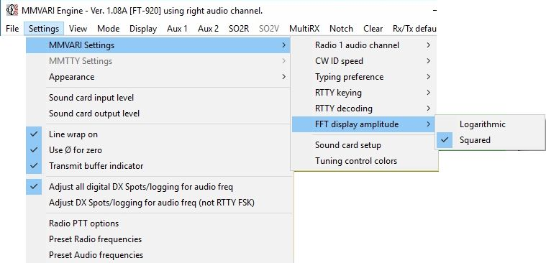

CWPAP\_29

**3.3.2** The following are settings listed under Settings | Appearance

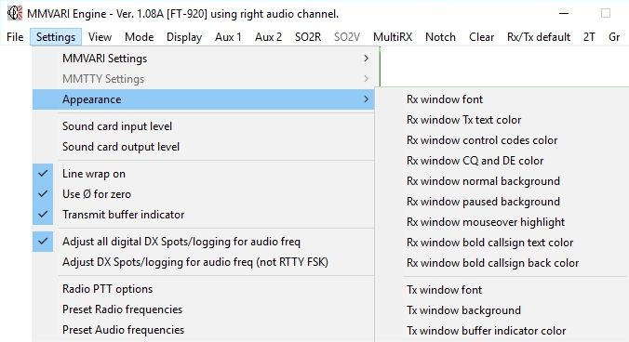

CWPAP\_30

* + **RX window font** - sets print style and text color.
  + **RX window TX text color** - sets color for echoed text.  Echoed text is enabled/disabled with the View | RX Window Options menu item.
  + **RX window control codes color**.  Control codes are enabled/disabled with the View | Show Control Codes menu item.
  + **RX window normal background.**
  + **RX window paused background** - sets the background color when all RX windows are paused with the <Insert> key.
  + **RX window mouseover highlight** - sets color for text change when the cursor is over it.  This is useful when you are selecting text to right-click for the comment field of Logger32, or when selecting a callsign or RST for a log.
  + **TX window font** - sets print style and text color
  + **TX window background** - sets the background color
  + **TX window buffer indicator color**.

### 3.4 RX Window Pause

### 3.4.1 Keyboard <Insert> Key

The RX Window has a scrollbar on the right-hand side when the window becomes full of text. Text will scroll from the top of the window downward until the window is full. At that point text is scrolled off the top, out of the user's view.  The user can see this text again by doing the following:

* + - Press the <**Insert**> key on the keyboard (one time).
    - The RX Window background will change to white (or whatever color you have selected in the Toolbox menu item) and the text is frozen.
    - The Scrollbar can now be clicked to scroll the buffered text through the RX Window.
    - Press the <**Insert**> Key on the keyboard to again start receiving text. (No RX text is lost).

This technique works during transmit, as well as in receive mode. You can freeze and scroll the RX Window while text you have already entered is being transmitted by Logger32.

**Note**: When you use the pause function, the background turns white.  If you are using a white font, the whole RX display will turn white and you won't be able to see the letters.  Use the Receive Window TX text Color menu item to change this color.

### 3.4.2 Mouse scroll wheel

If the RX window is full of text, and some text has scrolled off, you can pause the RX window by placing the Mouse cursor anywhere in the RX window and rotate the scroll wheel. This function will suppress incoming data, allowing the user to scroll the existing text without interruption by incoming text. While scrolling, this pause function is visually indicated by the word “Freeze…” in the upper left hand corner of the header. Data will continue to be decoded, but will not print. Freeze mode will time-out and self-cancel if no further scrolling is detected. If the cursor is moved away from the receive pane, freeze mode is immediately canceled and incoming text printing is resumed.

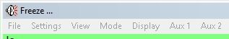

CWPAP\_36

The “Freeze” function is enabled by opening “View | Rx window options” and checking “Enable receive Freeze”.

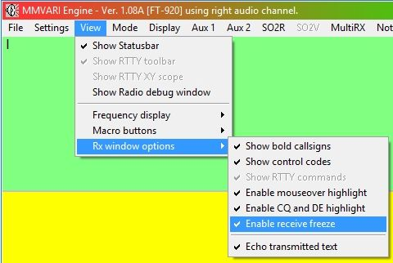

CWPAP\_36A

### 3.5 Aux 1 and Aux 2 and MultiRX Windows

There are three optional receive windows in the MMVARI engine.

* + Aux 1 & Aux 2 windows are duplicate presentations of the Main receive window and allow the user to decode any single signal on the display spectrum/waterfall. Use and setup of the Aux windows are covered in detail below.
  + The MultiRX window is a multi- receiver display. It can decode and display up to 24 receive channels simultaneously

Detailed setup and usage is covered in the [Sound Card Data window](#_topic_SoundCardDataWindow1) | [MultiRX topic](#_topic_MultiRX).

**Note**: When the MultiRX window is open Aux 1 & Aux 2 windows are disabled.

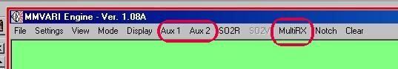

CWPAP\_2

### 3.6 Aux 1 & Aux 2 operation

The two Aux RX windows are user-selectable. By clicking on Aux 1 or Aux 2 on the toolbar, the Auxiliary Receive windows will be opened, displayed, sized, and positioned on your screen. If you have trouble fitting them on your screen, see Screen Control Operations.

The Auxiliary RX Windows can be used for the following purposes:

* + An additional window to receive a PSK31 signal (possibly ready for a change to QPSK).
  + To monitor a crowded band.
  + To look for the next contact while in QSO.
  + To work split frequency directly from Logger32 using audio split (not transceiver split).

From the Aux1 and Aux2 windows, a callsign can be captured by double-clicking on it. However all QSOs have to take place using the Main RX Window. If you saw a station on Aux 1 signing with R5ARE, you would do the following to give him a call:

* 1. Quickly, left double-click on the station's signal in the display window;
  2. Double-click the station's callsign in the Aux window (this will add the callsign to the log and $call$ macro); and,
  3. Call him.

The Aux windows have the same font and background controls as the Main RX window. Go to ToolBox on the menu of the Auxiliary RX window to change functions that apply separately to each Aux window.

To tune in signals for the two Aux windows, use the combination of the <**Alt**> key and mouse click for Aux 1 and the <**CtrlL**> key and mouse click for Aux 2.  The [AFC](#AFC) is controlled by clicking on the AFC pane on the Statusbar in the Aux window. The Aux window Statusbar also indicates the received signal frequency (Hz) and [IMD](#IMD).

The Aux 1 and Aux 2 windows can be resized and positioned anywhere on your screen display. The following drop-down items are on the Auxiliary Tuning windows.

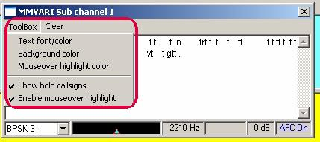

CWPAP\_31

* + ToolBox           Fonts and Background
  + Clear                Clears Aux Channel window of received text

### 3.7 Status Bar

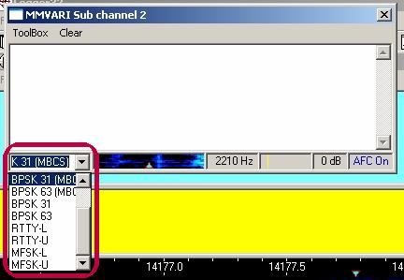

CWPAP\_32

* 1. The first pane shows the current mode.This pane has a pull-down menu where you can select the different operating modes for that window;
  2. The second pane is a signal spectrum;
  3. The third pane reveals the audio tone offset;
  4. The fourth pane shows the signal strength and squelch setting;
  5. The fifth pane is the signal to noise ratio; and,
  6. The sixth pane shows the AFC status.

To close the Aux Channel, click on the X in the upper right corner of the Aux Channel task bar or use the <**Alt+F4**> key combination with the focus on the window you wish to close.

### 3.8 OPERATING SPLIT FREQUENCY

There are times when you want to establish separate transmit and receive frequencies, i.e., operate split. There are several ways to do this:

* + If you are using [AFSK](#AFSK) for PSK31, use a different audio frequency for transmit and receive. This works as long as you only want to split the frequencies within the available range of audio frequencies;
  + If you have computer control of your radio, use the Split/Simplex pane or the $qsx$ Macro to change the transmit and receive frequency automatically each time you switch between transmit and receive; and
  + Operate without any special features and use two VFOs, one on receive and another on transmit, and set the transmit frequency manually at the radio.

### 3.8.1 Operating Split with a Computer Controlled Radio

This is the simplest way to operate split, but you must have communication between the radio and the computer.

### 3.8.2 Operating Split Frequency Using Different Audio Tones

Logger32 can work split frequency within its receive range (about 3000 Hz.) without relying on computer-radio communication, simply by sending a tone that is different from the one being received.   There are several ways to operate split in this way, but they only work in PSK mode.  With this method, you can operate a limited split even if your radio is not capable of two-VFO split operation.

### 3.8.3 Operating Split With Only the Main Window

We will assume that you know where the station you will call is operating, and have that station in the receive range

* 1. Turn Net On. This will cause you to transmit where you are receiving;
  2. Put the cursor on the spot where you want to transmit;
  3. Make a very brief transmission at that location (click transmit on and off).  This will move the transmit frequency to that location; and,
  4. Turn Net Off. This will leave the transmit frequency where you last transmitted.

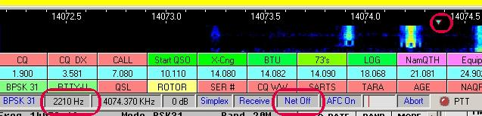

CWPAP\_33

Click on the station you are trying to work so you can receive him. **Note**: The transmit diamond is still at 2210 Hz.

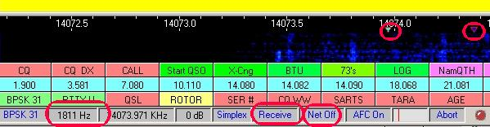

CWPAP\_3

At this point, you will transmit where you last transmitted because Net is off. You will receive where you click.

Here are pictures of two successive Logger32 screens. The first is at the beginning of this operation; the second is at the end.

You will note that the Transmit audio frequency is 1179.9 and the Receive audio freq is 825.9. You are now ready to give a call:

"CQ Split Listening +/- 350 Hz down de W5IFP"

You can program a Macro to repeat this CQ with the following Macro text:

$transmit$ CQ Split CQ Split listening +/- 350 Hz down de $mycall$  $mycall$

$transmit$ CQ Split CQ Split listening +/- 350 Hz down de $mycall$  $mycall$ pse k $receive$

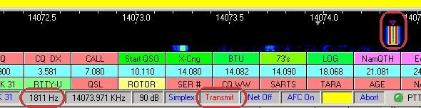

CWPAP\_4

**Note**: In the above picture you will see the audio frequency is still showing 1811 Hz. The actual transmitted signal will be 2210 Hz, which was the frequency where you turned NET OFF.

### 3.8.4 Operating Split By Transmitting at an Aux Window Passband Frequency and Receiving With the Main Window

* 1. You come upon a DX station operating split by calling "CQ DX CQ DX de SP1LT listening down 500 Hz pse."  Here is a way to follow his instructions.
  2. Turn Net Off (**this is a crucial step**). From now on your transmit frequency will not follow your receive frequency  
     .
  3. Open the Aux 1 RX window (blue passband). Look for activity down 500 Hz. (if he was calling on 1400 Hz. you should look down around 900 Hz).
  4. If you see some activity close to 900 Hz., hold the <**Alt**> key down and click on the signal in the display, to bring the Aux 1 RX window to that area (blue passband).
  5. Click the Audio Frequency Pane (second pane from left) on the Aux 1 window status bar.  This moves the transmit to that frequency.  When you transmit, your signal now will be at the blue passband and you are still listening to the station working split under the red passband Main RX Window.

You can use either Aux 1 or Aux 2 to set the transmit frequency when working split. Receive the station in the Main Receive Window. To reset the transmit frequency to the receive frequency simply click Reset on the Statusbar of the Main Receive Window.  Remember to turn Net on when you have finished working split.

The following example shows receiving the station in the AUX window at 2195 Hz. The transmitted signal in this example would be at 1706 Hz in the main window.

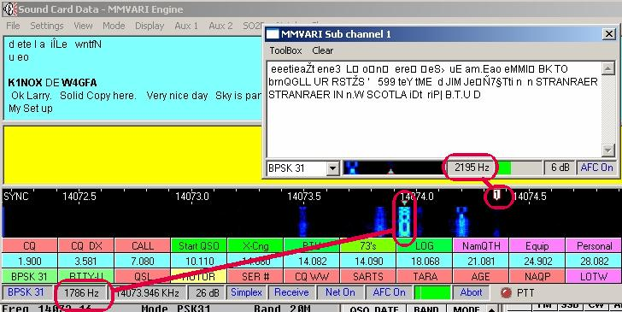

CWPAP\_5

### 3.8.5 Operating Split by Transmitting at the Main Window Passband Frequency and Receiving with an Aux Window

* 1. Turn Net On.
  2. Receive the station you are trying to work with Aux 1 or Aux2.
  3. Left-click the cursor where you want to transmit and the Main (red) passband indicator will go to that spot.
  4. At this point, you will transmit where the red indicator (main passband) is, and you can receive in the Aux window.

### 3.8.6 Manual Split Operation

Manual split is straightforward. If your radio has two VFOs, just go to split operation with your radio and set the transmit VFO to operate where you want. This is the same method you would use for SSB or CW split. Leave Net On in Logger32 and you will be shifted an amount exactly equal to the difference between your two VFOs.

### 3.9 Tuning Display And Controls

After adjusting the input volume to your Sound Card, you are ready to set up your display. If the background of your screen becomes red, then the sound card is overdriving the computer. Readjust the soundcard input level.

Logger32 has two types of displays, the Waterfall and the Spectrum Display. To select which display you will use, select Display on the [Sound Card Data window](#_topic_SoundCardDataWindow1) menu and then select Waterfall or Spectrum. The frequency display (receive range) is as wide as the audio bandwidth of modern receivers. The receive and transmit frequencies are limited to the range 300 to 3000 Hz. due to the passband of most rigs.

However it is better to stay away from the edges, because transceivers may have some limitations, as well and some sound cards may be audio limited   Remember, if you are in a QSO at the edge of the receive range, you may be at or beyond the edge of your transmit audio passband.  It is best to KNOW your equipment!  Power output may be lower at the edges of the receive range. There is a special Logger32 feature called align, which allows you to realign your radio and Logger32 so you can transmit at the preset audio frequency. Align requires that you have computer-radio communication.

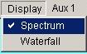

CWPAP\_6

### 3.9.1 Waterfall Display

In Waterfall mode, if the background turns red then the sound card input level is too high. In the Spectrum mode, the entire spectrum line will turn red in this situation.

With the Waterfall display, the PSK signal is displayed as the brightness of one horizontal line. The stronger the amplitude of the signal, the brighter the display. At time increments, each horizontal frequency sample line shifts down, and a new one is placed at the top. This effect looks like a waterfall.

A PSK signal should produce a fairly narrow trail (often called a snail trail). The advantage of this display is that it gives a history, in time, of the received signal for the last few seconds. The disadvantage is that it is difficult to judge the signal strength. In order to tune a signal:

* 1. Turn [AFC](#AFC) on.  An error or drift of only a few Hz. will stop decoding for PSK;
  2. Click on the PSK signal; and,
  3. The two red passband lines will reposition over the signal and text will print in the RX window.

### 3.9.2 Spectrum Display

The Spectrum Display shows amplitude versus frequency. Actual signals that you will see depend on the audio bandwidth of the receiver. The display starts at 0 Hz and goes to 4000 Hz (receive range).  The mouse cursor changes to a cross while in the display area. To tune in a signal:

* + - Turn on [AFC;](#AFC)
    - Click on the PSK signal; and,
    - The two red passband lines will reposition over the signal.

Select the View menu item of the Sound Card Data window menu and you will find Frequency display. After selecting Frequency display, you have the option to view the display, either Spectrum or Waterfall, scaled in with Audio frequency, or Frequency from your radio.

### 3.9.2.1 Display Using Preset Audio Frequency Reading

If you wish to use the display scaled in Audio Frequencies, go to View, Frequency display, and select Display audio frequency.

Under "Settings" on the Main menu, select "Preset Audio frequencies". Another window will pop-up where you can check your preferred audio receive and transmit tone frequencies. These settings will also be used when executing the $align$ macro.

The user can change the listed tones to any desired tone pair. Just edit any of the boxes and check the selection and click apply. These selections are immediate upon clicking Apply and will be saved when the Sound Card window is closed.

**Note**: If the line is checked: “Settings | Adjust DX Spots for audio freq”, the default frequency will offset the radio VFO so the target signal is aligned to the desired frequency on the spectrum/waterfall, when clicking on a DX Spot.

Once the preferred frequencies are established, they can be accessed and changed on the fly by clicking on the Rx/Tx default button in the toolbox. Check the appropriate tones.

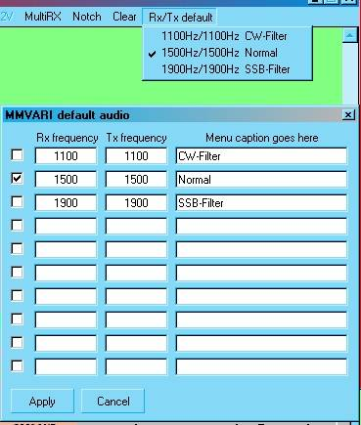

CWPAP\_34

### 3.9.2.2 Display Using Radio Frequency From Your Radio

From the Sound Card Data window menu select the View | Frequency display menu items

Select Display frequency from radio.

### 3.9.2.3 Display Using Preset Radio Frequency Reading

If you wish to use the display scaled in radio frequency instead of audio frequency, but you are not using Radio Control, do the following:

* + 1. Under Settings on the Main Menu, select Preset Radio frequencies;
    2. Set four preset frequencies and modes (USB or LSB). These are the frequencies to which you should adjust your receiver when operating on that band. If you set 14070.00 USB, then set your VFO to that frequency and mode when you are on 20 meters. Now your VFO and Logger32's display scale will agree; and,
    3. Under View on the Main Menu, select Frequency display and pick one of the fixed radio frequencies you entered in step 2.

When you have done the above, the following Macros will work properly and the radio frequency will be displayed on the third pane from the left on the Statusbar, even though the radio and computer are not in communication.

* + - * $radioandtone$
      * $radiofreq$
      * $upperorlower$
      * $rxtonefreq$

If you have radio-computer communicaiton, you can configure Logger32 to display beginning at your radio's frequency.

From the Settings menu item of the Sound Card data window, select "Preset Radio frequency".

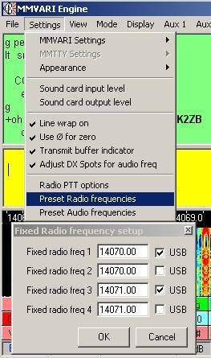

CWPAP\_35

Select mode (USB or LSB). If your radio sends sideband information to Logger32 then this setting will be ignored.

Under "View" on the Main menu select "Display Frequency display".

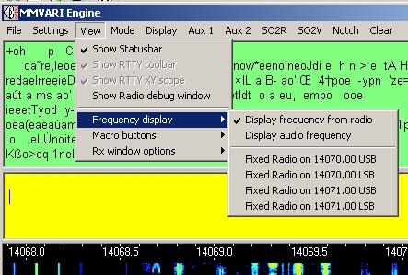

CWPAP\_15

When you have completed the above, the following Macros will work properly and the radio frequency will be displayed on the third pane from the left on the Statusbar.

* + - $radioandtone$
    - $radiofreq$
    - $upperorlower$
    - $rxtonefreq$

Logger32 can display a maximum of 4000 Hz. of receive bandwidth (receive range), however, it will only receive and transmit over a 3000 Hz. bandwidth, from 0 Hz. to 3000 Hz. of audio.

### 3.9.3 Adjusting Squelch

To adjust the squelch, go to the lower status bar and place the mouse pointer in the ninth pane. A left-click will set the squelch line in the pointer position. The signal indicator rises from left to right, so placing the squelch line at the left-most position will provide maximum sensiitvity. Any other signals to the left of the squelch line will not be decoded.

### 3.9.4 RX Frequency Controls

Here are three ways to control your receive frequency:

* 1. Click somewhere in the Logger32 receive range;
  2. Use the $qsy$ macro; and
  3. Use the $up$ or $down$ macros.

The actual Transmit /Receive frequency is your USB radio dial frequency setting plus the audio frequency displayed in Logger32. If you were using LSB then you would subtract the Logger32 audio frequency reading from your radio's dial frequency. You can go to View, Frequency display and choose whether you want Logger32 to display the audio frequency or preset radio frequency, or if you want Logger32 to read the transceiver using computer-radio communication to show you the actual frequency at which signals are received.

**Note**:  Logger32 will display the offset for RIT for some radios but not for others. You should verify how this works with your own radio.

### 3.9.5 AFC Control

Turn on the AFC in the pane on the Statusbar at the bottom. To receive PSK31, you will almost always need to turn [AFC](#AFC) on, because an error of only a few Hz. will reduce copy to zero. By the time the frequency drift contributions of your receiver, the other station's transmitter, and your sound card are added together, it is best to use AFC to follow the signal.

### 3.10 Received Signal Quality

The relative signal to noise ratio is expressed in db in the fourth pane of the lower status bar.

The squelch meter on the ninth pane of the status bar is actually a measure of signal quality; it has nothing to do with [IMD](#IMD). Signal quality describes how readable the signal is.

**Note**: A good quality signal is (by definition) a combination of many factors, including, but not limited to:

* + Quality and linearity of original transmitted signal;
  + Propagation path attenuation, distortion, etc;
  + Receiver distortion, noise, linearity, etc; and,
  + Interference.

### 3.10.1 Using Receiver Filters

3.10.1.1 Audio DSP

Logger32 uses audio [DSP](#DSP) to select one signal from many that are in the receive range. If you set your receiver selectivity to wide, you can still copy a single signal, as long as no signal is very strong. However, DSP in Logger32 works only on the audio coming into the sound card so if the transceiver receive passband is wide, noise and interference come through. If some of the interfering signals are very strong, they may affect the receiver AGC, which reduces the amplitude of a weaker signal that you are trying to copy.

Audio DSP in your radio will be of little benefit to Logger32. The narrower audio signal may sound nicer to you in the speaker, but you have not improved copy by using audio filtering or DSP. Logger32 (in either PSK31 or RTTY modes) already has about all the audio DSP it needs.

Some radios use IF DSP, and which may provide the filtering you need to prevent distortion from occurring in the IF stage of the receiver.

### 3.10.1.2 Transceiver IF Filtering

PSK31 is a narrow-signal mode, and the best results in terms of removing interference, and in terms of getting the best signal-to-noise ratio (S/N), comes from setting the IF selectivity as narrow as the signal. For PSK31, this IF bandwidth is about 50 Hz. You may not have a filter this narrow, but you may have some filtering that you can bring into play. Normally, IF filtering is in play when you select a narrow crystal or mechanical filter, when you use the passband or IF shift controls, when you use an IF notch filter, or when you implement IF DSP.

### 3.10.1.3 A Combined Approach

One tactic is to set your radio's selectivity to a wide setting while tuning the band, so you can see many signals.

Once you have found a signal and you want to make a QSO, narrow your radio bandwidth. If your radio uses passband tuning (PBT), IF shift, or some other passband-modification scheme, you may be able to adjust it to reduce interference. With Logger32's spectrum display, you can see the effect of making filter and other IF changes at your radio. Sometimes, all the filters are not exactly centered at the same frequency, and you may have to adjust the passband tuning control to ensure that you have the signal of interest in the passband. With the $hexcommand$ and $command$ Macros, you may be able to set Macro buttons that allow you to control your bandwidth right from the Logger32 screen. See the [Direct Control of Radios](#_topic_DirectControlofRadios) topic.

It is also possible to use your radio's manual IF notch filter to remove interference. Again, you will see the effect of this filter visually by watching the waterfall display. If your radio has an effective manual notch filter, tune it slowly and you will see a line of black (no signal) move across the display. However, if this notch is an audio filter, the warning above about audio filtering applies. With an audio notch filter, any distortion caused by the interfering signal will already be present by the time you apply the audio notch filter to remove it. An automatic notch filter will not work because it will remove the wanted signal along with the unwanted ones. The automatic filter cannot tell the difference between the signal you want and the signal you do not want.

### 3.11 S-Meter Readings

When you make a decision about receiver filtering, you may also want to consider the fact that your S-meter will show the summed signal strength of the many signals in the radio's passband. You may have poor copy of a weak signal using a wide passband, but the S-meter may report a high value due to nearby signals. When you narrow the passband with IF filtering in your transceiver, you also cause your transceiver S-meter to read the strength of the signal of interest.

### 3.12 Saving Received Text To A File

You can save a file for later reference (say a contest, where you may want to double-check callsigns), or to print all or part of it, using an editor such as Notepad or Wordpad. If you wish to save received text to a file (to hard drive or floppy), do the following:

* 1. Go the Main Menu and click on File;
  2. Select Open receive text file;
  3. Select a file or create one to receive the saved text;
  4. When saving is completed go to File; and,
  5. Select Close receive text file.

There is no indication that the text is being saved to file, except as viewed in the File drop-down menu. You should turn the Open receive text file off when the desired copy is complete by selecting Close receive text file. If this is not done the Main Receive Window will continue to save your text!

### 3.13 Evaluating The Other Guy's Signal

The presence of extra lines around someone's signal is a sign that he may be overmodulating. However, this is not a guarantee that the other station is distorting, since a strong signal can cause very similar distortion to take place in your receiver, even from a clean signal. This is receiver overload. The surest way to determine whether the other station is or is not clean is to use the [IMD](#IMD) indication in the fourth pane from the left in the Statusbar, also shown at the bottom left of the RX Tuning window. It will turn green at about -23 dB of IMD, but there is little noticeable distortion at -20 dB.

If you see a strong signal that is generating extra bars on the display, but whose IMD is good, then the distortion is in your receiver. You use your crystal filters and passband tuning to reduce the strength of the station by moving him out of the receiver's passband. Logger32's built-in DSP does a good job of copying through such distortion products, and if the strong station is the one you want to work, the DSP ignores the bars outside the main RX passband lines.

## 4.0 TRANSMITTING PSK31

# Randy Tipton, WA5UFH and Jim Hargrave W5IFP

**Note**: All operational references to PSK31 equally apply to PSK63, PSK-125, MFSK and QPSK modes.

Transmitting PSK31 signals involves several software options. Every operator is personally responsible for the quality of signal he or she emits. For information on adjusting your transmitter and sound card see the topic [Interfacing the Radio to a PC Sound Card](#_topic_InterfacingaRadioforPCControl). This discussion covers the software options available to the Logger32 user for transmitting PSK31 signals, and makes suggestions on how to use them. The best way to get familiar with the transmitting options is to read all the topics, and then, with the radio turned off, start playing with the options to become familiar with their operation.

### 4.1 Selecting an Operating Mode

The modes of operation are found under the [Sound Card Data window](#_topic_SoundCardDataWindow1) menu | Mode menu item. Modes not yet available in your version will be grayed out. The mode that is selected will have a check mark, indicating it is selected. The leftmost pane of the statusbar also indicates current mode. You can also use the following macro commands to change mode:



CWPAP\_19

### 4.2 TX (Transmit) Window

The TX window serves as an area to view text that is to be transmitted, The TX window also allows the user to type what they want to send while they are still in the receive mode. This is referred to as a type-ahead buffer. The text is transmitted in the order it is displayed in the window. This is also true for Macro keys; if you have text in the buffer and press a Macro key, the Macro will take effect after the text already in the buffer is sent. The Clear TX and Abort functions operate immediately, without waiting for the text to be sent.

The following are user-selected options for the TX Window (transmit window) in the MMVari "Settings|Appearance menu".

* + **TX Window font** - sets font, size and font style.
  + **TX Window background** - sets background color.
  + **TX Window buffer indicator color** - sets the color that text will change when it is transmitted.

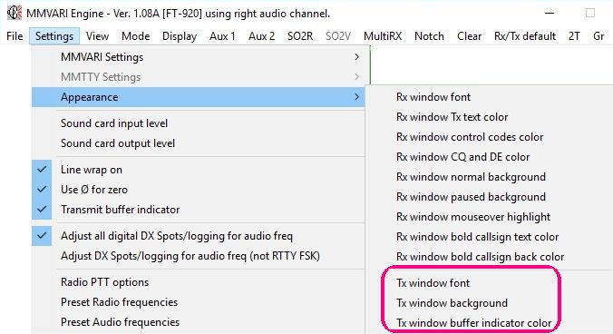

CWPAP\_20

The TX Window will have a scrollbar on the right-hand side when the window becomes full of text. It fills from top to bottom. When the TX window is full, text scrolls off the top, out of the user's view. The user can view this text again by using the scroll-down bar on the right side of the window. Transmit text is buffer-size limited.

Transmitted text is echoed in the receive window. This allows the user to see what text has been transmitted, and to monitor both the other station's transmission and their own transmissions, in context. You can change the color of the echoed transmitted text by using the MMVari menu items "Settings|Appearance|Rx window|Tx text color". In this way, you can use color to distinguish between received and transmitted text.

When the TX window is empty and Logger32 is still in transmit, an idle signal is transmitted. If you are asking another station for an [IMD](#IMD) report, you should send five seconds of PSK idle.

The TX Window can be resized using the Splitter Bar. Use the mouse and move the cursor over the splitter bar slowly until the pointer changes to the splitter identifier (up/down arrow) and left-click the mouse and drag the TX Window up or down to the desired width.

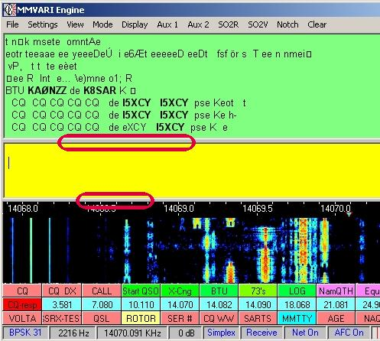

CWPAP\_21

### 4.2.1 Methods to Enter Text in the TX Window

* + Type text here using the keyboard;
  + Paste text from Logger32 or another application using standard Windows copy/cut and paste (mouse right-click or <**Ctrl+C**>/<**Ctrl+V**>);
  + Invoke text by with buttons and hot keys (see the [Hot Keys](#_topic_HotKeys) and the [Programmable Buttons](#_topic_ProgrammableButtons) topics); and,
  + Load a text file from a floppy or hard drive, using File, Send a text file on the MMVari Menu.

### 4.2.2 Methods to Correct Text in the TX Window

* + If incorrect letters have not been transmitted, backspace to erase them and then correct the letters. Transmitted text will come out as corrected;
  + If incorrect letters have been sent, the receiving station will see the incorrect text, then he will see the letters erased and replaced by whatever you type after erasing;
  + If a buffer (example: a Macro or typing ahead) has incorrect text, if you are fast enough, you can backspace and erase before the wrong text is transmitted;
  + A correction can only be made to the last letter in the TX buffer. It is not possible to use the back arrow to correct text in the middle of the buffer. You must erase backwards from the last letter in the TX buffer to the error;
  + Left-click the Abort (pane 7) to clear all text in the TX buffer and return to receive. This is the panic button, in case your radio starts to smoke during a transmission; and,
  + Left-click Clear on the top menu and select TX buffer.

### 4.2.3 To Call Up a Text File From a Floppy or Hard Drive

* 1. Click File on the MMVari menu
  2. On the drop-down menu select Send a text file;
  3. Select the prepared file using the Windows Open dialog that appears; and,
  4. When opened, the file is entered as text in the Window.

This option can be used for a brag file, etc.

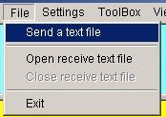

CWPAP\_22

### 4.2.4 To Clear All the Text in the TX Window

1. Click on Clear (on the Toolbar); and,

2. From the drop-down menu select Clear Tx.

It is also possible to use the $clearbuffers$ and $cleartxbuffer$ Macros.

**Note**: The TX Window and TX buffer are cleared, but you will not switch to receive.

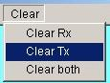

CWPAP\_23

To Abort All Text and switch the program to the Receive mode single-click on the Abort pane on the Statusbar

This could be considered an 'Emergency Kill.'



CWPAP\_24

### 4.3 Transmitting Upper and Lower Case

PSK can transmit all the letters on a computer keyboard, both upper (capital letters) and lower case, and the special characters. You can force Logger32 to transmit only upper or only lower case letters by selecting the MMVAri "Settings|MMVARI Settings|Typing preference" menu items, and making a selection.

The standard is to type as usual, using upper and lower case. With PSK31, uppercase letters take longer to transmit than lower case letters, and if you select "uppercase only" your transmissions will be slower.

### 4.4 Changing the Transmit/Receive Status of the Radio

To see how to interface the rig with the computer for controlling the switching from receive to transmit see the topic [Interfacing a Radio to the PC Sound Card](#_topic_InterfacingaRadiotothePCSoundCar)

### 4.5 Methods of Switching from Receive to Transmit

* + Click on the 6th pane from the left on the Statusbar. Pane text will change from Receive (blue) to Transmit (red);
  + Use the $transmit$ Macro. See the [MACROS](#_topic_MACROS) topic.
  + Press the <**Pause/Break**> key.

### 4.6 Methods of Switching from Transmit to Receive

* + Click on the 6th pane from the left on the Statusbar. Logger32 will type all the text in the TX buffer and then go to receive.The transmit/Receive pane will change from Transmit (red) to Receive (blue) when all the text is sent;
  + Press the <**Pause/Break**> key. This is the same as clicking Transmit/Receive;
  + Click on Abort pane (9th pane from the left) on the Statusbar. Logger32 will clear the TX buffer immediately and go to Receive;
  + ·Press the <Esc> key. This is the same as clicking Abort; and,
  + Use the $receive$ Macro invoked either by buttons or hot keys. See the [Hot Keys](#_topic_HotKeys) and [Programmable Buttons](#_topic_ProgrammableButtons) topics.

4.7 Select the Transmit Frequency

There is no place to enter your frequency within the sound card window. Frequency selection is accomplished by clicking in the display window, by tuning your radio, or by using the $qsy$ and $qsx$ Macros. You probably know how to tune your radio, so we'll just tell you about Logger32 here:

* + If you're going to transmit (call CQ, tune) click inside the display area in an open area not presently being used by another station and observe the frequency readout on the 2nd pane of the Statusbar; or
  + If you're going to be answering another station, click inside the display area on top of the other station's received signal. Your frequency will be displayed on the 2nd pane of the Statusbar.

The picture below of the display window indicates that the:

* + Display shows the audio frequency in the 2nd pane of the Statusbar;
  + User has clicked in the display part of the spectrum at an audio frequency of 1629 Hz. to transmit or listen;
  + Mode is BPSK;
  + Net feature is turned on. (Transmit frequency = Receive frequency); and
  + Radio is in receive mode.

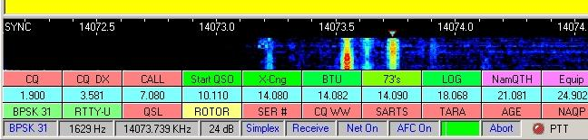

CWPAP\_25

The picture below of the display indicates that the:

* + User has left-clicked on the PSK signal in the display, and the main red passband marker is now centered over that signal;
  + Mode is BPSK;
  + Net feature is turned on. (transmit frequency = receive frequency); and
  + Radio is in receive mode.

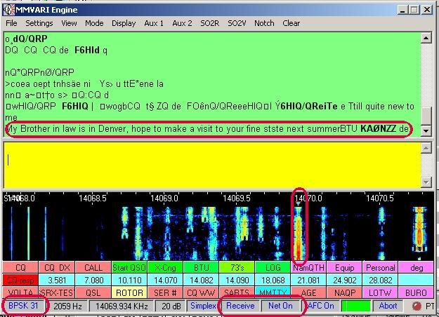

CWPAP\_26

### 4.8 Net Function

It is possible to work split-frequency by using different audio tones for transmit and receive. Net is turned off and the transmit frequency is set separately. For information on this process see [Operating Split Frequency Using Different Audio Tones](#3.8.2_Operating_Split_Frequency_Using_Different_Audio_Tones).

Net On forces Logger32 to transmit on the current receive frequency selected in the display, and shown on the Statusbar frequency pane. The advantage of having Net turned on is, it reduces the bandwidth used by the two stations because they both stay on one frequency. If neither station uses the Net function it is like operating split frequency, which uses more spectrum. If both stations use Net it is still possible for both stations to drift. If this happens, one station should change their Net status (if off - turn it on, if on - turn it off). In this way, one station will track the other station's frequency.

The Net function has two positions, either off or on. Click on the 6th pane on the Statusbar to toggle between these positions. (The pane will change from Net On to Net Off).

If you turn Net off, you will transmit at the last-used TX audio frequency. The transmit waterfall display will be at the audio frequency at which you are transmitting. If you have made a mistake, you can abort your transmission and turn Net on, or, if you decide to stay where you are, you can left-click on your own transmit waterfall during while you are transmitting, and your receive passband window will move to your transmit frequency, so you can copy someone who calls you zero-beat.

**Note**: The displayed PSK31 signal on the display and tuning windows is software generated and is not a true representation of your actual transmitted signal.

**PSK31 NET Rule of Thumb**: The station that is initiating a contact or calling CQ should leave the Net function off, thus setting the master frequency, and let the called station track the master frequency. This prevents "walking" up or down the band if one station is always a little off frequency.

### 4.9 Indications That You Are Transmitting PSK31

There are a number of ways to know that Logger32 is transmitting:

* + The 6th pane on the Statusbar indicates transmit;
  + The PTT light is green;
  + The display shows only the PSK31 signal at your transmit frequency;
  + The Main RX/TX Tuning window indicates the PSK31 signal; and
  + Transmitted text is echoed in the RX window.

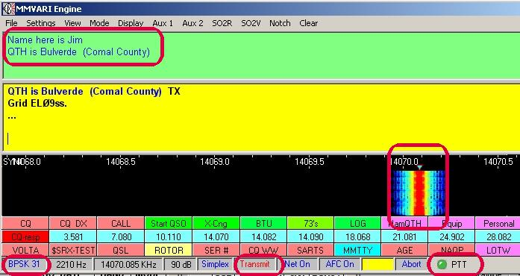

CWPAP\_27

The above picture of the display panel indicates the station is transmitting on 1699 Hz.

### 4.10 Macro Control of Transmit Frequency

The [topic on Macros](#_topic_MACROS) describes the $qsx$ and $qsy$ Macros.

### 4.11 TX/RX Tuning window

When Logger32 transmits, there will be a histogram display in the small TX/RX Tuning window. This display represents the audio that is being sent from the sound card to the radio. The TX/RX tuning window is not a display of your radio's actual output.

### 4.12 How Do I Transmit a CWID?

If you wish to send CW identification at the end of your text you can use the CW macros. To change the CW speed in words per minute go to "Settings|MMVARI Settings" and select CW ID speed on the drop-down menu.

The following are user-selected options for the MMVARI window. The highlighted menu options affect the amplitude of the Spectrum / Waterfall display.



CWPAP\_29

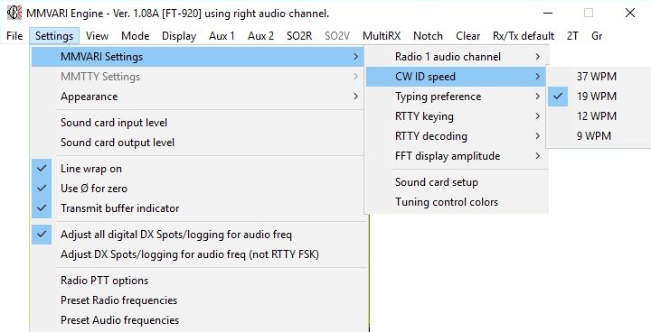

CWPAP\_28

### 4.13 Considerations When Transmitting at Display Frequency Extremes

The maximum displayed bandwidth in Logger32 is 4000 Hz. You can transmit up to 3000 Hz. from the frequency at which your transceiver is set, since Logger32 can set a tone up to an audio frequency of 3000 Hz.

There are two considerations to keep in mind when you click on a signal to call a station, and thereby select a transmit audio frequency.

### 4.13.1 Rolloff Consideration

Since you are using [AFSK](#AFSK) in the [SSB](#SSB) mode of your transceiver, you should remember that the transmit audio rolls off below 300 Hz. and above 3000 Hz. Those are just ballpark numbers, and some transceivers have a low-end rolloff above 300 Hz. and some have a high-end rolloff lower than 3000 Hz. This means that your signal will be attenuated when you are near those limits. If you have an output power meter the display will show that you are running lower power, for the same transceiver microphone gain setting, when you transmit very high or very low tones. You should be especially careful that you do not set your transmit audio microphone gain with a very high or low tone and then operate in the middle, because you may be overdriving in the middle, since the gain is higher.

### 4.13.2 Harmonic Consideration

If you do happen to overdrive, one type of distortion you will generate is harmonics. If you transmit a tone at 600 Hz, then you can also transmit a harmonic at 1200 Hz., 1800 Hz., 2400 Hz., and 3000 Hz. Above that, your transmitter audio rolls off and your harmonics will be attenuated. However, if you were to choose a transmit audio frequency of 2000 Hz. or above, and overdrive the audio, your first harmonic, 4000 Hz., is already well into the rolloff region of your transceiver transmit audio stage, and it will be attenuated, along with the higher harmonics. Clearly, you are safer operating at a tone above 2000 Hz. For more on this topic, see the topic [Transmitting a Clean Signal with PSK...](#_topic_TransmittingaCleanSignalwithPSKM)

The feature that allows you to transceive on your default Rx frequency can make it easier to transmit high tones even though you initially receive a station at a low frequency in your receive range. Invoke this align function with a right-click of the mouse. Align requires that you have computer control over your radio's frequency.

*Created with the Personal Edition of HelpNDoc:* [*iPhone web sites made easy*](http://www.helpndoc.com/feature-tour/iphone-website-generation)

**Communicating with RTTY**

# William R. Turner, W7TI and Jim Hargrave W5IFP

## 1.0 GENERAL

Logger32 uses three data engines to decode and generate [RTTY](#RTTY):

* + The MMVari engine, written by Makoto Mori, JE3HHT that supports [PSK](#PSK31/63/125), [MFSK](#MFSK), [QPSK](#QPSK) and RTTY;
  + The MMTTY engine, also written by Makoto Mori, JE3HHT. This RTTY engine supports a number of baud rates, shift widths and mark/space selections; and
  + The [2Tone Engine](#_topic_G3YYD2ToneRTTYEngine), written by David Wicks, G3YYD, that decodes and transmits RTTY signals. It can be open with MMTTY or MMVARI to provide a second decode window. When used with MMTTY, 2Tone can be configured to transmit RTTY in lieu of using MMTTY.

For the purposes of discussion, emphasis will be placed on the MMTTY engine. Operation of the RTTY mode in MMVari is similar in most cases.

## 2.0 RTTY BASICS

RTTY is a fun and easy mode to operate, but there are a few things that may be puzzling to the newcomer. Please take a few minutes to read the following and you will probably save yourself some time and frustration, as well as becoming more knowledgeable about the basics of RTTY.

Also, AA5AU provides a good overview of [Getting Started on RTTY](#Link:_RTTY_Overview). It is good for the beginner as well as seasoned RTTY operators

### 2.1 Mark and Space

An RTTY transmitter sends out a continuous carrier that shifts the frequency back and forth between two distinct frequencies. There is no amplitude modulation, only a pure carrier similar to CW with the addition of a frequency shift.The lower RF frequency is known as the SPACE frequency and the upper RF frequency is known as the MARK frequency. The difference between the two is known as the SHIFT. For amateur radio, the SHIFT has been standardized at 170 Hz. It is customary to refer to the MARK frequency as the frequency on which you are operating. For example, if you say you are transmitting on 14080.00 kHz, that means your MARK frequency is 14080.00 kHz and your SPACE frequency is 170 Hz lower, or 14079.83 kHz.

### 2.2 FSK and AFSK

You will often hear the terms [FSK](#FSK) and [AFSK](#AFSK) when talking about RTTY. FSK means Frequency Shift Keying and AFSK means Audio Frequency Shift Keying. Here is an important point; regardless of which method is used, the RF signal sent out over the air is identical. MARK is always the higher RF frequency and SPACE is always the lower RF frequency. The station receiving the RTTY signal cannot tell any difference at all. So what is the difference? The difference is the way your transmitter generates the RF signal.

With FSK, your transmitter receives a simple on-off signal that causes the carrier frequency to shift back and forth. Since you will be using MMTTY, the on-off signal will come from a COM port on your computer. Other stations that do not have a sound card program like MMTTY would use a separate box called a TNC. The TNC does the same job that MMTTY does with your sound card. FSK is simpler, easier and more foolproof than AFSK and is highly recommended if your transmitter supports FSK input. Check your owner's manual if you're not sure.

Since not all transmitters support FSK input, there is another method available with MMTTY; you guessed it - AFSK.  AFSK can be used with any SSB transmitter. AFSK is a bit trickier to set up and use, but when it is done correctly, it works just as well as FSK and will transmit a perfect RTTY signal. Also, AFSK can do some things FSK cannot, such as automatic frequency control (AFC) of the transmitter.

To operate with AFSK, you put your transmitter in the SSB mode instead of FSK mode, and you put an audio signal into the microphone input (some transceivers have a rear connector for data input).  When you transmit, MMTTY causes your sound card to put out a pair of audio tones that cause your transmitter to send the required RF output. Sounds simple, right?  Here's the tricky part --- the tones are two sine waves - nothing fancy - but the frequency and amplitude of the tones is critical. Let's say you want to transmit on 14080 kHz, as in the previous example. Remember, your MARK signal has to be on 14080 kHz. Here's how you get there with AFSK; With your transmitter in the LSB mode, whatever frequency goes into the microphone input will be subtracted from what your dial says and be transmitted on that frequency. For example, if your dial says 14080 kHz. and you put in a 1000 Hz. audio tone; your transmitter will put out an RF signal at 14079 kHz., exactly 1000 Hz. lower than your dial. In this case, if the 1000 Hz. represented your MARK signal, you would have to set your transmitter to 14081 on the dial, and your MARK signal would be transmitted on 14080, just as you wanted. OK so far? Now, what about SPACE?  Remember, you want your SPACE signal to be transmitted 170 Hz. lower, on 14079.83 kHz.  What audio tone will give you 14079.83?  Simple - 14081 minus 14079.83, or 1170 Hz.  So the MARK audio frequency is 1000 Hz. and SPACE is 1170 Hz.

There you have the basics of AFSK. MMTTY generates the two audio frequencies and your transmitter converts them to two RF frequencies. For technical reasons related to harmonic generation, audio frequencies of 1000 Hz. and 1170 Hz. are NOT recommended. They are used in this example just to keep the math simple. The recommended audio frequencies are 2125 Hz. for the MARK audio frequency and 2295 Hz. for the SPACE audio frequency. Making the frequencies higher like this will reduce any second harmonics that might be generated in your transmitter.

If you've been paying close attention, you may have noticed the SPACE audio frequency is higher than the MARK audio frequency - just the opposite of the RF frequency you actually transmit. This happens because you're using lower sideband. If you happen to forget and set your transmitter to USB instead of LSB, two things will happen. Because your MARK and SPACE are now reversed in your receiver, any RTTY signals you hear will not print correctly. All you will see is random characters that make no sense at all. The other thing is that YOUR transmissions will also be nonsense to the other guy.  Just remember - always use LSB. In the real world of course, sometimes USB gets selected accidentally.  This is why MMTTY has a button marked REV. When you have a station tuned correctly but all you see is nonsense printing, click on REV and your transceiver will be reversed. Now you can print the other fellow and tell him he is "upside down", as it's commonly called.  After he reverses himself, just click REV again and you will both be back to normal.

**Note**:  By default when using AFSK, REV reverses both your receiver and transmitter. If you want REV to reverse only your receiver, go to Option/Setup MMTTY, click the TX tab and click "Disable REV". When using FSK, REV reverses only your receiver. If you want to reverse your transmitter and receiver with FSK, your transceiver should have a way of doing that; check your owner's manual.

Also, you should know that in some parts of the world, especially Europe, the standard is to use USB instead of LSB.  This works fine as long as you also reverse the MARK audio frequency and the SPACE audio frequency. MMTTY defaults to LSB, and it is recommended to leave it there, even in Europe, since your signal will be identical. If you prefer to use USB, leave REV on all the time.

The really critical part about AFSK is the amplitude of the signal fed into the microphone connector (or rear panel connector), together with the microphone gain setting. You must NOT overdrive your transmitter or spurious signals will be transmitted. In general, keep the audio drive low enough that your transmitter does not generate any ALC voltage. Never try to drive your transmitter to maximum output. Around 80 to 90 percent of maximum is about right. Consult your owner's manual for more information on how to do this. If you ever hear a station at two or more frequencies at the same time, the cause is almost always an overdriven transmitter. None of this applies to FSK, of course.  With FSK, you can run full power and not worry about overdrive.

### 2.3 Figures Shift and Letters Shift

RTTY uses the Baudot code, invented before radio even existed, and still widely used throughout the world. The Baudot code uses data bits to represent letters, numbers and punctuation, much like your computer does. Unlike your computer, which uses eight bits for each character, the Baudot code uses only five, plus a start bit and stop bit. Using fewer bits is good because it speeds up transmission and reduces the chance of errors, but there is a complication. Five data bits can only represent 32 different characters. Since there are 26 letters in the English alphabet plus ten numbers, plus some punctuation, 32 different characters is not enough, even if you only use capital letters, which Baudot does.

Mr. Baudot could have chosen to use six data bits or even more, but he found a better solution. He reasoned that most of what would be sent would be letters rather than numbers or punctuation, so he assigned all the letters to the basic 32.  He then had six characters left over and he did a very clever thing with two of them. He made one of them a FIGURES SHIFT and another a LETTERS SHIFT. The way it works is this: when sending one of the basic 32 characters, nothing special happens. But when a number or punctuation is to be sent, a FIGURES SHIFT character is sent first (it's a non-printing character - you won't see it on your screen).  Whatever follows will still be one of the basic 32 characters, but the receiver will interpret it differently.  For example the letter Q uses the same five data bits as the number 1, but when the receiver gets a FIGURES SHIFT first, it prints the next character as a 1, not a Q. This continues until a LETTERS SHIFT character is received, at which time the receiver goes back to "normal" printing. All of this shifting is done by the system - there is no key marked LETTERS SHIFT or FIGURES SHIFT.  It's all automatic and you will scarcely notice it happening.

In fact, the only reason to mention it at all is because we are using radio instead of wires, and radio is susceptible to interference from various sources such as lightning static, man-made noise, etc. If a burst of static should happen to wipe out a LETTERS SHIFT or FIGURES SHIFT character, the characters following will not print correctly until another LETTERS SHIFT or FIGURES SHIFT is received. For example, suppose you are sending a signal report of 599, but the FIGURES SHIFT character gets wiped out by a burst of static.  Instead of printing 599, the other fellow's computer will print TOO. TOO is exactly the same as 599, without the FIGURES SHIFT. So how can he read what you intended to send?  It's easy if he knows the secret and here it is, look at the top row of letter keys on your keyboard - QWERTYUIOP. Now look just above each key and to the left. Each of those number keys is the same as the letter key below and to the right, plus the FIGURES SHIFT. In our example, TOO = 599. Likewise, the word PIPE, if the LETTERS SHIFT were missed, would print as 0803.  If 0803 lost its FIGURES SHIFT, it would print as PIPE.

When the bands are nearly empty, you can use practically any receiver bandwidth with good success. Your SSB filters are probably between 2.1 and 3.0 kHz. wide and as long as no other stations are nearby, copy will be fine. For optimum performance however, less bandwidth is better, in fact MUCH better. 170 Hz. shift RTTY only needs about 250 Hz. for proper copy.  If you don't have a 250 Hz. filter, 500 Hz. will do pretty well, but anything wider than that will not be satisfactory in the long run.

You may wonder why, if the shift is 170 Hz., do you need a 250 Hz. filter?  Why not 170?  The reason is that shifting the frequency generates sidebands adjacent to the actual signal and if the sidebands are attenuated, the signal will be degraded. RTTY is actually a form of FM, and if you'd like to understand more FM theory, there are a large number of books available. For amateurs, the ARRL Handbook is a good source.

Depending on your transceiver, you may or may not be able to use a narrow filter for RTTY. Some of the less expensive transceivers do not have an FSK mode, and also are unable to select a narrow filter while in the LSB mode. Some improvement can be made by using an outboard audio filter between the speaker output and the sound card input, but unfortunately, that will not prevent a strong adjacent signal from causing the receiver's AGC circuit to reduce gain, often to the point where the desired signal disappears. The best solution is to upgrade to a transceiver that has an FSK mode built in, AND which allows you to select a narrow filter while in that mode.

### 2.4 Band Plans

It's easy to remember the band plans for RTTY. Most activity will be found between 80 and 100 kHz. up from the bottom edge of the band, except for 80 meters that goes an additional 40 or 50 kHz. higher, and 160 meters. 160 meter RTTY activity is rare, but when found, it is usually between 1800 and 1820. Avoid the CW DX window between 1830 - 1840. At present, there is not much activity on the WARC bands, although 30 meters can be active at times.

Here is where you will find most of the RTTY activity:

* + 80 meters:  3580 - 3650 (3520 - 3525 in Japan)
  + 40 meters:  7080 - 7100 in the US (see note below)
  + 30 meters:  10110 to top of band
  + 20 meters:  14080 - 14099 (avoid the beacons at 14100)
  + 15 meters:  21080 - 21100
  + 10 meters:  28080 - 28100

RTTY allocations for 40 meters vary greatly all over the world. In the US, RTTY is permitted between 7000 and 7150, although most US activity is between 7080 and 7100.  DX activity is often found between 7020 and 7040.

For US operators, remember that RTTY is not allowed in the phone portions of the HF bands except on 160 meters, where it is legal anywhere in the band.

### 2.5 RTTY DX

Chasing DX on RTTY is highly popular with the RTTY crowd. As you might guess, 20 meters is the premier DX band for RTTY, and most rare DX stations and especially DXpeditions operate on 14080. Just like with CW or phone, if the DX is calling CQ and getting no answers, you can feel safe in calling him right on his frequency. If things are busy however, he will often work split, which means you should call him on a different frequency, usually 2-10 kHz. higher. He will say "up 2-10" or something similar at the end of his transmission, and that's your clue. Your transceiver owner's manual will explain how to do "split".

### 2.6 RTTY Contests

RTTY contesting is a passion with a lot of operators. There are about a dozen major RTTY contests each year and when they are on, the bands will be full!  Even if you don't care to compete, it's a great way to pick up new states or countries.  Many of the rare DX stations are serious contest operators. A list of RTTY contest times and rules can be found on the web by searching on "RTTY Contest", "RTTY Contest Rules", "SARTG RTTY Contest Rules" or "WPX RTTY Contest Rules". A recent search of those topics yielded over 10 pages of different RTTY contests.

Contesters are in a hurry, of course, so please don't send your name, QTH or anything except what is required by the contest.  There will be plenty of time for chatting after it's over.

If you get serious about RTTY contesting, you will probably want to get a program designed specifically for it.  In the meantime, MMTTY will let you try it out and see how you like it.

### 2.7 Your First RTTY QSO

OK, you've learned a bunch of stuff and you're ready to get on the air!  For your first time on RTTY, try the 20 meter band.  20 has the lion's share of RTTY activity and you can usually find someone, day or night. Try calling CQ between 14080 and 14087 kHz. A typical RTTY CQ would go like this: CQ CQ CQ CQ CQ CQ DE W7TI W7TI W7TI PSE K  Practically all RTTYers add the "PSE" at the end...kind of a friendly touch. Some will add their name and QTH, some will add the time and date. You'll find a lot of variety and it's all OK - just get on the air and try it out!

If you're familiar with CW procedures, you'll be right at home with RTTY. RTTYers use most of the Q-signals, as well as DE, K, KN, and all the rest. If you accidentally find yourself "upside down", don't get embarrassed - we've all done it!  RTTYers are some of the nicest people you'll ever meet, and things like jamming and profanity are almost unheard of.

### 2.8 RTTY Forever

In spite of the newer digital modes like PSK, PACTOR, GTOR and others, RTTY remains the favorite of contesters and DXers alike. RTTY does not use error correction, handshaking, or synchronizing, all of which slow things down. When quick back-and-forth exchanges are important, RTTY is the mode of choice. Roundtable discussions and nets that would be difficult or slow with other modes are a natural for RTTY, and RTTY is likely to be around for a long time to come.

So there you have most of what you need to know to become a proficient RTTY operator.

Welcome to RTTY!

Bill, W7TI

## 3.0 RECEIVING RTTY

# Andy O'Brien, K3UK and Jim Hargrave W5IFP

This topic will help you to receive RTTY signals when using Logger32. It is NOT a technical guide. For detailed information, see [RTTY Basics](#2.0_RTTY_BASICS) elsewhere in this document.

### 3.1 Getting Your Radio Ready

To receive RTTY signals one first has to find RTTY signals on the air. RTTY signals are not as prevalent as PSK31 signals these days, but you should be able to find them at: 7070-7085 kHz.,14080-14095 kHz., 21080 to 21095 kHz., and 28080-28110 kHz.  The best choice may be the 20 meter frequencies.

RTTY usually is received and transmitted using the lower sideband  (LSB). Put your transceiver in LSB and tune to one of the desired frequency ranges. If you are lucky, you should be able to find the quite distinguishable trill, chirpy, RTTY tones.  RTTY warbles, while PSK drones.

### 3.2 Getting Logger32 Ready

If you installed Logger32 from the full install package, MMTTY.EXE was furnished and should already be in the default Logger32 directory. If you are using an older version of Logger32, you might need to copy MMTTY.EXE (version 1.59D2 or above) into the same directory as Logger32. Logger32 will not be able to operate RTTY using the MMTTY engine without this file.

MMVARI.OCX is furnished by the Logger32 install package and should already be in the default Logger32 directory.

Open the [Sound Card Data window](#_topic_SoundCardDataWindow1) and click on "MODE". There are two selections that will allow you to operate RTTY.

## 4.0 MMTTY DATA ENGINE

From the MMTTY Main menu, select Mode | MMTTY engine menu items.

**Note**: You must have a copy of MMTTY.EXE in the Logger32 directory.

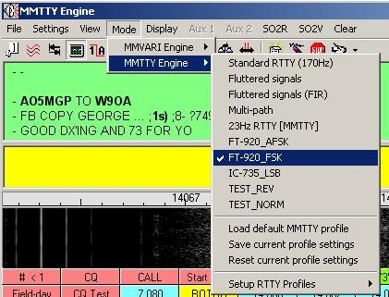

CWR\_1

## 5.0 MMVARI ENGINE

Select the MMVARI engine menu item, and then select RTTY-U or RTTY-L. On HF bands the most commonly used RTTY mode is LSB. If your radio is set to LSB, then you need to open RTTY-L. This is the equivalent of "RTTY NORMAL." You may find some stations using upper side band. If you are tuned into a station and printing garbage, then switch to RTTY-U mode. This will place you in "REVERSE RTTY."

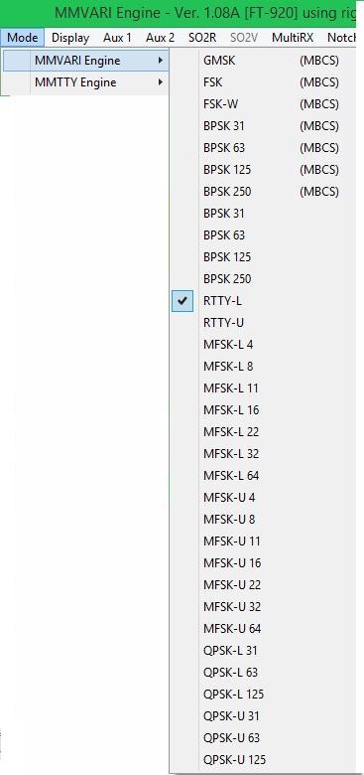

CWR\_2

Once you have selected an RTTY mode, then the specific setup of the different RTTY engines can be found in the [Sound Card Data window](#_topic_SoundCardDataWindow1) topic.

### 5.1 Okay, I'm All Set.  Bring On the RTTY

With your radio ready and Logger32 correctly configured, you are a mouse-click away from receiving RTTY. To make tuning easy, set AFC on by clicking the AFC icon on the RTTY toolbar or on the Status bar at the bottom until it says AFC On.  AFC will automatically fine tune and will compensate for drift.

Tune the radio until you hear an RTTY signal and look at your waterfall. As you tune the dial you will see the RTTY signal moving left or right. Tune so that the RTTY signal is completely in your waterfall display (Logger32 has lots of features that make this easier but we will save that for later). With the RTTY signal close to the center of the waterfall you should see the following:

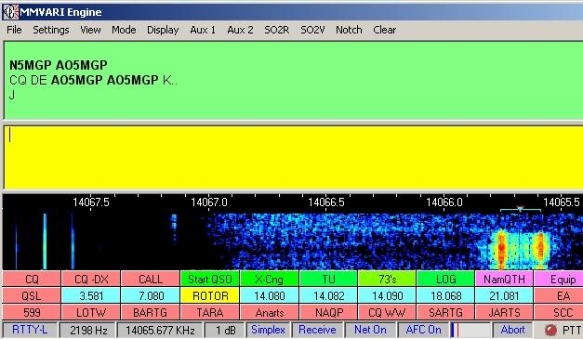

CWR\_3

The above is a representative screen using the MMVARI engine.

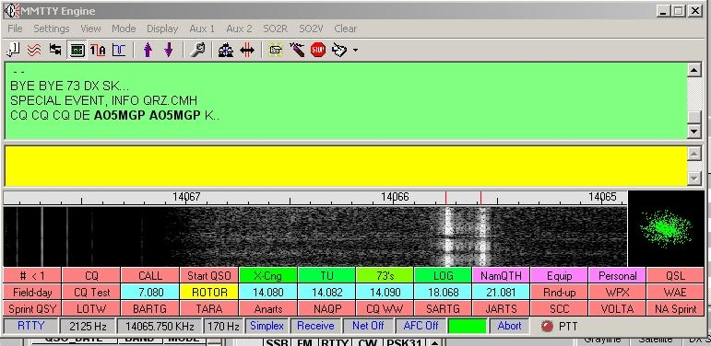

CWR\_16

The above is a representative screen using the MMTTY engine.

Left-click in the center of the signal (between the two vertical lines) and you should see copy printed on your screen.That's it -- not much to it. If you have received PSK31 before, it is simple for you. If you do not copy successfully, here are some points to consider:

* + Under weak signal conditions, RTTY is a little less robust than PSK31 or MFSK16, so if you see garbled characters on your screen it could be the result of a weak or noisy signal;
  + If nothing prints, you may not be using the same "sense" as the received signal, i.e., you are on the opposite sideband. In order to correct the signal, you may need to reverse the Mark/Space signals (whether MARK is the high or low tone);
  + If using the MMTTY engine, click the RTTY toolbar (above the RX screen) button that says Normal and it will become Reverse. This reverses the "sense" (whether MARK is the high or low tone) of the signal, and allows you to copy as if you had switched sidebands on your radio. This button will also change the "sense" of your transmitted signal, so you can work the other station this way. and,
  + If you are using the MMVARI-RTTY-U, then you need to change the mode to RTTY-L to reverse the sense.

With your radio ready and Logger32 correctly configured, you are a mouse-click away from receiving RTTY. To make tuning easy, set AFC on by clicking the AFC icon on the RTTY toolbar or on the Status bar at the bottom until it says AFC on. AFC will automatically fine tune and will compensate for drift.

Tune the radio until you hear a RTTY signal and look at your waterfall. As you tune the dial you will see the RTTY signal moving left or right. Tune so that the RTTY signal is completely in your waterfall display (Logger32 has lots of features that make this easier but we will save those for later). With the RTTY signal close to the center of the waterfall you should see the

RTTY signal's two vertical lines.

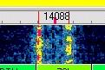

CWR\_4

### 5.2 Settings Drop-down Menu

**Note**:  The Settings menu works the same as it does when you receive PSK31. Some of the information from that topic is copied here.

The following are user-selected options for the RX window.

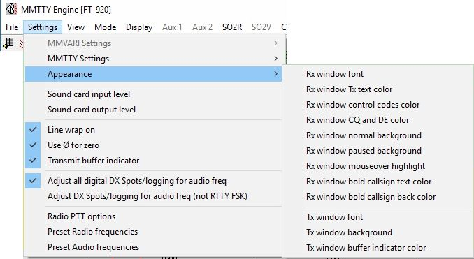

CWR\_5

### 5.3 RX Window Colors

As seen on the above drop-down "Settings|Appearance" menu, we find the following user options:

* + **RX window font** - sets print style and text color;
  + **RX window TX text col**or - sets color for echoed text. Echoed text is enabled/disabled with the View, RX Window Options menu;
  + **RX window control codes color**.  Control codes are enabled/disabled with the View, Show Control Codes menu item;
  + **RX window normal background;**
  + **RX window paused background** - sets the background color when all RX windows are paused with the <**Insert**> key; and,
  + **RX window mouseover highlight** - sets color for text change when you move the mouse cursor on it.  This is useful when you are selecting text to right-click for the comment field of Logger32, or when selecting a callsign or RST for a log.

### 5.4 RX Window Pause

### 5.4.1 Keyboard <Insert> Key

The RX Window has a scrollbar on the right-hand side when the window becomes full of text.  Text will scroll from the top of the window downward until the window is full.  At that point text is scrolled off the top, out of the user's view.  The user can see this text again by doing the following:

* + 1. Select the <**Insert**> key on the keyboard (one time);
    2. The RX Window background will change to white (or whatever color you selected in the "Settings|Appearance") and the text is frozen;
    3. The scroll bar can now be clicked to scroll the buffered text through the RX window; and,
    4. Select the <**Insert**> key on the keyboard to again start receiving text. (no RX text is lost).

**Note**: When you use the pause function, the background turns white. If you are using a white font, the whole RX display will turn white and you won't be able to see the letters. See the Receive Window Color instructions to change this color. This technique works during transmit, as well as in receive mode. You can freeze and scroll the RX window while the text you have already entered is being transmitted by Logger32.

**Warning**:  If Logger32 becomes unstable in RTTY mode, possibly operating slowly, or failing to do something, read the topic [Computer Tuneup](#_topic_ComputerTuneup).

### 5.4.2 Mouse scroll wheel

If the RX window is full of text, and some text has scrolled off, you can pause the RX window by placing the Mouse cursor anywhere in the RX window and rotate the scroll wheel. This function will suppress incoming data, allowing the user to scroll the existing text without interruption by incoming text.This pause function is visually indicated by the word “Freeze…” on the left side of the Sound card header. Freeze mode will time-out and self-cancel if no further scrolling is detected. If the cursor is moved away from the receive pane, freeze mode is immediately canceled and incoming text printing is resumed.

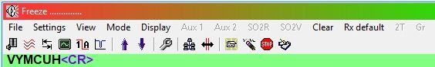

CWR\_28

The “Freeze” function is enabled by checking “Enable receive freeze” Function” in the Rx window options.

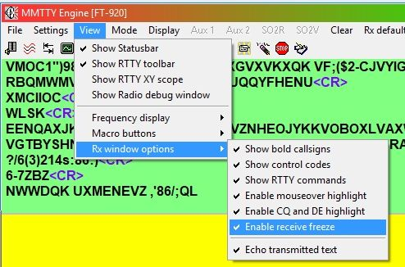

CWR\_28A

## 6.0 ADVANCED RTTY RECEIVING

Now that you are receiving, here are ways to fine-tune the received signal. First, we will look at the RTTY toolbar that appears at the top of the RTTY receive window.

### 6.1 RTTY Toolbar

When you go to RTTY mode an additional toolbar will appear, allowing you to operate the following controls. These appear from left to right on the toolbar:

* + **Squelch** - set this as with PSK, on the Tuning window vertical bar;
  + **Bandpass Filter** -  Set your transceiver to a wide passband and turn this on and off to see its action. This audio DSP filter remains centered on the receive frequency;
  + **Normal/Reverse mode RTTY**;
  + **XY display on/off**;
  + **UOS on/off** - Unshift on Space;
  + **FIGS shift -** [see below](#6.1.6_FIGS/LTRS_Shift);
  + **LTRS shift** - [see below](#6.1.6_FIGS/LTRS_Shift);
  + **Setup** - Bring up a set of screens that allow the user to control many receive and transmit parameters;
  + **Net on/off** - Transmit where you receive.  See [Transmitting RTTY](#7.0_TRANSMITTING_RTTY);
  + **AFC On/Off** - Automatic Frequency Control, track the received signal, [see below](#6.1.7_AFC);
  + **Reset** - The same as on the Status bar, reset to preset transmit and receive frequencies and shifts; and,
  + **Abort** - TURN TRANSMIT OFF RIGHT NOW !

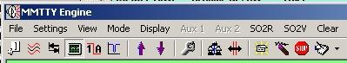

CWR\_6

### 6.1.1 Squelch MMVari engine

Squelch works in RTTY as it works in PSK31. If the signal does not reach the preset squelch level, it will not be decoded. This can decrease the amount of "garbage" characters that appear on your screen, but setting the squelch level high can also fail to decode some letters.

Change the squelch level by placing the cursor over the 9th pane in the lower status bar and left-clicking the mouse where you want the decoding to start/stop. Click low for an open squelch (print everything) and high for a tight squelch (print only strong signals).

The red line shows where the squelch is set, and the green bar shows signal strength.

### 6,1.2 Bandpass Filter

The bandpass filter narrows the receive bandpass, using audio DSP. This filter remains centered on the RTTY passband when the passband moves.

### 6.1.3 Normal/Reverse Sense

This switch reverses the relative positions of the Mark and Space tones. Normal operation is with the radio set to LSB, and the switch set to Normal. In this case the Mark signal is higher in radio frequency than the Space signal, since for LSB, a higher tone means a lower radio frequency. If you want to send to a station that is "upside-down" or "backwards" in sense, then press this button to reverse your Mark and Space tones. Your transmit will change to be the same sense as your receive setup.

### 6.1.4 XY Display (RTTY Tuning Scope)

In the past, a standard tool for receiving RTTY was to use an oscilloscope with an XY display. The two audio tones that make up the RTTY signal (Mark and Space) were displayed. One signal appeared as a vertical ellipse, and the other as a horizontal ellipse. The goal was to tune the signal so that the vertical ellipse was straight up-and-down. If the horizontal ellipse was not at exactly 90 degrees, this meant that the shift width for receive did not match the shift being used for transmit. With Logger32/MMTTY, you can set the AFC to free and it will always cause the ellipses to be at right angles.  See [AFC](#6.1.7_AFC) below.

You can switch the XY display on in the "View|Show RTTY XY scope". If your computer slows down or has other problems running Logger32 in RTTY mode, try eliminating the XY scope to save resources.

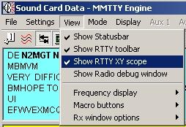

CWR\_7

You will then see the scope display in the right-hand side of the Waterfall/Spectrum display.

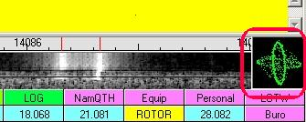

CWR\_17

### 6.1.5 Unshift On Space

Baudot uses a character to indicate that the next character will be LTRS (letters) or FIGS (figures) shift. In other words, each Baudot character can have two meanings, depending on whether it is preceded by LTRS or FIGS shift. Furthermore, once you shift into LTRS or FIGS, the original standard of Baudot was that the decoder stayed in that shift condition until it received a command to shift to the other state. If your decoder misses a shift character, then it will be in the wrong shift state until it receives another shift command. You can shift to numbers, miss a shift, and then continue to print garbage for a long while.

Most of the information that hams receive is in LTRS shift, with FIGS used only for the digits. The other FIGS characters are relatively unused in modern ham RTTY operation.   It has become common practice to have the decoder perform an "unshift on space" (UOS) operation.  After a FIGS shift, the decoder prints FIGS characters until it reaches a space character, after which it automatically performs a LTRS shift, whether or not it receives such a command. To make things consistent, many modern encoders automatically send a FIGS shift whenever they send a FIGS character after a space, even if the last character before the space was a number.

The recommendation is that you set UOS "ON" unless you have found a reason not to do this. See [Transmitting RTTY](#7.0_TRANSMITTING_RTTY) for a way to set your transmit to help others who are using UOS.

### 6.1.6 FIGS/LTRS Shift

If you think that you have missed a LTRS or FIGS shift you can use these two buttons to force Logger32 to make the shift on receive. This can only be done to characters that have not been decoded. Once a character is printed, it cannot be shifted.

### 6.1.7 AFC

You have a choice of four AFC modes, which can be set with the Setup (toolbar), [AFC/ATC/PLL Tab](#AFC/ATC/PLL_Tab):

* + **Free** - Allow both Mark and Space to vary to copy the signal best. Transmit with the receive Mark/Space;
  + **Fixed** - Mark can change, but shift is fixed at the default value;
  + **HAM** - The Mark can change, but the shift can only take the values of 170/200/220/240 Hz., whichever works for most letters copied. The shift will change only for receive, it will return to the HAM default for transmit; or,
  + **FSK** - The center frequency cannot change and the shift can only take the values of 170/200/220/240 Hz., whichever works for most letters decoded.

You can set the Mark and shift by clicking Setup, Demodulator Tab and setting them at the left. Select the < **OK**> button to leave this display and save the Mark/shift values. If you set the AFC at Fixed, then the Mark frequency can change to try to copy a signal, but the shift will stay as you set it on the Demodulator Tab.

If you are in Free AFC mode, the shift will change to match the actual shift of the received signal when you turn the AFC on. You can return to the standard HAM values by pressing Reset on the RTTY toolbar or the Status bar. The HAM values can be set on the Demodulator Tab. The MMTTY engine comes with these preset at Mark = 2125 Hz., shift = 170 Hz.

When you set the AFC at Free and turn AFC on, Reset returns you to the original Mark/shift values for a moment, then Logger32 looks around for RTTY signals and varies these parameters in an attempt to copy something. Left-Click to Reset Shift

When you are in an AFC mode that allows the shift to change (such as Free), Logger32 returns the shift to the HAM default every time you left-click in the waterfall. This means that Logger32 always begins to try to decode a new signal at the default shift.

### 6.1.8 Reset

The <**Reset**> button sets the Mark and shift frequencies back to the values set on the Demodulator Tab. RTTY and PSK31 modes differ in this situation, since PSK uses values that are set in the Settings menu item.

### 6.1.9 Show RTTY Commands

It is possible to have Logger32 echo in the receive window the RTTY control commands that you issue from the toolbar or from a macro.  Click View, RX Window Options, Show RTTY Commands and they will appear in the receive window, in brackets < >.

### 6.2 Show Control Codes

You can view the control codes that are sent and received by Logger32. Control codes are carriage returns. Click View, Window Options, Show Control Codes.

### 6.3 Macros

You will find special Macros for use in RTTY mode in the [MACROS](#_topic_MACROS) topic. You can use Logger32 Macros that are relevant to RTTY or to general Logger32 operation (example: [$transmit$](#$transmit$)), and you can use some MMTTY macros if you are familiar with them, as long as they apply to RTTY operation in Logger32, and do not require parts of MMTTY that are not part of Logger32.  For example, you can send %d and Logger32 will send the date, but you cannot use %c to send the other station's callsign, you must use Logger32's [$call$](#$call$) Macro because this feature pertains to the way that Logger32 captures callsigns.

### 6.4 Notch Filter

The MMTTY engine provides for one or two audio DSP notch filters for use during reception. To enable the notch filter(s), go to RTTY Setup (toolbar), Demodulator Tab. Now look to the right and you will see two smaller tabs, one is LMS/Notch. Click the LMS/Notch Tab. Set the tabs at 256 to start, this gives a relatively narrow, deep notch, and click the box next to Notch. You can also invoke two notches, but they will be at the same frequency, resulting in a deeper notch.  Select the <**OK**> button.

You turn the notch on by left-clicking in the graphic frequency display.  A bar appears at the notch frequency. Right-click in the frequency display and the notch turns off.

**Note**:  If you click in the waterfall, you will move the receive passband; you must click in the frequency display to operate the notch.

### 6.5 Display Smoothing

You can set the spectrum display to be smoothed, as you can for PSK31; the effect is the same. Select the Settings|MMTTY Settings|Display Smoothing menu items, and check the choice you want.

### 6.5.1 Fast Display (No Smoothing)

When using Fast Display, the signals are displayed in real time. In real time you see the noise spikes and the signals jump up and down in strength. There is no damping.

### 6.5.2 Medium and Slow Display (Little or Heavy Smoothing)

By selecting Medium or Slow Display options, the displayed signals are averaged over a period of time. The effect of these settings is to reduce the noise spikes, lower the overall background noise, and prevent the signal from jumping up and down on the display.

The effect of the smoothing is easily seen on the display. It is easy to experiment on received signals and determine which best suits the band conditions.

### 6.6 Align

When you transmit, there is less likelihood of your transmitting harmonic distortion products if you use high tones. Logger32 has an automated method for transmitting with high tones as long as your radio is in communication with the computer using a serial port. The [$align$](#$align$) Macro (or right-click in the display) does this. Logger32 will do the following:

* 1. Move the receive passband to a preset audio frequency (you should choose a high tone);
  2. Send a QSY command to your radio so whatever audio frequency you were receiving at is now at the preset audio frequency.

The result is that whatever station you were copying, wherever it was in the receive range, is now at the preset audio tone frequency, and Logger32 is listening at that frequency. Here is how to do the align operation:

First, before trying to use [$align$](#$align$), set a default audio frequency for Mark. Click Settings, Preset Audio Frequencies.

Place a checkmark in the appropriate box and click "Apply" If the desired frequency is not listed, the user can edit the Tx & Rx frequency box to the preferred operating tones. For FSK operation, the default must place the receiver at the same frequency of the transmitter. If the transmitter I s set for HIGH tones (2125/2295) then the Tx and Rx default frequency should be set to ?2210?. This will place the markers at 2125 MARK and 2295 SPACE. If the transceiver is set to use the Low RTTY tone pair (1275/1445) then the default should be set to 1360.

The default tones may also be setup to match the passband of the transceiver bandpass filters. Once established the tones can be selected from the pull down menu on the Toolbar

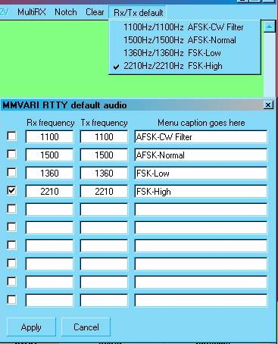

CWR\_27

A similar chart is available in MMTTY when in RTTY mode. In MMTTY it is only necessary to set the Rx audio default. When running MMTTY AFSK the default Tx audio frequency is ignored. The Tx frequency is either set to the HAM default, or if net is on, it follows the Rx frequency.

When running MMTTY in FSK keying, the Rx audio default should be set to coincide with the Transceiver RTTY tones. The default Rx setting should be set midway between the Mark and Space frequency.

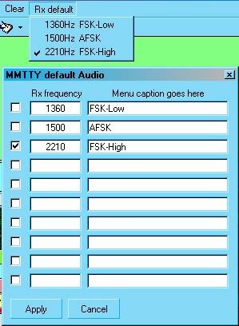

CWR\_26

### 6.7 Turn AFC on

To use this technique, tune in an RTTY signal somewhere on the receive range away from the default RX audio frequency.  Put the cursor in the middle of the receive passband lines and right-click the mouse. It may take a second or two, but Logger32 will send a frequency shift command ([$qsyxxxx$](#$qsy(nn)nnn.(nn)$)) to your radio so that the signal appears with the Mark at the preset audio frequency. At the same time, it will move its receive passband to that same area and retune the signal.

You can also use the [$align$](#$align$) Macro by putting the command on a Macro button.

When you go to transmit with Net On, you will be transmitting zero beat with the received signal, but using high tones.

Profiles

Logger32 has a special feature whereby you can set a number of parameters and remember them as a profile. When you want to operate with these parameters, instead of looking them up in a book and changing things, you can invoke the profile you have set. Profiles only work for RTTY mode, not for PSK.

The HAM default in Logger32's MMTTY RTTY engine makes it easy to return to a basic set of RTTY operating parameters. However, new modes, contest conditions, and other situations make it valuable for the operator to be able to define different operating parameters. To make MMTTY flexible under these new and changing conditions, the MMTTY engine has a feature call "Profiles" which allow Logger32/MMTTY to remember different sets of starting conditions.

6.8 Procedure for saving an RTTY profile

### 6.8.1 Using the Sound Card “MODE” menu:

You must go thru the RTTY setup and set all the options the way you want to operate. Once you have set up the system, you must then save the profile so the system will initialize with your parameters each time you open the RTTY mode:

* 1. Open RTTY mode and set all your parameters the way you operate. Don't forget the Settings under the wrench on the control bar (MMTTY Setup);
  2. Go to Mode | Setup RTTY profiles;
  3. Select Save RTTY profile to file and follow the prompts and assign a filename. This will save the settings you just established;
  4. Repeat 2 above and select Assign RTTY Menu Item;
  5. Assign the exact name you gave the profile that you saved (without the .Pro extension); and,
  6. Click on Mode and you will now see your profile in the menu. Place a check mark by it and that will become your default profile each time you open the RTTY mode.

You can have more then one RTTY profile; just remember to assign a menu item for each one. The system will use the last checked profile the next time RTTY mode is selected.

Once you have established a profile you can also save it to a file using the menu item under "Mode | MMTTY Engine". This method will save the setup under the currently selected profile.

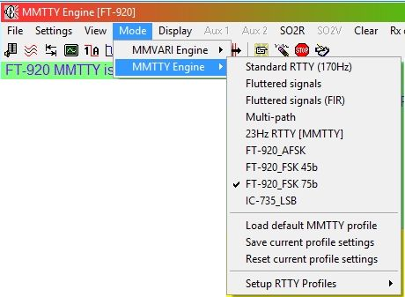

CWR\_18

### 6.8.2 Using the MMTTY “Profile” button:

Follow the same procedure as outlined above, using the Sound Card MODE menu.

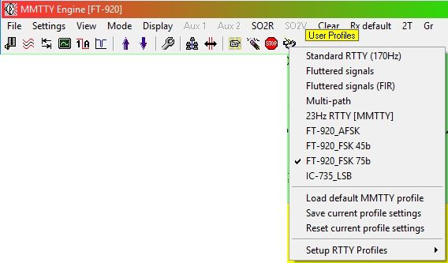

CWR\_18A

## 7.0 TRANSMITTING RTTY

Andrew J. O'Brien, K3UK and Jim Hargrave, W5IFP

### 7.1 Setting up to transmit RTTY

Logger32 uses MMTTY and MMVARI software modems, as its RTTY encoding/decoding engines. AFSK and FSK keying methods are supported by both MMTTY and MMVARI. The default settings for Logger32 incorporate Basic RTTY features. If you have successfully transmitted PSK31, you already have all the hardware hook-ups and radio interfacing ready to go to transmit RTTY using the AFSK mode. If you have not yet set up your computer and rig, please see the topic [Interfacing a Radio to a PC Sound Card](#_topic_InterfacingaRadioforPCControl).

### 7.2 Radio PTT options

The following PTT setup applies to both MMTTY and MMVARI. This setup must be accomplished before proceeding.

**Note**: If you change PTT settings it will affect both programs.

Open the Sound card, select the "Settings | Radio PTT options" menu items, set the appropriate PTT options and port and select the <**OK**> button..

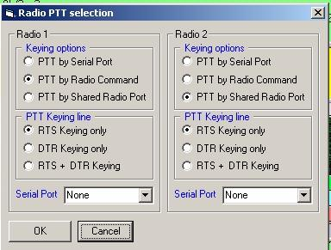

CWR\_8

### 7.3 Setting up RTTY for AFSK mode

### 7.3.1 Setting up MMTTY for AFSK mode

* 1. Open the Sound Card in MMTTY mode;
  2. Open "Settings | MMTTY settings | RTTY Keying";
  3. Select "Radio 1 uses AFSK";
  4. Open the MMTTY toolbox and select the "MISC" Tab; and,
  5. Under the "TX" Port select (.) Sound and click "OK".

MMTTY is now ready for RTTY operation.

### 7.3.2 Setting up MMVARI for AFSK mode

* 1. Open the Sound card in MMVARI RTTY-L mode;
  2. Open "Settings | MMVARI settings | RTTY Keying"; and,
  3. Select "Radio 1 use AFSK for RTTY".

MMVARI is now ready for RTTY operation.

### 7.3.3 Setting up RTTY for FSK mode

FSK Keying is functional in both MMTTY and MMVARI (Version 1.08 and later) .

There are five ways to run RTTY using FSK keying:

* + 1. Dedicated COM Port; \*Legacy or USB2Serial adapter,
    2. Parallel port; \*Requires EXTFSK64 ADD-ON
    3. EXTFSK ADD-ON; \*Used by MMTTY to interface with a USB2Serial adapter
    4. EXTFSK64 ADD-ON; \*Used by MMTTY & MMVARI for 64bit computers.

\*Supports 75b RTTY, Com and Parallel ports.

* + 1. FSK8250 ADD-ON. \*Used by MMVARI for Legacy com ports.

\*Can be used with MMTTY, but not required.

**7.3.3.1 RTTY FSK Keying on a Dedicated Com port**

This method of FSK keying is available in both MMTTY and MMVARI.

When using the dedicated COM. port method of FSK Keying, the PTT defaults to the RTS line and the FSK Keying defaults to the Txd line.

**Note**: MMVARI supports most generic USB adapters without additional Add-Ons. MMTTY supports Legacy COM. Ports and USB adapters using Legacy RS-232 protocol MMVARI will work on a Legacy Com port, but requires the use of FSK8250 add-on driver.

**7.3.3.2 Setup MMTTY for FSK keying on a dedicated Com port:**

* 1. Set the Radio PTT options as defined above in the Radio PTT Options section;
  2. Open "Settings | MMTTY settings | RTTY Keying" and select: "Radio 1 uses FSK" or "Radio 1 uses FSK and AFSK";
  3. Open the MMTTY setup and the "TX" tab Select the COM Port under the PTT & FSK section;

**Note**: You must define a port other than the Radio Control port

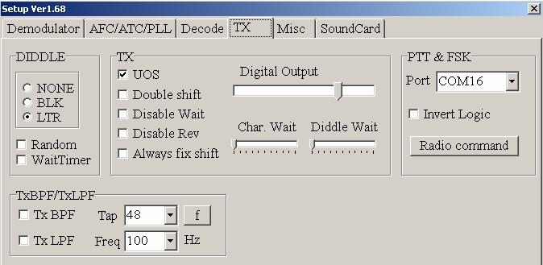

CWR\_20

* 1. Click on the MMTTY setup and select the "MISC" Tab; and,
  2. Select one of the FSK options in the "TX Port".

**Note**: "Sound + TxD (FSK)" provides for FSK keying and also allows you to monitor the audio from the sound card. COM-TxD (FSK) provides the same FSK keying, however the sound card output is muted.

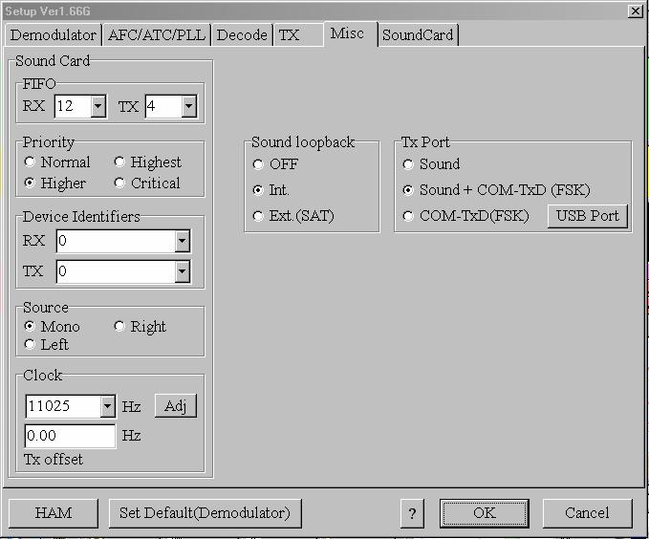

CWR\_11

Save your settings: Open "Mode | MMTTY" and select "Save current profile settings".

**7.3.3.3.Setup MMVARI for FSK Keying on a dedicated Com port:**

* 1. Set the Radio PTT options as defined above in the Radio PTT Options section;

**Note**: You must define a port other than the Radio Control port under "Settings | MMVARI Settings | RTTY Keying"; and,

* 1. If the FSK keying port uses a USB adapter select: "Use FSK for RTTY keying" or select "Use Internal INVERTED FSK for RTTY Keying. If a legacy serial port is used select: “Use FSK8250 for RTTY Keying”.

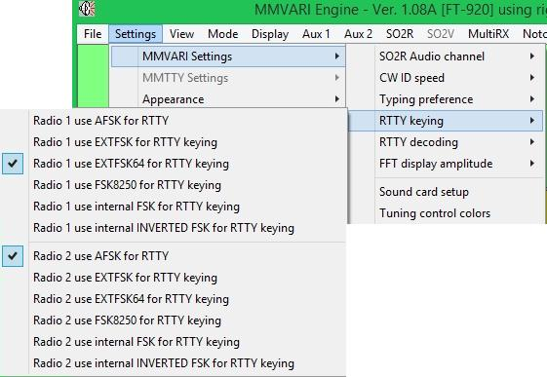

CWR-22

MMVARI is now ready to transmit using the FSK Keying mode.

**7.3.3.4 FSK Keying using the EXTFSK or EXTFSK64 ADD-ON**.

**Note**: Users with Win7 or Win8 64 bit computers should use EXTFSK64. The setup outlined below is the same for EXTFSK or EXTFSK64.

This add-on can be used in both MMVARI and MMTTY This requires EXTFSK.DLL to be in the Logger32 directory.

EXTFSK is a user-customizable PTT/FSK API of MMTTY. It gives a means of interfacing to a Windows DLL, which works just like a plug-in module.

You can use EXTFSK through legacy serial port, USB-serial adapter, or legacy parallel port (USB-parallel adapter is not supported).

The EXTFSK ADD-ON is used to drive USB2serial adapters and some USB interface equipment. EXTFSK is usually required to drive USB2serial ports where the speed of the USB device does not support the slow RTTY 45 baud rate.

EXTFSK provides the added advantage to port the FSK/PTT signal to the Txd, RTS, or DTR signal lines. It also provides for reverse FSK keying.

**7.3.3.5 MMTTY Setup using EXTFSK**

The following steps also apply to EXTFSK64 when using a Com port:

* 1. Open the Sound Card Data window;
  2. Select MMTTY mode;
  3. Select "Settings | MMTTY Settings | RTTY Keying" and select: "Radio 1 uses EXTFSK";
  4. Click OK and you will note the MMTTY symbol and "EXTFSK" appears in the task bar at the bottom;

  
  
CWR\_24

* 1. Left-click on the EXTFSK pane and it will open a Setup Window (See below);
  2. Select the port you plan on using for FSK. **Note**: This must be different than the port used for Radio Control; and,
  3. Select the signal line you would like to use for PTT and FSK.

**Note**: BOTH the line selected for PTT will key the radio as well as the selected PTT line/method used in "Settings | Radio PTT options". This allows you to use a dedicated port for FSK and retain your original settings for PSK.

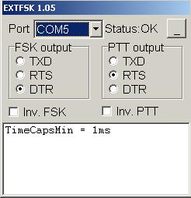

CWR\_9

**Note**: If you desire to use the LPT1 port for FSK Keying and your operating system is Win 2000 or XP, in addition to the EXTFSK.DLL, you must also have the following three files in the Logger32 directory:

**TDLPORTIO.DLL, DLPORTIO.DLL & DLPORTIO.SYS**

You can download the file DLPORTIO.ZIP at the following URL and extract these three files.

<http://hamsoft.ca/pages/mmtty/ext-fsk.php>

Once you have all three files in the Logger32 directory you can select the LPT1 parallel port for FSK Keying. The following chart shows the LPT1 setup.

**Note**: If you are using EXTFSK64 you will also need a copy of INPOUT32.DLL. Copies of both files are available at:

http://www.qsl.net/ja7ude/extfsk/indexe.html.

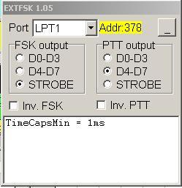

CWR\_10

Save your settings: Open "Mode | MMTTY" and select "Save current profile settings".

MMTTY is now ready for operation.

**7.3.3.6 MMVARI setup using EXTFSK**

* 1. Open the [Sound Card Data window](#_topic_SoundCardDataWindow1);
  2. Select MMVARI RTTY-L mode;
  3. Select "Settings | MMVARI Settings | RTTY Keying" and select: "Radio 1 uses EXTFSK for RTTY Keying". You will note the RTTY symbol and "EXTFSK" appears in the task bar at the bottom. of the screen;



CWR\_24

* 1. Left-click on the EXTFSK pane and it will open a Setup Window. (See [MMTTY setup](#4.0_MMTTY_DATA_ENGINE) above);
  2. Select the port you plan on using for FSK. **Note**: This must be different than the port used for Radio Control; and,
  3. Select the signal lines you would like to use for PTT and FSK.

**Note**: BOTH the line selected for PTT will key the radio as well as the selected PTT line/method used in "Settings | Radio PTT options". This allows you to use a dedicated port for FSK and retain your original settings for PSK.

**7.3.3.7 RTTY FSK Keying using the FSK8250 ADD-ON**

This ADD-ON emulates a true FSK port. It is used to support legacy COM ports and adapters subscribing to the true RS-232 protocol. It is used with MMVARI to support FSK interface adapters that are designed (Firmware and/or Software) to connect to a legacy serial port. This ADD-ON supports all keying speeds that are available in MMVARI.

A copy of the FSK8250.FSK needs to be in the Logger32 directory.

**Setup MMTTY for FSK Keying using the FSK8250 add-on**

FSK8250 can be used in MMTTY by selecting it in the MMTTY toolbox TX tab.

However, there is no known equipment that requires this add-on with MMTTY. Therefore, it is not included in the Logger32 RTTY Keying selections.

**MMVARI setup using FSK8250**

* 1. Open the [Sound Card Data window](#_topic_SoundCardDataWindow1);
  2. Select MMVARI RTTY-L mode;
  3. Select "Settings | MMVARI Settings | RTTY Keying" and select: "Radio 1 uses FSK8250 for RTTY Keying". You will note the RTTY symbol and "FSK8250" appears in the task bar at the bottom of the screen;



CWR\_23

* 1. Left-click on the FSK8250 pane and it will open a Setup Window;

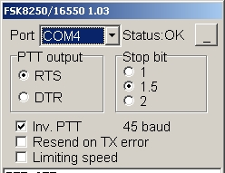

CWR\_25

* 1. Select the port you plan on using for FSK;
  2. Note: This must be different than the port used for Radio Control; and,
  3. Select the signal line you would like to use for PTT.

**Note**: BOTH the line selected for PTT will key the radio as well as the selected PTT line/method used in "Settings | Radio PTT options". This allows you to use a dedicated port for FSK and retain your original settings for PTT.

### 7.4 Enter RTTY Mode

You enter RTTY mode by one of the following methods:

* + Click on the mode pane in the upper task bar and select from MMVARI engine or MMTTY engine; or,
  + Use a Macro such as [$rtty$](#$rtty$) or [$rtty-i$](#$rtty-i$) from either engine. You can also use a Macro [$mmvarimode xx$](#$mmvarimodexx$) from either engine. These must be programmed on a Macro button, see the topic [Programmable Buttons](#_topic_ProgrammableButtons).  Be sure to read this topic, it is useful in RTTY mode.

**Warning**:  If Logger32 becomes unstable in RTTY mode, operating slowly, or failing to do something, read the topic Computer Tuneup.  RTTY mode is very demanding of computer resources.

### 7.5 Switch to Transmit

Transmitting in RTTY mode is mostly the same as transmitting in PSK31 mode. You can click on the RECEIVE button and it will switch to Transmit and Logger32 will begin to transmit. You can also use Macros such as [$transmit$](#$transmit$) and [$receive$](#$receive$).

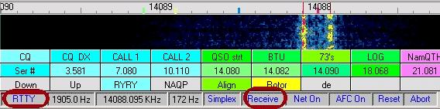

CWR\_12

8.0 MMTTY ENGINE

### 8.1 RTTY Toolbar and Status bar when in the MMTTY engine

There is a special toolbar that controls both transmit and receive functions in RTTY Mode. Here is the toolbar.



CWR\_13

Most of these items are presented in Receiving RTTY. There are two that pertain directly to transmitting, Net On/Off, covered below, and Setup, which brings up a set of displays that have both receive and transmit parameters.

### 8.2 RTTY Status bar

There are other important items on the Status bar.



CWR\_14

The key item is the transmit/receive pane in the middle of the Status bar. Click here to perform TX/RX switching. If you go to receive, Logger32 will first transmit all the characters in its transmit buffer before going to receive. There are also duplicates of the toolbar items, Net On/Off, AFC On/Off, Reset, and Abort.

### 8.2.1 MMTTY Engine Net On/Off

The Net function uses Logger32's ability to control the audio frequency of output tones to make sure that you transmit AFSK tones at the same frequency as your received tones. Click the Net button to set Net On and transmit zero beat with receive.  This is the usual way to call someone to establish a QSO.

When you turn Net Off, in RTTY mode, the MMTTY engine sets the transmit Mark and shift at the HAM default, which is set on the MMTTY Setup Demodulator Tab.  MMTTY comes with these values at Mark = 2125 Hz., shift = 170 Hz.  When you call CQ, you should turn Net off, but you can leave AFC on.  This means that your transmit frequency will not move to track the drift of the other station, and the two of you in QSO will remain at your original transmit frequency (assuming that you have a stable transmitter that does not drift).

If you operate split frequency from your transceiver (perhaps to chase a DXpedition), you should set Net off, because you will select your transmit frequency with your second VFO. You probably do not want your transmit frequency wandering around due to movement of your receive passband.  Remember, Net and AFC are different animals. Net controls the transmit frequency, AFC controls the receive frequency.

Be careful about turning Net off in RTTY mode. In PSK mode, when you turn Net off, you will transmit at the same audio frequency that you last used for transmit. In RTTY mode, you will always transmit at your default HAM Mark frequency, no matter where you last transmitted. The two modes do not operate in the same way.

The seventh pane indicates Net is on or off. Net can be toggled on/off by a mouse-click in this area.

* + **NET On** - will set the transmitted audio frequency to the receive audio frequency; and,
  + **NET Off** - will cause you to transmit at the last frequency at which you transmitted. If you have not gone to transmit since you started Logger32, you will transmit at the default TX audio frequency. When you transmit, the waterfall display of your transmit signal will be on the frequency where you are actually transmitting. A left click on a new signal will position the Receive at the new position, but will leave the Transmit at the last position.

Two vertical bars on the waterfall header identify the Received and Transmit positions.

## 9.0 MMVARI ENGINE

The Receive and Transmit positions are identified with a red diamond. The receive diamond is filled in with light blue and the transmit diamond is filled in with dark blue.

**Note**: The [$align$](#$align$) Macro works with the NET function ON or OFF. When you execute an [$align$](#$align$) Macro or a right click on the waterfall signal, both Receive and Transmit positions will be moved to the default audio position. If you have Radio control (CAT) operational, the radio will QSY to the new default location.



CWR\_19

### 9.1 Transmitted Characters

RTTY has its own alphabet, the Baudot code, which differs from the newer Varicode used for PSK31. First, transmitted text is always in UPPERCASE letters. Second, not all the characters on your computer keyboard are supported by RTTY's Baudot code.

The supported characters are:

A  B  C  D  E  F  G  H  I  J  K  L  M  N  O  P  Q  R  S  T  U  V  W  X  Y  Z

1  2   3   4  5   6   7   8  9   0

.   ,   "  (     )   /   ?  &   -   !   :

You will not be able to use such characters as an asterisk (\*), ampersand (&), or the @ symbol that is used in e-mail addresses. The # symbol, used in North America to denote "number" is also not supported. The dollar sign and the % sign are likewise not available. If you enter characters that cannot be transmitted, these characters will not change color if Settings, Transmit buffer indicator is on. This is because the characters are not transmitted in RTTY mode.

[RTTY Basics](#2.0_RTTY_BASICS) has a discussion on the way that Baudot RTTY encodes letters and figures.

Most people type faster than Baudot is sent. You can set the unsent and sent characters in the TX buffer to be different colors, so you can track what characters have been transmitted by Logger32. Click Settings, Transmit buffer indicator to turn this feature on.  You can change the color of the transmitted characters in "Settings|Appaerance|TX window buffer indicator color". These features work the same in both PSK31 and RTTY modes, and settings selected in one mode hold for the other mode.

### 9.2 Backspacing

The RTTY engine can backspace to correct typographical errors, but only before the character has been transmitted.  Baudot does not support backspace, so once a letter is sent, there is no character to tell the receiving station to back up and erase that character.  The easiest way to benefit from the backspace feature in RTTY mode is to set Settings, Typing preference to word out.

### 9.3 Word Out vs. Character Out

Logger32 in RTTY mode allows the user to choose either word out or character out. Click Settings, Typing Preference, RTTY- Send word out; unclick this choice for character out. With word out checked, Logger32 only transmits your typed text when you press the spacebar on your keyboard or use a macro containing the Baudot code for space. With word out unchecked, Logger32 sends each character to the radio for immediate transmission.

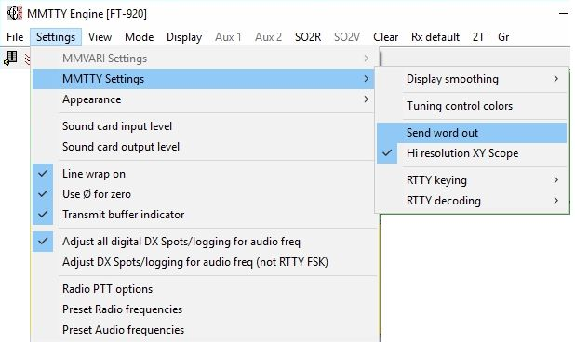

CWR\_15

### 9.4 Unshift On Space

In the topic [Receiving RTTY](#3.0_RECEIVING_RTTY) we discuss setting UOS for receive. It is possible for you to set your transmitted signals to be friendly to someone receiving you with UOS. The default for RTTY is to transmit numbers this way: (FIGS)599 599 (LTRS)good signal. However, if the other person has UOS on, he or she will print: 599 TOO good signal. You can change your transmitted signal so you send (FIGS)599 (FIGS)599 (LTRS)good signal, resulting in 599 599 good signal. To set the RTTY engine to transmit this way, use the RTTY toolbar Setup and select the TX Tab. In the middle of the display there is a checkbox for UOS. Check this box and you will transmit a (FIGS) character whenever you try to transmit a number after having sent a space.

### 9.5 Setting Audio Levels

As in transmitting PSK31, it is important that your transmitted AFSK tones are not overdriven and distorted. Here is a quick adjustment procedure, but you should read the topic on [Transmitting a Clean Signal](#_topic_TransmittingaCleanSignalwithPSKM).  It would also help to read the [PSK31 transmitting](#4.0_TRANSMITTING_PSK31) topic:

* 1. Switch your rig to display ALC; and,
  2. In transmit mode, adjust your transmitted signal to the point where the ALC setting JUST begins to show a slight deflection. You can do this with slight changes in your Mic gain and/or your sound card volume controls.

It is recommended that, unless you are using true FSK, you set your power output to around 50%. If your rig is capable of 100 watts, you should set the output to around 50 watts.

There is more information on this topic in [Transmitting a Clean Signal in PSK31 and RTTY](#_topic_TransmittingaCleanSignalwithPSKM). This topic discusses both the interface hardware you should use and adjustment procedures for setting transmit levels These methods are not always intuitively obvious, and some operators have had problems without realizing it.

### 9.6 Normal and Reverse Polarity

There is one more important step; you have to make sure that your transmitted RTTY signal is "the right way up."  Whether it is the "right way up" depends on two things, the sideband selected and the normal/inverted setting. If you have chosen to transmit using lower sideband, have your RTTY set to NORMAL (default).  If you transmit RTTY using upper sideband set Logger32's RTTY engine to reverse (inverse or inverted) polarity. See the RTTY Basics topic for more information on what this means. You can set the polarity with the RTTY toolbar Normal/Reverse button.

### 9.7 Switch Modes Using a Hotkey

Logger32 provides hotkeys that can be programmed as a Macro in RTTY mode for this purpose. [$rttyreverse$](#$rttyreverse$)  is the Macro command to invert the signal and [$rttynormal$](#$rttynormal$) is the Macro command to change back into normal setting  (see the [Programmable Buttons](#_topic_ProgrammableButtons) topic for full instruction on how to program Macros).

You can also use the Macros [$rtty$](#$rtty$) or [$rtty-i$](#$rtty-i$).  These two Macros can be used from any mode, and they will switch the Logger32 to RTTY mode, normal or inverted respectively.

If you want to enter the RTTY engine and set up normal or inverted mode, use the RTTY Setup button on the toolbar. On the Demodulator tab in this display there is a box at the extreme lower left, labeled Reverse. Put a check in this box to operate inverse polarity. MMTTY always receives and transmits with the same polarity, so when this box is checked, you will transmit and receive in inverse polarity.

### 9.8 Transmitting With Macros

In RTTY mode, Logger32 clears the PSK macros and starts fresh. Many Macros work with both PSK and RTTY (the basic ones like [$transmit$](#$transmit$) and [$receive$](#$receive$) are the same). Macros with "RTTY" in them are specifically for RTTY mode.

To copy Macros from PSK to RTTY:

* 1. Open the Macro for editing in PSK mode (right-click the Macro button);
  2. Leave the Macro open for editing;
  3. Switch modes to RTTY; and,
  4. Click OK to save it as an RTTY Macro.

### 9.9 Example Macros

Here are a few examples for you to cut and paste into the available RTTY Macro buttons.

**Returning a CQ**:

[$call$](#$call$) de [$mycall$](#$mycall$) $mycall$ KN

**Starting Conversation:**

FB [$name$](#$name$), The name here is Andy, QTH is Fredonia, New York. Located about 45 miles southwest of the city of Buffalo, NY.

**Over:**

So $name$, BTU.  $call$ de $mycall$ K

**My Station (change to suit your needs):**

Station at this end is a Kenwood T2000 running 30 watts into two stacked 7 element Yagis at 150 feet.  Software is Logger32 [$version$](#$version$)  by Bob Furzer. Also using MMTTY by Mako  JE3HHT as the RTTY engine within Logger32.

**73 and Log:**

So  $name$ , Thanks for the nice QSO, Will say 73 now. QSL via bureau. $call$ de $mycall$ $log$

73 $mycall$ SK

### 9.10 Example RTTY QSO

CQ CQ CQ de P5DX P5DX P5DX

PSE K.

You would click on macro "Returning a CQ", which would send:

P5DX DE KB2EOQ KB2EOQ      KN (your own call sign would be inserted here)

Here is the response:

KB2EOQ DE P5DX

HELLO, THANKS FOR ANSWERING MY CALL, BAND IS QUIET TODAY.  NAME HERE IS JAN.  JUST HERE IN P5 LAND ON BUSINESS.

You would then click on macro  "Starting conversation" which would send:

FB JAN.  THE NAME HERE IS ANDY.

QTH IS FREDONIA, NEW YORK.  LOCATED ABOUT 45 MILES SOUTHWEST OF THE CITY OF BUFFALO, NY.

You might have an "End of conversation" macro:

TNX FOR THE QSO JAN.  I WILL QSL VIA THE BUREAU.

SK

P5DX DE KB2EOQ      K

By the way, note that the final K or KN in each transmission follows several blank spaces. This makes it less likely that P5DX will copy your callsign as KB2EOQK. This is especially important when you have a short callsign that can sound like regular callsign if extra letters are added to it (P5DX would become P5DXK).

### 9.11 Contesting/DXing

RTTY is a major mode when it comes to contesting and those rare DXpeditions. In both contesting and DX hunting, the QSO takes place in rapid-fire mode. Here are a few macros to help you.

**CQ with continuous loop**:

.

$transmit$

 CQ CQ CONTEST  de  $mycall$  $mycall$  $mycall$

 K

$receive$

[$loop$](#$loop$) $loop$

If a station answers your CQ you click anywhere in the receive window to stop the loop.

**Contest Exchange**

$transmit$

   $call$ de $mycall$

   TU  599 [$serialnum$](#$serialnum$) 599 $serialnum$  bk

$receive$

This will generate your call and a serial number from Logger32.

**Thanks and QRZ**

$transmit$

  QSL $name$ TU

QRZ QRZ Contest de $mycall$

k

$receive$

[$log$](#$log$)

This will thank someone in the contest, log the QSO and send QRZ.

### 9.12 Operating Split

Take a close look at Using Logger32 as a contest log for information on how to use computer-controlled split. It is in RTTY DX chasing that you are most likely to use this feature.

*Created with the Personal Edition of HelpNDoc:* [*Create help files for the Qt Help Framework*](http://www.helpndoc.com/feature-tour/create-help-files-for-the-qt-help-framework)

**Callibrating the Sound Card**

# Jim Hargrave W5IFP and Jan Ditzian, KX2A

## 1.0 GENERAL

Computer sound cards are supposed to run at a given clock frequency, which controls the sampling frequency, most often 11025 Hz. However, most cards are not that accurate, and errors of a few Hertz to many Hertz are common. It is possible to measure the actual sampling frequency of the computer sound card and then to put this information into Logger32. Logger32 will then know, for instance, if the sound card sampling frequency is 11028 Hz., and will use this in its calculations instead of 11025. The sound card frequency is not changed.

## 2.0 MMVARI SOUND CARD SAMPLE RATE

The MMVari sound card sample rate uses the default 11025 Hz. For those with slow PCs, this is too high, and they need to run the sample rate at (say) 6000 Hz. For those with fancy new radios that have optical interfaces, they need a sample rate of 48000 Hz.

To accommodate these variations, the sound card sample frequency can be set to other than the default 11025 Hz by selecting the Settings | MMVARI settings | Sound Card setup menu items.

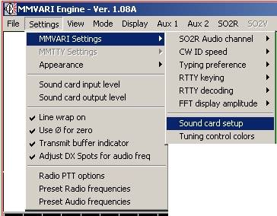

CTCSC\_5

This will bring up a Sound card setup pane. Select the desired sample frequencies and select the <**Apply**> button. This is a dynamic setting and will be applied immediately.

**Note**: The MMVARI default sample frequency is 11025Hz. This is based on the old CD standard (44100Hz divided by 4). However newer sound cards are based on the DVD standard of 48000Hz. For these newer sound cards, it is better to use 12000Hz, (48000Hz divided by 4). The higher sample rates of 24000Hz or 48000Hz can also be used with the newer sound cards. Proper sample frequency is necessary for accurate data decoding. The sample frequency will also affect the quality of the transmitted signal.

For more information see the topic:Sound Card Transmitter Audio Setup.

**Note**: On some sound cards, the sample rate affects the AFC capture rate. If you experience a slow capture when you click on a signal on the waterfall, try changing the sample rate and see if that helps. The default of 11025Hz will usually work with most sound cards.

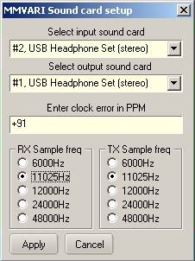

CTCSC\_4

On newer equipment, MMTTY and MMVARI should have their "Clock" set to an integral divisor of 48,000 (e.g. 6000, 8000, or 12000).

**Note**: The sample settings can be set differently for RX & TX. It has been reported that some users of Windows 7 and Windows 8 are experiencing a TX delay up to 2 seconds before the data stream is transmitted. If you experience this delay, it is recommended that both the RX and TX be set to the same sample frequency.

**Note**: If you are unsure about this setting, set both RX and TX to 12000

The next few sections discuss two ways of calibrating Logger32 in RTTY mode. Once you have done this, you can use the value you have found to modify the Logger32.ini file to improve PSK31 operation. The PSK procedure will be found following the RTTY calibration procedure.

## 3.0 CALIBRATION USING THE MTTY ENGINE AND A FREQUENCY COUNTER

* 1. Set the frequency counter to measure the audio frequency of the audio output from the sound card (the line that goes from the sound card to the audio input of the radio);
  2. Turn off AFC on the RTTY toolbar;
  3. Click Setup, Misc Tab and make sure that the clock at the lower left is set to 11025 Hz;
  4. Turn off diddle on the TX Tab;
  5. Set the mark frequency to 2000 Hz. on the Demodulator Tab.;
  6. Click OK to close this display;
  7. Go to transmit.  Do not put the transmitter on (turn off VOX or disconnect the PTT line), and do not send characters.  You want to transmit only the mark tone of 2000 Hz; and,
  8. Measure the frequency of the tone.

The actual sampling frequency, which is supposed to be 11025 Hz., can be calculated from the measured tone. The proportion of error of the tone shows how far the frequency is off. For example, with a mark frequency of 2000 Hz., and a measured tone of 2010 Hz., the actual sampling frequency must be high. It is (2010/2000) X 11025, which is 11080.125 Hz.

* 1. Click Setup, Misc Tab and set the frequency to 11080, you will be very close to the correct value;
  2. Click OK to exit Setup; and,
  3. Exit Logger32 and restart it.

The next sections discuss ways of calibrating the Sound Card with Logger32 in the RTTY mode.

## 4.0 CALIBRATION USING A TIME STANDARD ON SHORT WAVE

Logger32's MMTTY engine has a special display that allows you to find the true clock frequency of the sound card using an accurate 1-second tick. Here are some stations around the world that broadcast ticks each second.

* + **WWV** and **WWVH**       2500.0, 5000.0, 10000.0
  + **GBR**                           60.0 kHz
  + **RWM**                          4996.0, 9996.0, 14996.0
  + **CHU**                            7335.0

### 4.1 How the Calibration Procedure Works

The MMTTY engine has a calibration routine that listens to the sound card for two seconds (when the sampling frequency is around 11025 Hz.) and paints a picture across the screen of the sounds during those two seconds. If the clock window says that this takes 11025 Hz. then the software puts 11025 dots across the screen. If the clock window is adjusted to say that this takes 11030 Hz., then 11030 dots are painted across the screen. If the value (11025 or 11030) is correct, then this will result in the ticks occurring in exactly the same place on the screen every two seconds. Over time, there will be two vertical lines of ticks down the screen. However, if the clock number is incorrect, then it will take longer or shorter than two seconds to see two ticks. The white spot that shows a tick will be painted a little earlier or a little later each sweep, resulting in slanted lines.

### 4.2 Time Standard Calibration Procedure

* 1. Click the Setup, Misc. Tab. Click the <**Adj**> button at the lower left of this tab to bring up the calibration display;
  2. Turn off the AGC with the button at the bottom (button should be up);
  3. Tune your radio to the 1-second tick standard and set the radio display to the carrier frequency;
  4. Wait for about three minutes. If you are using 11025 Hz. calibration, you should see two lines of marks (vertical or slanted), corresponding to the 1-second tick sound bursts transmitted by the time-standard broadcast station.  You will see only one line with 8000 Hz. or 6000 Hz;
  5. Right-click to move the vertical green line to the tick line.This allows you to compare the tick line to vertical;
  6. Left-click a low tick burst mark (bottom one if possible), and move the cursor to the top of the line.  You will see a yellow line on the display;
  7. Overlay the yellow line with the tick mark line, and left-click a high burst mark (top one if possible);
  8. This will automatically put the correct clock frequency in the adjust window;
  9. Watch for a few minutes to make sure that the new tick line is vertical;
  10. Click OK to leave this display;
  11. Click OK to leave the setup display and to memorize the new value; and,
  12. Restart Logger32 for the new clock value to take effect.

Here is the calibration display showing a sound card clock that is pretty close to its intended value of 11025 Hz.

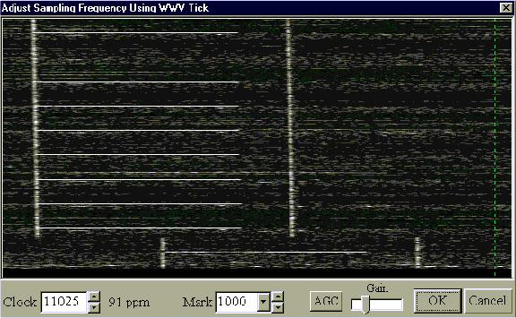

CTSC\_1

Here are pictures of some calibrations performed in Europe, using MMTTY and different time standard stations.

This is GBR, in Great Britain. The time ticks are wide, but you can pick any consistent spot on the time tick and use it as the focal point for clicking. The arrows show possibilities for the first and second clicks.

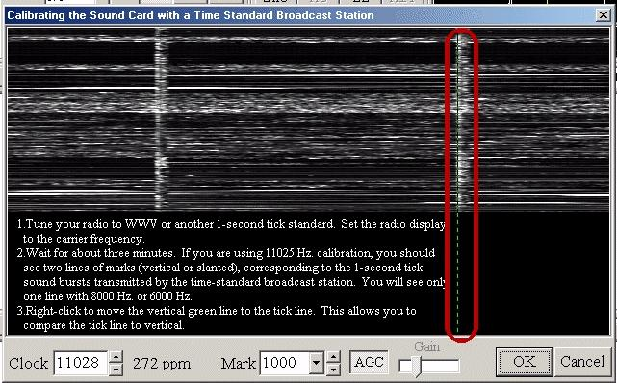

CTSC\_2

Here are two pictures of Russian time standard station RWM: the first shows a properly adjusted display; the second illustrates an error of 1000 ppm. Note the slanted lines. This will occur with any time standard if you have an error of 1000 ppm.

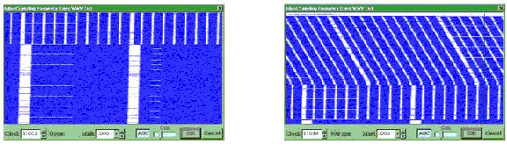

CTSC\_3

### 4.3 Hints

* + The green and yellow lines are provided by MMTTY as a vertical reference to compare to the tick line;
  + If the tick line is wide, reduce the sensitivity with the control at the bottom. If it is still wide, make sure to click at the same relative place on both top and bottom ticks, i.e.,left edge;
  + If the display is quite slanted at first, repeat this calibration two or three times. The last time should make only a small change;
  + If the time standard station broadcasts a strong tone along with the ticks, and you have trouble seeing the tick line, it is possible to use either the manual or automatic notch to get rid of the steady tone. The automatic notch is probably too slow to remove the ticks; and,
  + Right-click to move the vertical calibration reference line without beginning the procedure. This lets you look at the tick line in comparison with the vertical standard.

### 4.4 MMVARI Engine Calibration Procedure

The calibration for MMVARI involves adding a clock error adjustment.

This clock error PPM is derived by following the RTTY procedure and placing the resulting error PPM in the MMVARI Sound Card setup dialog box.

Where xxxx is the adjustment for the clock error in PPM (Clock speed is 8000 Hz in PSK).  A plus sign (+) makes the clock go faster, and a minus sign (-) makes the clock go slower. The value xxxx must be in the range of +/- 10000.

The MMTTY adjustment screen shows the adjustment in PPM to the right of the display of the actual sound card clock frequency. Copy this number down when you do the calibration in RTTY mode and put it in the MMVARI Sound Card setup box in the clock error PPM line.

Here is an example:

* 1. Do the RTTY calibration using the MMTTY engine and arrive at a new value of 11026 Hz., in place of the base frequency of 11025 Hz;
  2. Just to the right of 11026 is the display of 91 PPM;
  3. Since the new frequency is faster, use a plus sign; and,
  4. Add the new setting to the [Sound Card Data window](#_topic_SoundCardDataWindow1) MMVARI Sound Card Setup dialog box found in the MMVARI engine under "Settings|MMVARI settings|Sound Card setup"



CTSC\_5



CTSC\_4

**Note**: If you are using more than one sound card for PSK, you must calibrate and enter the appropriate clock error for each card.

*Created with the Personal Edition of HelpNDoc:* [*Free help authoring environment*](http://www.helpndoc.com/help-authoring-tool)

**Transmitting a Clean Signal with PSK, MFSK, QPSK and RTTY**

# Jan Ditzian, KX2A and Jim Hargrave W5IFP

## 1.0 GENERAL

When it comes to keeping our transmitted signal clean, most of us operate within guidelines. However, we also rely on the hams with whom we speak to inform us of distortion.

When we operate phone, distortion degrades the transmitted signal in a way that makes us hard to understand; we sound distorted.  When we operate CW, we may receive feedback about AC on our signal, or a chirp, or a click.  In both these situations, the other stations are likely to say something to us. However, when we operate [PSK](#PSK31/63/125), [MFSK](#MFSK), [QPSK](#QPSK) or [RTTY](#RTTY), distortion is a bit harder to recognize. The common types of distortion do not affect our own signal copy as much as they cause interference to other stations operating nearby.

This is why it is important for us to be aware of the kinds of distortion effects we may see, how to recognize them, how to discriminate transmitted distortion from distortion introduced by strong signals overloading our own receiver, and how to set up hardware and software so as to transmit a clean signal

## 2.0 SOME DEFINITIONS

In this discussion we refer to a transmitter, although most hams use transceivers. This is to clarify the fact that we are discussing the transmitted signal. Reference to audio means the input to the modulator of the transmitter part of the transceiver, from the sound card, not to the audio output of the transceiver, which is used by the computer to decode the digital signal.

## 3.0 HOW TO RECOGNIZE DISTORTION WHEN RECEIVING ANOTHER STATION (The Other Guy's Problem)

The most common effect of distortion during digital operation is the generation of extra audio tones. If we transmit a tone of 1000 Hz., nonlinearity in our transmitter can also cause us to generate tones of 2000 Hz., 3000 Hz., and so forth. We can also generate random tones that are not harmonically related to the fundamental tone. If we use a wideband waterfall display, during reception we see these tones as additional lines, which disappear as soon as the fundamental (distorted) signal stops.

Some PSK31, PSK63 and PSK125 programs have a digital readout of the [IMD](#IMD) of the received station. However, MMVARI, used in Logger32, has a digital readout of the Signal to Noise (S/N) ratio of the received station. The Signal to Noise number is a representative figure of the IMD quality. Bear in mind that many factors can affect this reading. First, the quality of the transmitted signal and second, the quality of the received signal sent to the input of the sound card. A strong signal can cause receiver front end overload, also too much receiver drive to the Sound Card can cause distortion that will affect this reading.

The Signal to Noise ratio is displayed in the fourth pane of the sound card status bar when in any of the MMVARI modes. The higher the S/N number the better the quality of the received signal

## 4.0 BASIC STEPS TO A CLEANER DIGITAL SIGNAL

The first step to take to keep the signal clean is to turn off the speech compressor in the transmitter. Speech compressors are designed to give a high average signal level during speech, to give the voice more "punch." This may be acceptable on phone, but is it disastrous with digital signals transmitted with [AFSK](#AFSK).

The second step is to barely give the ALC anything to do. If possible, set the microphone gain low enough that the ALC indicator (meter or light) shows little activity.

## 5.0 MODULATION OF THE TRANSMITTER BY A SOUND CARD

With a sound card-based digital system such as Logger32, MMTTY, DigiPan, or any of the SSTV computer programs, connect the output of the sound card to the input of the audio modulation in the transmitter. This input may be the microphone input, or it may be a separate connection intended for input of non-voice signals. Either way, the sensitivity of the input is usually high. This means that it takes a very low ac voltage, generally around tens of millivolts, to properly modulate the microphone input stage of the transmitter.

A sound card speaker output typically generates 100 millivolts to 5 volts, because it is intended to drive an unamplified speaker so that the computer operator can clearly hear the sounds. Therefore the sound card output voltage can be 100 or more times as great as the microphone input was designed to handle. The next few sections discuss how to deal with this problem.

There is a basic transmission check that you can use to assess the general quality of your transmitted signal. This is accomplished in the MMVari PSK31 mode. See the topic Sound Card Transmitter Audio Setup for detailed procedures.

### 5.1 Transmitter Audio Input Stage

### 5.1.1 Microphone Gain Control

When a ham who operates phone thinks of preventing overmodulation, the first thought is to reduce the input sensitivity of the transmitter audio by using the microphone gain.

The microphone gain control works fine at preventing overmodulation when a regular microphone is connected to the audio input, and the cause of the overmodulation is the strong voice of the operator, generating a slightly higher voltage at the microphone input than it was intended to handle. However, when the input is not the few millivolts for which it was designed, but instead is 100 or more times too great (as in our sound-card-to-microphone situation), distortion can occur in the first audio stage even before the signal has reached the microphone gain control.  No matter how low the operator sets the microphone gain control, the distortion is already happening before the control. Even if the operator were to reduce the microphone gain so low that it barely modulated the transmitted signal at all, that modulation would be distorted.  Instead of reducing the mic gain, reduce the level of the input signal.

### 5.1.2 Windows Gain Control

Lowering the voltage output from the sound card eliminates the audio (microphone) stage distortion. "Alright," says our prototypical ham, "I will use the computer mixer or volume control thoughtfully provided by my friend Bill, at Microsoft, when he created Windows, and I will move it down until the output voltage from my sound card is low enough for my transmitter microphone input."

There is still a problem. That volume control was designed to vary the voltage through a range of reasonable output for a speaker. The control and the sound card were not designed to be adjusted so precisely as to be reliably set at 5 millivolts.

### 5.1.3 Use an Attenuator to Reduce the Output of the Sound Card

The answer is a hardware solution--build an external attenuator to fit between the sound card output and the microphone input. Build a 100:1 voltage divider out of ? or 1/8-watt resistors, to reduce the voltage reaching our transmitter audio stage. A practical design consists of a 10,000 ohm (10-kilohm) resistor in series with the audio output from the sound card, and a 100-ohm resistor connected across the audio output, from the hot wire to the ground wire.

If we build such a divider, we will probably find that the microphone gain control on our transceiver now needs to be closer to where we normally keep it for phone operation, because we are feeding it a signal more in line with a microphone-level signal. If you want to get really fancy, you can replace one resistor with a potentiometer to adjust the attenuation.

### 5.2 Ground Loop Problems

Even after doing these things, we may still have ground loop hum problems. An isolation transformer will reduce ground loops. Put a 1:1 isolation transformer between the voltage divider and the computer. Radio Shack sells one as part number 273-1374. Mount the connectors for the attenuation/isolation network on an insulator, to keep the computer and the radio isolated from each other. When we test this interface, there should be no DC path between the two external connectors, either on the hot or the ground leads. In the year 2000, a voltage divider built to the above specifications could be constructed from new Radio Shack parts for about $10.00, including the case and a pair of phono jacks.

Here is a schematic diagram of this divider and 1:1 transformer.

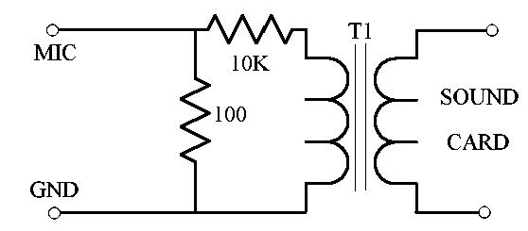

TCS\_1

### 5.3 RF Feedback Problems

We may need to add bypass capacitors between the hot and ground connections, on both sides of the interface, to reduce distortion caused by RF feedback from the transmitter into the sound card.  We can also try ferrite beads on both hot and ground leads.

## 6.0 THE DIGITAL MODE INTERFACE

Here is a link to a number of interface designs to go between the sound card output (speakers or headphone out) and the microphone or audio input at the transceiver. In addition to the interface between the sound card output and transceiver audio input this excellent site has schematics for interfaces that allow us to operate the PTT line of the radio from a COM port on the computer, yet keep the two components completely isolated by using an optoisolator. There are designs for switching [PTT](#PTT) using the [RTS](#RTS) or [DTR](#DTR) line, and the diagrams give the pinout on the computer DB-9 or DB-25 for each line. Take a look at http://www.qsl.net/wm2u/interface.html.

There are numerous manufacturers of such interfaces.The earliest of these commercial devices was the RigBlaster.

Transmit Tone Selection to Reduce Harmonics

We have discussed how to adjust the signal to reduce harmonics, and how to build hardware to reduce harmonics. There is another trick to reduce harmonic generation, but it requires that we tailor our operating procedures. We can generate high tones, say above 1600 Hz., rather than low tones. In this way, the second harmonic we may generate will be at 3200 Hz., which is attenuated by the filtering already in the transmitter. Commercial ham transceivers roll off their audio by 3000 Hz., sometimes even lower. Even if there is distortion that creates a harmonic tone, it will be attenuated by the filtering in the transmitter, as long as the harmonic is greater than 3000 Hz. The higher we generate our tones, the more attenuation of the harmonics will take place.

Logger32 has a special align function that can help to generate high tones. We point and click on a signal, whether high or low in the receive range, but if the radio is computer controlled, we can invoke the align function to retune to put the operating frequency higher in the transmit/receive range.  See align in the Using Logger32 topic.

## 7.0 HIGH TONES, LOW TONES, US VS EU STANDARDS

The US and Japan standard for RTTY tones is called "high tones."  Mark is 2125 Hz. and Space is 2295 Hz., and shift is 170 Hz. High tones is the original default for the HAM button in both MMTTY and in the MMTTY module for Logger32, and it reduces harmonics as described above. The European standard is called "low tones," where Mark is 1275 Hz. and Space is 1445 Hz. If we choose to use the low tone approach we will not have the extra harmonic reduction. Of course, if we generate a clean signal to begin with, this decision may not make much difference.

## 8.0 VERY STRONG RECEIVED SIGNALS

It is possible to be fooled into thinking that someone is distorting or generating harmonics although they are not doing so.  This happens when a received signal is so strong that it creates distortion within the receiver. This is not the fault of the transmitting station, any more than it is that station's fault if the receiver AGC desenses on CW or phone operation because the signal is strong.

The danger is that a strong signal will overload your receiver, and you will see a low Signal to Noise reading on the meter, and with lines on the display. You will give the poor guy on the other end a warning about his distortion, but, in fact, his signal is clean.

If you see a station with lines on the display and a low Signal to Noise ratio, first check to see if it is very strong.  If it is not strong, you can probably trust the indicators. If it is strong, try adding attenuation to the front end of your radio with the radio's attenuator button. If the If the Signal to Noise reading and lines improve then this suggests that the problem is not with the other station, but with your own receiver, and you need not warn the other fellow about his distortion. If stays the same, then please warn him so he can fix his problem

## 9.0 SOME STEPS TO ENSURE A CLEAN TRANSMITTED SIGNAL

* + Set the microphone gain to the setting used for phone operation. Reduce the setting of the output gain of the sound card, using the Windows mixer controls. As mentioned previously, this control may not be precise enough to adjust to a satisfactorily low level without shutting down the signal altogether. If so, the voltage divider solution should bring sound card output signal levels into a reasonable range for more precise adjustment;
  + Use a voltage divider and a transformer, as explained earlier. Actually, we should have already taken this step before trying to operate at all. If we are already using a divider, perhaps we need to increase the 10 kilohm resistor to a larger value; and,
  + Reduce the microphone gain at the transmitter. This may be a touchy adjustment. If we reduce the microphone gain and all that happens is that the tune power also drops and we simply run less power, this indicates substantial IMD before the microphone gain control.

## 10.0 OPERATING PHONE AND AFSK WITH THE SAME TRANSCEIVER

Some transceivers isolate the microphone input from the separate (AFSK) audio input internally. Some do this by having using different PTT lines for the microphone input and for the AFSK input. Others respond to computer commands by switching in the AFSK input instead of the microphone, however, many radios do not have such a provision. In this case, we should disconnect the microphone when we operate AFSK and disconnect the computer (or the interface) when we operate phone.

*Created with the Personal Edition of HelpNDoc:* [*Produce Kindle eBooks easily*](http://www.helpndoc.com/feature-tour/create-ebooks-for-amazon-kindle)

**Support for a Second Sound Card**

# Geoff Anderson G3NPA

## 1.0 GENERAL

Support is now provided for a second sound card. By default, Logger32 uses sound card 0, the operating system soundcard. The user can select a different sound card for use by Logger32 from the MMVari  Settings | MMAVRI Settings | Sound card setup menu in the [Sound Card Data window](#_topic_SoundCardDataWindow1):

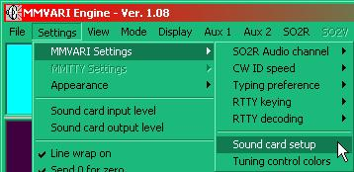

SSSC\_1

Clicking on this option will open the Sound card setup dialog box:

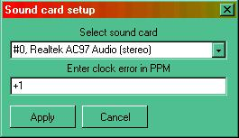

SSSC\_2

### 1.1 Selecting the PSK sound Card

Select the Sound Card number from the pull down menu on the left-hand side of this window and click on the <**Apply**> button.

**Note**: This ONLY applies to the MMVARI module in the Sound Card Data window. MMTTY has its own facility to use different sound cards.

**Note**: The first sound card in a PC is number 0, the second sound card is number 1, etc.

### 1.2 Calibration

Please refer to the topic [Calibrating the Sound Card](#_topic_CallibratingtheSoundCard).

### 1.3 Selecting the MTTY Sound Card

In the [Sound Card Data window](#_topic_SoundCardDataWindow1), select an RTTY mode and then click on the MTTY setup icon.

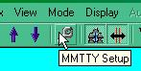

SSSC\_3

Select the "Misc" tab and then change the Device ID (Soundcard ID) to #1.

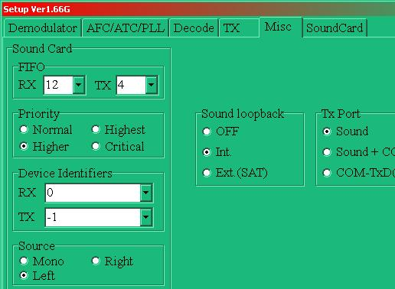

SSSC\_4

From MMTTY version 1.66G, the sound card selection process has been enhanced. Open the "SoundCard" tab and make selections for both Transmit and Receive.

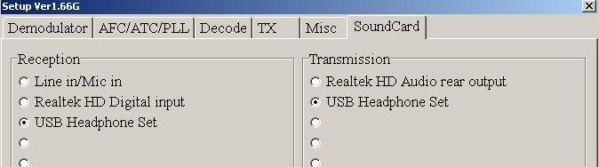

SSSC\_5

*Created with the Personal Edition of HelpNDoc:* [*Full-featured EBook editor*](http://www.helpndoc.com/create-epub-ebooks)

**Sound Card Transmitter Audio Setup**

# Jim Hargrave, W5IFP

## 1.0 GENERAL

The following procedure only applies to [AFSK](#AFSK) operation of the Logger32 Sound Card Digital modes. If you run [FSK](#FSK), then these adjustments are usually factory set in your radio.

### 1.1 Self-test of our own signal Using the Sound Card module of Logger32

Here is a procedure to check the quality of our AFSK [PSK](#PSK31/63/125) signal. developed by Peter, G3PLX.  If we generate a clean PSK signal, this is pretty good evidence that we will generate a clean [RTTY](#RTTY) signal from the same computer, transmitter, interface hardware, and software settings.

Please note the term "averaging RF power meter."  This is extremely important.  A peak-reading meter will not show the expected results as it will show high power at all times. Follow this procedure:

* + Open the Sound Card module in the MMVARI Engine BPSK31 mode. This test is most effective when in the BPSK31 operating mode
  + Transmit a single tone by placing MMVARI in the "Tune" mode. Right-click on the "Receive" pane in the lower status bar.

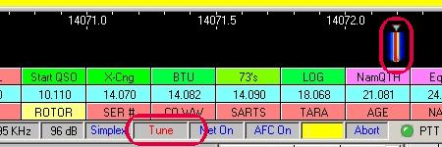

SCTAS\_1

* + Measure the output of the radio on an "averaging RF power meter."  This can be an external meter in average mode or it can be the meter built into most modern radios, as long as this is an averaging meter. Many radios use a peak-reading meter, and this is not what we want here. Even an older external SWR bridge can be used, just use the forward position to get a relative reading.  Note the reading.
  + Now switch from Tune to the PSK idle tone (no typing) and note the reading again  (Left-click on the Receive pane). The average power reading should go down to half or less than half the power of the original average power reading.

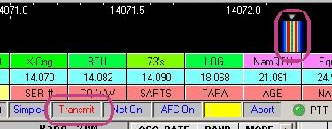

SCTAS\_2

### 1.2 If We Fail the Test

If the power does not drop by half or more when we go from Tune to BPSK, then we are probably generating substantial [IMD](#IMD).  The ultimate goal is to create a situation in which the microphone gain control is in the same position for both clean phone and AFSK input signals. This suggests that we are operating our transmitter in the manner intended by the manufacturer for audio signal inputs.

Here are some steps to reduce the problem:

* + Set the microphone gain to the setting used for phone operation;
  + Reduce the setting of the output gain of the sound card, using the Windows mixer controls. As mentioned previously, this control may not be precise enough to adjust to a satisfactorily low level without shutting down the signal altogether. If so, the voltage divider solution should bring sound card output signal levels into a reasonable range for more precise adjustment;
  + Use a voltage divider and a transformer, as explained earlier. Actually, we should have already taken this step before trying to operate at all. If we are already using a divider, perhaps we need to increase the 10 k resistor to a larger value;
  + Reduce the microphone gain at the transmitter. This may be a touchy adjustment. If we reduce the microphone gain and all that happens is that the tune power also drops and we simply run less power, this indicates substantial IMD before the microphone gain control;
  + A general rule of thumb on digital operation would be to adjust your transmit Audio drive until the ALC just starts to climb. Then back it off slightly so there is no movement of the ALC meter/indicator. This will generally result in approximately ? the power output you use on SSB. This setting will help improve the longevity of the radio finals. Remember that Digital operation is virtually 100% key down. This is especially true when operating in FSK mode.; and.
  + Adjustment of the sound card output gain affects the quality of the transmitted signal. This can be optimized using a closed loop without a radio using the following test setup.

To accomplish this test you will need an audio spectrum analyzer program such as the Spectral Lab by DL4YHF which can be found at <http://www.qsl.net/dl4yhf/spectra1.html>

Obtain an audio patch cable with 1/8th inch Male stereo connectors on both ends. Disconnect your audio interface and insert the patch cable into the Line/mike input and Line/speaker output of the sound card.

If you are using a radio with built in sound card or an external sound card in your interface, you can build a loopback connection on the radio data end. You can also monitor the signal using the monitor internal to the program. This is not as accurate, but will give you an indication of the audio quality.

Open the audio spectrum analyzer and configure it for your sound card. Place MMVARI in PSK31 mode and click on Transmit.

Adjust the Sound card gain controls for a minimum of distortion. I would suggest you start with the input and output gains set at 50%.

**Note**: Proper selection of the sound card sample rate also affects the quality of the transmitted signal. See the topic [Calibrating the Sound Card](#_topic_CallibratingtheSoundCard).

A properly adjusted sound card should produce a display similar to the following.

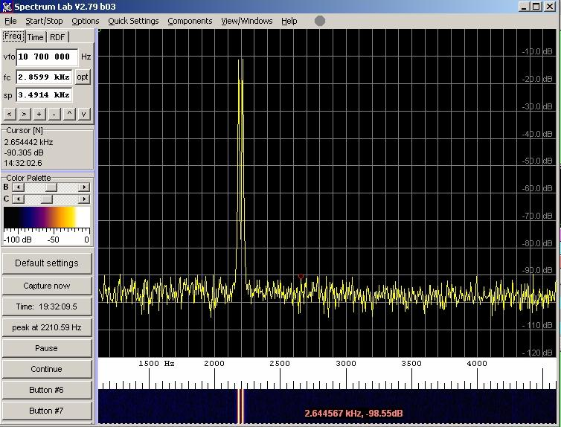

SCTAS\_3

The following displays an overdriven signal. Note the noise and presence of a pronounced second harmonic. This condition will result in a high IMD.

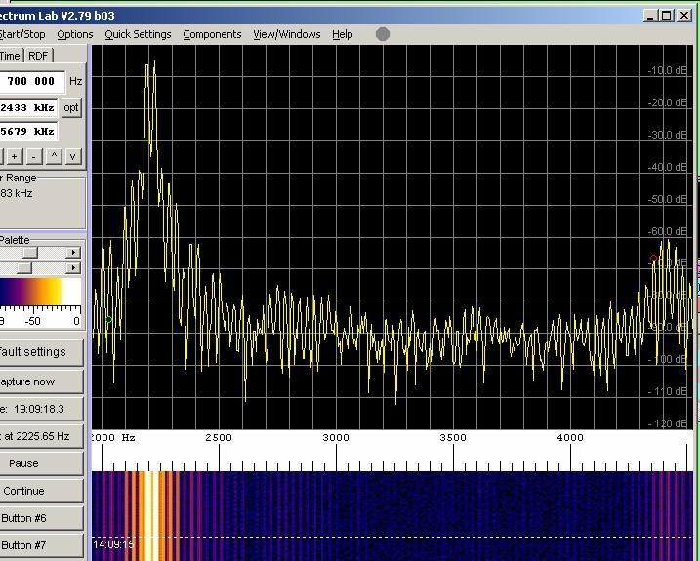

SCTAS\_4

*Created with the Personal Edition of HelpNDoc:* [*Easily create Qt Help files*](http://www.helpndoc.com/feature-tour)

**MultiRX**

# Jim Hargrave-W5IFP

## 1.0 GENERAL

MMVARI has the capability to decode and display up to 24 receive channels simultaneously. To access this capability, select "MultiRX" on the MMVARI Toolbar.

**Note**: When the MultiRX window is open the AUX channels are disabled.

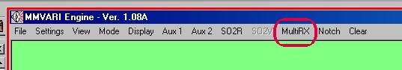

MRX\_1A

## 2.0 DESCRIPTION OF OPERATION

The audio spectrum is divided equally between channels like this: The lower limit is set to 500 Hz and the upper limit is set at 2500 Hz. So available spectrum = 2000 Hz. This gives you 6 channels of 333.3 Hz, 12 channels of 166.6 Hz, etc.

Each receiver starts in the middle of its allocated channel. With 6 receivers, receiver 1 will start at 666.6 Hz; receiver 2 will be 333.3 Hz higher, etc. With 12 receivers, receiver 1 starts at 583.3 Hz and receiver 2 will be 166.6 Hz higher, etc.

Each receiver is allowed to freely search within its channel. With 6 receivers, receiver 1 can move between 500 Hz and 833.3 Hz. Receiver 2 can move between 833.3 Hz and 1166.6 Hz. With 12 receivers, receiver 1 can move between 500 Hz and 666.6 Hz. Receiver 2 can move between 666.6 Hz and 833.2 Hz, etc. The user can configure the desired capture AFC sweep width and level threshold

## 3.0 SETUP

### 3.1  Open the MultiRX Window

You will see 6 (or more) channels in the MultiRX window. You will also see numbered markers on the frequency reticule. The numbered markers represent the operating frequency of each receiver.

The following columns are displayed on the MultiRX child window:

* + Column 1: Channel number. This number coincides with the channel numbers on the spectrum display;
  + Column 2: Audio frequency that the respective channel is decoding;
  + Column 3: Decoded text of each channel;
  + Column 4: Bookmarked callsigns; and,
  + Column 5: Representative S/N level.

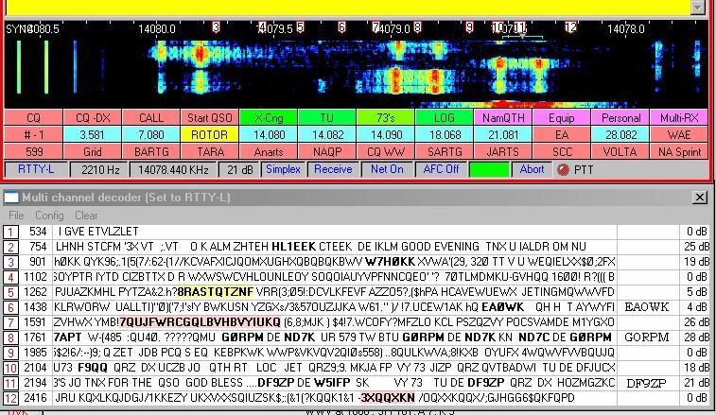

MRX\_1

### 3.2 AFC

[AFC](#AFC) Level sets the S/N level (in dB) at which the wide/coarse AFC becomes active.

AFC Width sets the width (+/- Hz) of the AFC sweep.

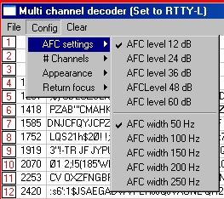

MRX\_2

### 3.3 Open "Config" and select "# Channels"

 Place a check mark by the number of receive channels you would like to display.

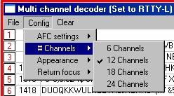

MRX\_3

### 3.4 Open "Config" and select "Appearance"

This allows you to turn ON/OFF the S/N ratio and channel markers and configure the highlight colors; and

 to select the received text color, font and size.

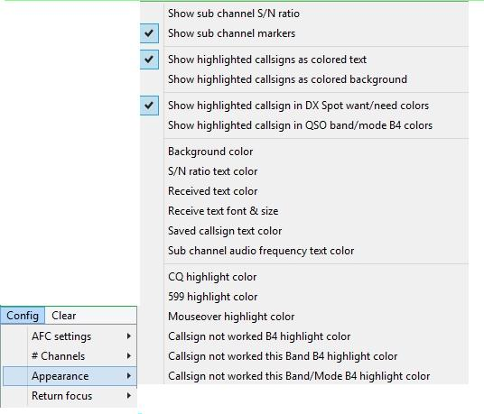

MRX\_4

### 3.4.1 Color selection

There are two main highlight color schemes. Colored text and colored background

If the colored TEXT is chosen, the highlighted text will change to the colors selected. The colored BACKGROUND will mask the highlighted text with the background color selected. Careful selection of the colors and background are important so as to not have a text and background of the same color.

**Example**: RED text and RED New Country is not optimum or maybe green mouseover highlight and green country not confirmed. It's also important to choose a Mouseover color that stands out above the background color

There are also two highlighting schemes: "DX Spot want/need colors" and "QSO band/mode worked B4 colors".

If the "Show highlighted callsigns in DX Spot want/need colors" is selected, the callsigns will be highlighted based on the "

Worked/Confirmed/Credited" colors configured in the DX Spot window.

If the "Show highlighted callsigns in QSO band/mode worked B4 colors" is selected, the callsign highlight will conform to the colors set in the three callsign highlight color selections under "Config/Appearances" in the MultiRX window.

### 3.4.2 Example 1

The following is an example of background coloring. This example uses a text color of BLACK and background color of WHITE. The highlight selection is: "Show highlighted callsigns in QSO band/mode worked B4 colors".

This sample shows several callsigns that have not been worked before (RED), One that has not been worked on this band (Orange) and two that have not been worked on this band or mode before.

Also note that CQ is highlighted by the selected background color.

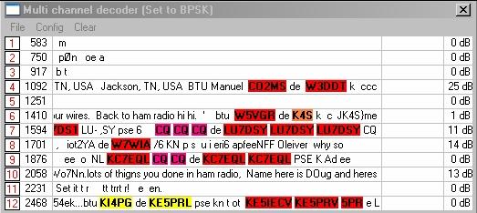

MRX\_5

### 3.4.3 Example 2

The following is an example where the chosen callsign color blends into the background making it difficult to promptly recognize. If the same colors happen to coincide, the callsign will disappear completely and show a blank pot. So it is important to choose background and highlight colors prudently. This example is configured for highlight set to colored Text.

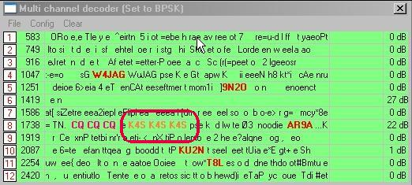

MRX\_6

### 3.5 Open "Config" and select "Return focus"

Check the desired window where the focus will return following actions in the MultiRX window.

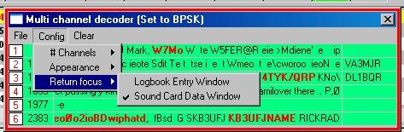

MRX\_7

## 4.0 OPERATION

Right-click on a callsign highlighted in the receive column will place the call in the right column for future use. This basically bookmarks the call without changing the [Logbook Entry window](#_topic_LogbookEntryWindow) or [Sound Card Data window](#_topic_SoundCardDataWindow1).

Left-click on a highlighted callsign in the text or the right column will place the call in the [Logbook Entry window](#_topic_LogbookEntryWindow) and shift the [Sound Card Data window](#_topic_SoundCardDataWindow1) to that signal.

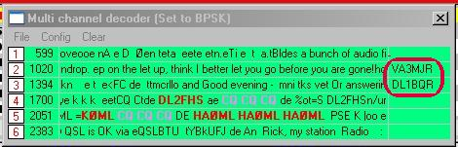

MRX\_8

Each channel is allowed to float within its assigned frequency segment. The [AFC](#AFC) function will capture and locks on to a signal within its range. You can also manually position a channel marker over a signal to enhance this process. Place the mouse pointer on the respective channel number in the Spectrum display and drag it over the desired signal. Once you release the pointer it will lock in and start decoding the signal. If this signal drops out, the AFC will take over and the channel will again float across its range.

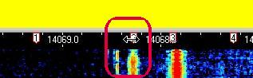

MRX\_9

## 5.0 CLEAR

On the MultiRX Window, clicking on the Clear will clear all receive channels and bookmarked callsigns.

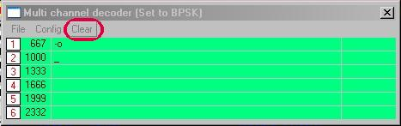

MRX\_10

Clicking on the column with channel numbers will clear the specific channel of text and any saved callsign

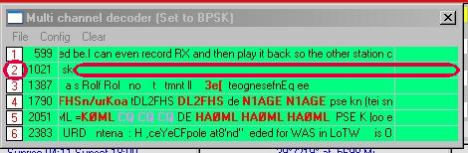

MRX\_11

Changing frequency of the radio will also clear all the MultiRX channels

## 6.0 MULTIRX AND SQUELCH

All receivers automatically follow the squelch setting of the [Sound Card Data window](#_topic_SoundCardDataWindow1).

## 7.0 OPERATING SPLIT

When using MultiRX to bust a pileup where the operator is working split, it is necessary to simply change the TX audio frequency without changing the callsign in the [Logbook Entry window](#_topic_LogbookEntryWindow) callsign field.

To use the MultiRX channels exclusively, the split frequency must be 2 KHz or less. If the split operation exceeds 2 KHz, this feature is not helpful.

Scan the MultiRX channels for a calling station to tail end, or select a quiet frequency. Click on the audio freq in the left column of MultiRX. This will place your main receive window and transmit frequency at the desired audio frequency. This allows you to now transmit at the split frequency while decoding the target DX station in one of the MultiRX channels. When using AFSK modulation, NET should be ON

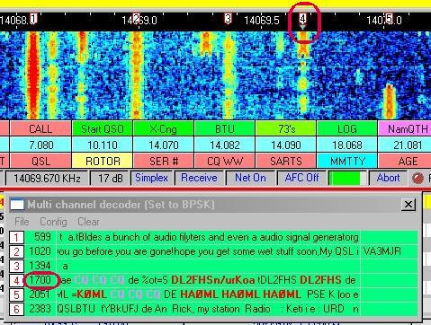

MRX\_12

### 7.1 Operating uing SO2V

Put the DX Station (your listening freq) on the [SO2V window](#_topic_SingleOperatorTwoRadiosSO2RSuppo). Find where you want to TX by monitoring the MultiRX or the main window. Make sure your TX is on the VFO displayed in the main window.

### 7.2 RTTY FSK Keying

Due to the fixed TX offset associated with FSK operation, it is more practical to use conventional methods of split operation using dual VFO or SO2V. The MultiRX window is useful to find a clear spot to transmit or find the target station?s listening frequency.

*Created with the Personal Edition of HelpNDoc:* [*Single source CHM, PDF, DOC and HTML Help creation*](http://www.helpndoc.com/help-authoring-tool)

**G3YYD 2Tone RTTY Engine**

# Jim Hargrave W5IFP David Wicks G3YYD

## 1.0 GENERAL

Logger32 supports the interfacing of the G3YYD 2Tone RTTY decoder and Transmitter. This program can be opened and run in parallel with the MMTTY engine or the MMAVRI engine. This provides for simultaneous RTTY signal display using two different decoding schemes. The 2Tone decoder is suspended during MMTTY or MMVARI transmit to provide dedication of the CPU timing to MMTTY/MMVARI. The 2Tone decoder is only available in MMVARI while in the RTTY mode.

2Tone and MMTTY are tightly coupled - activating Squelch, Net, or AFC from either 2Tone or MMTTY changes the setting on the other. Left or right-click on the MMTTY spectrum or waterfall moves 2Tone to the same frequencies as MMTTY.

**Note**: Transmitting with 2Tone is only available while using the MMTTY engine. It can be configured using AFSK or FSK mode of operation. The 2Tone decoder is also available in the [SO2R](#_topic_SingleOperatorTwoRadiosSO2RSuppo) and [SO2V](#_topic_SingleOperatorTwoVFOsSO2VSupport) windows when in RTTY mode. A copy of 2Tone.exe needs to be placed in the Logger32 MMTTY2 folders.

**Operational note**: It is recommended to disable the radio RTTY twin peak filtering when using the 2Tone decoder. The 2Tone decoder uses very narrow twin peak filters. If the radio twin peak filters and the 2Tone filters are slightly off in frequency to each other, it can cause clipping/distortion of the incoming signal, resulting in downgraded performance.

## 2.0 INSTALLATION AND SETUP

The 2Tone Help file can be opened from the Help menu. This requires a copy of the "2Tone.PDF" file placed in the same folder as "2Tone.EXE".

**Note**: The 2Tone decoder is only available in MMVARI while in the RTTY mode.

"2Tone.exe" and periodic updates can be downloaded from the.[Logger32 web site](#Links:_Logger32_Website).

To open the program, click on the 2T menu item in the MMTTY, MMVARI main, SO2R or SO2V menus.

Samples provided are for the MMTTY Engine and apply equally to the MMVARI Engine.

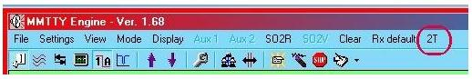

2T\_1

The program will open with the Decode and Spectrum/Setup panes being displayed.

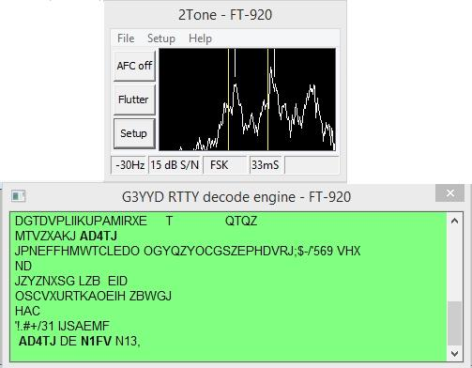

2T\_2

Clicking on the <**Setup**> button will bring up the setup window. Where the sound card and the RTTY decode parameters are selected. Once the selections are made, click on the <**OK**> button and the settings will be saved.

**Note**: The 2Tone Mark and Space settings must be set to coincide with the default Audio settings in this example:

**2Tone      Mark/Space     -     MMTTY / MMVARI Default Audio**

Low          1275/1445                      1360

High          2125/2295                      2210

With the above settings, the [$align$](#$align$) function in MMTTY or MMVARI will place both programs at the same frequency for simultaneous decoding. A Macro or right-mouse click on the waterfall will enable the [$align$](#$align$) function.

To select the sound card for 2Tone, open the setup window and make your selection. Select the proper sound card for both Receive and Transmit if you plan on transmitting AFSK RTTY using the 2Tone engine.

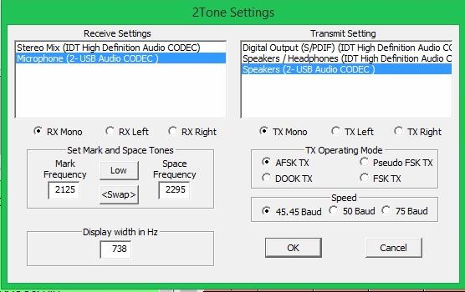

2T\_3

The following is a sample of a typical FSK transmit setup. Selecting FSK TX will open a Com port window.

The user can select the Com port as well as FSK and PTT keying lines. PTT is optional depending on hardware configuration. FSK on the DTR line seems to be more reliable

**Note**: If you plan on transmitting FSK with 2Tone, you cannot use the same COM port as set for MMTTY. MMTTY opens first and captures the port. Set the MMTTY "TX" FSK port to "none" to avoid a conflict. 2Tone does not support EXTFSK, however it should work with a USB to serial adapter, especially those using FTDI chipset.

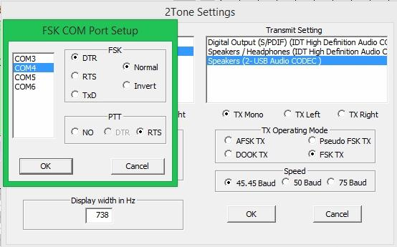

2T\_4

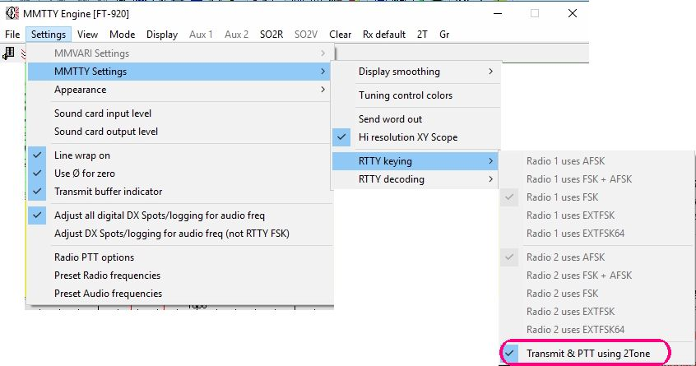

2T\_5

If the operator desires to make changes, the setup/spectrum pane can be re-opened again by clicking on the 2Tone box in the Windows task bar. The Spectrum display pane may be left running during operation.

The following is a screen capture showing the 2Tone decoder running in parallel with MMTTY.

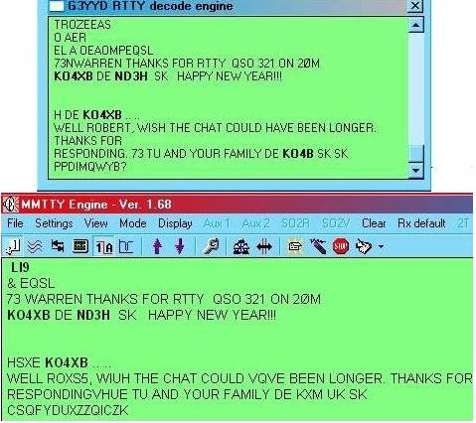

2T\_6

## 3.0 2TONE OPERATIONAL INFORMATION

# David Wicks G3YYD

### 3.1 Functionality

The Top button toggles AFC on/off. N1MM also controls this button via the Di.

The Middle button: optimizes the decoder for current signal propagation: Flat is for flat slow fading with mark and space fading at the same time; Flutter for very rapid fading conditions; Selectiv(e) for when mark and space fade independently of each other common on the lower HF bands; Spread not common and more often on the higher HF bands on trans-polar paths - the signal spectrum is spread over a wider bandwidth by the propagation.

The Setup button displays the 2Tone settings dialogue, in which clicking FSK TX in TX Operating mode grouping displays the FSK COM Port Setup dialogue and space fading at the same time; Flutter for very rapid fading conditions; Selectiv(e) for when mark and space fade independently of each other common on the lower HF bands; Spread not common and more often on the higher HF bands on trans-polar paths - the signal spectrum is spread over a wider bandwidth by the propagation.

### 3.2 The FFT display

### Tune the radio so the RTTY twin peaks and the short yellow (or white with AFC off) vertical tuning indicators are near or co-incident with the vertical yellow lines. The long vertical lines are at the set tone frequencies. The displayed band width can be adjusted, click on Setup button, between 449 and 1292Hz at 45.45 baud centered on the tone pair. Bandwidth at 75 bauds is 741 to 2133Hz. It has a 60dB dynamic range and updates every 85 milliseconds at 45.45 baud. Note unlike MMTTY FFT the display frequency range is not changed by AFC.

**Squelch**: Go to Menu Setup, Squelch left click will toggle on/off. Characters are displayed when the signal to noise is 1.5dB or higher. An occasional character will be displayed with a noise input. It takes a while after a signal goes before the output is squelched, this is deliberate to ensure nothing is missed in any replies. When squelched, 2Tone stores the last 4 characters. On squelch opening these characters are sent to the DI followed by newly received characters. Squelch can be disabled go to menu setup, uncheck squelch item.

**AFC** (Automatic Frequency Control) gives the best decode performance and will lock onto a signal within 60Hz of the set tones.

**Status Bar** - the numeric display along the bottom of the 2Tone window - left hand side shows the direction and value in Hz to tune the receiver to be exactly on frequency. In practice the receiver should be tuned to within 30Hz of the given signal. The AFC will lock onto a RTTY signal that is well below the decode threshold. The short vertical lines at the top of the FFT display shows where the AFC is compared to the set mark and space frequencies. AFC on is yellow while AFC off is White with the decoder tone frequencies unchanged from the set values. When transmitting 2Tone stops updating AFC preserving the AFC value for receive.

**Signal to Noise ratio**, next to the AFC value in the status bar is the measured signal to noise ratio of the decoded signal in dB. This is an average of S/N measured over several RTTY characters. The threshold to keep in mind is 10dB. Above this, the error rate will be reasonable and as it drops below 10dB decode errors will increase very rapidly. Sometimes a seemingly strong signal has a poor signal to noise ratio due to some types of signal propagation. It is a good indicator of why a strong signal has poor decode. A poor quality transmit signal can also have a degraded signal to noise ratio.

**NET** : Net ON will synchronize the transmit tones to the received tones. Net off will transmit at a fixed tone (default or where it was when Net was turned off).

**Baud Rate**: This can be selected in Set up dialogue for 45.45 (normal standard for amateur RTTY), 50 or 75. Stop Bit Length: On the status bar fourth in from the left is a display of the received stop bit length. Ideally this should be around 32 to 34 milliseconds. However some RTTY software differs from the 1.5 stop bit standard. Values around 44mS and 48mS are common in contest set ups, but do increase decode error rate. At low signal to noise ratios, this value will move either side of the transmitted value. 2Tone transmit uses the 1.5 stop bit standard.

**Receiver AGC**: This should be set to slow as fast will confuse the selective fade algorithms and cause AGC generated IMD. Normal SSB AGC setting is good but not CW fast setting.

**Carrier QRM**: Tuning in a carrier without any modulation and little QSB will result in no output from 2Tone, the AFC and S/N will not update. If a RTTY signal is QRM?d by a carrier on one of the tones, 2Tone will often decode the signal correctly even when it is weaker than the carrier. But do not expect miracles!

**TX Sound Card PTT**: Selecting AFSK, DOOK or pFSK button will open a dialogue for COM port PTT. If VOX or other PTT (e.g. Logger32) is used then select no, otherwise select COM port and output line required.

**TX AFSK**: The use of AFSK transmit audio is preferred as the audio amplitude is constant and with Net on will track the received signal frequency. Ensure the audio input of the transmitter is not overdriven. Use of tone frequencies above 1500Hz is preferred so that audio harmonics are removed by the rig's SSB filters.

**TX DOOK**: This stands for Differential On/Off Keying of mark and space tones. The signal waveform varies in amplitude and both tones are present at the same time during transition from one tone to the other. This requires the use of a linear transmitter as Intermodulation Products will broaden the signal width. Again use frequencies above 1500Hz.

**TX pFSK**: The Pseudo FSK setting outputs a 5KHz tone on both left and right channels of the selected sound card. Tone is on for space and off for mark. A suitable detector circuit can be found at <https://groups.yahoo.com/neo/groups/N1MMLogger-Digital/files/G3YYD/> The output connects to the FSK input of the rig. Search & Pounce: as the transmit frequency does not change with AFC, tune the rig so the small vertical AFC lines are co-incident with or very close to the long vertical lines. Not doing this will result in off frequency transmission.

**TX FSK**: This makes use of a COM port's DTR, RTS or TxD lines to key a radio's FSK input used via a keying transistor. Normal keying is -12v for Mark and +12v for Space with Invert being the other way round. Open Setup and click on FSK TX in the TX Operating mode group to open a dialogue for setting Com Port, DTR or RTS and Normal or Invert shift sense. The COM port is released during reception so another copy of 2Tone can use it for transmission. It is possible to use one of the DTR/RTS lines with Di1 and the other for Di2 for easy SO2R operating. Careful programming results in low levels of timing jitter. A CPU with 2 or more processors will minimize timing jitter. Excessive timing jitter will cause received character errors.

**TX PTT**: This only works on FSK and is selected when FSK is setup. -12v PTT off, +12v PTT on.

**RX Sound Card**: Select the correct input and tune in a strong RTTY signal. Adjust the receiver and sound card gains so the peaks on the FFT (spectrum display) are about 90% of the maximum height of the display. The FFT has a degree of AGC (Automatic Gain Control) so that the gain settings are not critical. Beware very cheap sound cards can create their own spurious QRM (I found this the hard way).

**Display**: 2Tone checks on startup that it is within the display area of your monitor(s), if it is not it will automatically center itself on the nearest monitor. If the 2Tone window is not visible it is because it is either behind another window on the display or has been minimized. Going to Menu Setup, Topmost on Checking this item will put 2Tone always on top.

**SO2R**: More than one 2Tone can be used at the same time by using separate folders for each 2Tone. By using one 2Tone in the Main MMTTY window configure the Setup dialogue to use Left "line in" and Left "line out" for the main rig (Radio 1) with another 2Tone for the MMTTY SO2R window with Right "line in" and Right ?line out? for the SO2R (Radio 2)rig. This is in conjunction with wiring the Radio 1 to the left Line in/out and SO2R Radio 2 with the right line in/out. See also notes under TX FSK above.

**Play WAV file**: This will read in a sound file that has been saved via the 2Tone command (see below) and play it at full PC speed through 2Tone. Just select the file to play and open it. Good idea to clear the Di window before playing. Use it for post contest analysis. Will only play 2Tone saved files.

**Save Text**: The decoded text can be saved to a file use menu File, Save Text. While saving text this menu item will be checked. To stop go again to File, Save Text and left click. The setting is lost when 2Tone is closed. The sound card on transmit is set for 16bits at 12,000 samples per second at 45.45 baud and proportionally faster for 50 and 75 baud. The receive sample rate is 48,000 for all baud rates. On receive and transmit sound card channels are chosen in 2Tone setup for mono, left or right.

2Tone has been optimized to work with 45.45, 50 and 75 baud RTTY and has no other baud setting. Transmit is set for one start bit, 5 data bits and 1.5bit stop length. Bit timing accuracy is as accurate as the sound card sampling rate for AFSK, DOOK and pFSK. FSK timing accuracy is as accurate as the CPU crystal plus some unavoidable jitter caused by Windows operating system.

The receive tone filters used for Flat, Flutter and Selective use 2nd Order Nyquist filters bandwidth of baud rate in Hz. Spread decoder uses a raise cosine Beta=0.5 with twice baud rate bandwidth. Flutter and Spread decoders also use post detection filtering with a bandwidth that varies with the measured signal to noise ratio.

The Selective decoder processes both tones separately using a threshold value derived from signal and noise amplitudes averages and then combined with the current tone amplitude. The individual mark and space tone values are combined to produce a final mark or space result for asynchronous decoding. Unlike standard FSK mark/space determination this system makes use of the absence of signal as well as the presence of signal and by treating the two tones separately and combining them together single tone copy is possible. This is sometimes called in-band diversity.

On transmit AFSK tapered cosine filtering, known as Tukey1 windowing, of the keying waveform is used to minimize occupied bandwidth. The filtered keying waveform is used to frequency modulate a carrier tone generating a FSK waveform with no amplitude variation.

Transmit DOOK uses raised cosine low pass filtering of the keying waveform that then amplitude modulates the mark tone and an inverse keying waveform modulates the space tone. During Mark/Space transitions both tones are present at the same time and the amplitude of the transmitted waveform varies, which will result in some broadening of the transmission due to transmitter IMD products <https://en.wikipedia.org/wiki/Window_function#Tukey_window> .

While the pseudo FSK mode outputs a 5KHz tone with tone on for space, The transmit start up sequence is one character length (165mS at 45.45 baud) of space tone followed by one character length of mark tone and then a shift character appropriate to the following printable character. The startup sequence has been optimized for 2Tone type decoders (FLdigi RTTY mode uses a similar technique) and is also suitable for MMTTY type decoders. All transmit characters are one start bit, 5 data bits and 1.5bit stop length.

Configuration settings of 2Tone are stored in 2Tone.ini file in the same folder. If you delete this file programmed defaults will be used until they are changed. Corruption of this file can impact adversely on 2Tone.

More technical information on RTTY modulators and history of technical developments can be found at [http://w7ay.net/site/Technical/RTTY%20Demodulators.](http://w7ay.net/site/Technical/RTTY%20Demodulators)

## 4.0 ACKNOWLEDMENTS

Peter Martinez, G3PLX was most helpful in guiding me on Windows and sound card programming. Rick Ellison, N2AMG help me overcoming a problem on the N1MM DI/MMTTY interface and Chen W7AY helped on Extended Nyquist filtering.

David, M7T & G3YYD@btinternet.com.

*Created with the Personal Edition of HelpNDoc:* [*Produce electronic books easily*](http://www.helpndoc.com/create-epub-ebooks)

**GRITTY Decode engine for RTTY**

# Jim Hargrave W5IFP

## 1.0 GENERAL

The GRITTY decode engine may be used with Logger32 to supplement [MMTTY](#2.1_MMTTY_Sound_Card_Selection) and [MMVARI](#2.2_MMVARI_Sound_Card_Selection) while in the [RTTY](#1.0_GENERAL) mode.

Obtain a copy of GRITTY from <http://www.dxatlas.com/GRITTY> and install it in the default location.

GRITTY comes with a help file. It can be accessed by clicking on the “?” icon. The HELP file is recommended reading before operating GRITTY

### 1.1 Sound card.

With the sound card open in RTTY mode, click on the menu “GR” to open GRITTY.

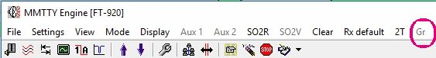

GR\_1

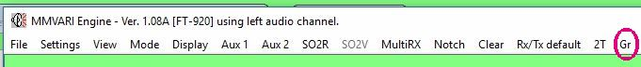

GR\_2

### 1.2 GRITTY

GRITTY will open with a lateral waterfall and decode pane.

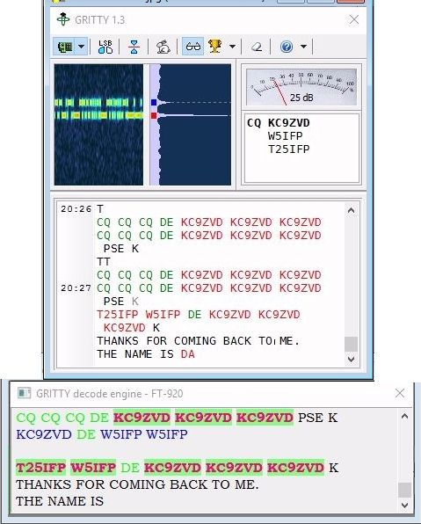

GR\_3

## 2.0 SOUND CARD SETUP.

Click on the down arrow in the first icon will open a sound card setup pane. Select the desired sound card and channel.

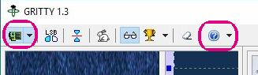

GR\_4

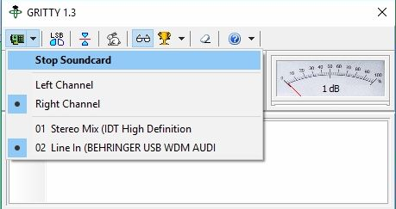

GR\_5

### 2.1 Default Audio Setting.

GRITTY defaults to HIGH audio tones: MARK 2125 and Space 2295. If you use low tones, you need to change GRITTY to be compatible with the setting in MMTTY/MMVARI. To change the Audio default requires modifying the “GRITTY.ini” file. See the GRITTY help file for details.

**Note**: Logger32 default audio setting is halfway between MARK & SPACE, whereas GRITTY sets default to the highest tone. Users of VISTA and later OS will need to do a file search for GRITTY.INI. The config files are saved in user files on these later operating systems.

### 2.2 Colors

The colors of the highlighted text and background of the default GRITTY decode pane is fixed. However the user can set the text and background colors of the Logger32 GRITTY decode pane by opening “Settings > Appearance” and make your selections. These selections will apply to both MMTTY/MMVARI and GRITTY receive panes.

## 3.0 OPERATION

### 3.1 Callsign transfer

The GRITTY decode pane functions like the MMTTY and MMVARI receive pane. Callsigns are printed in bold lettering. When a callsign is clicked on, the call will transfer to the Log Entry window.

Just below the SNR meter is a box that contains a list of calls heard. Clicking on these callsigns will also transfer the call to the Log Entry call field.

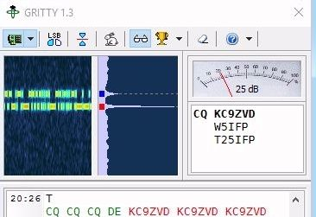

GR\_6

### 3.2 Scrolling

While scrolling, “Freeze…” will appear in the upper left hand corner of the header. Data will continue to be decoded, but will not print. Freeze mode will time-out and self-cancel if no further scrolling is detected. If the cursor is moved away from the receive pane, freeze mode is immediately canceled and incoming text printing is resumed.

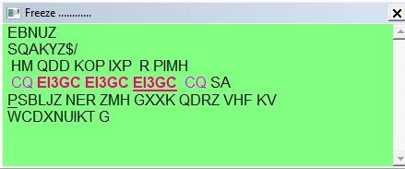

GR\_7

### 3.3 Screen position

The GRITTY application has a default decode pane and a Logger32 decode pane. To conserve screen space and eliminate duplication, the default decode pane may be minimized by sizing from the bottom up and placing the remaining decode pane below the waterfall.

Users running two monitors can move either pane to another screen if desired.

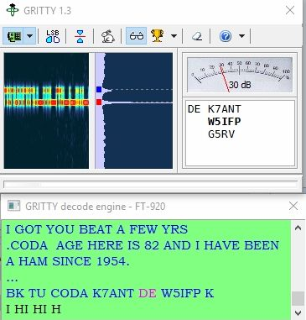

GR\_8

### 3.4 Signal alignment

GRITTY decoding is fixed at the audio default tones. In order to decode a signal, it must be aligned to the default position. This can be accomplished by tuning the radio or an easier method is to RIGHT click the mouse on the signal present in the MMTTY/MMVARI waterfall/spectrum. This will assure proper alignment of the received and transmitted signals.

*Created with the Personal Edition of HelpNDoc:* [*Generate Kindle eBooks with ease*](http://www.helpndoc.com/feature-tour/create-ebooks-for-amazon-kindle)

**MACROs Hot Keys and Programmable Buttons**

*Created with the Personal Edition of HelpNDoc:* [*Easy EBook and documentation generator*](http://www.helpndoc.com)

**MACROS**

# Randy Tipton, WA5UFH, Geoff Anderson, G3NPA, Jim Hargrave, W5IFP and Hew Lines VA7HU

## 1.0 GENERAL

Logger32 is user-friendly and can be customized to your own personalized likes by using the program's built-in Macro commands. These commands can be used to program up to 36 programmable buttons in the [Sound Card Data window](#_topic_SoundCardDataWindow1), the [Data Terminal window](#_topic_DataTerminalWindow) and the [CW Machine](#_topic_CWMachineWindow).

This topic is intended to be a reference document for details on how to use the Macro language. Specific details on programming buttons, selecting the number of buttons to display and some suggested functionality to assign to those buttons for each of the windows can be found in the topics [Hot Keys](#_topic_HotKeys) and [Programmable Buttons](#_topic_ProgrammableButtons).

## 2.0 MACRO COMMANDS

A number of these commands require a radio controlled by Logger32 via a serial port for their effective operation. These commands are colored red in the table below. For those who operate a software controlled radio, please see the section "Macros for Software Controlled Radios".

**Note**: The following list details the Macro commands for the individual Logger32 modules and modes.

* + **CW** applies to the [CW Machine window](#_topic_CWMachineWindow)
  + **DATA** applies to the [Data Terminal window](#_topic_DataTerminalWindow)
  + **RCP** applies to the [Radio Control Panel](#_topic_RadioControlPanelRCP)
  + **PSK** applies to the [Sound Card Data window](#_topic_CommunicatingwithPSKMFSKandQPSK)
  + **MMTTY** applies to the [Sound Card Data window](#_topic_CommunicatingwithRTTY)  and all profiles in the MMTTY Engine
  + **MMVARI** applies to the [Sound Card Data window](#_topic_CommunicatingwithRTTY)  and all modes in the MMVARI Engine
  + **LH (Local Host)** applies to the [Telnet Cluster window](#_topic_TelnetClusterWindow)

**$afc$ CW MMTTY MMVari**

Toggles the [AFC](#AFC) function on and off.

**$align$                                                MMTTY MMVari**

Adjusts the radio frequency so the captured signal appears at the default audio frequency. Details of the operation of the align function using mouse clicks are contained in the [Sound Card Data window](#9.2_Align) section.

**$ascii(n)nnn$ Data MMTTY MMVari**

Inserts the [ASCII](#ASCII) code ((n)nnn) of a character than cannot be entered from a keyboard into the output text string (if the first digit is a zero, it is optional.) See the section on [More Difficult Macros.](#7.0_MORE_DIFFICULT_MACROS)

**$band$ CW Data MMTTY MMVari Local Host**

Inserts the current band displayed in the [Logbook Entry window](#_topic_LogbookEntryWindow) into the output text string.

**$bookmark$ CW Data MMTTY MMVari**

Inserts a [Pseudo DXSpot](#_topic_PseudoDXSpots) into the [DX Spots window](#_topic_DXSpotsWindow1) and the [Bandmap](#_topic_TheBandmap).

**$call$ CW Data MMTTY MMVari Local Host**

Inserts the callsign currently displayed in the [Logbook Entry window](#_topic_LogbookEntryWindow) into the output text string.

**$callchanged$               CW**

This Macro is the same as [$call$](#$call$), but only sends something if the call has changed since it was last sent. This Macro is useful when correcting an erroneous callsign

$callchanged$ will not work standalone, it must be embedded with other data. If the Macro is not populated, then the Macro and the space trailing the Macro is erased from the string to be sent.

**Example**: Create a Macro "$callchanged$" 1234. In the [CW Machine](#_topic_CWMachineWindow), enter a callsign of AA1A and transmit the Macro. It should send "AA1A 1234". Transmit the Macro again. It should send 1234. Change the callsign to "AA1AA". Transmit the Macro should send "AA1AA 1234".

**$callsignbeforeclearlog$ CW         MMTTY               MMVari**

This Macro can be used in conjunction with [$clearlog$](#$clearlog$) to respond to dupes during contests or DX expeditions. It will insert the Callsign in the Logbook Entry window into the Macro and clear the [Logbook Entry window](#_topic_LogbookEntryWindow).

Typical use: [$transmit$](#$tune$) [$clearlog$](#$clearlog$) [$callsignBeforeClearLog$](#$callsignbeforeclearlog$) QSO B4 TU QRZ [$receive$](#$receive$)

**$CallsignGetsFocus$ CW**

At the end of a transmission, sets the focus on the Callsign field in the [CW Machine window](#_topic_CWMachineWindow).

**$cancelscrolllock$                 MMTTY                        MMVari**

Has been removed.

**$clear$ CW Data MMTTY MMVari**

An immediate command to clear the TX Buffer and callsign panel. This Macro only works if the keyer is in a Manual TX. [see [Note 2](#Note2)].

**$clearbuffers$ MMTTY**

Clears the TX Window and Buffer as well as the RX Window. Stops transmission but DOES NOT return to RX. [see [Note 2](#Note2)]

**$clearlog$ CW Data RCP MMTTY MMVari**

Clears the [Logbook Entry window](#_topic_LogbookEntryWindow).

**$cleartxbuffer$ MMTTY**

Clears the TX Buffer. [see [Note 2](#Note2)]

**$ClearCallsignOnQSYOn$ RCP**

Checks the Clear Callsign On QSY menu item.

**$ClearCallsignOnQSYOff$ RCP**

Unchecks the Clear Callsign On QSY menu item.

**$ClearQSYMarker$ RCP**

Clears the current Clear Callsign On QSY frequency from memory.

**Control\_<x> Data**

Where <**x**> is a control character (usually an upper case letter to be sent to the TNC to issue whatever command is needed). [**Note**: there are no "$" symbols enclosing this macro].

**$command$ CW Data MMTTY     MMVari**

Sends the text string following the command to a radio controlled by Logger32. **Note**: "xxxx" is a string.

If used from the [CW machine window](#_topic_CWMachineWindow), it is recommended that only one control command be given at a time. To allow multiple commands from a single Macro, the CW Machine will accept a format of $command 1234 / 5678 / 91011$. The "/" is used as a command separator. (See [Note 8](#Note8) )

If used under [SO2R](#_topic_SingleOperatorTwoRadiosSO2RSuppo) conditions, the Macro can accept the format $command[radio1text]|[radio2text]$ where [text] is an optional parameter and the "[" and "]" are NOT part of the parameter. Further information on this can be found in the [Single Operator Two Radios](#_topic_SingleOperatorTwoRadiosSO2RSuppo) topic.

As the TEN-TEC OMNI VII command set requires both ASCII characters and hex numbers, a further modifier has been introduced. Hex numbers can be passed in this Macro if enclosed in "<" and ">". Thus a Macro such as $command \*A<xx>$ where xx is a hex number is acceptable. For more information see the [TEN-TEC OMNI VII](#_topic_TENTECOMNIVII) topic.

**$cw$ MMVari**

Sends the text string following the command  (up to 40 characters) on CW, then switches to RX.

**$cwid$ MMVari**

Transmits a CW ID string at the end of the current transmission, then switches to RX.

**$CWspeeddn$ CW**

Permanently decreases the keying speed by one [WPM](#WPM).(See [Note 2](#Note2)).

**$CWspeedup$ CW**

Permanently increases the keying speed by one [WPM](#WPM).(See [Note 2](#Note2) ).

**$CWTextGetsFocus$ CW**

At the end of a transmission, sets the focus on the Text field in the [CW Machine window](#_topic_CWMachineWindow).

**$delay$ Data**

Pauses 250 [ms](#ms) before sending the next character to the [TNC](#TNC). This is typically used after sending control codes to the [TNC](#TNC) to change modes.

**$down$ MMVari**

Moves the main passband down 1 Hz. If [AFC](#AFC) is locked on, this command will have no effect.

**$endtime$ Data MMTTY MMVari**

Records the current time as the QSO end time.

**$escape$ Data**

Sends the ESC character (chr$(27)) to the [TNC](#TNC).

**$file$ Data MMTTY MMVari**

When followed on the same line with a fully qualified textfile name ($file$C:\LOGGER32\MYFILE.TXT), this command will load the contents of that file into the TX buffer. If only the filename is used, the command will default to the Logger32 directory. **Note**: The [$file$](#$file$) Macro in the [Data Terminal window](#_topic_DataTerminalWindow) does NOT show the text being loaded into the RX field in the window until load is complete. This is necessary because the software must make sure that any <**Esc**> characters that may be embedded in the text are stripped out and that an appropriate delay is inserted into the string. The same applies to any [Control\_<x>](#Control_<x>) strings in the text.

**$greeting$ CW Data MMTTY MMVari**

Send a greeting appropriate to the local time of the QSO partner. If Logger32 cannot determine the distant end time, then the default greeting will be sent. See The [Greeting Macro](#4.0_THE_GREETING__MACRO) section of the [Programmable Buttons](#_topic_ProgrammableButtons) topic.

**$hexbytes$ Data**

Sends the hexadecimal string following the command to the Data Terminal, Antenna switch port.

**$hexcommand$ CW Data MMTTY MMVari**

Sends the hexadecimal string following the command to the radio. When used from the [CW Machine window](#_topic_CWMachineWindow), it is recommended that only ONE command be issued. To allow multiple commands from a single the CW Machine will accept a format of $hexcommand 00 01 02 03 / 04 05 06 07 / 08 09 10$ The / is used as a command separator. (See [Note 8](#Note8) ).

**$IcomVFOB$ RCP**

Reads and displays VFO B on late model ICOM radios when in split operation..

**$lasthighlightedcall$ MMTTY MMVARI MMTTY**

Places the last highlighted call into the [Logbook Entry window](#_topic_LogbookEntryWindow).

**$lasthighlightedcallandlookup$ MMTTY MMVARI MMTTY**

This Macro is the same as [$lasthighlightedcall$](#$lasthighlightedcall$), and in addition does a callsign lookup (QRZ, Hamcall or whatever the user has configured).

**$lastloggedcallsign$ MMTTY MMVARI**

Use it like $call$, but it inserts the callsign of the last QSO in the logbook into the macro.

You must have logged a callsign (since starting Logger32) for it to work.  It doesn't actually look in the logbook for the callsign, it just remembers the callsign you logged.

**$lastloggedname$ MMTTY MMVARI**

Inserts the Name of the last logged QSO. You must have logged a callsign (since starting Logger32) for it to work.   It doesn't actually look in the logbook for the name, it just remembers the last name you logged.

**$lastqsoband$ Data MMTTY MMVari**

Inserts the last QSO band for the station being worked into the output text string.

**$lastqsodate$ Data MMTTY MMVari**

Inserts the last QSO date for the station being worked into the output text string in the same format as that of the log.

**$lastqsotime$ Data MMTTY MMVari**

Inserts the last QSO time for the station being worked into the output text string in the same format as that of the log.

**$lastqsomode$ Data MMTTY MMVari**

Inserts the last QSO mode for the station being worked into the output text string.

**$log$ CW Data MMTTY MMVari**

Enters the data currently displayed in the [Logbook Entry window](#_topic_LogbookEntryWindow) into the Log. **Note**: $log$ is not a standalone Macro but is to be used embedded into text Macros.

**$logimmediate$ CW MMTTY MMVari**

Logs the QSO and clears the buffer immediately.

**$longdate$ Data MMTTY MMVari**

Inserts the current UTC date into the output text string in the form dd-mm-yyyy.

**$longdateandtime$ Data MMTTY MMVari**

Inserts the current UTC date and time into the output text string in the form dd-mm-yyyy, hh:mm:ss.

**$longtime$ Data MMTTY MMVari**

Inserts the current UTC time into the output text string in the form hh:mm:ss.

**$lookup$ CW**

This Macro executes immediately regardless of where in the Macro it is placed, and triggers the Logger32 auto-lookup (if configured and there is a call in the Callsign edit box of the [Logbook Entry window](#_topic_LogbookEntryWindow)}.

**$loop$ CW MMTTY MMVari**

Causes a five (5) second delay after the Macro has completed, then restarts the Macro (see [More Difficult Macros](#7.0_MORE_DIFFICULT_MACROS)).

**$loop x$ CW MMTTY MMVari**

Causes a user defined delay after the Macro has completed, then restarts the Macro. The value "x" is in seconds.

**$mouseTF-Set$ CW RCP MMTTY MMVari**

For Kenwood radio sends TS1; or TS0; command corresponding to TF-Set state when button is pressed/ held and released by mouse or function key. It needs to check correspomding option in Setup Radio table.

**$mode$ Data MMTTY MMVari**

Inserts the mode currently displayed in the [Logbook Entry window](#_topic_LogbookEntryWindow) into the output text string.

**$msg(x)$ CW (WinKey2 ONLY)**

Macros $msg1$ to $msg6$ are for sending WinKey2 internal memories. These Macros are valid for a WinKey2 only and are immediate Macros.

**$MultiRX$ MMVari**

This Macro activates the multiple receive channels of the MMVari engine. See the [MultiRX](#_topic_MultiRX) topic.

**$mycall$ CW Data MMTTY MMVari**

Inserts the current "operator" value into the output text stream. Usually this would be a callsign.

**$name$ CW Data MMTTY MMVari**

Inserts the contents of the Name field currently displayed in the [Logbook Entry window](#_topic_LogbookEntryWindow) into the output text stream. For specific use in the [CW Machine](#_topic_CWMachineWindow), see [Note 5](#Note_5) in the CW Machine topic.

**$NameGetsFocus$ CW**

At the end of a transmission, sets the focus on the Name field in the [CW Machine window](#_topic_CWMachineWindow).

**$net$ MMTTY MMVari**

Toggles the [Net](#5.7_Net_On/Off) function on or off

**$numqsos$ Data MMTTY MMVari**

Inserts the total number of QSOs logged for the station being worked.

**$qsx+/-nnnn$ MMTTY MMVari**

Shifts the transmit frequency of the radio up or down by nnnn Hz. $qsx-2000$ shifts the frequency transmit frequency down by 2 kHz, $qsx+1500$ shifts it up by 1.5 kHz. This shift is terminated by the [$simplex$](#$simplex$) command.

**$qsy(nn)nnn.(nn)$ Data MMTTY MMVari**

Immediately changes the radio frequency to the specified value (nnnnn.nn). For example - $qsy7070$ or $qsy14070.22$. See [Note 1](#Note1) .

**$qth$ MMTTY MMVari**

Inserts the contents of the QTH field currently displayed in the [Logbook Entry window](#_topic_LogbookEntryWindow) into the output text string.

**$radioandtone$ MMTTY MMVari**

Returns the RF center frequency (radio carrier frequency plus audio tone frequency) when in [PSK](#PSK31/63/125) mode. Returns the RF frequency of the Mark tone (radio frequency plus the mark tone audio frequency) in RTTY mode (see the section on [More Difficult Macros](#7.0_MORE_DIFFICULT_MACROS)). See [Note 5](#Note5) .

**$radio1$ RCP**

Selects Radio #1. Does nothing if Radio #1 is already active.

**$radio2$ RCP**

Selects Radio #2. Does nothing if Radio #2 is already active

**$radio1->radio2$ RCP**

Transfers frequency and mode of Radio 1 to radio 2

**$radio2->radio1$ RCP**

Transfers frequency and mode of radio 2 to radio 1,

**$Radio1Offset xxxxx$ RCP**

xxxxx represents the offset/transverter offset in kHz. For example, to concert radio 1 from 28MHz to 144Mhz, the macro would be $Radio1Offset 116000$. To turn off the transverter offset the macro would be $Radio1Offset 0$.

**$Radio2Offset xxxxx$ RCP**

xxxxx represents the offset/transverter offset in kHz. For example, to concert radio 2 from 28MHz to 144Mhz, the macro would be $Radio2Offset 116000$. To turn off the transverter offset the macro would be $Radio2Offset 0$.

**$radiocontrolpanelmacroxx$  CW MMTTY MMVARI**

Allows execution of RCP macros while retaining Sound card or CWM focus. Where xx is 1 to 36. (For the 36 macro buttons)? Typical use would be to execute a RCP macro that increments the radio by 1 kHz for RTTY and PSK Sprint operation.

**Note**: This macro executes RCP macros assigned to the radio of focus. If you have 2 radios be sure the desired function is in the same macro slot for both radios. Otherwise you need to have a separate macro in the CWM/Sound card for each radio.

**Note**: The RCP panel does not have to be open for this macro to function.

**$radiofreq$ Data MMTTY MMVari**

For radios controlled by Logger32, returns the nominal RF carrier frequency of the radio (see the section on [More Difficult Macros](#7.0_MORE_DIFFICULT_MACROS)).

**$receive$ CW MMTTY MMVari**

Switches the radio from transmit to receive.

**$receivedrst$ CW Data MMTTY MMVari**

Inserts the contents of the RST received field of the [Logbook Entry window](#_topic_LogbookEntryWindow) into the output text string. The default is 599 if nothing is entered.

**$receivedrstn$ CW**

Inserts the contents of the RST received field of the [Logbook Entry window](#_topic_LogbookEntryWindow) into the output text string. Any figure 9 is sent as the character "N". The default is 5NN if nothing is entered.

**$receivedgrid$ Data MMTTY MMVari**

Inserts the received Grid Square, if entered, into the [Logbook Entry window](#_topic_LogbookEntryWindow).

**$reset$ CW**

An immediate command to reset the parallel port or the serial port CW keying and/or the PTT control lines to a low state (unkey the radio). [See [Note 2](#Note2) below]

**$rotor$ CW Data MMTTY MMVari**

This Macro rotates the antenna to the computed short path azimuth after a callsign is entered into the [Logbook Entry window](#_topic_LogbookEntryWindow). It is the same as the <**CtrlL+A**> key combination in that window.

**$rotorlp$ CW Data MMTTY MMVari**

This Macro rotates the antenna to the computed long path azimuth after a callsign is entered into the [Logbook Entry window](#_topic_LogbookEntryWindow). It is the same as the <**Alt+A**> key combination in that window.

**$rtty$ MMTTY MMVari**

Changes the operational mode of the [Sound Card Data window](#_topic_SoundCardDataWindow1) to MMTTY "Normal Mode".

**$rtty-i$ MMTTY MMVari**

Changes the operational mode of the [Sound Card Data window](mk:@MSITStore:C:\Ham%20Radio\Logger32\Help\Draft\Ver%2090.chm::/to%20do/sound%20card%20data%20window.htm#mode) to [MMTTY](mk:@MSITStore:C:\Ham%20Radio\Logger32\Help\Draft\Ver%2090.chm::/to%20do/sound%20card%20data%20window.htm#mmvari%20engine) “Reverse” mode  
  
**Note**: If a special MMTTY profile has been selected, this macro will switch to MMTTY and open the profile last used, retaining the selected mode. If the last used was the one of the default profiles, it will open to that profile in reverse mode..

**$rttybpfoff$ MMTTY MMTTY only**

Turns the receive bandpass filter off.

**$rttybpfon$ MMTTY MMTTY only**

Turns the receive bandpass filter on

**$rttyfigures$ MMTTY MMTTY only**

Shifts the RTTY transmission into Figures mode.

**$rttyletters$ MMTTY MMTTY only**

Shifts the RTTY transmission into Letters mode.

**$rttymarkfrequency$ MMTTY MMTTY only**

Returns the RTTY Mark frequency. This frequency will change depending on the commands [$rttynormal$](#$rttynormal$) or [$rttyreverse$](#$rttyreverse$).

**$rttynormal$ MMTTY MMTTY only**

Operate RTTY using normal shift (LSB).

**$rttyreverse$ MMTTY MMTTY only**

Operate RTTY using reverse shift (USB).

**$rttysetup$ MMTTY MMTTY only**

Display the MMTTY Setup dialog box. This is the equivalent of selecting the "Setup" button of the RTTY Toolbar.

**$rttyshift$ MMTTY MMTTY only**

Returns the current setting of the RTTY Shift (normal or reverse).

**$rttysquelchoff$ MMTTY MMTTY only**

Turns the RTTY Squelch off.

**$rttysquelchon$ MMTTY MMTTY only**

Turns the RTTY Squelch on.

**$rxtonefreq$ MMTTY MMVari**

Returns the Mark tone currently displayed in the second panel of the [Sound Card Data Window Statusbar](#5.0_THE_STATUS_BAR_-_AN_INFORMATION_CONTROL_MECHANISM) (see the section on [More Difficult Macros](#7.0_MORE_DIFFICULT_MACROS)).  See [Note 5](#Note5) below

**$selcal$ Data**

Inserts the contents of the SELCAL field (top left corner of the [Data Terminal window](#_topic_DataTerminalWindow)).

**$sentrst$ CW Data MMTTY**

Inserts the contents of the RST Sent field of the [Logbook Entry window](#_topic_LogbookEntryWindow) into the output text stream. The default is 599 if nothing is set in the Logbook Entry window.

**$sentrstn$ CW**

Inserts the contents of the RST Sent field of the [Logbook Entry window](#_topic_LogbookEntryWindow) into the output text stream. Any figure 9 is sent as the letter "N". The default is 5NN if nothing is set in the Logbook Entry window.

**$serialnum$ CW Data MMTTY MMVari**

Inserts the serial number of this QSO.

**$serialnum-1$ CW Data MMTTY MMVari**

Inserts the serial number of the previous QSO.

**$shortdate$ Data MMTTY MMVari**

Inserts the current UTC date into the output text string in the form dd/mm/yy.

**$shortdateandtime$ Data MMTTY MMVari**

Inserts the current UTC date and time into the output text string in the form dd/mm/yy hh:mm.

**$shorttime$ Data MMTTY MMVari**

Inserts the current UTC time into the output text string in the form hh:mm.

**$SlavePortClose$**

Closes the Slave Port **RCP**

**$SlavePortOpen$**

Opens the Slave Port **RCP**

**$simplex$ MMTTY MMVari**

Restores simplex operation by returning the Transmit frequency to the Receive frequency after a [$qsx$](#$qsx%20/-nnnn$) command.

**$so2r$ RCP**

Opens the [SO2R](#_topic_SingleOperatorTwoRadiosSO2RSuppo) [RCP Panel](#_topic_RadioControlPanelRCP). If it is already open, it does nothing.

**$so2v$ RCP**

Opens the [SO2V](#_topic_SingleOperatorTwoVFOsSO2VSupport) [RCP Panel](#_topic_RadioControlPanelRCP). If it is already open, it does nothing.

**$so2von$ RCP**

Opens the [SO2V](#_topic_SingleOperatorTwoVFOsSO2VSupport) [RCP panel](#_topic_RadioControlPanelRCP).

**$so2voff$ RCP**

Closes the [SO2V](#_topic_SingleOperatorTwoVFOsSO2VSupport) [RCP panel](#_topic_RadioControlPanelRCP).

**Note**: The above 2 Macros can be used standalone or included as part of the split/unsplit Macro commands.

**$speed-$ CW**

Temporarily decreases the keying speed by two WPM. This Macro is temporary, and only has effect within the current transmission. The Macro is reset at the end of the current transmission.

**$speed+$ CW**

Temporarily increases the keying speed by two WPM. This Macro is temporary, and only has effect within the current transmission. The Macro is reset at the end of the current transmission.

**$splitaudioalert$ RCP**

Sounds the split audio alert when the radio is placed into split mode using a manual Macro.

**$splitvisualalerton$ RCP**

Turns on Visual split alert when radio is placed in split mode with a manual Macro command.

**$splitvisualalertoff$ RCP**

Turns off visual alert when radio is placed in simplex using a manual Macro.

**$SRXGetsFocus$ CW**

At the end of a transmission, sets the focus on the SRX field in the [CW Machine window](#_topic_CWMachineWindow).

**$starttime$ Data MMTTY            MMVari**

Records the current time as the QSO start time.

**$srx$ Data MMTTY MMVari**

The content of this field in the [Log Entry window](#_topic_LogbookEntryWindow) will be transmitted.

**$stx$ Data MMTTY MMVari**

The content of this field in the [Log Entry window](#_topic_LogbookEntryWindow) will be transmitted.

**$TF-Set$ CW RCP MMTTY MMVari**

For Kenwood radio sends TS1; or TS0; command corresponding to TF-Set state when button is clicked by mouse or hit by function key. It needs to check correspomding option in Setup Radio table.

**$tncdate$ Data**

Sends the [UTC](#UTC) date and time as yymmddhhmmss.   **Note**: this is actually the computer date/time but it is intended for use in the setting of the TNC time. Some TNCs may require a command to prefix this Macro (e.g. "DATE $tnctime$").

**$toggleradios$ CW Data MMTTY MMVari**

An immediate Macro to toggle the ([SO2R](#_topic_SingleOperatorTwoRadiosSO2RSuppo)) radios in use. The same action as the <**Ctrl+T**> key combination (see [Note 2](#Note2) and [Note 4](#Note4) ).

**$transmit$ CW MMTTY MMVari**

Turns the transmitter on and transmit any text in the TXWindow

Raises the CW PTT. Can be used when MOX and/or slow typing modes are in use.

**$tune$ CW**

In the [CW machine window](#_topic_CWMachineWindow) this Macro acts as a toggle to transmit a carrier to tune the transceiver. The first instance turns the carrier on, the second instance turns the carrier off.

**$twohexbytes xx xx xx$ Data**

A Macro to send hex characters to the TNC

**$uham xx$ RCP**

Set op command without the need for the <**Cr**> key where xx is the appropriate microHAM control op command.

**$up$ MMTTY MMVari**

Moves the main passband up 1 Hz. If AFC is locked on, this command will have no effect.

**$upperorlower$ MMTTY MMVari**

Returns a plus sign (+) if the radio is in USB mode or a minus sign (-) if the radio is in LSB mode (see the section on [More Difficult Macros](#7.0_MORE_DIFFICULT_MACROS)). See [Note 5](#Note5).

**$version$ Data MMTTY MMVari**

Enters the version number of Logger32 into the output text stream.

**$wait x$ RCP**

Inserts a delay time between radio commands. The value "x" is in seconds.

**$winkeymergedletters$ CW**

To send concatenated letters with a Winkey enter a Macro like this ... $winkeymergedletters$BT This sends <**Esc**>BT to the Winkey  For Concatenation of adjacent letters see [Note 3](#Note3) below.

## 3.0 MODE SELECTION MACROS

**$mmvarimodexx$                                                 MMVari**

Changes the operational mode of the [Sound Card Data window](#2.2_MMVARI_Sound_Card_Selection) to MMVARI modes, where xx is the menu index number of the MMVARI modes as shown in the table below

$mmvarimode0$ GMSK (MBCS)

$mmvarimode1$ FSK (MBCS)

$mmvarimode2$ FSK-W (MBCS)

$mmvarimode3$ BPSK 31 (MBCS)

$mmvarimode4$ BPSK 63 (MBCS)

$mmvarimode5$ BPSK 125 (MBCS)

$mmvarimode6$ BPSK 250 (MBCS)

$mmvarimode7$ BPSK 31

$mmvarimode8$ BPSK 63

$mmvarimode9$ BPSK 125

$mmvarimode10$ BPSK 250

$mmvarimode11$ RTTY-L

$mmvarimode12$ RTTY-U

$mmvarimode13$ MFSK-L 4

$mmvarimode14$ MFSK-L 8

$mmvarimode15$ MFSK-L 11

$mmvarimode16$ MFSK-L 16

$mmvarimode17$ MFSK-L 22

$mmvarimode18$ MFSK-L 32

$mmvarimode19$ MFSK-L 64

$mmvarimode 20$ MFSK-U 4

$mmvarimode21$ MFSK-U 8

$mmvarimode 22$ MFSK-U 11

$mmvarimode 23$ MFSK-U 16

$mmvarimode 24$ MFSK-U 22

$mmvarimode 25$ MFSK-U 32

$mmvarimode 26$ MFSK-U 64

$mmvarimode 27$ QPSK-L 31

$mmvarimode 28$ QPSK-L 63

$mmvarimode 29$ QPSK-L 125

$mmvarimode 30$ QPSK-U 31

$mmvarimode 31$ QPSK-U 63

$mmvarimode 32$ QPSK-U 125

**Notes**:

Modes MFSK-L and MFSK-U have been replaced with MFSK-L xx and MFSK-U xx where xx defines the mode speed. If the original mode name of MFSK-L or MFSK-U was an operational mode for the user and the shortcut keys had been set up then the MMvarisoundcardmacros.ini file will need to be modified to regain the use of the original shortcuts. With Logger32 closed down, open the file MMvarisoundcardmacros.ini and look for [MFSK-L ] or [MFSK-U] including the brackets and change this header to read [MFSK-L 16]] or MFSK-U 16] as appropriate. On reopening Logger32 the original Macro set will appear.

All the mode index numbers greater than 6 have been changed. If the Macro $mmvarimode x$ (where x is an MMVARI mode index number) has been used within a shortcut then it may need to be recoded if it is to point at the correct mode.

## 4.0 ADDITIONAL MACROS

[                                                           **MMTTY**

Turn RTTY diddle off. This command also works if typed into the TXWindow.

]                                                           **MMTTY**

Turn RTTY diddle on. This command also works if typed into the TXWindow.

^          Concatenation of adjacent letters. [see [Note 3](#Note3) ].

## 5.0 MACRO NOTES

**Note 1**: These commands are designed to change the operation of a radio controlled by Logger32. Since these commands change mode, they can be invoked from any other mode. They are ignored if the radio is transmitting so they cannot be used if in a Macro statement that is meant to execute while the radio is transmitting (e.g. "Fred ? QSY to 14080",$RTTY$,$qsy 14080.00$).

**Note 2:** This command can be used ONLY as a standalone Macro. NO other text can be included in the command.

**Note 3** : Concatenated CW letters like AR, SK, BK, etc, are simulated by Macro text with a ^ (caret) between the letters to be joined, i.e., A^R, S^K.

**Note 4**: Macro commands are only available via the buttons. They may not be typed manually in the TX Windows.

**Note 5**: MMVARI shows the RTTY RX freq as the middle of the mark and space (unlike MMTTY).

**Note 6**: For those users who are familiar with Zakanaka, the following Zakanaka Macros have not been included in the Logger32 Sound Card module:

$cd$

$comment$

$page$

$previous$

The following Zakanaka Macros have been re-named in Logger32

$myrst$ to $receivedrst$

$hisrst$ to $sentrst$

This Macro will 'log' the QSO, clear the [Logbook Entry window](#_topic_LogbookEntryWindow) and revert back to receive mode.

73 [$name$](#$name$) TNX for the nice PSK QSO.

Hope to catch you on the 'waterfall' again soon...

[$call$](#$call$) de [$mycall$](#$mycall$) SK SK

[$log$](#$log$)

**Note 7**: This is not a standalone Macro and is to be used embedded in a text Macro. See the example below.

**Note 8**: The [$command$](#$command$) and [$hexcommand$](#$hexcommand$) macros have been expanded for use with SO2R set-ups. Please refer to the [SO2R](#_topic_SingleOperatorTwoRadiosSO2RSuppo) section of the Helpfile.

## 6.0 MMTY MACROS

A few MMTTY macros work in the RTTY mode of the Sound Card Data window:

]                       diddle on

[                       diddle off

~                      pause

%T                    UTC time

%t                     UTC time

%D                   UTC date

## 7.0 MORE DIFFICULT MACROS

This section provides examples of how to use some of the more difficult or unusual Macro commands.

### 7.1 $asciinnn$

This Macro inserts the ASCII code (n)nnn of a character than cannot be entered from a keyboard into the output text string. For example, the ASCII code 191 will display the symbol  "?". So the Macro command $ascii191$Que pasa  will insert "?Que pasa?" into the output text string. If the first digit is a zero, it is optional with this command, you can use either three or four characters.  In other words, $ascii0191$ or $ascii191$, entered in a Macro command, will both generate the character "?".

The character, tilde (~) cannot be typed into a Macro, but if you need the tilde character, use $ascii0126$ in its place, and the tilde character will appear.

**Example 1**:

Set up a Macro button (say F12) that has the command $ascii0176$ and a button caption of chr$(0176) and save it. Simple enough!

Now, with the cursor in the TxWindow, enter the text "The temp here today is 90<F12>F." (Bet you're wondering how I did that ...)

### 7.2 $upperorlower$, $radiofreq$, $rxtonefreq$, and $radioandtone$ Macros

These commands are applicable to both PSK and RTTY.

Here is an example of how to use these them in PSK:

The following text is entered into the text window for Hot Key <**F5**>

Your exact frequency is [$radioandtone$](#$radioandtone$).  Here's how I figure that out ... My receiver is on  [$radiofreq$](#$radiofreq$).  I am receiving your signal at $rxtonefreq$.  Therefore your actual signal is $radiofreq$ $upperorlower$ $rxtonefreq$ = $radioandtone$.

The Button caption is set to "FREQ IN" and the Back color is set to blue.

Pressing the <**F5**> key or clicking on the button titled "FREQ IN" will now insert the following text into the TX Window for transmission:

If you wanted to send the same message using RTTY, you need only change $rxtonefreq$ to $rttymarkfrequency$ in the macro text.

### 7.3 $command$ and $hexcommand$ Macros

These Macros are used to send strings of commands to the radio serial port in either ASCII ($command$) or hexadecimal ($hexcommand$). You can see these codes being sent to the radio in the Radio Debug window.  The topic [Direct Control of Radios](#_topic_DirectControlofRadios) shows how to use these codes for some radios.

Normally, control of the radio is handled by Logger32, but these Macros can be used to implement functions not already present in Logger32. Program them into Macro buttons so you can invoke a command sequence with a script assigned to a single Macro button.  For example, you could program a Macro button to select filters in your radio.

### 7.4 $log$ Macro

This Macro will 'log' the QSO, clear the [Logbook Entry Window](#_topic_LogbookEntryWindow) and revert the system back to receive mode.

73 $name$ TNX for the nice PSK QSO.

Hope to catch you on the 'waterfall' again soon...

$call$ de $mycall$ SK SK

$log$

$receive$

## 8.0 MACROS FOR SOFTWARE CONTROLLED RADIOS

### 8.1 $qsy$ and $command$ Macros

$qsy$ and $command$ Macro support has been added for software controlled radios

The format is $command 14000.123 CW$

The space(s) at the beginning and end of the string are optional. The space(s) between the frequency and the mode are NOT optional. The format of the frequency is in KHz, and the string can use either a "," (comma) or a "." (period) as the decimal separator. The mode must be a valid mode for the radio in use. The only valid $command$ is to change the radio frequency and/or mode.

## 9.0 THINGS TO WATCH OUT FOR

### 9,1 A Warning About Callsigns

When you use Macros to send your callsign at the end of a transmission, especially in RTTY mode, it is wise to put some spaces and the letter K after your callsign. When the receiving station displays or prints your transmission, there may be "garbage" characters that appear immediately after you end your transmission.  This is because the receiving station's squelch could take a second or two to adjust to the no-signal condition.  If your callsign was sent as the last item of text before you turn off the carrier, the other station may add some "garbage" characters to it.  For example, "... de KX2A" may become "... de KX2AP" because a "garbage" P was displayed when the carrier went off.  However, "... de KX2A    K" would be displayed as "...de KX2A    KP," and it is unlikely that the receiving station will confuse the callsign.

### 9.2 System Time Adjustment

If you decide to use a time stamp (some contests even require this) then you may want to be sure that your computer system clock is correct. See the topic [Atomic Clock](#_topic_AtomicClock).

*Created with the Personal Edition of HelpNDoc:* [*Write eBooks for the Kindle*](http://www.helpndoc.com/feature-tour/create-ebooks-for-amazon-kindle)

**HotKeys**

# Randy Tipton, WA5UFH, Geoff Anderson, G3NPA, Hew Lines VA7HU, and Aki Yoshida JA1NLX

## 1.0 GENERAL

Logger32 is user-friendly and can be customized to your own personalized likes by providing the capability to change the default functionality of Function Keys and assign user specific functionality to other Key combinations (HotKeys). This section is intended to be a reference document for details on how to change the functionality of the Function Keys.

## 2.0 USER-ASSIGNED HotKeys

In order to make your buttons more user friendly, consider the use of 'User Defined HotKeys". It may be easier to remember that the simultaneous combination of <**Alt+C**> keys (rather than the <**F1**> key) is the routine for calling CQ.

User Defined HotKeys are assigned to a button by using an ampersand (&) in the Button Caption immediately preceding the character you wish to use as the HotKey. For example, entering "&CQ" in the Button Caption field will cause the button text to show "CQ" and allow the pressing of <**Alt+C**> to be used as the HotKey for that button. Note that the underline under the "C" indicates the HotKey visually.

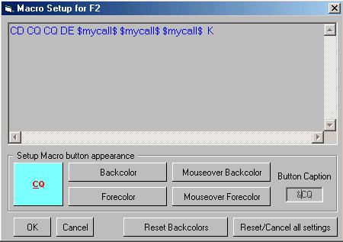

HK\_1

A Button Caption of "Msg &One" would display as "Msg One" on the button and use the <**Ctrl+1**> combination as the HotKey.

An extension of this feature allows the use of special characters on the Macro buttons. During Macro Setup, entering the ASCII code of any special character will display that character as part of the caption text. For example, entering caption of a button as chr$(191) would display "?" as the caption of the button.

## 3.0 TESTING THE HotKeys

It is strongly recommended that you test each HotKey after it has been re-assigned. With the radio turned off, and with either the [Sound Card Data window](#_topic_SoundCardDataWindow1), [Data Terminal wind](#_topic_DataTerminalWindow)ow or [CW Machine](#_topic_CWMachineWindow) open, select the changed HotKey to ensure that it is correctly assigned. It is better to find out about problems before sending the contents of the macro in a live QSO!

## 4.0 Master list of Included HotKeys

The following is a list of HotKeys used within Logger32. Most of these are active with focus in the [Logbook Entry window](#_topic_LogbookEntryWindow). Some of the HotKeys can be configured to Global and will work from any Logger32 window.

**Caution**: If you configure a HotKey for Global operation it will also be active in other programs that might be open. This could produce unwanted results.

### 4.1 The Following Hotkeys are Active in the Logbook Entry window, CWM and as Otherwise Indicated

|  |  |  |
| --- | --- | --- |
| **Character** | **Hotkey** | **Function** |
| A | **<Ctrl+A>** | Position antenna using short path. ( [Logbook Entry window,](#_topic_LogbookEntryWindow) [CW Machine](#_topic_CWMachineWindow), and [Sound Card Data window](#_topic_SoundCardDataWindow1) – and can be set Global ) |
| A | **<Ctrl+A>** | Position antenna using long path. ( [Logbook Entry window](#_topic_LogbookEntryWindow), [CW Machine](#_topic_CWMachineWindow), and [Sound Card Data window](#_topic_SoundCardDataWindow1) – and can be set Global ) |
| B | **<Ctrl+B>** | Bookmarks callsign to The [Bandmap](#_topic_TheBandmap), [DX Spots window](#_topic_DXSpotsWindow1) and [Tracking map](#_topic_TrackingWindow1) without sending to the [DX Cluster](#_topic_TelnetClusterWindow) |
| C | **<Ctrl+C>** | Clear entries |
| D | **<Ctrl+D>** | Sends a DX Spot. Will spot current callsign or the last QSO in the Logbook |
| E | **<Ctrl+E>** | Set QSO end time |
| F | **<Ctrl+F>** | Opens the Floating Callsign form |
| G | **<Ctrl\_G>** | Grabs the callsign from the Scratchpad |
| H | **<Ctrl+H>** | Home all rotors |
| I | **<Ctrl+I>** | Initiates Internet callsign lookup |
| K | **<Ctrl+K>** | Start [CW Machine](#_topic_CWMachineWindow) |
| L | **<Ctrl+L>** | Logs current QSO |
| M | **<Ctrl+M>** | Open Manually ADD QSO window |
| O | **<Ctrl+O>** | Change offset |
| P | **<Ctrl+P>** | Change prefix |
| S | **<Ctrl+S>** | Set QSO start time |
| T | **<Ctrl+T>** | Switches between Radio #1 and Radio #2. Can be set Global |
| V | **<Ctrl+V>** | Open [Tracking window](#_topic_TrackingWindow1) with View DX tab |
| W | **<Ctrl+W>** | Clear entries. Can be set global |
| X | **<Ctrl+X>** | Swap Logbook with Scratchpad |
| Z | **<Ctrl+Z>** | Move Log Entry to scratchpad |
|  | **<Enter>** | User-definable in [CW Machine](#2.1.8_Keyer_Setup_-_WinKey) only. |
|  | **<Insert>** | User-definable in [CW Machine](#2.1.8_Keyer_Setup_-_WinKey) only. |
|  | **<Space>** | User-definable in [CW Machine](#2.1.8_Keyer_Setup_-_WinKey) only. |

### 4.1.1 The following Hotkeys are active in the Logbook Entry window only.

Numeric keypad + / - keys: When used in the [Logbook Entry window](#_topic_LogbookEntryWindow), it will move the cursor of the Active [Bandmap](#_topic_TheBandmap) up or down to the next callsign. **The s**elected call will then populate the Logbook Entry window and command the radio to QSYto the spot frequency.

### 4.2 The Following HotKeys are Active in the Sound Card Data Window, Data Terminal Window and CW Machine

|  |  |
| --- | --- |
| **Hotkey** | **Function** |
| **<F1 to F12>** | Executes Row One of Macros |
| **<Alt+F1 to Alt+F12>** | Executes Row Two of Macros |
| **<Ctrl\_F1 to Ctrl+F12>** | Executes Row Three of Macros |
| **<Alt+Ctrl+F1 to Alt+Ctrl+F12>** | Executes Row Four of Macros |

### 4.3 Hotkeys Active in the Logbook Page Window

### 4.3.1 The Following Hotkeys can be Used in the Edit Mode

|  |  |
| --- | --- |
| **Hotkey** | **Function** |
| **<Tab>** | Finish editing in the field and move focus to the next (right) field |
| **<Esc>** | Abandon any editing in progress. Terminate editing and put the focus on the Callsign field of the Logbook Entry Window. |
| **<PgUp>** | If editing can be completed successfully, then complete editing and move the visible Logbook Page up one page. |
| **<PgDn>** | As above, but move down one page. |
| **<End>** | Moves the edit insertion point to the end of the edit text. |
| **<Ctrl+End>** | If editing can be completed successfully, then it completes editing and moves editing to the right most column on the same row. |
| **<Home>** | Moves edit insertion point to the start of the edit text. |
| **<Ctrl+Home>** | If editing can be completed successfully, then it completes editing and moves editing to the left most column on the same row. |
| **<LeftArrow>** | Moves the edit text insertion point to the left until it is at the start of text.  It acts as a normal edit key until it is at the start of text.  Then, if editing can be completed successfully, it completes editing and moves editing to the cell to the left. |
| **<Shift+LeftArrow>** | If editing can be completed successfully, then complete editing and move editing to the cell to the left. |
| **<RightArrow>** | Moves the edit text insertion point to the right until it is at the end of text.  It acts as a normal edit key until it is at the end of text.  Then, if editing can be completed successfully, then it completes editing and moves editing to the cell to the right. |
| **<Shift+RightArrow>** | If editing can be completed successfully, it completes editing and moves editing to the cell to the right. |
| **<UpArrow>** | If editing can be completed successfully, it completes editing and moves editing up one row. |
| **<DnArrow>** | If editing can be completed successfully, it completes editing and moves editing down one row. |
| **<Enter>** | If editing can be completed successfully, it completes editing and moves the focus to the Callsign field of the Logbook Entry Window. |

### 4.3.2 The Following Hotkeys are Used to Navigate the Logbook Page Window

|  |  |
| --- | --- |
| **Hotkey** | **Function** |
| **<PageUp>** | Scroll Up |
| **<PageDown>** | Scroll Down |
| **Mouse Wheel** | Scroll Up/Down |

### 4.4 Other Hotkeys that are Used in DX Spot Window, Award Table and Worked/Confirmed Window

|  |  |
| --- | --- |
| **Hotkey** | **Function** |
| **<PageUp>** | Scroll Up |
| **<PageDown>** | Scroll Down |

### 4.5 Global Hotkeys that can be Configured Within Logger32 by Using the Logger32 Setup Menu Hotkeys Menu Item

|  |  |  |
| --- | --- | --- |
| **Character** | **Hotkey** | **Function** |
| A | **<Ctrl+A>** | Position antenna using short path |
| A | **<Alt-A>** | Position antenna using long path |
| T | **<Ctrl+T>** | Toggle Radios |
| W | **<Alt-W>** | Wipe the Callsign field |
|  | **<Home>** | Move the focus to [Logbook Entry window](#_topic_LogbookEntryWindow) |

### 4.6 The Following Hotkeys can be used to Control the Radio VFO

Check proper option under [Griffin PowerMate](#_topic_GriffinPowerMate) USB VFO knob menu. If you want to use PowerMate Griffin USB VFO knob then this option must be checked. See more in [Griffin PowerMate topic](#_topic_GriffinPowerMate).

|  |  |
| --- | --- |
| **Hotkey** | **Function** |
| **<Ctrl+Right-Arrow>** | Radio1 main nHz up |
| **<Ctrl+Left-Arrow>** | Radio1 main nHz down |
| **<Alt+Ctrl+Right-Arrow>** | Radio1 main 1Hz up |
| **<Alt+Ctrl+Left-Arrow>** | Radio1 main 1Hz down |

### 4.6.1 If RCP SO2R is not opened then

|  |  |
| --- | --- |
| **Hotkey** | **Function** |
| **<Ctrl+Up-Arrow>** | Radio1 sub nHz up where n is defined by following steps: 1) Right click on frequency in Logbook entry window. 2) Select one of them except 0Hz |
| **<Ctrl+Down-Arrow>** | Radio1 sub nHz down where n is defined by following steps: 1) Right click on frequency in Logbook entry window. 2) Select one of them except 0Hz |
| **<Alt+Ctrl+Up-Arrow>** | Radio1 sub 1KHz up |
| **<Alt+Ctrl+Down-Arrow>** | Radio1 sub 1KHz down |

### 4.6.2 If RCP SO2R is opened then

|  |  |
| --- | --- |
| **Hotkey** | **Function** |
| **<Ctrl+Up-Arrow>** | Radio2 main nHz up where n is defined by following steps: 1) Right click on frequency in Logbook entry window. 2) Select one of them except 0Hz |
| **<Ctrl+Down-Arrow>** | Radio2 main nHz down where n is defined by following steps: 1) Right click on frequency in Logbook entry window. 2) Select one of them except 0Hz |
| **<Alt+Ctrl+Up-Arrow>** | Radio2 main 1Hz up |
| **<Alt+Ctrl+Down-Arrow>** | Radio2 main 1Hz down |

*Created with the Personal Edition of HelpNDoc:* [*Create iPhone web-based documentation*](http://www.helpndoc.com/feature-tour/iphone-website-generation)

**Programmable Buttons**

# Randy Tipton, WA5UFH, Geoff Anderson, G3NPA, and Hew Lines VA7HU

## 1.0 GENERAL

Logger32 is user-friendly and can be customized to your own personalized likes by using the program's Programmable Buttons. These buttons can be programmed to provider up to 36 user specific functions for the [Sound Card Data window](#_topic_SoundCardDataWindow1), the [Data Terminal window](#_topic_DataTerminalWindow) and the [CW Machine](#_topic_CWMachineWindow).

Each button can be programmed using Macros and/or text, and can be given a label with optional colors. By using your imagination, and working with the available list of [Macros](#2.0_MACRO_COMMANDS), you can create files that will make operating [PSK](#PSK31/63/125), [RTTY](#RTTY) and [CW](#CW) more enjoyable and easier.

This section is intended to be a reference document for details on how to program the buttons using the Macro language. Specific details on selecting the number of buttons to display and some suggested functionality to assign to those buttons for each of the windows can be found in the topics on the [Sound Card Data window](#_topic_SoundCardDataWindow1), [Data Terminal window](#_topic_DataTerminalWindow), and the [CW Machine](#_topic_CWMachineWindow).

## 2.0 PROGRAMMING THE BUTTONS

### 2.1 Default Hot Keys

The programmable buttons can be displayed in up to three rows of 12 buttons. Each button has a default hot key assigned to it as follows:

* 1. The top or first row of buttons defaults to the <**Fn**> keys, (F1 through F12);
  2. The middle row of buttons defaults to <**Alt+Fn**> keys (hold down Alt and press the function key); and,
  3. The bottom row of buttons corresponds to <**Ctrl+Fn**> keys (hold down Ctrl and press the function key)

Pressing any of the Hot Key combinations will execute any script programmed for the corresponding button.

The default Hot Keys may be changed as part of the button programming process if you wish.

In addition to the user-definable Hot Keys, the following Hot Keys have fixed functionality within the [Sound Card Data window](#_topic_SoundCardDataWindow1).

* + **Esc** - Change from Transmit to Receive. In order for this functionality to work correctly, the focus must be in the Sound Card Data window.
  + **Ins** - Toggle the reception of data on and off to allow scrolling back in the [RX window](#6.2_Pausing_the_RX_Window_) possible. The RX window background will turn white while data input is suspended.
  + **Pause/Break** - Toggle between transmit and receive. In order for this functionality to work correctly, the focus must be in the Sound Card Data window.

### 2.2 Programming the Button Functionality

To start, simply right-click on the button you wish to program and the Macro Setup dialog box will be displayed.

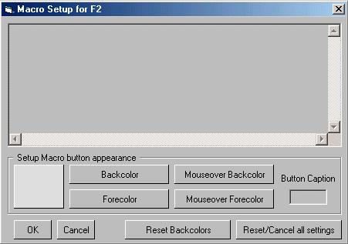

PB\_1

The Hot Key currently assigned to that button will be displayed in the Title bar (Macro Setup for F2 - the second button on the top or first row).  To program the button, click in the text window and enter any macro commands (those beginning and ending with $) and the text required to execute the functionality required for this button.

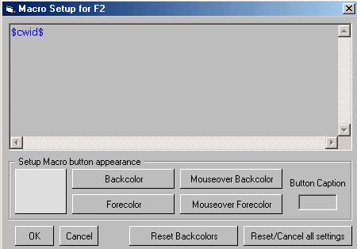

PB\_2

In order to enter a character that is not available on your keyboard, you must enter the ASCII code for that character. This is done by pressing the <**Alt**> key while you type the four digit code for the character on the numeric keypad. For example, to type the character "?", hold the <**Alt**> key down and type 0191 on the numeric keypad (you must be in Num Lock to do this).  When you release the <Alt> key, the ? will be displayed. When you type a character this way, you must enter a four-digit number, so for the ASCII character 191, you must type 0191.

After entering the routine, enter a name into the Button Caption edit box at the lower right. This is the text that will be displayed on the button itself.

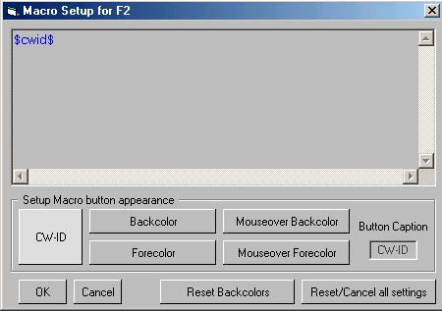

PB\_3

You can also program the following features of each macro button:

* + **Back color** - This displays a standard Windows color selection dialog box allowing you to select the color of the background of the button.
  + **Fore color** - This displays a standard Windows font selection dialog box allowing you to select the type, style and color of the font to be used on the button.

**Note** that even though the position of the text on the button in this window is not correct, it will be correct on the button in the [Sound Card Data window](#_topic_SoundCardDataWindow1), [Data Terminal window](#_topic_DataTerminalWindow) or [CW Machine](#_topic_CWMachineWindow).

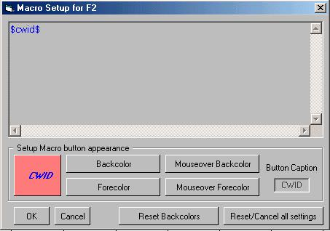

PB\_4

* + **Mouseover Back color** - This displays a standard Windows color selection dialog box allowing you to select the color to which the background will change when you drag the cursor over it.
  + **Mouseover Fore color** - This displays a standard Windows font selection dialog box allowing you to select the type, style and color to which the font will change when you drag the cursor over it. Note that even though the position of the text on the button in this window is not correct, it will be on the button in the [Sound Card Data window](#_topic_SoundCardDataWindow1), [Data Terminal window](#_topic_DataTerminalWindow) or [CW Machine](#_topic_CWMachineWindow).

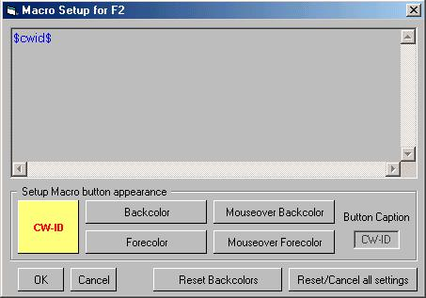

PB\_5

You can also restore the default background colors (a delightful shade of gray) using the <**Default Back Colors**> button.

When the Macro Setup is completed, and you are ready to save it, select the <**OK**> button.

Selecting the <**Cancel**> button will cause the Macro Setup window to close without saving your work.

The <**Delete/Cancel all settings**> button will restore the button to the way it was before you began editing. If it had a script, that script will be restored; if it was blank, it will return to blank.

## 3.0 TESTING THE BUTTONS

It is strongly recommended that you test each button after it has been programmed. With the radio turned off, and with either the [Sound Card Data window](#_topic_SoundCardDataWindow1), Data Terminal window or CW Machine open, click on the button to execute the Macro and observe its operation in the transmit and receive windows. If the button has commands to switch the radio to receive or transmit, observe that those operate properly by watching the TX/RX indication in the appropriate window.  If there is a problem with a button's operation you can edit it by right-clicking on the button and making whatever changes are necessary. Also execute the button by pressing the assigned Hot Key to ensure that the Hot Key is correctly programmed. It is better to find out about problems before sending the contents of the macro in a live QSO!

## 4.0 THE GREETING MACRO

To setup the greetings of your choice, Right-click on any Macro Button (just like you wanted to setup a Macro) and see the new option. Times listed on the Greeting Setup Window are local times of the station you are in QSO with. The default greeting is used if Logger32 cannot determine the time zone of the station you are in QSO with. Please note that there are separate set up panels for the [CW machine](#_topic_CWMachineWindow) and the digital modes

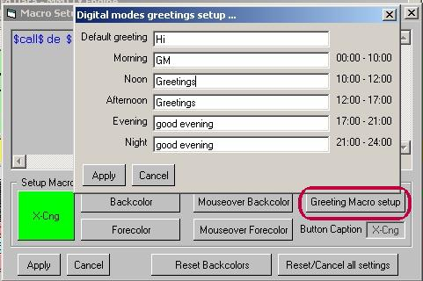

PB\_6

As an example - this Macro will send both callsigns, send the greeting and then the name of the QSO partner.

[$call$](#$call$) de [$mycall$](#$mycall$) [$greeting$](#$greeting$) [$name$](#$name$) nice to hear you again

*Created with the Personal Edition of HelpNDoc:* [*Create cross-platform Qt Help files*](http://www.helpndoc.com/feature-tour/create-help-files-for-the-qt-help-framework)

**DX Spots Window**

*Created with the Personal Edition of HelpNDoc:* [*Easily create Qt Help files*](http://www.helpndoc.com/feature-tour)

**DX Spots Window**

# Hal Miller KB1ZQ, Geoff Anderson G3NPA, Jim Hargrave W5IFP, Aki Yoshida JA1NLX and Gerry Hohn VE6LB

## 1.0 GENERAL

The DX Spot window uses inputs from the [Telnet Cluster window](#_topic_TelnetClusterWindow) to display received DX Spots [to display received DX Spots, and it handles max 300 to 1000 DX Spots. The number of max DX Spots can be specified in Logger32 Shortcut Properties.](#_topic_TelnetClusterWindow)

This is a sample for max 300 DX Spots.

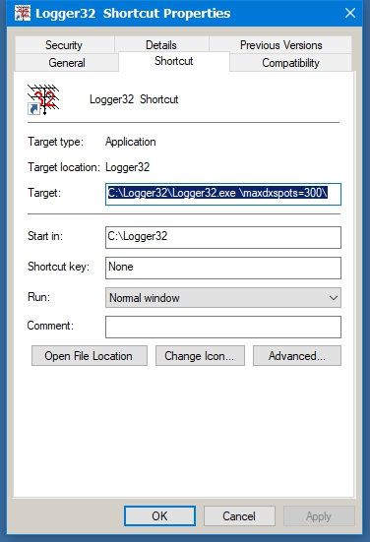

DXSW\_40

**Note**: Information on how to send a DX spot to a cluster may be found in the [Logbook Entry Window](#_topic_LogbookEntryWindow) topic.

Operators with computer-controlled radios or [CAT](#CAT) capabilities can also use this window to partially control their radios. By clicking on a spot, the radio will change frequency to the DX spot frequency and mode based on the operator's band plan allowing quick movement to a needed country or station. Then by right-clicking on the window one can go back to the original frequency by clicking on Reset radio frequency, this makes grabbing stations that pop onto the band easier. Please remember to verify the stations call before transmitting, as stations do move and another may have replaced the station you are looking for. With clusters being tied via the internet, spots are not always accurate.

**Note**: Clicking a DX spot while holding down the <**Shift**> or <**Ctrl**> keys now sends the DX spot frequency and mode to VFO-B of some [SO2V-capable radios](#_topic_SingleOperatorTwoVFOsSO2VSupport). This initial release supports a limited number of SO2V radio makes/models. If your radio did not make this initial release, please let Bob know the make/model and the command to set VFO-B's frequency and mode. It does not matter whether your radio actually has a second- or sub-receiver, just so long as it has two VFOs that can be commanded through the serial port. If you are operating [SO2R](#_topic_SingleOperatorTwoRadiosSO2RSuppo), the same SHIFT or CTRL-click on a DX spot sends the spot frequency and mode to VFO-A of the non-focus radio.

Some or all of the entries in the table will be highlighted as the spots are displayed, with the information for this highlight being derived from the active logbook, for the selected operator(s) and for the QSL type. The user selects the operator and QSL type from a menu within the [Worked Confirmed Window](#_topic_WorkedConfirmedWindow). The Dx Spot and Worked/Confirmed window title bars display that selection

The spots are displayed using the following columns, which are user-definable as to font, color and size (Grid Appearance):

* + **?** Worked before and LotW user columns;
  + **DX Spot** Call sign of the spotted station
  + **Pfx** Prefix or Country
  + **Freq** Frequency
  + **Comment** Free format comments
  + **Time** Time the spot was posted
  + **Origin** The originating stations callsign

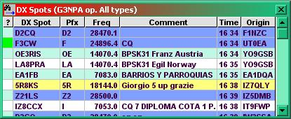

DXSW\_1

The Freq format is selectable. Click Setup|DX spots in the main Menu and check your favorite frequency format. This format is used to send DX spots as well.

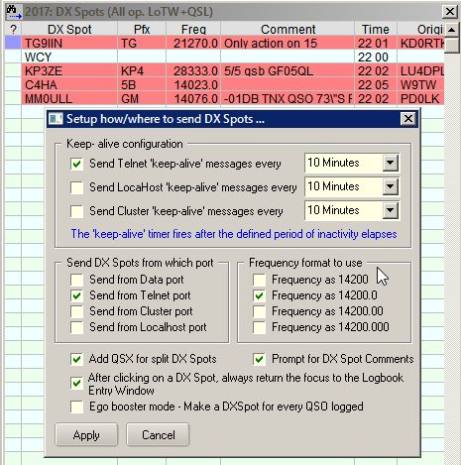

DXSW\_1A

Configuring the DX Spot Window makes extensive use of multiple pop-up and linked menus.

Right-clicking on the DX Spot window displays a pop-up menu that provides the operator with various functions and access to additional pop-up menus.

Individual column widths in the DX spot table may be altered to suit the user by placing the cursor over the divider between columns in the title section, i.e., between DX Spot and Pfx or Comment and Time. The cursor will change to a double-ended arrow with a left-click, hold and drag will allow changing the size.

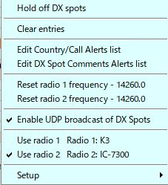

DXSW\_2

## 2.0  MAIN MENU

The Main menu items provide the following functionality:

### 2.1 Hold off DX Spots

This item is a toggle, and when checked, the display of incoming spots is disabled and the DX Spot window Title bar will display "On Hold". When un-checked, the display of incoming spots is again enabled and the title bar will revert to the normal "DX Spots" display.

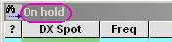

DXSW\_36

### 2.2 Clear entries

Clears all entries from the DX Spots Window.

### 2.3 Remove xxxxx DX Spot

If you have clicked on a specific DX spot, then this menu option will appear, allowing for the removal of that particular spot from the table and the map displays. In the example below, the cursor has been clicked on C5YK. Selection of this option will remove ALL occurrences of that callsign. This action also removes the spots from the DX Spot map and the appropriate bandmap (see the [Bandmap](#_topic_TheBandmap) topic).

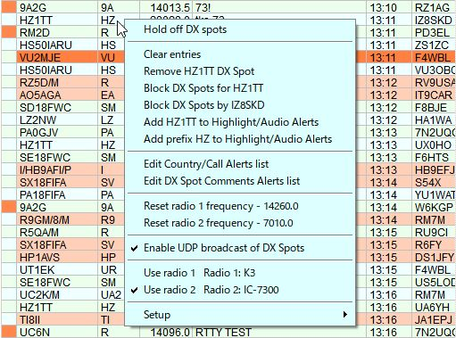

DXSW\_37

### 2.4 Block DX Spot for xxxxx

Listed DX callsigns will be filtered from the DX Spots window. To block spots for a callsign, right-click on the DX spot entry and then click on "Block DX spots for xxxxx" and the callsign will be entered into the appropriate list. See also the paragraphs on [Blocking Filters](#2.8.7_Blocking_Filters) towards the end of this topic.

### 2.5 Block DX Spots by xxxxx

DX Spots FROM the listed callsigns will be filtered. To block spots from a callsign, right-click on the DX Spot entry and then click on "Block DX Spots by xxxxx" and the callsign will be entered into the appropriate list. See also the topic on [Blocking Filters](#2.8.7_Blocking_Filters) towards the end of this section.

### 2.6 Highlight/Audio Alerts and Alerts List

2.6.1 Add xxxxx to Highlight/Audio alerts

Add the DX Callsign of the selected DX Spot to specific callsign list for Highlight/Audio alerts.

### 2.6.2 Add prefix xx to Highlight/Audio Alerts

Add the prefix of the selected DX Spot to specific prefix list for Highlight/Audio alerts.

### 2.6.3 Edit Country/Callsign Alerts list

Show Edit Country/Callsign Alerts list.

### 2.6.4 Edit DX Spots Comments Alerts list

Show Edit DX Spots Comments Alerts list. Details are described in 2.9.5 Alerts.

### 2.7 Reset radio 1 (or 2) frequency

Resets the radio (either #1 or #2) to the last frequency used, prior to selecting a spot. For example, you are on a net frequency when a needed country pops up on another frequency or even another band. Click on the spot to change bands/frequency, work the DX station, then click on Reset radio frequency and you will be returned to the original net frequency. Of course, this function does require a radio that is controlled by Logger32.

The menu item will show the frequency to which the radio will be reset.

### 2.8 Enable UDP broadcast of DX Spots

Logger32 broadcast DX Spots displayed in DX Spot Window via UDP port 12061 for external program.

This is a sample where external test program displays DX spot broadcasted by Logger32.

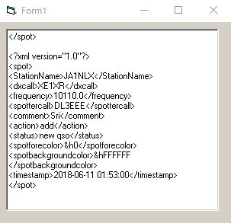

DXSW\_37A

### 2.9 Use radio 1 or 2

Allows the user to manually switch the "active" radio. The check mark will confirm which radio is "active".

### 2.10 Setup Menu

The Setup menu item displays an additional pop-up menu that provides the operator with the ability to select four more pop-up menus and three additional functions.

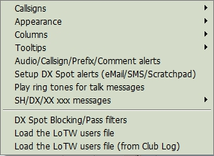

DXSW\_3

### 2.10.1 Callsigns

This pop-up menu, allows the user to display yet another pop-up menu in order to set the call signs to be used by the Telnet & Cluster and Local Host Tab Panels of the [Telnet Cluster window](#_topic_TelnetClusterWindow) and [Data Terminal window](#_topic_DataTerminalWindow).

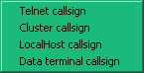

DXSW\_4

Clicking on any one of the selections will display a dialog box, allowing the user to enter a callsign to be used for the selected tab panel or [Data Terminal window](#_topic_DataTerminalWindow).

### 2.10.2 Appearance

This menu allows the user to select different color schemes and message selections to "individualize" the DX Spots window

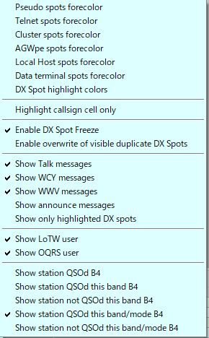

DXSW\_5

**Colors**

Selecting Pseudo, Telnet, Cluster, or Data Terminal spots foreground color displays a color selection box that allows the user to select individual forecolors for the connection being posted.

**DX Spot highlight colors**

Selecting the Worked / Confirmed/Credited colors opens a window that sets the background colors to be used in the DX Spot Window for each spot that meets the specified selection. The color displayed is based on the user's [Band Plan](#_topic_SetupBandsandModes) to determine bands and modes. The color selection is made using a standard Windows Color Dialog Box, by clicking on the color to be selected.

The one exception to the above is the selection of the LoTW/[OQRS/LoTW & OQRS](#LoTW) user color. In this case the highlight is applied to the "?" (leftmost) column in the DX Spot Window.

The details of syntax and logic to highlight is explained in [paragraph 2.9.5 Alerts](#2.9.5_Alerts).

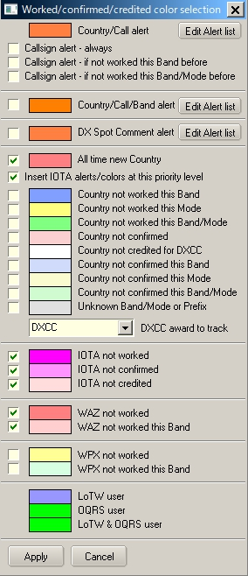

DXSW\_6

For Country/Callsign alert, clicking “Edit Alert list” shows an Edit list of Callsigns to highlight table.

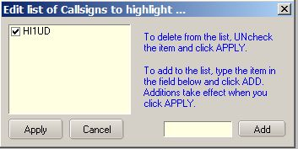

DXSW\_6A

For Country/Call/Band/ alert, clicking “Edit Alert list” shows Setup Conditional Country Alerts table. Check Edit this alert box to start edit. See details in the paragraph Alerts.

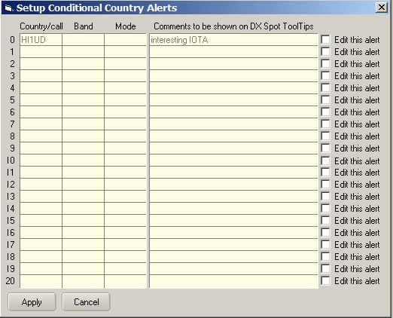

DXSW\_6B

For DX Spot comment alert, clicking “Edit Alert list” shows Edit list of Comments to highlight the table.

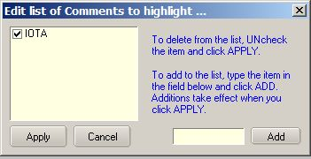

DXSW\_6C

The check boxes to the left allow the user to determine which, then they can simply uncheck that color selection.

The entry 6 from the top of the table is determined by the selection made in the pane below the entry for unknown band/Mode. In this case particular example the highlight colour depicts "Country not credited for DXCC\_MIXED". Note that "Credited and Confirmed" are not the same thing. "Confirmed" indicated that you have received confirmation in some form from the qso partner. "Credited" indicates that the contact has been adjudicated and included in your credits for the award in question.

The check option second from the top will give the option to insert the [IOTA](#IOTA) not worked/confirmed/credited highlight colors into the priority search at that level. If checked, Logger32 will highlight in the order New Country; IOTA not worked; IOTA not confirmed; IOTA not credited: Country not worked this band etc. etc.

See also the topics [Award Tracking](#_topic_AwardTracking1) and [Show only Highlighted DX Spots](#Show_only_highlighted_DX_spots).

Audio alarms and DX spot highlight coloring has been introduced for IOTA spots. As a byproduct of this code, changing the IOTA field in the [Logbook Entry Window](#_topic_LogbookEntryWindow) (either manually, or auto-populate) will show IOTA Want/Need status in the second pane (from the left) of the upper status bar (only if there is no DX Want/Need text displayed), as can be seen in the example below. Want/Need messages and highlight colors have the following precedence:

* + DX;
  + IOTA, and;
  + WPX Want/Need

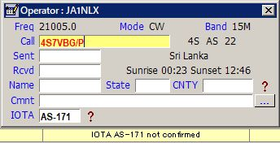

DXSW\_7

**Highlight callsign cells only**

Changes the general row highlighting to cover the callsign column only

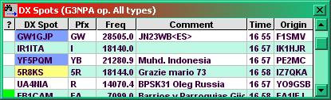

DXSW\_8

### Enable DX Spot Freeze

Mouse wheel or scroll bar activity, freezes incoming spots for 10 seconds in DX Spot Window. This should be enough time for the user to browse the history and click on a line. Following a mouse click, the freeze is canceled. During this freezetime, incoming spots are suppressed.

During the period that the software holds off incoming spots Title bar changes to display the fact that a "Freeze" is in effect. The series of dots following the word "Freeze" will display a count down to the freeze being released automatically if no further action is taken.

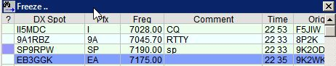

DXSW\_39

Those using a mouse configuration where Windows does not see mouse wheel events can simply scroll using the scroll bar

**Enable overwrite of visible duplicate DX Spots**

This option enables/disables the overwriting of duplicate DX Spots that are visible on the DX Spot Window.  The default is enabled.  As before, duplicate DX Spots that are visible on the DX Spot are simply overwritten with data from the new DX Spot.  If this option is disabled, then when a duplicate DX Spot is received where the original DX Spot is still visible on the DX Spot Window, the old DX Spot is removed and the new DX Spot is added to the end of the DX Spot Window

**Show talk messages**

Talk messages will be displayed in the DX Spot window.

**Show WCY messages**

WCY messages will be displayed in the DX Spot window.

**Show WWV messages**

WWV messages will be displayed in the DX Spot window.

**Show announce messages**

Announce messages will be displayed in the DX Spot window.

**Show only highlighted DX spots**

In the [Appearance menu selection](#2.8.2_Appearance) the user can select which DX Spots to have highlighted. This menu selection goes one stage further and will remove from the DX Spot list any non-highlighted spots. The screenshots below show the effects of both menu items:

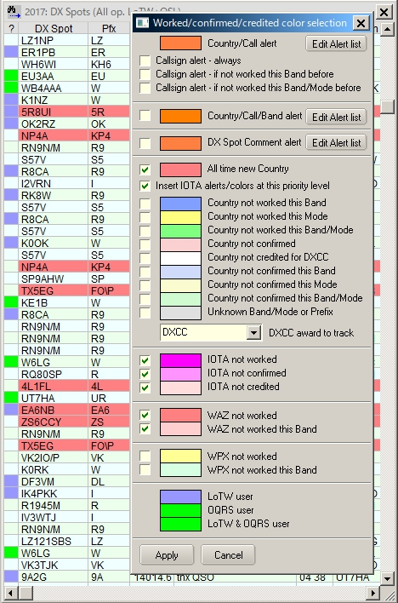

DXSW\_9

Almost all background colors selected.

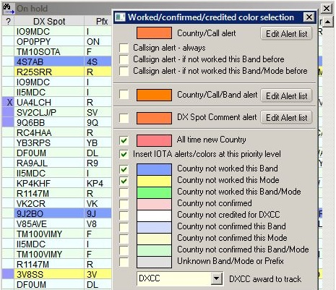

DXSW\_10

This screenshot shows the effect of only having four background colors selected. The spot data is the same as above. Note that non-highlighted spots still display in the listing

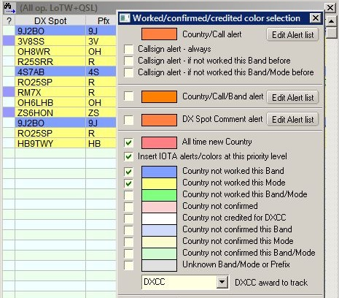

DXSW\_11

This screenshot shows the effect of selecting the [Show only highlighted DX spot](#Show_only_highlighted_DX_spots) menu option. Now only highlighted spots are displayed.

**Show LotW user and Show OQRS user**

Here the user can select to display if the station is known to be LotW user and/or OQRS user. This is indicated by a highlight color in the (leftmost) column of the DX Spot table

To choose the LoTW and OQRS user highlight colors, Right click on the DX Spot Window, Left Click SETUP | APPEARANCE | DX SPOT HIGHLIGHT COLORS.

To enable/disable LoTW and/or OQRS user highlights on the DX Spot Window, right click on the DX Spot Window, then left click SETUP | APPEARANCE | SHOW LOTW USER and/or SETUP | APPEARANCE | SHOW OQRS USER.

To enable/disable LoTW and/or OQRS highlights on the Bandmap Windows, Click CONFIG | SHOW LOTW USER.

**Show station QSOd before**

Here the user can select to display if the station has been worked before. This is indicated by an "X" in the "?" column of the DX Spot table

The user has four options to show:

* 1. Stations QSOd before on any band
  2. Stations QSOd before on the particular band
  3. Stations QSOd before on the particular band/mode combination, or
  4. None (Uncheck the options).

In the screenshot shown below it can be seen that 9K2ZZ has been worked on 20m but not on 40m. The colored highlight in the "?" column also shows that 9K2ZZ is a user of LotW.

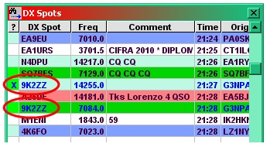

DXSW\_12

**A word of warning.**

These options use information contained in the bandmode.db file and in the log to derive the "Worked before" marker. Under contesting type conditions, the band plans usually are not adhered to so an incorrect mode might be determined by the software for a particular spot and hence not mark the callsign correctly if the band/mode option is used.

### 2.10.3 Columns

The four main items are toggles that, when checked, display the specified column in the DX Spot window. If a menu item is not checked, that column is not displayed.

The Show full country name option will change the Pfx column header to read "Country" and the column will fill with the full names of the country.

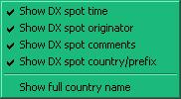

DXSW\_13

### 2.10.4 Tooltips

The Tooltips selection opens a panel that enables the operator to customize Windows Tool-Tips. When the cursor is placed over a callsign in the DX Spots column, the country prefix, country name, CQ Zone, continent, status of the country (needed on band, new country, not confirmed), status of IOTA (not worked, not confirmed, not credited),status of WAZ (not worked, not worked on this Band), status of WPX (not worked, not worked on this Band), and the elapsed time the spot has been posted will be displayed as a Windows Tool-Tip as selected.

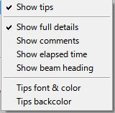

DXSW\_14

If you set any text in Comments column of Setup Conditional Country Alert table then this text is displayed. See [DXSW\_6B](#DXSW_6B) or DXSW\_15AA

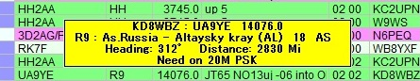

DXSW\_14A

**Show full details**

With this line checked the tool tips become more informative. They will provide the spotter's call, call of the spotted station,  and frequency of the spot on the first line. The second line will show the prefix of the spotted station, the country, CQ zone, and continent. The third line, if any, will state the operator's need for the spotted station, i.e., Need on 17m.

If this line is not checked then only the prefix of the spotted station, the country, CQ zone, and continent. The second line, if any,  will state the operator's need for the spotted station, i.e., Need on 17m.

**Show elapsed time**

With this option checked the tooltip will contain the time elapsed since the DX spot was reported

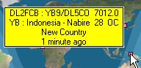

DXSW\_15

**Tips font & color**

Sets the tool tips font and color using Windows standard font setup box.

**Tips backcolor**

Sets the back color of the tool tips box displayed using Windows standard color selection box.

Tips font, color and backcolor setting affects appearance not only in tips in DX Spot Window but in all other tips in Logger32.

### 2.10.5 Alerts

**Enable audio alerts**

In this pop-up menu, the different audio alerts can be selected to sound when individual audio WAV files used in the DX Spots window for each spot that meets the specified selection. The WAV file played is based on the user's [Band Plan](#_topic_SetupBandsandModes) to determine bands and modes. Selections will only play when the small box is checked.

**Audio alert for callsign(s)**

This allows the operator to be alerted for a particular station. For example, if the operator is looking for KC4AAA, they would enter that call into the field, along with others separated by commas. When the spot appears, the audio alert will sound.

This syntax and logic are used for DX Spot highlight color for Country/Callsign as well. See Operational notes below also.

* + Full callsign - G3NPA, K4CY, etc
  + Full prefix - P5, VP8\SH, etc
  + Callsigns beginning with - UA9V\*, UA9X\*, etc
  + Callsigns ending with - \*CY, \*NPA, etc.
  + Partial callsign - \*2008\*

If an exact callsign match is found and if it also matches the users settings of a) Always, b) Not worked this band, or c) Not worked this Band/Mode, then audio alert (or highlight color) is applied.

If a prefix or partial callsign match is found and if it also matches the users settings of a) Always, b) Not worked this band, or c) Not worked this Band/Mode, then audio alert (or highlight color) is applied

Click “Edit Callsign Alert list.”

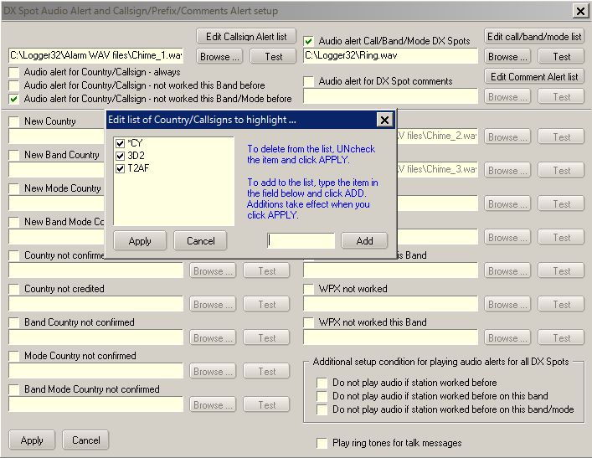

DXSW\_15A

**Operational notes**:

**Note 1**. Audio alerts are NOT played if transmitting using the sound card.

**Note 2**. Wild card options 4 must be used judiciously. Take the example given of \*CY - The bells will ring if the callsign contains the letters CY, so the following match - CY0XX, K4CY, K4CYA, etc.

**Note 3**. Callsign Audio alerts must be enabled by checking one of the three options at the top of the chart. These selections will take precedence over other Audio alert settings for the listed callsigns.

The order in which the audio alerts are determined cannot be changed; however, while the order of priority cannot be changed, the user can now eliminate items from the list (by unchecking items). For example, uncheck New Country - this Band, New Country - this Mode and new Country - this Band and Mode, the order becomes:

* + All time new Country
  + Not Confirmed
  + Not confirmed, this Band
  + Not confirmed, this Mode
  + Not confirmed, this Band/Mode
  + Unknown

**Note** that using the above example will still effectively show up those band/mode combinations not worked - for if not worked they can't be confirmed!

Audio alerts can be suppressed by selecting one of the options listed in the lower right hand corner of the DX Spot Audio alert setup chart. Use these new options, to suppress audio alerts if a station is worked/band/mode.  All audio alerts except callsign alerts and comment alerts will be suppressed.

**Audio alert for Call/Band/Mode DX Spots**

Click “Edit call/band/mode list”

The Country/Call field looks for a Prefix match (remember, Logger32 uses a \ as in VP8\F), a callsign or partial callsign, or a DXCC Country number. Wild cards are accepted

 The Band field can be empty (any Band) or a Band recognized by Logger32. The DX Spot Band is calculated from the DX Spot frequency and the users BandPlan.

The Mode field can be empty (any Mode) or a mode recognized by Logger32.  The DX Spot Mode is derived from the best information in the DX Spot.  A skimmer DX Spot, a Mode in the Comments field, or as a last resort, the mode from the users BandPlan.

The Comments column is optional and can be used for user personal reminders for the purpose of the alert and can be seen as the bottom line of the DX Spot ToolTip Window.

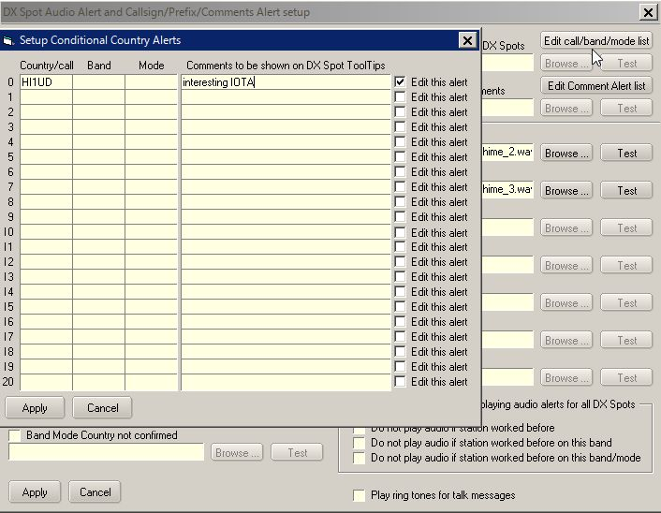

DXSW\_15AA

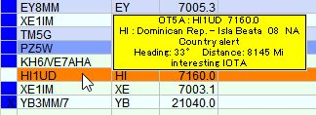

DXSW\_15AB

**Audio alert for DX Spot comments**

This allows the operator to be alerted when certain text is detected in the DX Spot Comments, such as contest and modes. Click “Edit Comment Alert list.”

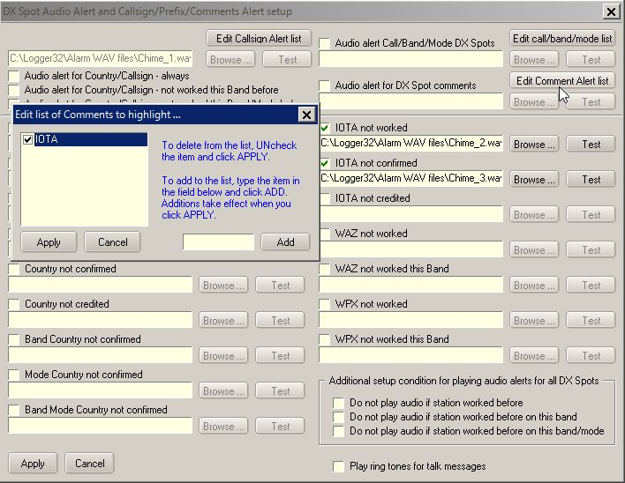

DXSW\_15B

**Audio alert for IOTA**

Three alert categories of IOTA are available for user selection.

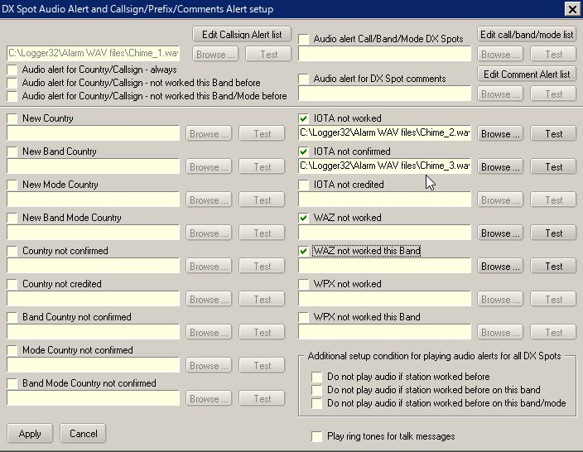

DXSW\_15C

**Audio alert for WPX**

Two alert categories of WPX are available for user selection.

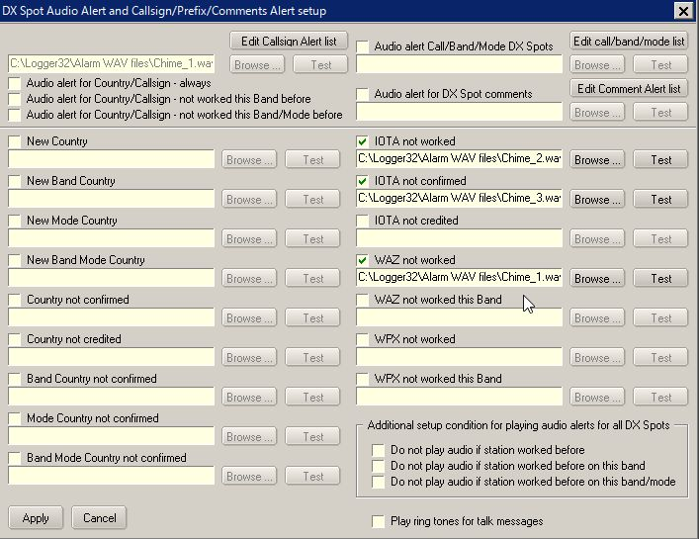

DXSW\_15D

**Additional setup condition for playing audio alert for all DX Spots**

The next three items are toggles which, when checked activate the following functions. If an item is not checked, that function is not available.

**Play Ring tones for TALK messages**

This menu selection is a toggle. When checked, a file called RING.WAV is played to give a telephone style "ring tone" whenever a "talk" message is received from the DX cluster.

1. **2.10.6 Setup DX Spot alerts (eMail/SMS/Scratchpad)**

You can receive eMail alerts when your interested DX is spotted. The default setting is for Gmail.The Gmail security is set to allow less secure apps to access Gmail.  Go to <https://www.google.com/settings/security/lesssecureapps> and turn it ON.

Click eMail alerts to open the Setup table. Put your Gmail address, Gmail password and optional address where Gmail is to send the alert Email. Do not change your Outgoing SMTP mail server and Outgoing SMTP port if you use Gmail. Click Apply.

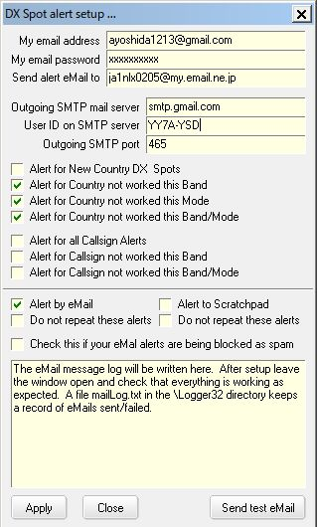

DXSW\_16

Logger32 shows the DX spot which is sent to Gmail in lower area in this table and writes the same data in the mailLog.txt in the Logger32 folder. See pic DXSW\_16A below.

Send Email to New Country DX Spots, Send eMail for country not worked this Band, Send eMail for country not worked this Mode and/or Send eMail for country not worked this Band/Mode:

If checked then Logger32 sends the spot to Gmail.

Send Email for Callsign Alerts, Send email for not workd this Band Callsign Alerts or Send Email for not worked this Band/Mode Callsign Alerts:

If checked and callsign to be alerted is specified in DX spot audio alert setup table then Logger32 sends the spot to Gmail.

**Note**: These are independent from Credited/confirmed/worked color on/off setting or DX spot audio alert on/off setting.

If you have no Gmail account then you may use your regular email account. Put Outgoing SMTP mail server and Outgoing SMTP port. There may be server which asks you to send a User ID different from the email address. This is another setup example..

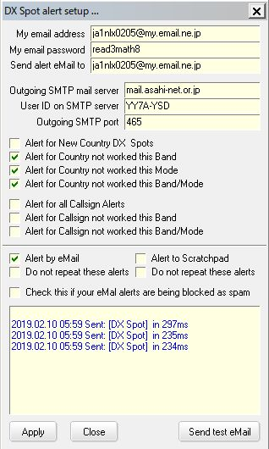

DXSW\_16A

If you can send and receive test eMail messages, but DX Spot alerts are not received, it is possible that the SMTP server is blocking the DX Spot messages as spam. Try checking this option.

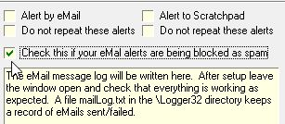

DXSW\_16B

Your received eMail looks like this.

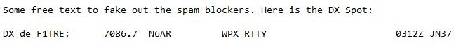

DXSW\_16C

### 2.10.7 SH/DX/XX xxx Messages

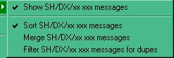

DXSW\_17

Here's how it's supposed to work:

**Show SH/DX/xx xxx messages** - This simply turns on/off the sending of SH/DX messages to the DX Spots Window.  With this option unchecked, the options below it have no effect. This gives the capability of NOT showing DX Spot information from an SH/DX/xx command sent to a cluster in the DX Spot Window. This is for those who want to collect the info in the telnet window but not have the information mess up the DX Spots list.

**Sort SH/DX/xx xxx messages** - With this option checked, and the Show SH/DX/xx xxx option checked, messages from a user command SH/DX are sorted in chronological order and appended to the bottom of the DX Spots Window.

**Merge SH/DX/xx xxx messages** - With this option checked, and the Show SH/DX messages option checked, messages from a user command SH/DX are sorted (regardless of the Sort SH/DX option setting) and merged into the entries already in the DX Spots Window.

**Filter SH/DX/xx xxx messages for dupes** - If this option is checked, and the Show SH/DX messages option checked, duplicate messages are filtered and not sent to the DX Spots Window.

Note: If Show SH/DX messages option is checked, and no other option is checked, the resulting messages from a user command SH/DX/xx xxx is appended to the DX Spots Window as received from the Telnet/Cluster (in reverse chronological order, as it was originally.).

### 2.10.8 Blocking Filters

This allows DX spots from an originating continent, to a destination continent, by band or mode to be blocked. For example, an operator not wanting to see spots from Europe, due to a European contest, can block all spots from Europe by selecting the Originating Continent Tab and checking the small box next to Europe. If an operator does not have the capabilities for 6 meters they can go to the Band tab and check the 6 meter box and block those spots. In addition the DX, Originator and Comments filters will allow for further specialised filtering.

If the bands or modes you want to block are not listed in the Band or Mode lists then the [Band/Mode table](#_topic_SetupBandsandModes) must be edited to add these bands and modes. In other words, if the band/modes are missing, make sure that these bands and modes appear in the BandMode table. If users do NOT want award stats to show because these are being introduced, then mark the BandMode table with an "N: in the Stats column for these new entries.

**2.10.8.1** In the example below, only DX spots originating from Europe are of interest.

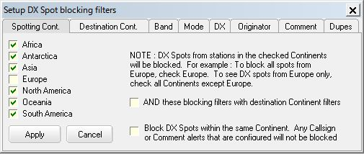

DXSW\_18

**2.10.8.2** If you want to block DX Spots within the same Continent (NA spotting another NA station, SA spotting another SA station, etc.)

DX Spot Callsigns (or prefixes) and DX Spot Comments that are configured to trigger Alerts are not blocked. This option can be checked under either Spotting Cont Tab or Destination Cont Tab.

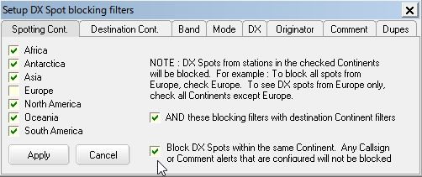

DXSW\_18B

**2.10.8.3** if you want to see all destinations

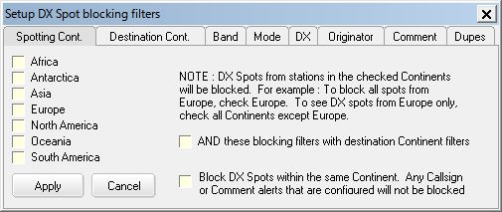

DXSW\_19

**2.10.8.4** In the example below, DX spots originating from North America AND to destination North America are blocked.

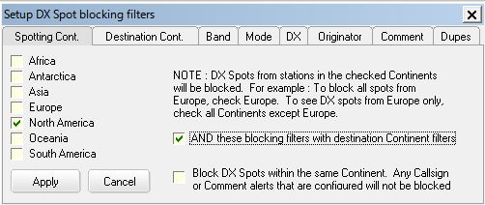

DXSW\_18A

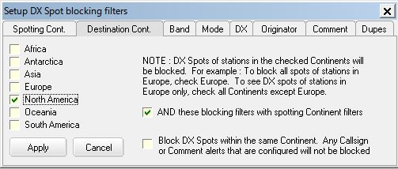

DXSW\_19A

**2.10.8.5** or possibly any annoying Mode and/or DX callsign

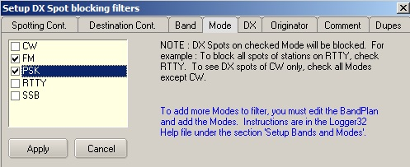

DXSW\_19B

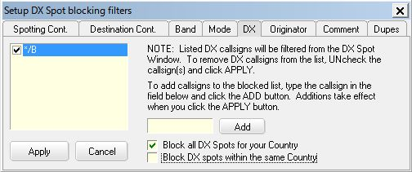

DXSW\_22

**2.10.8.6** The Block DX Spots by Callsign feature will accept wildcards

* + - Adding a callsign of K4\* will block all DX Spots that have a callsign starting with K4.
    - Adding a callsign of \*/B will block all DX Spots that have a callsign ending with /B.
    - Adding a callsign of \*XX\* will block all DX Spots that have callsigns containing XX.

**2.10.8.7** If Block DX Spots for country that matches Current Operator is checked then all DX spots Spots for country that matches current operator are blocked.

If you want to block DX Spots that are within a Country (an I making a DX Spot of another I, an EA making a DX Spot of another EA, etc.).

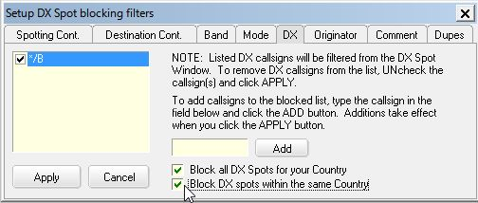

DXSW\_22A

Example: If current operator is JA1NLX then all DX Spots for JA are blocked, or even an originator self-spotting!

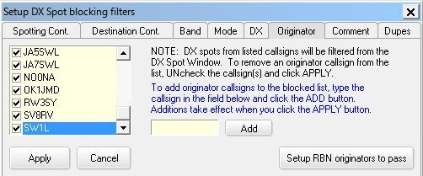

DXSW\_23

Note that ALL the parameters set through these option windows are remembered between Logger32 sessions and will remain in force until changed or deleted.

**2.10.8.8** If you want click “Setup RBN originator to pass” button.Type originator’s callsign and click “Add” button. The callsign is listed with “-#” at the end of the callsign. Finally click “Apply” button to make changes effective.

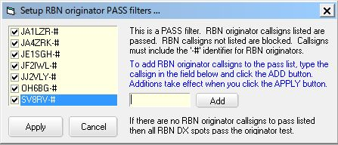

DSXW\_23A

**Application note from Gerry VE6LB:**

Some of you may wonder what the new RBN (Reverse Beacon Network) “Pass filter” is useful for. I’ll try to give you some idea of how to use it.

I’ve found that fewer and fewer people post spots of stations calling CQ on CW and RTTY, especially during contests. Why? Simply, the global RBN network and local skimmers post CQ’er heard much faster than any individual spotters. Many traditional clusters now integrate “real” spots with RBN/skimmer spots if the “Set/Skimmer” command is issued to them.

The problem is the flood of RBN spot one receives even with the Logger32 filters set to something like NA. This new feature can be set to only show you spots from skimmers located near you.

Simply leave you current filter settings as they are and in the “Originator” tab select Setup RBN Originators to Pass and fill in skimmers in your area. Just the call as Logger32 will add the –#. Since skimmers and skimmer servers vary in what the block (like dups and broken calls), some experimenting may be required.

The “apply a little sanity.......” option in under the “Dupe” tab should likely be Unchecked as it look for a number of incoming spots with the same information before doing an actual spot. If the skimmer/server is already taking care of this, you could miss that rare one you’ve been looking for since dups will not get to Logger32.

I want to know which spots are “real” and which were from the RBN so I have 2 network connection. One to the normal packet network with skimmer (VE7CC in my case) turned of and a second to the RBN Wholesale server (telnet.reversebeacon.net) using the Local Host tab. There are likely other RBN servers that will work fine. I then select a different color in the DX Spot window for RBN spots by a right click/setup/Appearance/Local Hosts spots forecolor.

**2.10.8.9 Remove bullshit from DX Spot comments field**

Click Setup DX Spot comment filters

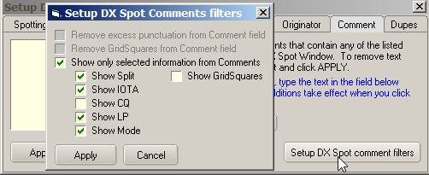

DXSW\_23B

Remove excess punctuation from Comment field:

(((((, ))))), !!!!!, are removed. CQ CQ CQ is replaced by CQ, ????? is replaced by ? etc

Remove GridSquare from Comment field:

GridSquare is removed

Show only selected information from Comments:

If this option is checked then options above are unchecked. Only selected information are displayed in Comment field. This is an example of DX Spot window when “Show only selected information from Comments” is checked with some items selected like above.

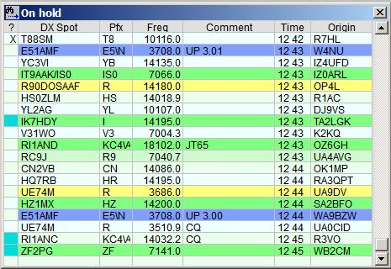

DXSW\_23C

**2.10.8.10** Even spots with annoying comments can be removed.

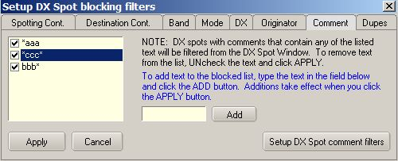

DXSW\_24

**2.10.8.11** Comment filtering is not case sensitive and wild cards may be used. Filter text may NOT contain a comma.

Examples:

* + - \*text for comments ending with the text
    - text\* for comments beginning with text, and
    - \*text\* for comments containing text.

**Beware** - if you simply use the "\*" symbol on its own, ALL DX spots will be filtered out and nothing will appear in the list. Use this with caution !

**2.10.8.12** This will allow display of multiple spots for DX Expedition?s and contest stations operating different modes on the same band while blocking dupes for the same operation.

A duplicate spot is not simply discarded. It overwrites the older entry in the DX Spot Window. As the DX Spot Window is sorted chronologically, the most current/recent DX Spots always have visibility.

Having both "Block duplicate RBN Spots" and "Block all duplicate DX Spots" does nothing but waste a lot of CPU cycles. Unless you have specific need to block RBN spots and not Telnet/Cluster Spots, then you should only check the Block all DX Spots option.

Apply a little sanity to Skimmer originated DX Spots. Checking this option does two things:

* + - Only the third skimmer spot for a station is processed - this attempts to remove the numerous false/bogus skimmer generated callsigns, and
    - After the third DX Spot for a station is processed, that callsign will not be accepted for processing for 60 seconds, and only after passing the test described in 1 three times.

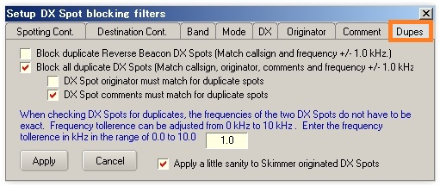

DSXW\_25

**2.10.8.13 Logic for DX Spot Dupes. (K4CY)**

DX Clusters works something like this ... Any time someone goes to a shipping hazard there is an unwritten rule that EVERYONE must make a DX Spot to confirm their QSO (sort of rite of passage for the DX’er). As a result, there is a constant blizzard of DX Spots.  A significant number completely bogus, and countless others on the completely wrong frequency.

Now, In Logger32, you can turn off duplicate DX Spot filtering.  Each DX Spot for the shipping hazard will be appended to the bottom of the DX Spot Window (chronologically)

If however, the user has duplicate DX Spot filtering enabled, then the following (or something like this) happens ... If the previous DX Spot is no longer in the visible part of the DX Spot Window, the original is deleted from the list (you can't see any change) and the new DX Spot is appended to the bottom of the list. The list simply scrolls up smoothly.  This procedure is not applied to DX Spots that are currently visible because would be very distracting to watch the list constantly shuffling the list as visible DX Spots are being removed from the list to be replaced by duplicate ones at the end.  So, in Logger32, the old visible DXSpot is simply overwritten (wherever it is in the visible list) with the new one.

I can assure you that the scenario I described of removing Visible DX Spots and adding the duplicate DX Spot to the end of the list is indeed VERY distracting.  Like trying to read the manufactures name on an accordion while it is being played.   Otherwise I would not have gone to the trouble of implementing the much more difficult code that simply overwrites the visible original DX Spot with its duplicate.

### 2.10.9 Load LotW user file

This gives the ability to download and create or update the user-selected database in the default Logger32 directory. This facility allows download of any suitably formatted file from the Internet or users archives.

Logger32 defaults to the LoTW user file. This file contains only LoTW user callsign. The following examples show the process for LoTW update and are representative of the process for any user-defined database.

To download the latest list of LoTW users with no date, Right click on the DX Spot Window, Left Click SETUP | LOAD LOTW USERS FILE.

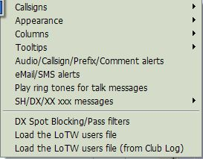

DXSW\_26

This will bring up a pane where you can update the current list by clicking on the <**Download**> button and then the <**Save data**> button. The Config menu item allows the user to change the name and data for a different list.

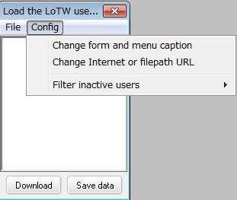

DXSW\_27

Selecting the Change form and menu caption menu item will bring up another dialog box. Enter the name of the list: Example: LoTW users, eQSL users, etc.

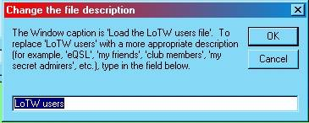

DXSW\_28

Once you select the name, the you need to define the source for the user list. By selecting the "Change Internet or file path URL" menu item. This brings up a window where you can enter the Internet address or local file path. Follow the appropriate format example shown on the window.

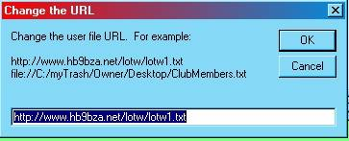

DXSW\_29

Once the user has established the Name and URL, Select the <**Download**> button and wait until the window populates, then select the <**Save data**> button.

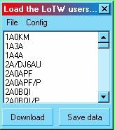

DXSW\_30

**Load eQSL user file**

If the user prefers to indicate the callsign is a user of eQSL, then download the eQSL user file, follow the above process and name the file "eQSL user" and enter the following URL to download the eQSL file.

http://www.eqsl.cc/qslcard/DownloadedFiles/AGMemberList.txt

**NOTE**: Only one database can be active at a given time.

### 2.10.10 Load LoTW user file from Club Log

To download the LoTW users file from Club Log, right click on the DX Spot Window, left Click SETUP | LOAD LOTW USERS FILE (from Club Log) This file contains not only callsign but more recent LoTW upload date, more recent Club Log upload date, status of OQRS user or not and Grid Square. Club Log updates this file once a week (on Sunday UTC).

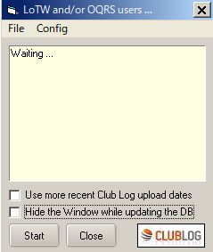

DXSW\_30A

Logger32 shows LoTW user and/or OQRS user on DX Spot Window, [Bandmap](#_topic_TheBandmap) and [Logbook Page Window](#_topic_LogbookPageWindow). If you prefer it shows LoTW/OQRS user based on recent Club Log upload date instead of recent LoTW upload date. Check “Use more recent Club Log upload date” in this case.

Click “Start” to download the file.

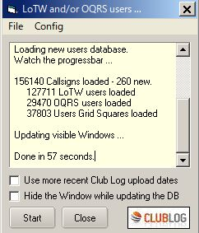

DXSW\_30B

The downloaded file is saved as clublog\_users.json in the Logger32 folder. The following is a part of the json file.

{"call":"JA1NLX","firstqso":"1963-02-28 08:00:00","lastqso":"2017-05-23 09:24:40","lastupload":"2017-05-23 10:01:01","locator":"PM95SM","oqrs":"true","last-lotw":"2017-05-18 02:26:05"},

Click “Config” to select more option.

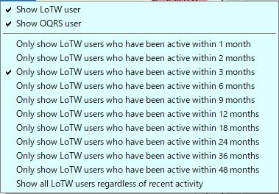

DXSW\_30C

The special tips is displayed on DX Spot Window, Bandmap. and Logbook Entry Window. Select the LoTW/OQRS user’s mark in each window.

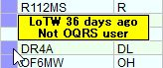

DXSW\_30D

Tooltips are displayed in different styles depending on your settings. Some examples below.

If both “Show LoTW users” and “Show OQRS users” options are checked then tooltips are displayed in 2 lines, upper for LoTW user and lower for OQRS user. See DXSW\_30D.

If either of these options is checked then tooltips are displayed in 1 line. (LoTW info or OQRS info) Example with “Show LoTW user” checked below.

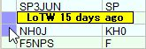

DXSW\_30E

Example with “Show OQRS user” checked below.

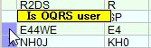

DXSW\_30F

**Clicking DX Spot**

If Club log knows the Grid Square of a user, when you click on a DX Spot of that user, the Grid Square automatically populates the Grid Square field in the [Logbook Entry Window](#3.4_GridSquares_in_Proper_Case) (if Logger32 has not already found the Grid Square elsewhere).

## 3.0 DX SPOT HISTORY

The DX Spot History buffer holds a running history of DX Spots that have been selected by the operator. These can be displayed in DX Spot history table. To display the DX Spot history, go to the Logger32 [Main menu](#_topic_MainMenu) [View menu item](#4.0_VIEW_MENU_ITEM) and select Show DX Spot History menu item from the list..

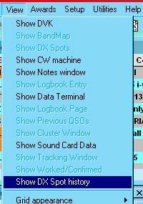

DXSW\_31

The following is an example of a DX Spot History table showing 20 DX Spots that have been selected by the operator. The operator can elect to click on any spot listed in the History chart. This will result in the [Logbook Entry window](#_topic_LogbookEntryWindow) being filled just as it is with a spot from the DX Spot window. The selected spot will be highlighted with a yellow background as shown in the sample table. This is especially useful when DX Spots are coming in too fast to scroll back. The buffer holds the last 20 spots selected. The newest is displayed at the bottom of the table and as new ones are added, the spots will scroll up. Once the buffer is full the top spot will scroll off as new ones are added.

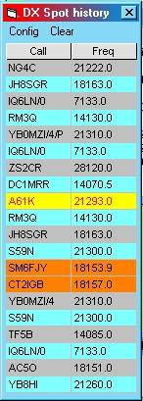

DXSW\_32

In Addition to the DX Spot History, this function can also be configured to show where the radio was before the spot was selected. On the Spot history chart, select the Config | Show before DX Spot table menu items. The Show colored DX Spots menu item will display the spots highlighted as selected in the DX Spot window setup. There are also options to show tooltips and enter the callsign from the previous DX Spot.

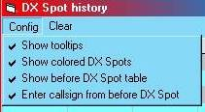

DXSW\_33

Following is an example of both tables. The operator can click on a listing in the B4 table, but it will only reset the radio to the frequency indicated and will not fill the call and other fields. This is useful to reset the radio to a frequency that was being monitored before clicking on a DX Spot. There are also options to show tooltips and enter the callsign from the previous DX Spot.

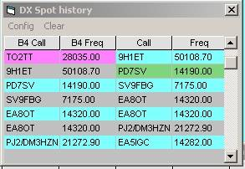

DXSW\_34

*Created with the Personal Edition of HelpNDoc:* [*Create HTML Help, DOC, PDF and print manuals from 1 single source*](http://www.helpndoc.com/help-authoring-tool)

**Adjust DX Spots for Audio Frequency**

# Geoff Anderson  G3NPA and Jim Hargrave W5IFP

## 1.0 GENERAL

Earlier issues of Logger32 simply used the transceiver VFO frequency when reporting and using DX spot information. This is fine for CW and SSB contacts but it is the custom for those using RTTY to use and report the MARK frequency of the transmission. Once again, Logger32 would comply with this requirement IF the operator was using the FSK or RTTY mode on the transceiver, for any offsets needed are usually built into the radio. Although the radio might indicate a particular frequency of transmission for an FSK contact, the virtual carrier frequency (the rigs actual VFO frequency) would be shifted by the audio tone frequency of the mark character.

When using an AFSK form of RTTY keying from Logger32's Sound Card Data window. the radio only knows its own VFO frequency and has no knowledge of the audio tone frequency being used for the mark frequency. A received RTTY spot for a freq of, say, 14083.00 would be acted upon as though this was the required VFO frequency, which would be correct if using an FSK mode on the rig but wrong if using an SSB mode. Indeed in the case of the SSB mode, the received signal would have been at the extreme left of the display, at a zero tone frequency.

Logger32 gives the operator the opportunity to correct these offsets when using an AFSK/SSB mode combination, both PSK and RTTY.

In addition, code has been added to actually log the RF frequency if this option is selected.

Selection of this option can be found on the [Sound Card Data window](#_topic_SoundCardDataWindow1).Settings menu.

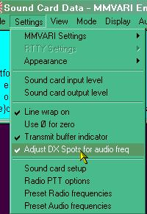

ADSAF\_1

## 2.0 SPOTS SENT TO THE DXCLUSTER

With the menu option selected, a "spot" sent to the cluster (RTTY or PSK) will indicate the Actual RF  mark frequency rather than the VFO freq of the radio.

### 2.1 The PSK case

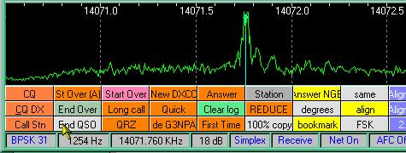

ADSAF\_2

The screenshot above shows a received PSK signal on an RF frequency of 14071.76 Khz. The radio was on USB (as can be seen by the fact that the frequency ribbon increases from left to right), with the VFO set to 14070.50 Khz and a tone frequency of 1254 Hz.

With "Adjust DX spot for audio freq." selected, the reported spot would look like:

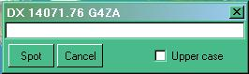

ADSAF\_3

**Note** that the reported frequency is the actual RF frequency.

### 2.2 The RTTY case

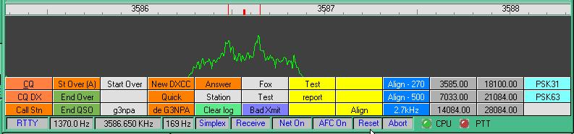

ADSAF\_4

The above screenshot shows a received RTTY signal on an RF mark freq of 3586.65. The radio was on USB (as can be seen by the fact that the frequency ribbon increases from left to right), with the VFO set to 3585.28 and a tone frequency of 1370Hz.

With the "Adjust DX spot for audio freq" selected, the reported spot would look like:

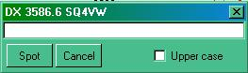

ADSAF\_5

3.0 USING SPOTS FROM THE DXCLUSTER

When using an incoming spot for a digital signal, Logger32 has to determine a number of things. First it will check to see if the Sound Card Data window is open. It then tests the spot frequency against the user defined Band/Mode table to ascertain the mode to be used. If the frequency is found to be outside a defined data band, then Logger32 will not modify the frequency and will put the transceiver VFO onto the frequency as seen in the spot. Likewise, if the frequency is within a data band but the mode selected for the radio is RTTY/FSK, then again, no change will be made. However if the frequency is within a data band and the radio mode is USB/LSB, then Logger32 will change the VFO frequency such as to place the received frequency at your preferred tone operating point.

In short, an audio frequency correction will occur only if:

* + The option is selected;
  + The Sound Card Data window is in use;
  + The mode is Digital (as defined by the [Band/Mode table](#BandMode_Table)); and,
  + The radio Mode is SSB, USB, LSB,PKT-USB, PKT-LSB, DATA-LSB or DATA-USB or DIG (as defined in the [Band/Mode table](#BandMode_Table)).

If the above criteria are met, the net result will be that the data signal should appear at your preferred operating audio frequency. Also, if a contact is made, then the true RF frequency will be recorded in the log.

## 4.0 IMPORTANT NOTES

If the preferred selected radio mode is FSK/RTTY or whatever, then no addition or subtraction of the tone frequency is necessary for the user will be just keying the FSK input to the rig. The rig will do the necessary frequency conversion and:

* + will (or should) give the right frequency to send to the cluster; and,
  + be set correctly to the spot frequency without the need for any tone correction.

There is one added complication and that is for the spotting of RTTY signals. For the signal to come into the right position you MUST have the MMTTY section set up to match your selected preferred receive tone. It is also advisable to have your rig set the same (i.e. standard tones or continental) to match. If you DO match everything up, then all will be well, even if you suddenly decide to change from an SSB mode for transmitting RTTY to FSK (in the bandplan). This later case does not require a radio offset; it will do it for you!

*Created with the Personal Edition of HelpNDoc:* [*Benefits of a Help Authoring Tool*](http://www.helpauthoringsoftware.com)

**The Bandmap**

# Geoff Anderson  G3NPA, Jim Hargrave W5IFP and Aki Yoshida JA1NLX

## 1.0 GENERAL

The BandMap is an additional or alternative way to display received DX Spots information in frequency order. The display can be used in the same way as the spot table in that clicking on a spot (callsign) will QSY the radio to that frequency and mode. It will also display pseudo spots (see the topic [Pseudo DX Spots](#_topic_PseudoDXSpots)).

To activate the basic BandMap window select the Logger32 [Main menu](#_topic_MainMenu) [View | Show Bandmap](#4.0_VIEW_MENU_ITEM) menu items.

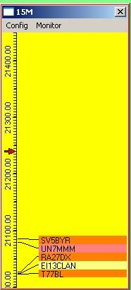

TBM\_1

The frequency scale to the left of the window is determined by:

* + The band currently in use on the radio;
  + The frequency range in the [Band/Mode table](#BandMode_Table); and,
  + The scaling as set by the user. (see [Config menu](#2.1_Config_Menu))

In the example shown there is a red arrow at 21.240 and this represents the actual radio frequency set. The marker position will change as the VFO is rotated

Clicking on the scale will QSY the radio to the frequency under the cursor. **Note**: If you are using the AFSK freq offset option (see [Adjust DX Spots for Audio Frequency](#_topic_AdjustDXSpotsforAudioFrequency)), then the VFO position cursor will not always align with the actual spot flag, the error being the amount of audio offset used.

Spot data appears to the right of the frequency scale (see [Operational notes](#2.2.3_Operational_Notes) below)

## 2.0 MENU BAR

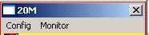

TBM\_9

**Note**: For the Bandmap to work as described above, the Bandmode selection panel must be set to have the "Band from Bandplan" option selected (see the [Logbook Entry window](#6.2.1_Band_from_Bandplan) topic).

### 2.1 Config Menu

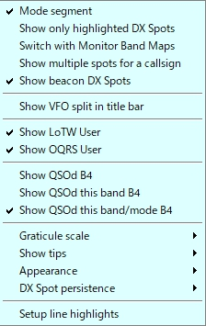

TBM\_7

### 2.1.1 Mode Segment

The frequency scale can be made to change for each mode segment (as defined in the [Band/Mode table](#BandMode_Table)). If this option is selected, tuning the radio through the band will cause the frequency scale to change and fill the available space with the max and min frequencies for the particular section (21.200 to 21.450 in this case). The title bar will denote the mode segment, as shown below.

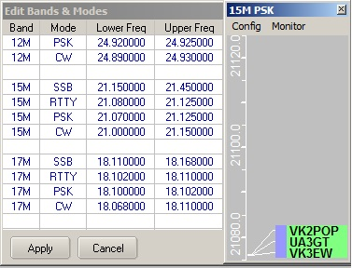

TBM\_4

When you tune into the adjacent mode section the scale will change again. **Note** that if a mode section has a narrow bandwidth, then it is quite possible that the frequency scale may be devoid of any numbers for this section.

### 2.1.2 Show colored DX Spots

The spot background colour may be turned on and off with this option. The colours are determined by those set in the Worked/Confirmed colour selection table (right click on the [DX Spot window](#_topic_DXSpotsWindow1) and select Setup | Appearance | Worked/Confirmed Colors)

### 2.1.3 Switch with Monitor Bandmaps

Please see the [Monitor](#2.2_Monitor) subsection below.

### 2.1.4 Show multiple spots for a callsign

This option will allow logger32 to display all spots for a callsign provided the spots refer to different frequencies. This is useful if the user has set up a bandmap to look at several frequency bands all at once (say 2 to 30 MHz) and wants to track the operation of a dxpedition. If the option is deselected then the callsign is only allowed to appear once in the listing and it will display for the last posted frequency.

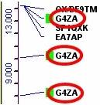

TBM\_6

### 2.1.5 Show VFO split in title bar

When the radio is operating in split mode, this option displays the up/down split differential in the title bar. This is expressed in kHz.

**Note**: This only works for radios that report VFO-B frequency during polling.

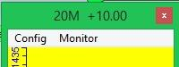

TBM\_18

### 2.1.6 Show LotW User

Logger32 has the capability of recognising a DX spot station who is known to use LotW (see the topic [DX Spots Window](#_topic_DXSpotsWindow1)). A colored highlight to the left of the DX callsign in the Bandmap windows indicates a station that uses LotW. This menu item enables that option. Note that each bandmap carries this option separately.

Information for setting the highlight color and the uploading of the necessary LotW user data is given in the topic [DX Spots wIndow](#_topic_DXSpotsWindow1)

### 2.1.7 Show QSOd this band before

Here the user can select to display if the station has been worked before. This is indicated by a colored highlight to the left of the displayed callsign.

The user has three options

* 1. to show stations QSOd before on any band
  2. to show stations QSOd before on the particular band/mode combination, or
  3. to show neither.

### 2.1.8 Graticule Scale

The user may select the most appropriate scaling for the display/freq range for the standard graticule. **Note** that different scaling may be used for each of the frequency bands as defined in the [Band/Mode table](#BandMode_Table).

The code has built-in protection to prevent frequency text from overwriting other frequencies. For example, you cannot show the 10M band showing the frequency every 10 KHz as it won't fit in.

### 2.1.9 Show Tips

Gives the user the choice of showing the mouse-over tool tips in full or reduced detail, with or without the spot elapsed time displayed.

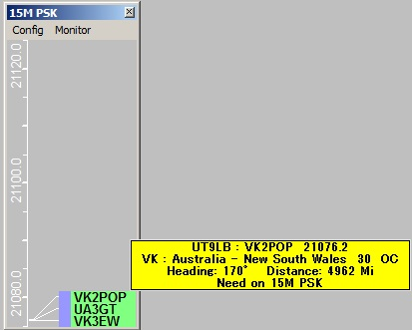

TBM\_12

If the mouse is moved to the LoTW/OQRS user’s mark then it shows special tooltips. Tooltip style depends on your setting. Details are described in the [DX Spot Window](#_topic_DXSpotsWindow1) topic.

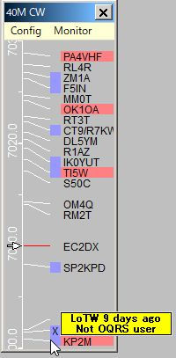

TBM\_12A

### 2.1.10 Appearance

This option allows the user to select fonts and color combinations for the display, to suit the user's taste.

In addition, the user can select the option to mark the DX spot as someone who they have worked before on this band or on this band/mode combination. When such a match occurs, a small "x" precedes the callsign in question.

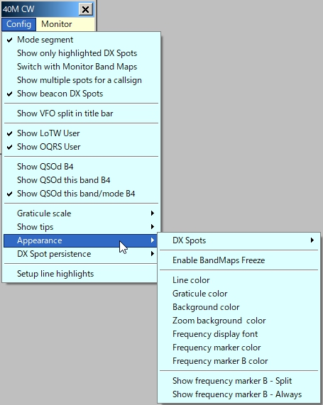

TBM\_13

**Important Note**: This feature works using information obtained from the current bandplan, the logbook and the DXSpot frequency. This means that there are numerous ways in which the derived information could be in error. If used with care it could be a useful function to have switched in during DXpeditions and/or contests. Use at your own risk.

Selecting "Show frequency marker B Split" will display a VFO-B arrow on the frequency scale when the radio is in split mode.

Selecting "Show frequency marker B-Always" will display VFO-B frequency regardless of operating mode.

**Note**: The above options only works for radios that report VFO-B frequency during polling.

### 2.1.11 DX Spot Persistence

This option allows the user to select the amount of time the spots will remain visible, from 5 minutes to no time limit. The display timing is taken from the time reported in the spot details, not the time the data was actually placed on the screen. A DX spot reported at 12:01 and using a 5 min persistence, will remain visible until 12:06 and then disappear. This filtering does not destroy the data. To see a spot that might only just have been removed from the Bandmap, simply increase the persistence time and it will re-appear.

**Operational note**: If you perform a SH/DX request, then only those spots that fall within the persistence timing window will be displayed.

### 2.1.12 Setup Line highlights

You can set the bandwidth and color of the highlight lines that join the frequency graticule and the list of DX Spots.These are set to match the reported radio mode that appears in the [Logbook Entry window](#_topic_LogbookEntryWindow). Bandwidth is in Hz and defaults to 2400 Hz if there is no mode to match the radio mode As example; If CW is set to 300 Hz, lines +/- 150 Hz will be highlighted.

**Note**: The Receiver bandwidth is based on the reported Radio mode. The user can configure different bandwidth settings based on the actual radio mode: CW-N, CW-R, DATA-USB, and DATA-LSB, etc.

The user can identify band segments of personal interest (beacons, RTTY, BPSK, etc.) and highlight the lines that connect the graticule to the DX Spot in a different color. The user enters the upper/lower limit of whichever little piece of the band he/she wants to highlight.

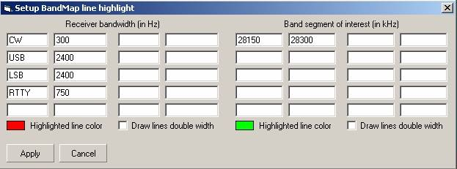

TBM\_17

### 2.1.13 Zoom

The zoom function allows the user to select a particular section of the Bandmap that may be of interest and to expand the displayed scale. Starting in Logger32 version 3.46 the Zoom menu has been removed and the Zoom function is now dynamic by scroll wheel action.

To activate this Zoom function, rrolling the mouse scroll wheel to the left of the list of callsigns will expand the main Bandmap frequency scale. This method will expand the entire scale with concentration near the radio VFO frequency.

**Note**: Normal rotation of the mouse wheel will result in a 10Khz increment per click. To speed up the zoom action, roll the Mouse wheel while pressing The <**Shift**> key will zoom at 100kHz per wheel click.

You can move the vfo frequency with a left-click in the frequency scale near the point of interest. This will set the radio VFO at this point, indicated by the red arrow. Scroll the mouse wheel forward to expand the scale. As soon as the scale starts to expand it will change color. Scrolling the mouse wheel backwards will re-compress the scale. If the scale is compressed back to the point that it covers the full band, the frequency scale will revert back to the original color.

**Note**: The scroll zoom is inhibited if the ?Mode segment? option is selected,

Below is a sample of this action. The left side is a normal display and the right shows the scale expanded.

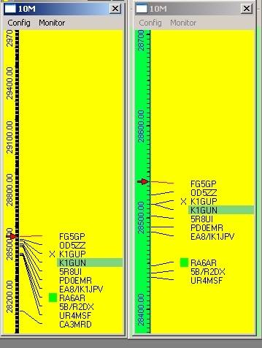

TBM\_15

The Zoom background color is user selected by opening the "Appearance" sub-menu.

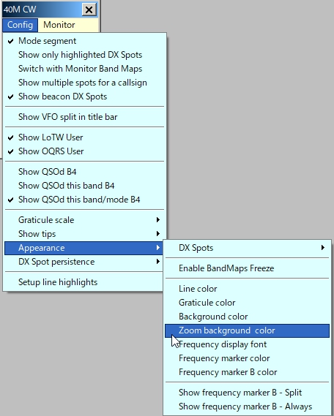

TBM\_16

### 2.2 Monitor

Ten monitor Bandmap windows are available to monitor. Bandmap windows are available to allow the user to monitor activity on bands other than the one currently being used (for example; a permanent activity monitor for 6M and 10M regardless of what/where the operator is doing). Clicking on the "Monitor" menu option on the main Bandmap will produce the additional display menu as shown below.

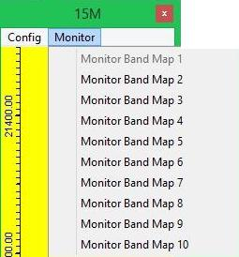

TBM\_10

The user can click on a DX Spot on the Monitor Bandmap and the Radio (if connected) and the [Logbook Entry window](#_topic_LogbookEntryWindow) will QSY to the frequency/mode. The Monitor Bandmap will switch when the user changes bands on the radio, or the radio changes band for whatever reason (clicking on a DX spot, clicking on a Monitor Bandmap, or whatever) to the band the radio was on (before the QSY) provided the "Switch with Monitor Bandmaps configuration" option is checked. If this option is unchecked, then the monitor windows will not change over with the main bandmap and will therefore continue to display spots for the selected band.

2.2.1 Config Menu

All config settings for the Monitor Bandmap are identical to those of the main except the Highlight line is not applicable.

### 2.2.2 Band

It is here where the user selects the band to monitor.  **Note** that the bands listed here are derived from the [BandMode table](#BandMode_Table) and will differ according to user preferences and setup.

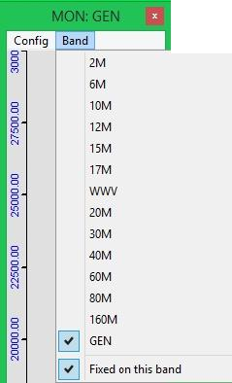

TBM\_8

### 2.2.3 Operational Notes

One of the tips given is to insert a statement in the [BandMode table](#BandMode_Table) to define the whole spectrum of the radio and call the mode GEN (see [Tips, Tricks & Troubleshooting](#_topic_TipsTricksandTroubleshooting1) Cluster/DXSpot window/Bandmap). If you have this set up then a bandmap can display all the spots received over the full spectrum of the radio as shown below.

In versions of Logger32 from 3.13 onwards if the GEN freq spread is more than 30MHz then the main graticule is not drawn. If the GEN freq spread is less than 30MHz then the main graticule is drawn at 1MHz increments.

General note

It is recommended that the "Mode Segment" Config option be turned off in the main bandmap window for cases when the radio is tuned to a GEN frequency (as this speeds up the redraw of the window)

for cases when the radio is tuned to a GEN frequency (as this speeds up the redraw of the window)

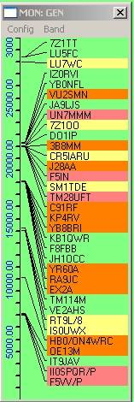

TBM\_11

### 2.2.4 Removal of Unwanted Spots

To match up with the same facility available on the [DX Spots window](#_topic_DXSpotsWindow1), individual spots on the Bandmap can be deleted/removed if so desired. A simple right-click on the appropriate DX spot flag will bring up the menu below, from which one can then delete the flag (K4CY in TBM\_14 below). If you do not click on a flag, the "Remove xxxxx" DX spot menu item will not appear.

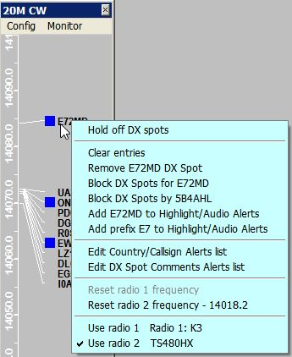

TBM\_14

**Note**: Removal of the flag will also ensure the removal of the spot from the [DX Spots window](#_topic_DXSpotsWindow1) and [DX Spots map](#6.0._DX_SPOTS_PANEL). If the same station is "spotted" again following your deletion, then the report will of course re-appear.

### 2.2.5 Blocking of un-wanted spots for a specific callsign

In the same way as is possible in the [DX Spots window](#_topic_DXSpotsWindow1), it is possible to block spots for a specific callsign. Having right-clicked on a selected callsign, the option is then presented to block DX Spots for that call. **Note** that the "spots by xxxxx" menu option indicates the callsign of the person reporting the spot.

### 2.2.6 Highlight/Audio alerts and Alerts list

Details are described in the topic [DX Spots window](#_topic_DXSpotsWindow1).

## 3.0 TITLE BAR APPEARANCE

### 3.1 In-Focus Color

The Bandmap and Monitor Bandmap window title bars are always shown with the “in focus” color even when they are not actually in focus. The Band, Mode and Split Alert in the title bar are still clearly visible even when the window is not in focus. The following figure (TBM\_19) shows an example where the focus is in [CW Machine window](#_topic_CWMachineWindow), however the Bandmap window looks as if it is also in focus.

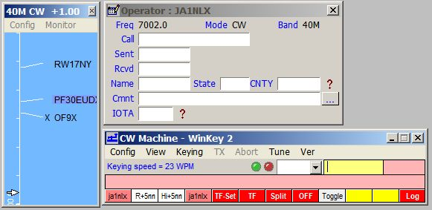

TBM\_19

3.2 “I’m lost” message on the Bandmap Title bar

This message appears if you ask Logger32 to do something that is not configured in the BandPlan, (like 30M SSB) then it will default to 20M frequencies on the frequency scale and 20M DX spots are displayed on the Bandmap.

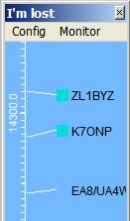

TBM\_19A

*Created with the Personal Edition of HelpNDoc:* [*Easy Qt Help documentation editor*](http://www.helpndoc.com)

**Pseudo DX Spots**

# Geoff Anderson G3NPA

## 1.0 GENERAL

The ability to add your own "pseudo spots" or bookmark a callsign to the [Bandmap](#_topic_TheBandmap), [DX Spots window](#_topic_DXSpotsWindow1) and the spot maps without having to actually publish them to the cluster has been implemented.

One way to add a bookmark/pseudo spot [P5AAA in the example] all that is necessary is to include the "!" character as a prefix to the callsign in the [Logbook Entry window](#_topic_LogbookEntryWindow) followed by <**CR**>.

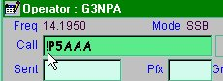

PDS\_1

This action will cause the pseudo spot to appear in the [DX Spots window](#_topic_DXSpotsWindow1), spot map and.

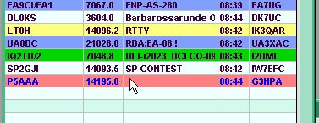

PDS\_2

the relevant bandmap (in this case 20m). **Note** that the pseudo spot is recorded as being at the frequency shown in the [Logbook Entry window](#_topic_LogbookEntryWindow).

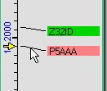

PDS\_3

Once the pseudo spot is in the listings or shown on the spot maps or bandmap, it can be used in exactly the same way as a normal DX spot.

Another way to add a bookmark is to use the shortcut key combination <**Ctrl+B**> or use the menu option from the [Logbook Entry window](#_topic_LogbookEntryWindow) right-click menu.

**Please note**:  This is not a shorthand method for the transmitting of spot data. It is for local use only.

To change the default forecolor of the pseudo spots, right-click on [DX Spots window](#_topic_DXSpotsWindow1) and use Setup | Appearance | Psuedo spot forecolor menu items.

 It is now possible to carry out the "bookmarking" using the Macro function [$bookmark$](#$bookmark$) from the [CW Machine window](#_topic_CWMachineWindow). Simply make sure that the callsign required is entered into the call pane of the [Logbook Entry window](#_topic_LogbookEntryWindow) and apply the Macro.

*Created with the Personal Edition of HelpNDoc:* [*Full-featured Kindle eBooks generator*](http://www.helpndoc.com/feature-tour/create-ebooks-for-amazon-kindle)

**CW Machine Window**

# Geoff Anderson G3NPA, Hew Lines VA7HU and Aki Yoshida JA1NLX

## 1.0 GENERAL

The CW Machine provides the capability to interface Logger32 to your transceiver and to send CW from Logger32 via a serial or parallel port interface. It is fully customizable and consists of a transmit buffer window and up to 36 user-programmable buttons that may be displayed in groups of  0, 12, 24 or 36. Each button may be programmed using Macro language statements and/or text and may be colored and labeled. Using your imagination and the Macro language, you can create single-button functionality which will make operating CW more enjoyable and easier.

The CW Machine is basically a software keyer but it will also support the use of a WinKey1 or 2 CW keyer.

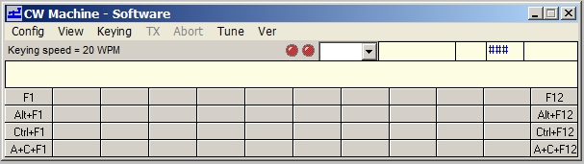

CWM\_1

**Note:**

If the CW Machine is running when WSJT/JTDX is started, the CW Machine will close automatically. If, while running WSJT/JTDX, a CW DX Spot is clicked, when WSJT/JTDX is closed the CW Machine will open automatically.

If WSJT/JTDX is running and the user wishes to switch, simply click on the CW Machine ICON on the ToolBar and WSJT/JTDX will close and the CW Machine will open.

## 2.0 MAIN MENU

The CW Machine Menu Bar provides the following functionality:

### 2.1 Config

As a general note, it is recommended that after making any change to the keyer's configuration settings that the CW Machine be closed down and then re-opened. This does two things;:

* + It saves the new configuration, and
  + It allows the software to configure itself correctly to the new settings.

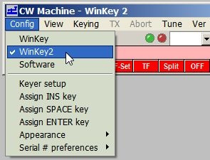

CWM\_2

### 2.1.1 WinKey/Software

It is in this menu where the selection between using the built-in CW keyer and an external WinKey keyer is made.

Select "Software" for the internal keyer. The selection made here will produce different keyer setup dialog boxes as described later. "Software" is displayed in the Title bar.

Also note that the meaning of the LEDs changes between the two configurations. When using the software keyer, the LEDs are as shown in the screenshot below and depict the keying and PTT.

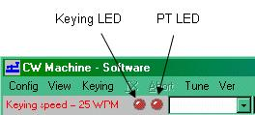

CWM\_3

When the WinKey option is selected, the left LED indicates (when green) that a Host connection with WinKey is established. “WinKey” or “WinKey 2” is displayed in the title bar.

The right LED indicates the following status:

* + **Green** Sending text;
  + **Red** Idle;
  + **Blue** Sending with paddle; and,
  + **Orange** Sending a Wnkey internal message.

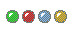

CWM\_4A

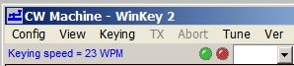

CWM\_4

### 2.1.2 Keyer Setup - Software

Selecting this menu item will display the Keyer Setup dialog box, as shown below (CWM\_6). From this panel the user can:

* + Set the serial port and/or parallel port address to be used;
  + Check which port is going to be active;
  + Select the PTT method;
  + Set the CW speed (faster to the right and slower to the left) in WPM;
  + Adjust the CW weighting;
  + Set the required transmit delay (the time between the PTT being activated and the start of the first symbol to be transmitted);
  + Set the "Disable radio polling when keying" option will do just as it indicates.  This feature was introduced to overcome a problem reported with Omni V rigs when being keyed;
  + Select an immediate character abort when using the <**Esc**> key (rather than allowing the character to complete) when using the software version of the keyer; and,
  + Test the actual keying speed.

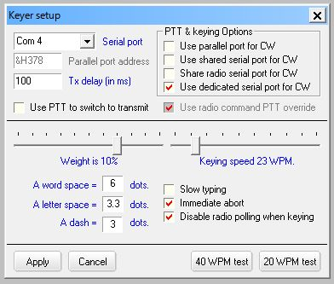

CWM\_6

### 2.1.3 Using the Parallel Port

If you choose to use the parallel port for the CW Machine, all that is required is that you set the parallel port address, select the "PTT on selected port" and "Use parallel port for CW" check boxes.

### 2.1.4 Using the Serial Port

If you choose to use a serial port, you have three options:

* 1. Use a dedicated serial port for PTT control and CW keying;
  2. Key the radio using the spare control signals in the ports used by the rotator or the radio; or
  3. Switch between the radio ports used for [SO2R](#_topic_SingleOperatorTwoRadiosSO2RSuppo).

**Note**: Only one of these options may be selected at any one tiome.

The serial port selection now supports USB adaptors.

### 2.1.5 Using a Dedicated Port

Select a Serial Port from the pull-down menu and then select "PTT on selected port" if required.

**Note**: Hex address only applies to parallel port selection.

### 2.1.6 Using a Shared Port

It is possible to share the CW port with either the (serial) radio port, (serial) rotor port, or (parallel) antenna port.

If sharing with the (serial) radio or rotator port, then check the "Use shared serial port for CW" option.

Sharing the radio serial port for CW is intended for SO2R users who require to use the [RTS](#RTS) and [DTR](#DTR) signals available in the radio comms ports and to have these switch between ports under the influence of the <**Ctrl+T**> SO2R changeover function.

If sharing with the (parallel) antenna port:

* + Set the parallel port address to match that for the antenna port; and,
  + Check the "use parallel port for CW" option.

Your attention is also directed towards the [Shared Serial and Parallel Ports](#_topic_SharedSerialandParallelPorts) section.

You will observe that the address for the parallel port is a hexadecimal value and should be entered in the format "&Hxxx" and not as a description as LPT1 etc. If you do not know the address of your port, right-click on the "My Computer" icon on the desktop and select the "Properties|Device Manager" entry. Highlight the port of interest and select "Properties"

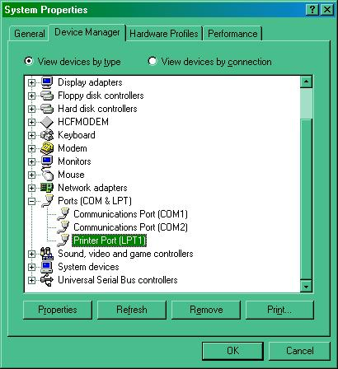

CWM\_7

The "Resources" tab will give details of the Input/Output ranges.

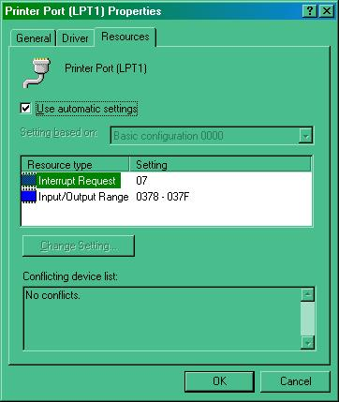

CWM\_8

The address you require will be the first of these two numbers. Drop the leading zero and enter the remainder in the form &Hxxx.  On standard systems LPT1 = &H378. For other ports, check the values needed using the method described above.

The PTT delay is a built-in delay to allow for relays (or other general delays) within your system to change over before the CW text is actually sent to the transmitter. The value entered here should be in milliseconds.

How fast are you really sending?  Selecting one of the two WPM test buttons will cause the keyer to place the word "Paris" into the TX buffer either 20 or 40 times and then send it. This is a timed process to determine the actual WPM that your computer is sending. The results will be displayed in the message box below. It is recommended that you have the radio turned OFF before you try this!

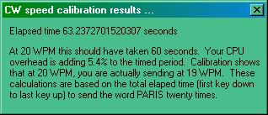

CWM\_9

### 2.1.7 Slow Typing Options

From Ver. 3.1.2 of the CW Machine, the Slow Typing option has a different function. With the Slow Typing option checked, the keyer does not automatically revert to receive when the buffer is sent. The keyer can be forced to receive (PTT turned off) by clicking Abort, typing the <**Esc**> key, or executing the [$receive$](#$receive$) macro.

**Note**: the object of the Slow Typing option is to prevent the radio PTT going on/off as slow typists pecked their way through a message.  Unless a user has a specific need for the slow typing option, it is STRONGLY RECOMMENDED THIS OPTION BE TURNED OFF.

### 2.1.8 Keyer Setup - WinKey

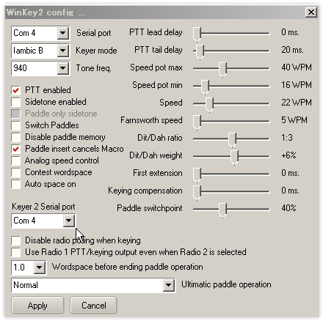

CWM\_10

Added Radio 2 serial port to the CW Machine WinKey and WinKey2 setup (ver3.50). In the case of WinKey2 it supports 2 CW output for Radio1 and Radio2. You must specify same serial port. in the Keyer 2 serial port box.

Full information on all of these settings can be obtained from the WinKey Interface manual downloadable from <http://k1el.tripod.com/docs.html>. Most of these settings can simply be left alone until you know what effect they will have. There are, however, one or two where a little extra information might help.

**Analog Speed Control** - Check this item if you wish to have control of the keying speed via the external control. Unchecked and Logger32 will be able to change the keying speed using a right-click on the speed indicator.

**Key On n (where n is 3 or 5)** - The default is pin 3 for the keying. Select pin 5 if this is your preference. Note for MicroKey users: It is recommended that you use pin 3 keying. If you select pin 5 then the PTT will key instead.

**Sidetone** - You are strongly advised to read the WinKey information about the use of sidetone - for this is related to the keying pin in use at the time. MicroKeyer users do NOT need the sidetone activated here. In this case it is better to use the sidetone switch in the USB device router (CW/WinKey tab).

**Key Radio 1 from pin 3, Radio 2 from pin 5** - This provides for an automatic change of the CW keying line from pin 3 to pin 5 when the radio is changed from Radio 1 to Radio 2. See the SO2R section for more details.

**Disable Radio Polling when keying** - Some radios seem to prefer that the polling cease when transmitting. This gives the user the ability to select that option.

**Notes for users of MicroKeyer -** When Logger32 opens the WinKey serial port then Logger32 takes control over ALL of WinKey including PTT on pin 5. If you do not want PTT generation from WinKey when Logger32 is running you must uncheck the PTT checkbox in Logger32. Logger32 ALWAYS has priority. WinKey pin 5 is multifunctional. Logger32 can use this pin for the following functions:

* + None;
  + PTT;
  + Sidetone; or
  + Second CW output.

MicroKeyer allows only "None" and "PTT", but Logger32 can control all functions. Inside the MicroKeyer is a jumper called SO1R/SO2R. It's a jumper for pin 5. If it is in the SO1R position then pin 5 is used for PTT. If in the SO2R position then pin 5 is disconnected from the PTT circuits and wired to the REMOTE mini DIN 6 connector (signal will be used in SO2R extension for MicroKeyer as second CW source).

### 2.1.9 Assign Insert Key

From this menu you can assign any of the preset shortcut keys to the <**INS**> key, <**SPACE**> key or <**ENTER**> key on the keyboard.

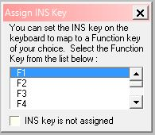

CWM\_5

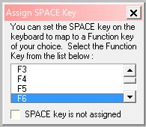

CWM\_5A

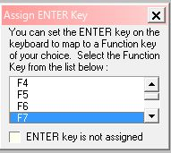

CWM\_5B

### 2.1.10 Appearance

Allows for the user selection of text fonts and colors. Font settings for the text part of the window are now applied to the callsign, SRX and Name fields.

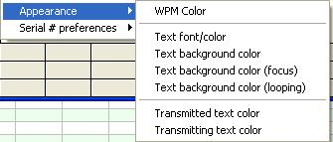

CWM-21

### 2.1.11 Serial # Preferences

This allows the user to send either a letter "T", the letter "O" or the figure 0(zero) when transmitting a zero in contest serial numbers.

### 2.2 View

* + **Show F keys**         -  Display the first row of buttons
  + **Show Alt+F keys**    -  Display the second row of buttons
  + **Show Ctrl+F keys**   - Display the third row of buttons
  + **Show Alt+Ctrl+F keys**    - Display the fourth row of buttons
  + **Always on Top**      -  Allows the user have the CW Machine always remain visible
  + **Show Controls in Microsoft 3D**  -  Displays the Visual Basic controls in 3D format
  + **Show tool bar**       -  Allows the user to display the tool bar or not
  + **Show SRX Field**   - Allows the user to display the SRX entry pane. Note: This pane normally shows '###'. To use, click the cursor into the pane and just over-type the received serial number. There is no need to backspace over the '#' symbols
  + **Show Sent RST Field** - Allows the user to display the sent RST report.

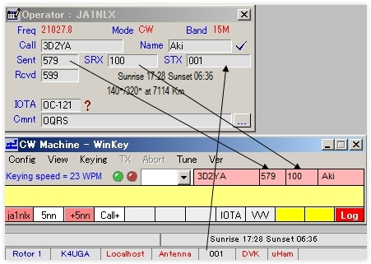

CWM\_21B

* + **Debug window** - Allow the user to display communication between the CW Machine and WinKey.

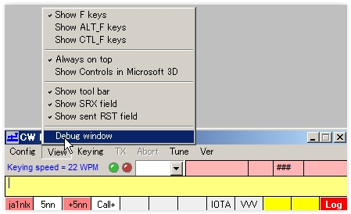

CWM\_21A

### 2.3 Keying

* + **Auto TX** - With this selected, whatever is entered into the transmit buffer will be sent immediately;
  + **Manual TX** - With this selected, the contents of the transmit buffer will be sent on selecting "TX" (see below);
  + **Dedicated Serial Port** - With this checked, keying will be applied to the port as set in the Config menu. With it unchecked, the PTT and keying LEDs will flash but the port will remain inactive. Note that this menu option will be available only If the use of a dedicated port is selected in the Config|Keyer setup menu;
  + **TX** - Transmit text (only available if Keying is set to Manual TX);
  + **Abort** - Stop transmitting immediately and clears the transmit buffer;
  + **Tune** - This allows the operator to tune up his radio. The button acts as a toggle; click once to activate, click again to de-activate; and,
  + **Ver** - Version and build number information

## 3.0 KEYING SPEED

Just below the menu bar, the CW Machine displays the current keying speed. A left-click on the text "Keying speed = nn WPM" will reduce the current timing element by 1ms, while a right-click will increase the timing element by 1ms.

**Note**: In addition the <**Pgup**> and <**PgDn**> keys have been assigned for speed up and speed down

## 4.0 CW MACHINE AND CWGET

Logger32 will now "integrate" with the CW decoding program CwGet in so far as simple mouse clicks can capture received text from CwGet and place the resultant text into the [Logbook Entry window](#_topic_LogbookEntryWindow) of Logger32.

CwGet is not part of the Logger32 distributed package and the user must obtain their own copy of this program. One source is <http://www.dxsoft.com/en/products/cwget/>.

To make use of this facility, CwGet needs to be set up as follows:

Check the CwGet SETUP menu options "CATCH WORD BY ONE MOUSE CLICK" and "COPY TRANSFERRED DATA TO CLIPBOARD" as shown below, and then save the new setup.

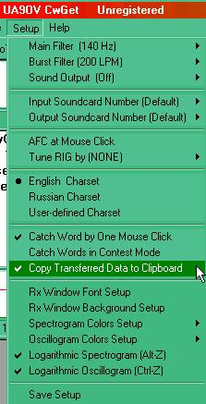

CWM\_16

To use the facility, left-click the mouse on the selected text as displayed in the CwGet decode window. A menu will then pop-up with the text selected.

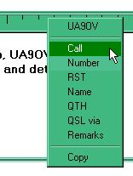

CWM\_17

Clicking on one of the menu options will then transfer the text to the [Logbook Entry window](#_topic_LogbookEntryWindow) in Logger32 as seen below.

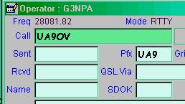

CWM\_18

## 5.0 MACROS AND PROGRAMMABLE BUTTONS

### 5.1 Definitions

**Macro** - Commands provided by the programmer so the user can create limited routines or shortcuts. Macros are used when creating routines for buttons and Hot Keys.

**Button** -  Designated buttons on a dialog box that the user can customize. Labels and color can be added to the buttons to identify the routine that the button will run when selected. Each button is also assigned to a 'Hot Key'.

### 5.2 Selecting the Number of Buttons Available

Go to the CW Machine View Menu, and select one or a combination of "Show F key" options. The macro buttons will be displayed below the transmit text window, in up to four rows.

### 5.3 Programming the Macro Buttons and Hot Keys

Using the mouse, point and right-click on the button you wish to program. The Macro Setup window will appear. At the top of the window there is a description for the Macro, (example: Macro Setup for F2). That would be the second button on the first row. To program the button, click in the text window and type in the text Macro you want to send when this button is clicked.

**Note** that the storage for each button will only allow a MAXIMUM of 200 characters (including non-printing characters such as a space)

After entering the routine, enter a name for the Button Caption in its associated window at the lower right. You can also program the following features of each macro button:

* + **Backcolor** - the color of the background of the button;
  + **Forecolor** - the color of the letters of the caption;
  + **Mouseover Back**color - the color to which the background changes when you drag the cursor over it; and,
  + **Mouseover Fore color** - the color to which the letters change when you drag the cursor over it.

If you make a mistake, highlight the text and use the <**Delete**> key to erase. When the Macro Setup is complete, and you are ready to save it, press the OK button. Pressing <**Cancel**> will cause the window to close without saving your work. You can also restore the default colors.

When you have finished programming the required text and Macro commands, and selected your desired button colors, select the <**OK**> button to save the script for that button. Cancel will erase your work.  Reset/Cancel all settings will restore the Macro button to the way it was before you began editing.  If it had a script, that script will be restored; if it was blank, it will return to blank.

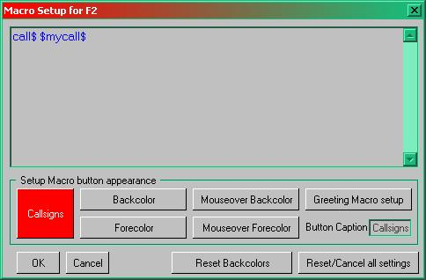

CWM\_11

### 5.4 Standard Hot Key Assignments

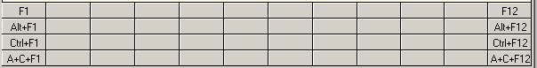

CWM\_12

The buttons have default Hot Keys assigned to them. If all 48 buttons are displayed, the first row of 12 buttons corresponds to the F-keys, F1 through F12.  The second row of buttons corresponds to the <**Alt+Fn**> keys (hold down Alt and press the function key).  The third row of buttons corresponds to the < **Ctrl-Fn**> keys. The fourth row of buttons corresponds to the < Alt-Ctrl-Fn> keys. If you press these keys, the script from the corresponding button will run. You can also see these assignments at the top of the Macro Setup window for each key.

### 5.5 User Assigned Hot Keys

If you wish to use other keys, rather than the combination of Function Keys assigned to the buttons, then consider the use of the User Defined Hot Keys. It may be easier to remember that the simultaneous combination of <**Alt+C**> (rather than F1) is the routine for calling CQ.  To assign <**Alt+C**> to the routine for calling CQ, follow this sequence:

* + Using the mouse, right-click on the button you wish to program and the MACRO Setup window will appear;
  + Program the button with text and/or macro commands;
  + Enter a name for the Button Caption (lower right of the window) beginning with the "&" (ampersand) symbol. Example: &CQ; and,
  + Select the <**OK**> button.  Selecting the <**Cancel**> button will cause the window to close without saving your work.

Now when you press the Alt and C keys simultaneously, your CQ will be sent. The label on the button looks like CQ, with the underlined first letter meaning it is a hot key <**Alt+C**>.  Now you can send CQ by three methods:

* 1. Select the button CQ;
  2. Press the F1 key; or,
  3. Simultaneously press the Alt and C keys.

### 5.6 CW Machine Macro Commands

The following Macros are available for use within a button script: See [5.7 Example Scripts Using Macros](#5.7_Example_Scripts_Using_Macros) for some useful examples.

|  |
| --- |
| **Macro** |
| [$band$](#$band$) |
| [$bookmark$](#$bookmark$) |
| [$call$](#$call$) |
| [$callchanged$](#$callchanged$) |
| [$callsignbeforeclearlog$](#$callsignbeforeclearlog$) |
| [$CallsignGetsFocus$](#$CallsignGetsFocus$) |
| [$clear$](#$clear$) |
| [$clearlog$](#$clearlog$) |
| [$command$](#$command$) |
| [$cwspeedup$](#$CWspeedup$) |
| [$cwspeeddn$](#$CWspeeddn$) |
| [$CWTextGetsFocus$](#$CWTextGetsFocus$) |
| [$greeting$](#$greeting$) |
| [$hexcommand$](#$hexcommand$) |
| [$log$](#$log$)  also see [Note 2](#_Note2) below |
| [$logimmediate$](#$logimmediate$) |
| [$lookup$](#$lookup$) |
| [$loop$](#$loop$) |
| [$loop x$](#$loop_x$) |
| [$msg(x)$](#$msg(x)$) |
| [$mouseTF-Set$](#$mouseTF-Set$)  also see [Note 7](#Note7) below |
| [$mycall$](#$mycall$) |
| [$name$](#$name$)  also see [Note 5](#Note5) below |
| [$NameGetsFocus$](#$NameGetsFocus$) |
| [$receive$](#$receive$)  also see [Note 6](#Note6) below |
| [$receivedrst$](#$receivedrst$) |
| [$reset$](#$reset$) |
| [$rotor$](#$rotor$) |
| [$rotorlp$](#$rotorlp$) |
| [$sentrst$](#$sentrst$) |
| [$sentrstn$](#$sentrstn$) |
| [$serialnum$](#$serialnum$) |
| [$serialnum-1$](#$serialnum-1$) |
| [$speed+$](#$speed%2B$)  also see [Note 3](#Note3) below |
| [$speed-$](#$speed-$)  also see [Note 3](#Note3) below |
| [$SRXGetsFocus$](#$SRXGetsFocus$) |
| [$TF-Set$](#$TF-Set$) |
| [$toggleradios$](#$toggleradios$) |
| [$transmit$](#$transmit$)  also see [Note 6](#Note6) below |
| [$tune$](#$tune$) |
| [$winkeymergedletters$](#$winkeymergedletters$) |
| [^ character](#^) |
| | character  See [Note 4](#Note4) below |

**Note 1**:  Macro commands are only available via the buttons. You cannot type them in the TX window and expect them to work.

**Note 2**: These will work correctly when using the software keyer.

**Note 3**: These will work correctly when using the software keyer and WinKey/WinKey2.

**Note 4**: A "|" embedded in a software CW macro (example: SP2|EWQ) will cause the inter-element spacing between the letters (in the example - between the 2 and the E) to be increased by 50%.

**Note** 5: The [$name$](#$name$) macro may send many things other than just the name, depending on the use of the [CW Free Field](#5.15_Free Field). If there is no NAME, then the $name$ and the trailing SPACE is replaced with nothing. This prevents an extra space being transmitted.

**Note** 6: Can be used when MOX and/or slow typing modes are in use. [$receive$](#$receive$) is not an immediate Macro, it switches PTT off when the buffer is empty. [$transmit$](#$transmit$) is an immediate Macro and switches PTT on only if there are characters in the buffer.

**Note** 7: TAP/HOLD function key for this macro works correctly only when focus is in CW Machine.

### 5.7 Example Scripts Using Macros

This Macro will 'log' the QSO, clear the [Logbook Entry window](#_topic_LogbookEntryWindow) and revert the system back to receive mode.

73 [$name$](#$name$) TNX for the nice PSK QSO.

Hope to catch you on the 'waterfall' again soon...

[$call$](#$call$) de [$mycall$](#$mycall$) SK SK

[$log$](#$log$)

[$receive$](#$receive$)

This Macro sends the DX station's callsign followed by a word space at the keyer speed. It will then send 5NN at keyer speed + 6 WPM. On completion of the transmission, the keyer speed is reset.

[$call$](#$call$) [$speed+$](#$speed%2B$)$speed+$$speed+$5NN

**Note**: It is not necessary to have corresponding $speed-$ macros unless you wish to reset the keyer speed within a single transmission.  As in $call$ $speed+$$speed+$$speed+$5NN$speed-$$speed-$$speed-$ QSL?

This will send the DX station's call followed by a word space at keyer speed. It will then send 5NN at keyer speed + 6 WPM.  A word space and QSL? is then sent at normal keying speed.

$call$ de $mycall$ tks fer the qso $name$. 73 es gd dx   $call$ de $mycall$  A^R S^K $log$

 This Macro will send both callsigns, send GM/GA/GE (the greeting) and then the name of the QSO partner.

          $call$ de $mycall$ $greeting$ $name$ nice to hear you again

If you are an inexperienced user of an automatic key, you might prefer to simulate others which seem to send numerals as 6 elements by using the ^ Macro such as:

For 599 enter "E^5T^9T^9" J

### 5.8 The $loop$ Macro

As mentioned above, the [$loop$](#$loop$) Macro will introduce a 5 second delay before the Macro in which it is placed starts again. If a longer delay is required, insert more $loop$ commands.  For example the script CQ CQ de $mycall$ $mycall$ $loop$ $loop$ will send CQ CQ your call your call and then wait for 10 seconds before starting again.

After the first sending of the script, the text window will change its background color to the default color of red (configurable from the View | Appearance menu) and it will stay red until the loop script is stopped, whereupon the text background color will revert to its original setting.

You can break the loop by mouse-clicking on any entry field, typing any character, or clicking any shortcut button.

### 5.9 Prosigns (Software Keyer only)

As well as correctly sending the punctuation marks quote ("), colon (:), comma (,), slash (/), question mark (?) and the open and close brackets (( )), the CW Machine also has some pre-programmed keyboard prosigns built in as follows:

**=** sends "BT"

**+** sends "AR"

**&**  sends "AS"

**!**  sends " SN"

**@**  sends "AC"

**-**  sends "DU"

**\***  sends "RR"

### 5.10 Prosigns (WinKey)

WinKey has its own set of prosigns as shown in the following table. Any additional prosigns can be easily generated using the merge character command. (see WinKey documentation)

**"** Sends RR **+** Sends AR

**#** Sends EE (null) **-** Sends DU

**$** Sends SX **/** Sends DN

**%** Sends EE (null) **:** Sends KN

**&** Sends EE (null) **;** Sends AA

**'** Sends WG **<** Sends AR

**(** Sends KN **=** Sends BT

**)** Sends KK **>** Sends SK

**\*** Sends EE (null) **@** Sends AC

### 5.11 Regional Characters (Software Keyer only)

If the language ID of your PC is set to Danish, Finnish, Icelandic, Norwegian(Bokmal), Norwegian(Nynorsk), Swedish, Swedish(Finland) - a language ID of 1030, 1035, 1039, 1044, 2068, 1053 or 2077 the following keyboard characters are supported:

ASCII 197 - Keyboard character (An A with a ring over it) sends ".--.-"

ASCII 196 - Keyboard character (An A with two dots over it) sends ".-.-"

ASCII 214 - Keyboard character (An O with two dots over it) sends "---."

ASCII 198 - Keyboard character (Looks like an A+E) sends ".-.-"

ASCII 216 - Keyboard character (Looks like a zero with a slash) sends "---."

ASCII 222 ? Keyboard character (looks like a pregnant I) sends ".--.."

### 5.12 Other Keyboard Keys

<**PgUp**> and <**PgDn**> have been assigned for keying speed up and speed down.

<**Left Arrow**> and <**Right Arrow**> keys shift the focus between the text pane and the callsign pane.

The <**Up**>/<**Down**> arrow keys will switch the focus between the callsign field and the text entry field.

All [Logbook Entry window](#_topic_LogbookEntryWindow) shortcuts are now active from the CW Machine.

Navigation between Callsign field, STX and Name field is by the <**Tab**> key

### 5.13 CW Callsign Field

If you ever wondered how the QRQ stations can come back with the station's callsign instantly after the other station quits calling, it's because they do this:

Type in G3N, hit transmit to send a Macro with "$call$ 599", and continue typing PA .. What is transmitted from the $call$ Macro is G3NPA (if one types fast enough).

Now, because the CW Machine grabs all the CPU time, this won't work when typing in the call in [Logbook Entry window](#_topic_LogbookEntryWindow) (the messages don't get to the CW Machine in time).

To cut this very long story short, a small window is now provided in the top right corner of the CW Machine. This is a duplicate of the callsign field in Logger32. Try this scenario:

Type in G3N, hit transmit, and continue typing PA to give the continuous callsign of G3NPA.

A callsign can of course be entered into the [Logbook Entry window](#_topic_LogbookEntryWindow) in the normal way, if desired, and it will transfer to this pane.

### 5.14 Previous Calls

Alongside the callsign entry pane, there is a "previous calls" pane. This is automatically populated once a QSO is logged from the CW Machine. Use the small down arrow to see more previously worked callsigns.

**Note**:  The terms "previously worked" or "previous calls" used above refer ONLY to those calls logged during the current CW session

### 5.15 Free Field

By default this pane is set to expect the QSO partner's name.

If you have worked the station before AND you have the QSO mask set to pull out the previously recorded name, then this field will populate automatically.

However, this is actually a free field and it can be set to accept any of the available [ADIF](#ADIF) fields provided that the field in question is set up to display in one of the user fields in the [Logbook Entry window](#_topic_LogbookEntryWindow) and is shown in the pull-down ADIF list.. For example one might want to be able to collect the IOTA Ref Number given in a contest.

To do this, select the setup user field edit window for the IOTA pane in the log input window and select "Use this ADIF field" in the CW Machine free field section in the lower half of the window.

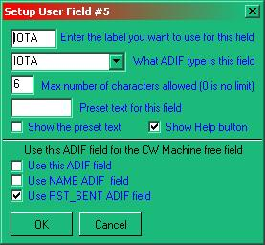

CWM\_19

There is one exception to the above and that is the RST Sent field. If this field is required to be collected from the CW Machine, then check the appropriate check box as shown in the above example. The user may select this option using any user field setup.

With this new option (if RST\_SENT is selected as the CW free field), RST\_SENT can be sent by using the [$sentrst$](#$sentrst$) or [$name$](#$name$) Macros.

### 5.16 SRX Entry Pane

A contest serial number received can be entered here.

By popular demand (and in violation of the ADIF spec), the CW Machine SRX field has been modified to allow entry of non-numeric characters. For contests that exchange other than a simple numeric serial number. If you do enter non-numeric data into this field, don't be surprised if some logbooks reject these QSOs.

## 6.0 INTERFACING THE CW MACHINE

### 6.1 Software Keyer

You cannot key your radio directly from either the serial or parallel ports from your computer and you will need to construct a simple interface depending on which options you select. A typical interface needed for each control wire is shown below, and this in conjunction with the table of connections should be sufficient to get you operational. This interface assumes that your rig gives a positive voltage onto the control and that this needs to be pulled to zero volts to operate.

**Typical interface circuit**

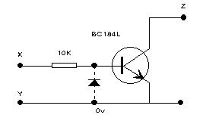

CWM\_13

**Notes** on the interface:

* 1. If you are interfacing between a Serial (COM) port and your rig, then include the diode;
  2. If you are interfacing between a Parallel (LPT) port and your rig, then the diode may be omitted;
  3. While a BC184L transistor is specified in the drawing, almost any NPN switching transistor will suffice; and,
  4. The connections to points X, Y and Z in the above diagram should be made in accordance with the following table:

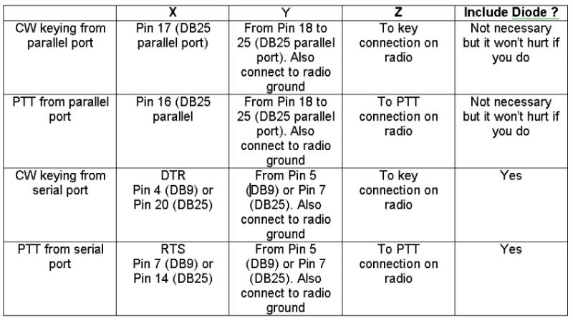

CWM\_14

**Note**: If your radio is turned on while Windows is booting up, you may experience a condition where the radio keys up when in the CW mode. To prevent this occurrence, you can use the "STROBE" line (pin#1) as a ground return to the keying circuit. This pin is normally set high when Windows boots up. When you open Logger32 it will set this pin to a low state making it available for CW keying ground return. Additional CW keying information is in the [Tips, Tricks and Troubleshooting](#_topic_TipsTricksandTroubleshooting1) section.

### 6.2 Alternate Interface

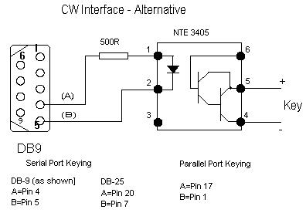

CWM\_15

### 6.3 WinKey

Consult your WinKey Interface manual.

*Created with the Personal Edition of HelpNDoc:* [*Full-featured EBook editor*](http://www.helpndoc.com/create-epub-ebooks)

**Data Terminal Window**

# Jim Hargrave W5IFP and Aki Yoshida JA1NLX

## 1.0 GENERAL

The Data Terminal emulates a standard terminal program and provides the interface between Logger32 and Terminal Node Controllers.

It interfaces with generic standalone TNC2 and the multimode TNCs, such as KAM, PK-232, PK-900 and MFJ-1278. The program provides for mode changes with the click of the mouse. It does not support modems that depend on the software to provide the AX.25 packet protocol.

The Data Terminal also has a serial port, whose primary function is to control remote antenna switches. This port is interfaced with the Bands and Mode chart antenna selection. For setup details see the “[Setup Antenna selector](#_topic_SetupAntennaSelector)” topic.

Operation of the Data Terminal is accomplished in much the same fashion as the Sound Card Data window. Many of the same Macros are available to make communications easier for the user.

## 2.0 SETUP

Initial setup is accomplished by opening the Data Terminal and selecting the Config menu item and then Port setup.

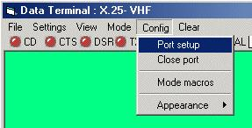

DTW\_1

This will open the Comport Setup dialog box that allows you to set your serial port parameters. These must match the TNC terminal settings. Click on Apply to save the settings and close the window.

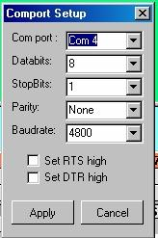

DTW\_2

## 3.0 MODE MACROS

If you have a multimode TNC, then you need to set up the Mode Macros. The Logger32 default settings are for the KAM, If you use a KAM the settings are already incorporated. If not then they must be tailored for your TNC. Select the Config and Mode macros menu items. This will open the Setup Mode Macros dialog box allowing you to label (left side) and build the command structure (right side). Just click on the left box and type the desired mode. Then click on the <**Show Macro**> button in the middle and the right side is where you can type in the commands for that mode. After you have entered all the commands for the modes. Select the <**Apply**> button to save the data and close the window. To change TNC modes you just click MODE and select the desired mode and the TNC should go into the selected mode.

**Note**: Each of the 10 Mode lines will support up to 36 Programmable buttons. The user can define more than one Mode line to the same mode, permitting more than 36 Macro buttons. This would allow establishing distinctive Macros for specific contests, etc. This feature is especially useful since most Multimode TNCs don’t have 10 different operating modes. To use this expanded feature, the user can list the same mode in more than one line and include a duplicate set of commands for each one.

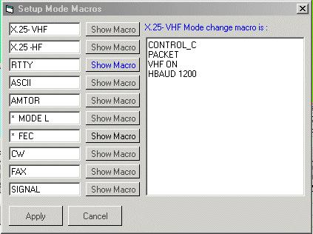

DTW\_3

## 4.0 LOGGING

You can enter data into the [Logbook Entry window](#_topic_LogbookEntryWindow) in the same fashion as the [Sound Card Data window](#_topic_SoundCardDataWindow1). A left-click on a callsign in the received text will automatically enter it into the Logbook Entry window callsign pane. A right-click on received text will bring up a selection menu. The following Items are available for direct entry:

SRX, QTH, NAME, CALLSIGN, SELCAL, QSL\_VIA, and GRIDSQUARE.

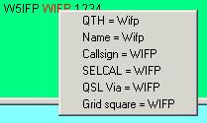

DTW\_4

## 5.0 FILE TRANSFER

### 5.1 Send a Text file

Select the File menu item in the upper left-hand corner and you will see 4 options. Select the Send a text file menu item and it will prompt you for the path/filename. When you Select the <**OK**> button or double-click the file, it will automatically be sent to the TNC. This is an excellent utility to set all the params in the TNC with a setup file in case the TNC goes into never land, or the battery dies.

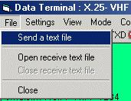

DTW\_5

### 5.2 Receive a Text file

Select the File menu item and then “Open receive text file”. The system will prompt you for the path/filename. Once you select the <**OK**> button the file will record all incoming data from the TNC. To close this file, select the File menu item and then “Close receive text file".

**Note**: This is an excellent way to save your TNC params. Once you have the TNC setup and working like you want it, just open a receive text file and give the TNC the dump params command “Disp Z” (PK-232) and it will dump all the settings currently in the TNC. Close the file and edit out all the garbage at the beginning of the file and you will have a good file to set up the TNC as mentioned above.

## 6.0 DATA TERMINAL MACROS

|  |
| --- |
| [$band$](#$band$) |
| [$call$](#$call$) |
| [$clear$](#$clear$) |
| [control\_x](#Control_<x>) |
| [$delay$](#$delay$)  See [Note 1](#Note_1) |
| [$escape$](#$escape$) |
| [$log$](#$log$) |
| [$longdate$](#$longdate$) |
| [$longdateandtime$](#$longdateandtime$) |
| [$longtime$](#$longtime$) |
| [$mode$](#$mode$) |
| [$mycall$](#$mycall$) |
| [$name$](#$name$) |
| [$qsy(nn)nnn.(nn)$](#$qsy(nn)nnn.(nn)$) |
| [$radiofreq$](#$radiofreq$) |
| [$receivedrst$](#$receivedrst$) |
| [$receivedgrid$](#$receivedgrid$) |
| [$tncdate$](#$tncdate$) |
| [$rotor$](#$rotor$) |
| [$selcal$](#$selcal$) |
| [$sentrst$](#$sentrst$) |
| [$serialnum$](#$serialnum$) |
| [$shortdate$](#$shortdate$) |
| [$shortdateandtime$](#$shortdateandtime$) |
| [$shorttime$](#$shorttime$) |
| [$version$](#$version$) |

**Note 1**: Pauses 250ms before sending next character to the TNC. This is typically used after sending control codes to the TNC to change mode (it takes a finite time for the TNC to get squared away).

## 7.0 MACRO BUTTONS

The Data Terminal will allow the user to configure up to 48 [Programmable buttons](#_topic_ProgrammableButtons) for each mode of operation. The current programming supports 10 different modes. There is a potential of 360 user-programmable buttons.

The Programmable buttons will support a combination of Macro commands and text to be sent to the TNC. This capability works in the same fashion as the [Sound Card Data window](#_topic_SoundCardDataWindow1). The user can include Macros and TNC control commands embedded into the text.

The control commands are case sensitive. The PK-232 must have the control code in uppercase to work, i.e., <**Ctrl+C**> in a command Macro can be either “control\_C” or CONTROL\_C. The word CONTROL is not case sensitive. TNC “control\_(x)” Macros do not use the $ preceding and following the command, These commands are interpreted as immediate commands. However Macros do require the $signs$.

7.1 Connect and Disconnect Macros

**Packet “Connect” Macro**:

[control\_C](#Control_<x>)    ( forces Command mode)

C [$call$](#$call$)       ( Callsign from the log Entry window)

**Packet Disconnect Macro**

[control\_C](#Control_<x>)

D

### 7.2 RTTY CQ Macros

The following Macro shows the proper use of the 'X' and 'Control-D' TNC commands embedded in a text Macro. The 'X' command forces the TNC to enter into transparent mode. The 'Control\_D' command stops transmission after the transmit buffer has been sent.

**Note**: Control\_D must be added to the end of the text stream. If the 'Control\_D' is placed on a separate line, it will cause the error message CMD:"\*\*\*Transmit Data Remaining" to be sent by the TNC:

[Control\_C](#Control_<x>)               (Forces Command mode)

X                           (Forces Transmit mode)

"CQ CQ CQ de [$mycall$](#$mycall$) $mycall$

"CQ CQ CQ de $mycall$ $mycall$ K 'Control\_D'

### 7.3 Logging Macros

Most of the normal logging function Macros that work with the [Sound Card Data window](#_topic_SoundCardDataWindow1) are available in the Data Terminal. Consult the [MACROS](#_topic_MACROS) topic to see which ones apply.

*Created with the Personal Edition of HelpNDoc:* [*Write eBooks for the Kindle*](http://www.helpndoc.com/feature-tour/create-ebooks-for-amazon-kindle)

**Digital Voice Keyer (DVK)**

# Geoff Anderson G3NPA

## 1.0 GENERAL

The DVK is designed to replay pre-recorded sounds to the user's radio system. Logger32 has three versions of the DVK as follows:

* + One that uses pre-recorded .wav files played via a sound card;
  + One that can be used to trigger pre-recorded messages as used by microHam products that include recorded message playback facilities; and,
  + One that can trigger the built-in message facilities in certain radios.

Only one version may be used at any one time.

All versions of the Digital Voice Keyer (DVK) are accessible by clicking on the DVK icon on the [Logger32 Toolbar](#_topic_ToolBar).



DVK\_1

Using the DVK Config menu, select the version of the DVK required. Please note that if port error messages are produced at this stage, simply ignore them.

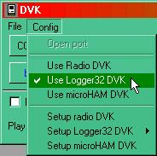

DVK\_2

Having selected the DVK type use the appropriate Setup procedure from the following list.

## 2. SETUP THE LOGGER32 DVK

To use the Logger32 DVK, you must first record your customized voice files. These .wav files can be recorded with an external program, or by using the File | Microsoft Sound Recorder menu option within the DVK. The sound (.wav) files can have any name and be located in a directory of your chose (typically the default Logger32 directory).

### 2.1 Macro setup

Having recorded your .wav files, you need to tell the DVK where to find them.

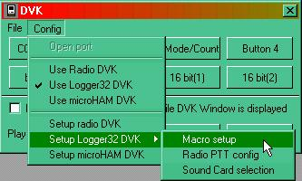

DVK\_3

Select the DVK Config | Macro Setup menu items to open up the Setup DVK dialog box,

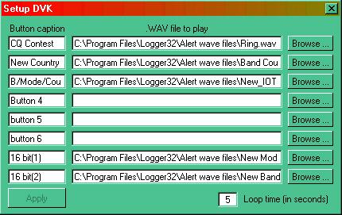

DVK\_4

and enter the appropriate button caption and .wav file details. In the above example just a few buttons are configured.

The loop time is the interval between the end of your message and the start of the repeat (if you have selected the <**Loop**> button on the main panel). This time delay is the same for all button selections.

To save your setup, select the <**Apply**> button.

### 2.2 PTT config

The DVK can key the transmitter either by selecting "VOX" on the radio, or by keying the PTT. The DVK menu option Config | Setup Logger32 DVK | Radio PTT will display the DVK Port setup dialog box. Select the PTT method and PTT Keying options as required and then the <**Apply**> button.

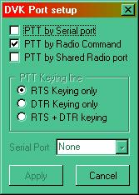

DVK\_5

### 2.3 Sound Card selection

The DVK menu optiosn Config | Setup Logger32 DVK | Sound card Selection will display the DVK Sound card selection dialog box and a list of available sound cards. Select the desired sound card and the <**Apply**> button.

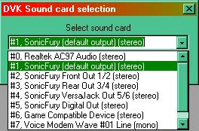

DVK\_6

### 2.4 Operation

On closing the setup window you will be returned to the main DVK control panel shown below.

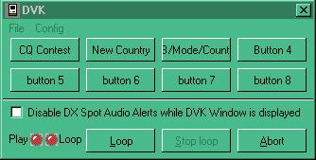

DVK\_7

Clicking on any one of the upper buttons will play your file via the sound card (see **Note 1** below). If you wish to use the loop facility, select on the <**Loop**> button and follow this with the selected announcement button. The <**Abort**> button will immediately terminate any voice file that is playing. The LEDs will indicate the current status.

If you wish to silence the DX spot audio alerts while the DVK is in operation, then simply check the box.

**Note** 1: In Logger32 versions BEFORE ver3.3.0 the DVK used the Windows operating system default sound card.

In version 3.3.0 the DVK used the sound device was defined in the digital sound card option Settings| Sound card Setup.

In versions 3.4.0 the DVK uses the sound card as defined in DVK|Config|Sound card Selection.

### 2.5 Shortcut Keys

The DVK supports the following hotkeys if the focus is on the DVK window:

* + <**F1**> to <**F8**>  Selects one of the Sound play buttons
  + <**Ctrl+L**> Turns Loop on
  + <**Ctrl+S**> Stops Play
  + <**Ctrl+A**> or <**Esc**> Aborts play.

If the focus is in the Log input window, then only the <**F1**> to <**F4**> keys will function.

**Note**: Intercept of the keys from the [Logbook Entry window](#_topic_LogbookEntryWindow) is by the [CW Machine](#_topic_CWMachineWindow), else the [Sound Card Data window](#_topic_SoundCardDataWindow1), else the DVK. If the CW Machine is loaded it will intercept the <**Fn**> keys. If the Sound Card Data window is loaded, it gets the keys. If neither of these is loaded, then the DVK gets the keys.

### 2.6 Disable DX Spot Audio Alerts while DVK Window is displayed

The box just above the Play and Loop LEDs provides the capability to disable DX spot audio alerts.This allows the DVK to be used while the [DX Spots window](#_topic_DXSpotsWindow1) can continue to display incoming spots.

An example of using this feature is, using the DVK to call CQ on a loop to open a dead band. If the audio alerts feature has been implemented, (right-click [DX Spots window | Setup | Enable audio alerts](#2.8.5_Audio_Alerts)) any alert (such as "New Band Country" or "Country Not Confirmed") will not be transmitted over the air.

## 3.0 SETUP THE MICROHAM DVK

The Logger32 DVK can be used to trigger any one of the first eight (8) pre-recorded messages as set up in the microHAM router DVK tab. It is assumed that these messages have already been recorded using the microHam facilities as the Logger32 DVK will only trigger these for playback. The Logger32 DVK offers no facility to record these messages.

**Note** that DVK messages are appropriate for microKEYER, microKEYER II and MK2R/MK2R+ units only. They are not supported with DigiKeyer, CW Keyer or USB Interface II.

### 3.1 Config

Select the DVK menu option Config. | Setup microHAM DVK to set up the button definitions, the loop time delay and the control port details, as shown below.

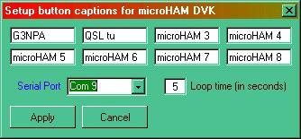

DVK\_8

Simply enter the required captions into the appropriate edit boxes, select the Serial Port, enter the Loop time and then select the <**Apply**> button.

The DVK communicates with the microHAM unit via a virtual control port. This virtual port is created within the microHAM router software and described below. **Note** that there is no need to define any more than just the port number.

### 3.2 Set-up control port for the microHam

You must initially create a virtual port to be used for control purposes in the device router. Use the microHAM menu option Virtual Port| Create. Once done you can then set this port number into the Control Port pane on the PORTS tab.

**Note** that this port is only going to be used for DVK triggering and therefore you are advised to check that the radio button called "microHAM control protocol on Com port" in the SO2R tab (MK2R/MK2R+ only) is NOT activated.

The screenshot below shows where (in this case) Com 9 port selection is entered in the microHam router setup. [See Control bottom left and indicated with cursor arrow]

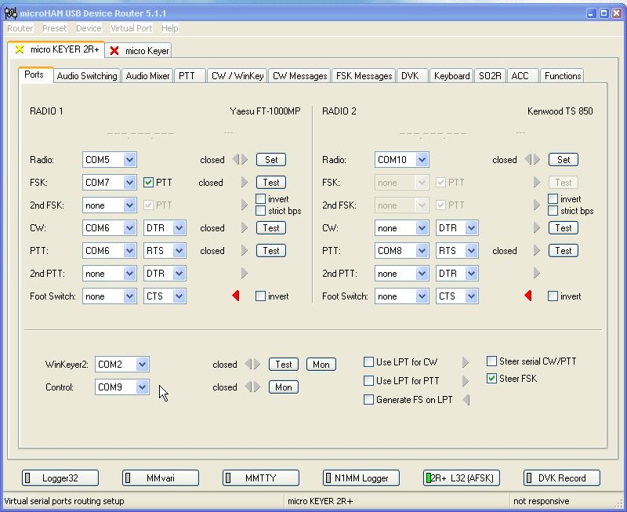

DVK\_9

### 3.3 Operation

Selecting each button will trigger the messages stored in the microHAM unit. If you wish to "loop" any announcement, select the <**Loop**> button and then the message button desired. The delay between repeat messages can be set in the setup DVK window [see [DVK\_8](#DVK_8) above] and to stop the loop, select the abort button.

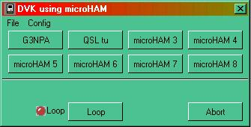

DVK\_10

## 4.0 SETUP THE RADIO DVK

This option allows the user to trigger the inbuilt sound recording memories in certain radios. Currently only the Elecraft K2/K3, and the Yaesu FT2000 and FT9000 are specifically addressed but others can be coded in the future. The memories are triggered by sending codes directly to the radio over the CAT interface and these codes are dependant on the particular radio command set.

### 4.1 Config

There is no need to advise Logger32 of the radio type (for the DVK option) as this is derived from the information contained in the [Radio Configuration](#_topic_SetupRadioControl) data, which is set up elsewhere for the CAT interface. However, the button captions require configuration using the DVK menu options Config | Setup Radio DVK. Simply enter the desired captions and select the <**Apply**> button.

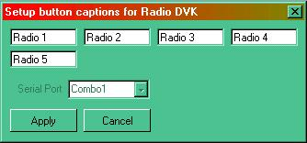

DVK\_11

### 4.2 Operation

Select the desired button to trigger the radio memory.

**Note**: There is no looping facility available for this option (because Logger32 does not know when a particular message has concluded).

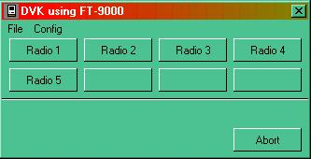

DVK\_12

**Note**: For [SO2R](#_topic_SingleOperatorTwoRadiosSO2RSuppo) users, you should make sure that both radios contain the same message for each message button as there is only one button set in Logger32. The window title will change when you swap radios (if you use different radio types) once a button is depressed.

*Created with the Personal Edition of HelpNDoc:* [*Free CHM Help documentation generator*](http://www.helpndoc.com)

**NCDXF Beacons Window**

# Geoff Anderson G3NPA

## 1.0 GENERAL

The NCDXF, in cooperation with the IARU, operates a worldwide network of high-frequency radio beacons on 14.100, 18.110, 21.150, 24.930, and 28.200MHz.

In principle, one can simply listen on the beacon frequencies and copy the CW callsigns of the various beacons to figure out where the band is open, but in practice, not every ham operator can copy calls at twenty-two words per minute and some beacons may be heard at too low a signal strength to catch the call. Because the beacons transmit at known times, it is easy to know which beacon is being heard without actually copying the CW callsign. Each beacon transmits every three minutes, day and night. A transmission consists of the callsign of the beacon sent at 22 words per minute followed by four one-second dashes. The callsign and the first dash are sent at 100 watts. The remaining dashes are sent at 10 watts, 1 watt and 100 milliwatts.

There are 18 beacons worldwide and each is allocated a 10 second time slot in which to transmit its identification plus a series of dashes. It is important therefore to have the computer clock synchronized to international time if you are to correctly determine which beacon is actually being heard at any one time.

More information concerning the beacons, including their current status, may be found at www.ncdxf.org/beacons.html.

Logger32 provides a window to assist in the determination of which beacon is active on which band and at a particular time. Click on the   Icon in the button bar to obtain the window shown below.

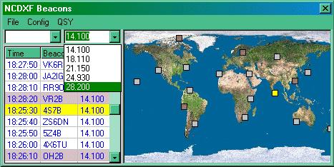

NCDXFB\_1

The beacons may be displayed as a list of all beacons on one frequency (above) or as a single beacon on its multiple frequencies (below).  The current position is the highlighted line in the center of the table, the active time showing in the left-hand column and frequency in the right. The display of the map is optional.

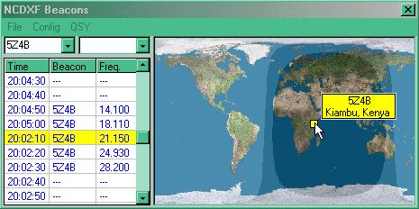

NCDXFB\_2

In the above screenshots, beacons that have been marked as being inactive (see [Setup Beacons](#2.2.3_Setup_Beacons) below) show with a darker background. This background color may be changed as desired (see [Appearance](#2.2.2_Appearance))

On the map all beacons are shown and in this case, inactive beacons are red, the currently operational beacon is yellow and the remainder are grey.

The lower of the two screenshots above also shows a typical mouseover tooltip and the grayline.

## 2.0 MENU ITEMS

### 2.1 File

Simply gives an alternative method to close the window

### 2.2 Config

### 2.2.1 Map

Here you may select the underlying map, switch the map section on/off, display the tooltips and or the grayline as required.

Please see the topic [Background Maps](#_topic_BackgroundMaps).

### 2.2.2 Appearance

Here you may set your preferences for the tabular display, including highlight, grid colours and the map markers.

### 2.2.3 Setup Beacons

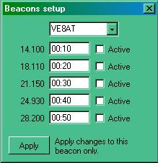

NCDXFB\_3

Here you can mark the beacons’ activity. In the screenshot above all frequencies for VE8AT are shown as inactive.  Simply check the appropriate frequency for activity (or otherwise) and select the <**Apply**> button.  Activity details can be obtained from the NCDXF web site <www.ncdxf.org/beacons.html>

### 2.2.4 Automatic Radio QSY

Check this option if you require automatic QSY of the radio. This feature will only function if the focus is in the NCDXF window.

### 2.3 QSY

When not grayed out, this menu option will allow for an immediate QSY to the active beacon frequency.

**Operational Tip**

This window will function at the same time as the [Sound Card Data window](#_topic_SoundCardDataWindow1).  It is therefore possible to use the spectrum or waterfall display to monitor the received signals even when extremely weak (and to note that no two beacons seem to be on exactly the same frequency!).

*Created with the Personal Edition of HelpNDoc:* [*Free EBook and documentation generator*](http://www.helpndoc.com)

**Additional Information Windows**

# Geoff Anderson G3NPA and Aki Yoshida JA1NLX

## 1.0 GENERAL

The main purpose of this section is to give the operator some brief and quick details that are related to the data entered in the [Logbook Entry window](#_topic_LogbookEntryWindow) and what is in your logbook. These windows are accessible ONLY via the "?" icons found in the Logbook Entry window. Please see the Logbook Entry window [Basic Setup](# 1.0_BASIC_SETUP) section for details on how to set up Information buttons.

Additional information is currently available for IOTA, US States, US Counties and Grid Squares only. If other ADIF input panels in the [Logbook Entry window](#_topic_LogbookEntryWindow) are set up with the "?" icon, then a "Not Coded Yet" message will appear when selected.

## 2.0 IOTA INFORMATION WINDOW

The picture below shows that the cursor has been placed over the IOTA information access button.

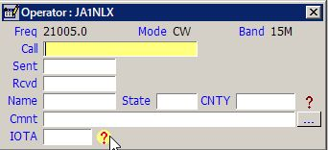

AIW\_1

To use the additional information, enter a callsign and the IOTA number into the appropriate edit boxes in the [Logbook Entry window](#_topic_LogbookEntryWindow) and then click on the IOTA "?" icon. This will bring up the IOTA Additional Information window advising the log status of the particular island group (see typical panel below). In this case, the Title bar is telling the operator that EU-006 is needed.

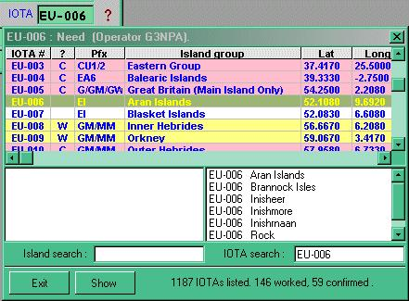

AIW\_2

The messages that appear in the Title bar will indicate “Worked”, “Confirmed” or “Need”.

As IOTA credits are neither band nor mode conscious, the information reflects the general state of the log for a particular IOTA group. If more specific band/mode information is required, then consult the IOTA awards table.

**Note** that the IOTA search has been set to EU-006 and the highlight placed in the correct position in the table.

The window shown above may be used to carry out searches for islands or groups. Typing in a word in the Island search will give island names that most closely match what you have entered in the left-hand pane. Alternatively, one can enter the known island IOTA code and all the known islands in that group will be displayed (note that this will depend on what you have entered into the main database). In the picture below the Island of "Belli" has been entered and by clicking on the name in the left pane, two things will happen. First, all the islands listed in that group will appear in the right-hand pane and second, the main title will be highlighted in the listing. In the case below, the highlighting is in yellow with a red script (but this is user-definable). The light red and light yellow highlights show island groups confirmed and worked (again these highlight colors are user-definable).

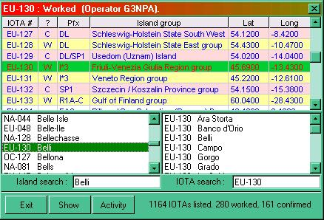

AIW\_3

Having highlighted an IOTA reference, you can now click on the <**Show**> button to produce a map with the nominal center of the island group marked as shown below. In the picture below, the island group is denoted by a small yellow square just at the northern end of Italy.

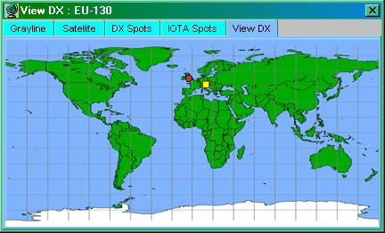

AIW\_4

Once this map is displayed, you can select any island group from the table above and the island marker will move to the appropriate location.

The map size can be changed to suit by using the normal operating system facilities for resizing a window.

By right-clicking on the map itself you can get at the menus for customizing the map, all of which are self-explanatory. You can change the map itself to something more appropriate and/or modify the island marker both for size and color. See the topic [Background Maps](#_topic_BackgroundMaps).

The <**Activity**> button will produce a table of data derived from the RSGB IOTA web site. See the [Utilities](#_topic_Utilities1) topic for more information.

## 3.0 US STATE, US COUNTY AND GRID SQUARE INFORMATION WINDOWS

The US State, US County and Grid Square information windows all work in a similar way as described above. Some examples are shown below.

### 3.1 US State Information Window

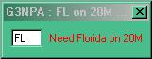

AIW\_5

### 3.2 US County Information WIndow

In the case of US counties, the information window has an additional facility in that the whole list of counties will be searched for a match as you type in a name. Clicking on any of the counties presented will give something similar to the info window shown on the right below.

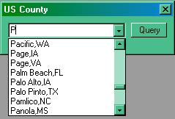

AIW\_6

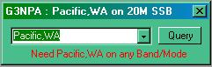

AIW\_7

### 3.3 Grid Square Information Window

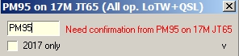

AIW\_8

*Created with the Personal Edition of HelpNDoc:* [*What is a Help Authoring tool?*](http://www.helpauthoringsoftware.com)

**Award Tables**

# Geoff Anderson G3NPA and Aki Yoshida JA1NLX

## 1.0 GENERAL

Logger32 contains a comprehensive set of tables to display the statistics from the current logbook. Versions of Logger32, up to and including 2.3.0, have considered all entries to be QSOs and therefore included these into the awards table statistics. From version 2.4.0 onwards, a feature has been added to support incomplete QSOs (or heard, not worked QSOs).  Simply put an '=' at the end of the call, i.e., G3NPA= will appear as a QSO in the Logbook, but any data recorded will not show in any of the Stats.

**Note**: If you try to QSL a recorded callsign which contains the "=" character, Logger32 will advise you of the error:

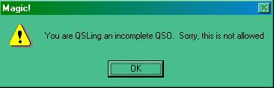

AT\_1

W2RU - Bud Hippisley says-

*"The uses for this feature are numerous, and limited only by your imagination.  For instance, if you were accustomed to putting your CQs in your paper log (say you wanted a total record of when you were on the air, in anticipation of possible TVI complaints), you can now do that in Logger32 without it appearing as a QSO simply by entering 'CQ='.*

*Similarly, an informational log entry of WWV sunspot numbers no longer need show up as a spurious USA QSO; simply enter 'WWV=' and the data you wish to record."*

Also see the topic [Logbook Informational Entries](#_topic_LogbookInformationalEntries).

From version 3.19.0 a new system of award tracking was introduced to supplement the awards tables as a result of changes made to the [ADIF](#ADIF) specification. For more details on this particular aspect please refer to the topic [Award Tracking.](#_topic_AwardTracking1)

The awards tables can be accessed through the Logger32 [Main menu](#_topic_MainMenu) [Awards menu](#5.0_AWARDS_MENU_ITEM) option.

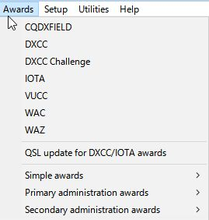

AT\_2

The information available from each option is of a similar format so only one table is described here.

Awards are divided into three types namely

* + Simple;
  + Primary Administration; and,
  + Secondary Administration.

Primary and Secondary awards rely on data stored in the Primary (STATE) and Secondary (CNTY) ADIF fields.

Simple awards rely on data stored in one of the USER\_X fields except for GridSquares, WPX and 10-10 award tables which use their own ADIF fields.

All awards tables show results for all bands but the 10-10 table need a special mention. Although the 10-10 awards table shows all bands, Only contacts made on 10M are valid and therefore only this column will be filled even if there are some records of 10-10 numbers against QSOs NOT on 10M in the logbook.

## 2.0 THE GENERAL AWARDS WINDOW

A typical Award Table is shown below. The data is shown on a per band basis as well as giving totals. Each band/country (or whatever) slot can show a (W)orked or (C)onfirmed flag. For some specific awards a credit (S)ubmitted or a credit (G)ranted flag can be shown. (An example of a “G” flag does not appear in the example below)

Selection of what is displayed can be refined further by the appropriate selection of the Mode, Operator and QSL type as desired.  What is available here is dependent on your own log and general set up.

The Stats reflected in this chart can be for the “Complete Logbook” or depicted by Calendar Year. User selection is by pulldown menu in the 5th pane. See the Worked/Confirmed window section for additional details

It is also possible in some tables to sort by column. Like all tables in Logger32, if any column header is in Red (as is PFX in AT\_3 above), then the option exists for the user to change the sort order to another indexed column (in the case of the DXCC Awards, the user can also sort by Country or CQZ). Simply click on the column title to sort.

The band order (high to low, or low to high) is dependent on the menu setting TOOLS | AWARDS SETUP | SHOW BAND COLUMNS IN REVERSE ORDER.

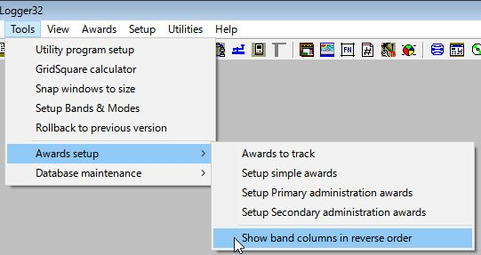

AT\_2A

**Award table for DXCC**

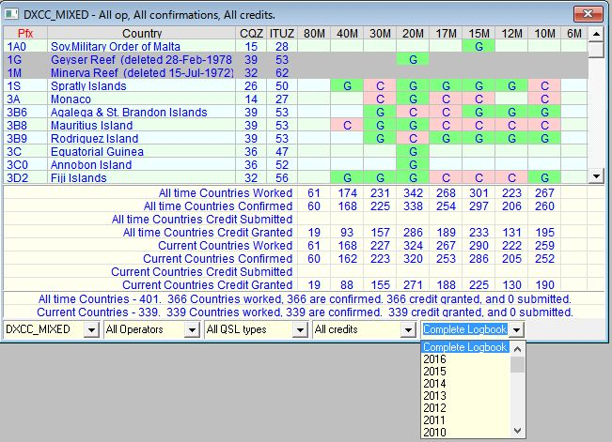

AT\_3

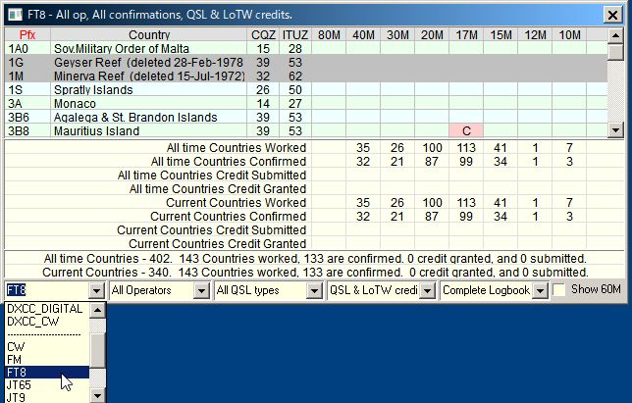

AT\_3AA

**Note**: The Annual stats option is available in CQDXFIELD, DXCC, DXCC Chalenge, VUCC and GRID squares Award table.

**Note:** DXCC stats are displayed by Mode, FT8, JT65 etc if user select Mode.

**Award Table for WAS**

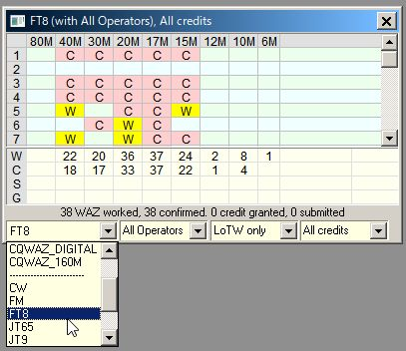

AT\_3AB

**Note:** DXCC and WAZ stats are displayed by Mode, FT8, JT65 etc if user select Mode.

**Award Table for IOTA**

Standard IOTA (All HF Bands) award counts QSOs only on HF Bands. If you want to see VHF/UHF award then check “VHF/UHF”.

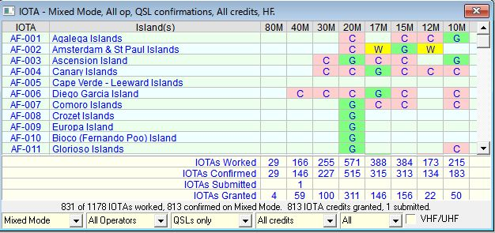

AT\_3A

A left-click on any of the “W”, “C”, "S" or "G" flags will bring up a further window showing the details of those contacted for the selected square. Example:

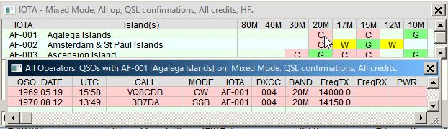

AT\_3B

The DXCC Challenge will always display the 10 bands covered by the award irrespective of the Band/Mode table.

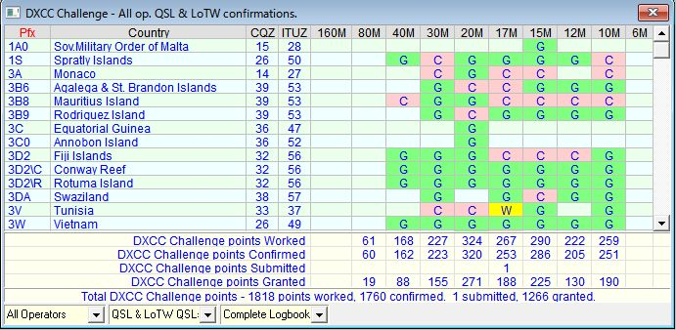

AT\_5

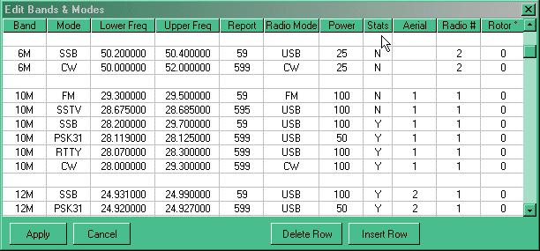

AT\_6

For additional information, see the sections [Logbook Page window](#_topic_LogbookPageWindow) and [Previous QSOs window](#_topic_PreviousQSOsWindow).

## 3.0 THE VERIFIED ENUMERATION

As far as Logger32 is concerned the “V” enumeration system that was introduced in earlier issues has now been totally removed and replaced with a much more comprehensive system. Refer to the [Award Tracking](#_topic_AwardTracking1) topic for more detailed information.

## 4.0 PHONE/DIGITAL MODE SETUP

For details on how to setup Awards for Phone and Digital modes, see the section [Phone/Digital Mode Setup](#7.0_PHONE/DIGITAL_MODE_SETUP) in the [Logbook Entry window](#_topic_LogbookEntryWindow).

## 5.0 PRINTING AWARDS TABLES

See the topic [Printing Awards Tables](#_topic_PrintingAwardTables).

## 6.0 FAQs

The most common question relating to the awards tables is:

**Q**:  “My awards table does not show up my 20M contact with xx9xxx (some remote or rare callsign)”

**A**: There can be a number of reasons why this might be, so check:

* + Was the QSO entry logged under the “Operator” you anticipated?
  + If you are not using the “Mixed mode” display, have you selected the correct mode for the QSO in question?
  + If you have been editing directly in the logbook it is advisable to perform a “recalc”. See the Logger32 Main menu Tools | Database Maintenance | Recalculate statistics menu items.
  + Check the actual log entry. Is all the data shown correctly? Quite often the problem is one of the DXCC entity recognition from the prefix.
  + Is the particular band/mode combination shown as a “Y” in the Stats column of the BandMode table?
  + Are you looking at the correct logbook? As Logger32 will maintain as many logbooks as you desire – are you looking at the right one?
  + If using the digital mode option, have you got that mode included in the digital mode table?

Be aware that CQ Zone tables compiled from your logbook may result in erroneous statistical summaries unless you take pains to clarify the status of ambiguous entries. This problem is most apt to occur where CQ Zones split political or radio licensing boundaries.

For example: all states in the USA 4th call area are in CQ Zone 5 except Alabama, which is in Zone 4.

In the absence of additional detail when logging a contact, Logger32 treats all 4th area stations as being in Atlanta, Georgia, and accordingly assigns CQ Zone 05 to these log entries. Thus, a QSO with W4AP in Montgomery, Alabama will be logged (incorrectly) as Zone 05 until you provide more detailed information. Upon entering "AL" in the State field of your Logbook Entry window or the State column of your Logbook Page window, the Zone entry will change from "05" to "04" which is correct.

**Note**: If you later remove the State information from your log entry, the CQ Zone for your contact with W4AP will revert to the generic "05" for 4th call area stations.

Also note that Logger32 does not automatically use State information from a QRZ.com lookup.

## 7.0 AWARDS TABLE SETUP

### 7.1 General

Releases of Logger32 up to and including Version 2.8.1 were designed to be compatible with the Amateur Data Interchange Format (ADIF) specification version 1. Any logbook information which complied with this specification could be used with Logger32. The ADIF specification has now moved on and although quite a lot of the specification remains unchanged there are some significant alterations. In an attempt to maintain compatibility, Logger32 has now undergone a major change. For those that would like to study the revised ADIF specification a copy can be found on the [ADIF web site](#Link:_ADIF).

The main changes to the specification have concentrated on the definition of the various fields, adding a large number but also changing the use of and/or deleting others.

Many countries (DXCC entities) are historically subdivided into smaller regions. And even these can be subdivided again. Take the USA where there are 48 contiguous states and in each state, numerous counties. Because there are so many variations, and not all of them geopolitical, it was very difficult to cover this in ADIF. It would have been impossible to cover all the variations unless you created a confusingly extra number of ADIF fields.  With the new system of Primary Subdivisions and Secondary Subdivisions almost all variations can be covered in only two fields. These fields are still called "STATE" and CNTY but from now on the State field will cover all primary subdivisions and the CNTY field all secondary subdivisions.

The most significant change, as far as Logger32 is concerned, is the redefinition of the original STATE and CNTY fields.  These are now defined as:

**Enumeration function of Country Code** - the code for the contacted station's Primary Administrative Subdivision, i.e., US State, JA Island, VE Province.

**CNTY Enumeration function of STATE** - the contacted station's Secondary Administrative Subdivision of contacted station, i.e., US county, JA Gun, in the specified format.

Some Primary Administrative subdivisions are also defined but no Secondary

This revised system now allows for the recording of award data in just two columns the primary (STATE) and Secondary (CNTY).  For example:

|  |  |  |
| --- | --- | --- |
| **AWARD** | **STATE** | **CNTY** |
|  | (Primary Subdivision) | (Secondary Subdivision) |
| WAJA | 12 | for Chiba prefecture |
| JCC | 01 | 03 for Hokkaido Otaru |
| JCG | 10 | 004 for Tokyo Oshima |
| DOK | E | 23 for Hamburg Trave |
| WAS | CA | for California |
| US Counties | CA | Alpine for Alpine County CA |

It can be seen in the last entry in the table above that the handling of the original State and County records is much the same but the system has been expanded to accommodate other information.

The new system allows for the generation of ones own awards tables to a limited extent. Based on the primary data there is no reason why a specific/personal secondary database could not be formed and hence listed in an “award” or stats table.  DOK, JCC and JCG awards will fall into this category.

Although Logger32 will include DOK, JCC and JCG data and awards tables, there are hundreds more awards that will NOT be included. It will be for the individual to add/subtract what they require in the way of awards data and for them to make up the appropriate databases accordingly.  While awards based on secondary administration information can be formulated, it is not generally possible in the case of primary administrations.   For example, it is not possible to generate an award for WAE or CCC where a large number (but not all) of DXCC entities are involved.  The maximum number of DXCC entities that Logger32 will accept, at this time, for a primary administration award is five.

The first thing to fully understand is that the fields that were called State and Cnty will now hold primary and secondary subdivisions data. You will have to ask those who wrote the ADIF specification as to why they didn’t actually change the name of these fields at the same time so as to make it less confusing.  Logger32 is simply following the specification.

If you have set up your Logbook Entry window to accept a US State and County, then it is recommended that you change the title of these input panes to reflect their new status as Primary Admin and Secondary Admin and the same applies to the column titles in the log AND the previous QSO tables.

In addition to the change of use of the STATE and CNTY fields, the original DOK, JCC and JCG fields have become redundant. These have been renamed as USER1 to 3 respectively and are used as data input for “simple” awards (discussed later).

Also the SubMode and VE\_Prov fields are not used in ADIF ver 2.

In versions of Logger from 2.9 onwards, the Submode field, a non-index field (you cannot sort on it), has been reused as the new K\_INDEX field and the VE\_Prov field, an indexed field (you can sort on it), has been reused as the new SFI field.

**Notes**

* 1. The original data (SUBMODE and VE\_PROV) has not been cleared from the logbook(s).  If you intend to use these new fields, you should check and edit out any data that is left from earlier use of the fields; and,
  2. The fields are now a maximum of three digits in length.

Finally the AGE field has been replaced by DISTANCE (being of far more practical use).

DISTANCE (in Km) is automatically logged the same way as SFI, A\_INDEX and K\_index.  This is a non-index field (you cannot sort by DISTANCE).

In summary, the following ADIF fields have been renamed/reused as follows:

**Original field name             New field name**

                                         State                                    State (Primary Admin Subdivision)

                                         Cnty                                     Cnty (Secondary Admin Subdivision)

                                         DOK, JCC, JCG                    User1,2 and 3

                                         VE\_Prov                               SFI

                                               Submode                              K\_Index

                                         Age                                     Distance

                                         New field (added)                  A\_Index

### 7.2 Databases

Two new databases are provided called PrimaryAdmin32.xxx and Secondary Admin32.xxx where xxx = ISD, ISF, ISM and ISL. As the names imply, the PrimaryAdmin32 database contains all the information about primary subdivisions (as listed in the ADIF specification) and the secondaryAdmin32 database holds the secondary information.  Typically, these will contain the US counties, the JCC, JCG and DOK information.  If the user adds any further secondary data, then it will be stored in this set of files.

Full editing facilities of both these databases are included with the new software.

In line with the general changes, the County32 database is no longer used and can be deleted. [**BUT DO NOT DELETE ANYTHING ELSE**]

### 7.3 Editing the New Databases

**General words of Caution**

As a general precaution, you are strongly advised to make a backup copy of any database that you are going to edit.  You are entering dangerous territory… and you might well need the ability to backtrack.

The basic primary admin. data is held in the four files named PrimaryAdmin32.ISD, .ISF, .ISM, and .ISL .  The secondary Admin. data is contained in the four files named SecondaryAdmin32.ISD, .ISF, .ISM, .ISL and all eight are located in the default Logger32 directory.

It should be appreciated from an early stage that Logger32 will only provide the backbone or basic primary and secondary subdivision databases. Any changes that you make or add to your personal copies of these databases will be destroyed on the loading of a new set of (say) Logger32 databases or set from anyone else – UNLESS definite precautions are taken.

It is possible to save each individual award and or country information (both primary and secondary) into CSV files and if you like to construct your own databases for awards this method of saving the files is HIGHLY recommended. It is then relatively easy to re-load your personal databases when required.

### 7.4 Primary Administration Data

To edit the contents of a particular Countries primary data, use the Logger32 [Main menu](#_topic_MainMenu) [Tools | Database maintenance | Primary administration maintenance.](#3.0_TOOLS_MENU_ITEM)

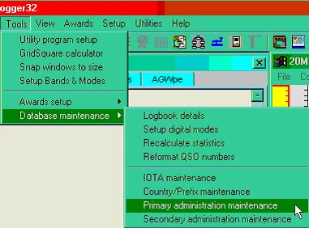

AT\_8

followed by the selection of the Country (or Administration) of interest

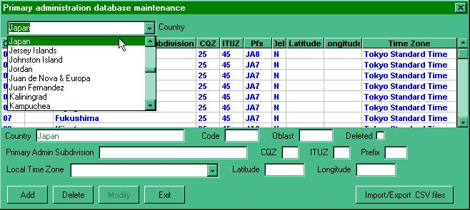

AT\_9

to open the appropriate edit page.

To edit a single entry, scroll to the required position in the list and left-click on the line required.  The existing data for that line will now appear in the panes below the main list ready for editing.  All panes can be edited except for the County.  When set to the new requirements, select the <**Modify**> button.

If it is a new entry that is required, scroll to the bottom of the viewing list and click on the blank line and enter the new data.  On completion, select the <**Add**> button to save the entry into the database. **Note** – the display will jump back to a point near the top of the list, so to check your new entry you will need to scroll down again.

If there are a large number of changes to be made then the facility to export the data to a .CSV file is available. Simply use the “Import/Export.CSV files” button located to the bottom right of the database maintenance window.

Make sure you are going to export the required county data (selected in the upper pane) and use the <**Export**> button as shown below. There will follow a familiar method of section of file name to use for the new file and this will be followed by an announcement of the number of records exported.

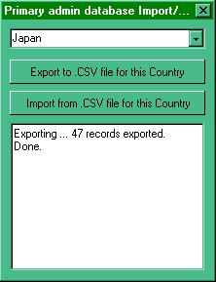

AT\_10

The CSV file produced is then available for import into Excel for further work. The same <**Import/Export**> button is used when re-loading the database.

**A Note of Caution**   When reloading revised data you MUST ensure that the correct country is showing in the various indicator panes.  If the wrong country is showing you will overlay data to the incorrect area in the database.

### 7.5 Secondary Administration Data

These databases are used to assemble the required data for some of the awards tables. It is here that it will be possible for the user to develop background information for individual award tables

From the Logger32 [Main menu](#_topic_MainMenu), select the [Tools | Database maintenance | secondary administration maintenance](#3.0_TOOLS_MENU_ITEM) menu items and then the required Award (JCC in this example) from the uppermost selection panel.

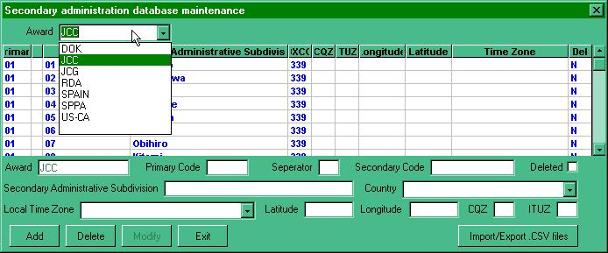

AT\_11

to obtain the edit window shown above. The editing and import/export are very similar to that described above.

A word of caution here when using Excel to generate the database. If the DXCC and primary and/or secondary data is numeric and has the need for leading zeros, then the appropriate cells should be formatted in Excel BEFORE exporting the data in CSV format.  Also it will be noticeable on import to Excel as the leading zeros will not show until the columns are formatted.

To format the particular columns in Excel, click on the column header to highlight the column required and RIGHT-click the mouse and select “format cells”.  Select “custom” and make the Type read 00 (for two digits) or 000 (for three digits) and select the <**OK**> button.  Leading zeros will now show and will be recorded in the output .CSV file.

## 8.0 AWARDS

Logger32 now supports three types of awards:

* 1. Based on Primary database (Primary Subdivision awards) example: WAS;
  2. Based on a Secondary database (Secondary subdivision awards) example: JCC, JCG, DOK; and.
  3. Awards having no databases or reference lists as such. The user simply enters the data and the list continues to grow. (Simple awards). example: Gridsquare, WPX.

In order to construct and use an award table it is necessary to go though a number of steps – depending on the type of award.  In the main the user will construct secondary or simple awards.

**Note** the terms “secondary” and “simple” here refer to the way Logger32 handles the tables, and no reference to the quality or otherwise of the award itself is implied

### 8.1 Primary Awards

The major primary awards use ONLY information from the primary administrations database.  The WAS (Worked all States) award is a good example as it uses data from three DXCC entities namely the USA, Alaska and Hawaii.  In order to set up this award (assuming that the primary administration database is present and complete), all that is required is to define the Award name and which administrations to use.

On the Logger32 Main menu, select the Tools | Awards setup | Setup primary administration awards menu items to open the Primary administration award setup dialog box as shown in [AT\_13](#AT_13) below.  Here it is possible to define the award name and the DXCC countries that count towards the award.

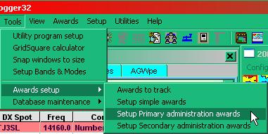

AT\_12

**Note** that award No.1 is already used (WAS).  If you are preparing a new award, then select an award number that has no associated name.  In any event, be VERY careful not to overwrite existing award data

When selecting a country, use the pull-down list as this will then only present those countries where data is present in the database.

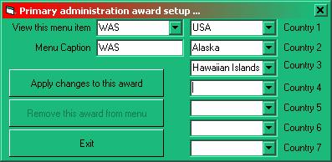

AT\_13

Once you have made your changes as required, select the <**Apply changes to this award**> button and the award table will become available in the primary admin. award menu listing as follows:

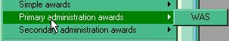

AT\_14

### 8.2  Secondary Awards

This is the area that is most likely to attract user attention and where awards based on more specific or perhaps personal preference data can be constructed. The award however MUST be associated with a primary administration database. For example – DOK, JCC and JCG are obvious selections but lists like UK lighthouses or something relevant to the users own country could also be included.

In order to make this work it is necessary to complete the following stages

* 1. Ensure primary data present.  It is important to realize that not ALL DXCC entities have primary data entered for their country;
  2. Construct a new secondary data list.  This would be the list of your choice;
  3. Load new secondary data list into the Secondary database itself; and,
  4. Make the new award available in the secondary admin. awards menu.

A description designed to give a better appreciation is given below entitled “Setting up for an award – an example.”

### 8.3 Simple Awards

These awards will have no reference list as such.  The data will be collected from one of three “User x” fields (where x=1, 2 or 3) and the data will simply continue to grow as new entries are made – in a similar manner to the WPX award listings.  The operator can collect almost anything they want but some obvious selections might be Special DOKs,  Castles or Summits on the air, lighthouse references, etc.  The User\_x fields are the re-named DOK, JCC and JCG fields so it is possible that there might be data contained somewhere within their columns.  The user will have to edit these entries as appropriate.

**Note**: Starting with Logger32 version 3.50 the user\_x fields are enlarged to 50 characters maximum. Like most of the ADIF fields, the User x fields may be utilized within the [Logbook Entry window](#_topic_LogbookEntryWindow) if desired.

In order to make the simple award table available in the awards selection menu and to define which fields are to be used for which award, select the Logger32 [Main menu](#_topic_MainMenu) [Tools | Awards setup | Setup simple awards](#3.0_TOOLS_MENU_ITEM) menu items from the main menu and complete – as appropriate.

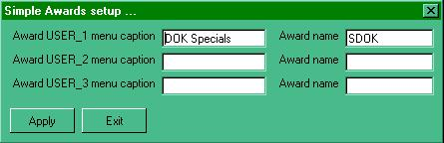

AT\_15

The left hand entries will appear in the simple awards menu

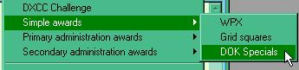

AT\_16

while the entries into the right hand entry panes will appear above the award table itself.

### 9.0 Entering award data via the Logbook Entry window

When entering award data into the log, simply add the primary (STATE) and secondary (CNTY) data to the Logbook Entry window (as one would have done for US State and County) and select the <**Enter**> key.

**Note** that in the example given below, the P.Admin and S.Admin input panes are actually the STATE and CNTY fields renamed in the user input setup options

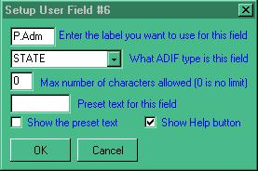

AT\_17

If this data is not known then left-click of either the primary or secondary <**?**> buttons (as seen below)

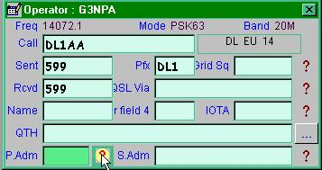

AT\_18

and select the primary and secondary subdivisions as required using the right mouse button and the data will update in the [Logbook Entry window](#_topic_LogbookEntryWindow).

Logger displays further information at the bottom of the window

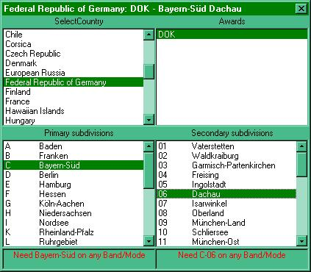

AT\_19

### 10.0 Entering/Editing award data via the Logbook Page window

It is not possible to edit directly into the primary/secondary columns of the logbook.  If this is required, then right click on the secondary admin column (was CNTY) to bring up the option menu.  Select “Edit Admin Subdivision info” and Logger32 will pause and then present the user with the complete set of primary and secondary selections available.

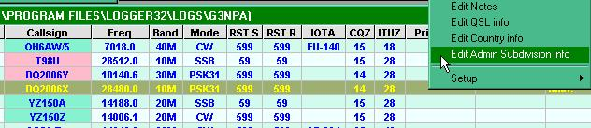

AT\_20

In the example shown above, where the QSO in question was with a German station, then Logger32 will display the appropriate table thus:

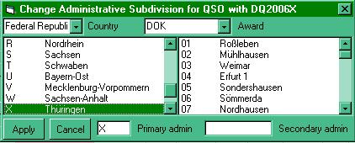

AT\_21

Simply select the appropriate award (for the country), highlight the primary and secondary data (or type in the code into the appropriate panes), then select the <**Apply**> button to transfer the data to the log.

On occasions the award pane may not fill automatically.  This is either because there are more than one award set up using the primary data (an example would be Japan and the JCC/JCG awards) and Logger32 cannot determine which to use or no primary data has been set up for the particular country.

**Note**: If the primary code does not exist, then Logger32 will generate an error message. If the code being entered is valid, then check the primary and secondary databases for the country and/or award.

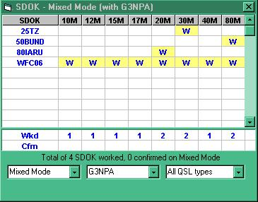

AT\_22

## 11.0 SETTING UP AN AWARD - AN EXAMPLE

Along with the new primary and secondary administration databases comes the option to construct award tables that are not otherwise provided.  Awards can be based on either primary administration information or a combination of primary and secondary information. The “walk through” example given below will be based on secondary information. Please note that the construction of awards tables based solely on primary administration data is a very similar to that described below except they do not require any action at [11.2 step 2](#11.2_Step_2_–_Create_the_secondary_(award)_database).

The example assumes the following:

* + that it is an award based on England;
  + that England is divided into two primary sections – North with the reference AA and South with the reference BB; and,
  + that the North has 3 subdivisions called demo only, demo2 and demo3, with the reference numbers 01, 02 and 03 respectively,  while the South has 2 subdivisions called demo 4 and demo 5 with references of 01 and 02 – thus giving a total of 5 subdivisions AA01, AA02, AA03, BB01 and BB02.

### 11.1 Step 1 – Create the primary database

Open the Primary admin. database maintenance window (as described in the described in the [Editing the New Databases](#7.3_Editing_the_New_Databases) section) and using the pull-down tab for the “Country”, select England.  In this particular case it will present a completely clear edit form. [Note – this might not always be the case]

Enter the two primary divisions [AA and AB] manually using the entry/edit panes below the blank data list.  When each entry is complete, “Add” the data.

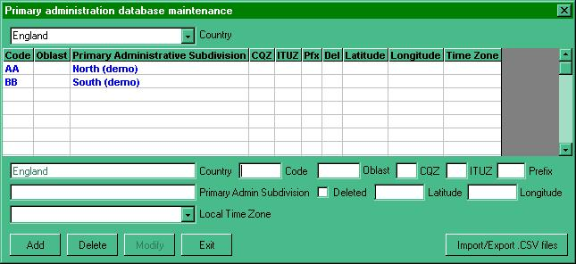

AT\_23

If you wish to retain the data in a CSV file for later addition or modification using Excel then use the <**Import /Export CSV files**> button.

### 11.2 Step 2 – Create the secondary (award) database

Open the secondary admin. database maintenance window as described above and using the pull-down tab for the “Award”, select the blank area at the base of the list.  This will present a completely clear edit form.

Enter the name you wish to use for the award in the topmost pane.  **Note** that whatever you have placed here will now appear in the “award” pane just below the blank data list.

Enter the first record manually using the entry/edit panes below the blank data list.  The Primary, Secondary codes, the Admin. subdivision (name) and the Country are required.  Note that the pane called separator allows for codes such as AA-01.  If left blank then the accepted code will become AA01. When complete, select the <**Add**> button.

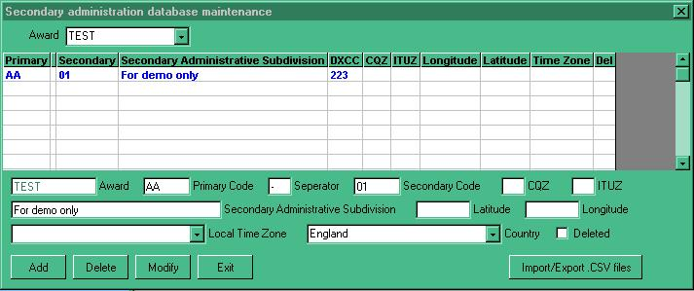

AT\_24

Export the CSV file, giving it a name and then import the resulting file to Excel and this will set up the spreadsheet ready for the addition of all the remaining data. (**Note** below that the numeric in the secondary column is without a leading zero. (See [A Note of Caution](#A_Note_Of_Caution) above).

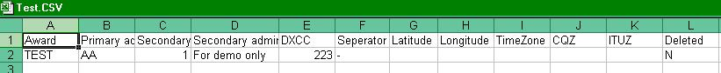

AT\_25

Add the required data to the spreadsheet.  Make sure that numeric columns are formatted as required and re-save.

Reload the new database into Logger32 using the import facility from the secondary admin. database edit window

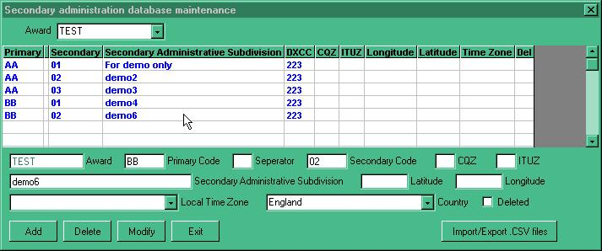

AT\_26

If the award subdivisions spread across different DXCC entities, then simply make sure that the appropriate DXCC code is entered in the column for the area concerned and that there is a valid entry in the associated countries primary database.  The example above shows areas for England only. If you wish to see an example of a database covering multiple DXCC entities, then look at the secondary database for US counties.

### 11.3 Step 3 -  make it all visible

Having made the database it is now necessary make the award available in the menu list.

From the Logger32 [Main menu](#_topic_MainMenu) [Tools | Awards setup | select Setup secondary administration awards](#3.0_TOOLS_MENU_ITEM) menu items to open the window shown below:-

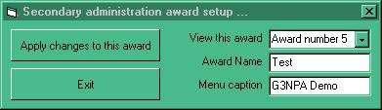

AT\_27

select the first available blank “Award number” and enter:

**The Award Name** – This is the file name that you have given to the award, and

**The Menu caption** – The description you wish to display in the pull-down awards menu list and click on “Apply changes to this award”.

The award will now appear in the menu list as shown below.

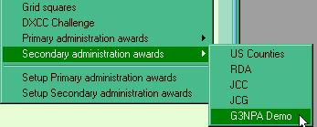

AT\_28

to give the award table from the log (as shown below)

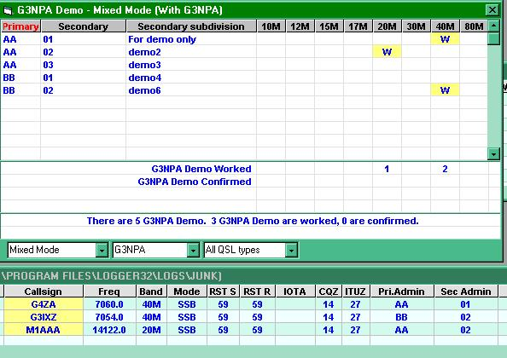

AT\_29

*Created with the Personal Edition of HelpNDoc:* [*Full-featured EBook editor*](http://www.helpndoc.com/create-epub-ebooks)

**Award Tracking**

*Created with the Personal Edition of HelpNDoc:* [*Single source CHM, PDF, DOC and HTML Help creation*](http://www.helpndoc.com/help-authoring-tool)

**Award Tracking**

# Geoff Anderson G3NPA, Jim Hargrave W5IFP and Aki Yoshida JA1NLX

1.0 GENERAL

As yet more new [ADIF](#ADIF) fields have been introduced and the logbook database has had to be changed to accommodate the changes. The point of the changes becomes obvious once the user appreciates that now he/she can record the QSL "Submitted" or "Granted" status for more than just one award. It is left to the user how they actually employ the new Submitted and Granted flags but for the purpose of this Helpfile it will be assumed that "Submitted" indicates that cards or whatever proof is required has been sent in for adjudication by the award issuing authority and that "Granted" indicates acceptance of the claim made for a particular contact.

One can now track progress towards gaining the following awards:

AJA, CQDXFIELD, CQWAZ\_MIXED, CQWAZ\_CW, CQWAZ\_PHONE, CQWAZ\_RTTY, CQWAZ\_160M, CQWPX, DARC\_DOK, DXCC, DXCC\_MIXED, DXCC\_CW, DXCC\_PHONE, DXCC\_RTTY, IOTA, JCC, JCG, RDA, WAB, WAC, WAJA, WAS, WAZ, USACA and VUCC.

The confirmations required may come from up to 4 different sources;

* + QSL cards;
  + [LoTW](#LoTW);
  + [eQSL](#eQSL); and/or,
  + A "Special" category,

and can be combined if allowed.

It should also be appreciated that this capability is for award tracking and NOT QSL tracking. This functionality will NOT show how QSLs have been generated and/or distributed.

The enumerations now available in Logger32 are:

* + W = Entity has been contacted and there is an entry in the logbook;
  + C = Entity has been actually confirmed by a QSL card, [LoTW](#LoTW), and/or [eQSL](#_topic_Abbreviations);
  + S = The contact has been submitted for adjudication towards an award; and,
  + G = The contact has been accepted and credited to the award.

The above enumerations are added automatically as a result of other user actions detailed below.

## 2.0 BASIC SETUP

It is unlikely that each operator will want to track more than just a few of the offered awards. As a result, and in order to cut down on the large number of possible selections that can be made, users can select the awards they wish to track. Select the [Logger32 Main menu](#_topic_MainMenu) items "[Tools](#3.0_TOOLS_MENU_ITEM) | Awards Setup | Awards to Track" to display the Awards to Track dialog box:

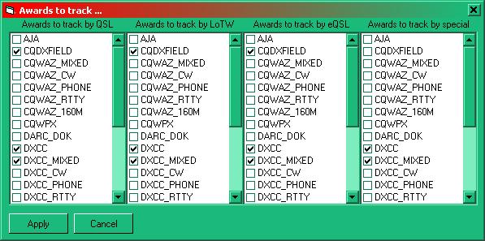

ATK\_1

## 3.0 TRACKING YOUR AWARDS

### 3.1 Marking the QSOs

The standard practice of marking the QSOs with QSL information has not changed so the "[W](#W_Enumeration)" and "[C](#C_Enumeration)" enumerations are exactly as described in the [Worked/Confirmed window](#_topic_WorkedConfirmedWindow) topic. However the QSL tracking information is added on an individual QSO basis. Right-click on a QSO in the [Logbook Page Window](#_topic_LogbookPageWindow) to display the menu:

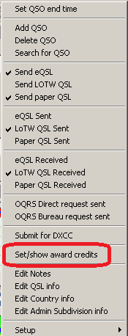

ATK\_2

and select the" Set/show award credits" menu item to display the Award Status dialog box for the selected QSO.

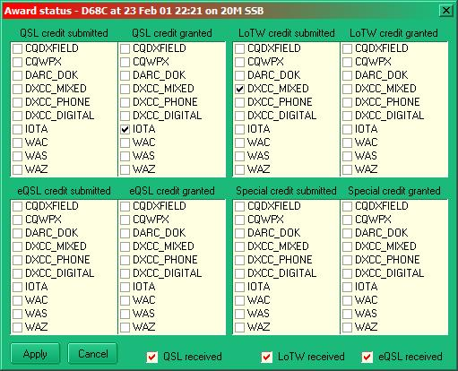

ATK\_3

Now select the appropriate award confirmation source and submitted or granted status as appropriate. It is also possible to mark receipt of QSLs in this table. Select the <**Apply**> button to enter the Award Status data.

Some simple error checking is performed at this stage. For example, if a credit/granted submission is entered without Logger32 having been told of the corresponding receipt of a QSL, then Logger32 will generate an error message.

The "Special" credit granted/submitted areas are for use when something does not quite fit the normal. One such example might be the one case where [IOTA](#IOTA) do NOT require an actual QSL card and that is if contacts can be confirmed from submitted [IOTA](#_topic_Abbreviations) contest logs. Recording these cases in the special section will keep things in order.

Note: ADIF file import/export will process the GRANTED and SUBMITTED fields as well as the APP\_LOGGER32\_GRANTED and APP\_LOGGER32\_SUBMITTED fields. As Logger32 keeps track of the GRANTED/SUBMITTED type (QSL, eQSL, LoTW, Special) this additional information would be lost using only the GRANTED/SUBMITTED fields. Importing an ADIF file from a source other than Logger32 will put all GRANTED/SUBMITTED contacts into the Special category.

In this dialog box it is also possible to see the effect of selecting the awards to track. Each of the eight lists hold only a fraction of the awards available for tracking and this reduction is a result of the selection process detailed in [section 2.0](#2.0_BASIC_SETUP).

### 3.2 Flagging and Exporting QSL Award files.

Logger32 can export a DXCC.ADI file containing a list of QSOs when a confirming QSL card has been received. This file is similar to the [eQSL](#eQSL) and [LoTW](#LoTW) export files. The DXCC export file may be used for submitting QSL cards for verification. Note that this file will be in Date order and the cards must be sorted to match the file.

This file can be created using one of two procedures:

* + Enter the callsign in the [Logbook Entry window](#_topic_LogbookEntryWindow) or highlight a QSO in the [Logbook Page window](#_topic_LogbookPageWindow) to display contacts in the [Previous QSOs window](#_topic_PreviousQSOsWindow). Right click on the QSO in the [Previous QSOs window](#_topic_PreviousQSOsWindow) and select "DXCC submission flagged" on the Quick QSL dialog box. This will flag the QSO for a DXCC export file; or,

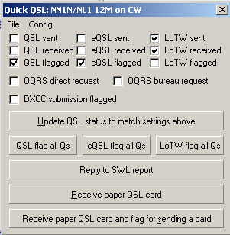

ATK\_8

* + Set the flags by right clicking on the highlighted QSO in the [Logbook Page window](#_topic_LogbookPageWindow) and selecting: "Submit for DXCC". This will automatically flag the QSO for a DXCC export file.



ATK\_2

To export the DXCC.ADI file, select the [Logger32 Main menu](#_topic_MainMenu) "[File](#2.0_FILE_MENU_ITEM) | Export files" menu items and select "Export DXCC File"

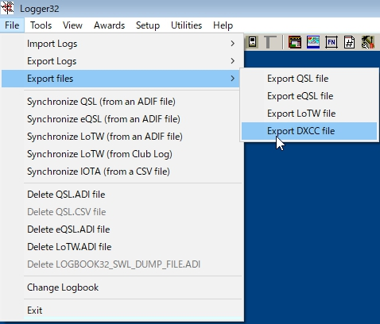

ATK\_10

This brings up the Export DXCC records dialog box where the user can select the operator and a filename.

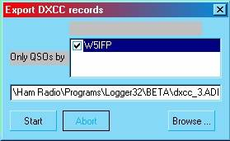

ATK\_12

Following the export, the user will be presented with the DXCC export complete dialog box with two options for setting the flags:

* + Delete DXCC export flags from the logbook. This option deletes the flags after the DXCC export file is created: and,
  + Flag QSOs as submitted for DXCC credit. This option will check the appropriate submitted boxes on the Award Status dialog box ([ATK\_3](#ATK_3)).

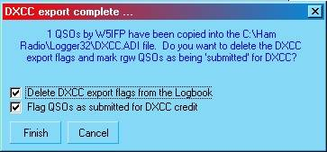

ATK\_11

If the "Flag QSOs as submitted for DXCC credit" check box is checked, the award table will be set based on the following logic:

* + **All QSOs** - If the QSO does not have the DXCC granted flag set, the DXCC submitted flag is set.
  + **All QSOs** - If the QSO does not have the DXCC\_MIXED granted flag set, the DXCC\_MIXED submitted flag is set.
  + **CW QSOs** - If the date is a valid date for DXCC\_CW and if the QSO does not have the DXCC\_CW granted flag set, the DXCC\_CW submitted flag is set.
  + **SSB, AM and FM QSOs** - If the QSO does not have the DXCC\_PHONE granted flag set, the DXCC\_PHONE submitted flag is set.
  + **All other mode (not CW, AM, FM, SSB) QSOs** - If the QSO does not have the DXCC\_RTTY granted flag set, the DXCC\_RTTY submitted flag is set.

**Note**: If the granted flag is already set, then Logger32 does nothing.

### 3.3 Viewing the results in the Awards Table

The results are viewed using the [Logger32 Awards menu](#5.0_AWARDS_MENU_ITEM) (in this example the [IOTA](#IOTA) menu item was selected), displaying the IOTA Award table.

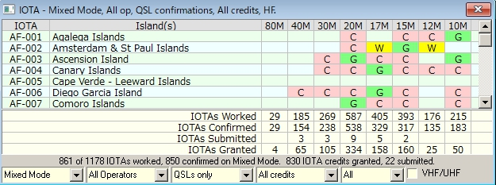

ATK\_4

The example in ATK\_4 shows the "Granted" IOTA QSL as shown entered in ATK\_3 above when viewed in the IOTA Award table. Note also that the entry for AF-003 shows a "Granted" marking (with a different highlight color) .

Clicking on a W/C/S/G cell on an award table (of an ADIF-defined Award) will open the [Generic QSOs window](#_topic_GenericQSOsWIndow). However, if the Highlight credit option is enabled, the SUBMITTED and GRANTED highlights will be filtered based on the Credit selection option on the Award Table.

**Note**: There are up to five filter selection drop down lists at the bottom of the Awards table: Mode selection; Operator selection; QSL Type selection, and QSO credit status (see ATK-6 below). The fifth pane is not visible on all Awards tables and the contents vary depending on the table selected.

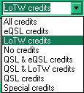

ATK\_5

There is one area that needs to be brought to the attention of the user concerning the DXCC table when displayed using the DXCC-CW filter. The ARRL does not recognize CW contacts before 1 Jan. 1975 for the DXCC CW award so this table alone contains that date restraint. Users will note that when calling up the entry in the DXCC\_CW totals the overall country window shows the contact as confirmed "C" while it is shown as "W" in the award stats window.

## 4.0 AWARD TABLES HIGHLIGHT COLORS

The Submitted and Granted credit highlight colors in the Award tables may be set using the [Logger32 Setup menu](#_topic_SetupMenu) items: [Highlight](#2.0_HIGHLIGHT_MENU_ITEM) | [Credit highlight](#Credit highlight) | Choose credit submitted highlight color as shown below.

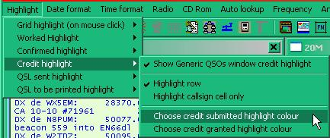

ATK\_6

## 5.0 DX SPOT TABLE WORKED/CONFIRMED/CREDIT HIGHLIGHT SELECTION

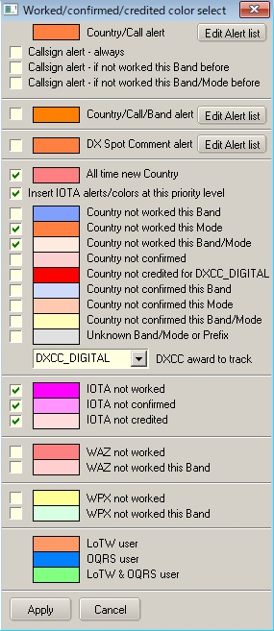

ATK\_7

The entry "Country not creditted for XXXXX" is determined by the selection made in the pane below the entry for unknown band/Mode. In this particular example the highlight color depicts "Country not credited for DXCC\_DIGITAL". The caption will follow the award selection

**Note** that "Credited" and "Confirmed" are not the same thing. "Confirmed" indicated that you have received confirmation in some form from the QSO partner. "Credited" indicates that the contact has been adjudicated and included in your credits for the award in question.

The award selection (DXCC, DXCC-MIXED, etc.) has no priority. Whatever is selected is what it is - Credits (no matter how many, or what specific DXCC they may be for) are ignored unless they have been applied to the specific DXCC award selected.

## 6.0 QSL UPDATE FOR DXCC/IOTA AWARDS

This function allows users to do batch updates of QSL status and convert them from "Submitted" to "Granted'. DXCC and [IOTA](#IOTA) awards are supported. The function is accessed by selecting the [Logger32 Main menu](#5.0_AWARDS_MENU_ITEM) [Awards](#5.0_AWARDS_MENU_ITEM) menu item.

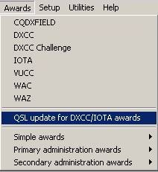

ATK\_13

### 6.1 DXCC Update

The following chart is representative of a list of QSOs in the logbook that have been submitted to the ARRL for credit toward an award. To update the status to Granted, the user must place a check in the box by the applicable QSOs. After all the affected QSOs have been checked, click on "Mark checked QSOs as granted". The checked QSOs will then be automatically updated in the logbook.

**Note**: If you have many records listed, you can click on "Check all" after you have verified acceptance by ARRL.

**Note**: For QSO records to show on this list, a QSL Card must be received and flagged as Submitted on the "Set/show awards credits" chart ([See paragraph 3.1 above](#3.1_Marking_the_QSOs)).

QSL/eQSL/LoTW QSLs received flags cannot be turned off if awards have been submitted/granted,

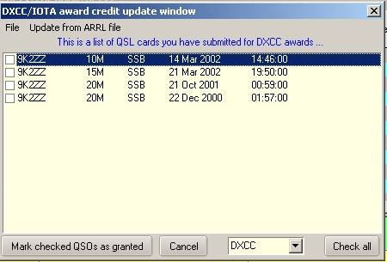

ATK\_14

Automatic Updates are also available from the ARRL by selecting the menu: Update from ARRL file.

To initiate the auto-update process, select "Update from ARRL file". Insert the Path/filename of the ARRL file. This file can be downloaded automatically using the supplied "[ARRL scraper.exe](#_topic_ARRLScraper)"

**Note**: See the [ARRL Scraper](#_topic_ARRLScraper) topic for obtaining a file from ARRL and details for automatic update.

The following depicts the screen where the file Path/Name is entered. This pane provides for a full update or just adding new credits.

Click "Start" after you have made your selections.

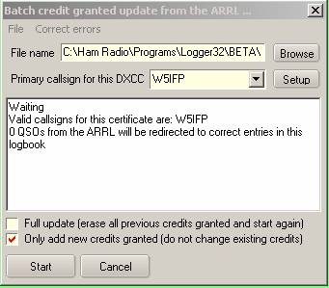

ATK\_15

If you have more than 1 callsign linked to your primary callsign, select "Setup" and the system will list all operator callsigns found in the logbook. Delete all calls not linked to the master callsign.

Clicking on the "Operators" button will get all the operators in the selected logbook.  Of course, if you have mixed and matched DXCCs all in one logbook, then this probably isn't the best option to click.

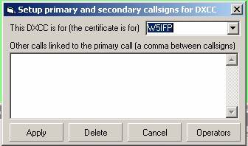

ATK\_15A

Once the process is started you can observe the Logger32 progress bar and the update window will display action as each record is processed. The following 2 screen captures depict a typical process.

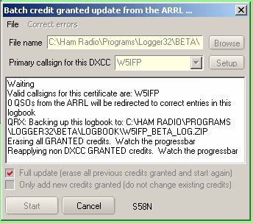

ATK\_16

When doing a "Full update" (first time around if you like) of ARRL statistics, the Logger32 statistics dataset is reconstructed without ARRL/DXCC information - Non-DXCC credits are then reapplied to the statistics and the download process is.

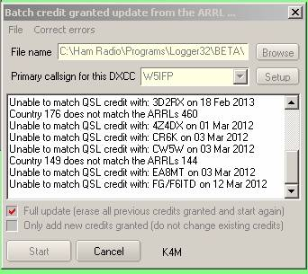

ATK\_17

Once all the records have been processed, the chart will display "Done"?.

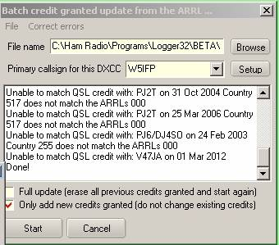

ATK\_18

As soon as the complete file is processed, you will be presented with a message showing how many QSOs were updated and how many were not updated.

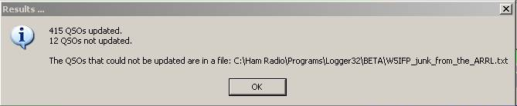

ATK\_19

You can click on the "Let me try" button and Logger32 will attempt to find a match. If no match is apparent, you will be presented with the following notice:.

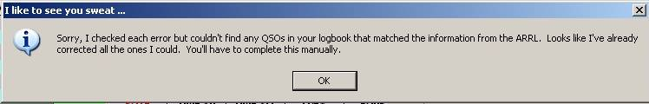

ATK\_20

Having failed to find any direct match, the user can manually update the QSOs. Click on the upper tab "correct error" and you will be presented with a chart that shows the ARRL records from the reject file. These are the records where a complete match could not be found.

Click on these records and a possible match from the Logbook will be posted on the right side of the window. If you find the correct record listed, click on it (right side of chart) and that QSO in the logbook will be updated.

**Note**: You may have to check the "Ignore DXCC" and or one of the other options to get down to the correct QSO record. When you select all possible matches click SAVE. This updates the ARRL file.

**Note**: In order to update the Logbook records you must repeat the update cycle. Click Start on the "Batch credit" table and be sure the option "Add only new credits granted" is checked. This process may have to be repeated several times until all records are mapped to the correct QSO.

**Note**: If you can't figure out what the text means (there's some weird stuff sometimes) for an entry in the left list, right click on the record in the left row and this will take you directly to the QSO record at the ARRL.  You can see for yourself what the ARRL says for the QSO. You will be prompted to login to LOTW, and then the QSO record will be displayed.

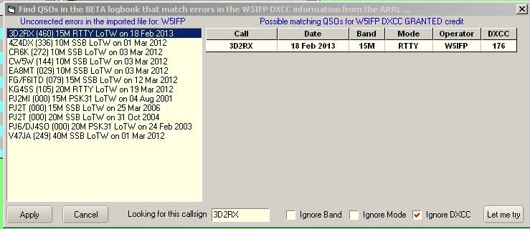

ATK\_21

**Note**: The first time this process is used, extensive manual correction/editing may be required.  In the case of some of the Beta testers, as many as 300 credits had to be manually corrected/edited using the window provided.  Once all errors in the ARRL data have been mapped to match correct QSOs in the users log, it should be plain sailing from then on out.

### 6.2 IOTA update

The update procedure is the same as the DXCC manual update. As yet this processes has NOT been automated. IOTA Updating will be manual but if the operator has marked his log as "QSO Submitted" for each claim these will be listed and all he/she has to do is to check them off one by one from a list of approved IOTA QSOs.

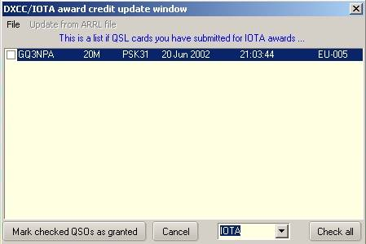

ATK\_22

To obtain a list of credits the user can Log-on to the [RSGB](#RSGB) IOTA web site and if you are registered sign in to your account. From the menu list select "My IOTA" and at the bottom of the QSO summary section click on "Download QSOs (CSV)".

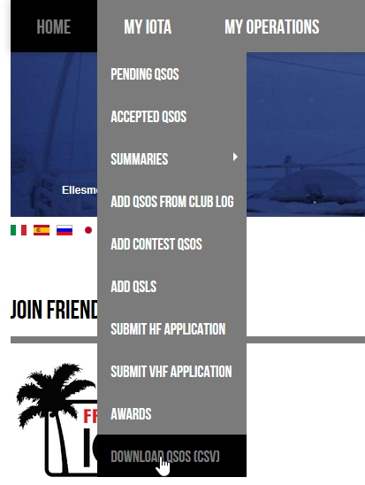

ATK\_23

One receives a file that looks like the following when opened in a text editor:

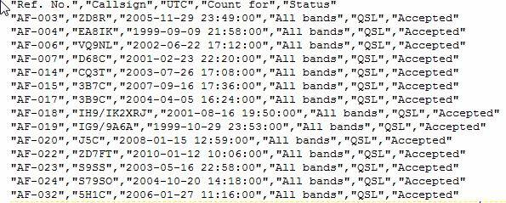

ATK\_24

The following is representative of the file when opened in Excel.

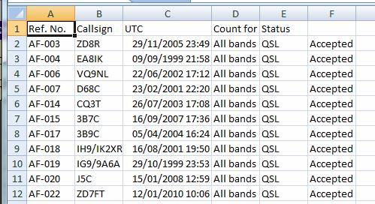

ATK\_26

*Created with the Personal Edition of HelpNDoc:* [*Generate EPub eBooks with ease*](http://www.helpndoc.com/create-epub-ebooks)

**ARRL Scraper**

# Aki Yoshida JA1NLX

## 1.0 GENERAL

ARRL Scraper is a stand alone program to scrape All credit QSO records (including pending credit) or Granted credit QSO records (only awarded credits) from [LoTW](#LoTW). The Logger32 function QSL update for DXCC/[IOTA](#IOTA) awards reads these records and sets the Granted flags in your Logbook. If you are lucky Granted flags are automatically updated. Otherwise you are presented with some options to correct the information if mismatches are found. See details in the [Award Tracking](#_topic_AwardTracking1) section.

## 2.0 SETUP

ARRL Scraper.exe can reside in the main Logger32 folder or you can make a new folder under the Logger32 directory. Place ARRL Scraper.exe in this folder. It is convenient to setup ARRL Scraper.exe as one of utility program.

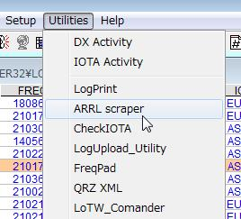

AS\_1

Run ARRL Scraper and you will see:

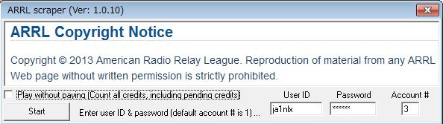

AS\_2

### 2.1 User ID and Password

These are the User ID and Password you use to log on to the [LoTW](#LoTW) web site.

### 2.2 Account #

This is your account # which is provided by [LoTW](#LoTW). If you have only one account then this is 1 (default). If you have multiple accounts then you have to know account # for each account.

To find your Account #, Log on to the [LoTW web site](#Link:_LoTW) with your browser.

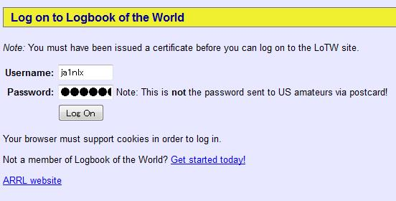

AS\_3

Click the Awards tab



AS\_4

Select "Your Account" and then Select the DXCC Award Account you wish to get the Account # for.

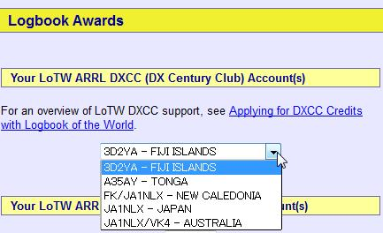

AS\_5

Look at the address line of your browser and you will find "\_acct=n” This is the account # for this account. In this example, the Account # is "3". I have 5 accounts. JA1NLX account #=1, FK/JA1NLX account #=2, 3D2YA account #=3 etc.



AS\_6

Make a note of all account #s and close browser.

### 2.3 Play without paying option

If this option is checked then it scrapes All credits QSO records (including pending credits). If this is unchecked then it scrapes Granted credits QSO records. (only awarded credits).

## 3.0 Operation

Click the <**Start**> button and as the processing progresses, the status of the processing will appear on the Status bar at the bottom of the window.

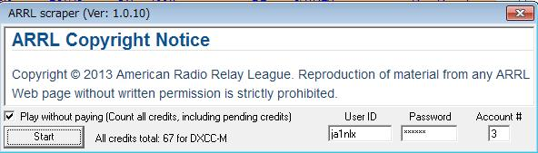

AS\_7

If you check the Play without paying option you will get the following warning message:

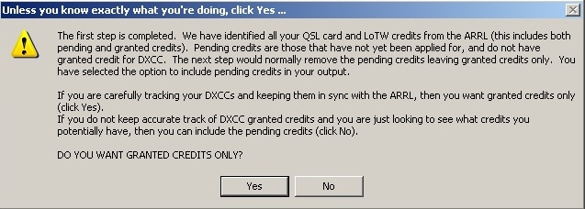

AS\_14

If you want Granted credits only then select Yes

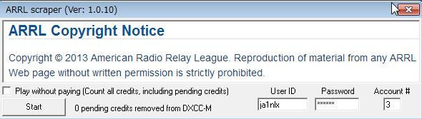

AS\_13

**Note**: Play without paying option is unchecked even if it was checked. If you want all credits including pending credits then click No.

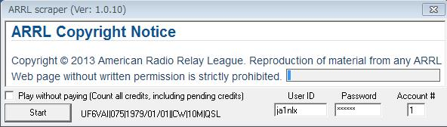

AS\_8

The following status message indicates that you put the wrong User ID/Password/Account # or the internet connection is disconnected.

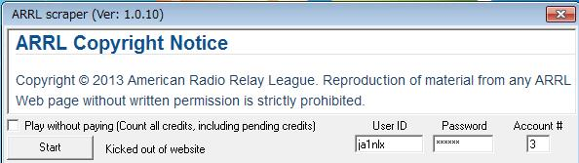

AS\_9

It takes about 20 minutes or so for ARRL Scraper to scrape 1200 records. When it scrapes records successfully then these records are saved in a text file in the same folder as ARRL Scraper.exe and this window close automatically. The file name is dependent on the Play without paying option being checked or unchecked.

* + If this option is checked then the file name should be like JA1NLX\_3\_all\_credits scraped data.txt, or,
  + if this option is unchecked then the file name should be like JA1NLX\_3\_granted\_credits scraped data.txt.

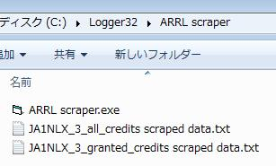

AS\_10

The following example is part of the JA1NLX\_3\_granted\_credits scraped data.txt.

.

4X4DK|336|2009/07/01|20:01:25|CW|30M|LoTW|https://lotw.arrl.org/lotwuser/qsodetail?qso=230235859

4X4JU|336|2012/03/20|04:39:44|CW|20M|LoTW|https://lotw.arrl.org/lotwuser/qsodetail?qso=415590602

4Z5LA|336|2009/07/02|04:06:36|CW|17M|LoTW|https://lotw.arrl.org/lotwuser/qsodetail?qso=230236001

5B4AHJ|215|2009/07/02|03:04:23|CW|17M|LoTW|https://lotw.arrl.org/lotwuser/qsodetail?qso=230235929

5B4AJC|215|2012/03/20|05:26:20|CW|20M|LoTW|https://lotw.arrl.org/lotwuser/qsodetail?qso=415590667

*Created with the Personal Edition of HelpNDoc:* [*Full-featured EBook editor*](http://www.helpndoc.com/create-epub-ebooks)

**Generic QSOs WIndow**

# Aki Yoshida JA1NLX

## 1. General

The Generic QSOs Window can be used to show QSOs from the Worked/Confirmed window or any of the Award windows. However it is not available from the View menu.

In all cases the Title Bar of the Generic QSOs window will display the the name of the original window providing the data.



GQW\_1

If the total number of QSOs to be displayed exceeds the number of lines available in the window, the Total count will appear in the Title bar. The Total will only display 1000 if the count exceeds that value.

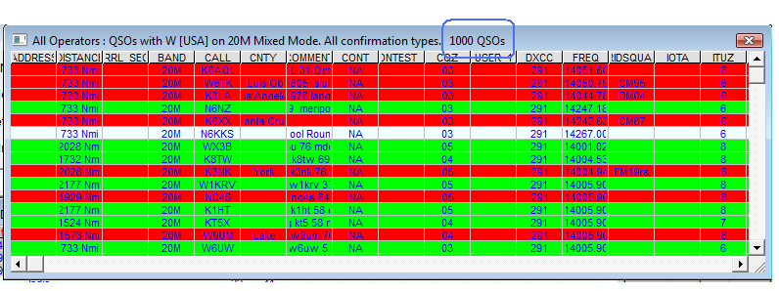

GQW\_1A

## 2. Examples

### 2.1 Worked/Confirmed Window

With the Callsign EP6T in Logbook Entry window and the Worked/Confirmed window is displayed:

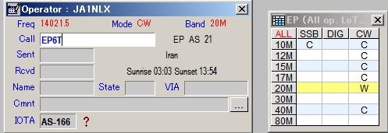

GQW\_2

the example below shows what is displayed in Generic QSOs Window when 10M/CW cell of the Worked/Confirmed window is clicked. You see all QSOs with EP on 10M/CW in the Generic QSOs Window.

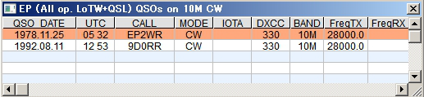

GQW\_3

### 2.2 Award Tables

This example shows what is displayed in the Generic QSOs Window when the AF-006/10M cell in the IOTA Awards table is clicked. You see all QSOs with IOTA AF-006 on 10M Band.

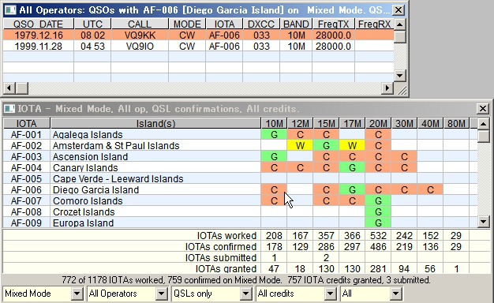

GQW\_4

## 3. Setup

### 3.1 Highlight setup

Select the "Highlight | Confirmed highlight | Generic QSOs window" menu item of the Logger32 Setup menu to highlight either the Row or Callsign and to select the Highlight color to use in the Generic QSOs Window for Confirmed QSOs.

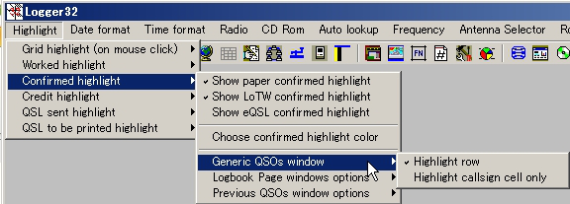

GQW\_5

### 3.2 Grid layout setup

You may setup the Grid layout for the Generic QSOs window by right-clicking on any empty cell in Generic QSOs Window and selecting Grid layout. See the Grid Layout Setup section for details on how to use the Grid Layout dialog box..

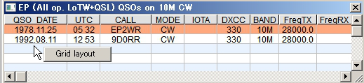

GQW\_6

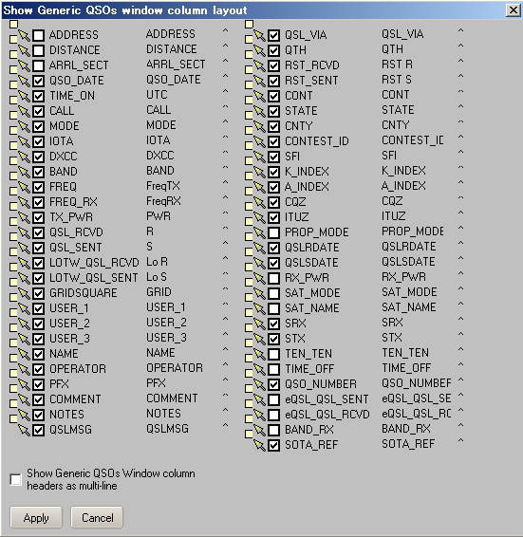

GQW\_7

*Created with the Personal Edition of HelpNDoc:* [*Full-featured multi-format Help generator*](http://www.helpndoc.com/help-authoring-tool)

**Database Updates**

*Created with the Personal Edition of HelpNDoc:* [*Easy Qt Help documentation editor*](http://www.helpndoc.com)

**Database Maintenance**

# Geoff Anderson G3NPA and Jim Hargrave W5IFP

## 1.0 GENERAL

### 1.1 Important Notes

* 1. **Before making any modifications to any of the databases make backup copies before proceeding to make changes;**
  2. Please note that changes made to the databases are not retroactive. They are only applied to logging of future QSOs;
  3. If you are in the habit of sending updated databases to friends, then you must send a copy of **ALL** the database files as one package. On **NO** account should you expect an updated database file to work correctly without also sending the all of the database files of the set. The database files are grouped into three database sets;

**Country/Prefix**, consisting of the following databases

ALIAS32;

COUNTRY32; and,

OFFSET32.

**IOTA**, consisting of the following databases:

IOTA32; and,

IOTAIsland

**US County** consisting of

COUNTY32

* 1. Each database consists of four files with the file extensions of ".ISD", ".ISF", ".ISL", and .ISM". All four files must be copied for each database; and,
  2. The Country/Prefix, [IOTA](#IOTA), and US County databases are all maintainable by the user from within Logger32. These three databases may be accessed from the Logger32 [Main menu](#_topic_MainMenu) by selecting the [Tools](#3.0_TOOLS_MENU_ITEM) | Database Maintenance menu items.
  3. Database date stamp. To determine how current the database is:

A) Enter “DATA” in the CALL field of the Log Entry window. The database version and initial distribution date will show in the first box of the upper status bar;

B) Enter “DATA1” in the CALL field and the latest Club Log exceptions update will be reflected; and,

C) Enter “DATA2” in the CALL field and it will show the date of the last full Club Log PFX sync.

### 1.2 General Information

Logger32 includes a facility to automatically update the Callsign and Prefix exception list in the Country/Prefix database. The data for these exceptions is derived from the Club Log database. Procedures to activate this function are detailed below in the [Country/Prefix Database](#2.0_Country/Prefix_Database) section.

As a general, where Time Zone information is required, use the included pull-down menu or where this does not appear, right-click in the appropriate box to obtain the same list. DO NOT TYPE IN THE TIMEZONE DETAILS YOURSELF unless you know the exact name and can get the spacing perfect.  Where Lat/Long information is required, this should be in the format: degrees and decimal degrees. If you prefer to enter this data in degrees and minutes, then right-click in either of the Lat or Long panes (or even in the tables) to bring up this facility.

## 2.0 Country/Prefix Database

The Country/Prefix database may be accessed from the Logger32 [Main Menu](#_topic_MainMenu) by selecting the [Tools](#3.0_TOOLS_MENU_ITEM) | Database Maintenance | Country/Prefix maintenance menu items. This will open the Country database maintenance window.

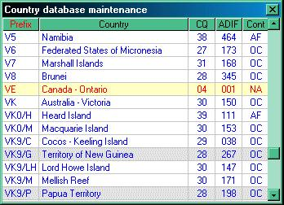

DBM\_1

**Note**: If you left click on any of the headings: Prefix, Country, CQ, ADIF or Cont in the table above, the grid will sort on that column.

This window displays a scrollable list of all [DXCC](#DXCC) Prefixes and associated;

* + Country Name;
  + CQ Zone;
  + [ADIF](#ADIF) Country number; and,
  + Continent.

To edit a specific country or prefix, double click anywhere on the row for that entry. This will enable the dbEdit dialog box for that particular entry.

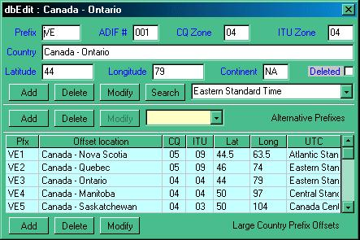

DBM\_2

The dbEdit window is divided into three sections:

* + Basic Information;
  + Alternative Prefixes; and,
  + Large Country Prefix Offsets.

### 2.1 Add a New Prefix

To Add a new prefix, click on the BLANK line at the bottom of the Country database maintenance window. This will display a blank dbEdit window, enabling you to enter the required data. Logger32 expects information in ALL the blank edit boxes and will prompt the user if any are missing or contain invalid data.

The pull-down list at the lower right in this section enables the user to select the correct Time Zone for the new prefix. Use the down arrow in this edit box to obtain a list of Time Zones available. See the topic [Standard Time Zones](#_topic_StarndardTImeZones) If you want to know the relationship between the name, time offset from [GMT](#GMT) and if the time zone has [DST](#DST). You can leave this entry blank BUT without a Time Zone here, Logger32 will NOT be able to determine the Local time for that prefix. When satisfied that all is correct, select the <**Add**> button.

**Note**: If you are entering a country name that will include the "&" character, you must enter the character twice in order for it to display correctly. For example, the country name for the prefix V2 must be entered as "Antigua && Barbuda".

2.2 Delete a Prefix

Deleting a prefix can be achieved in two different ways. First, select the row containing the entry you wish to delete, then:

* 1. If you simply wish to REMOVE the data from the database, select the <**Delete**> button. Logger will check that that this is what you really want to do; or,
  2. If you wish to just mark the country as having been deleted (but to keep the information in the database), select the "Deleted" check box and then the <**Modify**> button. This method will produce a gray background in the Country Database maintenance window for that prefix (see VK9/G and VK9/P above).

2.3 Modify a Prefix

To modify a prefix select the row containing the entry you wish to modify, make the changes in the appropriate edit box(s) and select the <**Modify**> button.

## 2.4 Alternative Prefixes

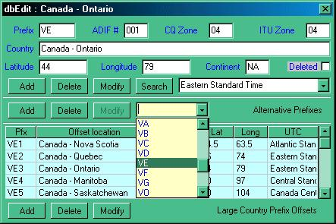

DBM\_3

### 2.4.1 Add an Alternative Prefix

To Add an alternative prefix, first ensure that the Alternative Prefixes edit box is blank, then type in the new alternative prefix and select the <**Add**> button.

**Note**: It is permissible to include specific callsigns in this section if required (see KC4/A - Antarctica). Callsigns must be enclosed in the symbols "<" and ">" in the format "<G3NPA>".

### 2.4.2 Delete an Alternative Prefix

To Delete an alternative prefix, open the pull-down list, select the appropriate prefix and then select the <**Delete**> button.

### 2.4.3 Modify an Alternative Prefix

To Modify an alternative prefix, first open the pull-down list, select the appropriate prefix, modify it as required and then select the <**Modify**> button.

### 2.5 Large Country Prefix Offsets

### 2.5.1 Add an Offset

To Add a new offset, select the first available blank row in the list, usually the row at the bottom of the list. The time details are entered from the Time Zone list presented when the operator right-clicks on the [UTC](#UTC) field of the selected row. When an entry has been completed, select the <**Add**> button to enter the data into the database. Always add one line at a time.

### 2.5.2 Delete an Offset

To Delete an entry, left click anywhere on the row to be deleted and select the <**Delete**> button.

### 2.5.3 Modify an Offset

To Modify an entry, right click on the row to be modified, make the required changes and then select the <**Modify**> button.

### 2.6 Automatic update of the callsign and prefix exceptions using Club log database

To access and setup the automatic update from the Logger32 [Setup menu](#_topic_SetupMenu), select the "Country database exceptions from Club Log" | "Enable auto updates" menu items.

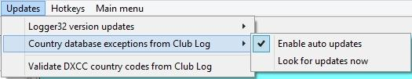

DBM\_9

Selecting the "Look for update now" menu item will trigger the update process. Once the update completes you will see a summary display.

**Note**: If you select the "Enable auto updates" menu item the update will automatically update daily. If this option is selected the summary page will automatically close at the end of the process.

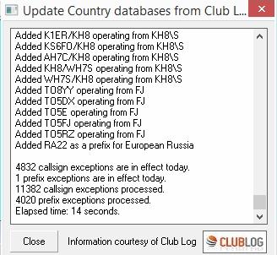

DBM\_10

## 3.0 PRIMARY/SECONDARY ADMINISTRATION DATABASES

### 3.1 Databases

Two databases are provided called PrimaryAdmin32.xxx and Secondary Admin32.xxx where xxx = ISD, ISF, ISM and ISL. As the names imply, the PrimaryAdmin32 database contains all the information about primary subdivisions (as listed in the [ADIF](#ADIF) specification) and the SecondaryAdmin32 database holds the secondary subdivision information. These databases will contain the US counties, the JCC, JCG and DOK information. If you add any further secondary data, then it will be stored in this set of files.

In line with the general changes, the County32 database is no longer used and can be deleted. **[DO NOT DELETE ANYTHING ELSE!]**

## 3.2 Editing the Databases

**Caution**: As a general precaution, you are strongly advised to make a backup copy of any database that you plan to edit. You are entering dangerous territory, and you might need the ability to backtrack to an earlier version.

The basic Primary administration data is held in the four files named PrimaryAdmin32.ISD, .ISF, .ISM, and .ISL. The Secondary Administration data is contained in the four files named SecondaryAdmin32.ISD, .ISF, .ISM, and .ISL and all eight files are located in the default Logger32 directory.

It should be appreciated from an early stage that Logger32 will only provide the backbone or basic Primary and Secondary subdivision databases. Any changes that you make or add to your personal copies of these databases will be destroyed on the loading of a new set of  Logger32 databases or set from anyone else – UNLESS definite precautions are taken.

It is possible to save each individual award and/or country information (both primary and secondary) into [CSV](#CSV) files and if you like to construct your own databases for awards, this method of saving the files is HIGHLY recommended. It is then relatively easy to re-load your personal databases when required.

Primary Administration Data

To edit the contents of a particular country's primary data, use the Logger32 [Main menu](#_topic_MainMenu) and select the [Tools](#3.0_TOOLS_MENU_ITEM) | Database maintenance | Primary administration maintenance menu items.

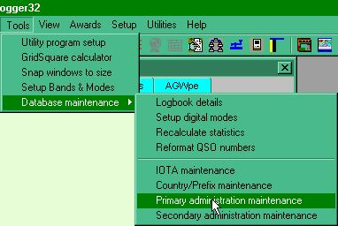

DBM\_4

Followed by the selection of the Country (or Administration) of interest.



DBM\_5

to open the appropriate edit page.

To edit a single entry, scroll to the required position in the list and left-click on the line required. The existing data for that line will now appear in the panes below the main list ready for editing. All panes can be edited except for the County. When set to the new requirements, select the <**Modify**> button.

If a new entry is required, scroll to the bottom of the viewing list and click on the blank line and enter the new data. On completion, select the <**Add**> button to forward the entry into the database. **Note** – the display will jump back to a point near the top of the list, so to check your new entry you will need to scroll down again.

If a large number of changes are to be made then the facility to export the data to a .[CSV](#CSV) file is available. Simply select the <**Import/Export .CSV fil**es> button located to the bottom right of the database maintenance window.

Make sure you are going to export the required County data (selected in the upper pane) and use the <**Export to .CSV file for this County**> button as shown below. You will be prompted to enter a file name to use for the new file and this will be followed by an announcement of the number of records exported.



DBM\_7

The [CSV](#CSV) file produced is then available for import into Excel for further work. The same “Import/Export” button is used when re-loading the database

**NOTE of CAUTION**: When reloading revised data you MUST ensure that the correct country is showing in the various indicator panes. If the wrong country is showing you will overlay data to the incorrect area in the database.

## 3.3 Secondary Administration Data

These databases are used to assemble the required data for some of the awards tables. It is here that it will be possible for you to develop background information for individual award tables

From the Logger32 [Main menu](#_topic_MainMenu), select the [Tools](#3.0_TOOLS_MENU_ITEM) | Database maintenance | Secondary administration maintenance menu items to display the Secondary administration database maintenance dialog box.and then select the required award (JCC in this example) from the "Award" drop-down list.



DBM\_8

A word of caution here…when using Excel to generate the database. If the [DXCC](#DXCC) and Primary and/or Secondary data is numeric and has the need for leading zeros, then the appropriate cells should be formatted in Excel BEFORE exporting the data in [CSV](#CSV) format. Also it will be noticeable on an import to Excel as the leading zeros will not show until the columns are formatted.

To format the particular columns in Excel, click on the column header to highlight the column required and right-click the mouse and select “Format Cells”. Select “Custom” and make the Type read 00 (for two digits) or 000 (for three digits) and click on “OK”. Leading zeros will now show and will be recorded to the output [CSV](#CSV) file.

*Created with the Personal Edition of HelpNDoc:* [*Create help files for the Qt Help Framework*](http://www.helpndoc.com/feature-tour/create-help-files-for-the-qt-help-framework)

**User Editable Databases**

# Geoff Anderson G3NPA

## 1.0 THE COUNTRY DATABASES

In order to provide maximum versatility and to maximize the capability of Logger32 to correctly identify the correct Country and Zone from a callsign, the program maintains three separate (but linked) databases.

### 1.1 The Country Database

The Country database contains information about:

* + The designated ARRL prefix (this must be unique);
  + The country name;
  + The latitude and longitude of the approximate center of the country;
  + The CQ zone; and,
  + A flag to determine if the country is current, or has been deleted from the ARRL countries list

This information is contained in the four files COUNTRY.ISD, .ISF, .ISL and .ISM.  These files must **ALWAYS** be treated as a set of four.

### 1.2 The Alias Database

The Alias database contains information about alternative prefixes for the country. For example, in the case of the USA, the prefix assigned is W.  Valid alternative prefixes include A, K, and 4U1WB. 4U1WB is included as an alias since that callsign, used by the World Bank HQ, counts for DXCC as the USA.

Each alias must be unique and hidden within the alias files are the ADIF country numbers.

This information is contained in the four files ALIAS .ISD, .ISF, .ISL and .ISM.  These files must ALWAYS be treated as a set of four.

### 1.3 The Offset Database

The Offset database contains offset information for countries having a large landmass that could span several Zones.

For example, in the case of the USA, an offset is provided for each of the call districts. This ensures that the zone is 3 if the callsign is a W6, and the zone is 5 for a W4.  Also, latitude and longitudes of the approximate center of each offset are maintained to ensure the calculated beam headings will be more accurate.  In the Offset database the offset prefix, i.e., W1, W2, VE1, VE2, VK6, VK7, etc.) must be unique.

This information is contained in the four files OFFSET.ISD, .ISF, .ISL and .ISM. These files must ALWAYS be treated as a set of four.

The ARRL prefix links the three databases. This unique identifier is the key to getting anywhere in any of the three databases.

The section Calculating a Country from a Callsign (below), is provided to further explain the process followed by Logger32 in determining a country from a callsign. This may seem overly complicated to some, however, if you anticipate doing major changes to the Country, Alias, and Offset databases, you must know what you are doing.  If you make modifications to the database, and the results are not as expected, you should review this section.

## 2.0 THE COUNTY DATABASE

The program maintains three separate (but linked) databases and it is used to check the validity of the entered County name against the US state:

The County database contains information about:

* + The US state;
  + The US county; and,
  + The latitude and longitude of the approximate center of the county or its most major city or town.

This information is contained in the four files COUNTY.ISD, .ISF, .ISL and .ISM.  These files must ALWAYS be treated as a set of four.

## 3.0 THE IOTA DATABASE

The IOTA database is copyright by the Radio Society of Great Britain, and is not provided as part of this program.

Information has been collected from various public domain sources and input into a comprehensive database now provided with this program.  It is provided for your reference only. The current RSGB IOTA listing includes some 1100 (or more) Island Groups and in excess of 15,000 individual islands. At the time of issue, these databases were current.  If you wish to correct, and/or maintain the data for yourself, then your attention is drawn to the topic [IOTA Database](#_topic_IOTADatabase).

## 4.0 CALCULATING A COUNTRY FROM A CALLSIGN

This topic describes the process that Logger32 follows in attempting to identify the country from a callsign entered into the Logbook Entry Window. This information is provided to assist the user in correctly modifying the Country, Alias, and Offset  databases in a manner that will increase the possibility of identifying the correct country from a callsign.

* 1. **First, strip the callsign down to essential parts only.**  
       
     Does the callsign appear in the Alias database?  If it does, then the first part is complete. This is done so that for certain callsigns (for example, SV8ASP/A in Mt. Athos, rather than the normal /A meaning of operating from an alternate QTH) you would put SV8ASP/A as an Alias for Mt. Athos. This check would find a match, and not proceed to the check below that would remove the /A.  
       
     Now strip off the /M, /P, /A, /MM, /AG, /AA, /AE. This information has nothing to do with the Country, which we determined above.  
       
     Determine which piece of a portable callsign is the portable piece. Is KI0K/VP2M in the US, or Montserrat?  The rule applied is:  the shortest piece (KI0K or VP2M), or if they are the same length the first part (following ITU convention), is the correct Country designator. In the KI0K/VP2M the callsign is (internally) changed to VP2M/KI0K.  A station using the callsign N6BFM/9K2 defaults (internally) to 9K2/N6BFM.
  2. **The next step is to identify the country prefix**  
       
     First, make all portable callsigns with a number only following the / reflect their correct location, i.e.,  N6BFM/4 = N4BFM, W8CNL/4 = W4CNL).  
       
     Now loop (reducing the length of the callsign by one letter at a time) to find an Alias that matches, i.e., N6BFM, N6BF, N6B, N6, N.  N is an Alias for W (the USA).  In the example above of SV8ASP/A, the first pass of the loop would identify SV8ASP/A as an alias for SY - Mt. Athos).  In the case of the KI0K/VP2M (internally converted to VP2M/KI0K), the following occurs in the loop: VP2M/KI0K, VP2M/KI0, VP2M/, VP2M where a match with Montserrat is identified.  
       
     The information regarding the matched Alias is correlated to the Country prefix.
  3. **The last step is to find out if there is any Offset information on the country, and determine the exact offset**  
       
     Check if the callsign is in the Offset database. N6BFM does not sign as portable 4 so you could, if you choose, put N6BFM into the Offset database (under W for the USA) with the details of zone and latitude and longitude of Atlanta.  If a match is found, then this step is complete.  
       
     Check if the prefix of the callsign (not the country prefix) is in the Offset database.  Use the example of CK1XX in Canada.  Under the offsets for Canada is there a CK1?  If so, the offset is found, and this step is complete.  
       
     Take the country prefix - use the example of the callsign EX0MM that has the country prefix of UA9.  If the number in the callsign differs from the number in the prefix, as it does in our example, strip the number from the country prefix (we now, temporarily, have UA as the country prefix), and add the suffix of the callsign (we now have UA0MM).  We now loop, decrementing the length of the callsign each loop, i.e., first pass UA0MM, second pass UA0M, etc., and check for a match in the Offset database.  Coincidentally, there is a UA0M in the Offset database that shows CQ zone of 16 (the default CQ zone for Asiatic Russia is Zone 19).  You can see that by using this method, all stations in Asiatic Russia with the Number 0 and the first letter of the suffix as M, i.e., UA0Mxx, RA0Mxx, EX0Mxx, RX0Mxx, etc., can be identified as being in Zone 16.  Easy, huh?  
       
     If an offset is found to match during the third step of the process, the CQ zone number, the latitude and longitude of the offset are used in the calculations.

The above description is very simplified. However, it will hopefully help the user understand the fundamentals that are followed, and allow the user to keep the databases current as more and more new callsigns and aliases are used.

*Created with the Personal Edition of HelpNDoc:* [*Free help authoring environment*](http://www.helpndoc.com/help-authoring-tool)

**Club Log Exceptions**

# Jim Hargrave W5IFP and Aki Yoshida JA1NLX

## 1.0 GENERAL

Logger32 provides the capability to automatically install current exceptions from Club Log, and also install the full list of Club Log prefixes.

## 2.0 SETUP UPDATE

To access and setup the update, from the Logger32 [Setup menu](#_topic_SetupMenu), select the Updates | Country database exceptions from Club Log menu items.

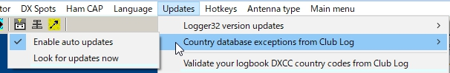

CLE\_1

If "Enable auto update" is checked then it will automatically trigger the update process daily. Summary page will automatically close at the end of the process.

Selecting the “Look for updates now” menu item will trigger the update process. Once the update completes you will see the Information in the "Update Country databases from Club Log" dialog.

If "Enable auto uodate" is unchecked then it is recommended to run "Look for updates now" once a week.

**Note**: If you select the “Enable auto updates” menu item the Exception list will automatically be updated daily. If this option is selected the summary page will automatically close at the end of the process.



## 3.0 VALIDATE DXCC COUNTRY CODES FROM CLUB LOG

This option synchronizes the logbook DXCC assignments to match the Club Log database. The user can opt to run this automatically or manual. In the Automatic mode (default) the changes will automatically modify your logbook DXCC assignment to match the Club Log database.

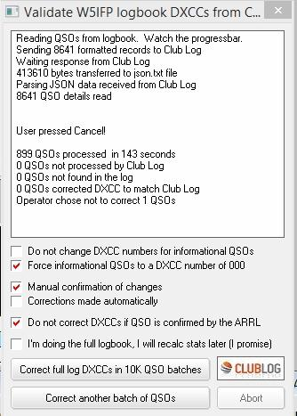

CLE\_3

If the “Manual confirmation of changes” is selected, the user is presented an option to accept the Club Log assignment or reject it, leaving the QSO with the Logger32 assigned DXCC. This suggested change will appear anytime there is a QSO where the QSO DXCC does not match the Clublog DXCC assignment based on PFX and Callsign exceptions.

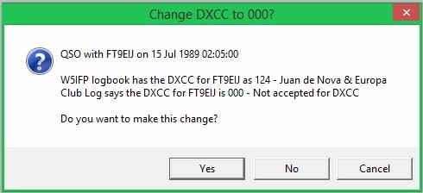

CLE\_4

*Created with the Personal Edition of HelpNDoc:* [*Free help authoring tool*](http://www.helpndoc.com/help-authoring-tool)

**IOTA Database**

# Geoff Anderson G3NPA

## 1.0 GENERAL

First a brief note concerning the database. The [IOTA](#IOTA) database distributed with logger32 contains all the active [IOTA](#IOTA) groups and their associated islands PLUS all island groups not yet activated together with their associated islands.

Should you find the need to add, modify or delete specific information, then:-

### 1.1 Add a New Island Group

To add a new Island group, select the first available blank row in the [IOTA](#IOTA) maintenance list, usually the row at the bottom of the list. This action will display a blank IOTA edit window.

Insert the island details to be displayed in the Island Group column in the large text box and complete the remaining details in the IOTA #, Prefix, Latitude and Longitude edit boxes and select the <**Add**> button.

### 1.2 Modify an Island Group

To modify an entry, left click on the pane to be modified, make the required change in the yellow highlighted area and then click on the <**Modify**> button at the bottom of the dbEdit window.

To modify an Island Group entry, click on the appropriate row of the IOTA Maintenance window, make the required modifications and select the <**Modify**> button.

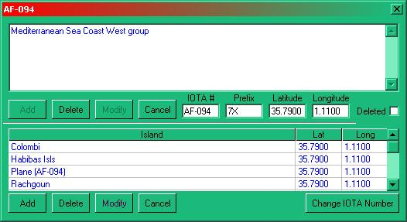

IOTA\_1

### 1.3 Delete an Island Group

To delete an Island Group entry completely from the database, click on the appropriate row of the [IOTA](#IOTA) Maintenance screen and then select the <**Delete**> button. However if you simply wish to show that an island group has been deleted and is no longer valid then select the "Deleted" check box. This will place a dark highlight into any of the IOTA lists, leaving the name and details available.

If you wish to add, modify or delete any additional information about the Islands within the group, this can be done in the lower half of the above screen.

*Created with the Personal Edition of HelpNDoc:* [*Easily create EPub books*](http://www.helpndoc.com/feature-tour)

**DXCC Validation**

# Jim Hargrave W5IFP

## 1.0 GENERAL

Logger32 has a facility to validate the user logbook country assignments with the extensive database at Club Log. This can be automated or manually processed giving the user the option to accept the Club Log assignment or leave the logbook record as is.

The Club Log process assigns the proper DXCC based on the callsign prefix. This assignment includes matching the PFX and callsign exceptions based on actual date of the QSO. This considers DX expeditions and country activation dates.

**Warning**: This process may modify the DXCC assignments in your logbook. Be sure and backup all logbooks before running this facility.

## 2.0 PROCESS

To activate the process, open the Logger32 [Setup menu](#_topic_SetupMenu) [Updates|Validate DXCC country codes from Club Log](#14.2_Validate_DXCC_Country_Codes) menu items.

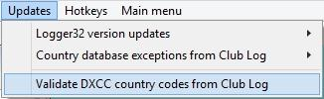

DV\_1

Once you select the update a selection screen will appear. This provides the user several options in addition to selecting manual or automatic update.

**Note**: If you check the option "I’m doing the full logbook. I will recalc stats later (I promise)" the process will execute a little faster but does not recalc the stats. Leaving this unchecked will result in the stats being updated as the process executes.

The program will batch process up to 10,000 records at a time. If your logbook is larger than 10,000 you must press “Correct another batch of QSOs” following completion of each batch.

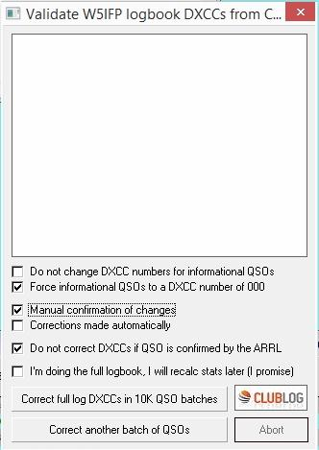

DV\_2

If you select the "Manual confirmation of changes" the process will go through the logbook until it finds a mismatch and presents the user with a pane giving you the option to accept or reject the proposed change. Make a selection and it will move on to the next record(s).

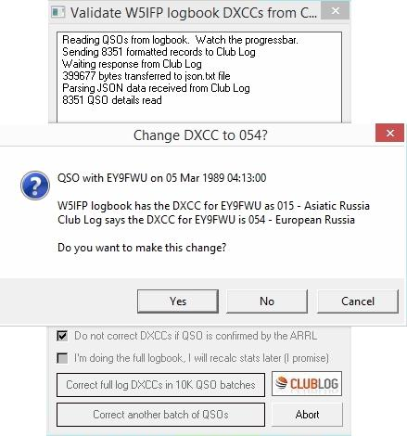

DV\_3

Once the complete logbook has been validated, the process will provide a summary of the records processed.

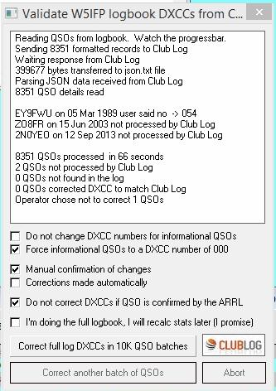

DV\_4

## 3.0 PERIODIC UPDATES

Logger32 keeps track of the last QSO verified. So, once the complete log has been verified, the user may want to periodically verify new QSOs with Club Log.

Daily updating of the Country database exceptions from Club Log will help insure new QSOs are logged properly. See the Database Maintenance section.

*Created with the Personal Edition of HelpNDoc:* [*Benefits of a Help Authoring Tool*](http://www.helpauthoringsoftware.com)

**Printing**

*Created with the Personal Edition of HelpNDoc:* [*Free Web Help generator*](http://www.helpndoc.com)

**Using External Print Programs**

# Geoff Anderson G3NPA

## 1.0 GENERAL

Logger32 does not contain any built in print routines. What Logger32 provides is the ability to shell out to other packages as the user desires and one such package is provided in the form of LogPrint. There are also a set of Word templates which can be used either as they stand or possibly with a little modification can be adjusted to suit individual needs.

Using the Logger32 Maine menu, select the Tools|Utility Program Setup menu items to open the Utility Program menu setup dialog box. You are given the opportunity to set up the path to your favorite program(s) and to give it (them) a suitable menu name. These menu names will appear in the Logger32 [Main menu](#_topic_MainMenu) [Tools|Utility program setup](#Utility_Program_Setup) menu items.

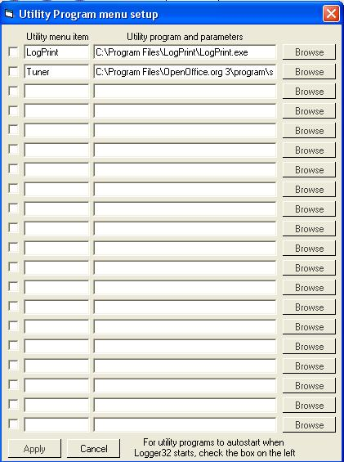

UEPP\_1

Up to ten of your favorite printing programs can be set up in this way.

It should be noted that Logger32 will not automatically output log or QSL data for the programs selected.  It is left for the individual to output the required data to the folder in the format needed by the programs selected. This can be achieved from the Logger32 [Main menu](#_topic_MainMenu) [File|Export Logs](#2.0_FILE_MENU_ITEM) or [File|Export Files](#2.0_FILE_MENU_ITEM) menu items.

## 2.0 LOGPRINT

See the separate Logprint helpfile.

## 3.0 QSL LABELS USING MICROSOFT WORD

In with the Logger32 package are five Microsoft Word files that will merge QSL data into to pre-formatted labels and are given as examples of what can be achieved with a little effort. An example of a QSL card is also given. The files are:

* + QSL\_Label 8160 (3by10).doc – for Avery 8160;
  + QSL\_Label 8163 (2by7).doc   – for Avery 8163;
  + QSL\_Label L7159 (3by8).doc – for Avery L7159;
  + QSL\_Label L8160 (3by7).doc – for Avery L8160  for QSL labels; and,
  + QSL Label 7421(2by2).doc – for Avery 7421 labels or card for QSL cards.

### 3.1 How to Use the Example Files

All of the above files expect to find QSL data in a file called QSL.CSV in the My Documents folder – but the data **MUST** be without header information. Logger32 has the ability to output the required format as follows:

* 1. Select the Logger32 [Main menu](#_topic_MainMenu)  [File|Export Files|Export QSL File](#2.0_FILE_MENU_ITEM) menu items;
  2. Select .CSV format, comma delimited and include spreadsheet column headers in the file type panel file type panel (as shown below);

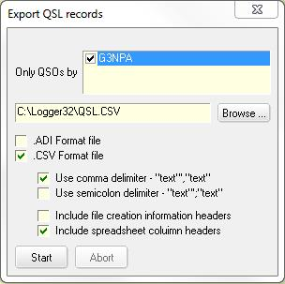

UEPP\_2

* 1. Select the <**Start**> button;
  2. Enter the file name QSL (or QSL.CSV) and select the <**Start**> button;
  3. Select the desired button from the panel shown below;

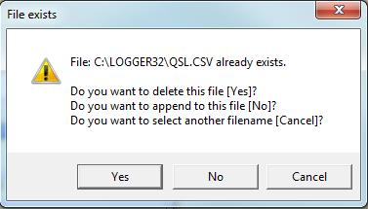

UEPP\_3

* 1. All QSOs marked as Send QSL will now be transferred to the QSL.CSV file; and,
  2. Now all that remains is to open up one of the four files – and print the results.

### 3.2 Modifying or Making Your Own QSL Label Mask

It should be noted that the masks provided have been designed on the assumption that the date format used in the log uses the format dd mmm yy (04 Aug 02) and the time format of hh:mm (18:50).  If other formats are used or preferred, then the label spacing/layout may need to be altered.  This is done from within Microsoft Word and you need to have the mailmerge toolbar visible. On that toolbar you will find a <<>> symbol with REC written underneath. If you click on this button you will reveal the actual mailmerge mask with things like <<Call>> and <<QSL\_via>> in the labels. These are the fields from the QSL.CSV data that will be merged and all of these are available from the mailmerge toolbar. If you already see this format, then click on the same button to see the mailmerged results.

It would be impossible to set out here what steps have to be taken to make the corrections you now desire and your attention is drawn to the help file associated with Microsoft Word. Suffice it to say that the general format and label presentation are without limits and you are urged to EXPERIMENT…. Perhaps the more adventurous could set up a web site where label formats using Microsoft Word could be exchanged!

One of the example layouts (part) is shown below.

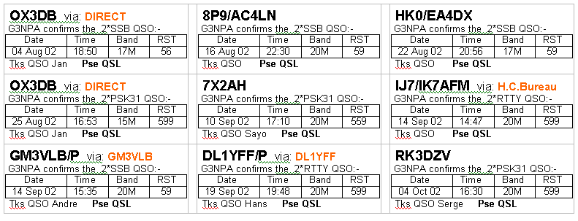

UEPP\_4

*Created with the Personal Edition of HelpNDoc:* [*Easy Qt Help documentation editor*](http://www.helpndoc.com)

**Printing Award Tables**

# Geoff Anderson G3NPA

1.0 GENERAL

It is now possible to make a hard copy of the Awards tables provided you have Microsoft Excel installed on your computer. The spreadsheet produced may be saved if desired.

If you do not have Microsoft Excel, then Logger32 provides the ability to output the details in either a comma or tab delimited format for import to any other suitable program.

For those who wish to disable Excel checking on Logger32 startup, add the following line to the [Globals] section of the Logger32.INI

[Globals]

Check For Excel=No

## 2.0 PROCEDURE

* 1. Open the Awards table you wish to print using the Logger32 [Main menu](#_topic_MainMenu) [Awards| xxxxx](#5.0_AWARDS_MENU_ITEM) menu items where xxxx is one of the options given;
  2. Select the Mode, Operator and QSL type desired from the drop-down lists of the Awards Table and let the table redraw;
  3. Right-click in the main table area to show the print option;

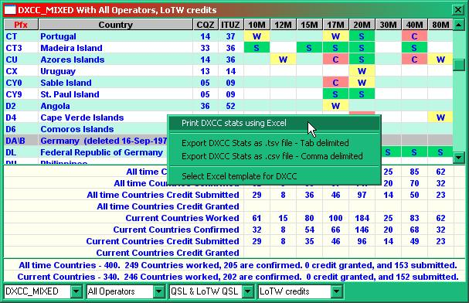

PAT\_1

2.1 Using Excel

* 1. Click on the print menu option. After a few moments you will see a print preview generated by Excel – with a title in the header and the date, log file used and a page number in the footer;
  2. To print this, click the print button in the preview screen;
  3. To return to Logger32, select the <**Close**> button in the preview screen or press the <**Esc**> key on the keyboard;
  4. At this stage the Excel spreadsheet will not have closed and it is still available so that it may be saved to a file if required; and,
  5. To close the spreadsheet, either shutdown the spreadsheet using the “X” in the top right-hand corner or by closing the award table itself.

The above method will use the default "donotdelete.xls" spreadsheet template supplied with the basic Logger32 files.

From Logger32 ver. 3.12.0 onwards, the user may select the Excel template to be used with the awards tables (see option menu in Fig. [PAT\_1](#PAT_1) above). It is for the user to construct these. A different template can be selected for each of the main (Continents, CQ Zones, DXCC, DXCC Challenge, IOTA) Awards.

Included in the Support Files section of the [Loger32 website](#Links:_Logger32_Website) are two "donotdelete.xls" replacement files written by Javier EA1AUS. These are called iota-4l32f.xls and dxcc-4l32f.xls. See below for installation and use details.

Or Generating a Text File

Click on either the tab delimited or comma delimited option to produce a .txt file in the default Logger32 directory. The file name for each award is "Award Name" = "Stats.txt" (example: IOTAStats.txt).

**Note**: For those who select to use the text file format for DXCC information you will find additional columns to the right) of the main data.

## 3.0 DXCC-4L32f.xls & IOTA-4L32f.xls v.3.2 for Logger32 V3.19.0 and later

These two replacement files are Excel spreadsheet template(s) designed to print or display DXCC and/or IOTA awards from Logger32.with the added ability to be able to filter the data for specified criteria.

For both files, the original "DoNotDelete.xls" has been modified and using the buttons in the top right of the form the following can be displayed:

**W** .- Worked

**nW** .- Not worked

**W/N** .- Worked not confirmed and not worked

**C** .- Confirmed

**G** .- Granted

**nG** .- Not Granted

**S** .- Submitted

**D** .- Deleted

**Blank Button** - Reset. (Without filter)

For the IOTA award version in addition to the buttons mentioned there are additional filters for the Continental areas.

Installation and use

To use these files, copy them (dxcc-4L32f.xls and iota-4L32f.xls) into the default Logger32 folder.

### 3.1 Installation and Use

To setup as default template for your Award:, click on the "Awards" drop-down menu and select DXCC or IOTA. Right-click on the awards display and select "Select Excel template for award".

### 3.2 Using this template

Click on the "Awards" drop-down menu and select DXCC or IOTA. Right click on the awards display and select "Print DXCC Stats using Excel". After the print preview, click on the "close" button. Open the minimize excel spreadsheet and test this macros for this radio awards.

The filters buttons are only available in DXCC and IOTA awards.

*Created with the Personal Edition of HelpNDoc:* [*Easy CHM and documentation editor*](http://www.helpndoc.com)

**Menu Bars**

*Created with the Personal Edition of HelpNDoc:* [*Single source CHM, PDF, DOC and HTML Help creation*](http://www.helpndoc.com/help-authoring-tool)

**Main Menu**

# Hew Lines VA7HU and Aki Yoshida JA1NLX

## 1.0 GENERAL

Logger32 utilizes two standard Windows Menu bars, the Main Menu and [Setup Menu](#_topic_SetupMenu).

The Main Menu consists of seven menu items that enable the user to access the following functionality:

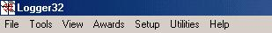

MM\_1

## 2.0 FILE MENU ITEM

The FILE menu item allows the user to:

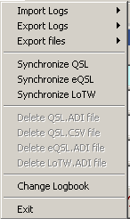

MM\_2

* + Import logs in ADIF (.ADI) format;



MM\_3

* + Export logs in the following formats:

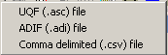

MM\_4

* + - UQF (.ASC);
    - ADIF (.ADI); and,
    - Comma Delimited (.CSV).
  + Export files in the following formats:

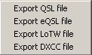

MM\_5

* + - QSL;
    - eQSL;
    - LoTW; and,
    - DXCC.
  + Synchronize paper QSLs;
  + Synchronize your eQSL records;
  + Synchronize your LoTW records;
  + Delete your QSL.ADI file:
  + Delete your QSL.CSV file;
  + Delete your eQSL.ADI file;
  + Delete your LoTW.ADI file;
  + Change your logbook; and,
  + Exit Logger32.

3.0 TOOLS MENU ITEM

The TOOLS menu item allows the user to:

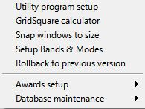

MM\_6

* + Setup Logger32 to use external applications such as QSL Printing programs, WordPad, Notepad, etc.
  + Utilize the Grid Square Calculator;
  + Snap windows to size;
  + Setup Bands & Modes;
  + Rollback to previous version  
      
    If you have a problem after an update then you can rollback to the previously used version saved in the rollback folder. See details in the [Updating Logger32](#4.2.2_Rollback_to_previous_version) topic.
  + Setup and track various awards:

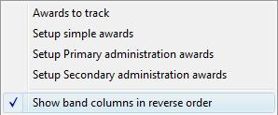

MM\_7

* + - Select the Awards they wish to track;
    - Setup Simple Awards;
    - Setup Primary Administration Awards; and,
    - Setup Secondary Administration Awards.
    - Show band columns in reverse order
  + Configure and maintain Database tables and QSO numbers:

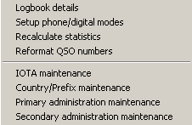

MM\_8

* + - Display Logbook details;
    - Setup phone and digital modes;
    - Recalculate statistics;
    - Reformat QSO numbers;
    - Maintain the IOTA database;
    - Maintain the Country/Prefix database;
    - Maintain the Primary Administration database; and,
    - Maintain the Secondary Administration database.

## 4.0 VIEW MENU ITEM

The VIEW menu item allows the user to:

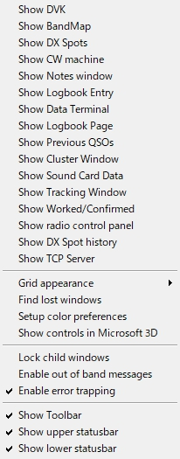

MM\_9

* + Display the Digital Voice Keyer (DVK);
  + Display the Bandmap;
  + Display the DX Spots window;
  + Display the CW machine;
  + Display the Notes and Comments window;
  + Display the Logbook Entry window;
  + Display the Data Terminal window;
  + Display the Logbook Page window;
  + Display the Previous QSOs window;
  + Display the Telnet Cluster WIndow;
  + Display the Sound Card Data window;
  + Display the Tracking Window;
  + Display the Worked/Confirmed window;
  + Display the Radio Control Panel;
  + Display DX Spot History;
  + Modify the Grid appearance:

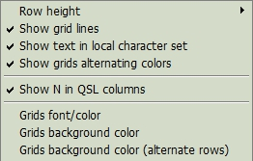

MM\_10

* + - Set the Row Height;
    - Display Grid Lines;
    - Show text in local character set;

**Bob's note**:

Logger32 uses the NAME and QTH field defined in the ADIF spec.  Not NAME\_INTL and not QTH\_INTL. By definition, these fields must have ascii characters in the range of 32 through 126.

Should the user import data (or enter it) with characters outside the defined range.  They will not show as expected.  Names like Stanis³aw will be displayed.  The simple solution to the users self-induced problem would be to enable the Logger32 Windows to show local regional characters (a violation of the ADIF spec), but more pleasing to the eye.

Unfortunately, while this makes Eastern European user happy, Asian users do not want local character sets enabled because the Microsoft Fonts using local character sets, are a little disappointing.

So, in an effort to keep everyone happy, look under VIEW | GRID APPEARANCE for a new menu option. 

* + - DIsplay the Grid in alternating colors;
    - Show the letter N in QSL columns; and,
    - Change the Grids colors.
  + Find any Lost windows
  + Setup color preferences.   
      
     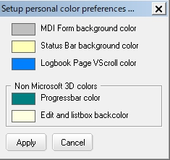  
      
     MM\_10A  
      
    This menu item allows the user to select colors from the color pallet to be used for:
    - The MDI Form background color;
    - The Status Bar background color;
    - Logbook Page VScroll color;
    - Progress Bar colors; and,
    - Edit and Listbox background colors.
  + Show controls in Microsoft 3D. This menu item changes the display characteristics of all Checkboxes, Editboxes, Listboxes, and Date Selection boxes. With this menu item enabled, check marks in the Checkboxes will be displayed in black, and 3D shadows will be created in the other controls. With this item disabled, check marks will be displayed in red, and no shadows will be shown in other controls;

* + Lock child windows. Checking this menu item will lock a child window at its current position so it cannot be moved accidentally;
  + Enable or disable Out-of-Band messages;
  + Enable or disable Error Trapping;
  + Display or Hide the Toolbar;
  + Display or Hide the upper Statusbar; and,
  + Display or Hide the lower Statusbar.

## 5.0 AWARDS MENU ITEM

The AWARDS menu item enables the operator to create and display the Award table data:

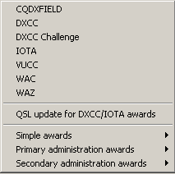

MM\_11

* + CQDXFIELD;
  + DXCC;
  + DXCC Challenge;
  + IOTA;
  + VUCC;
  + WAC;
  + WAZ;
  + QSL Update for DXCC/IOTA awards;
  + Simple awards:

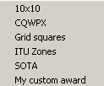

MM\_12

* + - 10x10;
    - CQWPX;
    - Grid squares;
    - ITU Zones;
    - SOTA; and,
    - Create your own Custom Awards.
  + Primary administration Awards. Currently only WAS; and,
  + Secondary administration Awards. Currently only USACA.

## 6.0 SETUP MENU ITEM

The SETUP menu item switches the Logger 32 Menu bar to the [Setup Menu](#_topic_SetupMenu);

## 7.0 UTILITIES MENU ITEM

The UTILITIES menu item allows the user to:

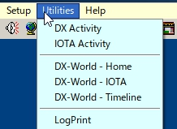

MM\_13

* + Display DX Activity from the 425DX Organization;
  + Display IOTA activity from the RSGB;
  + Display DX-World Home;
  + Display DX-World IOTA;
  + Display the DX-World timeline; and,

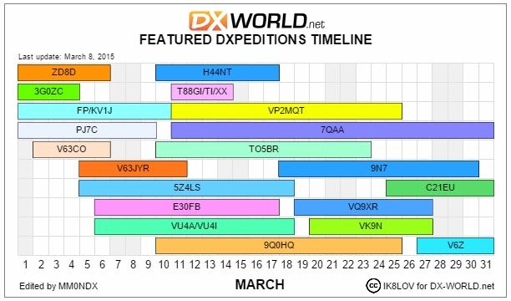

MM\_13A

* + Shell out to external programs such as QSL printing software, WordPad, Notepad, and others. These programs are installed by selecting the [Tools | Utility Program Setup](#Utility_Program_Setup) menu item.

8.0 HELP MENU ITEM

The HELP menu item allows the user to display the:

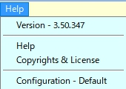

MM\_14

* + Logger32 Version Number;
  + Helpfile contents;
  + [Copyrights and License Helpfile topic](#_topic_CopyrightsandLicense); and,
  + Current INI File in use.

*Created with the Personal Edition of HelpNDoc:* [*Full-featured multi-format Help generator*](http://www.helpndoc.com/help-authoring-tool)

**Setup Menu**

# Hew Lines VA7HU and Aki Yoshida JA1NLX

## 1.0 General

Logger32 utilizes two standard Windows menus, the [Main Menu](#_topic_MainMenu) and Setup Menu. The Setup Menu enables the user to access the following Logger32 Setup functions:



SM\_1

## 2.0 HIGHLIGHT MENU ITEM

The **HIGHLIGHT** menu item allows the user to configure and show the following selectable highlight options for Grids displayed in Logger32:

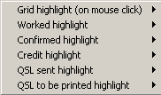

SM\_2

* + **Grid Highlight (on mouse-click)**. These options display a Windows Color dialog box that the user can use to set the Foreground (Text) and Background colors of a Grid line that has been selected;

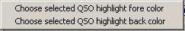

SM\_3

* + **Worked highlight**. This option allows the user to:

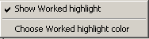

SM\_4

* + - Show or Hide the Worked highlight color; or,
    - Set the Background color for contacts with a state of Worked (W).
  + **Confirmed highlight**. This option allows the user to:

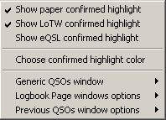

SM\_5

* + - Show or Hide the highlight color for contacts Confirmed by paper QSL;
    - Show or Hide the highlight color for contacts Confirmed by [LoTW](#LoTW);
    - Show or Hide the highlight color for contacts Confirmed by [eQSL](#eQSL);
    - Set the Background color for contacts with a state of Confirmed (C);
    - Highlight the Row or Callsign for Confirmed contacts in the [Generic QSOs window](#_topic_GenericQSOsWIndow);
    - Highlight the Row or Callsign for Confirmed contacts in the [Logbook Page window](#_topic_LogbookPageWindow); and,
    - Highlight the Row or Callsign for Confirmed contacts in the [Previous QSOs window](#_topic_PreviousQSOsWindow);
  + **Credit highlight**. This option allows the user to:

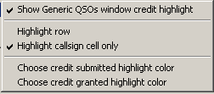

SM\_6

* + - Show or Hide the highlight color of the [Generic QSOs window](#_topic_GenericQSOsWIndow) for contacts with an Award credit;
    - Highlight the Row or Callsign for contacts in the [Generic QSOs window](#_topic_GenericQSOsWIndow);
    - Set the Background color of the [Generic QSOs window](#_topic_GenericQSOsWIndow) for contacts with an Award credit that has been submitted; and,
    - Set the Background color of the [Generic QSOs window](#_topic_GenericQSOsWIndow) for contacts with an Award credit that has been granted.
  + **QSL sent highlight**.

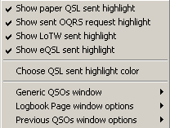

SM\_7

* + - Show or Hide the highlight color for contacts sent a paper QSL;
    - Show or Hide the highlight color for contacts sent an [OQRS](#OQRS) request;
    - Show or Hide the highlight color for contacts sent an [LoTW](#LoTW) confirmation;
    - Show or Hide the highlight color for contacts sent an [eQSL](#LoTW) confirmation;
    - Set the Background color for contacts that have been sent a confirmation;
    - Highlight the Row or Callsign in the [Generic QSOs window](#_topic_GenericQSOsWIndow) for contacts that have been sent a confirmation;
    - Highlight the Row or Callsign in the [Logbook Page window](#_topic_LogbookPageWindow) for contacts that have been sent a confirmation;; and,
    - Highlight the Row or Callsign for contacts in the [Previous QSOs window](#_topic_PreviousQSOsWindow) for contacts that have been sent a confirmation;;
  + **QSL to be printed highlight**.

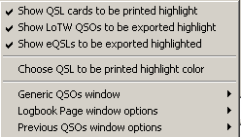

SM\_8

* + - Show or Hide the highlight color for contacts with a paper QSL flagged for printing;
    - Show or Hide the highlight color for contacts with an [LoTW](#LoTW) confirmation flagged for exporting;
    - Show or Hide the highlight color for contacts with an [eQSL](#eQSL) confirmation flagged for exporting;;
    - Set the Background color for contacts that have a paper QSL flagged for printing or a confirmation flagged for exporting;
    - Highlight the Row or Callsign in the [Generic QSOs window](#_topic_GenericQSOsWIndow) for contacts that have been sent a confirmation;
    - Highlight the Row or Callsign in the [Logbook Page window](#_topic_LogbookPageWindow) for contacts that have been sent a confirmation; and,
    - Highlight the Row or Callsign for contacts in the [Previous QSOs window](#_topic_PreviousQSOsWindow) for contacts that have been sent a confirmation;;

## 3.0 DATE FORMAT MENU ITEM

The **DATE FORMAT** menu item allows the user to select the Date format to be used by Logger32 from a drop-down menu.

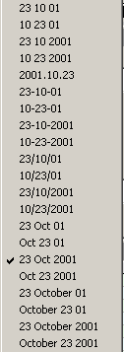

SM\_9

## 4.0 TIME FORMAT MENU ITEM

The **TIME FORMAT** menu item allows the user to select the Time format to be used by Logger32 from a drop-down menu.

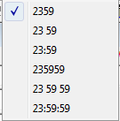

SM\_10

## 5.0 RADIO MENU ITEM

The **RADIO** menu item allows the user to:

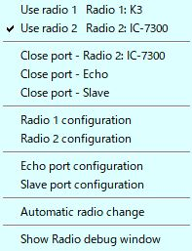

SM\_11

* + Use radio 1
  + Use radio 2
  + Open and Close (toggle) the Radio port
  + Open and Close (toggle) the Echo port
  + Open and Close (toggle) the Slave port
  + Setup Radio 1 configuration
  + Setup Radio 2 configuration
  + Setup Echo port configuration
  + Setup Slave port configuration
  + Automatically change the radio
  + Show the Radio debug window

## 6.0 CD ROM MENU ITEM

The **CD ROM** menu item allows the user to select a CDROM Callbook to be used by Logger32 from the following list:

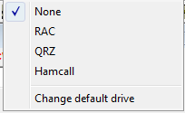

SM\_12

* + None;
  + RAC;
  + QRZ;
  + HamCall; or to
  + Change the default drive

## 7.0 AUTO LOOK UP MENU ITEM

The **AUTO LOOKUP** menu item allows the user to configure Logger32 to automatically search for callsign data from one of the following selections, when a callsign is entered into the Logbook Entry window:

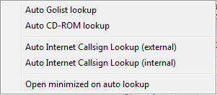

SM\_13

* + Auto Golist lookup;
  + Auto CD-ROM Lookup;
  + Auto Internet Callsign Lookup (external);
  + Auto Internet Callsign Lookup (internal);
  + Open minimized on auto lookup.

## 8.0 FREQUENCY MENU ITEM

The **FREQUENCY** menu item allows the user to select the frequency format to be used by Logger32 from a drop-down menu list.

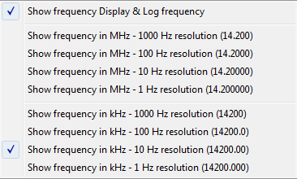

SM\_14

## 9.0 ANTENNA SELECTOR MENU ITEM

The **ANTENNA SELECTOR** menu item displays the Antenna Selector dialog box that enables the user to configure Logger32 to use an electronic antenna switch to automatically select different antennas for different bands. Details can be found in the [Setup Antenna Selector](#_topic_SetupAntennaSelector) topic.

## 10.0 ROTOR MENU ITEM

The **ROTOR** menu item allows the user to interface Logger32 to an antenna rotator using an RS-232 serial interface. Details can be found in the [Setup Antenna Rotator](#_topic_SetupAntennaRotator) topic.

## 11.0 DX SPOT MENU ITEM

The **DX Spot** menu item allows the user to setup the DX Spots message interface and message data for Logger32 to send from the Logbook Entry Window.

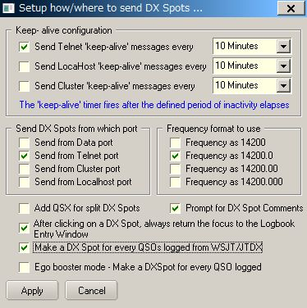

SM\_15

* + Configure the port Keep Alive functionality;
  + Select the Port (interface) to be used;
  + Define the Frequency format to be used in the message and incoming spot;
  + Include the QSX data in the message for split operations;
  + Prompt for comments to add to the message; and,
  + Return the cursor to the [Logbook Entry window](#_topic_LogbookEntryWindow) upon message completion.
  + Make a DX Spot for every QSOs logged from WSJT/JTDX.

This is a sample of a logged QSO and DX Spot for YC6JRT. In this sample VFO frequency is 21074.0KHz, receive tone frequency is 1371Hz and transmit tone frequency is 400Hz.

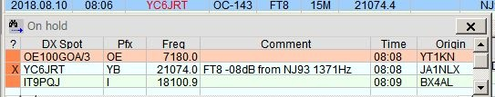

SM\_15D

If you prefer to operate in Ego trip booster mode then check this option. If you check this option then new button appears.

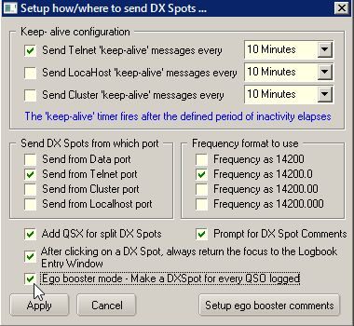

SM\_15A

Click the Setup ego trip comments button.

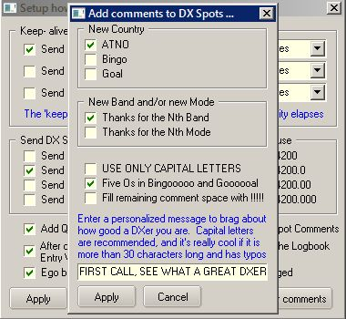

SM\_15B

Check your favorite options and click Apply. Now ready to go. DX spot with ego comment will be sent whenever QSO is logged. Ego comment is automagically generated by Logger32. You can add personalized message too. Some ego comment samples below.

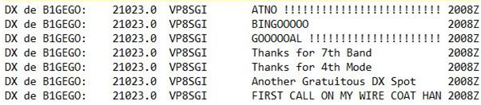

SM\_15C

## 

## 12.0 HAM CAP MENU ITEM

The **Ham CAP** menu item displays the Ham CAP setup dialog box to configure the default configuration of the Ham CAP propagation prediction program.

## 13.0 LANGUAGE MENU ITEM

The **Language** menu item displays the current language configured for Logger32 and the instructions to change that language.

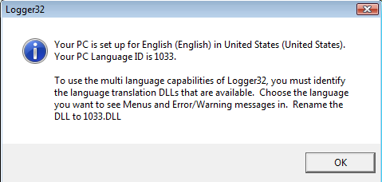

SM\_16

## 14.0 UPDATES MENU ITEM

The **Updates** menu item provides the capability to configure and enable the Update functions of Logger32.

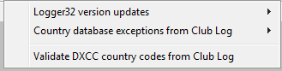

SM\_17

### 14.1 Logger32 Version Updates

The “Logger32 version updates” brings Logger32 up to the latest public release. This update can be set to run automatic or manual. If the automatic update option is selected, Logger32 will automatically poll the internet location 10 seconds after each startup of Logger32. The manual update can be initiated at operator discretion. You can also read the latest release notes.

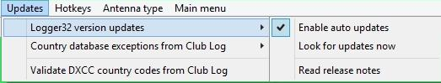

SM\_17A

## 14.2 Country Database Exceptions

The "Country database exceptions" will update the Logger32 country database to match the Club Log database. This will update both the PFX and callsign exceptions. This will be repeated daily if "Enable auto update' is checked, it will run as a background process, has no window and will run 10 seconds after you start Logger32. or If you should run click "Look for updates now" at least weekly. it will start to update and show the window

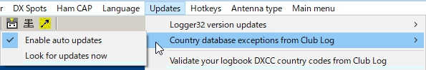

SM\_17B

## 14.3 Validate DXCC Country Codes

The "Validate DXCC country codes" will update the user logbook to show the proper DXCC assignment. This validation is based on the Club Log knowledge base and are based on the actual time periods of specific operations. This option can be run automatic or manually at operator discretion. If manual mode is selected, the operator will be prompted for approval where Logbook differs from the Club Log record. If the user has evidence such as QSL card supporting validity of the logbook record, it is suggested that the evidence be presented to the Club Log help desk so they can update their records. There is also an option to leave the logbook records as is when the QSO already has ARRL confirmation.

This validation updates the statistics automatically unless the operator chooses to do it later to speed up the process.

**Note**: This function modifies your Logbook records. Recommend a full logbook backup before proceeding.

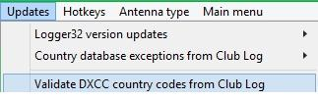

SM\_17C

## 15.0 HOTKEYS MENU ITEM

The **Hotkeys** menu item provides a list of items that can be "checked" to enable global hotkeys within Logger32. The default setting is off (not checked and it is recommended that if you don't use hotkeys, you leave them off.

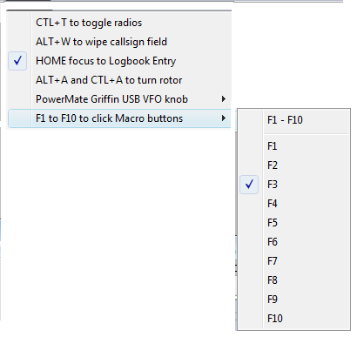

SM\_18

## 16.0 ANTENNA TYPE MENU ITEM

The **Antenna Type** menu item provides the capability to select either the SteppIR antenna controller or the Ultra Beam antenna controller..

## 17.0 MAIN MENU ITEM

The **MAIN MENU** menu item allows the user to switch back to the [Main Menu bar](#_topic_MainMenu).

*Created with the Personal Edition of HelpNDoc:* [*Free iPhone documentation generator*](http://www.helpndoc.com/feature-tour/iphone-website-generation)

**Tool Bar**

# Hew Lines VA7HU

## 1.0 GENERAL

The Logger32 Toolbar provides a set of quick access Tool Buttons allowing the user to select most commonly used Logger32 windows and functions. The display of this toolbar is user selectable through the Logger32 [Main menu](#_topic_MainMenu), [View](#4.0_VIEW_MENU_ITEM) menu item.



TB\_1

## 2.0 TOOL BAR GROUPS

The Toolbar is divided into six general groups.

### 2.1 Toolbar Group One



TB\_2

The first group of two buttons allows the user to save, in compressed (ZIP) form:

* + [Databases and Logbooks](#_topic_BackingupLogger32FilesandDatabas); and,
  + [User Files and Databases](#_topic_BackingupLogger32FilesandDatabas).

### 2.2 Toolbar Group Two



TB\_3

The second group of thirteen buttons allows the user to display the:

* + [DX Spots window](#_topic_DXSpotsWindow1);
  + [Logbook Entry window](#_topic_LogbookEntryWindow);
  + [Logbook Page Window](#_topic_LogbookPageWindow);
  + [Previous QSOs window](#_topic_PreviousQSOsWindow);
  + [Telnet Cluster window](#_topic_TelnetClusterWindow);
  + [Sound Card Data window](#_topic_SoundCardDataWindow1);
  + [Tracking window](#_topic_TrackingWindow1);
  + [Worked Confirmed window](#_topic_WorkedConfirmedWindow);
  + [Notes and Comments window](#_topic_NotesandCommentsWindow);
  + [Data Terminal window](#_topic_DataTerminalWindow);
  + [CW Machine window](#_topic_CWMachineWindow);
  + [Digital Voice Keyer (DVK)](#_topic_DigitalVoiceKeyerDVK); and,
  + [Bandmap window](#_topic_TheBandmap).

### 2.3 Toolbar Group Three



TB\_4

The third group of six buttons allows the user to:

* + Snap Windows to Size;
  + [Access the HamCap propagation prediction software](#_topic_SupportforHamCAP);
  + [Access the Grid Square Calculator](#_topic_GridSquareCalculator1);
  + Setup contest serial numbers;
  + [Access the Conversion Utility](#_topic_ConversionUtility); and,
  + [Display the NCDXF Beacons window](#_topic_NCDXFBeaconsWindow).

### 2.4 Toolbar Group Four



TB\_5

The fourth group of four buttons allow the user to perform:

* + Internet callsign lookup;
  + HamQTH Lookup www.hamqth.com;
  + CDROM callsign lookup; and,
  + GOLIST callsign lookup.

### 2.5 Toolbar Group Five



TB\_6

The fifth group of buttons enables the user to use:

* + The Alpha 87 Linear.
  + The Virtual SteppIR Controller and UltraBeam Controller. and,
  + Preset Rotor Headings

*Created with the Personal Edition of HelpNDoc:* [*Full-featured multi-format Help generator*](http://www.helpndoc.com/help-authoring-tool)

**Status Bar**

*Created with the Personal Edition of HelpNDoc:* [*Easily create HTML Help documents*](http://www.helpndoc.com/feature-tour)

**Status Panels**

# Hew Lines VA7HU and Aki Yoshida JA1NLX

## 1.0 GENERAL

Logger32 provides two user-selectable ( Upper and Lower ) Status Bars. The display of these status bars is controlled through the Logger32 [Main Menu](#_topic_MainMenu), [View menu item](#4.0_VIEW_MENU_ITEM).

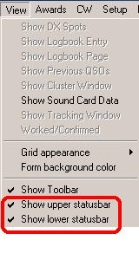

SB\_1

## 2.0 UPPER STATUS BAR

The Upper Status Bar displays five panels of specific information for any callsign entered in the [Logbook Entry window](#_topic_LogbookEntryWindow). These panels consist of:

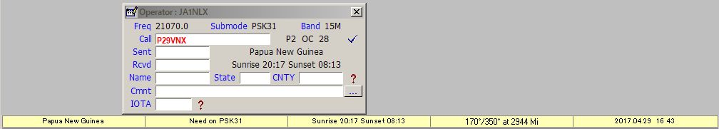

SB\_2

### 2.1 The Country panel

Displays the country name of the contact.

### 2.2 The Confirmed Panel

If you place the cursor over the Confirmed panel, a yellow pop-up hint box will display the confirmed status of the country.

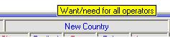

SB\_25

### 2.3 The Sunrise and Sunset Times Panel

If you place the cursor over the Sunrise and Sunset times panel, a yellow pop-up hint box will display your local times.

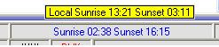

SB\_26

### 2.4 The Beam Headings Panel

Displays the Short and Long path beam headings and Short Path distance to the station. The [ADIF](#ADIF) spec specifies DISTANCE will be in Km. and this is what is output to the ADI file. However, the logbook will show Miles, NMi or Km depending on the user-setting found in "My QTH Lat'Long". The values in the logbook will re-calculate automatically if the basic distance unit is changed.

If you place the cursor over the Beam Headings panel, a yellow pop-up hint box will display both path headings and distances.

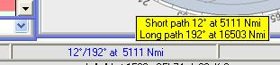

SB\_27

### 2.5 The Date and Time Panel

Displays local date and time at the station, including "polar day" and "polar night" for locations with 24 hour daylight or darkness.

If you right-click on the Date and Time Panel while information is being displayed, complete details for the Time Zone of the selected station will be displayed.

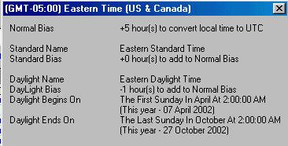

SB\_3

**Note**: The above details will show as displayed when you manually input a callsign into the [Logbook Entry window](#_topic_LogbookEntryWindow). They will also display following a click on the [Logbook Page window](#_topic_LogbookPageWindow) highlighting a particular QSO provided that the [Worked/Confirmed window](#_topic_WorkedConfirmedWindow) is active. If the Worked/Confirmed window is not active, then no details will show when using this alternative method.

## 3.0 LOWER STATUS BAR

The Lower Status Bar displays general system and status information.



SB\_4

The system and status information displayed in the Lower Status Bar consists of:

**3.1 Logger32 Date and Time Panel**

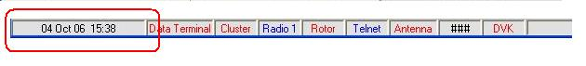

SB\_5

If you place the cursor over the Logger32 date and time, a yellow pop-up hint box will display your PC system date, time and time zone.

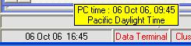

SB\_6

If you right-click on the Logger32 date and time, a pop-up menu will be displayed,

The NIST clock sync capability has been replaced with an NTP clock client since version 3.50.376.  Go to <https://support.ntp.org/bin/view/Servers/StratumOneTimeServers> and choose an open accesss NTP server near you. Right click on the Time pane at the left of the lower status bar. Click GET ATOMIC CLOCK TIME.  Click SETUP and choose/set your options. After you've played around a while, open your favorite web browser and type TIME.IS in the URL search box.

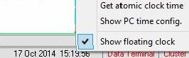

SB\_7

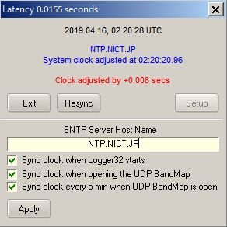

SB\_7A

Click “Get atomic clock time” to allow you to set your PC time to an [Atomic Clock](#_topic_AtomicClock) standard Click “Show PC time config” to view details of your PC Time Zone using the same display as described above for the Upper Status Bar [local date and time](#2.5_The_Date_and_Time_Panel).

Placing a check mark on the Show floating clock menu item, a small Floating Clock will open. This clock can be configured and placed anywhere on the display for a quick reference in local or UTC time.

Right click on the clock pane and a menu will open allowing the user to configure the clock. The show time only option will display the time without the date.

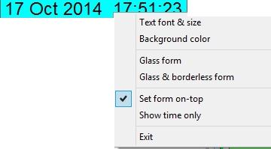

SB\_7B

### 3.2 Data Terminal Window Status

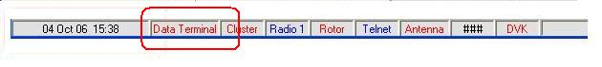

SB\_8

If you place the cursor over the [Data Terminal Window](#_topic_DataTerminalWindow) status, a yellow pop-up hint box will display the current status

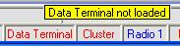

SB\_9

### 3.3 Cluster Window Status

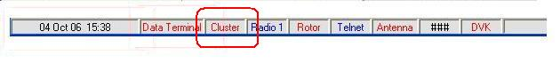

SB\_10

If you place the cursor over the [Cluster window](#_topic_TelnetClusterWindow) status, a yellow pop-up hint box will display the status of the serial (COM) port configured for the Telnet Cluster window.

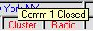

SB\_11

If you right-click on the Cluster status, a pop-up menu will be displayed allowing you to open or close (toggle) the serial (COM) port configured for the Telnet Cluster window.

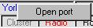

SB\_12

### 3.4 Radio Control Status

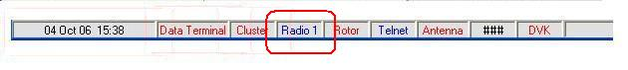

SB\_13

If you place the cursor over the Radio control status, a yellow pop-up hint box will display the status of serial (COM) port configured for the [Radio port](#_topic_SetupRadioControl), [Echo Port](#_topic_TheEchoPort) and [Slave Port](#_topic_TheSlavePort).

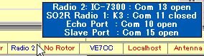

SB\_14

If you right-click on the [Radio control](#_topic_SetupRadioControl) status, a pop-up menu will be displayed providing a number of choices.

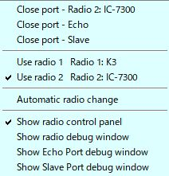

SB\_14A

### 3.5 Rotor Control Status

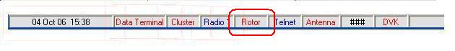

SB\_15

If you place the cursor over the [Rotor Control](#_topic_SetupAntennaRotator) status, a yellow pop-up hint box will display the status of the Rotor.

### 3.6 Telnet Window Status



SB\_16



SB\_16A

If you place the cursor over the [Telnet Window](#3.0_TELNET_PANEL) or [Local Host](#6.0 LOCAL_HOST_PANEL) status pane, a yellow pop-up hint box will display the status of the socket connection.

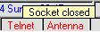

SB\_17

If you right-click on the Telnet or Local Host window status, a pop-up menu will be displayed allowing you to connect or disconnect from the Default Remote Host configured in the Telnet Cluster window and Local Host window.

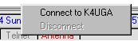

SB\_18

### 3.7 Antenna Selector Status

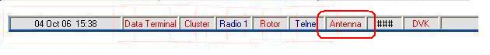

SB\_19

If you place the cursor over the [Antenna Selector](#_topic_SetupAntennaSelector) status, a yellow pop-up hint box will display the status of the parallel port configured for the Antenna Selector.

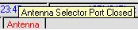

SB\_20

### 3.8 Serial Number

See the [Contest Serial Numbers](#_topic_ContestSerialNumbers) topic.

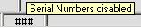

SB21

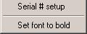

SB\_22

### 3.9 Digital Voice Keyer (DVK) Status

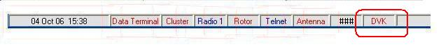

SB\_23

If you place the cursor over the DVK status, a yellow pop-up hint box will display the status of the serial (COM) port configured for the DVK port.

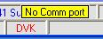

SB\_24

### 3.10 microHAM (uHAM) Status

If you place the cursor over the uHam status, a yellow pop-up hint box will display the status of the serial (COM) port  configured for the microHam port.

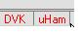

SB\_28

**3.11 TCP Server status**

The TCP Service Status pane displays the current state of the TCP Server port. If the port is opened the caption is highlighted in blue. If the port is closed the caption is highlighted in red .

If you place the cursor over the TCP pane a yellow pop-up hint will display the TCP server status。

### 

SB\_29

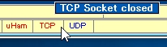

SB\_30

Right click on the TCP pane to display the TCP Server menu.

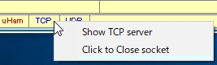

SB\_31

**3.12 UDP Bandmap status**

The UDP Bandmap status pane shows the current statte of the UDP Bandmap. If the socket is opened then the caption is highlighted in blue. If the socket is closed then the caption is highlighted in red. If you place the cursor over the UDP Bandmap pane a pop-up hint will display the UDP Bandmap status.

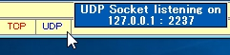

SB\_32

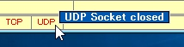

SB\_33

Right click on the UDP Bandmap pane to display the UDP Bandmap menu.

You can configure different UDP port numbers for Radio 1 and Radio 2. This allows the user to connect to two different instances of WSJT/JTDX. A simple**<CTRL>** + **<T>** toggles the radios and connection to different WSJT/JTDX engines. If you only have one radio, you can simulate this by configuring Radio 1 and Radio 2 the same but assigning different UDP port numbers. The default UDP port number for both Radio 1 and Radio 2 is 2237. When configuring UDP port numbers be careful of conflicts with the UDP repeater port.

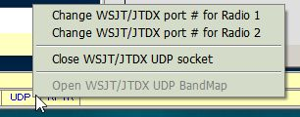

SB\_34

## 3.13 RPTR status

See details in UDP BandMap section.

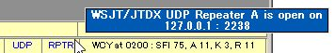

SB\_34A

### 3.14 WWV and WCY Messages Received in the Cluster Window

If you right-click on this pane you will connect to a NOAA website and collect the latest geophysical alert information.

*Created with the Personal Edition of HelpNDoc:* [*Free Kindle producer*](http://www.helpndoc.com/feature-tour/create-ebooks-for-amazon-kindle)

**Starndard TIme Zones**

# Geoff Anderson G3NPA

## 1.0 GENERAL

The [Date and Time panel](#2.5_The_Date_and_Time_Panel) in the [Upper Status Bar](#2.0_UPPER_STATUS_BAR) gives the local time for the prefix entered in the [Logbook Entry window](#_topic_LogbookEntryWindow). The generation of this time information relies on the Standard Time names used within the Microsoft operating system in use. It has been found that there are some differences between the various Windows systems, and in earlier versions some of the Standard Time names, which have been set within the Logger32 country database, are not present.

The Country and Offset databases provided with Logger32 use the Windows XP (English) Time Zone names. Depending on what operating system you use, some Time Zone calculations may fail.

If your PC is configured for a language other than English and your Windows operating system is NT (this includes XP), Logger32 will do the necessary translation, and the feature will work correctly. If you are not using an NT operating system, the DX Station local time feature will not work.

If you are using Win 98 or Win 98SE, and the base language for the computer is English, a local time will not be shown for some prefixes unless steps are taken to correct this problem.

**Note**: If you are using a version of Windows where the base language is something other than English, then none of the time zone names will match those in Logger32 and hence the QSO partner's time/date will not be displayed.

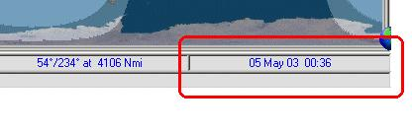

STZ\_1

## 2.0 USE STANDARD TIME NAMES

A list of the Standard Times names used in the database is shown in Table 1. Note that some Standard Time names are marked with a "**#**", indicating those that are not within Win98, Win 98SE or Win NT and therefore if a local time is required from these time zones, some of the countries within the database will need to be modified. Table 2 shows those prefixes affected and gives a suggested alternative. Please note that these suggestions are considered the best alternative. They will not necessarily give the correct local time throughout the whole year.

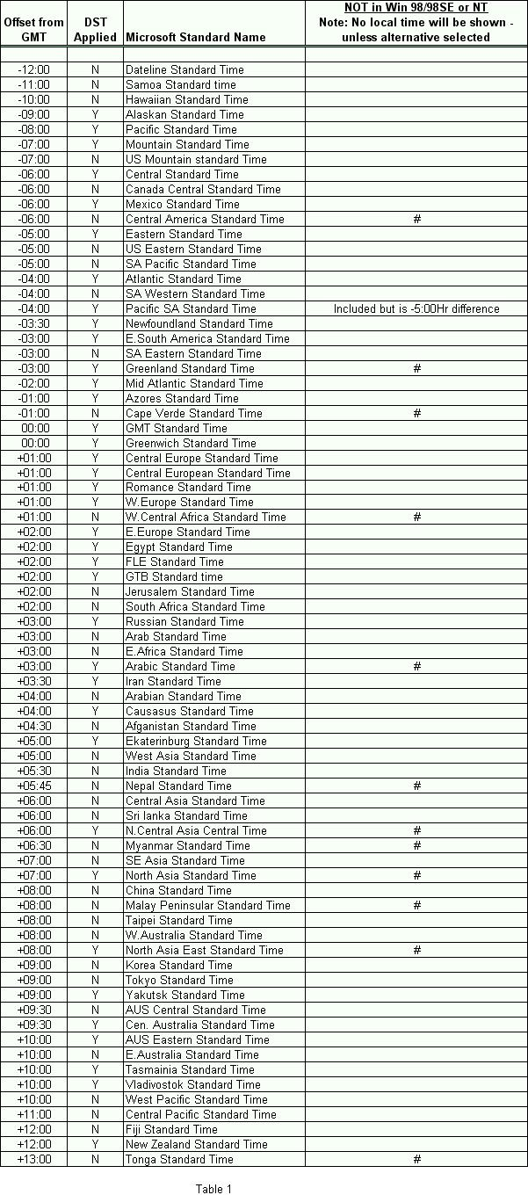

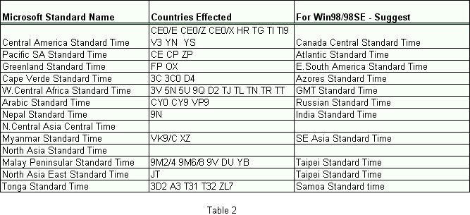

## 3.0 USE TZEDIT

As a much better alternative, one can edit and/or add to the actual time zone list within the operating system using TZEdit. The Time Zone Editor is part of the Windows 98 Resource Kit, Windows NT 4.0 Resource Kit, and Windows 2000 Resource Kit. Find the directory tools\reskit\config on your Windows installation CD, and run Tzedit.exe. If you use this method, then it is imperative that the Microsoft standard name is used (exactly as shown above in Table 1), for it is this, which Logger uses and it **MUST** match exactly. If you make a mistake in typing the time zone name (abbreviation), it will not work correctly with Logger32.

An example is given below for Greenland's time zone.

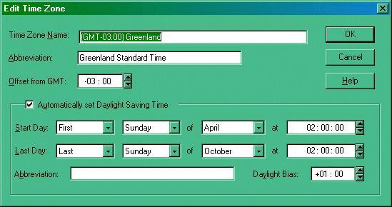

STZ\_2

**Note**: In Win 98 it is not possible to generate a time zone of +13 hours for Tonga. However a very close approximation can be achieved but using a GMT offset of 12:59.

Remember also that DST in the southern hemisphere (if applicable) is the reverse to that in the northern hemisphere (i.e., it starts in Sept/Oct and ends in March/April).

*Created with the Personal Edition of HelpNDoc:* [*Full-featured Kindle eBooks generator*](http://www.helpndoc.com/feature-tour/create-ebooks-for-amazon-kindle)

**Misc.**

*Created with the Personal Edition of HelpNDoc:* [*Easily create PDF Help documents*](http://www.helpndoc.com/feature-tour)

**Snap Windows to Size**

# Bob Furzer K4CY

Snap Windows to Size is a function that attempts to align and resize all of the main logging windows to the nearest 25 pixels on the screen.

It is difficult to drag and resize all windows to be exactly the same size, at the same width, and all neatly at the same height using the mouse. One can get close, but often not exact.

Snap Windows to Size is based on the nearest 25 pixels to each window top, left, height, and width. Let's assume a simple case of only two windows. With the mouse, you have dragged the Logbook Entry Window to a location where its top is 20 pixels below the top of the Logger32 main window, and the Previous QSOs Window is moved with the mouse to a position 2 pixels from the top of the Logger32 main window. You're almost there, but the windows are still not exactly in line (they are in fact, 18 pixels apart).

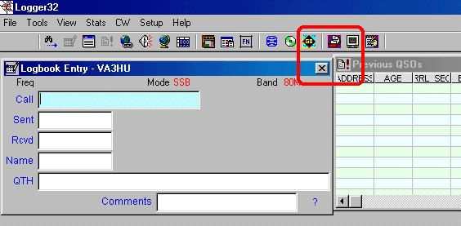

SNWTS\_1

From the Logger32 Main menu, select the Tools|Snap Windows to Size menu items, and the top of the Logbook Entry Window will snap down to 25 pixels from the top of the Logger32 main window, and the top of the Previous QSOs Window will snap to the top (0 pixels) of the Logger32 main window.

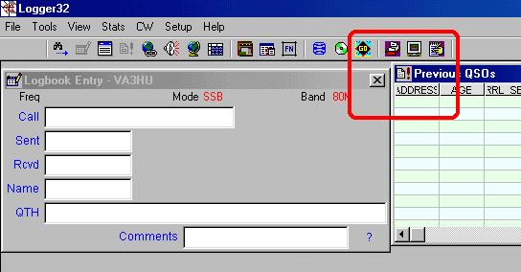

SNWTS\_2

The tops of the two windows are now 25 pixels apart - worse than before. However, the tops of the two windows are now set at the magic 25 pixel positions apart on the Logger32 main window. Which position do you prefer?

Let's assume the Logbook Entry Window at 25 pixels from the top. Drag the Previous QSOs window with the mouse so the top is very close to being aligned to the top of the Logbook Entry Window,  let's say it's at 27 pixels (just a little higher).

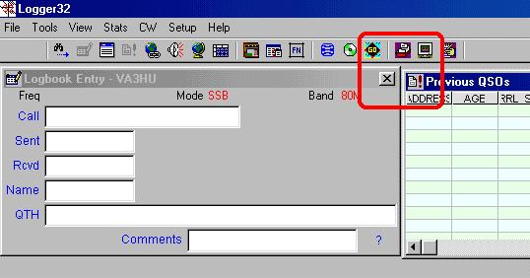

SNWTS\_3

Select Snap Windows to Size again, and the top of the Previous QSOs Window will snap to 25 pixels, and the tops of both windows are now exactly aligned.

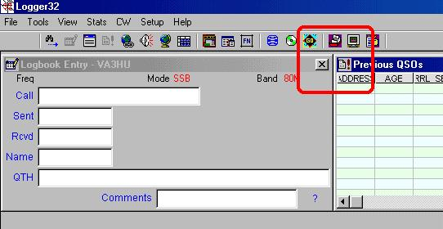

SNWTS\_4

The above example was worst case. If you were lucky, when you first aligned the Logbook Entry Window and the Previous QSOs Window, you would have gotten closer than we did above. Assume the top of the Logbook Entry Window was at 10 Pixels and the Previous QSOs Window was at 12 pixels from the top of the Logger32 main window.

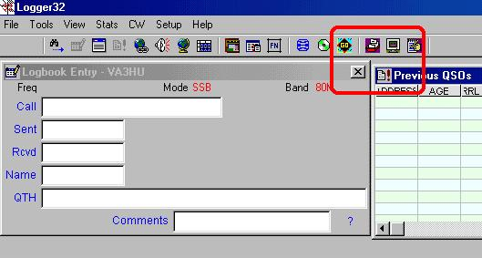

SNWTS\_5

Selecting Snap Windows to Size would have aligned the tops of both Windows at exactly the same height (0 pixels from the top of the Logger32 main window).

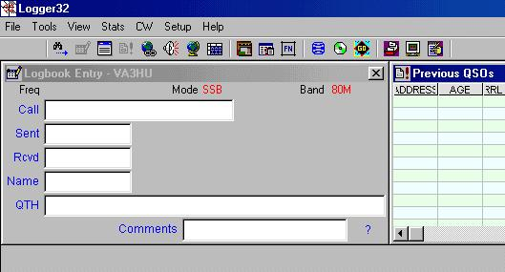

SNWTS\_6

**A Reminder** - Snap Windows to Size adjusts all four dimensions of the windows (Top, Left, Height, and Width), so the same applies for aligning windows side by side, and one above another.

Easy huh?

*Created with the Personal Edition of HelpNDoc:* [*News and information about help authoring tools and software*](http://www.helpauthoringsoftware.com)

**Atomic Clock**

# B. Charles Sutton W1MCP

## 1.0 GENERAL

If you have the Lower Status bar turned on, you will find in the bottom left hand corner of the Main Window, Logger32's clock. Logger32 provides the capability to set the computer's clock from an Atomic Time standard via the Internet. The clock will show GMT (Zulu) time. Logger32 reads the timezone settings you have defined in Windows and adjusts itself accordingly. There is no manual intervention required to allow for Standard Time or Daylight Savings Time.

If you hold the mouse over the time, a ToolTip will pop up to show the date and time your PC is set to. If you right-click on the clock, a small menu will pop up with two selectable options:

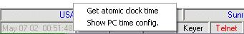

AC\_1

### 1.1 Get Atomic Clock Time

This option will query an [Atomic Clock server](#2.0_ATOMIC_CLOCK_SERVERS) via the Internet and set your computer time accordingly.

**Note**: You must be connected to the internet for this feature to work. Any adjustments made will be displayed:

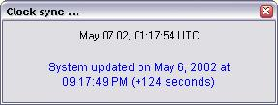

AC\_2

### 1.2 Show PC Time Config

This option will display the TIme settings you have set up in Windows.

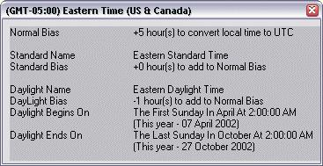

AC\_3

## 2.0 ATOMIC CLOCK SERVERS

The functionality of this feature is dependent on the availablity of the Atomic Time Server. In the event the time server is down, there are changes you can make to reconnect.

The URL for the time server is stored in the Logger32.ini file, which can be edited with any text editor (such as notepad).  Search for the [**Atom Clock**] section and edit the line **ClockAddress=time-a.timefreq.bldrdoc.gov.**  Replace the URL listed (to the right of the equal sign) with a different time server URL.

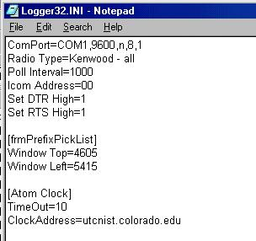

AC\_4

The National Institute of Standards and Technology maintains a list of time servers and their current status on their webpage: <http://tf.nist.gov/tf-cgi/servers.cgi>

There are technical limitations to Window's ability to adjust itself. If your PC clock is off by more than a day or two, you should manually set the clock as close as possible before running synchronizing your PC. Depending on how close you are to a Standard Time/Daylight Savings Time change, you may have to synchronize twice. Again, this is only if your PC is drastically out of sync.

*Created with the Personal Edition of HelpNDoc:* [*Single source CHM, PDF, DOC and HTML Help creation*](http://www.helpndoc.com/help-authoring-tool)

**Conversion Utility**

# Geoff Anderson G3NPA

Included in Logger32 is a utility for the quick conversion of some basic units (Kilometres to Miles, etc). From the Logger32 [Toolbar](#_topic_ToolBar), select the [Conversion Utility icon](#2.3_Toolbar_Group_Three) to open the Conversion dialog box. Enter the value to be converted into the left-hand pane, select the particular conversion required freom the pull down list in the middle pane, and the answer will be displayed in the right-hand pane.

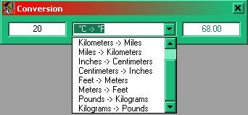

CU\_1

*Created with the Personal Edition of HelpNDoc:* [*Produce electronic books easily*](http://www.helpndoc.com/create-epub-ebooks)

**Using Logger32 as a Contest Log**

# Andy Obrien K3UK

In the Logger32 help files Geoff says "It is NOT a contesting log (although there is no real reason why it could not be used for such)".

I would like to remind folks that Logger 32 does really well for casual contesting. You're not likely to use it for your multi-multi CQDX contest entry from Bhutan, but it can be a useful contesting application.

I played around in the recent RTTY contest and I set up Logger32 to generate serial numbers. I opened the [Previous QSOs window](#_topic_PreviousQSOsWindow) and the [Worked/Confirmed window](#_topic_WorkedConfirmedWindow) to provide good dupe checking capability and a reasonable "needed Mult" capability. To get needed multipliers, and to be more efficient. I could have started a totally new log for the contest but did not do this for my casual effort.

The [DX Spots window](#_topic_DXSpotsWindow1) worked well for tracking needed stations. Essentially, Logger32 did everything I needed except to score the contest results.

I accomplished this by exporting the partial log from Logger32 and importing it into a program that scored my efforts.

You might wonder why I did not just use the contesting software, I simply like the RTTY/PSK interface in Logger32 so much that I did not want to try the others. Logger32 still has some rig control features within RTTY/PSK that other programs do not have.

If you are a person just wanting to work a couple hundred QSOs in a contest, Logger32 is all you need.

*Created with the Personal Edition of HelpNDoc:* [*Free EPub producer*](http://www.helpndoc.com/create-epub-ebooks)

**Contest Serial Numbers**

# Geoff Anderson G3NPA

## 1.0 GENERAL

Although Logger32 is not designed as a contesting program, serial numbers may be sent automatically when using the [Sound Card Data window](#_topic_SoundCardDataWindow1), [CW Machine](#_topic_CWMachineWindow) or [Data Terminal window](#_topic_DataTerminalWindow) by writing shortcuts employing the [$serialnum$](#$serialnum$) Macro. The serial number will increment each time a QSO is logged.

The current serial number is shown in the [Lower Status Bar](#3.8_Serial_Number) at the bottom of the screen. If the serial numbering is not enabled, then this panel will display ###.

The format of the serial numbers, for numbers below 100, is user-selectable.

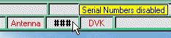

CSN\_1

## 2.0 SETTING UP SERIAL NUMBER PREFERENCES

Right-clicking on the contest serial number pane in the Lower Status Bar will display a small menu giving access to the setup panel.

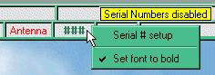

CSN\_2

Left-click on the Serial # setup menu item to display the setup panel.

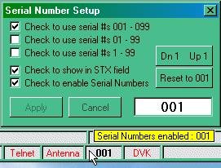

CSN\_3

*Created with the Personal Edition of HelpNDoc:* [*Generate Kindle eBooks with ease*](http://www.helpndoc.com/feature-tour/create-ebooks-for-amazon-kindle)

**The F11 Key Explained**

# Bob Furzer K4CY and Aki Yoshida JA1NLX

Using the F11 to clear the [Logbook Entry Window](#_topic_LogbookEntryWindow).

The object is to allow the user to send commands to other windows, i.e., the [DVK](#_topic_DigitalVoiceKeyerDVK), [Sound Card Data window](#_topic_SoundCardDataWindow1), [Data Terminal window](#_topic_DataTerminalWindow) and [CW Machine](#_topic_CWMachineWindow), to execute macros while the focus is on the Logbook Entry Window -- This allows the user to continue to work on the Logbook Entry window without the necessity of switching the focus, to execute commands in the other windows.

If, for example, the CW Machine is running (albeit minimized), all function keys typed in the Logbook Entry window are passed directly to the CW Machine.

There was much reference to F11 as the 'standard' key used in logging software to clear logbook entries. To conform to this (alleged) standard, it is suggested that users program the F11 key on the Sound Card Data Window, Data Terminal and CW Machine to execute the [$clearlog$](#$clearlog$) Macro.

If none of the [DVK](#_topic_DigitalVoiceKeyerDVK), [Soundcard Data Terminal Window](#_topic_SoundCardDataWindow1) and [CW Machine](#_topic_CWMachineWindow) are opened and the focus is on the [Logbook Entry Window](#_topic_LogbookEntryWindow) then F11 clears the Logbook Entry Window.

*Created with the Personal Edition of HelpNDoc:* [*Free help authoring tool*](http://www.helpndoc.com/help-authoring-tool)

**Scrolling Using a Wheel Mouse**

# Geoff Anderson G3NPA

## 1.0 GENERAL

Code has now been introduced to allow the scrolling of the [Logbook Page window](#_topic_LogbookPageWindow) and other windows using a wheel mouse. It is designed to work if the focus is on the Logger32 main form and not on the Awards or Telnet Cluster windows. The low-level mouse wheel capture is done on the MDI window. The Awards windows are not child forms (they're not subordinate to/of) the main Logger32 window.

**Note**: The testing teams have had varying results with this code and it seems dependent on the operating system in use and the particular mouse drivers being used. This is what has been found to date:

* + Win98SE - the scroll facility works as advertised but only if you are running with a Microsoft mouse driver. Using a Logitech mouse driver with Win98SE allows all windows to be scrolled except the Logbook Page window.
  + WinXp - This seems to be OK in all areas, however this may not be the case - so be prepared. If it works for you then please don't announce that it works for you in reply to others without giving full details of your operating system and mouse driver details.
  + Bob Furzer has researched this for several days and as yet has not found an overall solution to these problems. If it works for you - enjoy.

## 2.0 RADIO FREQUENCY

Code has also been included to allow the scrolling of the radio frequency using the mouse wheel. Right-click on the frequency information in the [Logbook Entry window](#_topic_LogbookEntryWindow)

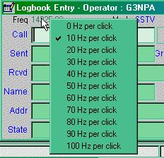

SUWM\_1

and select your desired increment. With the cursor located anywhere within the Logbook Entry window, roll the mouse wheel to QSY the radio.

## 3.0 OPERATIONAL NOTES

* + The faster the radio polling, the less the latency between mouse wheel roll and radio freq change.
  + As with the [Telnet Cluster window](#_topic_TelnetClusterWindow), the [Radio Debug window](#_topic_RadioDebugWindow), which also uses a RichTextBox, will capture mouse wheel movements if the focus is on that window. It's a Windows thing, and Bob Furzer hasn't found a cure for it yet.
  + Hold the <**Shift**> key down and roll the wheel for greater increments.

*Created with the Personal Edition of HelpNDoc:* [*Create cross-platform Qt Help files*](http://www.helpndoc.com/feature-tour/create-help-files-for-the-qt-help-framework)

**Finding Lost Windows**

# Geoff Anderson G3NPA

## 1.0 GENERAL

There have been a number of reports/problems where a window, although open, has not been visible for some reason. Quite often this was because they were hidden behind other open windows but occasionally (and for reasons unknown) they disappear off screen completely. This utility is intended to force the “lost” window to appear in the top left-hand corner of the main computer screen or, for those running two monitors, monitor 1 thus making it available again.

## 2.0 GENERAL CASE

The utility is accessed from the Logger32 [Main menu](#_topic_MainMenu) [View](#4.0_VIEW_MENU_ITEM) menu item as shown below.

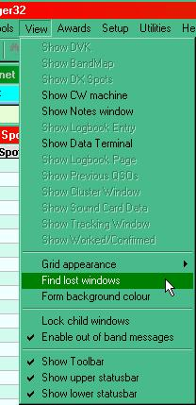

FLW\_1

This action will open the Currently open windows dialog box shown below where a list of currently open windows is shown. Simply scroll to the window to be recovered, insert a check mark by clicking on the check box and then select the <**Find**> button.

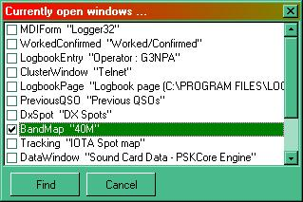

FLW\_2

3.0 SPECIFIC CASE

There is one specific case that needs to be considered and that is when the main Logger32 window itself is not visible. In this instance, the general method described above cannot be used because the menus cannot be selected.

When Logger32 is booted, the focus will be on the Callsign field of the Logbook Entry window (no matter if the main Logger32 form is visible or not). By blind typing "FIND"+<**Enter**> the main form will be commanded to an X, Y location of 0,0.

*Created with the Personal Edition of HelpNDoc:* [*Create iPhone web-based documentation*](http://www.helpndoc.com/feature-tour/iphone-website-generation)

**Multi-Language Support**

*Created with the Personal Edition of HelpNDoc:* [*Free Kindle producer*](http://www.helpndoc.com/feature-tour/create-ebooks-for-amazon-kindle)

**Multi-Language Support**

# Bob Furzer K4CY

## 1.0 GENERAL

Logger32 supports local languages for: Menus, Error and Warning messages and a limited number of Data Entry field names. This capability will continue to be enhanced in future releases.

Internally, Logger32 has been coded to support character sets for Japanese, simplified Chinese, Korean, Traditional Chinese, Eastern Europe, Russian, Western Europe, Greek, Turkish. Hebrew, Arabic, Italian and Baltic. This does not mean you can enter data into Logger32 in these language character sets; only the Menus and Error/Warning messages are supported in these languages.

Multi language support has been implemented by using resource only DLLs (also known as satellite DLLs). What this means is that Logger32 is written in English (US), and there is only one version of Logger32. Everyone has the same basic executable. If you wish to have Menus and Error/Warning messages shown in a language other than English, you select the language DLL you want, rename it (details below), and put it in your Logger32 directory.

An example of a small section of the Main Menu is shown below, using the Japanese DLL.

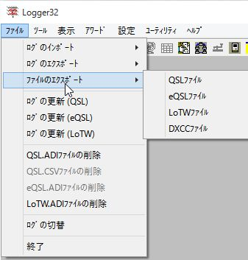

MLS\_1

## 2.0 SETUP

With your computer set to your normal regional settings, run Logger32 and from the Logger32 [Main menu](#_topic_MainMenu), select the [Setup | Language](#13.0_LANGUAGE_MENU_ITEM) menu items. This will display an information window that will display your PC Language ID number.

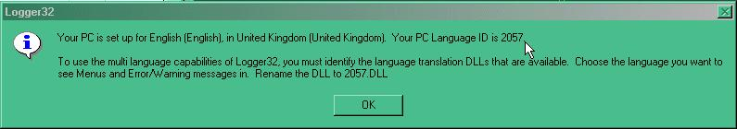

MLS\_2

Make a note of the LCID number and select the <**OK**> button.

Unzip the distribution file called DLL.ZIP and look for your own language .dll file and extract this file to your Logger32 default directory.

Now rename the .dll that you have just extracted to nnn.dll where nnn is the LCID number displayed in MLS\_2 above.

Open Logger32 and you should see the language that you have just configured.

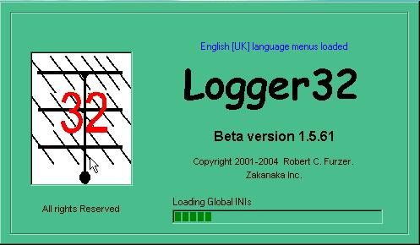

MLS\_3

This may seem unnecessarily complicated, but here is the reasoning for asking you to do this. Throughout the development and enhancement of Logger32, we have tried to provide the user with maximum flexibility. Sometimes this comes at the expense of appearing to make things more complicated than they need to be.

Your PC knows what its language settings are by/with an identifier known as LCID (Locale ID). Logger32 uses the PCs LCID as the key to what (if any) language DLL to look for. If you select the Logger32 [Main menu](#_topic_MainMenu) [Setup | Language](#13.0_LANGUAGE_MENU_ITEM) menu items, you can see your PCs LCID.

Again, always keeping user flexibility in mind, let's assume you (the user) are German speaking, have your PC set to German, and want to see the Menus and Error/Warning messages in English. You have nothing to do to the program as the default language of Logger32 is English (US).

Now, let’s assume that you are German speaking, your PC is setup for German, and you want to see Menus and Error/Warning messages in German. Here is what you do. First, is there a German language DLL? It will be called DL.DLL. Yes, there is one provided in the Language. zip file. Next, what is the LCID for your PC settings? from the Logger32 [Main menu](#_topic_MainMenu), select the [Setup | Language](#13.0_LANGUAGE_MENU_ITEM) menu items to display Fig. [MLS\_2](#MLS_2). This will tell you that your PC is set for German, and the LCID for German is 1031. Rename the file DL.DLL to 1031.DLL, copy it to the Logger32 directory, and run Logger32. It will now speak German.

As a final example, let’s assume you are German speaking, your PC is set to English (US), and you want to see Menus and Error Warning messages in German. Here is what you do – First, is there a German language DLL? It will be called DL.DLL. Yes, there is one provided in the Language.zip file. Next, what is the LCID for your PC? From the Logger32 [Main menu](#_topic_MainMenu), select the [Setup | Language](#13.0_LANGUAGE_MENU_ITEM) menu items to display Fig. MLS\_2. This will tell you that your PC is set for English (US), and the LCID for English (US) is 1033. Rename the file DL.DLL to 1033.DLL, copy it to the Logger32 directory, and run Logger32. It will now speak German (on your PC set to English (US)).

Language DLLs are now provided with either full release or upgrades of Logger32. The file Language.zip contains text for translation, creation and distribution of language specific DLLs by users. It should be noted that there may be compatibility problems between language DLLs and different releases of Logger32. As Logger32 evolves, new menus and Error/Warning messages are added. These changes need to be included in the language DLL. If there seems to be an inaccuracy in the wording of a menu or an error/warning message, check to confirm that you have the most current language.dll file for your release of Logger32.

Users are encouraged to make their own language DLLs for their own languages. Instructions on how to make a language DLL are at <http://support.microsoft.com/default.aspx?scid=kb;EN-US;q232625> information about LCIDs is at <http://support.microsoft.com/default.aspx?scid=kb;en-us;221435>

For those wishing to create their own language DLLs, I have included (in the Language.zip file) two additional files, Menus.txt and ErrorsAndWarnings.txt. These files are the English (US) text used by Logger32. When creating your own language DLL, note that many Error/Warning messages are made up of several text strings with data embedded in the string. For example “Are you sure you want to permanently delete this QSO with “ JA1NLX “ from the logbook?” Notice the space after the word ‘with ‘, and before the word ‘ from. You will see lines 10000 and 10001 of the ErrorsAndWarnings.txt file. Of course, when creating the DLL, the “ marks are not used, they are in this file only to show the correct text formatting. Also, note in the Menus.txt file there are menus (for example: “This && that”. When the character & is used in a menu it must be typed as &&, or the software will assume it is identifying a hot key. Further information can be found in the section Creating Language DLLs.

The following table lists some of the languages that are supported by Microsoft Office and their corresponding LCIDs.

**Language LCID**

Croatian 1050 (&H41A)

Czech 1029 (&H405)

Danish 1020 (&H406)

Dutch 1043 (&H413)

English U.K. 2057 (&H809)

English U.S. 1033 (&H409) \*

French 1036 (&H40C)

German 1031 (&H407)

Icelandic 1039 (&H40F)

Italian 1040 (&H410)

Japanese 1041 (&H411)

Polish 1045 (&H415)

Portuguese 2070 (&H816)

Russian 1049 (&H419)

Spanish Spain (Modern Sort) 3082 (&HHC0A)

Swedish 1053 (&H41D)

\* Indicates the default language for logger32

*Created with the Personal Edition of HelpNDoc:* [*Easily create PDF Help documents*](http://www.helpndoc.com/feature-tour)

**Creating Language DLLs**

# Marek Niedzielski SP7DQR

## General

## 1.0 GENERAL

Logger32 now offers multi-language support. This means that menus and warning/error messages can be displayed in your national language. You only need to translate the original English text and compile the result to produce your own language DLL.

## 2.0 STEP 1 - TRANSLATION

Source English text files are distributed with both the full and upgrade versions of Logger32 packages as the Language.zip file. This compressed file contains two files:

* + Menus.txt with menus items; and,
  + ErrorsAndWarnings.txt with source errors and warnings messages:

Both files have the same structure: first is the text ID and this is followed by the text assigned to this ID. There is a <**Tab**> character between ID and the text fields.

Menus.txt file can be translated directly. Items marked as “hidden” need not be translated – they are not visible in Logger32.

Errors and warnings messages require more comments. The text is placed between double quotation marks ( “ ). These quotation marks are specially used to indicate the start/end of text and must be deleted during translation – but not the beginning or end spaces. The example below shows the reason for the spaces. The two first messages in the file are:

10000 "Are you sure you want to permanently delete this QSO with "

10001 " from the Logbook"

These messages are displayed, when you want to delete a QSO from the log. For example, if it was a QSO with SP7DQR, the whole message will be:

"Are you sure you want to permanently delete this QSO with SP7DQR from the Logbook"

Between line 10000 and line 10001 the callsign SP7DQR is added. If spaces on the end of item 10000 and on the beginning of item 10001 were deleted, the message will be look like:

"Are you sure you want to permanently delete this QSO withSP7DQR from the Logbook"

If your language’s grammar requires a different sequence of the words, you can freely manipulate the contents of the two dependent lines, but any one line can not be empty. In the limit, the line may have one character only (space, dot, etc.). Note that if you have an empty line, it will be deleted during compilation and Logger32 will then use the corresponding default English text.

Once you have translated all items from both files, proceed to the next step.

## 3.0 STEP 2 - RESOURCE FILE CREATION

A text editor was sufficient for the basic translation, but now something a bit more powerful is required. The minimum would be Microsoft © Visual Basic, but in this case all text ID and translated text must be input manually into VB’s internal resource editor. This is not the best way to proceed as there are more than 1000 items to enter.

Visual Basic requires a .res file (resource file - compiled binary file) as source file. Theoretically, it is possible to create a source text file (.rc) and compile it to a .res file using special software (e.g. Resource Workshop from Borland Pascal 7.0) and then compile the .res file to our DLL language file.

The simplest way is to use software to convert a text file or other easy to edit file to a .res file. I would recommend the program “Resource Manager”, also known as “YARE” or “ResMan”. This program can import data from an Excel file and save it as a .res file. The program is free and can be downloaded from: http://www.yare-vb.com. It requires MDAC\_TYP.EXE, version 2.5 or later (this is Microsoft© program and can be downloaded from: http://ww.microsoft.com/data).

If you decide to use ResMan to create the .res file required, you must initially prepare an Excel file;

Run MS Excel. Open menus.txt with Notepad, select all text and copy it to the Clipboard. Go to Excel and use the Paste function to paste data from Clipboard to the Excel Sheet. Open ErrorsAndWarnings.txt with Notepad, select all text, copy it and paste to the Excel file on the end of the menus data, without blank lines in between the two imported files. Because between text ID and text there are TAB characters, Excel puts ID in the first column and text in second. All text you have now in one Excel file. Save it in Excel format (as .xls file).

Now this Excel file must be prepared for ResMan requirements. You must add a new first line with column names: ID in the first column and your PC Language ID in the second.

The Language ID number can be taken from the Logger32: go to the Setup menu and next Language menu. You can see message as follow:

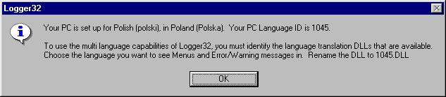

CLD\_1

My PC Language ID is 1045, so I must type 1045 in second column. If you make a translation for another language, then use the proper language ID. If you don’t know it, set this language in Regional Settings, re-run Logger32 and check PC Language ID. You can set required language during Excel file import to the ResMan, too.

The beginning of Excel file will be looks like:

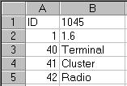

CLD\_2

The first column in the Excel file is numerical, second is text. The second line (ID=1) is very important. It is information about the version number. If you run Logger32 using non-compatible version of the language DLL, all menu items will still display in English. ResMan deletes items from the second column, if it is not text. If there are numbers, date or time, you must add ( ‘ ) on the beginning of the text. So, 1045 in first row must be typed as ‘1045 and 1.6 must be typed as '1.6.. You must add a single quote ( ‘ ) in the lines 1644-1671 – date and time format. Compare date lines (1644-1664) in the Excel file with the original text file – Excel can interpret these items as real date and change its for format setup in Regional Settings. Look for the examples below – you must add ( ‘ ) on the text beginning of all lines with text align to the right side of the column.

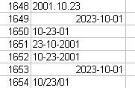 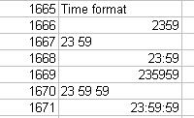

CLD\_3 CLD\_4

When all above changes are made, save the file and close Excel. Run the ResMan program and select the Import option from File menu.

Now run this very simple Excel to Res import wizard:

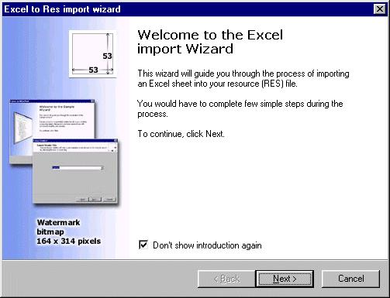

CLD\_5

In turn in wizard steps you must:

* 1. Select your source Excel file;
  2. Select Sheet with source data from Excel file; and,
  3. If you add line with “ID” and language ID, and your Excel file has only two columns, you will see following wizard screen.

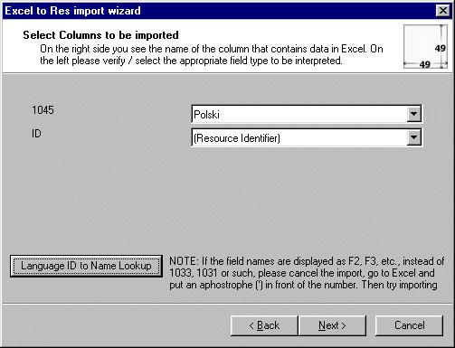

CLD\_6

If you forgot to add ( ‘ ) before language ID or you don’t put language ID at all to the Excel file, fields will be look like this:

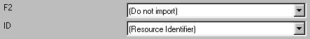

CLD\_7

You can select the required language from the list under the right-arrow. You can change the language, if you have not selected the proper Language ID:

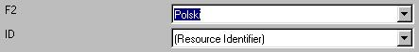

CLD\_8

The screen will inform you, that all is ready for the import. Select the <**Finish**> button After importing, ResMan shows the following information:

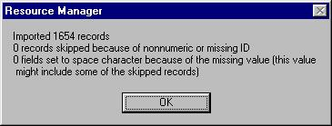

CLD\_9

If there are any errors, you must carefully check the source data. If any fields are set to space, they can be edited directly in ResMan.

The table in ResMan now includes the text ID and assigned text (in example below it is Polish text):

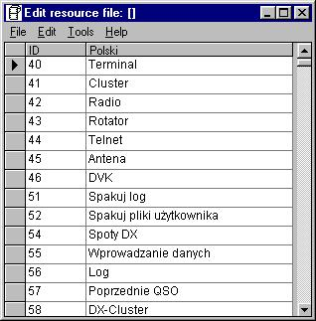

CLD\_10

Select the Save As option from the File menu, select the folder, where the .res file is to be saved, type name of the file (don’t forget add .res to the name) and click Save. Your resource file is ready to compiled to the DLL.

**Note**: Logger32 uses <**Alt + first letter**> menu item as shortcuts (for example, <**Alt + V**> opens View menu). If your translated words clash with other shortcuts, it can evoke some strange Logger32 reaction. For example, Polish translation of View is Widok, and when I pressed <**Alt + W**> to clear the QSO Entry Window fields, the View menu automatically was opened... if some menu items have the same first letter, you must chose a different letter to underline. To do this, it is necessary to find the menu item in the source RES file, select one letter from the item, which will be used for the shortcut and precede it with “&” character, i.e. Wid&ok instead of Widok. This menu item will be visible in Logger32 as Widok (with underline “o” letter), and <**Alt + O**> will be new shortcut for this menu. The most items in Polish menu are modified in that way:



CLD\_11

4.0 STEP 3 - DLL FILE CREATION

Some more professional software is required to compile our .RES file to DLL library. I tested compilation with Microsoft© Visual Basic 6.0 from MS Visual Studio 6.0 and with Borland Delphi 5.0 Standard.

### 4.1 Compilation with Microsoft © Visual Basic

Run Microsoft© Visual Basic from Microsoft Visual Studio 6.0 package, select New Project option from the File menu and select ActiveX DLL from project templates:

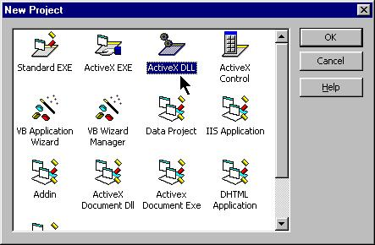

CLD\_12

Now you must activate the VB Resource Editor. Select Add-In Manager from the Add-Ins menu and select VB 6 Resource Editor from the available Add-Ins list. On the Load Behavior panel check the Loaded/Unloaded option – in the Load Behavior column must be “Loaded”.

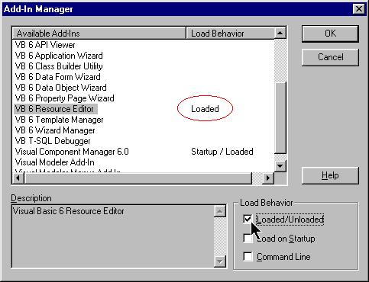

CLD\_13

Select the <**OK**> button. If the VB Resource Editor is not be automatically visible, click on the Resource Editor item in the Tools menu. The Resource Editor window will be opened:

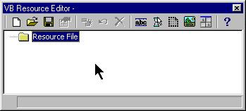

CLD\_14

Click on the Open Resource File icon or select Open from the pop-up menu. Select your .res file to load and load it. The String Table will be added to your resource. If you click on the Edit String Tables  icon, the Edit String Tables window will be displayed:

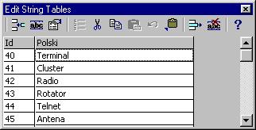

CLD\_15

You can check items one last time and make any needed changes.

If you decide to manually insert all items to the String Table (without .res file creating by ResMan program), don’t select Open Resource File option, but click the Edit String Tables icon and the empty Edit String Tables window will be displayed. All text ID and items can be typed directly to the String Table.

For the final step in DLL creation: select Make Project1.dll. From File menu, select the folder, where the DLL must be written and type in name such as 1045.dll. Click OK: The “Compiling” and “Writing” messages will be displayed on the Toolbar.

That completes this part of the operation. Copy your new Language DLL to the Logger32 folder and rename it to your PC Language ID (if you used other file name). Run Logger32 and automatically your own Language DLL will be used.

### 4.2 Compilation with Borland Delphi 5.0 Standard

Run Delphi 5.0, select File|New and click on the DLL icon. Empty Library Project will be opened:

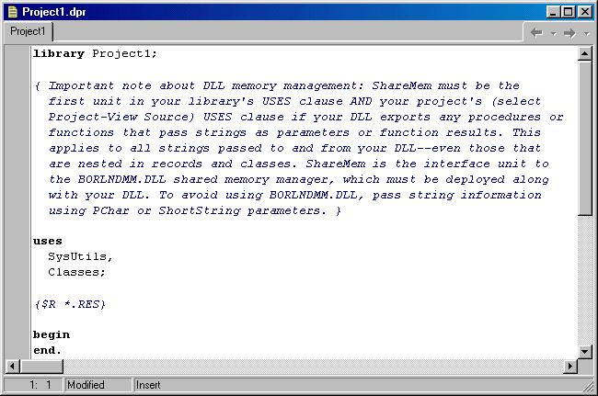

CLD\_16

Only four lines are required, so delete all other lines from the project. Replace \*.RES with your RES file name and location, and save your project. My RES file had SP.RES name, it was lacated in root D: directory and I saved project as SP. After these operations my project looks like below:

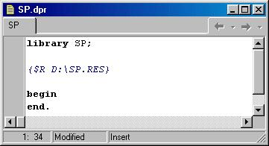

CLD\_17

Now select Project|Build Project (Build SP for my file) and SP.DLL will be created in SP project directory.

If you don’t delete any lines from project, the only one difference will be DLL size – it will be about 50% bigger.

*Created with the Personal Edition of HelpNDoc:* [*Full-featured Kindle eBooks generator*](http://www.helpndoc.com/feature-tour/create-ebooks-for-amazon-kindle)

**Grid Squares**

*Created with the Personal Edition of HelpNDoc:* [*Free Qt Help documentation generator*](http://www.helpndoc.com)

**Grid Square Calculator**

# Geoff Anderson G3NPA

When you have the need to calculate a Grid square reference, a simple converter is provided which will accept a latitude and longitude reference and produce the appropriate code.

On the [Logger32 Tool Bar](#_topic_ToolBar), select the  button to display the Gridsquare calculator dialog box.

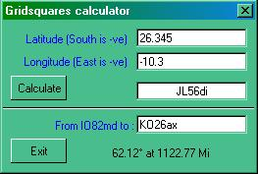

GSC\_1

The calculator is divided into two sections.

* 1. The upper section will calculate the Grid square reference for a specified latitude and longitude. Enter the latitude and longitude and select the <Calculate> button. The code will appear in the pane to the bottom right of the top section. Note that the latitude and longitude should be entered as decimal numbers with positive values representing North and West and negative values representing South and East.
  2. The lower section will calculate distance and Great Circle bearing from the location specified in My QTH (right-click on the [Logbook Entry window](#_topic_LogbookEntryWindow) and use Setup | My QTH Lat/Long) to the center of the Grid square entered.

The same calculator is used automatically if a Grid square reference is entered into the [Logbook Entry window](#_topic_LogbookEntryWindow). The result is displayed in the upper of the two announcement bars at the bottom of the screen.

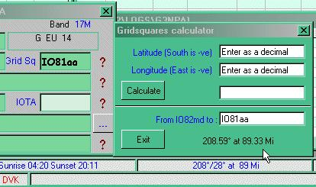

GSC\_2

**Notes**:

* 1. The above screen shot is just for example purposes. The actual calculator does not get its input window updated automatically from an input via the [Logbook Entry window](#_topic_LogbookEntryWindow). In this example, these details have been entered separately just to show the similar results for either method of deriving the bearing and distance.
  2. Logger32 uses the QTH Lat/Long information to calculate the operator's Grid Square. It also uses this same information when calculating bearing and distance to another square. Indeed it calculates from the user's location (Lat/Long) to the calculated Lat/Long of the center of the square required. It follows therefore, that when performing calculations to squares that are very close to the user's square, the bearing and/or distance might not appear to be correct. Logger32 is in fact calculating correctly and the reason for the apparent error is because the user may not be located exactly at the center point of their grid square.

*Created with the Personal Edition of HelpNDoc:* [*Easy Qt Help documentation editor*](http://www.helpndoc.com)

**Maidenhead Locator System**

# Geoff Anderson G3NPA

The Earth's surface is divided into 18 \* 18 = 324 "Fields", each one being 20 degrees longitude \* 10 degrees latitude.

Each Field is divided into 10 \* 10 = 100 "Squares", each one being 2 degrees longitude \* 1 degree latitude.

Each square is finally divided into 24 \* 24 = 576 "Subsquares", each one being 5 minutes longitude \* 2.5 minutes latitude.

The Fields are indicated by two letters AA - RR, the Squares by two digits 00 - 99 and the Subsquares by two letters aa - xx. The first character is the longitude and the second character is the latitude on each level. The numbering is always West to East and South to North. The start reference for Longitude is the -180deg line of longitude and the Latitude reference start is the South pole (-90).

The complete locator is the sum of all 6 characters, for example "FN43mj", which gives a location to within 2.5nmi N/S and between 0 and 5nmi (depending on Latitude) E/W.

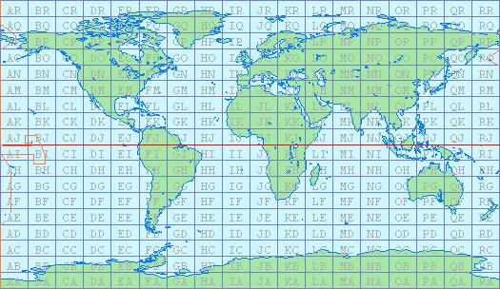

MLS\_1

*Created with the Personal Edition of HelpNDoc:* [*Create help files for the Qt Help Framework*](http://www.helpndoc.com/feature-tour/create-help-files-for-the-qt-help-framework)

**External Interfaces**

*Created with the Personal Edition of HelpNDoc:* [*Free Kindle producer*](http://www.helpndoc.com/feature-tour/create-ebooks-for-amazon-kindle)

**Using the Logger32 External Interface**

# Bob Furzer K4CY

## 1.0 GENERAL

A series of Windows messages have been coded that allow message exchange between Logger32 and a user-developed application, and data transfer using ADI formatted strings.

A skeleton VB application (with source code) is provided as a starting point for those who wish to write interfaces.

## 2.0 ESTABLISHING COMMUNICATION

The first step in establishing communication between your application and Logger32 your application must identify the hWnd of the Logger32 MDI:

Dim L32hWnd as long

L32hWnd = FindWindow(vbNullString, "Logger32")

If Logger32 is not running, your application must retry periodically until Logger32 is running.

### 2.1 Initial WIndows Messages to Logger32

Second, your application must register/identify an unused Windows message (Logger32 supports up to 5 simultaneous external applications):

### 2.1.1 Message 1

Dim L32Msg as long

L32Msg = RegisterWindowMessage("Logger32 1")

PostMessage L32hWnd, L32Msg, 1, GhW ‘ GhW is the hWnd of your main form

Logger32 will reply to you with a message number 0. If the L32Msg you send is in use by another external application, the lParam will be set to 0. If the L32Msg is unused, then the lParam will be set to 1. If your connect request was rejected (lParam is 0), then your application must retry using a different L32Msg:

L32Msg = RegisterWindowMessage("Logger32 2")

PostMessage L32hWnd, L32Msg, 1, GhW ‘ GhW is the hWnd of your main form

Logger32 currently supports up to 5 external interface applications. Your application can retry the connection using a RegisteredWindowMessage “Logger32 1” to “Logger32 5”.

### 2.1.2 Message 2

When your application has successfully connected to Logger32 (you receive a message number 0 with an lParam of 1), you must now send a message number 2 to Logger32 with an lParam of the TextBox.hWnd Logger32 is to send text strings to. If your application does not want unsolicited data from Logger32, then you set the lParam to 0:

PostMessage L32hWnd, L32Msg, 2, TextBox.hWnd

### 2.1.3 Message 3

Immediately following the message 2 to Logger32 you have the option to send a message 3 to Logger32. Setting the lParam to 0 (or simply not sending a message 3) will tell Logger32 to not send any DX Spot information to your application (I suspect most applications will not want to receive DX Spots from Logger32). Setting the lParam to 1:

PostMessage L32hWnd, L32Msg, 3, 1

will tell Logger32 to send [ADIF](#ADIF) formatted text to your application for each DX Spot received by Logger32. If you have previously set the message 2 lParam to 0 (no TextBox hWnd provided to Logger32) and you set the message 3 lParam to 1 (telling Logger32 to send your DX Spot information) Logger32 will complain, generate a warning message and turn off the request.

Logger32 will respond by doing three things:

* + 1. Logger32 sends your application a message number 3. The lParam of this message is the hWnd of a TextBox in Logger32 your application sends ADI formatted text strings to.
    2. Logger32 sends your application a message 99. The IParam of this message is the radio currently in use (1 or 2).
    3. Logger32 sends your application a message 100. The lParam of this message is the radio frequency (in Hz).

If your application has OK’d the receipt of unsolicited text strings from Logger32 (you sent a TextBox hWnd as the lParam of your message number 2), Logger32 will send your application a WM\_SETTEXT message and put the current Radio Mode in the TextBox you have identified. The format of the text is (say) <APP\_RADIO\_MODE:3>SSB

## 3.0 ADDITIONAL MESSAGES TO LOGGER32

The basic connection and synchronization between Logger32 and your application is complete. Logger32 will respond to the following additional messages from your application.

**Message 4**. lParam is 0. Your application tells Logger32 it has stopped. Logger32 will free up the RegisteredWindowMessage your application was using.

**Message 5**. lParam is 0. Your application tells Logger32 to shut down.

**Message 6**. lParam is 0. Your application relinquishes PTT control. Logger32 assumes PTT control and initialized PTT ports/keying lines.

**Message 7**. lParam is 0. Your application assumes control of the PTT.

**Message 8**. lParam is 0. Your application tells Logger32 to key the PTT.

**Message 9**. lParam is 0. Your application tells Logger32 to unkey the PTT.

**Message 10**. lParam is the hWnd of a TextBox in your application to write to. Logger32 will respond with an ADIF formatted text string in the following format <APP\_SET\_FREQ\_MODE:27>18132.012|CW The frequency is in KHz and the decimal separator will be in the correct format for the PCs regional settings.

**Message 11**. lParam is 0. Your application tells Logger32 to release CAT control of the Radio.

**Message 12**. lParam is 0. Your application tells Logger32 to take CAT control of the Radio.

**Message 13**. lParam is 0. If the Logger32 Mode controlled by Sound Card option is checked, then <APP\_FORCE\_MODE:x> messages from your application will change Logger32 Mode.

**Message 14**. lParam is 0. Disables the feature turned on by message 13. Remember to turn this off when your application closes.

**Message 15**. If lParam is 1 then a flag is set so that Logged QSOs will be marked for QSLing. If lParam is 0 then the flag is turned off.

**Message 16**. If lParam is 1 then a flag is set so that Logged QSOs will be marked for eQSLing. If lParam is 0 then the flag is turned off.

**Message 17**. If lParam is 1 then a flag is set so that Logged QSOs will be marked for LoTW. If lParam is 0 then the flag is turned off.

**Message 18**. If IParam is 1 then Logger32 radio polling is turned off. If IParam is 0 then Logger32 radio polling is turned on. If your application

disables Logger32 radio polling, remember to turn it back on when your application closes.

**Message 19**. If lParam is 0 then Logger32 Mode from BandPlan option is turned off. If lParam is 1 then Logger32 Mode from BandPlan is turned on. If lParam is 2 then Logger32 will respond with a message 103 indicating the Mode from BandPlan in the lParam. If your application uses message 19, remember to set the value back to the original setting when your application closes.

**Message 20**. lParam is ignored. An ExternalInternetCallsignLookup module sends this message on lookup completion. On receipt of this message, Logger32 looks for and processes the data file written by the external lookup module.

**Message 21**. lParam is ignored. When Logger32 receives this message, the export LoTW file process is started. On completion of the export, Logger32 sends unsolicited messages to the app: <APP\_LoTW\_RECORDS:xx> and <APP\_LoTW\_FILENAME:xx>.

**Message 22**. lParam is ignored. When Logger32 receives this message the export eQSL file process is started. On completion of the export, Logger32 sends unsolicited messages to the app: <APP\_eQSL\_RECORDS:xx> and <APP\_eQSL\_FILENAME:xx>.

**Message 23**. lParam is ignored. When Logger32 receives this message, the sync LoTW process is started. Prior to sending this message the application should send a <APP\_IMPORT\_SYNC\_FILENAME:xx>xxx message to Logger32 to advise the filename of the file to be imported.

**Message 24**. lParam is ignored. When Logger32 receives this message, the sync eQSL process is started. Prior to sending this message, the application should send a <APP\_IMPORT\_SYNC\_FILENAME:xx>xxx message to Logger32 to advise the filename of the file to be imported.

**Message 25** An lParam of 1 flags Logger32 to write an ADIF formatted record to a file ‘eQSL Dump File.txt’ in the application directory for each QSO logged. If the lParam is 2, the ADIF record is written and the EQSL\_QSL\_SENT field in the Logbook is set to ‘Y’. If the lParam is 0, the function is turned off and no ADIF formatted records are written. Logger32 remembers any previous setting of this function. It is not necessary to send this message every time the external application is executed, only when the user wishes to change the setting. Logbook informational entries like G3NPA=) are not written.

**Message 26**. An lParam of 1 flags Logger32 to write an ADI formatted record to a file 'ADIF audit trail.txt' in the application directory as each QSO is logged or modifies. An lParam of 0 flags Logger32 to not write the record. It is not necessary to send this message every time the external application is executed, only when the user wishes to change the setting. New QSOs added to the Logger32 Logbook, and written to the 'ADIF audit trail.txt' file, are prefixed with the text <APP\_QSO\_LOGGED:0>. QSOs deleted from the Logger32 Logbook, and written to the 'ADIF audit trail' file, are prefixed with the text <APP\_QSO\_DELETED:0>. QSOs in the Logger32 Logbook that are modified, and written to the 'ADIF audit trail' file, are written as two records. The first, as the unmodified QSO prefixed with the text <APP\_QSO\_DELETED:0>, the second as the modified QSO prefixed with <APP\_QSO\_LOGGED:0>. It is the responsibility of the external application to do whatever file maintenance/cleanup of the 'ADIF audit trail.txt' as necessary. All logbook entries (including informational entries like G3NPA=) are written. The user must remove these if they are not required for your application.

**Message 27**. Same as message 26, but enables/disables writing to the "ClubLog Dump File.txt" in the application directory. Logbook informational entries like G3NPA=) are not written.

**Message 28**. Sending this message to Logger32 (params are ignored) opens the External Interface Debug window to allow message sequences to be monitored. This window can also be turned on by adding this entry to the Logger32.ini file:

[Globals]

External Interface Debug=1

**Message 29**: Sending this message to Logger32 (params are ignored) makes Logger32 send all current QSO information from the Logbook Entry Window.

**Message 120**. Send this message to Logger32 if you have written data to a disk file as the result of an internet lookup.

## 4.0 ADDITIONAL MESSAGES FROM LOGGER32

Logger32 will send the following additional messages to your application:

**Message 99** This message is sent prior to message 100. The IParam contains the number of the currently in use radio (1 or 2).

**Message 100** This message is sent whenever the radio frequency changes. The lParam contains the radio frequency in Hz. Message 100 is always preceeded by message 99.

**Message 101** This message is sent if Logger32 has calculated a valid beam heading and the user types CTL\_A or ALT\_A. The iParam contains the Short Path direction (if the user typed CTL\_A) or Long Path direction (if the user typed ALT\_A). The directions are calculated to include any/all Logger32 corrections the user has set. No checking is done to ensure that direction is within the range of 0 to 360 degrees; this checking/correction must be done by the external application.

**Message 102** This message is sent following a user click on a DX Spot.

**Message 103** This message is sent in response to receipt of a message 19 with IParam of 2. The message 103 will have an IParam of 0 if the Logger32 Mode from BandPlan option is off and an IParam value of 1 if the Logger32 Mode from BandPlan is on.

**Message 104** This message is sent whenever the secondary radio frequency changes. The IParam contains the radio frequency in Hz. Message 104 is always preceded by message 99.

**Message 105** Logger sends this message to the application every time a QSO is written to the log and an ADIF formatted message is written to the eQSL Dump File. When an ADIF file is imported into Logger32 a single message 105 is sent on completion of the import. This function is enabled/disabled when Logger32 receives a message 25. Prior to sending message 105, Logger32 sends a <APP\_eQSL\_DUMP\_FILENAME:xx>filename to the application.

**Message 106** Logger32 sends this message every time a record is written to the ‘ADIF audit trail.txt’ file. When a logbook QSO is deleted, and ADIF formatted is added to the file. The record has the additional field of <APP\_QSO\_LOGGED:0> to indicate why the record was added to the file. Logger32 sends your application a message 106 with an lParam of 0. When a logbook QSO is added, an ADIF formatted record is added to the file. The record has the additional field of <APP\_QSO\_LOGGED:0> to indicate why the record was added to the file. Logger32 sends your application a message 106 with an lParam of 1. When a logbook QSO is modified, an ADIF formatted record is added to the file. The record has the additional fields of <APP\_QSO\_MODIFIED:0> and <APP\_HRD\_APIKEY:xx>call|date|time (call, date and time are the values prior to modification) to indicate why the record was added to the file and to provide the necessary keys for the application to identify the original QSO record that was modified. Logger32 sends your application a message 106 with an lParam of 2.

**Message 107** Logger sends this message to the application every time a QSO is written to the logbook and an ADIF formatted message is written to the ClubLog Dump File. When an ADIF file is imported into Logger32 a single message 105 is sent on completion of the import. This function is enabled/disabled when Logger32 receives a message 27. Prior to sending message 107, Logger32 sends a <APP\_CLUBLOG\_DUMP\_FILENAME:xx>filename to the application.

**Message 108** If the currently selected rotor is “External Interface” Logger32 sends this message to the application to request azimuth rotor position. This is a poll message. The application will reply with a message 108 that has the position in the lParam

**Message 109** Logger32 sends this message when the auto-lookup process (callsign lookup) is triggered.

**Message 110** Logger32 sends this message when the antenna selector is changed. The lParam contains the antenna number (either decimal of BCD).

**Message 111** Logger32 sends this message to external applications when a QSO is logged.  The message is not sent if QSOs are imported or added from the ADD Window.

## 5.0 ADIF TEXT STRINGS

Data is exchanged between your application and Logger32 by writing ADIF formatted text strings to identified TextBoxes. It is suggested/recommended that the user utilize the TextBox\_Change event as a trigger to process the ADIF data received.

### 5.1 Logger32 recognizes the following ADIF strings

**<EOR>** If received without additional text, Logger32 will clear all current entries in the Logbook Entry Window.

**<APP\_TAB>** If received without additional text, this simulates moving the focus from the Callsign field of the Logger32 Logbook Entry Window. Automatic functions (like QRZ lookup, Previous QSOs lookup, auto-populate of data from previous QSOs, etc. are triggered.

**<CALL:x>** Callsign is placed on the Logbook Entry window.

**<RST\_RCVD:x>** The RST Received is placed on the Logbook Entry window.

**<RST\_SENT:x>** The RST Sent is placed on the Logbook Entry window.

**<NAME:x>** The name is placed on the Logbook Entry window.

**<APP\_TIME\_ON:x>** is in the Microsoft timestamp format (example: 39470.6737384259) and sets the ADIF QSO\_DATE and TIME\_ON fields.

**<APP\_TIME\_OFF:x>** is in the Microsoft timestamp format (example: 39470.6737384259) and sets the ADIF TIME\_OFF field.

**<APP\_QSL:1>Y** sets the Logger32 QSL flag on. Any other character(s) turns the flag off.

**<APP\_eQSL:1>Y** sets the Logger32 eQSL flag on. Any other character(s) turns the flag off.

**<APP\_LoTW:1>Y** sets the Logger32 LoTW flag on. Any other character(s) turns the flag off.

**<COMMENT:x>** the comment is placed on the Logbook Entry window.

**<QTH:x>** the QTH is placed on the Logbook Entry window.

**<ADDRESS:x>** the address is placed on the Logbook Entry window.

**<STATE:x>** if the user has assigned STATE as a user field on the Logbook Entry window then the Primary Administrative Subdivision is placed on the Logbook Entry window.

**<CNTY:x>** if the user has assigned CNTY as a user field on the Logbook Entry window then the Secondary Administrative Subdivision is placed on the Logbook Entry window.

**<GRIDSQUARE:x>** if the user has assigned GRIDSQUARE as a user field on the Logbook Entry window then the gridsquare is placed on the Logbook Entry window.

**<IOTA:x>** if the user has assigned IOTA as a user field on the Logbook Entry window then the IOTA is placed on the Logbook Entry window.

**<STX:x>** if the user has assigned STX as a user field on the Logbook Entry window then the transmitted serial number is placed on the Logbook Entry window.

**<SRX:x>** if the user has assigned SRX as a user field on the Logbook Entry window then the received serial number is placed on the Logbook Entry window.

**<QSL\_VIA:x>** if the user has assigned QSL\_VIA as a user field on the Logbook Entry window then the QSL information is placed on the Logbook Entry window.

**<QSLMSG:x>** if the user has assigned QSLMSG as a user field on the Logbook Entry window then the QSL message is placed on the Logbook Entry window.

**<SAT\_NAME:x>** if the user has assigned SAT\_NAME as a user field on the Logbook Entry window then the satellite name is placed on the Logbook Entry window.

**<SAT\_MODE:x>** if the user has assigned SAT\_MODE as a user field on the Logbook Entry window then the satellite mode is placed on the Logbook Entry window.

**<PROP\_MODE:x>** if the user has assigned PROP\_MODE as a user field on the Logbook Entry window then the propagation mode is placed on the Logbook Entry window.

**<FREQ\_RX:x>** if the user has assigned FREQ\_RX as a user field on the Logbook Entry window then the receive frequency is placed on the Logbook Entry window.

**<TEN\_TEN:x>** if the user has assigned TEN\_TEN as a user field on the Logbook Entry window then the 10x10 number is placed on the Logbook Entry window.

**<USER\_1:x>** if the user has assigned USER\_1 as a user field on the Logbook Entry window then the user defined data is placed on the Logbook Entry window.

**<USER\_2:x>** if the user has assigned USER\_2 as a user field on the Logbook Entry window then the user defined data is placed on the Logbook Entry window.

**<USER\_3:x>** if the user has assigned USER\_3 as a user field on the Logbook Entry window then the user defined data is placed on the Logbook Entry window.

**<APP\_LOGQSO:x>** will log data currently on the Logbook Entry window. This may be sent as standalone data, or part of a complete QSO to be logged..

**<FREQ:x>** if the Logger32 Radio Type is set to none, then this data (in KHz) will simulate a change of radio frequency in Logger32.

**<MODE:x>** if the data received does not match the mode of the Logbook Entry window, a warning message is generated.

**<APP\_FORCE\_FREQ:x>** If a message 18 with IParam of 1 has been sent to Logger32 (radio polling has been turned off) this will change the frequency in the Logbook Entry window.

**<APP\_FORCE\_MODE:x>** This will change the mode in the Logbook Entry window. The message is intended to be used when Logger32 does not have control of the radio. If Logger32 has control of the radio, the Mode you have forced may be overwritten by the mode from the next poll.

**<APP\_SET\_FREQ\_MODE:x>** Logger32 will set the radio frequency and radio mode to the data received. The format is (say) <APP\_SET\_FREQ\_MODE:14>14003.451|CW-R Note that the frequency is in KHz.

**<APP\_SET\_FREQ:x>** Logger32 will set the radio frequency to the data received. The format is (say) <APP\_SET\_FREQ:9>14003.451 Note that the frequency is in KHz.

**<APP\_SET\_MODE:x>** Logger32 will set the radio mode to the data received. The format is (say) <APP\_SET\_MODE:3>USB. For this to work, the Logger32 Mode from BandPlan or Mode from Radio must be enabled

**<APP\_SET\_MODE\_DIGITAL:x>** Logger32 will set the radio mode to the data received. The format is (say) <APP\_SET\_MODE\_DIGITAL:3>USB. This is used with radios that have modes like USB-D.  For this to work, the Logger32 Mode from BandPlan or Mode from Radio must be enabled.

**<APP\_CLICK\_DXSPOT:x>** This simulates clicking on a DX Spot in Logger32. Your application must pass both the frequency (in KHz) and the DX station callsign. The format is (say) <APP\_CLICK\_DXSPOT:13>14003.01|K4CY.

**<APP\_IMPORT\_SYNC\_FILENAME:xx>** This is sent to Logger32 prior to sending message 23 or 24 to update Logger32 on the file to be imported.

**<APP\_CLICK\_RCP\_BUTTON:x>** Your application sends this ADIF message to Logger32 to click a Radio Control Panel macro button. y is the button number in the range of 1 to 48. The Radio Control Panel does not have to be open for this to work.

**<APP\_QSO\_UPDATE:0>&ADIF field data&<EOR>** Logger32 update ADIF field in the Logbook (NAME, ADDRESS, STATE, CNTY, IOTA, GRIDSQUARE, QSL\_VIA and QTH) ADIF field data will be like this. <IOTA:6>AS-007<GRIDSQUARE:4>PM95

**<APP\_OVERWRITE:1>0 or  <APP\_OVERWRITE:1>1** 0 meaning only populate empty fields and 1 meaning overwrite existing fields with new data.

### 5.2 Logger32 sends the following ADIF strings to your application (if you have allowed unsolicited data to be sent)

**<CALL:x>** is sent if the Callsign is changed on the Logbook Entry window

**<RST\_SENT:x>** is sent when the RST\_SENT field is changed on the Logbook Entry window

**<RST\_RCVD:x>** is sent when the RST\_RCVD field is changed on the Logbook Entry window

**<NAME:x>** is sent when the NAME field is changed on the Logbook Entry window

**<MODE:x>** is sent when the MODE of the Logbook Entry window is changed.

**<APP\_RADIO\_MODE:x>** is sent when the radio mode is changed.

**<APP\_RADIO\_MODE\_SECONDARY:x>** is sent when the secondary radio mode is changed.

**<APP\_DXSPOT\_CALLSIGN:x>** is sent when a DX Spot is received.

**<APP\_DXSPOT\_DXCC:x>** is sent when a DX Spot is received.

**<APP\_DXSPOT\_FREQ:x>** is sent when a DX Spot is received.

**<APP\_DXSPOT\_BAND:x>** is sent when a DX Spot is received. The band is derived from the Logger32 BandPlan.

**<APP\_DXSPOT\_MODE:x>** is sent when a DX Spot is received. The operation mode (i.e. SSB, CW, RTTY, etc.) mode is derived from the Logger32 BandPlan.

**<APP\_DXSPOT\_TIME:x>** is sent when a DX Spot is received.

**<APP\_DXSPOT\_COLOR:x>** is sent when a DX Spot is received if the DX Spot is highlighted.

**<APP\_DXSPOT\_CLICKED:x>** is sent when a DX Spot has been clicked on. The format is: <APP\_DXSPOT\_CLICKED:18>HB9RDE|14225.0|SSB

**<APP\_PTT\_STATUS:x>** is sent when Logger32 receives a message 6, 7, 8 or 9. Additional message may be sent if messages are ignored (as an example if PTT is OFF and Logger32 receives a message 9).

**<APP\_LoTW\_RECORDS:x>** is a count of exported QSOs sent when Logger32 completes a LoTW file export.

**<APP\_LoTW\_FILENAME:xx>** is the filename of a LoTW export.

**<APP\_eQSL\_RECORDS:x>** is a count of exported QSOs sent when Logger32 completes a eQSL file export.

**<APP\_eQSL\_FILENAME:xx>** is the filename of a eQSL export.

**<APP\_QSO\_UPDATE:x>y <EOR>** is callsign for lookup. It will be like this. <APP\_QSO\_UPDATE:6>JA1NLX<EOR>.

**<EOR>** is sent when Logger32 clears the Logbook Entry window.

## 6.0 THINGS TO CONSIDER

If you write an application or interface to Logger32, please check the code handles frequency strings where the decimal separator may be either a period or a comma (depending on the users PC Regional Settings). Also, please ensure you handle the connect sequence correctly so that you don’t tie up more than one RegisteredWindowMessage. The sample code provides a working sample.

Finally, please make sure you release any resources (including your assigned RegisteredWindowMessage when your application closes.

*Created with the Personal Edition of HelpNDoc:* [*Write EPub books for the iPad*](http://www.helpndoc.com/create-epub-ebooks)

**The TCP Server**

# Javier Bermejo EA1AUS (SK), Aki Yoshida JA1NLX, Rick Williams VE7TK, Ron Walters W4LDE and Prasad Rajagopal VU2PTT

**1.0 GENERAL**

The TCP Server provides an interface to any TCP client like JTDX or JTAlert

.

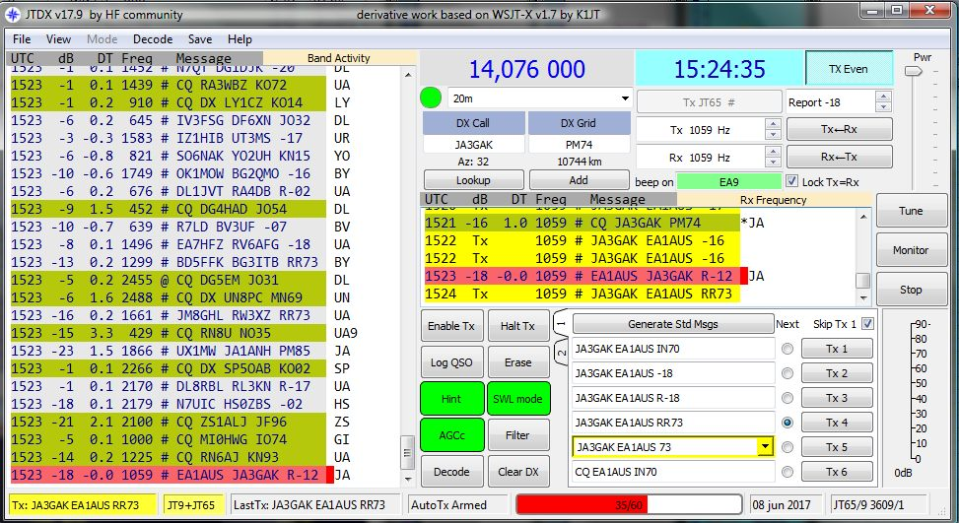

TCPS\_1

When the port of TCP Server is opened in Logger32, any JTDX QSO data can be transferred automatically to Logger32, and Logger32 will log this QSO in the current Logbook.

If you use WSJT-X with JTAlert WSJT-X QSO data can be transferred to Logger32, and Logger32 will log this QSO in the current Logbook as well.Add on software, SOCAT 1.7.3 is required for proper transfer.

WSJT-X / JTAlert has the capabilities to include call book lookup data in addition to the basic logging provided without call book provided by QRZ.com and HamQTH.com to name a few.

The following sites are available to download the latest stable version of these programs.

**JTDX**:

<http://www.qrz.lt/ly3bg/JTDX/jtdx.html>

**WSJT-X:**

<https://physics.princeton.edu/pulsar/k1jt/wsjtx.html>

**JTAlert:**

<http://hamapps.com/>

**SOCAT:**

<https://github.com/tech128/socat-1.7.3.0-windows>

## 2.0 Configuration.

### 2.1 Configuration in Logger32

* + Open the TCP Server from “View” option in main menu of Logger32 and Click File.
  + **Click to Close Port** : Click to close port or open port
  + **Popup on connect**:: The TCP Server window appears when it is connected to client if this option is checked.
  + **Hide**: Click to hide TCP Server window.

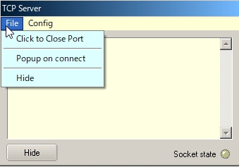

TCPS\_2

Click Config to see the Host ID (PC name for this PC), the Local IP, IP address and Port number.

Default Port # is 5001. If you need to change Port # then click “Change Port #” and type new Port #.

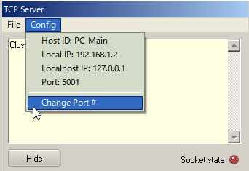

TCPS\_3

The Socket state LED shows port/connection status .

* + **Red**: Port is closed;
  + **Orange**: Port is opened but no connection established (or no connection request from JTDX); and
  + **Green**: Connection established while JTDX or JTAlert is sending QSO data.

This status is also displayed in the lower status bar.

Move the cursor to the TCP pane. If the port is opened the text is highlighted with **Blue** color. If the port is closed the text is highlighted with **Red** color.

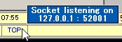

TCPS\_3A

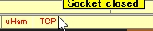

TCPS\_3B

Right click on the TCP pane to show the Server menu.

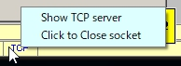

TCPS\_3C

### 2.2 Configuration in JTDX

JTDX may be installed not only in the same PC as Logger32 but diffrent PC if both PC are connected with LAN.

Open the Reporting tab on JTDX settings, look for External logbook connection section. You see “127.0.0.1” as TCP Server and “52001” as TCP Port. These are default values.

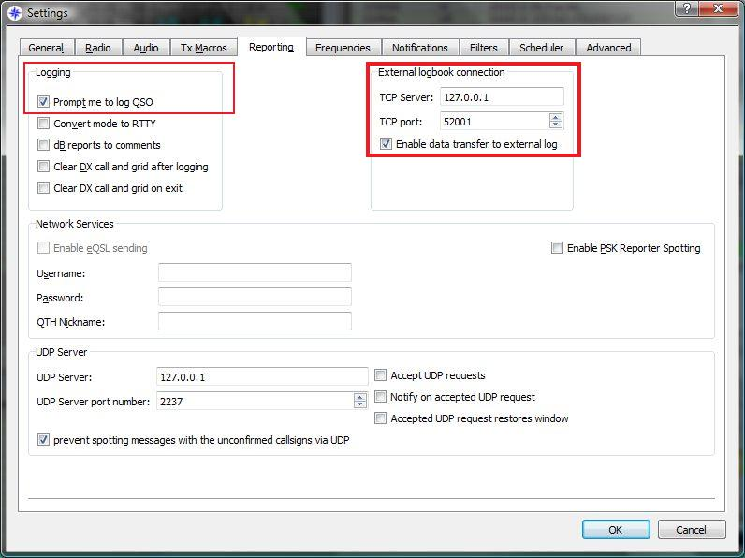

TCPS\_4

If JTDX is installed in the same PC as Logger32 then leave TCP Server and TCP port as they are. If JTDX is installed in the different PC then enter the Local IP as the TCP Server which you see in Logger32 TCP Server. (TCPS\_3) Leave the TCP Port as it is. In this case the TCP Server tooltips are displayed like this once connection is established.

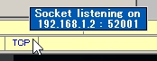

TCP\_4A

Check "Enable data transfer to external Log" option.

It's preferable to also check "Prompt me to log QSO" in Logging section. This way whenever we send a goodbye message, we will see the QSO data waiting to be transfered to logger32.

Click OK to save settings.

The following graphic shows the fields of the QSO waiting to be transferred to Logger32.

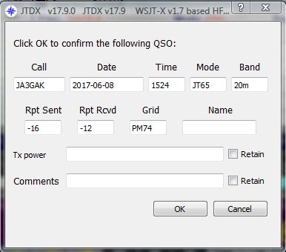

TCPS\_5

2.3 Configuration in WSJT-X/JTAlert  
  
JTAlert receives QSO data from WSJT-X via UDP port and send it to Logger32 via TCP port. Following are general step-by-step of configuration. Details are provided by Prasad, VU2PTT at https://goo.gl/cHBKhr

* Download SOCAT the Ten (10) files at the link in [para 1.0 above](#SOCAT_url).
* Save files in a **C:/** folder.
* In the JTAlert *Settings* window, select *Logging* marked on the left in the picture below, click on *Standard ADIF File*, click on the Enable Standard Logging check box, create a new log by clicking on *Create New* and create a new ADIF log with a filename you wish to use. Click on *OK*.

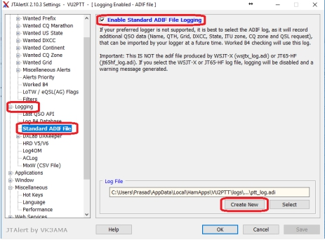

TCPS\_5A

* In the JTAlert *Settings* window, select *Auto\_Start* marked on the left in the picture below.

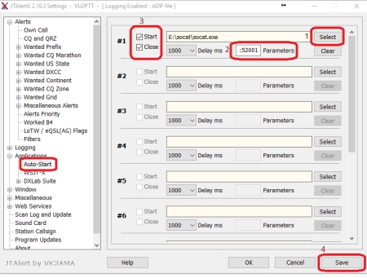

TCPS\_5B

* On the right side of this window we will configure JTAlert to use SOCAT and also automatically start and stop it whenever JTAlert is opened and closed.
* Click on *Select* button (1) and use the browse window that pops up to go to the folder where you saved the SOCAT utility. Select the file *socat.exe* and click on the *Open* button of this window.
* Next in the textbox marked *Parameters (2)* copy and paste the following command parameters for SOCAT: 　Copy exactly, do not add or delete spaces if entering data manually.

*-d -v -T30 -ly UDP4-LISTEN:52001,fork,bind=127.0.0.1 TCP4:127.0.0.1:52001*

* Make sure the Start and Close checkbox (3) on the left of these fields is checked as shown in the picture above.
* Now click on the *Save* button (4) at the bottom of the JTAlert window.
* Now in the *Logging* section of the JTAlert *Settings* window, select the Last QSO API option as marked in the picture below.
* Make sure the UDP Port setting is the same as the TCP Port setting seen earlier in Logger32 TCP Server configuration (default in Logger32 is 52001).
* Once this is set, click on OK.

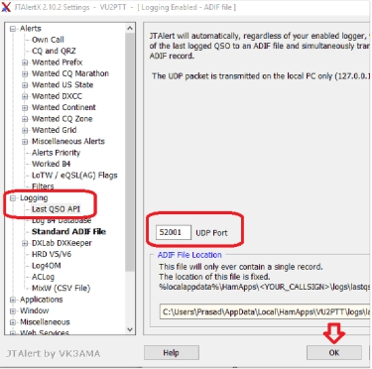

TCPS\_5C

Logging data provided via the TCP port without XML call book service are:

* + Date, Time ON, Time OFF, RST RX, RST Sent, Grid, Name (If entered manually in the WSJT-x log pop-up
  + Window) and two other manual entries which are TX power and comments, again in the WSJT-x log Popup window.

## 

TCPS\_5D

If you wish you can configure JTAlert to include CALL Book information when logging a QSO through the TCP port. In JTAlert settings, select WEB SERVICES, Refer to Online XML call books TCP\_5E per your preference. Click OK to save setting.

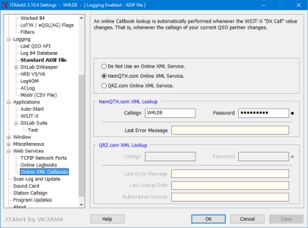

TCPS\_5E

## 3.0 OPERATION

### 3.1 JTDX

Open the TCP Server using the View menu item of the Main menu in Logger32 and open the port. (Next time you start Logger32, this action will be remembered)

Log the QSO in JTDX. QSO data are momentarily displayed in Blue text in the TCP Server window. This QSO is logged automatically in the current Logger32 Logbook. Example of traffic received through the TCP Server is shown below.

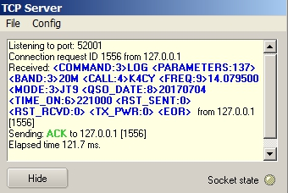

TCPS\_6

### 3.2 WSJT-X/JTAlert

Leaving WSJT-X and Logger32 running, shut down and restart JTAlert. If everything is configured correctly, the SOCAT utility command window should pop up with a blank screen. This is where the magic happens. You can leave this SOCAT window open and resize/move it to a corner of the screen or even minimize it later once everything is working fine. Now make a QSO in WSJT-X and log the QSO. This is what will happen:

* The SOCAT window will now show the ADIF string sent out over the UDP port configured in JTAlert. This is what it looks like:

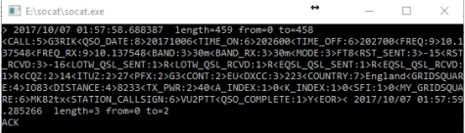

TCPS\_6A

* The Logger32 TCP Server will show the incoming ADIF string from SOCAT.

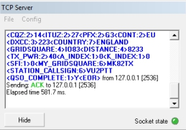

TCPS\_6B

* And the [Logbook Page Window](#_topic_LogbookPageWindow) of Logger32 shows the logged QSO

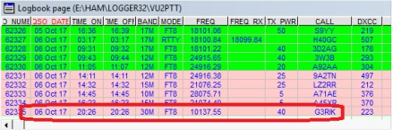

TCPS\_6C

### Logging via TCP using JTAlert with WSJT-X

Note by Ron, W4LDE:

If you have configured a XML call book lookup in JTAlert settings and depending on the data provided service, Logger32 log will save the following, they are:

A call book server such as HamQTH will provide, including ADDRESS, SFI, A-index, K-index, BAND\_RX, CALL, CONT, COUNTY, CQZ, DISTANCE, DXCC, FREQ\_RX, GRIDSQUARE, ITUZ,MODE, NAME, QSO\_DATE, QTH, RST\_RCVD, RST\_SENT, TX\_PWR, STATE, PFX to name a few.

The actual data provide through the TCP connection is a subject of data provided to JTAlert from the call book service and WSJT-x.

From actual data transferred to Logger32. Note the difference between log book service on and off.

**Service turned on in JTAlert. Common data highlighted**

<CALL:5>WT9WT<QSO\_DATE:8>20171104<TIME\_ON:6>190100<TIME\_OFF:6>190200<FREQ:6>10.136<FREQ\_RX:6>10.136<BAND:3>30m<BAND\_RX:3>30m<MODE:3>FT8

<RST\_SENT:3>-03<RST\_RCVD:3>+04<GRIDSQUARE:6>EM59DT<DISTANCE:3>829

<TX\_PWR:2>50<A\_INDEX:1>9<K\_INEX:1>1<SFI:2>73<NAME:7>William<QTH:11>Springfield

<STATE:2>IL<CQZ:1>4<ITUZ:1>8<PFX:3>WT9<CONT:2>NA<CNTY:11>IL,Sangamon<ADDRESS:67>William W Tinsley, 114 Calvin, Springfield, IL 62704, United States<DXCC:3>291<COUNTRY:13>United States<MY\_GRIDSQUARE:6>EM73ol<MY\_CQ\_ZONE:1>5<MY\_ITU\_ZONE:1>8<STATION\_CALLSIGN:5>W4LDE<QSO\_COMPLETE:1>Y<EOR>

Now compare the difference between a service turned off.

**Online Call Book service turned OFF**

<call:5>VE7ON <gridsquare:4>CN89 <mode:3>FT8 <rst\_sent:3>+04 <rst\_rcvd:3>-12

<qso date:8>20171105 <time\_on:6>154945 <qso\_date\_off:8>20171105 <time\_off:6>155045 <band:3>30m <freq:9>10.137933 <station\_callsign:5>W4LDE <my\_gridsquare:6>EM73ol <tx\_pwr:3>50w <eor>

**Online Call book service turned back on Data added highlighted**

<CALL:4>KU0D<QSO\_DATE:8>20171105<TIME\_ON:6>155200<TIME\_OFF:6>155300<FREQ:6>10.136<FREQ\_RX:6>10.136<BAND:3>30m<BAND\_RX:3>30m<MODE:3>FT8<RST\_SENT:3>- 02<RST\_RCVD:3>-01<GRIDSQUARE:4>EN66<DISTANCE:4>1460

<TX\_PWR:2>50<A\_INDEX:1>4<K\_INDEX:1>0<SFI:2>72<NAME:15>Shawn W Johnson<QTH:8>Munising<STATE:2>MI<CQZ:1>4<ITUZ:1>8<PFX:3>KU0<CONT:2>NA<CNTY:8>MI,Alger<DXCC:3>291<COUNTRY:13>United States<MY\_GRIDSQUARE:6>EM73ol<MY\_CQ\_ZONE:1>5

<MY\_ITU\_ZONE:1>8<STATION\_CALLSIGN:5>W4LDE<QSO\_COMPLETE:1>Y<EOR>

## 4.0 TIPS

4.1 Logbook synchronization

If you want to synchronize both Logbooks in Logger32 and JTDX then try following steps.

If your Logger32 logbook already contains JT65 and/or JT9 QSOs:

(1) In Logger32 export a PARTIAL log containing your JT65 and JT9 QSOs.

(2) Name the exported file **wsjtx\_log.adi** and save it to a safe location.  
  
(3) Replace the default **wsjtx\_log.adi** file located in c:\user/name/AppData/Local/JTDX with the new file exported from Logger32.

Importing the data from YOUR Logger32 logbook will ensure that JTDX has updated DXCC / Mode and QSO data and will flag the calls heard correctly.

### 4.2 Connection errors

If you receive the JTDX error message "Socket operation timeout" or "Host not found" then try following steps.

(1) Close/Open TCP port

(2) Look at IP address displayed in Config menu and lower status bar. Type this IP address in JTDX TCP Server box.

*Created with the Personal Edition of HelpNDoc:* [*Benefits of a Help Authoring Tool*](http://www.helpauthoringsoftware.com)

**The UDP Bandmap**

Aki Yoshida JA1NLX

## 1. 0 GENERAL

Logger32 has a function to receive and display decoded callsigns with some additional information on the UDP Bandmap and send a reply message to JTDX or WSJT-X. JTDX or WSJT-X works as if the callsign is double-clicked on it's window when it receive reply message.. This data is distributed via UDP (User Datagram Protocol) approximately every 15 seconds (FT8 Mode) or 60 seconds (JT65, JT9 Mode etc) by WSJT-X/JTDX program. The reply message is sent via UDP.

When the QSO is logged in WSJT-X/JTDX then Logger32 will log this QSO via UDP and sends this QSO automatically as a DX Spot if you want. See the [Setup Menu](#_topic_SetupMenu) section in details.

**Note 1**: The UDP Bandmap and JTAlert program can not run at the same time.

**Note 2**: Use TCP or UDP for logging.

**Note 3:** 77 bit protocol which will be implemented in WSJT-X ver 2.0 is supported.

**Note 4:** WSJT-X only responds to one type of UDP Reply Message - "Answer this CQ call".

**Note 5:** Logger32 should log QSOs from JS8call and any other program that sends the WSJT-X formatted messages to the UDP port.  It is not necessary to have the UDP Bandmap open.

**Note 6:** UDP message processing to queue up to five QSO Logged messages is supported.  The QSOs should be logged about 5 seconds after they are received.  If the messages are from software other than WSJT/JTDX, no additional information (from the [Logbook Entry Window](#_topic_LogbookEntryWindow), or the QSO mask is added.  Also, if the messages are not from WSJT/JTDX, it is not necessary to have the UDP BandMap open, but the UDP socket must be open.

**Note 7**: WSJT-X FT4 mode is supported.

## 2. WSJT-X/JTDX SETTINGS

### 2.1 Settings in WSJT-X program

Look for UDP Server group. You should leave the default value like this.

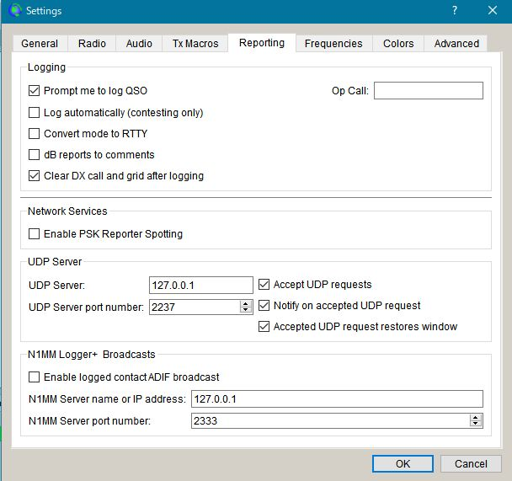

UBM\_1

### 2.2 Settings in JTDX program

Look for UDP Server group. You should leave the default value like this.

Look for External logbook connection group. Uncheck "Enable data transfer to external log"

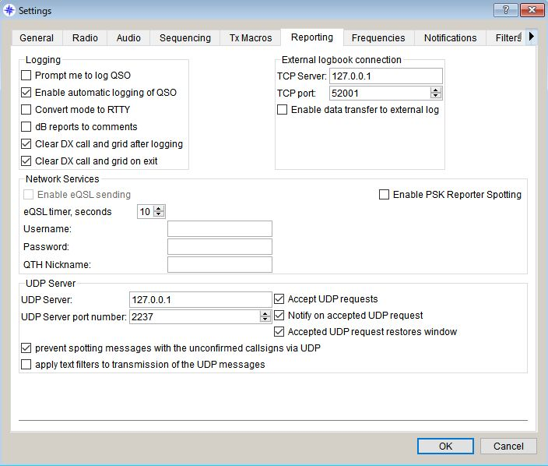

UBM\_2

## 3.0. LOGGER32 SETTINGS

The callsign highlight colors and DXCC award tracking information are displayed in UDP Bandmap depend on the settings in "DX Spot highlight color" and "Setup phone/digital modes"

Settings for me to operate FT4, FT8, JT9 and JT65 below.

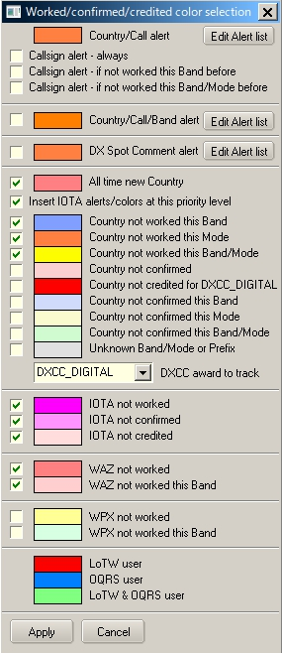

UBM\_3

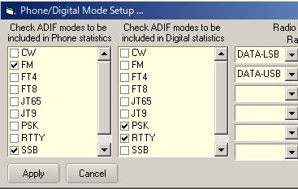

UBM\_4

With this settings Worked/confirmed Window looks like below.

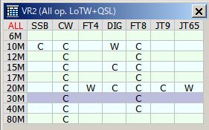

UBM\_4A

## 4. OPERATION (1)

* + Run WSJT-X or JTDX. Do not run JTAlert at same time.
  + Run Logger32
  + Right click on "UDP" in the lower status bar. Click "Open UDP Bandmap"

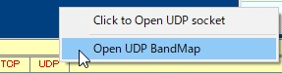

UBM\_5

When WSJT-X or JTDX decode callsigns these callsigns are displayed in the UDP Bandmap.

WSJT-X or JTDX, Band and Mode are displayed in title bar. Band and Mode are derived from WSJT-X or JTDX.

* + Click " "X" to close UDP Bandmap.

It is more convenient to run/close WSJT-X or JTDX from “Start”/”Stop” in the menu. See paragraph 5.4 Start.

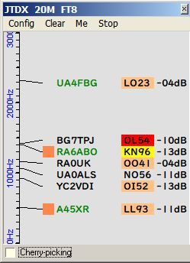

UBM\_6

### Logging QSO

When QSO is logged in JTDX/WSJT-X this QSO is logged directly in Logger32. You should notice the difference between JTDX and WSJT-X.

If you use JTDX you need no mouse clicking. QSO is logged automatically in Logger32.

If you use WSJT-X you need to click “OK” in the WSJT-X logging window in order to log QSO in WSJT-X and Logger32.

“OK” and “Cancel” button appears here and there.

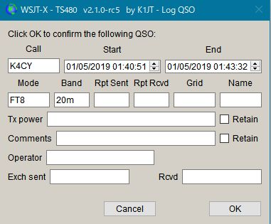

UBM\_6AC1

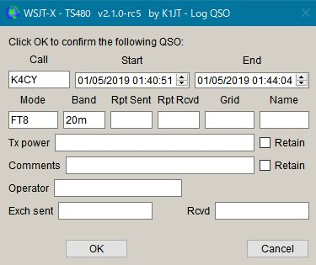

UBM\_6AC2

The UDP Logging requests.txt file logs every QSO logging request received from the WSJT/JTDX UDP.  This file is created in the \Logger32 directory and erased every time Logger32 starts.



UBM\_6AC3

The VFO frequency plus receive tone frequency are written in the ADIF FREQ\_RX field in the Logbook. Logger32 calculates and logs the ADIF DISTANCE field. Look at logged QSO with below. Gridsquare and Distance are logged only if they there are decoded.

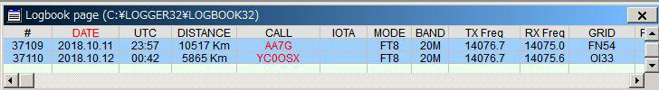

UBM\_6AC4

## 5.0 MENU

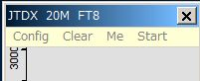

UBM\_6A

## 5.1 Config

Select the Config menu item.

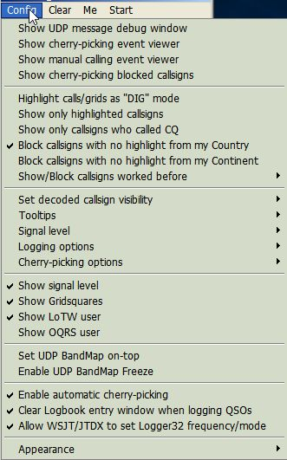

UBM\_6AB

There are a lots of options. You may choose whatever you prefer now.

If you want to see highlight colors and tooltips information based on every mode then un-check "Highlight callsigns as "DIG" mode" This option works for displaying "QSOd B4" mark as well.

If you want to set the Logger32 frequency/mode from WSJT-X/JTDX then check “Allow WSJT/JTDX to set frequency/mode” Logger32 radio port must be closed. See paragraph 5.4 Start for related explanation and paragraph 5.0 Band Mode Selection Setup in the Logbook Emtry topic.

If you want to see the Gridsquare then check "Show Gridsquares".

### Sub menu for Logging options



UBM\_6AC

The UDP Logging requests.txt file logs every QSO logging request received from the WSJT/JTDX UDP. This file is created in the \Logger32 directory and erased every time Logger32 starts.



UBM\_6AD

If you want to use direct logging then check “Allow automatic WSJT/JTDX QSO logging”. When “WSJT-X Automatic logging (no mouse clicks)” is enabled, this will automagically close the insanely annoying WSJT-X logging window. The first time you are prompted after starting WSJT-X, Logger32 will close it for you in under 5 seconds (you can close it manually if you like). After that, Logger32 will close in less than 500ms.

The VFO frequency plus receive tone frequency are written in the ADIF FREQ\_RX field in the Logbook. Logger32 calculates and logs the ADIF DISTANCE field. Look at logged QSO with below. Gridsquare and Distance are logged only if there are decoded.

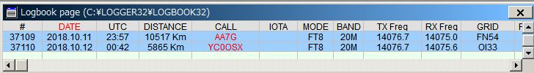

UBM\_6B

When “Log additional info from Logbook Entry Window” is checked, the following data entered into the Logbook Entry Window is logged with the UDP logging information if not already in the UDP logging message.

TX\_PWR, QTH, ADDRESS, COMMENT, NAME, STATE, and CNTY.

If you want to set the Logger32 frequency/mode from WSJT-X/JTDX then check “Allow WSJT/JTDX to set frequency/mode” Logger32 radio port must be closed. See paragraph 5.4 Start for related explanation and paragraph 5.0 Band Mode Selection Setup in the [Logbook Entry Window](#_topic_LogbookEntryWindow) section.

### Sub menu for Signal level

If you want to see the signal level then check "Show signal level" and click ”Signal level” to select the signal level type, SNR or S units.

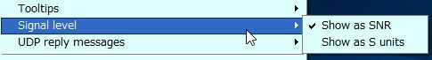

UBM\_6C

If you want to see the Gridsquare then check "Show Gridsquares".

### Sub menu for “Show/Block callsigns worked before”

If you want to block callsigns QSOd this band/mode B4 then check like this.

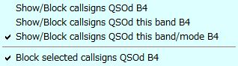

UBM\_6D

## Sub menu for "Set decoded callsign visibility"

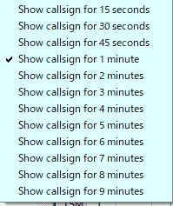

UBM\_8

## Sub menu for "Tooltips"

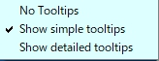

UBM\_9

## Sub menu for "Cherry-picking options"

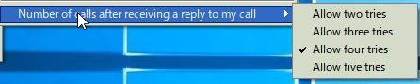

UB9\_A

## Sub menu for "Appearance"

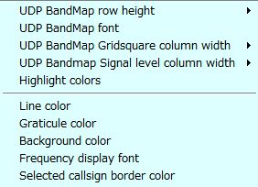

UBM\_10

UDP Bandmap Gridsquare and Signal Level column width can be selected respectively.

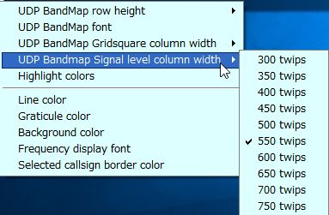

UBM\_10A

Click "Highlight colors" to configure Gridsquare highlight colors and UDP Bandmap text color. If you prefer to see bold text for callsign who have called CQ then check "Show bold text who have called CQ"

. 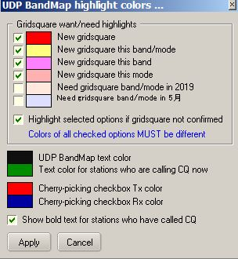

UBM\_11

Sample below.　The stations who are calling CQ now are displayed in Green text, the stations who have called CQ are displayed in Black/bold text and the stations who are working other stations are displayed in Black text.

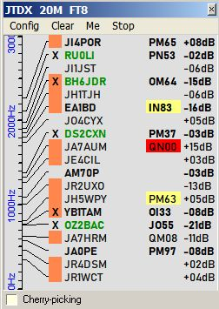

UBM\_11A

## 5.2. Clear

This clears UDP Bandmap.

## 5.3. Me

This opens the Calling Me UDP Bandmap and hide this item in the menu bar. See details in paragraph [Operation(4)](#8.0._OPERATION(4)).

## 5.4. Start

Default item is WSJT-X and/or JTDX if these programs are installed in your PC. You may add another shortcut using unique radio name. See details in WSJT-X/JTDX Help.

If you start WSJT/JTDX from Start menu, the Logger32 radio serial port is closed before the digital application starts. WSJT-X/JTDX caption is replaced by shortcut caption + “& Logger32”and “X”is hidden in the title bar.



UBM\_11AB

Then if you close the digital application from Logger32 (either by UN-checking the START menu, or by closing the UDP Bandmap), the Radio serial port is automatically reopened.

If the Logbook Entry Window stays populated, Logger32 makes the Radio be aligned with the Logbook Entry Window (spotted) information.

If the Logbook Entry Window is empty/wiped, Logger32 sets the Radio to pre-WSJT-X/JTDX opening state.

If you click WSJT-X, WSJT-X starts, then if you click JTDX, WSJT-X close and JTDX starts.

If WSJT-X/JTDX opens with Radio in split mode then Radio turns in split off mode. You need to add $SplitVisualAlertsOff$$clearlog$ as “before starting WSJT/JTDX” macro.

**Note: DO NOT TRY TO RUN WSJT-X/JTDX IN XP COMPATIBLE MODE, OTHERWISE IT DOES NOT WORK CORRECTLY.**

## 

UBM\_11B

Click “Setup shortcuts” to add/edit shortcut and put commands/macros for Radio 1/2 if you like to execute before starting WSJT-X/JTDX and after closing WSJT-X/JTDX.　Macros for Radio Control Panel can be used in this table as well.

Example macros below are Split OFF, Power 50W, NB OFF/ NR OFF (Radio2-IC7300) for before starting WSJT-X/JTDX and Power 100W for after closing WSJT-X/JTDX.

## 

UBM\_11C

## 6.0 OPERATION (2)

If you move mouse over callsign then tooltips appears.

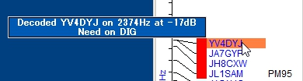

UBM\_12

If you left-click any callsign then this callsign is transferred in [Logbook Entry Window](#_topic_LogbookEntryWindow).

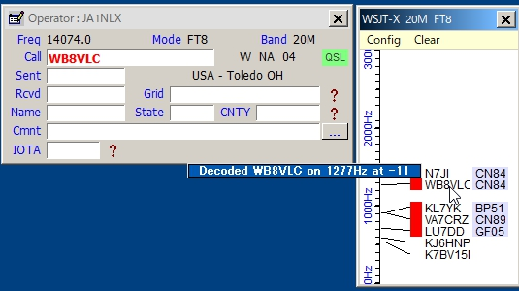

UBM\_13

If you right-click any callsign then history of this callsign is displayed. (max 15 messages)

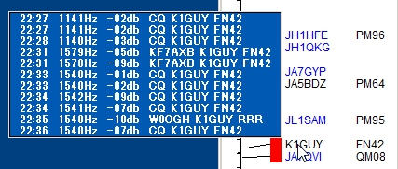

UBM\_14

If you configure various options properly then you see LoTW/OQRS user, QSO B4, highlighted callsign and Gridsquare.

When QSO is logged in WSJT-X/JTDX then Logger32 log this QSO via UDP if "Allow QSO automatic logging" is checked.

## 7.0 OPERATION (3)

Logger32 can send reply message to JTDX or WSJT-X When it receives reply message then it will transmit message corresponding to the reply message.

For JTDX following options should be checked and “AutoTX” should be turned ON.

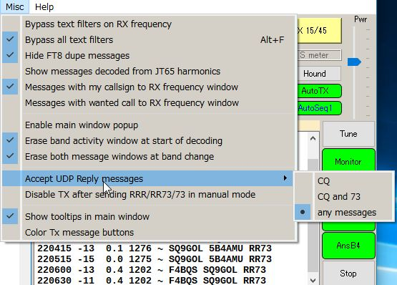

UBM\_14A

For WSJT-X Auto Seq should be checked and “Call 1st” should be unchecked.

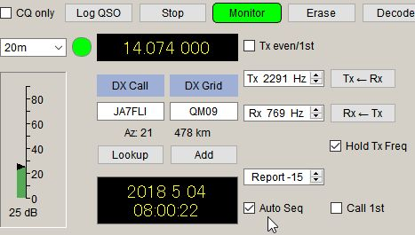

UBM\_14B

The following options should be checked in the UDP Bandmap Config menu. Uncheck “Call selected callsign at end of QSO” if WSJT-X is used.

## 

UBM\_14C

## Manual Calling

Click on any callsign you want to call. The callsign is surrounded by a box and transferred to the [Logbook Entry Window](#_topic_LogbookEntryWindow). The box border color can be configured in “Config”, “Appearance”, “Selected callsign border color”.

## 

UBM\_14D

When:

* + (a) The operator calls CQ on the next time slot, a reply message is sent to JTDX or WSJT-X and it will transmit a message calling him/her.
  + (b) The operator sends a message with 73 or RR73 or RRR, a reply message is sent to JTDX and it will transmit message calling him/her.
  + (c) If the operator replies to you then the box disappears.
  + (d) If the operator dose not reply to you then it tries max 5 calling cycles and the call is canceled.
  + (e) If there is nothing heard from the station for 90 seconds then the call is cancelled.

**Note**: For WSJT-X users, do not use this feature, otherwise you have unexpected result.

The [Logbook Entry Window](#_topic_LogbookEntryWindow) is cleared.

To show the manual calling process click “Show manual calling event viewer” in Config menu.

## 8.0. OPERATION(4)

## Cherry-Picking

Logger32 can send reply message to JTDX or WSJT-X for automatically selected callsign. When JTDX or WSJT-X receives reply message then it will transmit message corresponding to the reply message.

**Note:** JTDX allows reply message for CQ/73/RR73, however WSJT-X allows reply message only for CQ.

**Note:**

a)  It does not work duplicate QSOs on a Band/Mode

b)  It does recognize CQ, CQ DX, and CQ <your Continent>. All others are ignored.

c)  It does call DXCC highlighted callsigns (based on user configuration options in DX spot highlight color　table.

d) It does call stations with highlighted Gridsquares.(based on user configuration options in UDP Bandmap highlight color table).It picks highlighted callsigns or stations with highlighted Gridsquares with the following priority:

Priority in DX spot color table → Grid highlight color table → CQ  
(Highest-left to lowest-right)

There is a menu on the UDP Bandmap under CONFIG | CHERRY-PICKING OPTIONS.  If the option CHERRY-PICK HIGHEST PRIORITY CALLSIGN FIRST is checked, then after each decode period, Logger32 chooses the highest priority station and calls it (cherry-pick only the ripest cherry).  If the option is not checked the Logger32 calls the first cherry it sees.

e) It remembers the callsign of a station that drops his callsign in the middle of a QSO.  On completion of the current QSO (or attempted QSO), Logger32 automatically replies to the station that called.

To enable Cherry-picking, click “Config” then check “Enable automatic cherry-picking” Status bar appears at bottom in UDP Bandmap. Check “Cherry-picking” Check/Uncheck this option to turn Cherry-picking ON/OFF.

When Cherry-picking pick callsign, the callsign is displayed in status bar in Red color. When he send CQ/73/RR73 JTDX will call him automatically.

After 90 seconds Cherry-picking for the callsign ends and the callsign disppears.

“Enable sympathy calls” option (see UBM\_14C). If this option is checked it calls any CQ caller at random even if he is not highlighted. The tooltip for the cherry-picked callsign is displayed like this.

## 

UBM\_14DA1

To show cherry-picking process click “Show cherry-picking event viewer” in Config menu.

## Cherry-picking blocked callsign

“Show cherry-picking blocked callsigns” option.

If you right-click on the area where cherry-picked callsign is displayed then you see another menu.

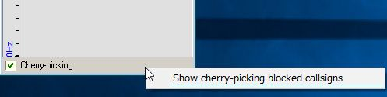

UBM\_14DA2

Click “Show cherry-picking blocked callsigns” to show the table. Click “Wide” button.

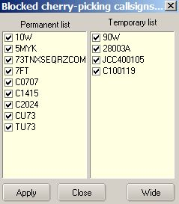

UBM\_14DA3

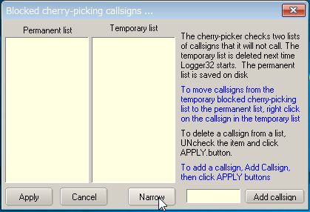

UBM\_14DA4

See the text above. It explains how to add callsign you want to block and how it works.

## Drag mode:

You can now drag & drop callsigns from the UDP Bandmap into the cherry-picking blocking window. If not already open, the cherry-picking window will automatically open, once you start to drag a callsign.

You will notice the APPLY button is no longer visible unless the user wishes to make changes by UNchecking callsigns and clicking APPLY.

Drag & drop changes are made automatically.  Moving a callsign from temporary to permanent makes changes automatically.

If the UDP Bandmap receives text like JCC10010 73 The UDP Bandmap will block the call and also add it to the list of temporary blocked calls.

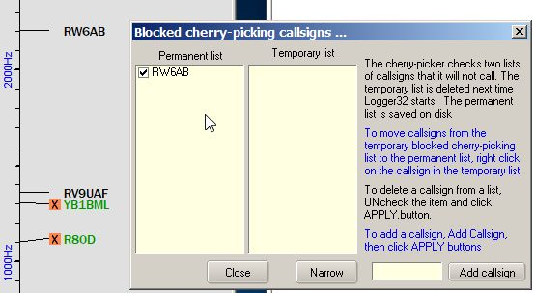

UBM\_14DA5

**Note:** Right-click on “Cherry-picking” to show menu. If you prefer then check this option.

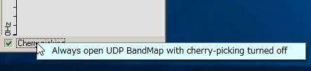

UBM\_14DAB

Click “Me” in the Menu to show the Calling Me Bandmap. Only callsigns calling me are displayed in this window.

## 

UBM\_14E

**For JTDX:**

It may be a little complicated because JTDX has various options for Auto Seq.　It is better to use following setup to use this functionality.

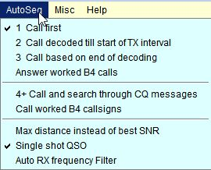m

UBM\_14F

When you call CQ and receive multiple replies, these callsigns are displayed in Calling Me Bandmap. JTDX will transmit message automatically for the first decoded callsign. When you finish this QSO, click another callsign. JTDX will transmit message for this callsign.

**For WSJT-X:**

Set options like pic [UBM\_14B](#UBM_14B). When you call CQ and receive a reply, callsigns are displayed in the Calling Me Bandmap. Click any callsign you want to answer. WSJT-X will transmit a message for this callsign.

If you move the mouse over a callsign then a tooltip appears.

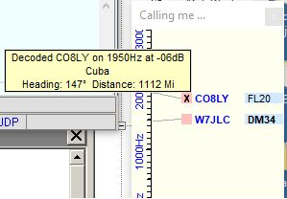

UBM\_14G

## 9.0 RPTR (WSJT/JTDX UDP message repeater)

For those who want eye candy programs to monitor UDP messages, but can't get them to work because Logger32 is using port 2237, then right click RPTR at the right of the lower status bar.  Click Setup WSJT/JTDX UDP repeater. Check Enable SEND A, set the port number to 2238, and click APPLY.

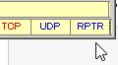

UBM\_14H

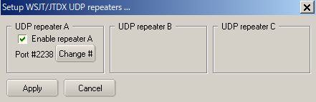

UBM\_14I

If you want to use GridTracker (by N0TLL) then follow the steps below:

Run GridTracker and click Setup icon. The default Port for Receive UDP Message is 2237.

Type 2238. Backlight color is changed to Red. (This change is not saved. Every time you run GridTracker it shows default 2237)

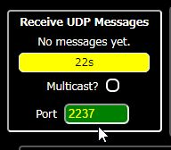

UBM\_14J

If you want to use default UDP port 2237 in GridTracker then you can change UDP port in Logger32 and WSJT-X/JTDX.

In the case of Logger32:

(a) right click RPTR at the right of the lower status bar.  Click Setup WSJT/JTDX UDP repeater. Check Enable SEND A, set the port number to 2237, and click APPLY.

(b) right click on UDP in the lower status bar, click Change WSJT/JTDX port #, type 2238 and click OK. You must change UDP port to 2238 as well in WSJT-X/JTDX.

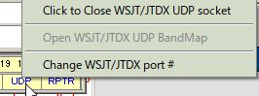

UBM\_14K

## 10.0. TIPS

If you have "Show only callsigns calling CQ" and "Show only highlighted callsigns" checked then the only station that are highlighted and calling CQ will show.

The BLOCK COUNTRY and BLOCK CONTINENT options look for a Country/Continent match with the Logger32 Current Operator.  If you have the Logger32 operator set to "At the Beach" or "Club Station" or something other than the callsign of where you are operation, the results will be unpredictable.

Try to change settings of "DX Spot highlight colors" in DX Spot Window and settings of "Setup phone/digital modes" in Tools menu. It affects the way to display highlight colors and tooltips in UDP Bandmap.

## UDP message debug window

This Debug window is very useful to check problem. Click "Show debug window" in Config menu to show debug window. The Reply message is displayed in Red text.

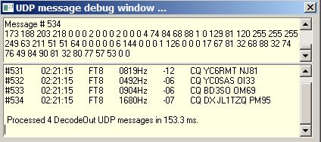

UBM\_15

## Cherry-picking event viewer

The cherry-picking event viewer shows all steps regarding cherry-picking. You may understand what is happening now. It shows the number of callsigns decoded this cycle at the bottom right hand corner.

## 

UBM\_16

## Manual calling event viewer

The manual calling event viewer shows all steps regarding manual calling. You may understand what is happening now.

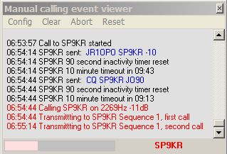

UBM\_17

*Created with the Personal Edition of HelpNDoc:* [*Single source CHM, PDF, DOC and HTML Help creation*](http://www.helpndoc.com/help-authoring-tool)

**UDP Broadcast of DX Spots**

# Don Beaudry K1DBO, Lou Dietrich N2TU and Aki Yoshida JA1NLX

## 1. 0 GENERAL

Logger32 can relay DX Spots and Local Spots using the N1MM logger+ protocol. DX Spots, as displayed in the Logger32 [DX Spot Window](#_topic_DXSpotsWindow1), are broadcast via UDP. The default port is 12061. If your configuration has a port conflict with 12061, you can edit the Logger32.INI and change the default setting in the [Globals] section

**[Globals]**

**DX Spot UDP Port=12061**

DX Spots are readily available to anyone from many sources, DX Clusters, aggregators, reverse beacons, etc. Once these DX Spots are fed into Logger32, and filtered as required by the user, they are then matched with the user’s logbook. New Countries, new Bands, new Modes, new [Band/Modes](#_topic_SetupBandsandModes) are now associated with the DX Spots. Logger32 then displays the DX Spots with colored backgrounds and text that the user has chosen to uniquely identify information about the DX Spot. Additionally, information is attached to the DX Spot that identifies the Country, distance, beam heading of the DX Spot. This is the information that is included in the DX Spot broadcast message.

But why bother? The logging program knows, and displays, everything there is to know about the DX Spots. Software plays an increasing role in Ham Radio. More and more applications show spectrum displays, waterfalls and all kinds of eye candy. Today the operator’s eyes tend to focus more on the spectrum displays and not on the DX Spot windows of the logging programs. So, why not put the DX Spots on the spectrum, sort of like a ‘Heads Up Display’?

**Note:**

a. Currently UDP broadcast of DX spots can be used only with Flex Radio.

b. The details of N1MM logger+ protocol is explained in paragraph "N1MM logger+ protocol"

## 2.0 SETUP IN LOGGER32

The DX Spot broadcast feature is enabled/disabled with a right click on the DX Spot Window then check/uncheck the Enable UDP broadcast of DX Spots menu.

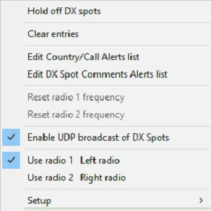

UBDS\_1

## 3.0 HOW TO USE UDP BROADCAST OF DX SPOTS

Here are examples of how the UDP broadcast of DX Spots can be used with a Flex Radio to improve the users experience.

Flex Radio has a software module SSDR CAT. Connect SSDR CAT to Logger32 like this:

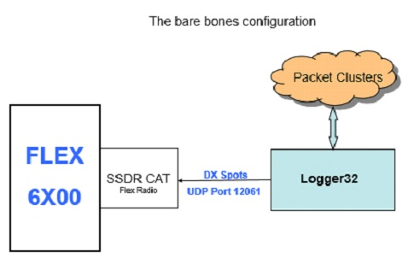

UBDS\_2

**Note**: The details to setup SSDR CAT is explained in paragraph 5 “How to create the SSDR CAT Flex Radio UDP Port”

DX Spots will now be shown on the Flex Radio like this:

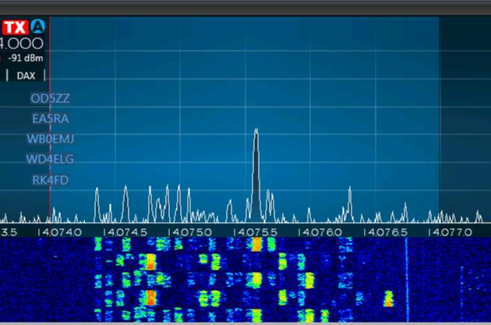

UBDS\_3

All the DX Spots will have blue text, will not be shown in any form of priority (example: Need for new country first, need for WPX last), and will have no ToolTips with any additional information.

Results can be improved with a configuration like this:

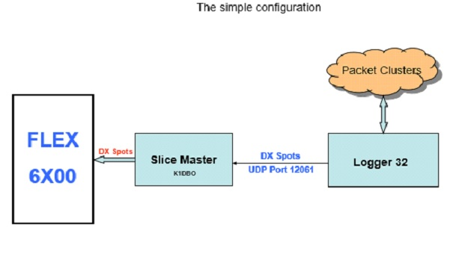

UBDS\_4

**Note**:

a. Slice Master 6000 can be downloaded at https://github.com/K1DBO/slice-master-6000

b. Slice Master 6000 can be configured to send the Logger32 DX Spots to the Flex Radio with these settings:

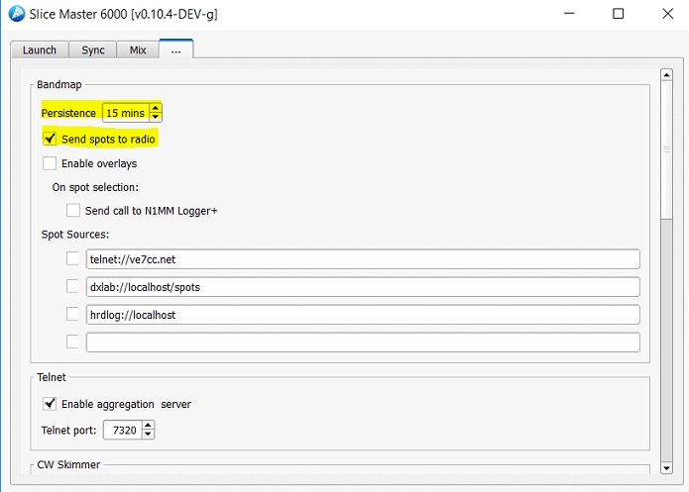

UBDS\_5

This improves the DX Spots shown on the Flex Radio spectrum. DX Spots now have colored text. The text color is the same as the Logger32 DX Spots background color. DX Spots will be prioritized. A New Country DXSpot will be shown in preference to one of lower importance. Here is a sample of what the user will see:

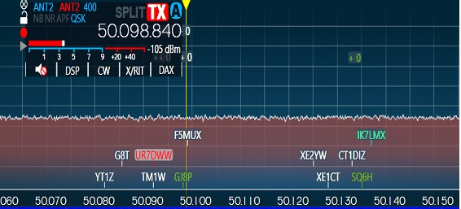

UBDS\_6

In this example, Logger32 is configured so that New Countries have a red background. As you can see, UR7DWW is a new Country.

Slice Master 6000 can be configured to create its own DX Spots and overlay them on top of the Flex Radio pop-up windows. Slice Master 6000 configuration is like this:

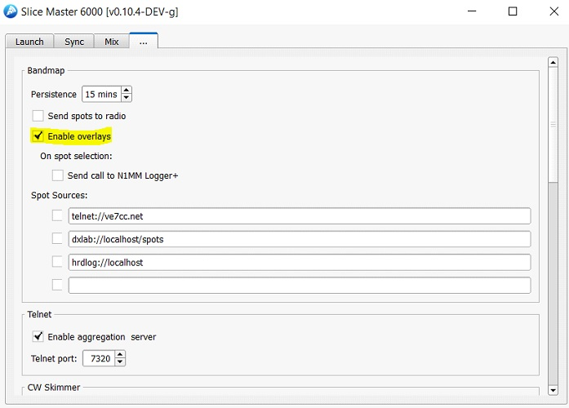

UBDS\_7

The result is DX Spots with background and text colors that match the Logger32 DX Spot Window. ToolTip showing additional information can be seen. DX Spots are prioritized with most wanted/need first. Like this:

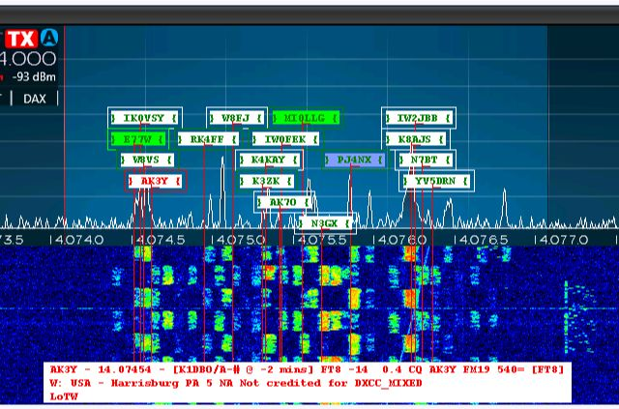

UBDS\_8

For the very brave, and those with an addiction to DX Spots, a more complex configuration could be implemented:

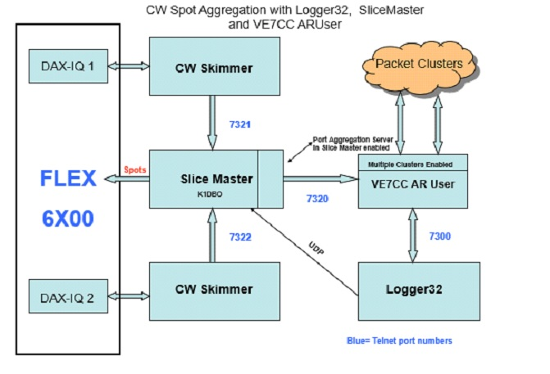

UBDS\_9

## 4.0 N1MM LOGGER+ PROTOCOL

The N1MM logger+ protocol has been enhanced to include information added by Logger32, such as DX Spot priority, color, heading, distance and needed status.

The XML message structure is like this:

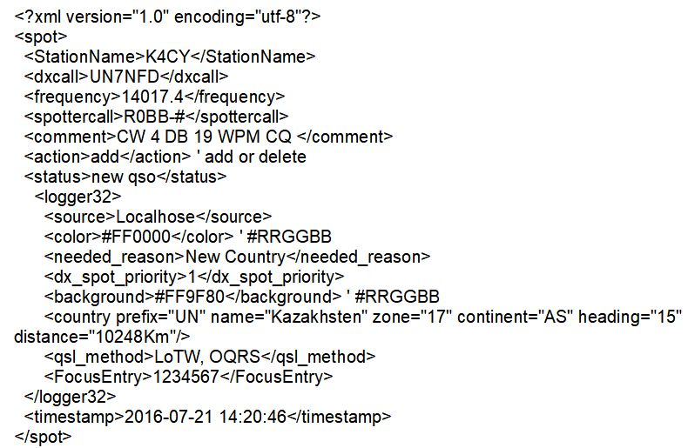

UBDS\_10

## 5.0 How to create the SSDR CAT Flex Radio UDP Port

Open the SmartSDR CAT interface for the the FlexRadio Systems Signature Series radios.

Example:

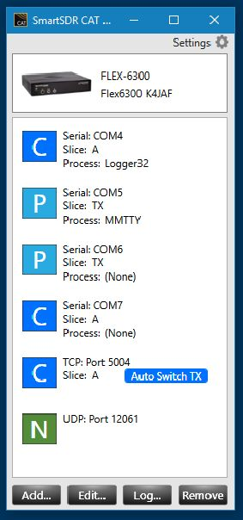

UBDS\_11

Click on ADD Port. Change Port Protocol to N1MMSpot. Change UDP Port number to 12061 if necessary. Save the Port.

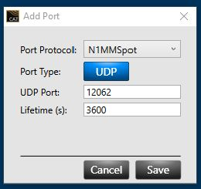

UBDS\_12

*Created with the Personal Edition of HelpNDoc:* [*Easily create Qt Help files*](http://www.helpndoc.com/feature-tour)

**Support for Ham CAP**

# Geoff Anderson G3NPA

## 1.0 GENERAL

Logger32 will support the propagation prediction software Ham CAP. Copies of this freeware application can be obtained from the [Ham CAP website](#Link:_HamCap).

## 2.0 INSTALLATION

Download the files HamCap.zip and itshfbc.exe and install them using the instructions provided. At this point, Ham CAP should run in stand-alone mode.

When used with Logger32, there are a number of preferred default options that should be set from the Logger32 [Setup menu](#_topic_SetupMenu) [Ham CAP](#12.0_HAM_CAP_MENU_ITEM) menu item.

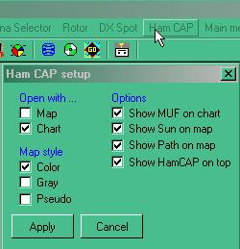

SFH\_1

Set your preferences and select the <**Apply**> button.

## 3.0 USING HAM CAP

You can launch Ham CAP at selecting the [HamCap icon](#2.3_Toolbar_Group_Three) on the Logger32 Toolbar.

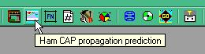

SFH\_2

If you are running a [CAT](#CAT) interface and have entered a callsign into the [Logbook Entry window](#_topic_LogbookEntryWindow), then Ham CAP will receive the time, band, call and your location information and it will display according to the options set.

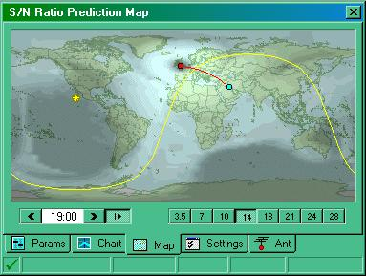

SFH\_3

**Note**: There are a few additional parameters needed in Ham CAP that cannot be passed from Logger32, RF power, long or short path and your antenna arrangement. Setting these in Ham CAP will produce more accurate results.

Set the desired path and transmit power on the "Params" page,

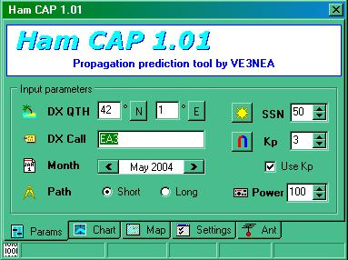

SFH\_4

and the antenna information on the "Ant" page.

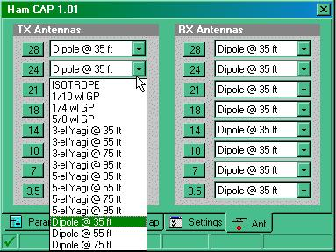

SFH\_5

In addition, if you also have the DX Atlas and IonoProbe software, these can be activated on the "Settings" page.

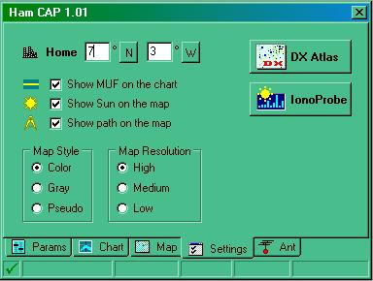

SFH\_6

*Created with the Personal Edition of HelpNDoc:* [*Free EBook and documentation generator*](http://www.helpndoc.com)

**Utilities**

# Geoff Anderson G3NPA

## 1.0 GENERAL

Heading the list of Utilities is access to two sets of data that are derived from the web, one being the 425DX collated DX activity and the other is specific IOTA activity. Clicking on the Logger32 [Main menu](#_topic_MainMenu) [Utilities](#7.0_UTILITIES_MENU_ITEM) menu item produces the two fixed menu items as shown below.

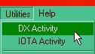

U\_1

**Note** that listed below the two items mentioned above are user-definable menu items and these will vary from user to user. See the topic [Using External Print Programs](#_topic_UsingExternalPrintPrograms) for examples of how to set up external user programs.

## 2.0 DX ACTIVITY

Selecting the DX Activity menu item will produce a table derived from the 425DX organization

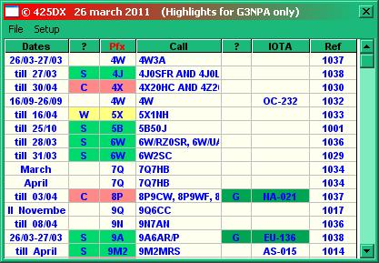

U\_2

The table will contain the current 425DX calendar information obtained from <http://www.425dxn.org/425/calendar.html> with the date of the bulletin being shown in the window's title bar. Moving the mouse pointer over the “Call” column will produce a tooltip with more information that is also derived from the same source. In addition the table will be marked with "Worked/Confirmed/Submitted/Granted" data derived from the Logbook.

The table can be sorted on Date, Call, Prefix or IOTA by clicking on the column header which will then turn red. In the above example the sort has been performed on the Pfx column (as depicted by the column title being in red). Click on the column title to sort.

In the Setup menu the option is given to select the highlight colors for the preferred DXCC credit.

The “Ref” column refers to the weekly 425DX news bulletins. A left or right-click on any of these numbers will produce the full bulletin in your web browser.

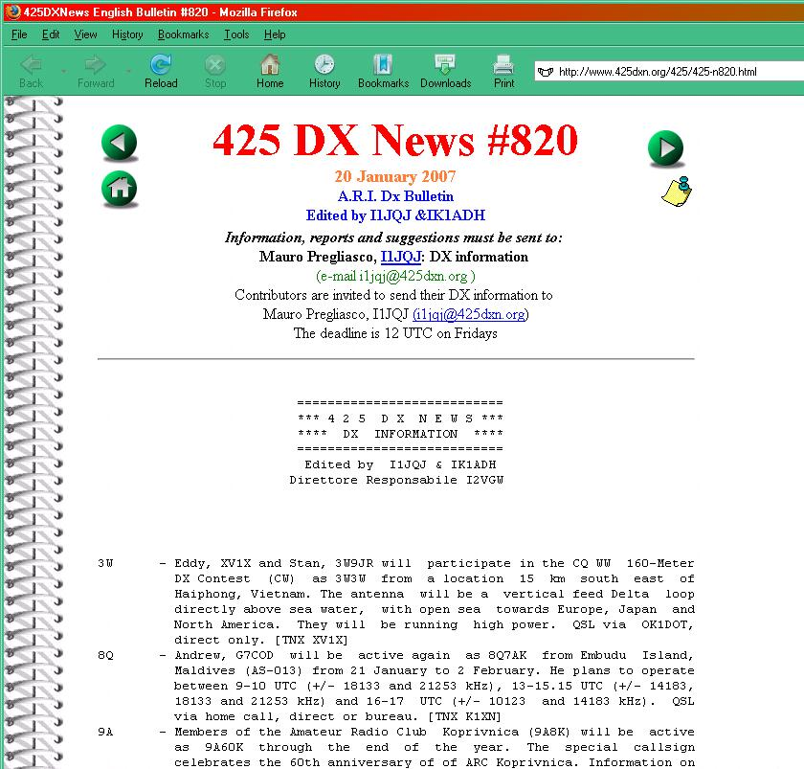

U\_3

## 3.0 IOTA ACTIVITY

The IOTA Activity menu item will produce a table of data derived from the RSGB IOTA web site. This table:

* + can display notified upcoming IOTA activations and/or current activities as listed on the RSGB web site;
  + checks the activations against your log and marks the worked, confirmed and/or granted groups as shown in the example below; and,
  + allows sorting by IOTA, Call, Island Group, and Start Date Columns. (as depicted by the column title being in red). Click on the column title to sort.

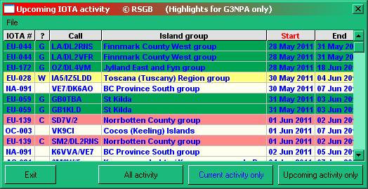

U\_4

The basic information for this table is downloaded from <http://www.rsgbiota.org/activations/coming.php>. and

<http://www.rsgbiota.org/activations/today.php>.

If you place the cursor over a particular island group, Logger32 will produce a tooltip containing more information about the activation.

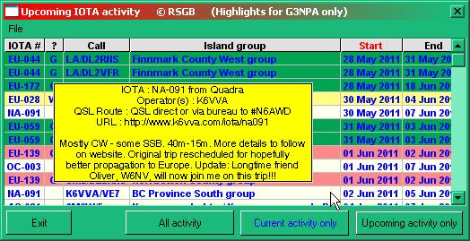

U\_5

**Note** that the IOTA website is access limited in that it will only allow a single hit in a specific time period. Currently this is once every 30 minutes. If you attempt to access the website for a second or subsequent time within the time period you will receive the following information window.

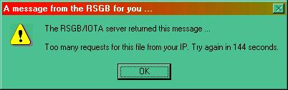

U\_6

and the IOTA table as shown in U\_5 above will be completely blank. Under normal circumstances a single hit on the website will be sufficient and further access will be required only on reboot of Logger32.

If there are no current activities then a message such as:

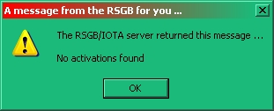

U\_9

will be displayed.

## 4.0 UTILITY PROGRAM SETUP

Logger32 provides the ability to shell out to other packages, such as LogPrint, DXAtlas, CwGet, etc.

Under the Logger32 [Main menu](#_topic_MainMenu) [Tools](#3.0_TOOLS_MENU_ITEM) | Utility Program Setup menu items, the user is given the opportunity to set up the path to their favorite program(s) and to give it (them) a suitable menu name. These menu names will appear in the Logger32 [Main menu](#_topic_MainMenu) under the [Utilities](#7.0_UTILITIES_MENU_ITEM) menu item.

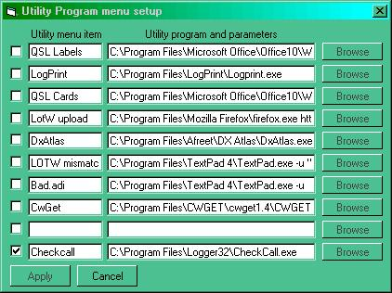

U\_7

Up to twenty of your favorite programs can be set up this way.

In addition, an auto launch option is provided for any of the utility programs. Simply click the checkbox to set any/all utilities to auto-start when Logger32 starts.

The utilities menus will display those set to auto-start as shown by the checkmark alongside the menu item.

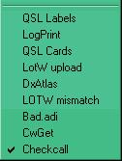

U\_8

*Created with the Personal Edition of HelpNDoc:* [*Create iPhone web-based documentation*](http://www.helpndoc.com/feature-tour/iphone-website-generation)

**Computer Setup**

*Created with the Personal Edition of HelpNDoc:* [*Free iPhone documentation generator*](http://www.helpndoc.com/feature-tour/iphone-website-generation)

**Computer Suggestions**

# Jim Hargrave W5IFP, Javier Bermejo EA1AUS and Curt Wann K4ITO

## 1.0 GENERAL

The following sections are general in nature and provide some guidance for things to consider if the user is experiencing difficulty running Logger32 or obtaining the auto updates. These suggestions are primarily for Windows Vista, 7 & 8 operating systems. However many of the suggestions could apply to other Operating systems. They are not all inclusive, but offer some guidelines to persue.

## 2.0 WINDOWS VISTA & 7 SUGGESTIONS

### 2.1. Logger32 will run on Windows Vista and Windows 7

The following paragraphs provide some suggested setup conditions. Initial installation and subsequent operation and upgrades will require the program to run as administrator.

The default directory can be C:\Radio\. Logger32 should not be installed in the C:\Program files\ directory.

### 2.2. Run as administrator

The following depicts 2 methods of setting up administrator privileges.

### 2.2.1 Program Shortcut

Right-click on the Logger32 shortcut on the desk top and select "Properties".

Select the “shortcut " tab, and finally press the "Advanced" button.

In the new box, check the Settings, "Run as administrator" and click "Apply".

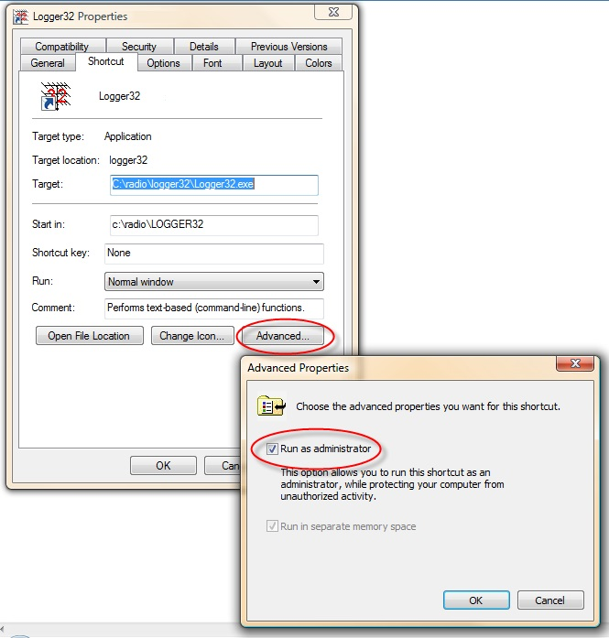

CS\_1

### 2.2.2. Program setting

Open Windows Explorer and navigate to the Logger32 folder and right-click on Logger32.exe. Check the line: Run as administrator. Or click in Start button, look for Logger32 in all programs, right click in Logger32.exe and click the line: Run as administrator

**Note**: This function is a onetime setting that will Logger32 to startup properly when Logger32 is double clicked from Windows Explorer.

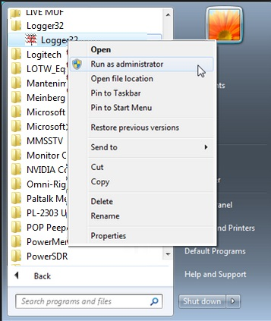

CS\_2

### 2.3. User Account Control (UAC)

The UAC should be disabled. This is necessary for the Logger32 auto-update to function.

At this point, there is minimal difference between Windows Vista and Windows 7 in the way to disable UAC.

**Important**: Turning off UAC reduces the security of your computer and may expose you to increased risk from malicious software. Microsoft does not recommend leaving UAC disabled.

**Note**: In order to insure system security entirely, the user may opt to return the UAC to enable following a Logger32 upgrade.

### 2.3.1. Use the following procedure to disable UAC in Windows Vista

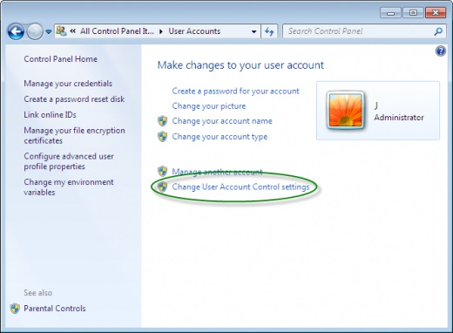

CS\_3

* 1. Click Start, and then click Control Panel;
  2. In Control Panel, click User Accounts;
  3. In the User Accounts window, click User Accounts;
  4. In the User Accounts tasks window, click Turn User Account Control on or off;
  5. If UAC is currently configured in Admin Approval Mode, the User Account Control message appears. Click Continue;
  6. Clear the Use User Account Control (UAC) to help protect your computer check box, and then click OK; and,
  7. Click Restart Now to apply the change right away, or click Restart Later and close the User Accounts tasks window.

### 2.3.2 Use the following procedure to disable UAC in Windows 7

* 1. Open the Start Menu;
  2. Click on the Control Panel button on the right;
  3. Click on the User Accounts icon;
  4. Click on the Change User Account Control settings link. (See screenshot above);
  5. If prompted by UAC, click on Yes to approve;
  6. Adjust the slider to the level of protection of how much you want to be notified from UAC;
  7. Click OK when done; and,
  8. Close the User Account Control Settings window and Restart.

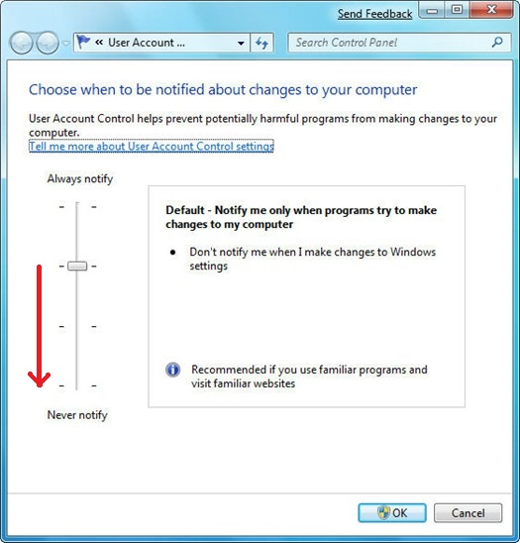

CS\_4

### 2.4. Anti-Virus

If you experienced problems with your Anti-Virus when auto-upgrade Logger32. You can disable temporally or exclude Logger32 of Antivirus checking.

In case of NOD32, you can append in Exclusions of Antivirus the path where is located Logger32.

**Note**: Other anti-virus programs have a similar setup.

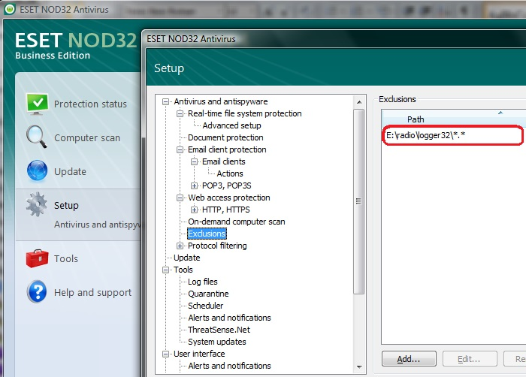

CS\_5

## 3.0 WINDOWS 8 SUGGESTIONS

### 3.1. General

The following is representative and is not all inclusive. It is furnished as a general guide only.

Logger32 will run on Windows 8 & 8.1. The following paragraphs provide some suggested settings and configuration conditions. Initial installation and subsequent operation and upgrades may require the program to run as administrator.

**Note**: In Windows 8, Microsoft "Windows Defender" replaces "Security Essentials" used with earlier Operating systems. Logger32 seems to run without issue when Windows Defender is the primary Anti-virus protection program.

The default directory is C:\Logger32\. Logger32 should not be installed in the C:\Program files\ directory.

### 3.2. Run as administrator

The following provides 2 methods of setting up administrator privileges.

### 3.2.1 Program Shortcut

Right click on the Logger32 shortcut on the desk top and select "Properties".

Select the "Compatibility" tab. Check the Settings, "Run this program as administrator" and click "Apply".

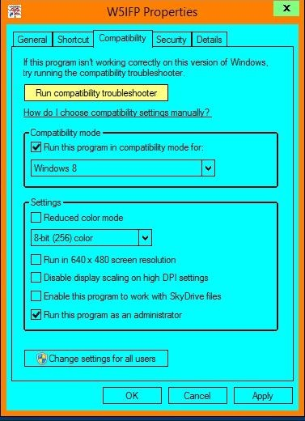

CS\_6

### 3.2.2. Program setting

Open Windows Explorer and navigate to the Logger32 folder and right click on Logger32.exe. Check the line: Run as administrator.

**Note**: This function is a onetime setting that will Logger32 to startup properly when Logger32 is double clicked from Windows Explorer.

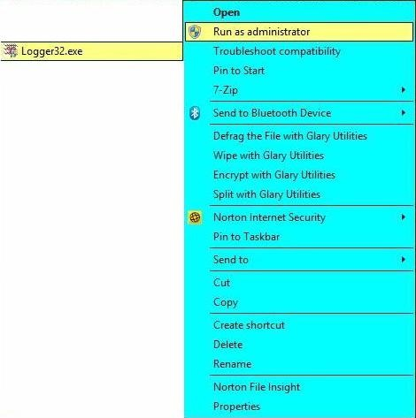

CS\_7

### 3.3. User Account Control (UAC)

The UAC should be set to minimum. This is necessary for the Logger32 auto-update to function without interference. To change this setting, place the cursor in the upper right hand corner of the screen to display the Windows 8 charms. Click on the search and type in: Change User Account Control settings.

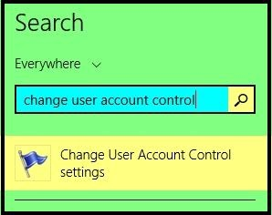

CS\_8

This will open a User Account pane with a vertical sensitivity scale. Grab the bar and drag it all the way to the bottom of the scale. This does not completely turn off the UAC, but minimizes its interference to normal operation.

**Note**: In order to insure system security integrity, the user may opt to return the UAC to its normal position following a Logger32 upgrade.

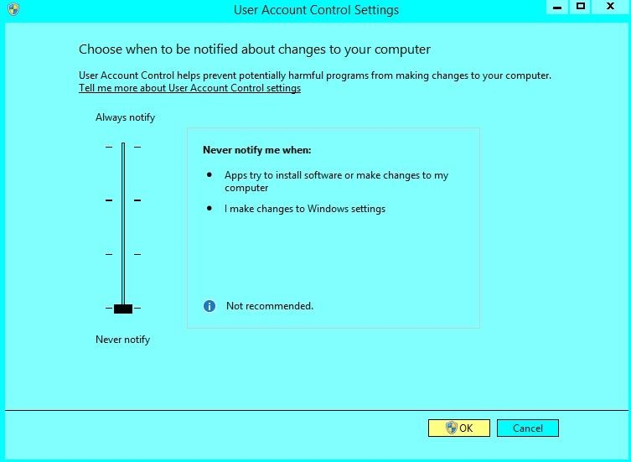

CS\_9

### 3.4. Norton Anti-Virus

### 3.4.1 Administrative Privileges

Norton users will occasionally see a pop-up screen requesting confirmation of administrative privileges. This will appear following a manual upgrade where the upgrade file is copied into the Logger32 folder. This does not seem to affect the auto-upgrade. It only pops up the first time Logger32 is opened following installation of a revised Logger32.exe.

Place a check mark in the line " Always allow this file (if Run is chosen)".

Click on "Run this program anyhow".

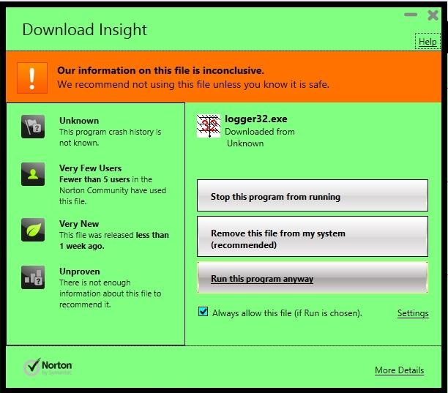

CS\_10

### 3.4.2 Problems with Logger32 Auto Update

For users having problems with Logger32 auto update, the following steps will disable Norton and should allow a successful update:

* 1. Open Norton Security Suite;
  2. Select Settings;
  3. Select Anti-Virus from the list;
  4. In the SONAR Protection row turn off SONAR Protection, move the On/OFF switch to the right to the off position; and,
  5. Select Apply and have a time of 15 minutes.

After you do the Logger32 update go back into Norton and move the On/Off switch to the on position.

## 4.0 MISSING FONTS

Logger32 sometimes find missing fonts in your system. This is likely to happen when you upgrade/update OS. If you buy brand new PC and install Logger32 it may happen as well.

The font used in various windows of Logger32 are saved in INI file. If you are unlucky you may have following message during Logger32 startup or when you open a specific window.

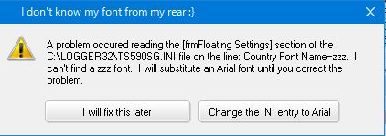

CS\_11

## 4.1 You have two options.

1. I will fix this later.

Missing fonts are temporally replaced by Arial, however this is not saved INI file, You have to install missing fonts later or use Arial.

1. Change the INI entry to Arial

Missing fonts are fully replaced by Arial and this is saved in INI file,

## 4.2 Examples of Font name saved INI file

[Globals]

Grid Font Name=Arial

[wndTracking Settings]

Tab Font Name=Arial

*Created with the Personal Edition of HelpNDoc:* [*Free HTML Help documentation generator*](http://www.helpndoc.com)

**Computer Tuneup**

# Jan Ditzian KX2A and Jim Hargrave W5IFP

## 1.0 GENERAL

During the development of Zakanaka, the predecessor of the Logger32 [Sound Card Data window](#_topic_SoundCardDataWindow1), some users reported complaints such as:

* + Letters appear slowly on the display;
  + The mouse cursor moves slowly or jerkily;
  + The mouse cursor disappears;
  + The display freezes;
  + The program freezes and must be removed with <**Ctrl+Alt+Del**>; and,
  + The whole machine freezes and must be rebooted.

The underlying problem may be that the computer is overloaded. There are a number of ways where this can occur:

* + There is too much for the CPU to do in real time
  + There is a need for more computer memory (RAM) than is available
  + There is more for the display processing subsystem to do than it can handle.

When the MMTTY engine detects a shortage of CPU resources, the CPU LED at the lower right turns red for a few seconds.

## 2.0 REDUCE CPU USAGE

The most likely cause of problems is that your CPU cannot keep up with all the activity you are requiring. Actually, you need not shoulder all the blame: Bob Furzer and Makoto Mori helped to load down your computer when you run RTTY, the people at the company that installed your operating system and associated software may have sneaked a CPU load onto the computer (these are the folks from whom you purchased the computer), and the gremlins who are on the payroll at Microsoft may have sneaked something onto the computer as part of Windows, and other programs you run may have installed components that are running and you are unaware.

The following recommendations should reduce CPU usage. A few of these items apply to general operation, and work for both PSK31 and RTTY modes. However, most of these items are specific to RTTY operation, where CPU usage seems to be higher. We shall begin with the general items.

### 2.1 Run Only Logger32

Try exiting all other programs and run only Logger32 and see if it runs properly. If this is the case, there is a reasonable possibility that you do not have sufficient memory (RAM) in your computer system to run Logger32 along with the other programs that you want to run. However, it could mean that your CPU is too slow.

64 MBytes of memory should be able to handle Logger32 in RTTY mode plus a few other programs running under Windows 98. The newer Windows operating systems, such as Windows2000 and Windows XP, will require even more memory.

### 2.2 Remove Programs By Using MSConfig

Many computers that come with Windows have additional programs also loaded. In fact, Windows does this without being explicit about it. You may find a task scheduling program, virus checker, power management, sound card controls, fax receive software, modem sharing software, internet hacker protection software, a screen saver, and so forth, all running without anyone telling you about them. Many of these programs make themselves known at the lower right, on the taskbar. Any additional programs will be using some amount of your computer's RAM and can take away memory that could help Logger32 run morw efficiently.

### 2.3 Clean out your computer

In Windows 98, it is possible to stop most programs other than the ones you want to run. In Windows 98, Click Start | Programs | System Tools | MSConfig.exe to run MSConfig. If it is not there, use Windows Find and click MSConfig.exe it to run it when you find it.

* + When MSConfig is running, you will see a series of tabs. Go to the right-most tab, Startup, and write down every program that has a check mark next to it. This is your insurance that you can restore the old setup. You could create a backup on the General tab, but we will use the simple approach here
  + Click on every program in Startup, and you will remove each check mark
  + Return to the General tab and click Selective Startup

Press OK and reboot the computer. The only programs that will appear in your system tray at the bottom right of the Windows display will be those that bypass Startup and still work themselves into the boot procedure.

### 2.4 Try Logger32

At this point, you should run System Monitor and see how much CPU usage you have. Begin a log of this usage, and make notes about what uses a lot of CPU power.

At this point, nothing is running in your computer except the Windows operating system. This is a good time to exercise Logger32 and see whether it runs. Be sure to use all the features that you can use, and do this for a while. Especially, try RTTY, use BPF and Notch, transmit (you do not have to actually put a signal on the air) and move the cursor. Switch among all modes (BPSK, QPSK, Tune, RTTY) using both techniques. Bring up some Macros. If it seems to run successfully you can begin to add back some of the programs you previously removed.

### 2.5 Restore Programs

Go back to the Startup Tab and selectively add those programs that you really want to run all the time, such as a virus checker, the sound card controls, and possibly power saver monitoring software. Reboot again.

Run the System Monitor to see the level of CPU usage. This program itself uses CPU power, of course, but not too much. Once you have done the measurements you need to do, you can stop running the Monitor. There is no need to run this program all the time.

If you have enough time, you might want to add programs slowly. You might choose to add only your virus program at first, since you will almost certainly want that back in operation if it can run at all. Try things with that program and Logger32 for a day, then add another program.

If you find that your computer does not operate as it should, scrounge around on your desk for that piece of paper telling you all the processes that were originally running and put checks next to them again with MSConfig. You can do this for one program at a time, if you are unsure what they do. Restore only those programs you need.

Each of these programs has a purpose, the question for you is, do you need them as much as you need Logger32 ? Of course, we know the answer to that question.

### 2.6 Turn Off XY Display in RTTY Mode

The XY display mimics the old oscilloscope phase display that once was needed for RTTY operators to adjust Mark and Space to the proper value. You are properly tuned to Mark and Space frequencies when the ellipses are vertical and horizontal.

The XY display is a big consumer of computer resources, but has less importance than it used to have, because the AFC feature can tune in signals for you.

If you are operating AFSK, first go to RTTY mode and then set your AFC to Free. To do this, click Setup | AFC/ATC/PLL Tab, and click Free in the AFC area at the left. Click OK to save this value. Now turn on AFC on the RTTY toolbar. When you click a signal to copy it, both the Mark and Space (shift is the distance between them) can vary, and the computer will automatically adjust Mark and shift so reception is as good as it can be. There is no need for the XY display, so you can turn it off at the RTTY toolbar to reduce CPU usage.

Turning off the XY display decreases the CPU load during both receive and transmit.

**Note**: Be careful, turning off the entire tuning window in the View menu as it does not stop the processing for the XY display. You must turn off the XY display at the RTTY toolbar.

### 2.7 Turn off RTTY Notch

The RTTY Notch function is invoked by left-clicking the mouse with the cursor in the analog frequency display area. Examination with the Windows System Monitor reveals that Notch is a heavy user of CPU resources.

### 2.8 Turn Off RTTY Receive BPF

The bandpass filter also is a heavy user of resources, so if you can avoid using this you will ease the CPU load. You may want to choose between BPF and Notch if you occasionally have problems.

### 2.9 Turn Off RTTY Oversampling

Turn off the oversampling mode of the limiter. Click Setup, Demodulator Tab and uncheck the Over Sampling box in the middle.

### 2.10 Avoid the RTTY FIR Demodulator Filter

The default filter is IIR. The FIR filter seems to use more resources than either the IIR or PLL filter.

### 2.11 Do Not Use RTTY Tx Filters

The TX BPF (bandpass) and TX LPF (low pass) filters work to keep your transmit audio signal narrow and clean. However, they also take processing power during transmit. If you have problems during RTTY transmit, try clicking Setup, TX Tab, and uncheck these two items at the lower left. If CPU usage during transmit is not a problem, however, leave these filters in place.

### 2.12 Reduce Sound Card Buffer Size in RTTY Mode

This recommendation can have profound effects on the transmitted signal, and should probably be a last-ditch effort to get Logger32 to operate in RTTY transmit. Other changes should be tried first. You can reduce the size of the sound card buffer as long as the transmit audio does not begin to break up. This is tricky to adjust.

Click Setup, Misc Tab, and look to the left for the window labeled FIFO. The default FIFO values are Rx = 24 and Tx = 4.. Too low a number can chop up the transmitted audio. Too high a number can create transmit delays.

*Created with the Personal Edition of HelpNDoc:* [*Easy Qt Help documentation editor*](http://www.helpndoc.com)

**Screen Control Operation**

# Randy Tipton, WA5UFH, Jim Hargrave W5IFP, and Bob Furzer K4CY

## 1.0 GENERAL

This topic discusses the way that Logger32 presents information on the screen. If you're competent with the manipulation of windows, you might skip this topic. Each user is encouraged to experiment with different screen configurations to find the one most comfortable to them. It isn't our intent to tell you to use any particular configuration. Instead, we want to make you feel comfortable manipulating windows so you can decide how you want to use Logger32.

**Note**: Different versions and releases of Windows, and variations in setup, may create variations in the exact sequence of commands you must use to get to a screen or display setting option. These are Windows operations, not Logger32 operations.

Logger32 screens can be configured to be as simple or as complicated as you desire. You decide the level of complexity.

If you only plan to use Logger32 without any other application, start Logger32 and operate it full screen size. Pick the resolution which best suits you.

## 2.0 COLOR

Set your screen display (Settings, Control Panel, Display, Settings) to a value more than 16 colors. High color (16 bit) is acceptable. Failure to set the color setting to a high enough value will cause problems with viewing the waterfall display.

## 2.1 Windows 10 colors and Font setup

Windows 10 users may not like the new Microsoft bland color scheme. The following paragraphs contain procedures for changing the default Windows pale colors to a more pleasing screen presentation in Logger32.

**WARNING**: This process involves changes to the Operating System Registry. This should not be attempted unless you are familiar with the process and not hesitant to make Registry changes. The process is provided for the more competent computer operators.

**Note**: Before proceeding, it is highly recommended that you backup your files and complete a current System restore point. This will allow you to undo any changes in case there is a problem. It is also recommended that you record your current settings for each of the steps below as you make changes. This will allow you to revert to default settings in case you don't like your new setting

### 2.1.1 Capture of the Logger32 Logbook Entry pane with focus

The following is a typical [Logbook Entry pane](#_topic_LogbookEntryWindow) display with Windows 10 default settings.

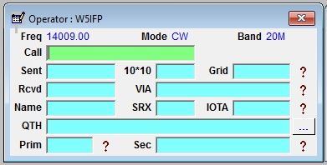

SCO\_2

The following is the Logbook Entry pane after the changes outlined below. With these changes it is much easier to recognize the window that has the current focus. Each color is user definable.

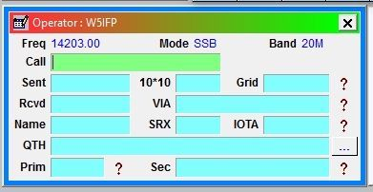

SCO\_3

### 2.1.2 Color Chart

The Registry colors are in RGB format. There is an active color chart on-line that can be used to select the respective colors.

<http://www.rapidtables.com/web/color/RGB_Color.htm>

Open the above page and scroll to the color computer. Hover the mouse pointer over the desired color. The computer will display the RGB equivalent numbers below the color chart. Record these numbers and edit the registry accordingly. Do this for each of the desired color changes.

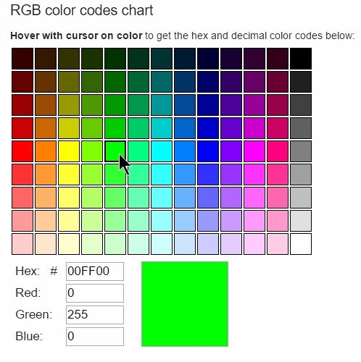

SCO\_4

### 2.1.3 Editing the Registry

The following changes will produce the colors as shown in above sample. The user may choose desired colors for each entry or leave them as they are.

A: Open the registry by pressing: <**Window key+R**>;

B: Type REGEDIT in the Run slot, press <**Enter**>; and,

C: Scroll down and find:

HKEY\_CURRENT\_USER\Control Panel\Colors.

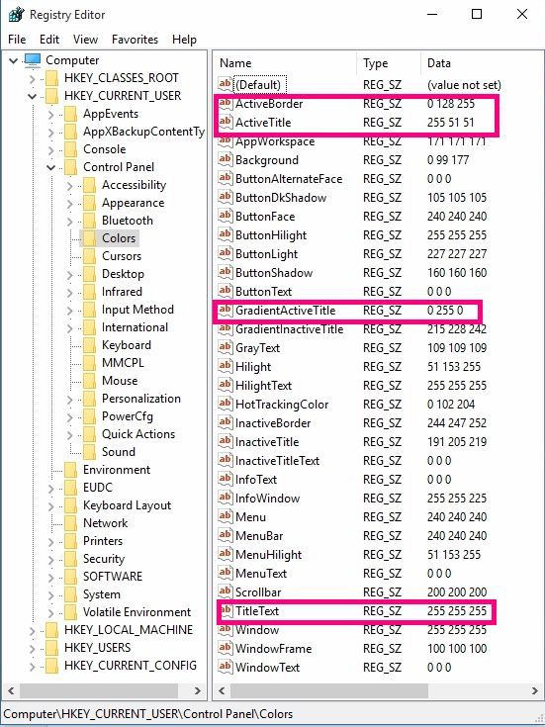

SCO\_5

D: Double Click on a line to open the Edit String dialog box.

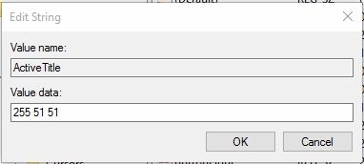

SCO\_6

Change ActiveTitle Value data to: 255 153 153 (Left side color);

Change GradientActiveTitle Value data to: 255 204 204 (Right side color. Can be the same as ActiveTitle for solid color title color);

Change TitleText Value data to: 255 255 255; and,

Change ActiveBorder Value data to: 0 128 255.

### 2.1.4 Change Compatibility Mode

Using Windows Explorer, navigate to the Logger32 folder. Find Logger32.exe and right click on it. Open the Properties > Compatibility tab.

Under Compatibility, place a check mark by the “Compatibility Mode” and select “Windows XP (service pack 3). This will show the MDI title bar in traditional format.

Under Settings, place a check mark by “Reduced color mode” and Select “8 bit (256) color”.

Select the <**Apply**> and <**OK**> buttons to save and exit.

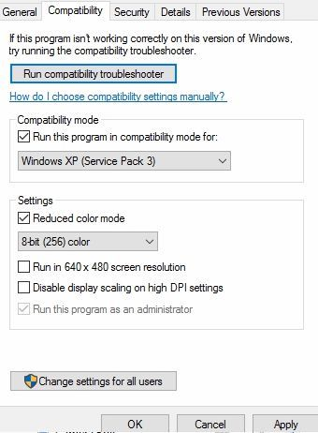

SCO\_7

### 2.1.5 Menubar

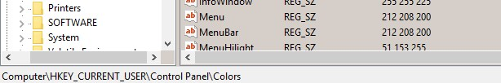

SCO\_8

Change HKEY\_CURRENT\_USER\Control Panel\Colors Menu and MenuBar to 212 208 200.  On my PCs, this changes the Logger32 MenuBar on the MDI Form from white to the same color as the toolbar.

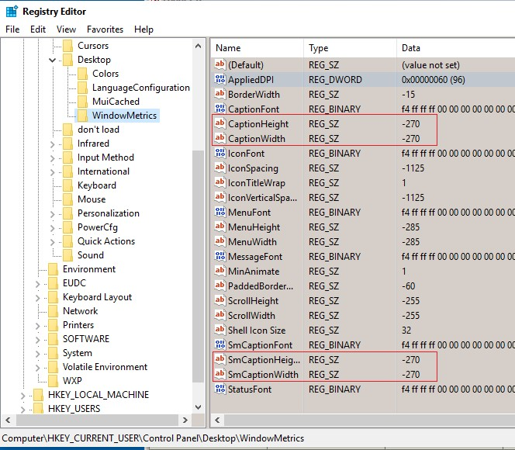

SCO\_9

Next, I changed HKEY\_CURRENT\_USER\Control Panel\Desktop\WindowMetrics CaptionHeight and CaptionWidth to -270 (note minus 270).  On my PCs, this reduced the size of the form Titlebars and the buttons to a reasonable size. Do the same for smCaptionHeight and smCaptionWidth. The SmCaption Height/Width change adjusts the Bandmap captions to match.

The following changes (highlighted) set the Bandmap captions to bold (just like the other Windows):

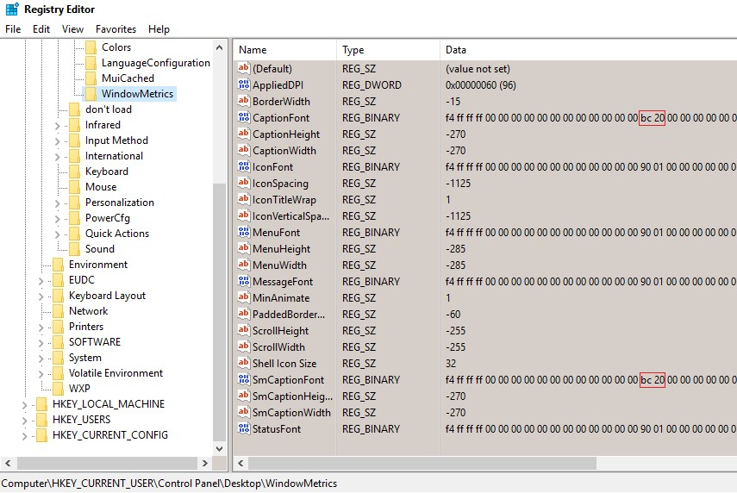

SCO\_9A

### 2.1.6 Titlebar Font

WINDOW+R to open the Registry editor. This time, navigate to HKEY\_CURRENT\_USER\Control Panel\Desktop\WindowMetrics Find the entry for CaptionFont and double click on the word CaptionFont You will see the Edit Binary value window.

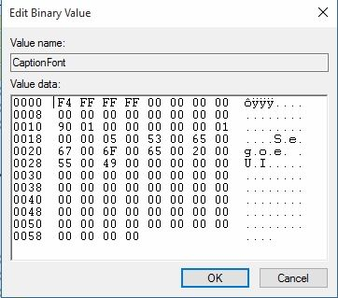

SCO\_10

At the left of the top row of data you see in this example 0000 F4. This is what you want the Font size is 9. If the value is not 0000 F4 (for

example, say you see 0000 F5), put the blinking cursor between F5 and the FF to its right. Type <**Backspace**>. This clears the value to the left of the cursor (in the example, F5 will be cleared). Type F4. You will see 0000 F4 FF at the top left. You have now set the font size to 9. To double check you have not added/removed some data, look at the bottom row.

It should read 0058 00 00 00 00 Correct ?

Now look at the third row. It will be something like 0010 90 01 00 at the left side. The 90 01 says the font is not bold. You want to see 0010 BC 02 00. The BC 02 says the font is bold. So, if you must make a change, put the cursor between the 01 and the 00. Backspace twice. This removes the 90 02. Type BC02. You have now set the font to bold. To double check you have not added/removed some data, look at the bottom row.

It should read 0058 00 00 00 00 Correct ?

You now know the ActiveTitleBar is font size 9 and the font is bold. Do the same for smCaptionFont. Set the font size to 9 and font to bold.

### 2.1.7 Close all windows and Reboot the computer

Open Logger32 and see what it looks like for you.

## 3.0 WAYS TO MANIPULATE AND VIEW THE SCREENS

Depending on how much of the Logger32 screen you wish to view, select a screen resolution starting with 800 X 600. If you wish to see more of the Logger32 windows try 1024 X 768 or 1152 X 864. You should go to Settings, Control Panel, Display, Settings to set these values for all of Windows 95/98.

With this configuration when you click on a call you see it replicated in the Log Window. Also all the features of Logger32 can be seen at a glance. (example: previous QSOs, new country, past comments, distance, and bearing headings).

## 4..0 POSSIBLE ERRORS USING THESE CONFIGURATIONS

Why Logger32 Might Appear to Have Stopped Operating!

If you make a mistake in Logger32, such as not entering a frequency when configured for frequency input, or entering a wrong county for a state, the Error Window for Logger32 could be hidden behind the [Sound Card Data window](#_topic_SoundCardDataWindow1). Logger32 did not stop working; you just made a keyboard mistake. In this case, click on the Logger32 Sound Card Data window tool bar and drag it down so you can acknowledge the error window and correct your mistake.

## 5.0 LOST WINDOWS

If you change screen resolutions, it is possible to leave pop-up windows such as the Individual tuning windows and Aux Rx windows outside the viewing area (especially at low screen resolution). The result is that you cannot find your window. To find your windows, return back to the higher screen resolution setting and close the windows before changing back, or place the lost windows inside the Main QSO window before changing to the next screen resolution.See the topic [Finding Lost Windows](#_topic_FindingLostWindows).

## 6.0 SCREEN SIZE RESOLUTION

It is up to every user to decide what is comfortable to your eyes. If you're running Windows 95/98 you can see what your system is capable of displaying by doing the following:

1. Double-click on My Computer.

2. Double-click on Control Panel

3. Double-click on Display.

Below, you see the Display Properties Window (the layout might change from Windows 95 to 98 to 2000). The example Desktop area selected is 1024 X 768, with Small Fonts selected for Font Size. Notice that the Desktop area can be resized by clicking on either side of the scale pointer.

If you're going to try different screen sizes, you can check the box Show settings icon on task bar. This box requires that you go further, to Settings, and General. By making the screen size resolution options available on the tool bar, you can to quickly change your settings. Some configurations require restarting your computer, which can take a lot of time.

Examples of Screen Configurations for Windows ME.

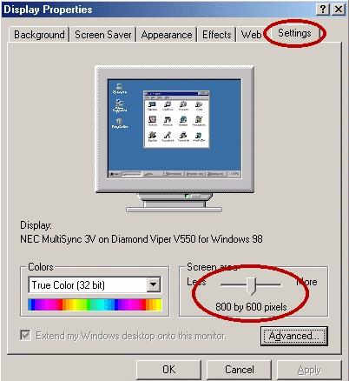

SCO\_1

With every screen configuration there is an option in Display / Settings to select either Large or Small Fonts. After changing from Small to Large or Large to Small your system might ask you to restart Windows to make the change effective.

## 7.0 SOUND CARD SETTINGS

The following paragraphs contain settings that affect the various display aspects while in the Sound Card Data window. These aspects are also covered in various sections of the Sound Card Data Window.

Open the [Sound Card Data window](#_topic_SoundCardDataWindow1) and go to "Settings|Appearance" for PSK31 and RTTY. You can also set tuning colors by going to "Settings|MMVARI settings" and "Settings|MMTTY settings. You can set font colors, background colors for different windows, colors for the waterfall, and colors for the RTTY XY scope.

## 8.0 RESIZING WINDOWS WITHIN THE SOUND CARD DATA WINDOW

The TX and RX windows share a common screen area, and you can make one window larger and the other smaller by using the mouse to position the cursor over the splitter bar, which is the dividing line between the TX and RX windows.If you do this carefully you will see a special cursor appear; now left-click the mouse and you can drag the splitter bar up or down. This will allow you to see more of what you type, while giving up some display area for received text.

## 9.0 LINE WRAP

Line wrap works the same way for PSK31 and RTTY.

### 9.1 RX Window Line Wrap

Logger32 displays received text in the RX Window exactly as it is received. The only exception is that when text reaches the right-hand edge, it wraps to the next line. There is no special line wrap: the next character (70) will appear at the left. It is up to the sending station to include carriage return/line feeds (CR/LF); otherwise words will be broken at character 70.

### 9.2 TX Window Line Wrap

To transmit with line wrap, click Settings, Line wrap on. For RTTY using the MMTTY engine, you must also check Settings, Typing Preference, RTTY - send word out. A check mark to the left of this choice means that it is on. On RTTY, if you do not check Send word out, Logger32 sends letter by letter, and ignores the content.

When you are typing in the TX window, text is wrapped between 63 and 69 characters. This means that when there are 63 characters in a transmitted line, Logger32 begins to look for a space in the typed input. When a space occurs between character 63 and 69, Logger32 generates a carriage return/line feed (CR/LF), the text wraps to the next line, and when you reach the end of the word this CR/LF is also transmitted to the receiving station. If all goes well, his line will wrap when yours wraps. Remember, in RTTY mode you must have "word out" enabled.

If there is no space between character 63 and 69, Logger32 inserts a CR/LF after character 69 and puts what would have been the 70th character on the next line as the first character. This CR/LF is also transmitted to the receiving station. This means that if you see that words are being split between lines, you should try to type a carriage return (Enter key on the keyboard) before you reach that point. If you would rather send text without Logger32 putting in line wrap, turn line wrap off in the Settings menu by clicking it so the check mark disappears.

### 10.0 SLASH-ZERO OPTION

You can have Logger32 print a slash-zero instead of a plain zero. Go to Settings and select Use slash-zero for zero.

### 11.0 Mouseover

There are a number of capture operations that can be performed on mouseover (passing the mouse cursor over the text).

To capture receive text, position the pointer at one end of the text, press the left button and drag the mouse pointer over the desired text. Release the mouse button and the highlighted text will automatically be placed on the clipboard.

You can set the color of the mouseover text highlight by going to "Settings|Appearance|Receive window mouseover highlight".

*Created with the Personal Edition of HelpNDoc:* [*Free EPub and documentation generator*](http://www.helpndoc.com)

**Shared Serial and Parallel Ports**

# Jim Hargrave, W5IFP

## 1.0 GENERAL

Logger32 uses serial RS-232 ports to interface with the Radio, Rotor and Terminal Node Controllers (TNC). Logger32 also uses Parallel ports for Antenna switching and CW Transmit interface. To accommodate limited hardware configurations, several of these functions can be shared on the same ports, but some rules must be observed when setting them up. The TNC must be operated on a dedicated serial port. The PTT is the most common shared function.

User sometimes need to share serial port for radio or other device. There are some program with which user share serial port for radio or other device. VSPE (Virtual Serial Ports Emulator), LP-Bridge and LPB2 (LP Bridge 2) are popular.

**Note**: Even if serial port can be shared among each program, it is not always perfect. As each program does not know what others do, each program may receive unexpected data caused by other program. You may need to change parameters in Logger32 radio setup table or in other program's setup.

**Note**: In order to share PTT, CW and Radio control on the same serial port requires the use of TXd, RXd, RTS & DTR data lines. The interface must use a RS-232 serial port on the computer or an USB2Serial (RS-232) adapter cable. The cable can feed an adapter with the CAT (CI-V), PTT and CW circuitry. The adapter may be Homebrewed or use a commercial interface that supports these functions.

## 2.0 PORT SETUP

The port setup of each function is defined in the specific portion of this help file related to the respective functions. If you choose to use shared ports, you must make sure that each shared function is setup in a manner that will not cause any conflicts.

The following Serial port combinations are possible:

* + Radio Control, PTT and CW transmit.
  + PTT and CW transmit.
  + PTT, CW transmit and Rotor control.

The only Parallel combinations that possible are Antenna Switching, Selected Radio and CW transmit including PTT. See below for specific rules that must be followed if this configuration is used.

### 2.1 Serial Port configurations

The following is a list of the signal lines used by each module in Logger32:

* + Radio Control: TxD and RxD
  + PTT: RTS and/or DTR
  + CW: RTS for PTT keying and DTR for CW data.
  + RTTY: TxD line is used in the FSK mode of operation.

**Note**: The TxD line is only used in the RTTY module if folks want to use FSK operation rather than AFSK

Specific details on pinouts and RS-232 signals for both DB-9 and DB-25 pin connectors are available in the Glossary.

### 2.2 Parallel Port configuration

Antenna switching; Pins 2 thru 9

Selected Radio: Pin 14

CW transmit: PTT on Pin 16 and CW Data on Pin 17

**Note**: If the same Parallel Port is used for both the Antenna and the CW module, then the same Hex address must be specified in both setup configurations.

**CAUTION:** The Parallel port PTT only functions when using the CW machine. You cannot share Radio PTT on a serial port and CW PTT on a parallel port at the same time. **NEVER** connect a Serial and Parallel connection together. Equipment failure could result.

If the parallel port PTT is used for the CW machine, then the PTT control from the sound card would have to be by radio command, (assuming that the rig has only one external PTT control point). Otherwise the user must have an external PTT switching setup that would provide complete isolation between the ports, either by mechanical switch or electronic circuitry.

### 2.3 PTT using a Shared Radio port

You may choose to operate a PTT line directly from a pin on a Com port, and also have Logger32 communicate with the radio for frequency information and software command control on the same Com port. In the [Sound Card Data window](#_topic_SoundCardDataWindow1), Click Settings, Radio PTT Options, and select PTT by Shared Radio Port.

**Note**: The sound card in Logger32 allows the option to use DTR or RTS for PTT. However if you plan on sharing a serial port with the CW Transmit, it is suggested that you use RTS so your PTT line will be compatible with the CW Transmit module, which is hard coded for PTT on RTS line and CW data on the DTR line. Both the PTT, and CW can be shared on the same Com port used for Frequency and Mode information exchange between the radio and Logger32.

When you set up your ports configurations, you need to check and make sure you do not have any conflicts between modules. Port configurations can be found in the following five locations within Logger32:

* + Setup | Radio | Radio Port Configuration
  + Setup | Rotor
  + Setup | Antenna Selector
  + CW | Config | Keyer setup
  + Sound Card | Settings | Radio PTT Options

## 3.0 USING THE VSPE TO SHARE THE SERIAL PORT

There are two types of VSPE available, one is free for 32bit OS and another is NOT free for 64bit OS. VSPE can be downloaded at following web page:

<http://www.eterlogic.com/Products.VSPE.html>

### 3.1 Setup VSPE

VSPE provides various ways to share serial port, however Split Device and Connector Device are described in this section.

### 3.1.1 Setup VSPE Splitter Device

Splitter Devise creates virtual device that represents existing serial port to share it between different applications.Run VSPE.

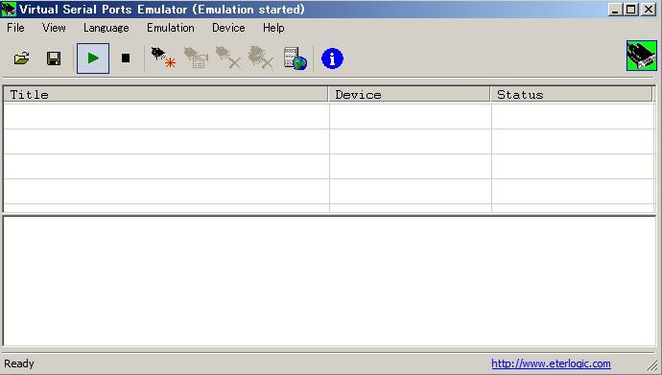

VSPE\_1

Click Device and Create

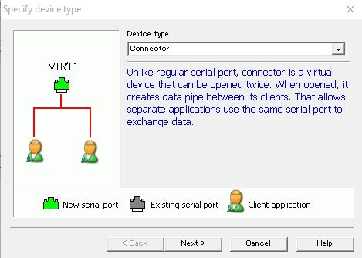

VSPE\_2

Select Splitter in Device type list

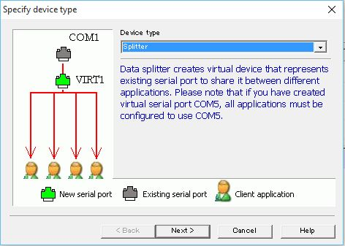

VSPE\_3

Click Next

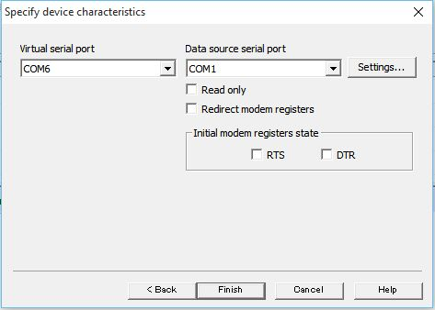

VSPE\_4

In this tabel

Select COM for Data source serial port. This is serial port which is connected to radio.

Select COM port for Virtual serial port. This is serial port which user configure in Logger32 and other program.

Click Settings to configure Baudrate etc. This must be same as radio configuration.

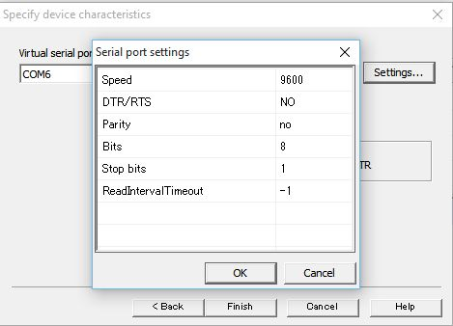

VSPE\_4A

Click OK and finish..

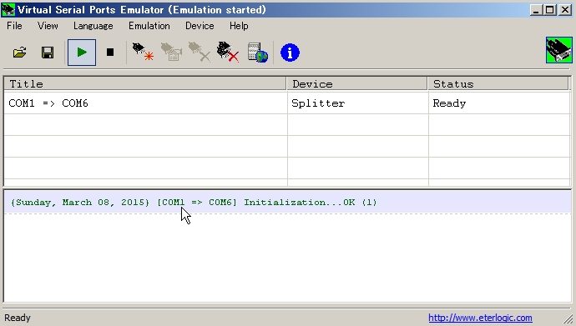

VSPE\_5

Click File then Save as to save this setup. When user run VSPE next time user open saved setup. (File/Open).

### 3.1.3 Setup VSPE Connector Device

Connector Device is virtual device that allows separate applications to use same serial port.

Run VSPE (See above VSPE\_1)

Select Connector in the Specify device type table. (See above VSPE\_2)

Select Virtual serial port.

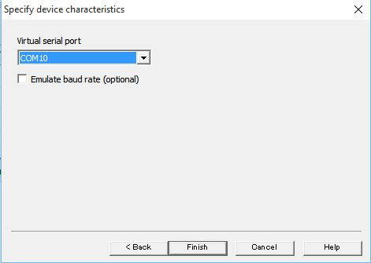

VSP\_5A

Click Finish.

Click File then Save as to save this setup. When user run VSPE next time user open saved setup. (File/Open)

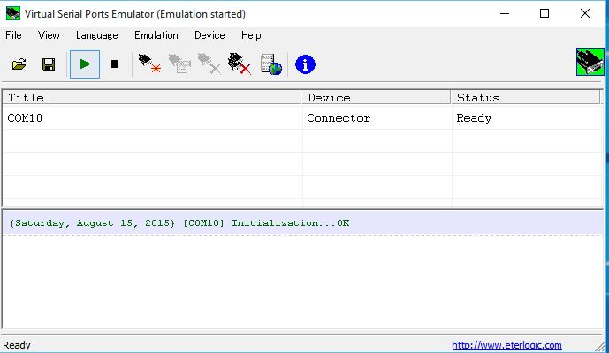

VSP\_5B

### 3.2 Examples

### 3.2.1 How to use Logger32 and ARCP-590 or ARCP-590G (graphical control program for TS-590 or TS-590G) (Splitter Device).

**VSPE setup**

See above [VSPE\_4](#VSPE_4) and [VSPE\_4A](#VSPE_4A)

**Logger32 setup**

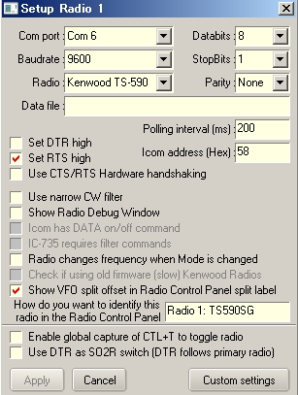

VSPE\_6

**Note**: COM port and Baudrate should be same as setup in VSPE.

**ARCP-590 or ARCP-590G setup**

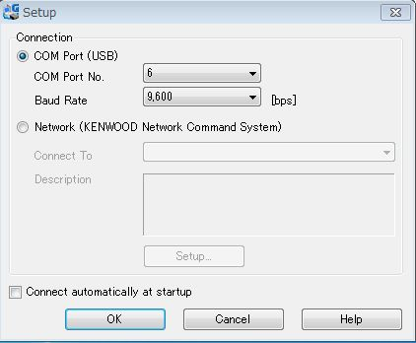

VSPE\_7

**Note**: COM port and Baudrate should be same as setup in VSPE.

### 3.2.2 How to use Logger32 and HDSDR (panadapter program for TS-590 or TS-590G) (Splitter Device)

**VSPE setup**

See above [VSPE\_4](#VSPE_4) and [VSPE\_4A](#VSPE_4A)

**Logger32 setup**

See above [VSPE\_6](#VSPE_6)

**HDSDR setup**

This is a example to use PMSDR SDR receiver. Click ExtIO button in HDSDR window to open PMSDR setup table.

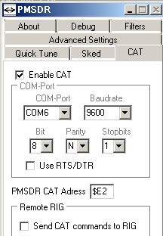

VSPE\_8

**Note**: COM port and Baudrate should be same as setup in VSPE

### 3.2.3 How to use Logger32 and NaP3 (panadapter program for KX3) (Splitter Device)

**VSPE setup**

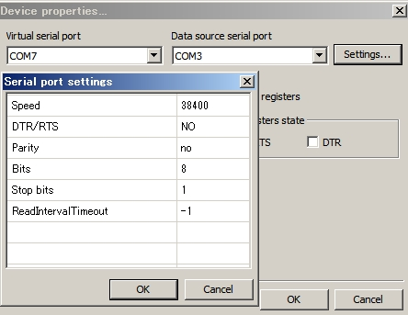

VSPE\_9

**Logger32 setup**

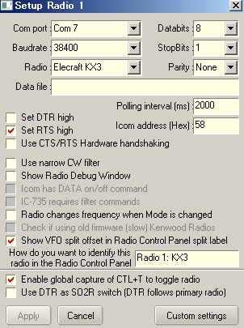

VSPE\_10

**Note**: COM port and Baudrate should be same as setup in VSPE.

**NaP3 setup**

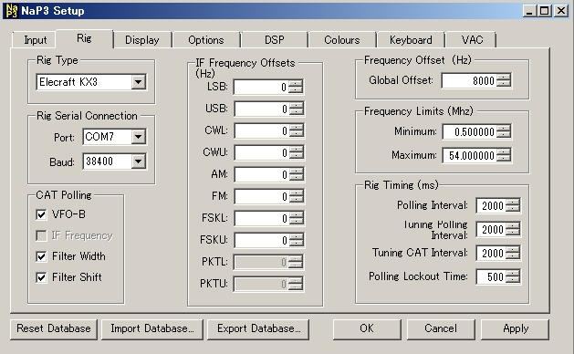

VSPE\_11

**Note**: COM port and Baudrate should be same as setup in VSPE.

### 3.2.4 How to use Logger32 and HDSDR (panadapter program for TS-590 or TS-590G) (Connector Device)

In this case Logger32 Echo Port and HDSDR use the same serial port using VSPE Connector Device.

VSPE setup

See above VSPE\_5A and VSPE\_5B

Logger32 setup

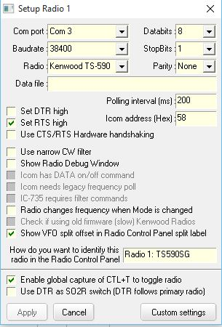

VSP\_11A

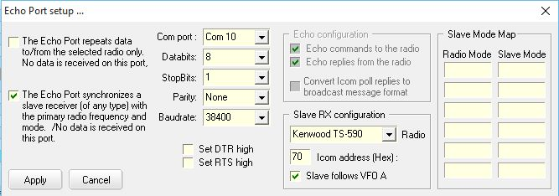

VSP\_11B

**Note**: COM 10 is Connetor Device created by VSPE.　See Echo Port section.

**HDSDR program and PMSDR receiver setup**

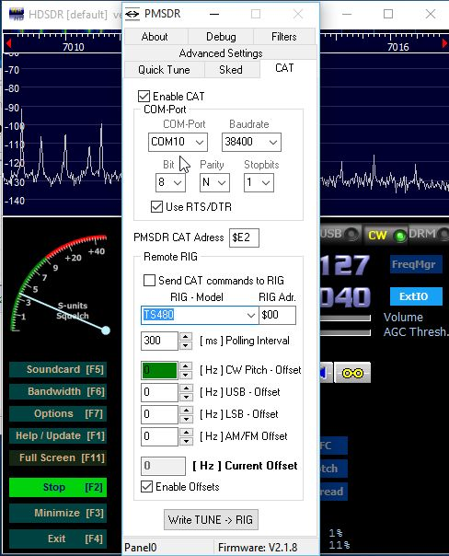

VSP\_11C

**Note**: COM 10 is Connector Devise created by VSPE. In this example HDSDR is tuned to TS590-SG frequency while turning TS-590SG VFO knob or hitting DX spot.

### 3.3 LP-Bridge

### 3.2.1 Setup LP-Bridge

LP-Bridge can be downloaded at following web page. There are two types of LP-Bridge.

LP-Bridge only support K3, however it works with KX3. LBP2 supportt K2, K3, Yaesu (950,2000,5000) and Kenwood. Both are free. Explanation below is for LP-Bridge.

<http://www.telepostinc.com/LPB.html>

K3 Com Port: COM port which is connected to KX3. Click Connect button first. Auto Connect option is available.

SDR Com Port: COM port for NaP3 (This is a virtual serial port). Click Create button. Auto Create and Auto Launch option are avalable.

Virtual Com Port #1: COM port for Logger32. Click Create button.Auto Create and Auto Launch option are avalable.

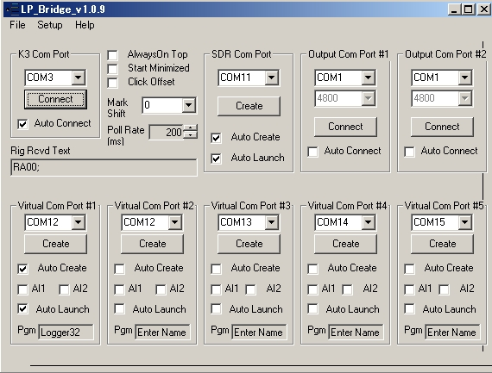

VSPE\_12

### 3.2.2 Example

How to use Logger32 and NaP3 (panadapter program for KX3)

Setup and run LP-Bridge first.

Logger32 setup

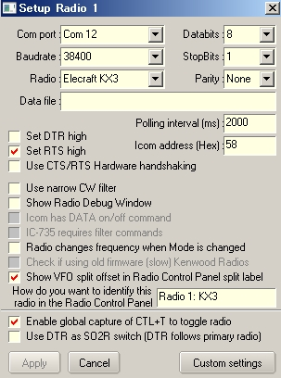

VSPE\_13

**Note**: Com port and Baudrate setting should be sam as setting in LP-Bridge.

**NaP3 setup**

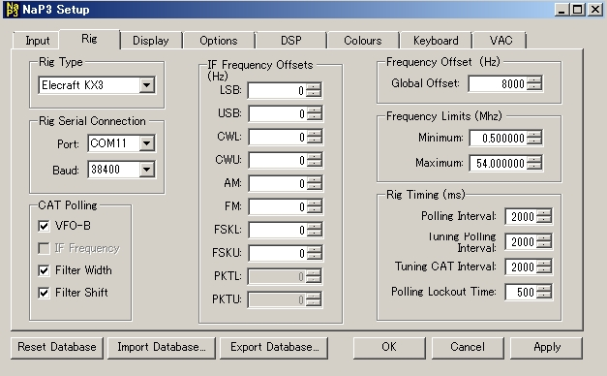

VSPE\_14

**Note**: Port and Baud setting should be same as setting in LP-Bridge. Global Offset should be 8000 if KX3 is in IF 8KHz mode, otherwise zero.

*Created with the Personal Edition of HelpNDoc:* [*Easily create EPub books*](http://www.helpndoc.com/feature-tour)

**Dual Monitors**

# Jim Hargrave W5IFP

## 1.0 GENERAL

Logger32 will function using 2 computer monitors.

**Note**: The following is a guide only. Individual hardware and Operating system setup will vary and under some conditions Logger32 may become unstable.

## 2.0 RUNNING LOGGER32 EXCLUSIVE TO MONITOR 2.

The main Logger32 MDI form will run on monitor 2 and can be sized to full screen.

**Note**: Logger32 should NOT be run “Maximized” on monitor #2. It may become unstable and when Logger32 is opened, there is no guarantee that all of the child widows will open in the same position they were in when it was last closed.

Each user can configure monitor #2 on any of the four sides of the main monitor (Software position – not physical placement). You may experience problems if monitor # 2 is positioned to the left of Monitor #1. This is because the child windows will have a negative left position number. Logger32 and some OS are not consistent in handling negative positions.

The following is the recommended position of Monitor 2. In this setup Monitor #1 is the main monitor and displays the desktop. This is a Windows 8 capture.

The “Extend these displays” option should be set by selecting "Control panel > All control panel items > display > Change display settings".

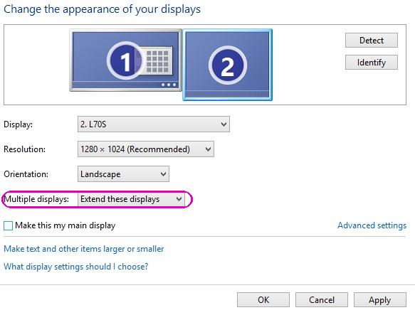

DM\_1

## 3.0 LOGGER32 WINDOW POSITIONS

The main Logger32 MDI form can be positioned and sized to fit on either monitor. It can also be stretched to fit on parts of both monitors.

Logger32 child windows must reside within the Logger32 main MDI form. Modules such as the [Sound Card Data window](#_topic_SoundCardDataWindow1), [Tracking window](#_topic_TrackingWindow1), [Bandmap](#_topic_TheBandmap), [CW Machine](#_topic_CWMachineWindow), [Data Terminal window](#_topic_DataTerminalWindow) and [Radio Control Panel](#_topic_SetupRadioControl) are not child windows and can reside anywhere on either monitor.

To readily identify which panes are child windows, you can grab the header bar of any module and attempt to move it outside the main MDI. Child windows will not allow you to exceed the boundary of the main MDI form.

*Created with the Personal Edition of HelpNDoc:* [*Free CHM Help documentation generator*](http://www.helpndoc.com)

**Radio Control Setup**

*Created with the Personal Edition of HelpNDoc:* [*Full-featured multi-format Help generator*](http://www.helpndoc.com/help-authoring-tool)

**Setup Radio Control**

# Hew Lines VA7HU and Jim Hargave W5IFP

## 1.0 GENERAL

Many modern transceivers provide the capability to interface with the serial (COM) ports of computers to send and receive data from software applications and Logger32 supports this functionality. Logger32 also supports Software Defined Radios (SDR) using Virtual Com ports with the "PowerSDR" software.

Interfacing your transceiver with Logger32 will provide you with the following features:

* + Automatic display and logging of the radio Frequency/Band and Mode of operation;
  + Automatic setting of the radio Frequency and Mode to that of a station that is selected in the [DX Spots window](#_topic_DXSpotsWindow1).

## 2.0 PORT SETUP

Setting up Logger32 to interface with a transceiver is very simple. From the Logger32 [Main Menu](#_topic_MainMenu), select the Setup menu item. From the [Setup Menu](#_topic_SetupMenu) select the [Radio | Radio # configuration](#5.0_RADIO_MENU_ITEM) menu item to display the Setup Radio # dialog box.

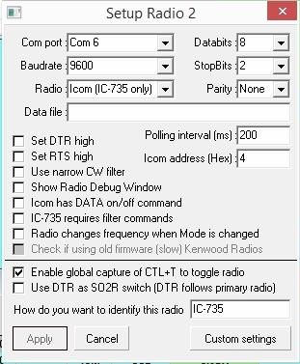

SRC\_1

**NOTE**:

* + Some radios change the [VFO](#VFO) frequency offset when the Mode is changed. This is a setup function of the radio and is normally done in order to keep the Receive and Transmit frequency at the same [RF](#RF) frequency when switching modes. The user can also setup the [CW](#CW) mode offset so the RF frequency will provide a desired CW audio tone when tuned to the transmitting station.
  + If you click on a DX Spot and your radio does not QSY to the exact frequency, try clicking the spot again. If the radio then goes to the correct frequency, you need to change your radio port setup.
  + In the Logger32 [Setup menu](#_topic_SetupMenu), select the [Setup | Radio | Radio 1(2) configuration](#5.0_RADIO_MENU_ITEM). Select the" Radio changes frequency when Mode is changed" check box and then the <**Apply**> button.
  + Your radio should now go to the correct DX spot frequency.

The first step is to select your radio from the Radio drop-down list. Currently supported transceivers are listed below. Detailed interface information for the radios underlined in green can be found in the Radios section of the Hardware Setup topic:

* + [Elecraft K2/K3/KX3](#_topic_ElecraftK2K3)
  + [ICOM (General)](#_topic_ICOMGeneral)
  + [ICOM IC-706](#_topic_ICOMIC706)
  + [ICOM (IC-735)](#_topic_ICOMIC735)
  + [ICOM (not IC-735)](#_topic_ICOMGeneral)
  + [ICOM IC-746](#_topic_ICOMIC746)
  + [JST-245](#_topic_JRCJST245)
  + [Kachina 505](#_topic_Kachina505)
  + [Kenwood (all models)](#_topic_KenwoodGeneral)
  + [Kenwood TS-440](#_topic_KenwoodTS440)
  + [Kenwood TS-570 TS TS-870 TS-2000](#_topic_KenwoodTS570TS60TS870andTS2000)
  + [Kenwood TS-50 TS-60 TS-850 TS-940 TS-950SD TS-950SDX](#_topic_KenwoodTS50TS60TS840TS940TS950SD)
  + [TEN-TEC Omni V VI and VI+](#_topic_TENTECOMNIVVIandVI)
  + [TEN-TEC](#_topic_TENTECOMNIVVIandVI) [Omni VII](#_topic_TENTECOMNIVII)
  + TEN-TEC Omni V.9
  + [TEN-TEC](#_topic_TENTECOMNIVVIandVI) [Orion](#_topic_TENTECORION)
  + [TEN-TEC](#_topic_TENTECOMNIVVIandVI) [Paragon 585](#_topic_TENTECParagon585)
  + [TEN-TEC](#_topic_TENTECOMNIVVIandVI) [Paragon](#_topic_TENTECParagonII)
  + TEN-TEC Pegasus
  + [YAESU FT-100](#_topic_YaesuGeneral)
  + [YAESU FT-450](#_topic_YaesuGeneral)
  + [YAESU FT-747](#_topic_YaesuGeneral)
  + [YAESU FT-757](#_topic_YaesuGeneral)
  + [YAESU FT-767](#_topic_YaesuGeneral)
  + [YAESU](#_topic_YaesuGeneral) [FT-817](#_topic_YaesuFT817)
  + [YAESU FT-840](#_topic_YaesuGeneral)
  + [YAESU FT-847](#_topic_YaesuGeneral)
  + [YAESU FT-857](#_topic_YaesuGeneral)
  + [YAESU FT-890](#_topic_YaesuGeneral)
  + [YAESU FT-897](#_topic_YaesuGeneral)
  + [YAESU FT-900](#_topic_YaesuGeneral)
  + [YAESU](#_topic_YaesuGeneral) [FT-920](#_topic_YaesuFT920)
  + [YAESU FT-950](#_topic_YaesuGeneral)
  + [YAESU FT-980](#_topic_YaesuGeneral)
  + [YAESU](#_topic_YaesuGeneral) [FT-990](#_topic_YaesuFT990)
  + [YAESU FT-9000](#_topic_YaesuGeneral)
  + [YAESU FT-1000D](#_topic_YaesuGeneral)
  + [YAESU](#_topic_YaesuGeneral) [FT-1000MP](#_topic_YaesuFT1000MP)
  + [YAESU FT-2000](#_topic_YaesuGeneral)
  + [YAESU](#_topic_YaesuGeneral) [FTDX-5000](#_topic_YaesuFTDX5000)

Accept the default values for the remaining serial port parameters or change them as required, according to the specific requirements of your radio.

There is an edit box with a prompt "How do you want to identify this radio". Enter the radio type or any short name to identify the radio. This identification will appear as an optional label for the spectrum display in the [Radio Control Panel](#_topic_RadioControlPanelRCP). This identification will assist you in readily identifying each radio in an [SO2R](#SO2R) setup.

Ensure that the radio is connected to the configured [COM](#COM) port and the port is opened from the Logger32 [Setup Menu](#_topic_SetupMenu) by selecingt the [Radio | Open port](#5.0_RADIO_MENU_ITEM) menu items.

**Note**: Logger32 supports the use of a [USB](#USB) to Serial adapter and multifunction [USB](#USB) Radio interfaces, such as the MicroHam, Winkeyer, RigExpert and RigBlaster. Some of these units have their own software/drivers to configure the unit. In order to set up the [CAT](#CAT) for the radio, the user must first determine the exact [COM](#COM) number to use for radio control. The [COM](#COM) number must be recognized in the Windows Device Manager before Logger32 can communicate with them. To determine the correct [COM](#COM) port to use in the radio control setup, go to the Windows "Control panel | System | Hardware" tab, select "Device Manager" and click on "Ports (COM & LPT)". You should see the interface device listed.

The default values of 9600 baud for the [COM](#COM) port and 1000 [ms](#ms) (1 second) for the Polling interval should be used as a starting point for your configuration. If your radio and computer can handle faster baud rates, you should select the highest baud rate that provides reliable operation with your specific hardware. Reducing the value of the Polling interval (increasing the rate of radio polling) will provide a faster and smoother display of all band, frequency and mode changes.

3.0 FILTER SETUP

If you have [CW](#CW) and [SSB](#SSB) narrow filters installed you can tell Logger32 which filters to use for DX spots. The filter selections will automatically be applied based on the frequency of DX spots and your settings in the BandMode table.

**Note**: Starting with Logger32 version 3.48.133, it is no longer necessary to edit the Logger32.ini file. This is now accomplished by editing a filter chart in the Setup Radio # dialog box ([SRC\_1](#SRC_1));

In the Setup Radio # dialog box, check the "Use Narrow Filters for CW" option;

Select the <**Custom settings**> button to open the Custom Settings for Radio dialog box.

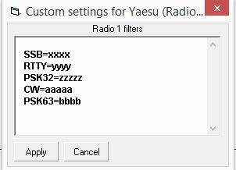

SRC\_2

Enter the desired data in the Radio 1 filters list boxt and select the <**Apply**> button.

* + CW Normal=xx
  + CW Narrow=xx
  + SSB Filter=xx

**Note**: xx equals the filter command number 01, 02 or 03. The above sample format is representative of ICOM radios. Most radios will respond to just the operating mode. CW=xx, SSB=xx, etc.

Previously the custom radio settings have been set to radio mode - example:

* + USB=xxxxx
  + LSB=yyyyy
  + CW=zzzz
  + RTTY=aaaa

The format has now been changed to be set to operating mode. Hopefully this provides the user with more flexibility - example:

* + SSB=xxxx
  + RTTY=yyyy
  + PSK32=zzzzz
  + CW=aaaaa
  + PSK63=bbbb

**Note**: The software defaults to filter 01 for CW normal and filter 02 for CW narrow. If the defaults are inadequate (the user wants to use filters other than the default), then the following section(s) need to be added to the filter setup char.

**Note**: If you have more than one CW filter, you need to consult your manual and experiment with the filter numbers. The SSB Filter line is only needed if your radio supports more than one SSB filter setting.

The following are some examples of the Radio filter setups.

#### 3.1 Elecraft K3 Filter Setup

K3 Data submodes : DT0 (DATA A), DT1 (AFSK A), DT2 (FSK D), DT3 (PSK D)

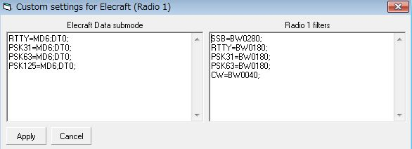

SRC\_3

#### 3.2 Kenwood TS-590 Filter Setup

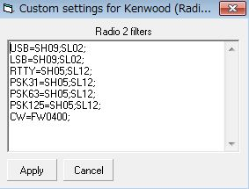

SRC\_4

Kenwood radios do not have a direct command to set IF band width except [CW](#CW) and [FSK](#FSK) mode. You must use SH (set high cut frequency) and SL (set low cut frequency) instead.

#### 3.3 ICOM Filter Setup

The following chart, from the [CI-V](#CI-V) specification, shows the relationship of the numbers to filter width:

Control Data                   IF Width

     01                         Width 1 (Wide)

     02                         Width 2 (Narrow)

     03                         Width 3 (More Narrow)

The following is the setup for the IC-7600

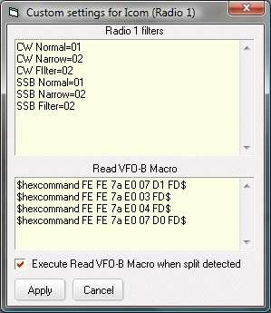

SRC\_5

#### 3.4 Yaesu FIlter Setup

The following is setup for the FT-920. This sample depicts the syntax for Yaesu radios using Hexadecimal [CAT](#CAT) commands.

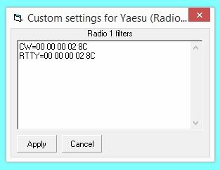

SRC\_6

Following is setup for the FT-9000. This example depicts the syntax for late model Yaesu radios using Kenwood style [CAT](#CAT) commands. Note: Each command must be terminated with a semi-colon.

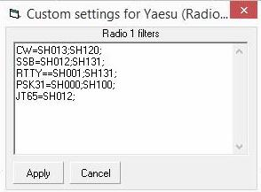

SRC\_6B

## 4.0 ICOM VFO-B display

Most Icom radios do not have a [CI-V](#CI-V) control code to interrogate VFO-B status. A Macro has been implemented to display and allow logging of the VFO-B Frequency and mode.

The macro is $Icom VFOB$

To personalize the Macro, in the Setup Radio # dialog box, select the <**Custom settings**> button.

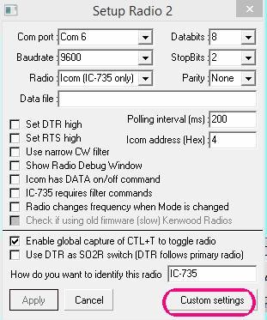

SRC\_7

This will open the Custom Settings for ICOM (Radio n) dialog box ([SRC\_5](#SRC_5)) where you can see four ICOMM commands. The xx represents the ICOM radio [CI-V](#CI-V) address. Overwrite the XX in each command with the specific Hex address of your ICOM radio.

The default [CI-V](#CI-V) commands shown initially are for the IC-7000. The [CI-V](#CI-V) commands should work with most late model ICOM radios. You will need to verify the actual command for the radio type in use.

They are in order:

* 1. Switch to VFO-B;
  2. Poll frequency;
  3. Poll Mode; and,
  4. Switch to VFO-A.

Setup the Macro with the correct [CI-V](#CI-V) address for the applicable radio.

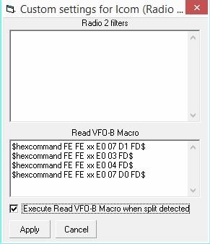

SRC\_8

Verify the [CI-V](#CI-V) commands are appropriate for your radio. To activate this function, select the "Execute read VFO-B Macro when split detected" check box  If you're lucky, your ICOM (if it is a more modern one) will read the VFO-B frequency/mode every time you put the radio in split.  Also, if you setup a Macro button on the [RCP](#_topic_RadioControlPanelRCP) with the $IcomVFOB$ Macro, you can update the VFO-B reading at will..

For automatic operation, the $IcomVFOB$ Macro should be added to the Split macros in the RCP. See the "Setup DX Spot macros" in the [Radio Control Panel](#_topic_RadioControlPanelRCP) topic for specific details to setup and use of the Macro.

*Created with the Personal Edition of HelpNDoc:* [*Write EPub books for the iPad*](http://www.helpndoc.com/create-epub-ebooks)

**Radio Control Panel (RCP)**

# Geoff Anderson G3NPA, Jim Hargrave W5IFP, Javier Bermejo EA1AUS and Aki Yoshida JA1NLX

## 1.0 GENERAL

The basic Radio Control Panel (RCP) is shown below. It consists of two parts, the upper panel to display either a waterfall or spectrum representation of the received audio, and the lower panel consists of 12, 24, 36 or 48

user definable Macro buttons for the control of the radio via the [CAT](#CAT) interface.

You should be able to control the RCP with function keys directly (on the RCP), from the [Logbook Entry window](#_topic_LogbookEntryWindow) (if the [CW Machine](#_topic_CWMachineWindow), [Sound Card Data window](#_topic_SoundCardDataWindow1), [Data Terminal](#_topic_DataTerminalWindow) and [DVK](#_topic_DigitalVoiceKeyerDVK) windows are closed), and if the global function key capture is enabled from any application anywhere on the screen.

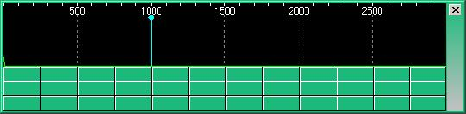

RCP\_1

By design there is no header line to the window but instead this appears to the right hand side of the buttons/spectrum display areas. Access to this window is obtained in one of two ways:

1. By using the Logger32 [Main menu](#_topic_MainMenu) [View | Show radio control panel](#4.0_VIEW_MENU_ITEM) menu items; or,

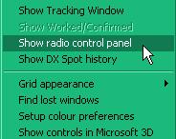

RCP\_2

1. or right-clicking on the [Radio panel](#3.4_Radio_Control_Status) on the [Lower Status bar](#3.0_LOWER_STATUS_BAR) and selecting the same option.

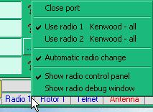

RCP\_3

## 2.0 MENUS

To obtain the set up menus associated with the Radio Control panel, right-click on the side bar.

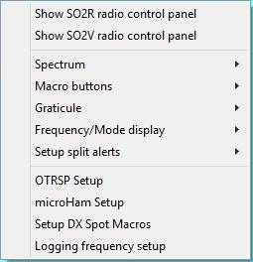

RCP\_4

### 2.1 Spectrum

Select the Spectrum | Setup spectrum audio menu items.

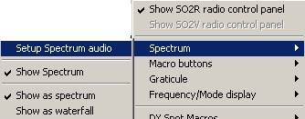

RCP\_4A

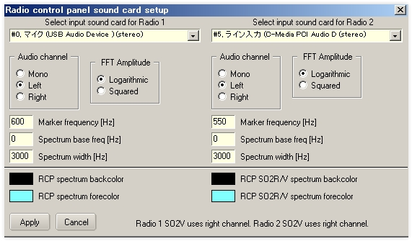

RCP\_5

On this set up panel the user can select the sound card to use for Radio 1 and Radio 2, the spectrum color options, the frequency marker position, the audio channel to use, the spectrum width (values between 500 -3000) and the FFT amplitude.

**Note**: If the user does not have a sound card installed, or does not desire to display the audio spectrum, uncheck the option: “Show audio spectrum when RCP opens”

The Spectrum base can be set from 0-399 Hz. This allows the display to be expanded starting at the Spectrum base frequency. The maximum allowable total spectrum width is 3000. In the above example the Spectrum base is set to 300, so the maximum width becomes 2700 (Base plus width).

Example: if the VFO is set to 14.100.0 Mhz, the frequency scale will display from 14.100.3 to 14.103.0.

**Show spectrum** (panel)

This option allows the user to show or hide the spectrum panel. If this option is unchecked just the Macro buttons will be displayed.

**Show as spectrum / waterfall**

The option selects either a spectrum or waterfall display.

### 2.2 Macro Buttons

Each Radio Control Panel has its own set of Macros. The user can select 0, 12, 24, 36 or 48 macro buttons for each of these panels.

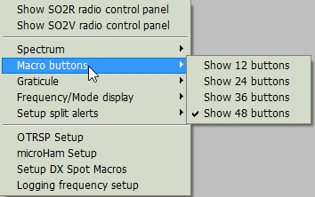

RCP\_5A

### 2.3 Graticule

Select between displaying the radio VFO or audio frequency.

### 2.4 DX Spot Macros

Select “Setup DX Spot Macros” from the main RCP Menu. See #dxspotsplit# function below for much more detaIL.

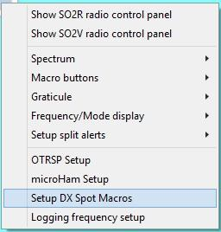

RCP\_6

### 2.5 Setup split alerts

The following options allow the user to setup Audible and Visual alerts when Split mode is enabled. It also allows for enabling automatic split mode options and Clear split Macro on QSY.

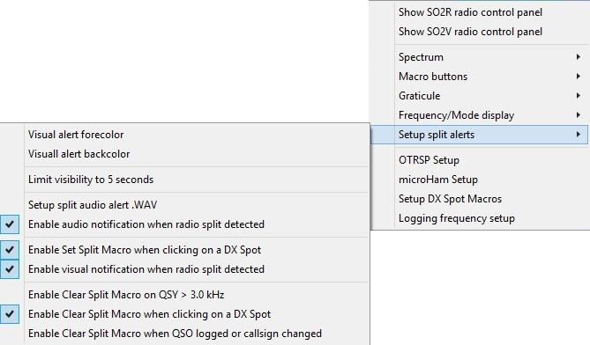

RCP\_6A

### 2.6 Logging frequency setup

This option provides the user with several logging options when operating in Split mode.

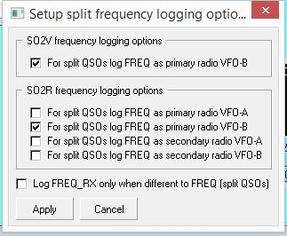

RCP\_6B

## 3.0 MACRO BUTTONS

Setting up these buttons is exactly the same as is described in the [Programmable Buttons](#_topic_ProgrammableButtons) topic.

**Note** however that the list of Macros designed for use in the [CW Machine](#_topic_CWMachineWindow) and the [Sound Card Data wiindow](#_topic_SoundCardDataWindow1) do not apply here except for those detailed below. The primary use of these buttons is for the control or parameter changing of the actual radio in use so the basic Macros of [$command$](#$command$) and [$hexcommand$](#$hexcommand$) are the main ones to use here.

There is a set of Macro buttons for each of the definable radios. This allows for the single radio user to employ up to 72 macro buttons by setting Radio 2 CAT parameters to the same as Radio 1 and using the <**Ctrl+T**> key combination to swap radios, providing a second set of 36 buttons.

## 4.0 MACROS AND FUNCTIONS IN THE RCP

### 4.1 Macros

The following Macros are available in the RCP.

|  |
| --- |
| **Macro** |
| [$clearlog$](#$clearlog$) |
| [$ClearCallsignOnQSYOn$](#$ClearCallsignOnQSYOn$) |
| [$ClearCallsignOnQSYOff$](#$ClearCallsignOnQSYOff$) |
| [$ClearQSYMarker$](#$ClearQSYMarker$) |
| [$command$](#$command$) |
| [$greeting$](#$greeting$) |
| [$hexcommand$](#$hexcommand$) |
| [$IcomVFOB$](#$IcomVFOB$) |
| [$logimmediate$](#$logimmediate$) |
| [$Mouse TF-Set$](#$mouseTF-Set$) |
| [$qsy(nn)nnn.(nn)$](#$qsy(nn)nnn.(nn)$) |
| [$radio1$](#$radio1$) |
| [$radio2$](#$radio2$) |
| [$Radio1Offset xxxxx$](#$Radio1Offset_xxxxx$) |
| [$Radio2Offset xxxxx$](#$Radio2Offset_xxxxx$) |
| [$radio1->radio2$](#$radio1->radio2$) |
| [$radio2->radio1$](#$radio2->radio1$) |
| [$SlavePortClose$](#$slaveportclose$) |
| [$SlavePortOpen$](#$slaveportopen$) |
| [$so2r$](#$so2r$) |
| [$so2v$](#$so2v$) |
| [$so2von$](#$so2von$) |
| [$so2voff$](#$so2voff$) |
| [$splitaudioalert$](#$splitaudioalert$) |
| [$splitvisualalerton$](#$splitvisualalerton$) |
| [$splitvisualalertoff$](#$splitvisualalertoff$) |
| [$TF-Set$](#$TF-Set$) |
| [$toggleradios$](#$toggleradios$) |
| [$uham xx$](#$uham_xx$) |
| [$wait x$](#$wait_x$) |

4.2 Functions

The following functions are available in the RCP:

|  |  |
| --- | --- |
| **Function** | **Description** |
| #call# |  |
| #dxspotsplit# |  |
| #greeting# | Send a greeting appropriate to the local time of the QSO partner. If Logger32 cannot determine the distant end time, then the default greeting will be sent. See the [Macros topic](#_topic_MACROS) for information on setting up the default greetings.  **Note**:: This function is only available for radios that accept CW keying information by CAT commands. Syntax would be something like:  $command BLAH #greeting# BLAH$$logimmediate$ |
| #keyboard# | This function, when imbedded in a Macro, will allow the user to increment the selected VFO by the amount keyed In via the keyboard. An example is  $hexcommand FE FE 04 E0 05 #keyboard# FD$ Increments IC-735 active VFO “n” kHz  The keyboard entry is nominally two digits and the number must be in whole kHz. Plus (up) is assumed, however you can increment it down by adding a <minus sign> preceding the number ( -5).  There is a fixed 5-second delay to allow keyboard action. However, if 2 digits (as in 05 or 10) are entered the execution is Immediate. |
| #mode# | When using any of the [#split#](##splitxxx#) type functions, it is important to make sure that the complete Macro sets the MODE of the VFOs to be the same.  **Note**: The #mode# function is a single digit function. Where the radio setmode is two digits, the user must configure the Macro to include the leading “0” or other digit as required.  An example is Yaesu FT-920 sets VFO-A with: 00, 01, 02 ,03 etc and VFO-B with: 80, 81, 82, 83.  A Macro to set VFO-B mode must have a leading “8”. The Macro would be like this:  $hexcommand 00 00 00 8#mode# 0C$  In most of the modern radios there is a simple CAT function that will do this called A>B which will set the freq and the modes to be the same. However in some of the more vintage radios there may not even be a button to do this or the button is there but there is no matching CAT command. The #mode# function can possibly help here for it can take the mode of the A VFO and make the information available to be pushed back into the B VFO.  In the case of the TS-850 for example one could use this function:  $command FR1;$ Swap to VFO B  $command MD#mode#;$ Make MODE same as VFO A  **Note**: When constructing a full Macro using this function you MUST swap VFOs before and after. |
| #modeModifier# | Sends a bandwidth command to the radio when a split command changes the operational mode.  Basic syntax is like the #split# function: $command xx xx #modeModifier# xx$.  See paragraph 6.3 for detailed use of this function. |
| #mycall# | Inserts the current "operator" value into the output text stream. Usually this would be a callsign.  **Note**: Only available for Radios that accept keying information when in CW mode. |
| #name# | Inserts the contents of the Name field currently displayed in the Logbook Entry window into the output text stream.  **Note**: Only available for Radios that accept keying information when in CW mode. |
| #sentrst# | Inserts the contents of the RST\_SENT field in the Logbook Entry window. If the field is empty, the #sentrst# modifier will default to to 599. |
| #splitxxx# | An additional feature in the Radio Control Panel (RCP) is a #split# function for use within these Macros (in the RCP only), The purpose of this function when embedded in a Macro string is to insert a frequency based on the current VFO frequency, and to format that frequency for the command and radio in use.  The basic syntax is #splitxx# xx is a frequency offset in KHz. For example, to shift the VFO frequency up 10KHz the syntax would be #split+10#. To shift the VFO down 5KHz, the syntax would be #split-5#. The frequency string that the function generates is formatted for a $command xxxx$ Macro specific to the radio in use.  The frequency string the function generates is in KHz regardless of the radio type. |
| #splitxxxh# | The“h” specifies the command in which the function is embedded. If the #split function is embedded in a $hexcommand xxxx$ Macro, the syntax is #splitxxxh# the frequency string that the function generates is in hex and is formatted for the particular radio in use, |
| #splitxxxq# | If the #split# function is embedded in a $qsy xxxx$ Macro.  The correct syntax is #splitxxxq#.  **Note**:- The #splitxx# function has been simplified and the #splitxxxq# and #splitxxxh# functions no longer require the "q" or the " h". It is not mandatory to rewrite these Macros, but it is no longer necessary to use the q or h modifier. .  If the #split# function is embedded in a $qsy xxxx$ Macro.  The correct syntax is #splitxxxq#. |
| #spleeetxxx# | As part of the ongoing multi-lingual efforts of Logger32, the #splitxxx# function has been expanded. #spleeetxxx# is now acceptable This variation can be used interchangeable with the above listed #splitxxx# commands. |
| #wait n# | Used in conjunction with $command ... $ Macro. The syntax is $command #wait n# xyz;$ or $hexcommand #wait n# xx yy zz$. Executing these commands will pause n seconds then execute the command xyz or hexcommand xx yy zz  Examples:  $command do this first;$  $command #wait xx# do this next after waiting xx seconds;$  $command #wait xx# do this last after waiting xx seconds;$  #wait5# or #wait 5# should both work. |

### 4.3 Examples of Simple Macros

Also see the topic [Direct Control of Radios](#_topic_DirectControlofRadios).

### 4.3.1 ICOM Macros

This is the Macro to change an ICOM VFO to 14123.456:

$hexcommand FE FE 74 E0 05 56 34 12 14 FD$. The red text is the frequency formatted in hex just like ICOM likes to see it.

Say that your ICOM is on 14001.234 and you want to QSY the VFO +10KHz, the Macro is:

$hexcommand FE FE 74 E0 05 #split+10h#FD$

The split function will read the VFO frequency from Logger32, add 10KHz to it, and convert it to hex in the required ICOM format. In this example, the output of the function is 34 12 01 14 this is then inserted into the Macro to replace the #split# function. The Macro now looks like this $hexcommand FE FE 74 E0 05 34 12 01 14 FD$ which will move the VFO to 14011.234 (up 10).

### 4.3.2 Radios that accept keying information when in CW mode

In addition to commands and functions effecting the frequency and radio selection control it is possible to use a limited number of functions when using CW for those radios that will accept keying information directly via the CAT interface.

These functions would be used something like:

$(hex)command TXON; SCW;#call# de #mycall# Hi #name# ur 599 ok bk;$

$(hex)command TXOFF;$

Where:

TXON is the command to put the radio in TX; and,

SCW is the command to send CW and TXOFF put the radio in RX.

#call# and #name# are replaced by entries in the Logbook Entry Window (if it is open) and #mycall# is replaced by the current operator.

An example for the K3/KX3 might be:-

$command KY #call# Hello #name#;$ or

$command KY 73 #mycall# \*;$

**Note** - these functions will only work with radios that will accept keying text via the CAT interface.

### 4.3.3 A set of simple Macros for the IC-7600 and IC-756 Pro III together with a suggested use in the RCP

|  |  |  |
| --- | --- | --- |
|  | **ICOM IC-7600 (hex address 7A)** | **ICOM IC-756 Pro III ( hex address 6E)** |
| **Mute** | $hexcommand FE FE 7A E0 14 01 00 FD$ | $hexcommand FE FE 6E E0 14 01 00 FD$ |
| **AF Volume 30** | $hexcommand FE FE 7A E0 14 01 30 FD$ | $hexcommand FE FE 6E E0 14 01 30 FD$ |
| **AF Volume 50** | $hexcommand FE FE 7A E0 14 01 50 FD$ | $hexcommand FE FE 6E E0 14 01 50 FD$ |
| **USB** | $hexcommand FE FE 7A E0 06 01 FD$ | $hexcommand FE FE 6E E0 06 01 FD$ |
| **LSB** | $hexcommand FE FE 7A E0 06 00 FD$ | $hexcommand FE FE 6E E0 06 00 FD$ |
| **RTTY** | $hexcommand FE FE 7A E0 06 04 FD$ | $hexcommand FE FE 6E E0 06 04 FD$ |
| **CW** | $hexcommand FE FE 7A E0 06 03 FD$ | $hexcommand FE FE 76E E0 06 03 FD$ |
| **Split On** | $hexcommand FE FE 7A E0 0F 01 FD$ | $hexcommand FE FE 6E E0 0F 01 FD$ |
| **Split Off** | $hexcommand FE FE 7A E0 0F 00 FD$ | $hexcommand FE FE 6E E0 0F 00 FD$ |
| **A=B** | $hexcommand FE FE 7A E0 07 B1 FD$ | $hexcommand FE FE 6E E0 07 B1 FD$ |
| **A/B** | $hexcommand FE FE 7A E0 07 B0 FD$ | $hexcommand FE FE 64 E0 07 B0 FD$ |
| **14.195 SSB** | $qsy 14195$ $hexcommand FE FE 7A E0 06 01 FD$ | $qsy 14195$ $hexcommand FE FE 6E E0 06 01 FD$ |
| **Split Up 5** | $qsy #split+05q#$ | $qsy #split+05q#$ |
| **Split Down 10** | $qsy #split-10q#$ | $qsy #split-10q#$ |
| **NB On** | $hexcommand FE FE 7A E0 16 22 01 FD$ | $hexcommand FE FE 6E E0 16 22 01 FD$ |
| **NB Off** | $hexcommand FE FE 7A E0 16 22 00 FD$ | $hexcommand FE FE 6E E0 16 22 00 FD$ |
| **Dual Watch On** | $hexcommand FE FE 7A E0 07 C1 FD$ | $hexcommand FE FE 6E E0 07 C1 FD$ |
| **Dual Watch Off** | $hexcommand FE FE 7A E0 07 C0 FD$ | $hexcommand FE FE 6E E0 07 C0 FD$ |

**Note**: If the function exists for the ICOM transceiver, note that the only difference in the hex command between all ICOM radios (not IC-735), is the third byte of the hexadecimal command, the default address hex for each ICOM radio.

**and the way EA1AUS uses these in the RCP is shown below**

**Icom IC7600**

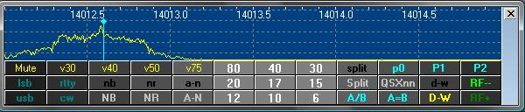

RCP\_7

**Icom IC-756 ProIII**

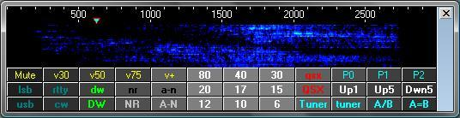

RCP\_8

### 4.4 Examples of Combined Macros

Set up a “split” operation based on the frequency in the A VFO

### 4.4.1. Kenwood TS-850

$command FB#split 05#;$

where (in this case) the 05 represents 5KHz offset. Note also the semi colon between the final # and $ characters

This will take the frequency from the "Active" VFO add the KHz offset and place the resultant in the B VFO.

**Note:** If the A VFO is "active" at the time and the Macro is repeated several times then the resultant in the B VFO store will remain the same. However IF the B VFO is active at the time then the B VFO will step up 5KHz for every application of the macro. This effect can be reversed if the command is changed from FB rather to FA

### 4.4.2. Yaesu FT-920

$hexcommand 00 00 00 01 01$ Sets FT-920 to Split mode

$hexcommand #spleeet+0h# 8A$ Sends FT-920 VFO-A freq to VFO-B (A>B)

$qsy#split+10#$ Increments FT-920 VFO-A by 10 kHz

$hexcommand #spleeet+10h# 0A$ Increments FT-920 VFO-A by 10 kHz (A+10)

$hexcommand #spleeet+10h# 8A$ Sends FT-920 VFO-A+10kHz to VFO-B (A+10 > B)

**Note**: When Logger32 polls The FT-920 for Frequency and Mode of VFO-A, it only reports the correct frequency and Mode if the radio is in VFO mode. If the radio is in MEM, M-TUNE or QMB, an error flag will pop up on the RCP spectrum and the bottom of the radio de-bug window. This flag advises the operator to turn off the MEM. M-TUNE or QMB as appropriate.

### 4.4.3. Yaesu FT1000mp

$hexcommand 00 00 00 00 85$ copy A VFO frequency and mode to B VFO

$hexcommand #split+5h#8A$ VFO A plus offset pushed into B VFO

$hexcommand 00 00 00 01 83$ turn ON dual mode receive

$hexcommand 00 00 00 01 01$ turn on split mode in ft1000mp

or combined

$hexcommand 00 00 00 00 85 #split+5h#8A 00 00 00 01 83 00 00 00 01 01$

### 4.4.4. Yaesu FT2000

$command FB#split 05#;$

This acts a little differently when applied to the FT2000. It takes the freq from the A VFO and increases the frequency by the offset and applies it to the B VFO

If the command is changed to read

$command FA#split 05#;$

Then it acts as the TS-850 and steps the A VFO up by the offset for each application of the Macro. So, a complete Macro to take a freq in the A VFO and make sure that the freq and mode for the QSX is correct will be:

$command AB;$ Copy A VFO to B VFO-To make frequencies and more importantly the MODES the same

$command FB#split 05#;$ Take A VFO freq add the offset and push to the B VFO

$command FT3;$ TX on the B VFO

$command FR2;$ Turn ON both the main and sub receivers

For the FT2000, exactly the same result can be obtained another way

$command AB;$ Copy A VFO to B VFO- To make frequencies and MODES the same.

$command EX033+05;$ Set the offset value in the menu settings for the QS function

$command QS;$ Select quick split option

$command FR2;$ Turn ON both the main and sub receivers

### 4.4.5 Elecraft K3

**Method 1** - Using the new #split# function :

$command K31;FT0;SWT13;FB#split+1#;SWH13;$

Where

K31: sets K3 mode

FT0: sets TX VFO to VFO A This always reset to VFO A before sending split command.

SWT13: transfers VFO A to VFO B (VFO A = VFO B)

FB#split+1#: sets VFO B +1KHz

SWH13: sets radio Split mode ON

**Method 2** - Using K3 commands:

$command K31;FT0;SWT13;FT1;UPB4;$

Where

K31: sets K3 mode

FT0: sets TX VFO to VFO A

SWT13: transfers VFO A to VFO B (VFO A = VFO B)

FT1: sets TX VFO to VFO B

UPB4: sets VFO B to up 1KHz (UPB5 = +2KHz, UPB6 = +3KHz, UPB7 = +5KHz)

### 4.4.6. ICOM IC-735

$hexcommand FE FE 04 E0 05 #split+10h#FD$ Increments IC-735 active VFO by

10 kHz

### 4.4.7. ICOM IC-7600

$hexcommand FE FE 7A E0 0F 01 FD$ Split ON

$hexcommand FE FE 7A E0 07 b1 FD$ VFO A=B

$hexcommand FE FE 7A E0 05 #split-10# FD$ Define fixed split 10 Kcs Down.

$hexcommand FE FE 7A E0 07 b0 FD$ VFO A/B

Example Setup Macros for split from keyboard:

$hexcommand FE FE 7A E0 0F 00 FD$ split off

$hexcommand FE FE 7A E0 07 b1 FD$ vfo A=B

$hexcommand FE FE 7A E0 0F 01 FD$ Split ON

$hexcommand FE FE 7A E0 05 #keyboard# FD$ Up/Dn(xx)

$hexcommand FE FE 7A E0 07 b0 FD$ VFO A/B

**Note**: The examples given above are known to function with the specified radios. However users will have to consult with their own radio operating or CAT manual for other models as the commands and parameter formats vary.

### 4.4.8 Kenwood TS-590

The following Macro will set the radio into split mode with QSX applied to VFO B.

$command VV;$ copy VFO A to VFO B (Freq and Mode)

$command FT1;$ Turm Split mode ON

$command #modeModifier#FB#DXSpotSplit#;$ Set VFO B Freq

Undo Split

$command FT0;$ Turn Split mode OFF

### 4.4.9.Kenwood TS-990

The following Macro will set the radio into split mode with QSX applied to the Sub Band.

$command VV;$ copy MAIN BAND to SUB BAND (Freq and Mode)

$command TB1;$ Turn Split mode ON

$command #modeModifier#FB#DXSpotSplit#;$ Set SUB BAND Freq

Undo split

$command TB0;$ Turn Split mode OFF

The following Macros can be configured for RCP F-Key.

**Up 1 split**

$command SP1;

$command SP001;

**Up 2 split**

$command SP1;

$command SP002;

### 4.4.10 ICOM 746 PRO

$hexcommand FE FE 66 E0 0F 00 FD$ split off

$hexcommand FE FE 66 E0 07 A0 FD$ VFO A=B my RxVFO is always A

$hexcommand FE FE 66 E0 07 01 FD$ select VFO B

$hexcommand FE FE 66 E0 0F 01 FD$ Split ON

$hexcommand FE FE 66 E0 05 #dxspotsplit# FD$ Set Split from spot

$hexcommand FE FE 66 E0 07 b0 FD$ VFO A/B

$icomVFOB$ read VFO B

## 5.0 ADDITIONAL INFORMATION

Some of the detailed examples above have comments to the right of each command. These can be left in the Macro without adversely effecting performance.

As part of the ongoing multi-lingual efforts of Logger32, the syntax of the #splitxx# function has been expanded. #spleeetxx# is now acceptable.

For those who might like to know, all the set up data for this window is held in the file called RadioPanel.ini found in the default Logger32 directory.

When checked, the RCP (and other windows that respond to function keys) should be responsive to F1 - F10 keystrokes from outside Logger32.

## 6.0 AUTOMATIC DX SPOT SPLIT OPERATIONS

### 6.1 #dxspotsplit# Function

This function is used to try and interpret any "split" details found in comment column of a dxspot clicked on and to apply that information, if possible by automatically applying user defined Macros in which this function is used.

**Note**: Once the Split function is setup, the user can click on a DX Spot containing a split designation and the split function will be active even when the Radio Control Panel is closed.

One of the main problems when trying to implement this is the non standard way in which operators actually report split operation so in some cases it will work and in other not so. Logger32 will assume that frequencies reported are in KHz. In some cases it will also recognise a freq offset range and will calculate the mid position in this offset and use this for the setting of the split vfo. There has been a lot of testing and using live traffic via the clusters and to date the function acts correctly on reports like:

|  |  |
| --- | --- |
| up 1 | up 5-10 |
| up 01 | up 10 |
| DN 01 | DOWN 01 |
| DOWN1 | QSX 21260.50 |
| SPLIT +5 | Tnx up up up 5 |
| 59 qsx 21285-21290 | qsx 21084.00 |
| up-2 | dn-2 |
| Tnx 4 nu band! Up 1.45 | PSE QSX 1810-1825 |
| LONGPATH UP 3-5 | qsx 7081 Alain |
| WRK CQ,CQ UP 7012.9 | RX 18.159.0 |
| QSX 14.033.35 | 59 qsx 21.285-21.290 |
| QSX UP 1.25KHZ 599 |  |

Logger32 attempts to determine the mid freq of a report which shows a QSX freq. For example "59 qsx 21285-21290" will use a freq of 21287.50. This may not function as expected IF there are additions characters ( like a space) between the two figures in the report. In these cases the first of the two QSX frequencies is used.

The reports below do not work:

|  |
| --- |
| LP up I (<-- this is a caps I not the fig 1) |
| tnx band #4 - up 107 LP |
| Up 111 |
| QSX 1.55 |
| QSX 111 |

and there are, no doubt, many others that will not work either.

### 6.2 "#DXSpotSplit#"

The syntax is exactly the same as #keyboard#. The difference being one derives the split from what you type, the other from comments (always very difficult to interpret) from a DX Spot you clicked on.

Two user defined Macros are used in this process, one to be used if a split is detected in the comments text and the other to restore the radio if there is no split defined. Each of these can be turned off individually if desired - See [RCP-6](#RCP_6) above

These Macros are entered into the Setup RCP macros for DX Spot clicks..window seen below.. [See also [para 2.4](#2.4_DX_Spot_Macros) above].

The left hand side of the table is for Radio 1 and the right for Radio 2. The upper sections are for the Macro(s) required to undo a split operation while the lower sections are what has to be applied to the radio to set up the split operation.

### 6.3 #modeModifier# function

The #modeModifier# function provides for radio filter selection based on the mode of operation. This object of #modemodifier# is not simply to change receive bandwidth, but also to do more creative things like different AGC for different modes, different transmit filter bandwidths for different modes, turning off speech processors for digital modes, reducing output power for PSK, disable the microphone and enable accessory audio input for digital modes. Use your imagination.

The function must be embedded in a Macro as shown in the DX Spot split command (setup window - center section). The actual Macro will vary based on the radio type and CAT/CI-V command structure. The actual command sent to the radio is selected based on the interpretation table listed in the bottom section of the setup chart as shown below. A comma must follow each entry in the table, including the last entry.

A typical Macro to set the bandwidth on a Yaesu radio would be:

**Macro**: $hexcommand 00 00 00 #modeModifier# 8C$

**Filter table**: SSB=01,CW=02,RTTY=03,PSK31=04,

A typical CI-V Macro for ICOM radios would be:

**Macro**: $hexcommand FE FE xx E0 06 #mode# #modeModifier# FD$. Where xx=radio CI-V address

**Filter table**: SSB=01, CW=03, RTTY=02,PSK31=02

**Note**: ICOM uses the Mode command to set the bandwidth. The #mode# function reads the operating mode listed in the Logbook Entry window and sends the mode and bandwidth information in a single radio command.

The following is an example of the split setup for Elecraft K3 and Kenwood TS-590. The individual setup will have distinctive commands based on the radio type and associated CAT/CI-V command structure. Some samples of known types are listed in the charts below.

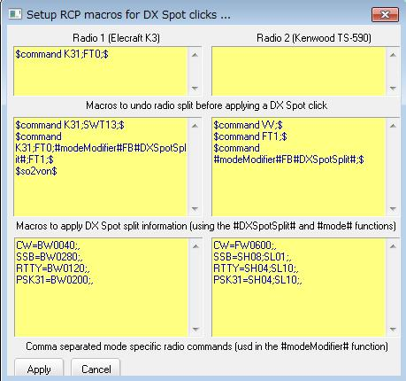

RCP\_9

**Note**: All of the Macros entered here will be radio dependent but some examples are given below as good starting points.

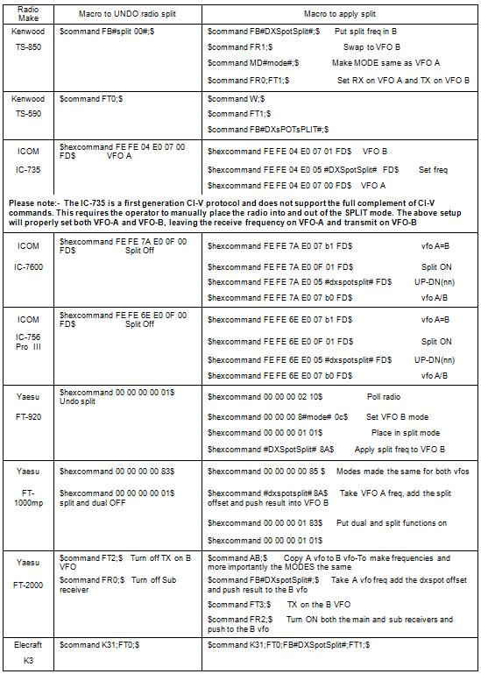

RCP\_10

6.4 $IcomVFOB$

To personalize the Macro, using the Logger32 [Main menu](#_topic_MainMenu) item, select [Setup | Radio | Radio x Configuration](#5.0_RADIO_MENU_ITEM) and then the <**Custom Settings**> button.

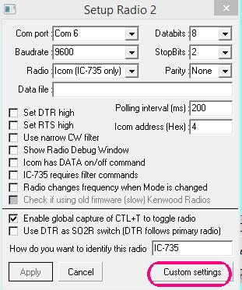

RCP\_26

This will open a setup widow where you can see four ICOM commands. The xx represents the ICOM radio CI-V address . overwrite the XX in each command with the specific Hex address of your ICOM radio.

The default CI-V commands shown initially are for the IC-7000. The CI-V commands should work with most late model ICOM radios. The user will need to verify the actual command for the radio type in use.

They are in order:

* 1. Switch to VFO-B
  2. Poll frequency
  3. Poll Mode
  4. Switch to VFO-A

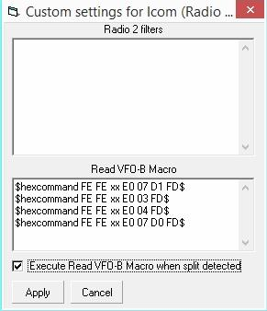

RCP\_27

Setup the Macro with correct address for your radio and if you like check the Execute Read VFO-B Macro when split detected check box. If you're lucky, your ICOM (if it is a more modern one) will read the VFO-B frequency/mode every time you put the radio in split. Also, if you setup a Macro button on the RCP with the $IcomVFOB$ Macro, you can update the VFO-B reading at will.

The following pictures show how to setup the split Macro these samples are for the IC-7600 commands.

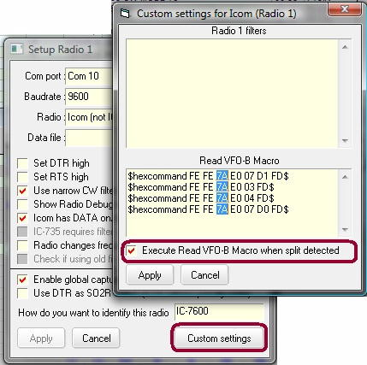

RCP\_28

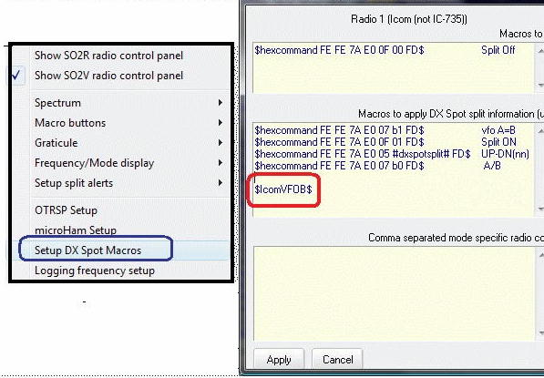

RCP\_29

**Note** that ICOM radios don’t have specific command for reading Frequency and Mode in sub VFO as other radios can do. This new ICOM Macro helps to read the frequency and mode, but can’t do a tracking of the frequency while in normal split operation we are changing the VFO-B frequency. It will be necessary occasionally refresh with the $IcomVFOB$ macro.

The following RCP panel shows Both VFOs during operation.

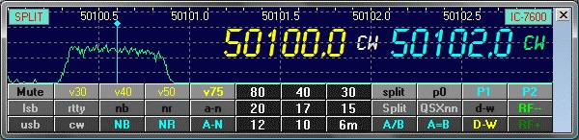

RCP\_30

## 7.0 ALERTS FOR SPLIT OPERATION

The user can enable visual and audio alerts when the radio has been placed in Split mode following a DX Spot selection that contains comments that meet the [qualifying Split syntax](#6.1__#dxspotsplit#_Function).

### 7.1 Visual Alert

To setup the Visual alert function, you have two choices.

**Note**: The user can select not only font forecolor and background color but font name, style and size. The Visual Alert Window size is automatically adjusted.

### 7.1.1 Setup in Radio Control Panel

Right click on side bar. Select “Setup split alerts” and then select “Visual alert font & color” or “Visual alert backcolor”.

The user can configure the text and background colors. The visual alert will continue to display until the split function is disabled. It can be limited to 5-second display by selecting the line “Limit visibility to 5 seconds”.

To enable the Visual alert function, select the line “Enable visual notification when radio split detected".

If the user wants to position Visual Alert Window anywhere then select the “Unlock Visual Alert from Logbook Entry Window” option and drag the window.

If the user wants to position the Visual Alert Window within the [Logbook Entry window](#_topic_LogbookEntryWindow) then deselect the “Unlock Visual Alert Window from Logbook Entry Window” option. The Visual Alert Window is always positioned at title bar of the Logbook Entry window.

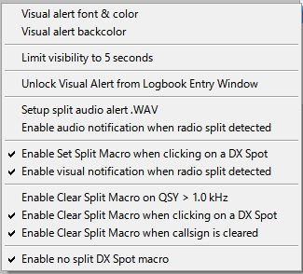

RCP\_11

When split visual alert has been initiated by selecting a DX Spot with the [qualifying Split syntax](#6.1__#dxspotsplit#_Function) in the comments, the [Logbook Entry window](#_topic_LogbookEntryWindow) will provide a visual indication.

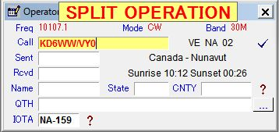

RCP\_12

### 7.1.2 Setup in Visual Alert Window

If the Visual Alert Window is visible then right click on this window.

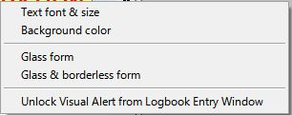

RCP\_12A

* + **Text font & size**: setup text font, forecolor and size
  + **Background color**: setup text background color
  + **Glass form**: set transparent form
  + **Glass & borderless form**: set transparent form without border line
  + **Unlock Visual Alert from Logbook Entry Window**: if this option is checked then the Visual Alert Window can be positioned anywhere.

### 7.2 Audio Alert

To setup the split Audio alert, open Setup and select “DX Spot Macros | Setup audio alert.wav”. This will open another pane where the audio wave file is selected.

To enable the audio alert click on the line “Enable audio notification when split macro executed”

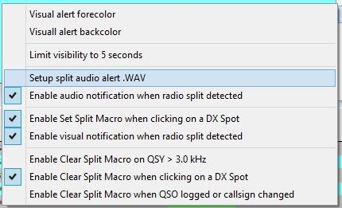

RCP\_13

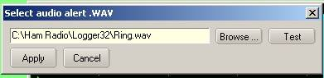

RCP\_14

### 7.3 Clear on QSY Option

When checked, the Logbook Entry window will clear, and if in "Split" mode, the radio will revert to Simplex operation.

## 8.0 SO2R AND SO2V OPERATION

The Radio Control Panel supports SO2R and SO2V operation much the same as the Sound Card. **Note:** For installation setup, see the topics [SO2R support](#_topic_SingleOperatorTwoRadiosSO2RSuppo) and [SO2V support](#_topic_SingleOperatorTwoVFOsSO2VSupport).

SO2V support is only available for radios with a second receiver.

To Select SO2R/SO2V operation right click on the right side of the Radio Control panel and select “Show SO2R radio control panel” or “Show SO2V radio control panel”

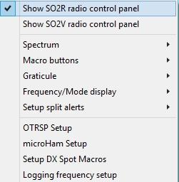

RCP\_15

This will open up a second Radio Control Panel.

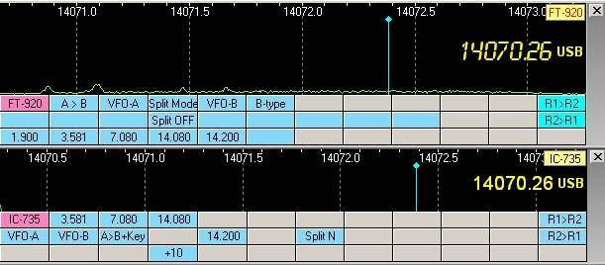

RCP\_16

In the above example, the VFO frequency and mode of the radio is displayed on the right side. This display is optional and the appearance can be adjusted for font, color, size and position.

The appearance of the Radio Control Panel can be enhanced by the use of special fonts. The upper pane above is a variation of an LCD display. The font is copyrighted, but is available as Freeware at: http://www.spinwardstars.com/scrfonts/.

The Radio type label shown in the upper right hand corner is user configurable. See the [Setup Radio Control](#_topic_SetupRadioControl) topic.

To configure the Frequency and mode, open: “Frequency/Mode display > Frequency/Mode appearance”. This will bring up a Frequency display setup chart

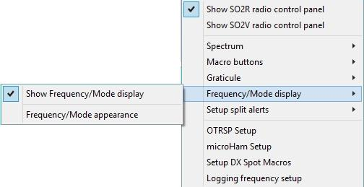

RCP\_17

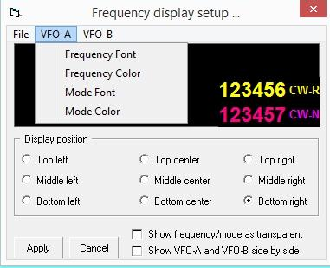

RCP\_18

### 8.3 OTRSP Setup

Users can now set up customized OTRSP commands that are automatically sent when the radio is switched with <**Ctrl+T**> or mouse click. The format follows that of OTRSP Macros - THIS|AND|THAT.

**Note**: See OTRSP hardware operation and setup.

To access the setup panel, select "OTRSP Setup" from the RCP Menu

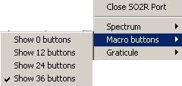

RCP\_19

This will open up the OTRSP Radio switching and keyboard commands dialog box where the radio specific macros can be configured.

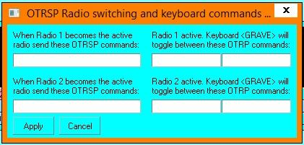

RCP\_20

As with Radio Control Panel DX Spot SPLIT/UNSPLIT Macros, this is a set once and forget setting. Once it is set up the way the user likes, the Radio Control Panel need not be open for the Macros to function.

### 8.4 Setup of DX Spot QSX Notices

Logger32 has a facility to automatically log split frequencies add QSX frequency to the “Comments” section of the DX Spots.

This capability is implemented for radios with dual receivers and some radios with independent VFO-A and VFO-B. The radio must have the CAT capability to reply to a simple poll and include Frequency and mode for both VFOs.

**Note**: Logger32 has a limitation of 100 Khz in split mode. If the QSX exceeds 100 KHz, it will be ignored.

However the QSO can be logged with greater splits such as cross band operation.

To configure the DX Spot <**Ctrl+D**>, from the Logger32 [Main menu](#_topic_MainMenu) select the [Setup | DX Spot](#11.0_DX_SPOT_MENU_ITEM) menu items and check the two bottom options.

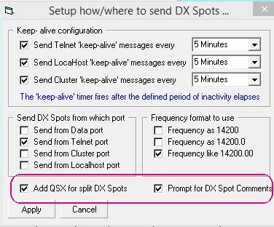

RCP\_21

### 8.5 Setup Split Frequency Logging

Open the RCP Menu and select “Logging Frequency Setup”. This will open pane where you select desired options.

**Note**: Logger32 will log both TX and RX frequencies. Too make both frequencies visible, you must add the ADIF field “FREQ\_RX” to the logbook grid.

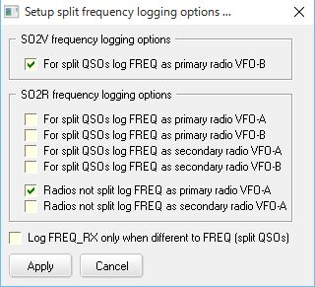

RCP\_22

### 8.6 Flags and Indicators

The following is a typical RCP window. It shows the frequency of VFO-A (yellow) and VFO-B.

VFO-B will only display if the radio poll reply includes VFO-B data. The appearance size, color and position of the Frequency and Mode are user selected.

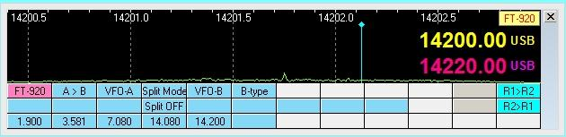

RCP\_23

The following shows that the radio is in split mode, as indicated in the upper left hand corner.

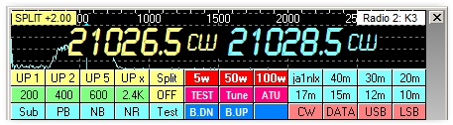

RCP\_24

It shows “SPLIT” + offset frequency differencial. You can change text color and back color for the Split/Radio label.

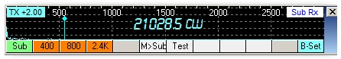

RCP\_24A

The following is an example of a SO2V setup. VFO-A is on the bottom (User preference) and VFO-B is on top. The radio is setup for split operation with transmit on VFO-B as indicated by the “TX” flag in the upper left hand corner. It shows “SPLIT” + offset frequency differencial. You can change text color and back color for the Split/Radio label..

This display also advises the user that the radio is in MEMORY mode and not in VFO mode. Some radios only return the VFO-A data in response of the Logger32 poll. If the radio is in MEM, M-Tune or a QMB channel, the frequency reported to Logger32 will be wrong. This notification is a blinking flag in the lower left corner of the spectrum display.

Currently this function applies to the Yaesu FT-920 and FT-1000. Others will be added as needed.

Radios react differently, leaving it up to the user to familiarize themselves with the operation of the radio in use.

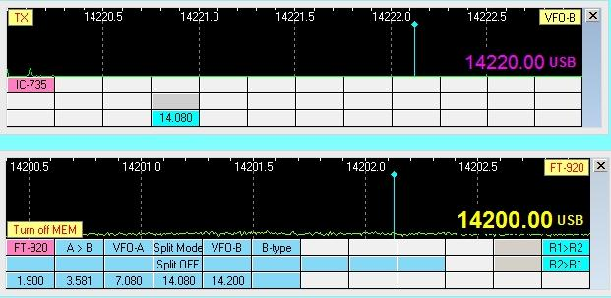

RCP\_25

*Created with the Personal Edition of HelpNDoc:* [*Create help files for the Qt Help Framework*](http://www.helpndoc.com/feature-tour/create-help-files-for-the-qt-help-framework)

**Radio Debug Window**

# Hew Lines VA7HU, Jim Hargrave W5IFP and Aki Yoshida JA1NLX

The Radio Debug window is provided as a tool to trouble shoot communications between Logger32 and the [CAT](#CAT) assisted radio. The following picture shows Radio Debug Window when user configures single radio. Radio #1 selected (upper) and Radio #2 selected (lower).

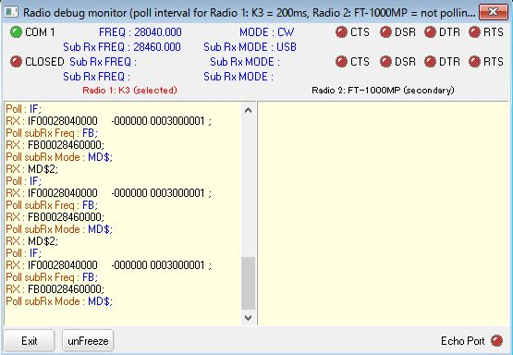

RDW\_1A

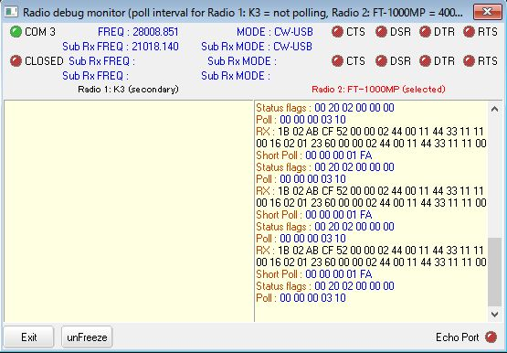

RDW\_1B

The Debug window will simultaneously display the communications status of Radio #1 and Radio #2 in an [SO2R](#_topic_SingleOperatorTwoRadiosSO2RSuppo) setup. It will also display communications status of the Radio main receiver and Sub receiver in an [SO2V](#_topic_SingleOperatorTwoVFOsSO2VSupport) setup.

The following paragraphs depict the operation of the De-Bug window in an SO2R setup.

The Radio Debug window can be opened two ways:

* 1. From the Logger32 [Setup Menu](#_topic_SetupMenu), selecting the [Radio | Show Radio debug window](#5.0_RADIO_MENU_ITEM) menu item.
  2. From the [Lower Status bar](#3.0_LOWER_STATUS_BAR), right-click on the [Radio panel](#3.4_Radio_Control_Status), (4th from the left) and select "Show radio debug window".

This window shows the actual communications between the radio CAT port and Logger32. The upper status section shows the COM port, Frequency, Radio Mode and status of the handshaking lines.

The SO2R line will only reflect data/status if the user has two radios connected and both com ports are open. This activity will be active when the Sound Card is open in either MMTTY or MMVARI and the SO2R child window is open.

The following picture displays communications between Logger32 and an Elecraft K3 as Radio #1 (Main) and the SO2R, Radio #2, which is a Yaesu FT-1000MP..

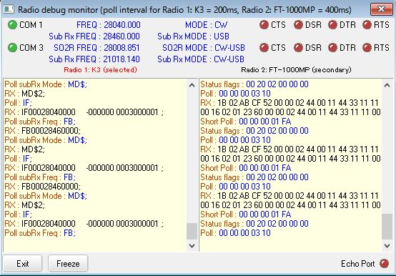

RDW\_1

This window monitors the serial link between Logger32 and the radio and displays:

The hardware status of the serial port using two LEDs to show the current state of the DSR and CTS hardware handshaking signals. If the LED is green then that line is active or at logging HIGH state. When the LED's are red, they are inactive or at logic LOW state.

* + Transmitted data from Logger to the radio - in blue
  + Received data from the radio - in black
  + the radio frequency and mode of operation.

### Tips:

If the user wants to copy text strings displayed in Radio Debug Window then follow these steps:

1) Click Freeze;

2) Select text strings. Selected text strings are copied on Windows clip board; and,

3) Paste anywhere.

This is an example:

RX : 1B 02 AB CF 52 00 00 02 44 00 11 44 33 11 11 00 16 02 01 23 60 00 00 02 44 00 11 44 33 11 11 00

Short Poll : 00 00 00 01 FA

*Created with the Personal Edition of HelpNDoc:* [*Easily create Help documents*](http://www.helpndoc.com/feature-tour)

**Direct Control of Radios**

# Geoff Anderson, G3NPA and Aki Yoshida JA1NLX

Additional information for this topic was provided by G0WZY, DF3IAL, W4JSI, G3VFP, KX2A, W7DPW, KD6AZN.

## 1.0 GENERAL

It is possible to use the [$command$](#$command$) and [$hexcommand$](#$hexcommand$) Macro commands to send any legal command to a radio under computer control. Each radio manufacturer has their own set of commands, and these are changed as radios change. This topic has instructions for Kenwood, Yaesu, ICOM, and Ten-Tec radios.

**Note**: Radio control is normally included in Macro scripts executed by the Macro buttons. If you write a string of commands to be activated by a single Macro button, every time you put a carriage return <**CR**> or a <**space**> within the Macro sequence the <**CR**> or <**space**> will go into the transmit text buffer. It will be sent on your next transmission. If this is annoying to you, simply concatenate the commands on a single line, with no space between sequential commands.

For specific information on how to set up Logger32 to operate PTT using direct commands, see [Configuring Push-to-Talk](#_topic_ConfiguringPushtoTalk) or the specific appendix for your radio.

Remember also that Logger32 has [$qsy$](#$qsy(nn)nnn.(nn)$) and [$qsx$](#$qsx%20/-nnnn$) Macros. These Macros do not require that you know any special codes. If you have the computer controlling your radio frequency, just click the Simplex/Split button on the Statusbar of the Sound Card Data window and Logger32 will change frequency as it switches to transmit.

## 2.0 DIRECT CONTROL OF KENWOOD RADIOS

The original material for this section was developed on the Kenwood TS-850. It was then found to be partly applicable to the Kenwood TS-570 and TS-870. The fundamentals described may give an insight to those owning other equipment on how to construct Macros in Logger32 to control their rigs.

Some of the suggestions will work with all Kenwood equipment having remote control interfaces. However, because of changes in filter switching and the introduction of DSP since the release of the TS-850, the selection of filters and effective receiver bandwidths and the associated command sequences will be slightly different.

The reader is left consult his/her radio's instruction manual and to experiment to achieve his/her own desired results.

Logger32 has two Macros for the direct control of transceivers using a remote interface: one for those rigs that require a string command and the other for hex commands. The format of the Macro is:

[$command$](#$command$) for strings

[$hexcommand$](#$hexcommand$) for hex values.

Both Macros allow for multiple commands. For example, filter selection and slope tuning can all be achieved using one instruction.

For Kenwood rigs, the [$command$](#$command$) string version is used.

In the case of the Kenwood rigs, the string to set various functions is composed of the following sequence:

· two alphabetical characters;

· various parameters; and,

· and a sem i-colon (;) terminator to indicate the end of the command.

For example, this command sets VFO A to 7.000 MHz:

**FA 00007000000**; where FA is the command, the numbers are the parameter, and the semicolon is the terminator.

The most useful commands for rig control in connection with Logger32 are filter selection and slope tuning or filter bandwidth settings. Naturally, there are many combinations of the above, so the reader is left to his/her own preferences, but some of the codes required to perform these functions are included here.

### 2.1 Applying Macro Control to Select a Filter and Initialize Slope Tuning

### 2.1.1 Codes for Filter Selection for the TS-850

The Kenwood TS-850 command for this function is FLaaabbb, where:

· FL is the filter command,

· aaa and bbb are the codes required for the 8.83 kHz. and 455 kHz. filters respectively.

The aaa/bbb codes are:

· 000 = No select

· 002 = FM wide

· 003 = FM Narrow

· 005 = AM

· 007 = SSB (2.7 kHz.)

· 009 = CW (500 Hz.)

· 010 = CW narrow (270 Hz.)

So the Logger32 macro to set up the filters for 2.7 kHz./2.7 kHz. (8.83/455) would be:

**$command FL007007;$**

For 500 Hz./500 Hz. the macro is:

**$command FL009009;$**

Macros for other filter combinations follow this pattern.

### 2.1.2 Codes for Filter Passband (Slope Tuning) for the TS-850, TS-870 and TS-570

The Kenwood TS-850 command for this function is SHaa; ( **Note**: this assumes you are using USB and is only really effective if the 500 or 270 Hz. filters are selected), where:

· SH is the command for Slope High,

· aa is the code for the tuning position, in the range 00 to 20.

The following codes set the nominal filter center frequency as noted:

· 00 = 1450 Hz.

· 01 = 1300 Hz.

· 02 = 1100 Hz.

· 03 = 950 Hz.

· 04 = 800 Hz.

· 05 = 600 Hz.

So for a passband centered on 950 Hz., the full macro would be:

**$command SH03;$**

Example Codes for the filter bandwidth adjustment for the TS-870 and TS-570:

**TS-870**

**$command FW0100;IS+1400$** Sets low to 1000 Hz. and high to 1400 Hz. for 400 Hz. filter width

**$command FW0030;IS+3400$** Sets low to 300 Hz. and high to 3400 Hz. for normal use

**TS-570**

**$command SH19;SL19;$** (Sets a 200 Hz. bandpass centered on 1 kHz.)

**$command SH00;SL00;$** (Sets a normal bandwidth)

### 2.1.3 VFO/Memory Channel Selection for All Kenwood Rigs

Selecting VFO or Memory Channel

The command to set the VFO or to select a memory channel is:

$command FRx;FTx;$ (**Note**: that is a semicolon between the two commands)

FRx is the receive VFO selection, and FTx is the transmit VFO selection, while x is:

· 0 for VFO A

· 1 for VFO B

· 2 for memory

To set receive as VFO A, transmit as VFO B:

**$command FR1;FT2;$**

**Note**: Be careful when using this command. The right-click function to move the receive/transmit frequency to the preferred audio frequency works only with the A VFO. The use of the line $command FR0;$ at the start of any [$align$](#$align$) macro will ensure that the A VFO is selected.

### 2.1.4 Specific Memory Channel Selection for All Kenwood Rigs

The Kenwood TS-850 command for memory channel selection is MC\_aa, where MC is the command and aa is the channel number. In this command string, a blank or an underscore is required between MC and the parameter aa. This command will only take effect if the memory channel has first been activated, as shown directly above. That is, you must set FRx or FTx to 2, so that there is something for the selected memory channel to do.

Here is the command to select memory channel 05 for transmit and receive:

**$command FT2;FR2;MC\_05;$**

**Combining Codes in a Macro**

The above two rig commands (filter selection and slope tuning), can be combined to perform a complex procedure with one set of commands. Here is an example (for a TS-850) to select an 8.83 MHz. filter for 500 Hz with a passband centered on 950 Hz:

**$command FL007009;SH03;$**

Here is how to select the 270Hz/8.83 filter with a passband centered on 950 Hz

**$command FL010007;SH03;$**

Here is a set of three macros that provide a range of choices:

If you choose to operate at aTX and RX audio setting of 950 Hz., here are three macros to control the rig filtering:

· 2.7 kHz. filter with no change in the passband control **$command FL007007;$**

· 500 Hz. filter with a passband centered at 950 Hz. **$command FL009007;SH03;$**

· 270 Hz. filter with a passband centered at 950 Hz. **$command FL010007;SH03;$**

### 2.1.5 Additional Kenwood Macros

This material is by Gil Baron. It is possible to extend control over many parameters in newer radios that now provide extensive computer control. The TS-870 is one such radio. It uses IF DSP filtering, rather than crystal or mechanical filtering.

Some amateurs have found it best to receive in CW mode and to transmit in USB mode. This might seem too complicated to use during a QSO, but you can implement these commands in Macros and all it means is that your "transmit" and "receive" buttons will be Macros instead of the transmit/receive pane in Logger32.

There is some preparation of your Kenwood radio for the following two commands:

· Set the menu item 24 to 1000 on your radio.

· Set RIT to +1.00 kHz.

· Set the preset audio frequencies in Logger32 to 1000.

Receive in CW mode (RXCW)

**$command MD3;RD1;FW0005;$**

This command script does the following three actions:

· Sets the radio to CW mode.

· Turns the RIT on.

· Sets the filter to 50 Hz.

Now follow or precede this sequence with a [$receive$](#$receive$) command and you have the receive in CW mode command. The developer of this Macro script calls it RXCW.

Transmit in USB mode (RTN USB)

**$command MD2;RT0;FW0030;IS+3400;$**

This command script does the following four actions:

· Sets radio to USB.

· Sets RIT off.

· Sets Bandpass filter lower to 300 Hz.

· Sets Bandpass filter upper to 3400 Hz.

Of course, you can select other modes and filters if you want. Just use these scripts but change the commands.

## 3.0 DIRECT CONTROL OF YAESU RADIOS

This detailed information is for the Yaesu FT-990, and the FT-1000MP, however the fundamentals described may give an insight to those owning other equipment on how to construct Macros in Logger32 to control their rigs. Some of the suggestions will work with all Yaesu equipment having remote control interfaces. However, because of slight changes between models, command sequences may be slightly different.The reader should consult his/her radio's instruction manual to understand the capabilities of these rigs and to experiment to achieve their own desired results.

Logger32 has two Macros for the direct control of transceivers using the remote interface: One Macro for those rigs that require a string command and the other for hex commands. The format of the macro is:

[$command$](#$command$) for strings and

[$hexcommand$](#$hexcommand$) for hex values.

Both Macros allow for multiple commands. For example, filter selection and mode selection can all be achieved using one instruction. For Yaesu rigs, the HEX version is required.

### 3.1 Applying Macro Control to Select a Filter

In the case of the Yaesu rigs, all commands sent from the computer to the transceiver consist of blocks of five bytes each. The last byte in each block is the instruction code, while the first four bytes of each block are arguments: either parameters for the instruction or dummy values. It should be noted that the block MUST be five bytes long, no matter how many bytes are actually required in the argument; unused bytes should be filled with dummy values. It is suggested that one uses Byte 00 as a dummy (although this is not essential, and the fill can be any hex value). No terminator is used.

For example:

00 00 00 01 0C will command the transceiver to switch to USB. 0C (zero C) represents the instruction code and 01 denotes USB. The remaining parameter bytes are filled with a dummy code of 00, because there is nothing else to tell the radio for this operation.

When constructing your own commands, it might be easier to create the code sequence from the right end (i.e., Instruction, parameter) and then REVERSE it when writing the Macro. In any event, take note that the least significant parameter digit (right side) should be first in the actual code.

The most useful commands for rig control in connection with Logger32 are filter selection, and slope tuning or filter bandwidth settings. Naturally, there are many combinations of the above, so the reader is left to his/her own preferences, but some of the codes required to perform these functions are included here.

### 3.1.1 Codes for Filter Selection for the FT-990

The Yaesu FT-990 instruction code for this function is 8C, and it uses a single parameter code for the desired filtering:

00 = 2.4 kHz.

01 = 2.0 kHz.

02 = 500 Hz.

03 = 250 Hz.

The complete macro to select the 250 Hz. filter would be

**$hexcommand 00 00 00 03 8C$**

or, to select the 2.4 kHz filter

**$hexcommand 00 00 00 00 8C$**

### 3.1.2 Macros for other filters follow this pattern.

If you send a command sequence to select a filter that is not actually installed in the radio, that sequence is ignored.

### 3.1.3 Codes for Filter Selection for the FT-1000MP

In the case of the FT-1000MP, there are two IF filters that can be controlled, one at 8.215 MHz. and the other at 455 kHz. Here are some examples for filter selection for the FT-1000:

**$hexcommand 02 00 00 03 8C$** Sets the 455 kHz. filter to 250 Hz.

**$hexcommand 01 00 00 03 8C$** Sets the 8.215 MHz. filter to 250 Hz.

**$hexcommand 02 00 00 02 8C$** Sets the 455 kHz filter to 500 Hz.

**$hexcommand 01 00 00 02 8C$** Sets the 8.215 MHz filter to 500 Hz.

**$hexcommand 02 00 00 00 8C$** Sets the 455 Khz filter to 2.4 kHz.

**$hexcommand 01 00 00 00 8C$** Sets the 8.215 KHz filter to 2.4 kHz

Both the FT-990 and the FT-1000MP have IF-shift controls to move the passband center frequency when the narrow IF filters are selected, but there are no control codes to perform this function. With the IF shift control in its central position, the nominal passband is centered on 1 kHz. in the USB mode and 2 kHz. in the Packet mode. In the FT-1000MP, there are control codes for the setting the EDSP, with which the user can experiment. For those who like to experiment, some examples are given below.

### 3.1.4 HP Filter (USB mode)

The upper frequency of the filter remains fixed on 2300 Hz. but the lower frequency may be changed to reduce the bandwidth as follows:

**$hexcommand 00 00 50 42 75$** produces a filter with the range 1500-2300 Hz.

**$hexcommand 00 00 60 42 75$** produces a filter with the range 1800-2300 Hz.

**$hexcommand 00 00 67 42 75$** produces a filter with the range 2050-2300 Hz.

### 3.1.5 LP Filter (USB mode)

In this case the lower frequency of the filter remains fixed on 2 khz and the upper frequency may be changed to reduce the bandwidth as follows:

**$hexcommand 00 00 90 41 75$** produces a filter with the range 2000-2700 Hz.

**$hexcommand 00 00 80 41 75$** produces a filter with the range 2000-2500 Hz.

**$hexcommand 00 00 70 41 75$** produces a filter with the range 2000-2250 Hz.

**$hexcommand 00 00 00 40 75$** will switch the EDSP off

These Macros have no effect if Packet mode is used on the FT1000MP.

### 3.1.6 Combining Codes in a Macro

Control codes can be combined to perform a complex procedure in one Macro in one of two ways. Either each command is placed on a separate line, or they can be combined on one line as shown below. Both examples set USB with the 2.4 kHz filter

**$hexcommand 00 00 00 01 OC$** - sets USB

**$hexcommand 00 00 00 00 8C$** - sets the 2.4 kHz. filter

Or combined

**$hexcommand 00 00 00 01 0C 00 00 00 00 8C$**

**Note**: It has been found that for the FT990 only two commands can be put in one line, but for the FT-1000MP this increases to three.

## 4.0 DIRECT CONTROL OF TEN-TEC OMNI VI TRANSCEIVERS

It is possible to use the [$hexcommand$](#$hexcommand$) and [$qsy$](#$qsy(nn)nnn.(nn)$) commands to set modes and frequencies in ICOM radios that are in communication with Logger32. Read the above sections for general information on what to do and what to expect. This section contains information specific to some ICOM radios. The Ten-Tec Omni VI and VI+ use the same syntax. For the full syntax of these commands, consult the radio user's manual. There may be commands that work for one radio and not another, but the format is the same.

ICOM radios do not have a transmit/receive command, but the Ten-Tec Omni VI does. Therefore, you cannot transceive via radio command with an ICOM radio, you must use another form of T/Rcontrol. See the topic [Configuring Push-to-Talk](#_topic_ConfiguringPushtoTalk) (PTT).

### 4.1 Default Address

ICOM radios do not share a single universal default address, and the correct one must be set in the Logger32 setup for the radio used. You will find this information in the instruction manual for your radio, or you can review your radio menu and find the value in the radio. For example, the IC-706MKII uses 4E, the IC-735 uses 04, the IC-761 uses 1E. See the topic, [Interfacing a Radio for PC Control](#_topic_InterfacingaRadioforPCControl) for information. The Omni-VI address is 04 by default, but it can be changed in the radio.

### 4.2 Setting a Frequency

The following example commands use a default address of 4E (IC-706MKII).

### 4.2.1 Set LSB on 80 Meters

Put the following in a Macro button and execute the Macro. **Note**: The commands are hexadecimal numbers, so 0 is zero, not the letter O.

**$hexcommand FE FE 4E E0 06 00 FD$**

Set LSB, do not select a filter, use the one currently selected

**$qsy3581.50$**

Change radio frequency to 3581.5 kHz.

Set USB on 20 meters

**$qsy14069.50$**

Change radio frequency to 14069.50 kHz.

**$hexcommand FE FE 4E E0 06 01 01 FD$**

Set USB with a wide filter

The order of the qsy and hex commands is not important.

### 4.3 Some Filter Selection Commands

USB wide: **$hexcommand FE FE 4E E0 06 01 01 FD$**

USB narrow: **$hexcommand FE FE 4E E0 06 01 02 FD$**

LSB wide: **$hexcommand FE FE 4E E0 06 00 01 FD$**

LSB narrow:  **$hexcommand FE FE 4E E0 06 00 02 FD$**

FSK: **$hexcommand FE FE 4E E0 06 04 FD$**

FSK narrow: **$hexcommand FE FE 4E E0 06 04 02 FD$**

### 4.4 Ten Tec Omni VI commands

Here is a similar example for the Omni VI:

LSB, 0.5 kHz. 6.3 IF filter **$hexcommand FE FE 04 E0 06 00 04 FD$**

The Omni VI manual documents the mode, but not the filter codes. Here is what you need to know:

Each command begins with $hexcommand FE FE 04 E0 (assuming you left the radio address at the default address)

* + Right after E0, 06 means set mode/filter.
  + Next, 00 means LSB, 01 means USB.
  + Next 02=2.4, 03=1.8, 04=.05, 05=.25, all are 6.3 MHz. IF filter positions.
  + If you set the last value to 06 this toggles the narrow (9 MHz.) filter, meaning if it is off, it will go on, and if it is on, it will go off (we did not invent the code, we just report it).

Here are some of the useful Omni VI commands:

LSB mode **$hexcommand FE FE 04 E0 06 00 FD$**

USB mode **$hexcommand FE FE 04 E0 06 01 FD$**

FSK mode **$hexcommand FE FE 04 E0 06 04 FD$**  If you use FSK rather than AFSK.

Each of these can be combined with filter selection codes. In fact, to set the filter, you must specify a mode in the command. The following all specify LSB.

LSB, 2.4 kHz. **$hexcommand FE FE 04 E0 06 00 02 FD$**

LSB, 1.8 kHz. **$hexcommand FE FE 04 E0 06 00 03 FD$**

LSB, 0.5 kHz. **$hexcommand FE FE 04 E0 06 00 04 FD$**

LSB, Narrow **$hexcommand FE FE 04 E0 06 00 06 FD$** Toggles the narrow 9 MHz. IF filter on and off.

For an Omni VI+, with two narrow filters:

LSB, Narrow 2 **$hexcommand FE FE 04 E0 06 00 07 FD$** Toggles the second narrow 9 MHz. filter.

Remember, the [$qsx$](#$qsx%20/-nnnn$) command works in all modes, USB, LSB, and FSK, so there is no need to call up special tricks to operate split.

## 5.0 DIRECT CONTROL OF ELECRAFT TRANSCEIVERS

### 5.1 Basic Macros

For Elecraft rigs, the [$command$](#$command$) string version is used. In the case of the Elecraft rigs, the string to set various functions is composed of the following sequence:

* + two alphabetical characters;
  + various parameters; and,
  + and a semi-colon (;) terminator to indicate the end of the command.

For example, this command sets VFO A to 7.000 MHz:

$command FA 00007000000;$ where FA is the command, the numbers are the parameter, and the semicolon is the terminator.

### 5.2 Special Macros for K3 Sub RX

In the case of K3, the string to set various functions is composed of the following sequence:

* + two alphabetical characters with additional “$”;
  + various parameters; and,
  + and a semi-colon (;) terminator to indicate the end of the command.

For example, this command sets Sub RX IF Band Width 200Hz

$command BW<24>0020;$ where BW is the command, the numbers are the parameter, and the semicolon is the terminator.<24> is HEX code for “$”

See more samples in [Elecraft K2 K3 section](#_topic_ElecraftK2K3).

*Created with the Personal Edition of HelpNDoc:* [*Create help files for the Qt Help Framework*](http://www.helpndoc.com/feature-tour/create-help-files-for-the-qt-help-framework)

**Interfacing a Radio to the PC Sound Card**

# Jim Hargrave W5IFP and Scott Thile, K4SET

## 1.0 GENERAL

There are two things you must do to interface the radio to the PC Sound Card:

* + Get audio from the radio to the computer so Logger32 can decode received signals; and,
  + Get audio from the computer to the radio so you can transmit a PSK or RTTY signal.

All other interfacing (PTT, radio control, interaction with Logger32) is covered elsewhere in this Helpfile. Depending on your station configuration and operating preferences, you may want to refine this setup. For instance, you may want to buy a commercial interface that takes care of some of the connections that will be explained in this topic. Check these additional resources on the WWW. A quick search on Google using "interfacing a sound card to a radio" produced over 1,300,000 hits!

See Help Topic [System Requirements](#_topic_SystemRequirements) for information on what is needed within your PC to allow operation of the software, and see [Interfacing A Radio for PC Control](#_topic_InterfacingaRadioforPCControl) for information on connecting your radio to use Logger32's PC control features.

**Note**: It is VERY important that you have installed the latest Microsoft patches and upgrades to your version of Windows. Go to: <www.microsoft.com/downloads/search.asp>

## 2.0 INTERFACES

### 2.1 Receive Interface

To receive and decode digital mode signals, connect the receive audio to either the PC sound card Line In or Mic In port. The simplest way to do this is to use three-conductor shielded audio cable between the receiver's headphone jack (usually a 1/4" PHONO Jack) and the sound card's Line or Mic In jack (most often a 3.5mm stereo "mini-phone" jack). The sound card's Line In jack is a better choice than the Mic in jack, because the Line input is harder to overload, but either should work. Some sound cards only have a Mic In jack. You must adjust the Windows Recording Volume for the correct input levels, as described below.

It is also possible to purchase a commercial interface that will tailor the input and output sound card audio to your radio.

Here is a receive audio cable using a pre-made (Radio Shack) 3.5mm to 3.5mm stereo audio cable and a 3.5mm to 1/4" stereo adapter for the transceiver side.

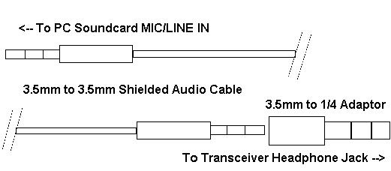

IRPCS\_1

In some setups, with the headphone plug part of the way in, you can monitor transceiver audio through the radio speaker while sending the audio to the sound card. This is a great aid in tuning signals by ear while monitoring them on Logger32's tuning display.

With this simple cable (no soldering required) you're ready to try to receive digital mode signals with Logger32.

### 2.2 Set Receive Audio Levels

It is important to adjust your sound input and output levels. This is done with the Volume and Recording controls in Windows 2000, 98, 95 and NT, and XP. Logger32 enables you to get to these controls from within the program. Let's look at a warning feature provided by Logger32.

Some sound cards do not overdrive easily, and others do. Some cards may have an AGC or some other limiting system. The popular Creative Labs (copyright) cards overdrive if the level is set too high.

Click on "Settings|Sound Card input level", like this:

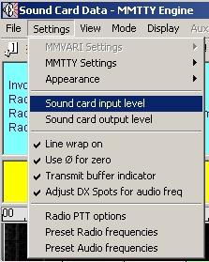

IRPCS\_2

This brings up the Recording mixing console. Note: In Windows 95 this feature brings up the Volume Mixer. From the Volume Mixer click on Options, then Properties, then select the recording radio button. Make sure the input(s) you are using (Mic or Line) are selected in the check boxes, and then click OK. This will bring up the Recording mixer window.

For the next adjustments, arrange your Logger32 window and your Recording Mixer Window so that you can easily see both windows and switch between the two. Set your transceiver's audio (listening) volume to a comfortable listening level. You should be able to see both windows like this.

Depending on your setup, adjust the Mic or Line level input controls and the overall recording level (far left slider). The best way to set these levels is to tune in digital mode activity with your transceiver, and then click on the area of the strongest activity as shown in the spectrum display (lower segment of Logger32's main operating window) to direct Logger32's attention to that QSO.

Start by setting the overall recording volume in the center of its adjustment range. Adjust the input level on the Mic or Line input until you can clearly see the signals on the spectrum display, but they do not turn the display red. Signals will not reach the top of the spectrum display if they are adjusted properly.

Overdriving these inputs will severely degrade your copy. Adjust for the minimum record levels, while still providing a good display in Logger32. It may be necessary to reduce the overall recording level as well as the Mic or Line inputs to achieve this. It may also be necessary to attenuate the signal between the transceiver and sound card, especially if you're using the Mic input of your sound card.

If you don't see any receive activity on Logger32's displays, make sure that your Mic or Line input control is not muted ("Mute" is a check box next to the slider in your record mixer) and also double-check all connections. It is possible to overdrive the sound card, and may need to attenuate the input signal. It is also possible that the sound card is incompatible with Logger32. Some hams have found that sound cards built into the motherboard do not work. The only solution to this problem is to disable the on-board sound card in Windows' Settings, Configuration, System menu, and install a separate sound card.

After these receive adjustments are made, try to copy some QSOs by tuning them in using Logger32's tuning indicator(s) as shown above and described in Tuning Display and Controls, in the topic on Communicating with PSK31 and PSK63.

### 2.3 Transmit Interface

To transmit digital signals, you need to connect the sound card output (often through an isolation transformer, or 100:1 attenuator) to the transmitter microphone or AFSK input. The following picture shows a direct connection, but many transceivers and sound cards will need the voltage divider shown later in this section. However, please check the instructions for your rig. Some radios have a divider in the rear audio input, but do not have it at the microphone connector. If you connect to the rear input, you do not need the external divider. One radio that does have such a divider is the Kenwood TS-680.

NOTE: Make sure that you do not use speech processing in the radio. Any type of speech processing will distort the audio, and this distortion hurts digital signals more than speech signals.

Overdriving your transmitter audio stage in PSK31 creates big IMD problems, and is a major cause of interference in this mode. It is very important to get this right. Be sure to check in your first QSOs to make sure that you do not have a high IMD. Many PSK programs, like Logger32, read this value out on received signals. You must give the other station about five seconds of idle signal for them to get a stable IMD reading.

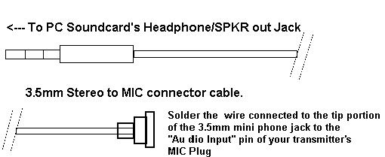

IRPCS\_3

With the above interface connected, and your transceiver's antenna jack connected to a dummy load, set the audio output level of your PC sound card to match your transceiver's input circuit.

### 2.4 Voltage Divider Output Connection

In most cases the sound card provides too much drive for the radio's audio stage. Even by setting the computer mixer output control to its lowest level, you may still have a high IMD value. You are actually overdriving your radio's microphone input stage before the Mic gain control, so no matter how low you set the Mic gain, you are already distorting. It is strongly recommended that you use a voltage divider to reduce your sound card output. You can make or purchase add-on hardware designed for PSK and other digital modes that includes this circuitry.

Here is a voltage divider. If you want greater control, you can replace the series resistor with a potentiometer:

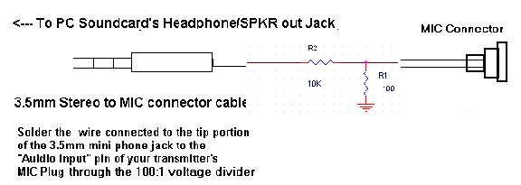

IRPCS\_4

Again, it is extremely important to match your sound input and output levels. To set the output level we bring up the Windows Volume control just like we did with the Recording Control panel before, only this time we select ToolBox, then Sound card output level. This brings up the Volume Control mixer.

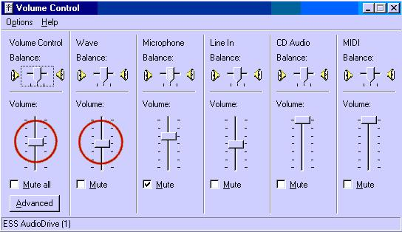

IRPCS\_5

### 2.5 Set Transmit Level

These audio output adjustments are best made with your transceiver connected to a dummy load. Set your transceiver Mic gain control slightly above its minimum setting and make sure your rig's VU meter (or modulation indicator) is set to monitor ALC. Some rigs do not have such a meter, and use only a light. Your VOX settings (if you're using VOX) should be adjusted as you normally have it for other modes, and it should be engaged. If you're not yet using VOX or PTT (more info on that in Configuring Push-to-Talk), you can make these adjustments by manually engaging transmit on the rig at the same time that you tell Logger32 to transmit.

### 2.6 Prepare to Adjust the PC

Again, make Logger32 active in one window and the Volume Control mixer in a second window, as you did for the recording (receive) settings. Click on Tool Box, Sound Card output level. For now, slide the Windows Volume Control to a minimum (all the way down), and the Wave slider at just slightly above the minimum setting.

Click on the small blue Receive indicator in the pane in the middle part of the Statusbar. Receive (blue) changes to Transmit (red), and Logger32 transmits a single tone in the Tune mode. To return to receive mode simply left-click the same pane again, which now says Transmit. You can also toggle between transmit and receive by pressing the Pause/Break key on your keyboard.

Don't lose track of how long you are transmitting. Long transmissions can overheat your finals.

Here is what this setup should look like with both windows visible:

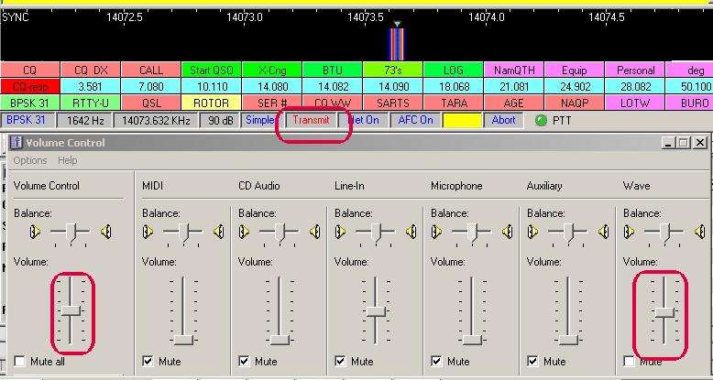

IRPCS\_6

### 2.7 Adjust Rig Audio and VOX

There is a lot of interaction between the VOX level setting and the audio setting.

Slowly raise the Volume control on the mixer until the rig's VOX circuit engages and the radio starts transmitting. If VOX has not engaged by the time the Volume control is midway up the slider scale, then raise the rig's Mic gain slightly and try again. Watch the rig's ALC indicator. You want a minimum reading here, indicating that there is just enough audio to drive the rig, but not so much that you run the risk of overdriving the Mic input. Overdriving the Mic input circuit is a common cause of distorted and wide signals when using this type of sound card set up. In fact, any operation of the rig's ALC means that it is distorting your transmitted signal. PSK31 is especially sensitive to these settings, but all the digital modes will suffer. Voice signals are not as distorted by the action of ALC.

If VOX does not seem to operate at low enough audio levels, you may want to set the levels by manually putting your rig into transmit, then setting the levels to optimize your audio signal (again you should just see your ALC indicator moving). After this, reset your VOX circuit to trip at that level of input. If you normally use VOX, then the voice setting should be OK, but if you have not set your VOX level; you may have to do so. You can do this by manually putting your rig into transmit, adjusting the transmit level for the above no-ALC level, and then adjusting your VOX gain so the rig goes into transmit when you send it a tone.

If your radio does not return to receive, but keeps cycling between receive and transmit when you use VOX, then another input is operating the VOX circuit. Go back to the Volume control mixer, bring up all the controls, and mute every one. Now, uncheck the one(s) you need to output a tone, and the one you need to get a display on the Logger32 screen. Leave all the others muted or turned all the way down. Remember, you can hear the output tone in your speakers.

The optimal setting when using the above interface will usually set your sound card output (Volume and Wave Control settings) very low, and your radio's Mic gain control is at a little lower than normal for SSB operations. If you are unable to control the audio using these controls at reasonable levels, you very likely need to add attenuation between the sound card output and the rig's Mic input. You can also try using a direct audio input on your accessory jack or rear panel (if your rig is so equipped). This may avoid your Mic pre-amp circuit and be a better choice for signal matching, however this may also make it impossible to use your VOX circuit for engaging your transmit and receive modes. Some radios do not connect VOX to the rear input.

Once you've optimized these settings, make a note of the positions of your rig controls as well as the Windows Volume and Recording mixer positions. You may make changes for other software and operating modes, and this makes it easier to reset things for Logger32.

There is an additional adjustment that you can make to tell Logger32 the actual value of the sound card clock. This adjustment holds only for the RTTY mode. See the topic [Calibrating the Sound Card](#_topic_CallibratingtheSoundCard).

Note: Some commercial interface units get their power from the computer via DTR, DSR, or RTS lines. Logger32 may not work properly with this type of interface. You must modify the interface so that it gets power directly from the radio, or from some external source, but does not use the DTR, DSR, or RTS line for power.

### 2.8 PTT Possibilities

A spare serial port is an advantage, to allow direct keying of the radio. You can also use software, VOX, or manual keying of the radio. See the topic [Configuring Push-to-Talk](#_topic_ConfiguringPushtoTalk) for more guidance. For VOX keying, also see [Interfacing a Radio for PC Control](#_topic_InterfacingaRadioforPCControl).

If you have no unused serial port on your PC for PSK PTT, but do have a serial port that you use to interface to your radio (for Frequency/Mode control), you can share this port with PSK PTT. The Configuring Push-to-Talk topic has information about this. Logger32 will not operate the PTT over a parallel port.

## 3.0 ADDITIONAL INFORMATION ON THE WEB

The following sites are recommended for additional information on PTT, optical Isolators, filtering, and attenuation circuits. Some sites have general information on PSK or other digital modes. Please do not ask the maintainers of these sites for Logger32-specific information. If you need help with Logger32, try the Yahoogroups reflectors, and any further sites you may find from those sources.

**Note**: These sites were active at the time of printing, however due to the fluid nature of the WWW, there is no effort to keep the list updated. If the sites are no longer active, please go to GOOGLE or other search machines and do a search for additional sites.

### 3.1 Plans

The WM2U page has radio-specific interface designs for sound-card-output-to-radio audio connections, and also for PTT connections. Ground loop solutions are addressed.

<www.qsl.net/wm2u/interface.html>

### 3.2 Commercial Interfaces

These interfaces and interface kits provide various combinations of plug compatibility, sound card output voltage reduction and isolation, PTT isolation, and other features.

<www.westmountainradio.com/>

<www.buxcommco.com/buxcat.html>

<www.mfjenterprises.com/>

### 3.3 MMTTY

MMTTY is used as a plug-in engine to copy RTTY under control of Logger32. The official MMTTY English-language site:

www.qsl.net/mmhamsoft

You can sign up for the MMTTY reflector, which operates like Logger32's reflector, by going to Yahoogroups as you would for Logger32 or Hamlogger. When you get there, sign up for MMTTY.

<http://www.yahoogroups.com>

### 3.4 Proposed RF transmitting frequencies for PSK31 and PSK63 QSOs

1838.150

3580.150

7035.15 for region 1 and region 3, and 7080.15 for region 2 \*

10140.150

14070.150 <--- Very active frequency for PSK..

18100.150

21080.150

24920.150

28120.150

\* The 7 MHz. band is much wider in region 2 (the Americas), and the IARU bandplan reflects this.

The plan for PSK31 & PSK63 activity has been to concentrate activity starting from the bottom edge of the IARU RTTY bandplan, expanding upward as activity increased. The exception is in the 10-meter band, in order to give hams with less than full privileges a chance to meet.

The recommendation is to begin 150 Hz above the bottom frequency. Keep in mind that all you need is about 100 Hz. for channel separation.

*Created with the Personal Edition of HelpNDoc:* [*Free EPub producer*](http://www.helpndoc.com/create-epub-ebooks)

**Interfacing a Radio for PC Control**

# Andy O'Brien, K3UK and Jim Hargrave, W5IFP

## 1.0 GENERAL

Many modern radios allow the radio CPU to be interfaced with software products. Radios can send data about operating parameters, and can receive commands. Many HF radios manufactured since 1990 can be interfaced to a computer via serial (Com) port connections. If your radio is capable of PC-to-Radio interfacing, this will enable many features within Logger32 that you will find useful.

This section contains general instructions. Some specific instructions are contained in other parts of the Helpfile.

## 2.0 BENEFITS OF A RADIO CONNECTION WITH LOGGER32

Here is what Logger32 can do in PSK and RTTY mode when there is a radio communicating with the PC. You should also read the sections on Macro[s](#_topic_MACROS), [HotKeys](#_topic_HotKeys) and [Programmable Buttons](#_topic_ProgrammableButtons) as well as [Direct Control of Radios](#_topic_DirectControlofRadios).

Display radio frequencies on the analog frequency display in the [Sound Card Data window](#_topic_SoundCardDataWindow1) (go to View, Frequency display, Display Frequency from radio).

Display radio frequencies on panel 3 of the Statusbar in the [Sound Card Data window](#_topic_SoundCardDataWindow1).

Set the transmit frequency to that of an Aux window by turning Net off and then clicking on pane 3 in the Aux window (see [Communicating with PSK31 and PSK63](#_topic_CommunicatingwithPSKMFSKandQPSK) - Operating Split Frequency by Transmitting at an Aux Window Passband Frequency).

Automatically retune your radio so that you are transmitting a tone of a selected audio frequency while remaining on the same transmitted radio frequency (see the [Align section](#9.2_Align) of the Sound Card Data window).

Retune your radio to a favorite frequency using Macros.

Set the receiver filter bandwidths using Macros.

Select mode and sideband using Macros.

Operate split frequency (separate transmit and receive frequencies) using Macros.

The Macro[s topic](#_topic_MACROS) has a list of all Macros in Logger32. The [Direct Control of Radios](#_topic_DirectControlofRadios) topic discusses how to use those Macros that are specifically designed to control the radio over the Com port.

## 3.0 CONNECTING A RADIO TO YOOUR COMPUTER AND LOGGER32

General information is provided here to interface radios to Logger32. Detailed interface instructions for some specific radios can often be found in the appendix for those radios.

You will need to refer to your radio instruction manual for details of the exact protocol used by your radio, the communications port (com port) settings, and the cable and interface requirements.

In Logger32, you must first configure a port to communicate with your radio. Do this in the [Setup | Radio | Radio 1(2) configuration menu](#5.0_RADIO_MENU_ITEM) at the top of Logger32. You must do this first, and have your radio on before doing the next step.

ICOM and Ten-Tec Radios require a specific address for the radio type. This address can be set within Logger32. For example, here is how to set up an IC-751 in the Logger32 program, Click on Setup | Radio | Radio 1(2) configuration. Select “ICOM (not IC-735)”. Input the radio address (in Hex), i.e., 1C for an ICOM 751. **Note**: Do not include the “H”as Logger32 assumes the address is in Hex format. For a Ten-Tec radio, you must set the “ICOM address” to 04, which is the default port for all Ten-Tec radios, and also go to “Radio” and select Ten-Tec for radio type.

**Note**: You must have your radio connected through a Com port, and have the port selected and communicating with your radio before setting radio type, or Logger32 may freeze and have to be closed via <**Ctrl-Alt-Del**>.

## 4.0 RADIO DEBUG WINDOW

To assist in setting up the communications and troubleshooting, there is a [Radio Debug window](#_topic_RadioDebugWindow) that displays the data sent to and received from the radio. You can activate this window by checking the box in the port Setup described above. You can also activate the Radio Debug window by right-clicking the “Radio #” box in the lower status bar and checking “Show radio debug window”.

## 5.0 LOGGER32 BANDPLAN

Not all radios return their mode when interrogated. Also, when attempting to QSY a radio to a DX spot some guess work is required in determining the mode to put the radio on, i.e., is a DX Spot on 14080 a CW, or RTTY spot? To address this difficulty, see the Logger32 Help Topic [Setup Bands and Modes](#_topic_SetupBandsandModes).

## 6.0 POLLING SPEED

You must set the speed which the software polls the radio for information. The slower it is set, the more delay you will see when you change frequencies, but the less likely it is that you will overload your computer.

From the Logger32 [Main menu](#_topic_MainMenu), select the [Setup | Radio | Radio 1(2) configuration](#5.0_RADIO_MENU_ITEM) menu items to set the polling speed in milliseconds. 500 ms. is fairly fast and a larger number will slow down polling.

Logger32 communicates with a connected radio under the following conditions:

### 6.1 Polling

Logger32 automatically polls the radio for frequency and mode when the radio port is open. The polling speed is set in the Radio Port Setup. The polling is automatically suppressed during transmit except when "PTT by Radio Control" is selected in the "Sound Card | Settings | Radio PTT Options"

### 6.2 FREQ

Clicking the word "Freq" on the [Logbook Entry window](#_topic_LogbookEntryWindow) will allow you to set the format for the frequency display.

### 6.3 BAND/MODE

Clicking on the Band or Mode button will open the Band/Mode window where the operator can select the conditions for Band, Mode and manual frequency logging.

### 6.4 DX Spot

Clicking on a DX spot (in the [DX Spots window](#_topic_DXSpotsWindow1)) will read the current radio frequency (for later reference), and set the radio to the frequency/mode of the DX spot.

### 6.5 Reset

Clicking the Reset radio # frequency line on the [DX Spots window](#_topic_DXSpotsWindow1) will return the radio to its previous frequency/mode (before you clicked on a DX spot).

### 6.6 Sending DX Spots

When focus is in the [Logbook Entry window](#_topic_LogbookEntryWindow), pressing Control\_D will open the [DX Spots window](#_topic_DXSpotsWindow1) that will allow you to send the spot as well as add comments. In order to post a spot, you must be connected to a DX cluster, have a callsign entered in the call field and have a frequency listed in the frequency field.

## 7.0 DISPLAY FREQUENCY FROM RADIO

From the Logger32 [Main menu](#_topic_MainMenu), select the [Setup | Frequency | Show frequency Display & Log frequency](#8.0_FREQUENCY_MENU_ITEM) menu items. Logger32 will, if computer-radio communication is operating, display the frequency from your radio in the [Logbook Entry window](#_topic_LogbookEntryWindow) and it will enter the frequency into the logbook when the QSO is logged. Logger32 will use this information for your log and for transmitting information in a QSO.

Mode and Band are the primary features that your radio will share with Logger32. This information can then be used via the Macro feature.

The following is a sample of the radio settings in the [Logbook Entry window](#_topic_LogbookEntryWindow).

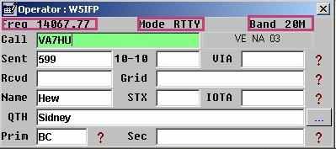

IRPCC\_1

The following is representative of the radio frequency display on the Sound Card Waterfall/Spectrum display.

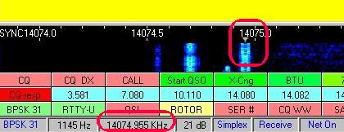

IRPCC\_2

## 8.0 USING A COMMERCIAL COMPUTER-RADIO INTERFACE

You can build an interface to provide hardware isolation and signal reduction in the audio line from the computer to the radio input. The topic on [Interfacing a Radio to the PC Sound Card](#_topic_InterfacingaRadiotothePCSoundCar) provides the information you need. This interface requires no power, but only operates in the transmit audio line.

The World Wide Web can help you find a commercial interface to operate between your computer sound card and the radio. Some interfaces have features such as providing extra connectors and switches to allow you to switch between microphone and computer, and adjustable signal levels so you can set the computer audio at exactly the same level as the microphone audio. Each model of interface is different, and you must read the instructions for the interface to see how to use it.

If your radio interface gets its DC power from the computer over the RTS, DSR, or DTR lines, it may not work properly with Logger32. You should try to provide power from the radio or from an external power source.

## 9.0 RADIO SETTINGS

Check the Helpfile topic for your specific radio to see if it supports radio-computer communication and if so, what protocol is used.

If your radio is not listed, the following information may prove helpful. Manufacturers often use the same communication protocol for their complete line of amateur equipment. If your radio is not listed, the settings for a similar radio by the same manufacturer may work or prove a good starting point for experimentation. A good example is the ICOM series of radios. All ICOM radios that operate under "ICOM CI-V" protocol will work with Logger32.

*Created with the Personal Edition of HelpNDoc:* [*Full-featured EBook editor*](http://www.helpndoc.com/create-epub-ebooks)

**Single Operator Two Radios (SO2R) Support**

# Geoff Anderson G3NPA and Aki Yoshida JA1NLX

## 1.0 OVERVIEW

Logger32 provides the capability for one operator to use two radios simultaneously.

A hard interface changeover signal is available and can be derived from pin #14 of the parallel interface. This can be used to operate an external switch box for the changeover of [PTT](#PTT), audio or a keying connection.

A keyed line changeover can be derived from using a hardware add-on called WinKey.

Configure both radios, K3 as Radio 1 and FT-1000MP as Radio 2 in this case. Open SO2R window. Radio Debug Window shows data like this:

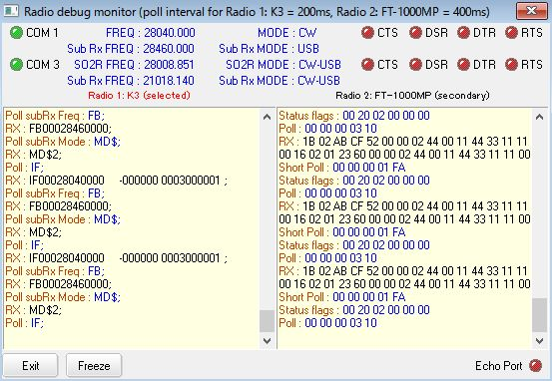

SO2R\_27A

## 2.0 RADIO CHANGEOVER

### 2.1 Antenna Selector

Logger32 will change the state of pin #14 on the antenna selector port depending on the radio in use (see [Setting up to Use Two Radios](#_topic_SettinguptoUseTwoRadios)).

In order to use this SO2R support you must have a parallel port set up as detailed in the [Setup Antenna Selector](#_topic_SetupAntennaSelector) topic. Once this has been set up, pin #14 will change state in step with the radio selected.

**Note**: The following is the default setting:

Radio in use         State of LPT pin #14

       #1                     High or +5v

       #2                     Low or zero volts.

If the hardware is wired for a Logic LOW for radio # 1 selection, the Logic level of pin 14 can be inverted. This is accomplished by checking the line: "Invert pin 14 (currently radio 1 sets pin14 Hi)". See [Setup Antenna Selector](#_topic_SetupAntennaSelector).

Another option is available that will mark the [DTR](#DTR) signal on one of the [CAT](#CAT) Com ports according to which radio is selected. The user should select the "Use [DTR](#DTR) as SO2R switch ([DTR](#DTR) follows primary switch)" from the Setup Radio # dialog box as shown below. An active [DTR](#DTR) marks the active radio.

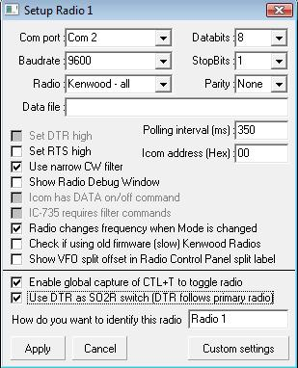

SO2R\_27

### 2.2 Shortcut Key

There is a Shortcut Key for this change-over <**Ctrl+T**> which can be used directly from the keyboard (see note 1 below ) or you can change the radios by using the mouse to select the pop-up menu from the [Logbook Entry Window](#_topic_LogbookEntryWindow) as shown below:

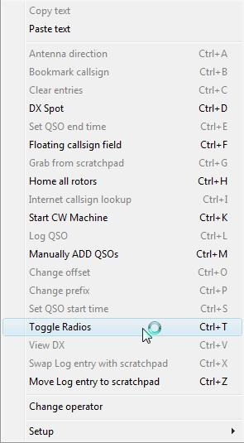

SO2R\_1

or by using the right-click menu from the Radio panel on the Lower Status Bar.

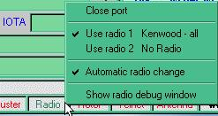

SO2R\_2

Indication of this change-over can be seen in the Antenna Selector window.

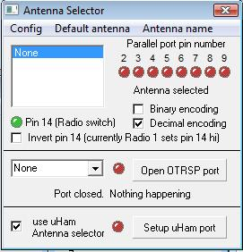

SO2R\_3

and in the Lower Status Bar

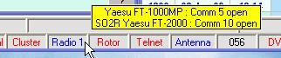

SO2R\_4

**Note**: <**Ctrl+T**> can be used directly from the keyboard. If the option shown below is checked then the <**Ctrl+T**> function will work wherever the cursor may be located. If left unchecked, the keyboard action will only work if the cursor is placed within the Log input window.

You need to use caution in selecting this option if you run other programs that use these two hot keys. Selection for global use will route the hot keys to rotor commands even if Logger32 is running in the background.



SO2R\_23

### 2.3 Changeover MACRO

Toggling of the radio is also possible using the immediate MACRO $toggleradios$ and this will work for the [Soundcard](#_topic_SoundCardDataWindow1), [CW Machine](#_topic_CWMachineWindow) and the [Data Terminal](#_topic_DataTerminalWindow) windows.

## 3.0 CW MACHINE

The [CW Machine](#_topic_CWMachineWindow) (software version only) will support SO2R of [PTT](#PTT) and [CW](#CW) keying when using a shared serial port with the radio.

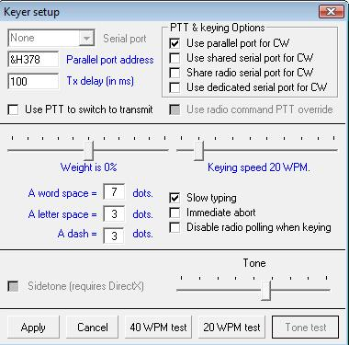

SO2R\_24

This option is selectable in the Keyer Setup (software version only) as shown above. The [RTS](#RTS) ([PTT](#PTT)) and the [DTR](#DTR) ([CW](#CW)) signals from the software keyer switch between the two radio Com ports under the control of the <Ctrl\_T> function.

## 4.0 WINKEY

Logger32 now supports the use of WinKey1 and 2, and one of the functions available in that hardware is the ability to switch the keyed outputs between two pins on the device. Under normal use the keyed [CW](#CW) is available on pin #3 and pin #5 is a [PTT](#PTT) line, but this can be changed such that pin #5 becomes the keyed line by using a particular command.

As an alternative, Logger32 allows the user to set up for the [CW](#CW) keyed output to appear on pin #3 when Radio 1 is in use and to automatically change to pin #5 when Radio 2 is in use. Additionally, the reverse of this is available. If either of these two alternatives is selected, then the "Key on pin #3" and "Key on pin #5" check boxes will be grayed out.

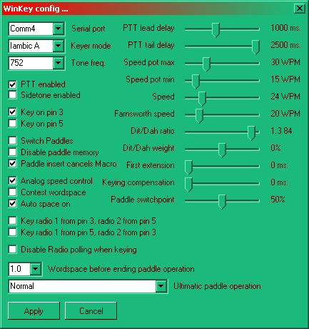

SO2R\_5

You are strongly advised to consult the WinKey Interface manual on the functions of these pins.

## 5.0 ADDITIONAL MACROS

Macros are sent to either Radio 1 or Radio 2, whichever is selected at the time. This means that when running dual radios, the button definitions designed for one radio may not work with the other.  To overcome this, the $hexcommand$ and $command$ macros include a "|"  [[ASCII](#ASCII) 124] character which will allows for the building of a shortcut definition where text to the left of the "|" will be sent if  Radio 1 is selected and text to the right of the | is sent if Radio 2 is selected ...

The MACRO would be:

$hexcommand [radio1text]|[radio2text]$

or

$command{radio1text]|[radio2text]$

where [text] is an optional parameter and the "[" and "]" are NOT part of the parameter.

If no "|" is detected, then the same instruction is generated regardless of which radio is selected

**Note**: Logger32 does NOT strip spaces from this MACRO so care must be taken to ensure there are no redundant spaces either side of the "|" character for if there are any, these will be forwarded to the radio concerned, possibly upsetting the action of the intended command.

Complex commands, made up from both the $hexcommand$ and $command$ MACROs, are possible

As an example of this, if one had a YAESU rig for Radio 1 and a Kenwood rig for Radio 2, then any shortcut button definition requiring the use of a particular command set to make up an instruction would be different for the two radios.  In this example, the YAESU radio would require the use of the $hexcommand$ MACRO while the Kenwood would require the $command$ MACRO.  There is a need to have something that can instruct Logger32 to change the shortcut sent according to which radio is in use at the time.

For the sake of this example, assume Radio 1 requires a $hexcommand$ string and Radio 2 requires a $command$ string to perform the same (or similar) function like a filter setting and the individual radios require the following:

Radio 1  IF 500Hz     $hexcommand 00 00 00 02 8c$

Radio 2  IF 500Hz     $command FL009007;$

The combined MACROs in this case become:

$hexcommand 00 00 00 02 8c$|$command|FL009007;$

Looking at each part we see a $hexcommand of 00 00 00 02 8c$ for Radio 1 with nothing for Radio 2  (to the right of the first "|" character), followed by a command of nothing for Radio 1 (there's nothing to the left of the second "|" character) or no hexcommand for Radio 2 and a command of fa00014070; for Radio 2.

If both Radio 1 and Radio 2 need (say)$hexcommand$ instructions but they are different then the combined MACRO would become

$hexcommand xx xx xx xx xx|yy yy yy yy yy$

where xx xx xx is the command string for Radio1 and yy yy yy.is the string for Radio 2

### 6.0 USING THE BANDMODE TABLE

Code has been added to Setup Bands & Modes to support SO2R radio mode. Use the same syntax as $command$ and $hexcommand$ macros, for example, the Radio Mode column may be RTTY|SSB where if using Radio 1, the Radio mode would be set to [RTTY](#RTTY) and if using Radio 2, the Radio mode would be set to [SSB](#SSB).

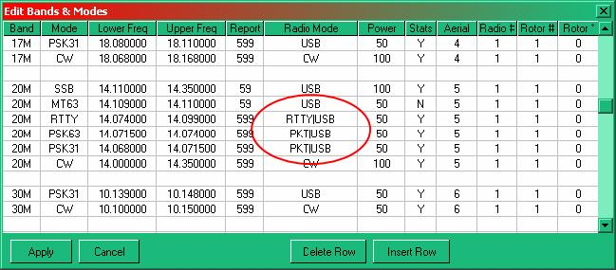

SO2R\_6

As with the $command$ and $hexcommand$ macros, if no | is detected in the string, the mode is applied for both Radio 1 and Radio 2.

## 7.0 SOUNDCARD ENHANCEMENTS FOR SO2R

The Soundcard Data window includes dual displays for both the [MMTTY](#MMTTY) and [MMVARI](#MMVARI) engines. The SO2R facilities include the [MMTTY](#MMTTY) module as well as those installed for [MMVARI](#MMVARI) and an SO2R menu option is now available.

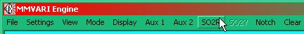

SO2R\_7

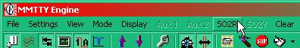

SO2R\_8

Selecting this option will produce a secondary (soundcard) display and the title bars of the two windows will show which radio is currently switched to the primary display. The two displays differ in that only the primary display has a macro button tablet.

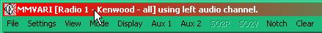

SO2R\_9

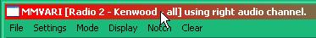

SO2R\_10

OR

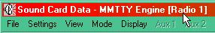 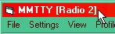

 SO2R\_11                                                              SO2R\_12

Under normal operation, one of the above displays will be driven from the left audio channel and the other from the right.  See Selection of Audio Channel below. **Note**: As Logger32 cannot determine the audio settings for the [MMTTY](#MMTTY) engine, the audio channel in use is only displayed in the window title bar for the [MMVARI](#MMVARI) engine.

If the SO2R option is not used then the soundcard option will accept audio from either input channel.

It is also possible to turn the SO2R [CAT](#CAT) port on and off as desired. When the option is OFF, the SO2R soundcard window will display an audio frequency ribbon. If the option is turned ON then the [RF](#RF) frequency of the second radio is displayed. This option may be found under "settings" in the SO2R window.

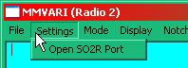 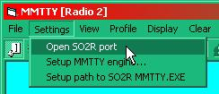

SO2R\_25              or                      SO2R\_26

**Note**: BOTH these menu options are the same so it does not matter which of the two soundcard engines is in use at the time

## 8.0 RELIMINARY SETUP OF FILES.

### 8.1 MMTTY

To fully utilize SO2R capability with [MMTTY](#MMTTY), two different copies of MMTTY.EXE need to run simultaneously.

It is necessary to create a new directory (say)  \Program Files\MMTTY2.  In this new directory copy, from your default Logger32 directory), MMTTY.EXE, USERPARA.INI and MMTTY.INI but do NOT delete the original files as they are still needed in the Logger32 directory.In addition, check that your default Logger32 directory contains the file called XMMT.OCX.

The SO2R copy of MMTTY defaults (for new users) to the Logger32 directory.  This means users who have no interest in the feature have nothing to do, and don't even know it's there.  For those who want to use the full capabilities of SO2R MMTTY, enter the path name to the directory where you have copied the second copy of MMTTY.EXE and its supporting .INI files (\Program Files\MMTTY2).  The SO2R copy of MMTTY.EXE will automatically be switched to run in this directory.

On the Logger32 Sound Card Data Window (with MMTTY running) select the SO2R menu option. This will open the MMTTY SO2R Window. Click the SETTINGS | Setup path to SO2R MMTTY.EXE.

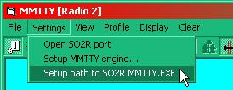

SO2R\_13

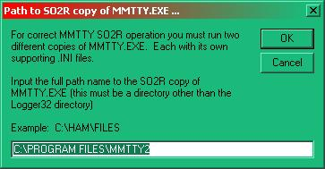

SO2R\_14

### 8.2 MMVARI

The [MMVARI](#MMVARI) module does not require any specific preliminary set up of files for SO2R.

## 9.0 SOUNDCARD SELECTION

Logger32 will allow for those who wish to use different soundcards for different mode generating engines.

### 9.1 MMVARI

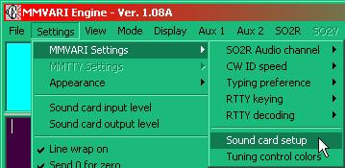

SO2R\_15

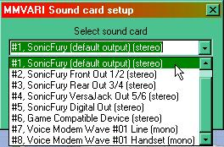

SO2R\_16

**Note:** the device numbers in the list as one of these will be required for the [MMTTY](#MMTTY) set-up - see below.

### 9.2 MMTTY

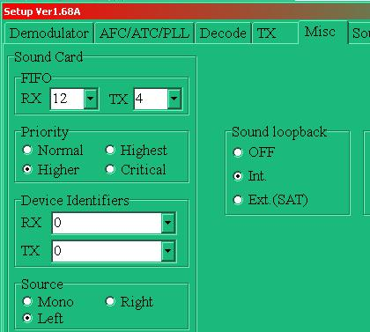

SO2R\_17

## 10.0 SELECTION OF AUDIO CHANNEL

Under normal use (single radio input), the soundcard will generally use the audio signal being fed to the left channel.  However, when using the SO2R facilities both channels are used independently, usually one from each radio. Logger32 gives the user the option to set up the sound card (SO2R function) to accept either the left or the right channel as being for/from Radio 1.

### 10.1 MMVari

See Settings|MMVARI Settings|SO2R Audio channel. Note that this option ONLY becomes available if SO2R has been selected and that this option applies to BOTH radios 1 and 2 windows as set here. If Radio 1 is set to left channel, then by default Radio 2 will be automatically use the right channel.

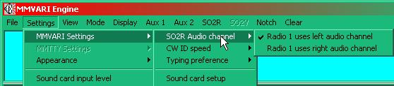

SO2R\_18

### 10.2 MMTTY

For [MMTTY](#MMTTY), the association of the audio channel has to be set for each radio (from each of the SO2R windows).

For Radio 1, select the Set-up spanner icon in the Radio 1 window and mark your choice of Mono/Left/Right on the Misc Tab ([SO2\_012](#SO2R_12)).  Repeat for Radio 2 from its window

## 11.0 RADIO PTT PORT SELECTION

### 11.1 MMVARI and MMTTY

The Radio [PTT](#PTT) selection includes SO2R operation.This user option can be configured from the Soundcard menu Settings|Radio PTT options.

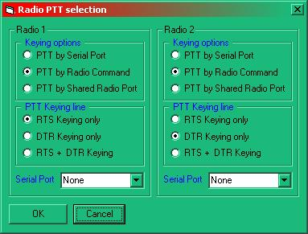

SO2R\_19

**Note**: Both the [MMTTY](#MMTTY) and [MMVARI](#MMVARI) [PTT](#PTT) settings are set at the same time. Do not attempt to change the port settings from the MMTTY engine setup ([TX](#TX)) panel. The settings will not be saved.

### 11.2 MMTTY Only

For [MMTTY](#MMTTY), the [PTT](#PTT) port has to be set for each radio (from each of the SO2R windows).

For Radio 1, select the Set-up spanner icon in the radio 1 window and select the com. port on the TX tab. Repeat for Radio 2 from its window.

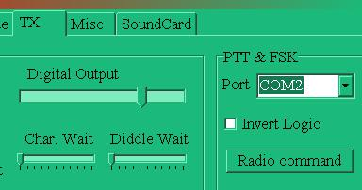

SO2R\_20

Sample Screen shots showing MMVARI (SO2R) in use

The screen shots below show the soundcard being used in SO2R mode.

These next two screen shots show several things:

First they show that the main and the secondary screens are receiving different audio streams.  They are actually derived from two different receivers; one tuned to 14 [MHz](#MHz) and the other to 7 MHz.

It is also possible to see that the main and secondary screens are set to receive different modes [PSK](#PSK31/63/125) and [RTTY-U](#RTTY-USB). In the first of the two screen shots, Radio 1 is showing the PSK signal in the main window while Radio 2, a RTTY-U signal, in the secondary window.  In the lower of the two screen shots this has been reversed.

Notes: Only the primary SO2R window has the macro keys.

The frequency ribbon in the SO2R window will only display an RF frequency if:

a) There is a functioning radio connected to a second radio port, and

b) The SO2R port is activated.

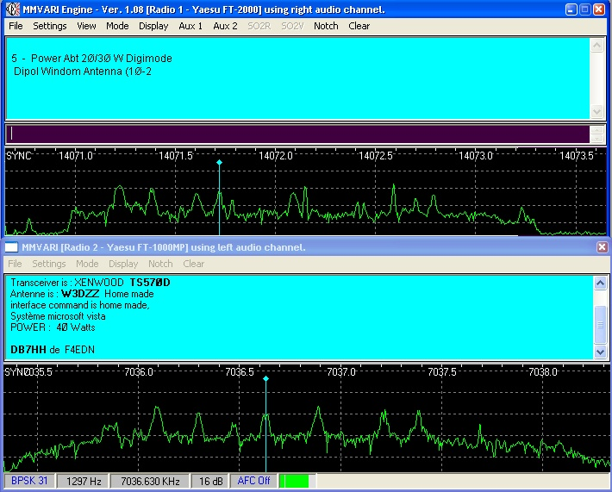

SO2R\_21

The screen shot below has been taken using the same set up as the picture above except that in this case the Radio 1 and Radio 2 signals have been swapped using either the <**Ctrl+T**> function from the log input window OR selecting the radio in use from the Radio pane in the lower status bar.  Here it can be seen that not only has the audio channel been swapped over but the received text AND the mode settings have all changed over as well.

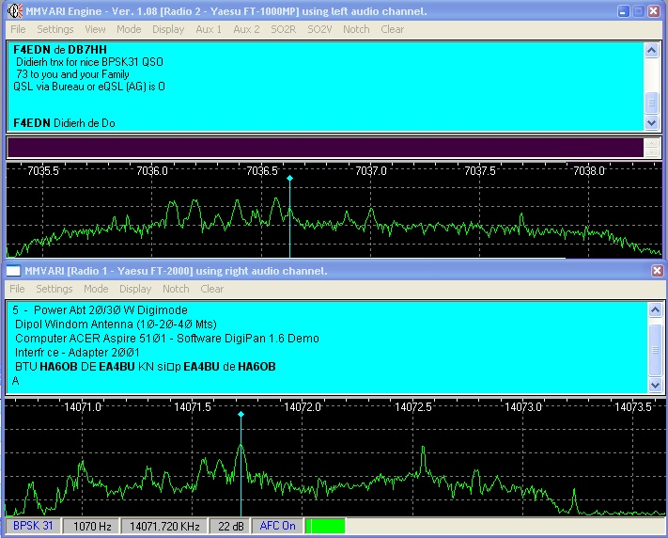

SO2R\_22

**Note**:  These two digital windows do not have to be derived from physically separate radios of course.  There is no reason why they should not be fed with audio from the A and B receivers of an FT1000MP for example. However, if this method is adopted, then take additional note that although a <**Ctrl+T**> will switch the radio panes on the screen, the radio itself will not change and transmit from the other VFO.  Where this IS useful however is when chasing DX when you can look at the DX station in one pane and tune around using the second VFO or receiver looking for the station he is working at the time ? using the second pane.

*Created with the Personal Edition of HelpNDoc:* [*Free HTML Help documentation generator*](http://www.helpndoc.com)

**Setting up to Use Two Radios**

Geoff Anderson G3NPA

## 1.0 General

Logger32 will support the transfer of Frequency, Mode and general command data to either of two radios via serial data connections. Manual and automatic switching between the two data connections is also included.

**Note**: Logger32 does not include any automatic switching of audio and/or other hardwired control connections to or from the second radio.  This you will have to organize this separately.

I think a **MAJOR word of caution** is in order here ... Using the Radio Reset menu item (right-click on an entry in the DX Spots window), or the Logger32 [Setup menu](#_topic_SetupMenu) [Radio menu item](#5.0_RADIO_MENU_ITEM), can, if you are not VERY careful, cause you to log QSOs on the wrong Band or Mode. It's very easy (with two radios running) to have a QSO, and log it with Logger32 connected to the other radio.

## 2.0 Setting up

1. Set up the configuration details for each radio.  From the Logger32 [Setup menu](#_topic_SetupMenu), select the [Radio | Use radio 1 or Use radio 2 configuration menu items](#5.0_RADIO_MENU_ITEM) to display the Setup Radio n dialog box.

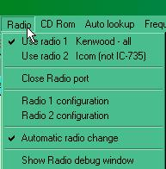

SUTR\_1

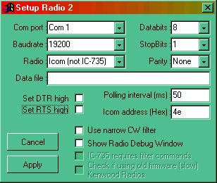

SUTR\_2

1. From the Logger32 [Setup menu](#_topic_SetupMenu), [Radio](#5.0_RADIO_MENU_ITEM) menu item, select the radio you wish to be active (Use Radio 1 or Use Radio 2 menu item). At this stage, if you place the mouse over the Radio panel in the Lower Status bar:

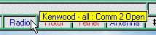

SUTR\_3

1. Right-clicking on the Radio panel will display the menu below.  You can change radios by selecting the appropriate menu item (Use radio 1 or Use radio 2).

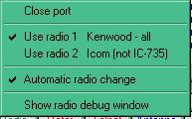

SUTR\_4

1. The "Automatic radio change" menu item refers to the action to be taken following the clicking of a DX spot. If checked, this action is dependent on the value in the "Radio #" column in the current "Band"" segment of the BandMode table. .

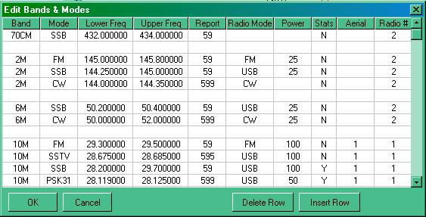

SUTR\_5

1. For every segment entered in the Bandplan, an entry in the "Radio #" column is mandatory.  You will see in the example above that Radio 1 is configured for [HF](#HF) while Radio 2 is configured for [VHF](#VHF)/[UHF](#UHF). Selecting any 6m, 2M, or 70cm spot will switch to Radio 2, while selecting any 10M segment will switch to Radio 1.
2. You are not limited to just the Band column. Any defined Band Segment entry can use either radio. The options are limitless
3. You can also manually switch between Radio 1 and Radio 2 via the keyboard by pressing <**Ctrl+T**>.

*Created with the Personal Edition of HelpNDoc:* [*Create cross-platform Qt Help files*](http://www.helpndoc.com/feature-tour/create-help-files-for-the-qt-help-framework)

**Single Operator Two VFOs (SO2V) Support**

# Geoff Anderson G3NPA

## 1.0 GENERAL

Simple support for SO2V is provided in Logger32. At the moment there is no A-B switching and no display of the [TX](#TX) or [RX](#RX) [VFOs](#VFO), etc. The assumption is made that VFO-B drives an actual sub-receiver.

It is also a prerequisite that any radio that is an SO2V candidate has the physical capability to output stereo audio - one channel for the main VFO and one for the sub VFO.

Radios supported for SO2V include the FT2000/D, FTDX9000, FT-1000mp/mk5 and the K3. The TS-950SD/SDX and FT-1000D have been implemented but remain untested.

Important note: For those using an FT-1000D and/or an FT-1000mp/mk5 and are experimenting with SO2V will need to appreciate that the radio normally responds to a poll with 16 bytes of data. When switching to SO2V, the radio will respond to polls with 32 bytes of data. So, if you have a very short poll interval, the radio may not have time to respond with twice the data. Practical tests show that an FT-1000D with the poll interval set at 300 ms worked perfectly, however it failed to respond to SO2V polls correctly. The poll interval needed to be increased. If you suddenly find problems associated with the [CAT](#CAT) interface when using SO2V then check the CAT data using the radio debug window and try increasing the poll time.

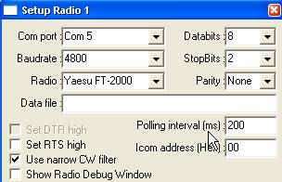

SO2V\_1

Users will notice that when using [MMVARI](#MMVARI) or [MMTTY](#MMTTY), an SO2V menu option is now available.

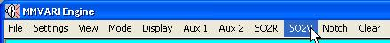

SO2V\_2

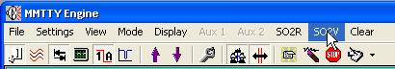

SO2V\_3

Selecting this option will produce a secondary (soundcard) display and the Title bar of both windows will show the radio as well as the soundcard audio channel being used.

The two displays differ in that only the primary (A-VFO) display has a macro button tablet.

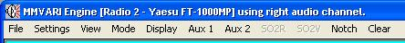

SO2V\_4

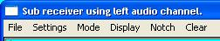

SO2V\_5

Under normal operation, one of the above displays will be driven from the left audio channel and the other from the right. See Selection of Audio Channel below. As Logger32 cannot determine the audio settings for the [MMTTY](#MMTTY) engine, the audio channel in use is only displayed in the window title bar for the [MMVARI](#MMVARI) engine.

If you happen to be running a system using two SO2V compatible radios together with suitable change over switching, it is possible to run either [SO2R](#SO2R) or SO2V by using the <**Ctrl+T**> changeover control as described n the SO2R topic of this help file.

It is recommended that for further information on:

* + Preliminary set up of files;
  + Soundcard Selection;
  + Selection of audio channel; and,
  + Radio [PTT](#PTT) Port Selection.

you consult these same paragraphs in the [SO2R section](#_topic_SingleOperatorTwoRadiosSO2RSuppo).

*Created with the Personal Edition of HelpNDoc:* [*Single source CHM, PDF, DOC and HTML Help creation*](http://www.helpndoc.com/help-authoring-tool)

**Griffin PowerMate**

# Aki Yoshida JA1NLX

## 1.0 GENERAL

The Griffin PowerMate is a tool which navigates an application program like mouse. There are 6 actions in PowerMate, and each action can be assigned to one of three categories of commands:

* 1. Mouse;
  2. Scrolling; and,
  3. HotKeys.

### 1.1 IMPORTANT NOTE for Windows 7 and 8 Users

If the HotKeys described below do not work then you must check the Graphic options in your system. In my system some of these HotKeys work only if HotKeys in Graphic options is disabled. (Right click on desk top. Select Graphic option, HotKeys and Disabled).

1.1 IMPORTANT NOTE for Windows 10 Users

* + Powermate.exe should be set to run as “Administrator”;
  + Compatibility Mode should be set to: Windows VISTA (service pack 2); and,
  + To set: Right click desktop PowerMate Icon and select “Properties”

## 2.0 POWERMATE INSTALLATION

Go to the PowerMate Support page, to download a proper driver. PowerMate for Windows, ver2.0.1 for XP & Vista works for Windows 7 as well.

## 3.0 POWERMATE SETUP

Plug the PowerMate USB cable into one of the USB ports of your PC and run PowerMate. You will see the PowerMate icon in the Task tray.



GPM\_1

Right click on this icon and select the PowerMate Editor.

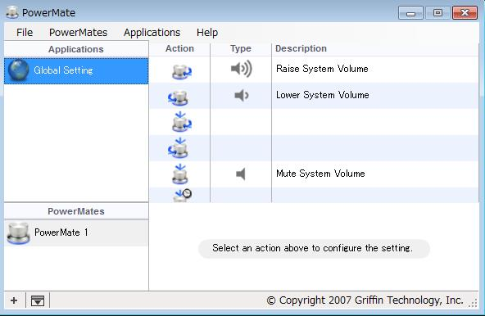

GPM\_2

To use the PowerMate with Logger32 you must first have Logger running, so launch Logger32 if it is not running

On the PowerMate Editor, select the Applications menu item and then select Add.The Editor will show a list of currently running applications..

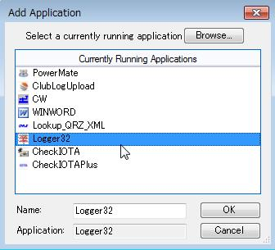

GPM\_3

Select Logger32 and click the <OK> button to return to the Editor.

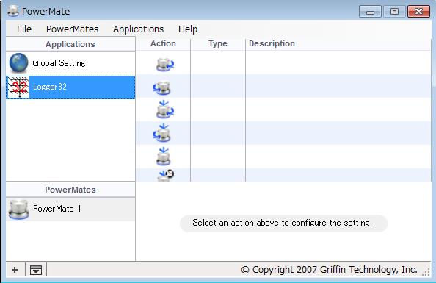

GPM\_4

Logger32 will be displayed in the Applications list, However, you will see nothing in the Type and Description columns.

## 4.0 CONFIGURE POWERMATE

You can now configure each action in the Action list to do something you want as detailed in the following examples:

### 4.1To Configure the Turn Right Action to Scroll Up;

* 1. Select Turn Right, Scrolling and Scroll Up;

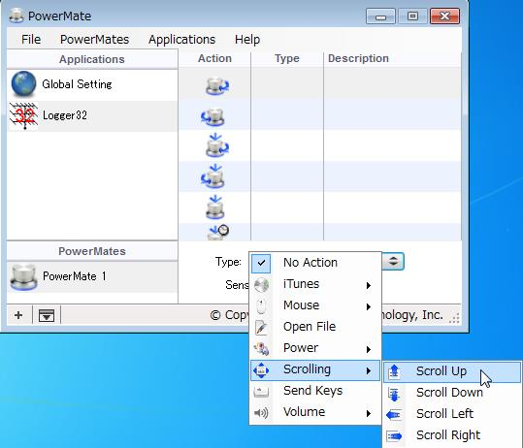

GPM\_5

* 1. Add an appropriate description to the Description edit box; and,
  2. Configure the Turn Left Action action in the same manner.

### 4.2 To Configure SendKey Actions

Select Click-Turn RIGHT and SendKeys. Click Keys box. Key ALT,+CTL+ Right arrow.

The Sensitivity adjustment gives you a way to fine-tune the speed of PowerMate knob.

### 4.3 To configure other Turn and Click options, repeat the steps above.

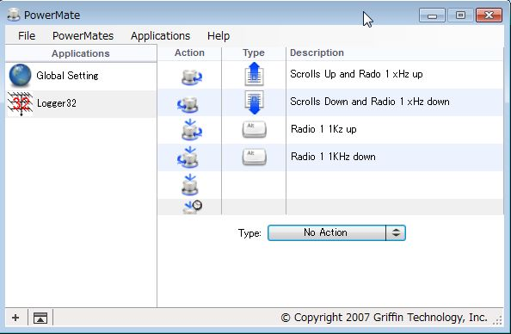

GPM\_6

The following image shows my PowerMate configuration.

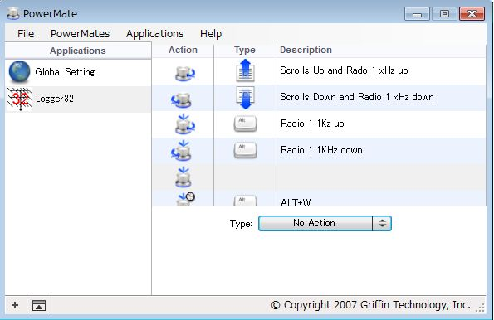

GPM\_7

* + Turn Right is used for Scroll Up and Radio 1 xHz up;
  + Turn Left is used for Scroll Down and Radio 1 xHz down;
  + Click and Turn Right is used for Radio 1 1KHz up;
  + Click and Turn Left is used for Radio 1 1KHz down;
  + Click or Short Click (not used); and,
  + Long Click is used for sending ALT+W.

## 5.0 HOW TO USE THE POWERMATE WITH LOGGER32

If you want to use PowerMate and/or HotKeys to control VFO then following option must be checked. If you want to toggle radios then "CTL + T to toggle radios" must be checked.

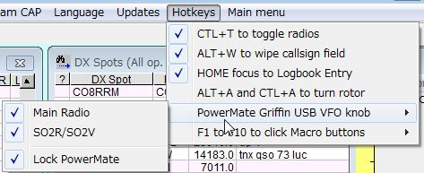

GPM\_8

### 5.1 HotKeys to control Radio VFO

* + <**Ctrl+Right Arrow**> Radio 1 main xHz up
  + <**Ctrl+Left Arrow**> Radio 1 main xHz down
  + <**Alt+Ctrl+Right Arrow**> Radio 1 main 1KHz up
  + <**Alt+Ctrl+Left Arrow**> Radio 1 main 1KHz down

**5.2 If RCP SO2R is not open then**

* + <**Ctrl+Up Arrow**> Radio 1 sub xHz up
  + <**Ctrl+Down Arrow**> Radio 1 sub xHz down
  + <**Alt+Ctrl+Up Arrow**> Radio 1 sub 1KHz up
  + <**Alt+Ctrl+Down Arrow**> Radio 1 sub 1KHz down

### 5.3 If RCP SO2R is open then

* + <**Ctrl+Up Arrow**> Radio 2 main xHz up
  + <**Ctrl+Down Arrow**> Radio 2 main xHz down
  + <**Alt+Ctrl+Up Arrow**> Radio 2 main 1KHz up
  + <**Alt+Ctrl+Down Arrow**> Radio 2 main 1KHz down

## 6.0 OPERATION SAMPLE BASED ON MY CONFIGURATION

### 6.1 Frequency Control

**Click and Turn Right/Left** This controls Radio 1 main VFO up or down 1KHz. Focus must be on any child window.

**Turn Right/Left** This controls Radio 1 main VFO up or down xHz. Focus must be on Logbook entry window. Note: x is defined by following steps.

Right click on frequency in Logbook entry window.

Select one of them except 0Hz

**Scrolling** Move mouse on window you want to scroll and Turn Right/Left.

**Move focus to callsign field in Logbook Entry window - Long Click** Focus must be on any child window.

### 6.2 More Examples

**Logger32**

HotKeys

PowerMate action

PowerMate type

Description

**<Ctrl+T>**

Click

Send Keys

Toggle Radio

**<Ctrl+Right Arrow>**

Turn Right

Send Keys

Radio 1 main xHz up

**<Ctrl+Left Arrow>**

Turn Left

Send Keys

Radio 1 main xHz dn

**<Alt+L>**

This is a useful HotKey to enable/disable VFO control with <**Ctrl+Arrow**> and <**Alt+T+Ctrl+Arrow**> by both Keyboard and PowerMate. This does nothing for other control (<**Alt+W**>, <**Ctrl+T**>, VFO control by scrolling and scrolling). Check the Lock PowerMate option in the HotKeys menu. See Fig. [GPM\_8](#GPM_8).

Select <**Alt+T+L**>. You will see Lock icon just under X on the RCP. VFO control is now disabled.

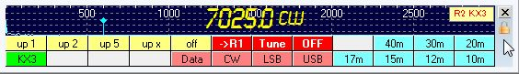

GPM\_9

Select <**AltT+L**> or click on this icon and the Lock icon will disappear and VFO control is now enabled. The Enable/disable flag is saved in Logger32.ini.

**CW Machine**

HotKeys

PowerMate action

PowerMate type

Description

**Mouse Right click**

Turn Right

Mouse, Right click

Speed up

**Mouse Left click**

Turn Left

Mouse, Left click

Speed dn

More configurations are possible depending on your preference. Study the [HotKeys](#_topic_HotKeys) implemented in Logger32 first. If you find PowerMate is better then try to configure Send Keys

*Created with the Personal Edition of HelpNDoc:* [*Easy to use tool to create HTML Help files and Help web sites*](http://www.helpndoc.com/help-authoring-tool)

**Hardware Setup**

*Created with the Personal Edition of HelpNDoc:* [*Easily create EPub books*](http://www.helpndoc.com/feature-tour)

**Antennas**

*Created with the Personal Edition of HelpNDoc:* [*Full-featured Kindle eBooks generator*](http://www.helpndoc.com/feature-tour/create-ebooks-for-amazon-kindle)

**Setup Antenna Selector**

# Jim Hargrave W5IFP

## 1.0 GENERAL

### 1.1 Support

Logger32 currently supports four methods of automatically switching antennas:

### 1.1.0 Using the antenna switch built into some of the later model radios.

This method uses CAT commands to the radio and implementation is covered in detail in the [Setup Bands and Modes](#_topic_SetupBandsandModes) topic.

### 1.1.1.Using a Remote Antenna Switch

Logger32 also provides the capability of using a remote electronic antenna switch to automatically select different antennas as you change bands. This is accomplished by interfacing to the antenna switch through the computer's parallel port and assigning the desired antenna for each band defined in the “aerial" column of the "Bands and Modes" definition. In addition, the user can configure any antenna as a default antenna that will automatically be selected when a frequency is reported by the radio that falls outside of the normal Bandplan entries or an antenna is not defined for a specific Bandplan segment.

### 1.1.2 Using Serial Ports

Logger32 also supports three methods of controlling the antenna switch using serial ports: The Data Terminal Window, [OTRSP protocol](#_topic_OpenTwoRadioSwitchingProtocolOTR) and [MicroHAM](#_topic_SupportformicroHamControlCommand) are supported. See respective topics for setup details.

### 1.1.3 Manual Antenna Switch

Logger32 also supports manual operation of the antenna switch for testing the configuration setup and the antenna switch hardware. The automatic antenna switch must be installed and Logger32 properly configured. See [Testing the Antenna switch](#_3.0_TESTING_THE_ANTENNA_SWITCH_3.0_TESTING_THE_ANTENNA_SWITCH) below:

### 1.2 Setup

This section covers setting up Logger32 to operate the remote programmed antenna switch. A simple antenna switch example is detailed the topic [Automatic Antenna Switch](#_topic_AutomaticAntennaSwitch).

There are two programming schemes available, Decimal and Binary. Both of these use the parallel port and provide a digital HIGH state (5V) on the respective line(s).

* 1. **Decimal -** This option allows up to 8 antenna lines. Logger32 will program the parallel port pins 2 thru 9. The antenna numbers are in order starting with Pin # 2, antenna number 1, Pin # 3 is antenna #2…etc …with Pin # 9 being antenna #8. Only one pin is high at any given time.
  2. **Binary** - This option provides a 4-bit Binary output on the parallel port. Pins 2, 7, 8, & 9. The output is in BCD and allows up to 15 selected numbers. Pin # 2 is data line A (1), Pin # 7 is data line B (2), Pin number 8 is data line C (4) and Pin number 9 is data line D (8). The specific antenna number listed in the Bands/Mode chart will result in a BCD equivalent output.

## 2.0 ANTENNA SELECTOR SETUP

## 2.1 PARALLEL PORT

From Logger32 [Main Menu](#_topic_MainMenu), select the [Setup | Antenna Selector](#9.0_ANTENNA_SELECTOR_MENU_ITEM) menu items.



SAS\_1

The Antenna Selector dialog box will be displayed allowing the user to configure and monitor the automatic antenna selection process.

You will also note an LED with caption "Pin 14 (Radio switch)". This LED reflects which radio is in use when two radios are configured in Logger32. The LED will be green when Radio #1 is selected and will turn red when Radio #2 is selected. When the LED is green, pin 14 of the parallel port will have logic 1 (+5vdc). When the LED is red, pin 14 will have logic 0 (0vdc). This signal can be used to switch interface cables, microphones, and operating adapters between the two radios. It can also be combined with the antenna lines to switch antennas and linear amplifiers. Additional information for Pin 14 application is contained in the in the Hardware Setup portion of the [Automatic Antenna Switch](#_topic_AutomaticAntennaSwitch) and [SO2R](#_topic_SingleOperatorTwoRadiosSO2RSuppo) sections.

**Note**: The logic level of this pin can be reversed by checking the box “Invert pin 14”. This will result in logic HIGH when radio # 2 is selected.

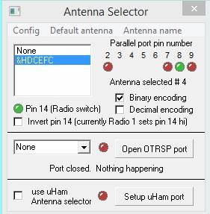

SAS\_2

Select the "Config" menu item and the Parallel Port address dialog box will appear. Enter the correct parallel port address for your computer and operating system and select the <**OK**> button. Typical parallel port addresses are &H378 for LPT1 and &H278 for LPT2.

**Note**: Some PCI parallel port plug-in cards use an address other than the conventional LPT1 or LPT2 address. You should open the Device Manager and determine the exact address assigned to your parallel port, then enter that address in the Parallel port dialog box.

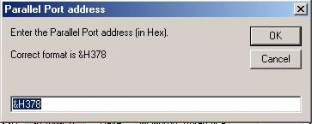

SAS\_3

## 2.2 SERIAL PORTS

For Antenna switches that operate from a serial port, select the appropriate COM port number from the drop-down menu.

### 2.2.1 OTRSP

The following shows the drop down menu for antennas using the OTRSP protocol. See the [OTRSP](#_topic_OpenTwoRadioSwitchingProtocolOTR) topic for more details.

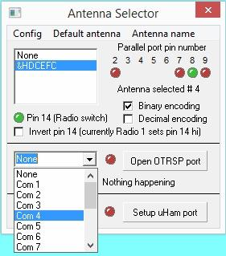

SAS\_3A

### 2.2.2 microHAM

The following shows the drop down menu for microHAM antenna switch. Select the <**Setup uHam port**> button and a drop down menu will appear. See the [Support for microHAM Control Commands](#_topic_SupportformicroHamControlCommand) topic for detailed setup.

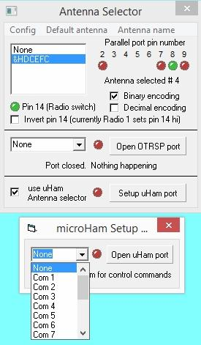

SAS\_3B

### 2.2.3 Data Terminal

The Data Terminal can communicate directly to an antenna switching device using a dedicated serial port.

The following procedure defines the setup for the KMTronic USB Relay unit (or equivalent). This unit has 8 built in relays suitable of controlling remote antenna switching relays. It can be configured for Decimal or Binary output.

Open the Data Terminal and select “Mode | Antenna Selector”

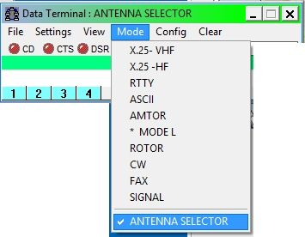

SAS\_3C

This will open a typical communication terminal and establishe direct communication between Logger32 and an external serial device by executing command Macros that control the external devise. The Macros can be manually sent by the operator using the F keys or by mouse clicks.

In addition the Macros will be automatically sent when changing bands. Automatic Macro selection is based on the aerial column in the Bands and Mode chart.

Data is sent direct to the serial port using the Macro format: [**$hexbytes FF xx xx$**](#$hexbytes$).

The following are example Macros to control the KMTronic USB Relay unit for decimal output:

F1 $hexbytes FF 0A 00$ $hexbytes FF 01 01$ (clears all relays and turns on #1)

F2 $hexbytes FF 0A 00$ $hexbytes FF 02 01$ (clears all relays and turns on #2)

Etc.…

.

The following sets the unit for Binary output.

F1 $hexbytes FF 0A 00$ $hexbytes FF 01 01$

F2 $hexbytes FF 0A 00$ $hexbytes FF 02 01$

F3 $hexbytes FF 0A 00$ $hexbytes FF 01 01$ $hexbytes FF 02 01$

F4 $hexbytes FF 0A 00$ $hexbytes FF 03 01$

Etc.

The USB Relay set to Binary output can control remote units, such as the Ameritron RCS-10. Parallel units can be converted to serial ports by adding a USB relay between the computer and antenna SWITCH.

Once the Data Terminal is setup, it can reduced in size or minimized.

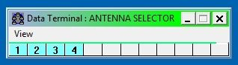

SAS\_3D

### 2.2.4 Antenna Name

From the Antenna Selector dialog box, select the default antenna menu item to display the default antenna list. Simply select the desired default antenna to be used for any frequency that is not defined in the [Bandplan](#_topic_SetupBandsandModes) or does not have an antenna defined in the Bandplan. The last line allows the operator to select the last selected antenna and ensures that Logger32 will continue using the last selected antenna when the frequency goes out of a frequency defined in the Bandplan as having an antenna. As an example, assume the operator was on 20m and had a beam selected as the operating antenna. If the operator should move outside of the defined Bandplan segment, Logger32 would keep the same beam active until a frequency was entered that was defined in another segment of the Bandplan.

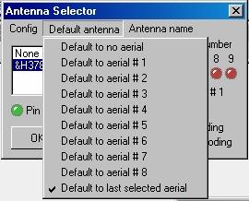

SAS\_4

Click on the "Antenna name" menu item and a list of the eight antenna positions will appear. Move the cursor to one of the positions and left-click to select the antenna to which you wish to assign a name.

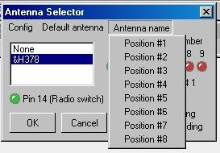

SAS\_5

This action will open another window with the space to assign a name to the antenna in the selected position. Type in the name of the antenna and select the <**OK**> button. Repeat this process until you have named all the antennas you have connected to antenna switch.

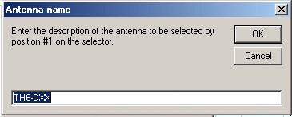

SAS\_6

Now, select the <**OK**> button and the configuration you have selected will be saved in the Logger32 INI file.

On the right side of the Antenna Selector dialog box is a series of LEDs that show which Parallel port pin number and associated antenna are selected. **Note**: this table shows the correlation of the antenna number and actual Parallel port hardware pin number. LEDs will turn Green indicating which antenna is active. You can open this window during operation to monitor the antenna switching activity and as an aid to troubleshooting the antenna control interface.

Antenna status can also be monitored from the Logger32 [Lower Status bar](#3.0_LOWER_STATUS_BAR) [Antenna](#3.7_Antenna_Selector_status) panel. Placing the mouse cursor over this pane will pop up a yellow Hint Box with the currently selected antenna.



SAS\_7

After the Antenna Selector setup has been completed, the user must edit the "[Bands & Mode](#_topic_SetupBandsandModes)" setup to enter an antenna number in the aerial column of the appropriate frequency segments. See the section on setting up the Bandplan for detailed procedures.

## 3.0 TESTING THE ANTENNA SWITCH

To manually switch the antennas, tune the radio to a frequency that does not have an antenna designated in the Bandplan or just turn the radio OFF so no frequency will be displayed.

From the Logger32 [Main menu](#_topic_MainMenu), select the [Setup | Antenna selector](#9.0_ANTENNA_SELECTOR_MENU_ITEM) menu items and then “Default antenna”. Select an antenna and the antenna switch should make the selected antenna active. The LED display will show the active parallel pin number. Be sure and re-set to the desired default antenna after you have verified that the switch is working properly.

*Created with the Personal Edition of HelpNDoc:* [*Free Qt Help documentation generator*](http://www.helpndoc.com)

**Automatic Antenna Switch**

# Jim Hargrave W5IFP

Parallel port data lines are typical TTL logic levels of 0 and 5 VDC. These signals must be isolated and converted to operate normal antenna switching relays. Standard TTL logic circuitry can be used between the parallel port and the relay control circuit. This could allow for controlling multiple functions using a combination of antenna and radio control logic levels.

The antenna pins are pins 2 through 9. Specific assignment will be found in the [Setup Antenna Selector](#_topic_SetupAntennaSelector) topic.

The radio selection pin is pin 14. Additional information on using pin 14 is found in the [Support for SO2R](#_topic_SingleOperatorTwoRadiosSO2RSuppo) topic. The relay interface circuits found below can also be employed for the radio and interface relay switching.

The following interface will provide proper isolation of the parallel port data lines and supply sufficient drive power for most antenna switching or radio equipment control relays. The TIP120 transistor should be mounted on an adequate heat sink. A duplicate circuit should be built for each antenna or equipment relay to be interfaced to Logger32.

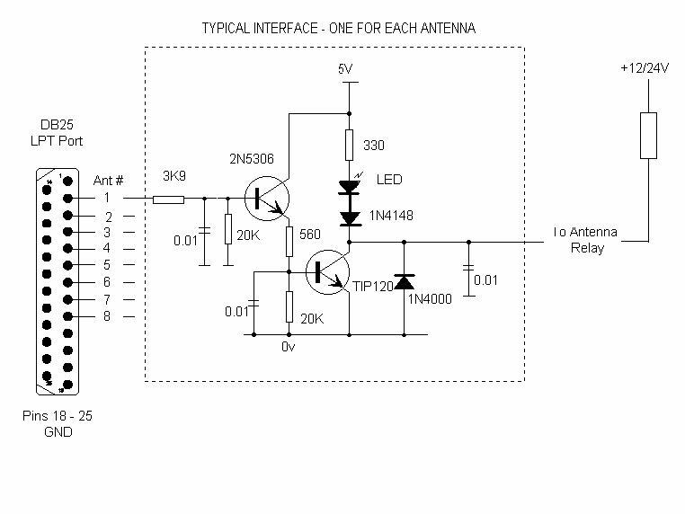

AAS\_1

The following circuit is a typical interface where the antenna switch uses common ground on the remote relays. This circuit can be used to automate the Ameritron RCS-8 remote antenna switch.

The Ameritron RCS-8 control box can be modified by the addition of a mini DPDT switch to disable the existing common connections on the LED and relay switch wafers. VCC power to the interface can be supplied by switching the common to the relay wafer to the interface. The LED and relay lines from the interface circuits can be connected directly to each LED switch position. This will provide a simple means to switch between MANUAL and AUTO modes. Diodes are provided to preclude any interference with manual operation.

The Ameritron RCS-4 controls the switching by feeding relay voltages thru the coax. This unit can be modified to work with Logger32, however, it must be modified to add a remote control line and make minor wiring modifications to the control box and remote relay box.

The following depicts a simplified Binary decoding circuit that can be used with Logger32 for selecting up to 9 different antennas. This circuit operates from the computer Parallel (LPT) port.

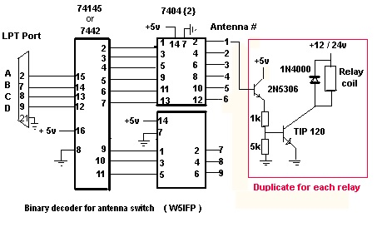

AAS\_2

*Created with the Personal Edition of HelpNDoc:* [*Free EBook and documentation generator*](http://www.helpndoc.com)

**Virtual SteppIR Controller (VSC)**

# Aki Yoshida JA1NLX

## 1.0 GENERAL

Logger32 provides a user interface to the SteppIR antenna transceiver controllers (Original and the new SDA 100) through the VSC Tool bar button. The VSC Dialog box provides control and the display of the SteppIR status for all of the SteppIR antenna selections.

**Note** that the optional SteppIR Transceiver Interface board is required to provide these features. Once interfaced to the SteppIR, Logger32 receives frequency data from the transceiver and sends and receives status and commands to the Transceiver Interface.

With the VSC implemented the user can:

* + Change the frequency/band setting of the antenna;
  + Change the radiation pattern of the antenna (except for the dipole)
  + Retract the elements;
  + Calibrate the antenna; and,
  + Change the current frequency setting using the Up/Down arrow buttons.

**Note** that the configuration of the VSC dialog box and the status and functionality available changes with the different antenna selections.

## 2.0 SETUP

### 2.1 Hardware

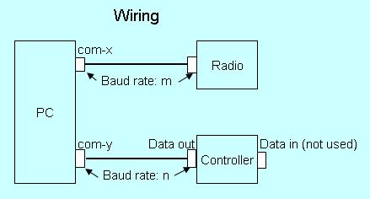

VSC\_1

The serial interface to the SteppIR controllers (both types) requires a null-modem cable between the Data Out port of the Transceiver Interface to an available serial port on your computer. Ensure that this is a true NULL MODEM cables (pins 2 & 3 crossed). A normal straight-through cable WILL NOT work. The PC serial port must be dedicated for VSC use and not shared with another device.

The Data In port of the Transceiver interface is not used by the VSC.

The serial interface to the radio is the same interface to Radio1 or Radio 2 used by Logger32. An additional serial interface is not required. If there is no interface between Logger32 and a radio, then the VSC can still be used, however frequency data from the radio will not be sent to the controller. The buttons on the VSC can still be used to control the antenna based on the Frequency and Band setup of the VSC.

### 2.2 Software

### 2.2.1 SteppIR Transceiver Interface

You must setup the SteppIR Rig Type and Baud Rate using the Transceiver Interface setup menu.

The baud rate must be between 4800 and 19.2k. Try 4800 first. When you change the baud rate, you must reset the SteppIR interface:

Turn the SteppIR interface off.

Remove the DC power cable.

After a few seconds, plug it back in and turn the interface back on.

Set the Mode to "General Freq" for the Original controller or "Autotrack" for the SDA 100 controller.

**Note** that the interface is not completely powered down until you physically remove the power cable. In addition, on the Original controller, although the term "General Freq" is labeled on the front panel, the LCD display will show "Ham Mode".

### 2.2.2 Logger32 VSC

The Setup menu item of the VSC provides the capability to:

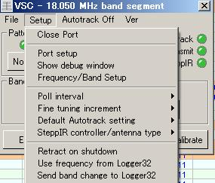

VSC\_2

* + **Open and Close Port** - This menu item is a "toggle". If the SteppIR port is closed, it will allow you to Open it. If Open, it will allow you to Close it;
  + **Port Setup** - This menu item configures the VSC COM port;

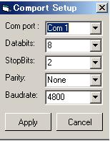

VSC\_3

* + **Com port** - Any available serial port;
  + **Databits** - 8;
  + **StopBits** - 2;
  + **Parity** - None;
  + **Baudrate** - Try 4800 first. Note that the baudrate MUST be the same as that configured for the controllers designated baud rate; and,
  + **Show Debug Window.**

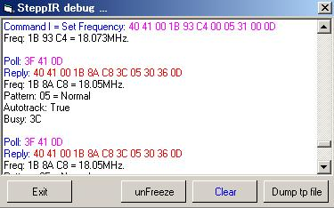

VSC\_4

The Debug window displays all serial data sent to and received from the SteppIR controller. If you have any problems you can monitor the data flow. Using the buttons provided you can:

* + - Freeze and UnFreeze the data flow;
    - Clear the window; and,
    - Dump (save) the captured data to a file.

The first two lines display a command from the VSC to the controller (Hex data) as well as a plain-language decode of the frequency data (bytes 4-7).

The next set of lines display a Poll from the VSC to the controller followed by the reply from the controller and a plain-language decode of the reply.

Specific details on all of the commands and possible replies can be found in the SteppIR Transceiver Interface Protocol document. This document and other SteppIR documents can be found at <http://www.steppir.com/Manuals>.

### 2.2.3 Frequency Band Setup

When you select the Frequency/Band setup menu item, The Setup Frequencies and Bands dialog box is displayed, with default data entered.

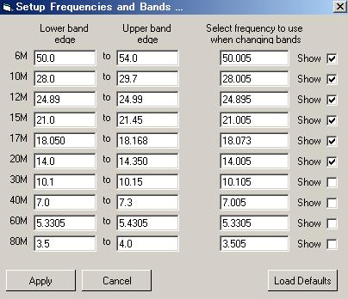

VSC\_5

The Lower and Upper band edge values are used by the VSC. Upper and Lower frequencies set the frequency range of each band. If the controller tells the VSC it's set to 14200, then the VSC turns the 20M LED green. If the controller tells the VSC it's tuned to 13500, then the VSC turns NO green LEDs on.

The 3rd column (Select frequency to use) is the default frequency used when a band is changed using the Band button on the VSC dialog box. When you click on the Band button of the VSC, both the controller and transceiver will change to this predetermined frequency.

The Show check box enables the Band button on the VSC dialog box for each band. If this box is checked, a button will be displayed for that specific band.

At any time, the default data can be reloaded by selecting the "Load Defaults" button.

### 2.2.4 Poll Interval

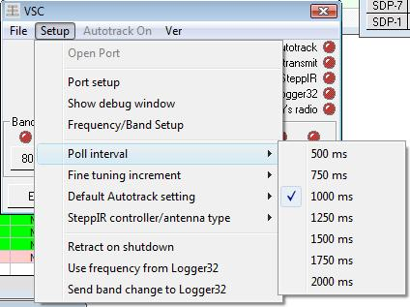

VSC\_6

This menu item selects the time interval between VSC polls to the Transceiver Interface. Try the default 1000 ms first.

### 2.2.5 Fine Tuning Increment

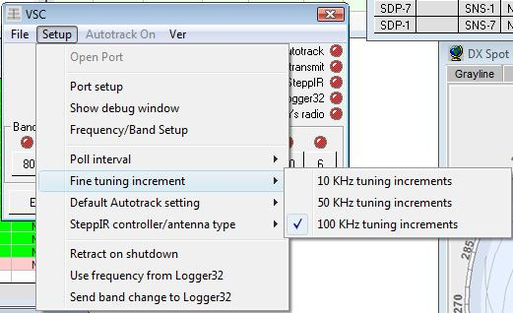

VSC\_7

This menu item sets the value to be used by the Up and Down buttons of the VSC dialog box. This sends the current frequency plus/minus increment to the Transceiver Interface.

### 2.2.6 Default Autotrack Setting

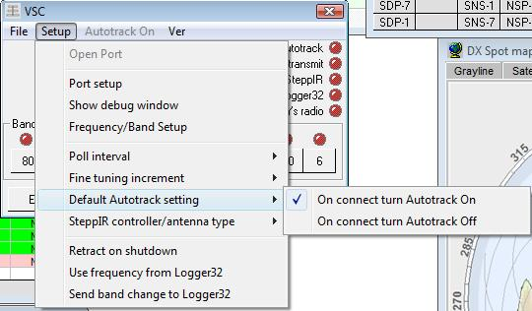

VSC\_8

This menu setting sets the default Autotrack state of the controller when the VSC is opened.

### 2.2.7 SteppIR Controller/Antenna type

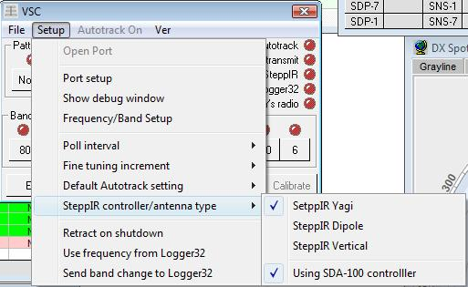

'

VSC\_9

This menu item has two functions. It selects both the antenna and controller type. If you are using the Original SteppIR controller ensure that the Using SDA 100 controller option is un-checked.

### 2.2.8 Retract on Shutdown

This menu item retracts the antenna elements when the VSC is closed.

### 2.2.9 Use Frequency From Logger32

This menu item will use the Logger32 radio frequency when sending commands to the Transceiver Interface.

### 2.2.10 Send Band Change to Logger32

This menu item will cause a band change message to be sent to the Logger32 radio whenever a Band button is selected in the VSC dialog box.

## 3.0 OPERATION

The VSC user interface provides the capability to operate and monitor the status of the Transceiver Interface.

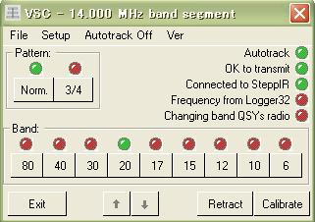

VSC\_10

The VSC dialog box displays status and control indicators/buttons as follows:

**Title Bar**: The Title bar displays the current band segment that the antenna is tuned to;

**Menu Bar**: There are a number of control functions available from the menu bar. From the Setup menu item you can:

* + Retract the antenna when the VSC is closed;
  + Use the frequency from Logger32; and,
  + Send band changes to Logger32.

**Autotrack**: You can also toggle Autotrack on and off.

**Pattern Panel**:

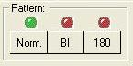 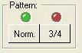

VSC\_11A VSC\_11B

Yagi Vertical

The Pattern panel provides the capability to select and display the setting of the antenna patterns available for the Yagi and Vertical antennas. There is no pattern control or status available for the dipole antenna.

**Status LEDs**:

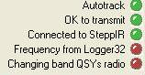

VSC\_12

There are a series of 5 status LEDs that show the current status of the VSC/Transceiver interface.

**Band Button Panel**:

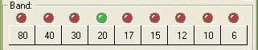

VSC\_13

The Band Button panel provides a configurable set of Band Selection buttons that select and display the status of the band setting of the antenna, These buttons are enabled/disabled by the Show check boxes on the Setup Frequencies and Bands dialog box. Click on any Band button to QSY to another band. If the Use frequency from Logger32 is checked, then Logger32 sends the new frequency to the controller as soon as you turn the VFO.

**Up/Down Arrow Buttons**:

These buttons enable you to increment or decrement the band segment that the antenna is tuned to. The Up and Down arrows are enabled when Autotrack is ON and Use frequency from Logger32 is NOT selected.

**Retract Button**:

Provides the capability to retract the antenna elements of the Yagi antenna.

**Calibrate Button**:

Executes the Transceiver Interface Calibrate function.

*Created with the Personal Edition of HelpNDoc:* [*Easily create Help documents*](http://www.helpndoc.com/feature-tour)

**Virtual UltraBeam Controller (VUC)**

# Jim Hargrave W5IFP and Aki Yoshida JA1NLX

## 1.0 GENERAL

This topic covers the setup of the UltraBeam. Open the Logger32 [Setup menu](#_topic_SetupMenu) and select the [Antenna type](#16.0_ANTENNA_TYPE_MENU_ITEM) menu item. Place a check mark by UltraBeam. This will toggle the Antenna Type icon (UB\_2) below to select the UltraBeam topic.

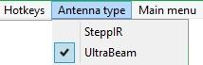

UB\_1

## 2.0 SETUP

The UltraBeam setup is opened by selecting the VUC (Virtual UltraBeam Controller) icon from the [Toolbar](#_topic_ToolBar).



UB\_2

This opens the UltraBeam virtual port

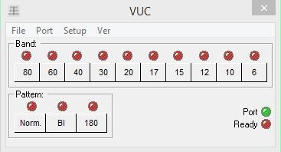

UB\_3

Select and open the serial port:

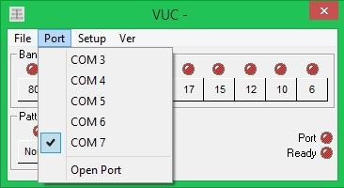

UB\_4

Select operating environment:

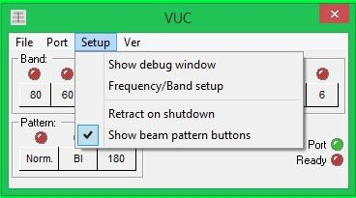

UB\_5

Selecting Frequency/Band setup will open a setup chart where band limits can be entered. Freq increment is a user option to adjust the minimum frequency increment for the antenna to re-tune.

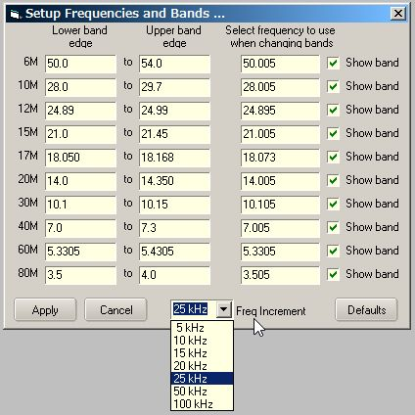

UB\_6

*Created with the Personal Edition of HelpNDoc:* [*iPhone web sites made easy*](http://www.helpndoc.com/feature-tour/iphone-website-generation)

**Rotators**

*Created with the Personal Edition of HelpNDoc:* [*Benefits of a Help Authoring Tool*](http://www.helpauthoringsoftware.com)

**Setup Antenna Rotator**

# W5IFP Jim Hargrave and K5LAD Jim Pickett

## 1.0 GENERAL

Logger32 can be configured for using up to 9 rotors. There are two places to setup the rotor: this section and [Setup Bands and Modes](#_topic_SetupBandsandModes). There is a column in the bands and mode chart. It must be populated for the rotor to function. Selection of the specific rotor for each band is accomplished by entering the desired rotor number in the Band and Mode chart. The rotor will only function on bands that you specify the rotor. If the radio is tuned to a band where you do not use the rotor, it will automatically close the rotor port.

The antenna positioning is communicated via Logger32 commands sent through the TxD line of an RS-232 serial port. This is accomplished by using [HotKeys](#_topic_HotKeys), [Macros](#_topic_MACROS) and mouse clicks.

The global positioning information is available as soon as a prefix or callsign is entered in the "Call" field of the [Logbook Entry window](#_topic_LogbookEntryWindow). Once this is accomplished, Logger32 will send positioning commands to the rotor control by either of the operator commands listed below. The user can select short path or long path positioning.



SAR\_13

**Note**: Logger32 computes this heading based on the center of the call area. The heading is refined once a Grid Square is entered into the [Logbook Entry window](#_topic_LogbookEntryWindow). This can be done manually, by QSO mask or QRZ.COM lookup. The heading will be then be re-computed to the center of the posted Grid Square

## 2.0 SUPPORTED ROTORS

### 2.1 Rotors

Logger32 supports the following popular auto-positioning rotors. Control is limited to azimuth positioning, as Logger32 does not provide for elevation control.

* + Alpha Spid (Direct support is provided, however some models use the HyGain DCU-1 protocol)
  + [EA4TX ARS](#_topic_EA4TXARSSupport)
  + Green Heron Engineering RT-20 and RT-21 (Use HyGain DCU-1 protocol)
  + [HyGain DCU-1](#_topic_HygainEZRotator)
  + ProSis Tel C
  + ProSis Tel D
  + Idiom Press - RotorCard DXA (Use HyGain DCU-1 protocol)
  + Idiom Press - RotorCard SDX (Use HyGain DCU-1 protocol)
  + Idiom Press - RotorEZ (Use HyGain DCU-1 protocol)
  + Yaesu GS-23 (GS-232A and B)
  + Yaesu GS-232B AZ/AZ A
  + Yaesu GS-232B AZ/AZ B
  + Yaesu RC28000 series (M2 Rotor)
  + Zelpro SAK-232
  + EZ Rotor Control ERC-M

### 2.2 External Interface

Logger32 also supports automatic rotor positioning and feedback through the external Interface; see [Using the Logger32 External Interface](#_topic_UsingtheLogger32ExternalInterfac) topic for programming information.

## 3.0 ROTOR SERIAL PORT SETUP

To setup the rotor controller, from the Logger32 [Main menu](#_topic_MainMenu) select the [Setup | Rotor](#10.0_ROTOR_MENU_ITEM) menu items.



SAR\_3

A window will appear where the user can select the type of rotor controller and setup the serial port parameters.

**Note**: If one is using the EA4TX ARS system, then the rotor setup window is slightly different. See the topic [EA4TX ARS Support](#_topic_EA4TXARSSupport).

The example below is for the [HyGain and RotorEZ](#_topic_HygainEZRotator) controller

### 3.1 Rotor Selection

First select the Rotor number and then set the port parameters.

Automatic tracking is available when using 2 or more rotors. This is useful if you have different antennas at different heights or on different towers. The tracking is by antenna position and not necessarily by rotor position. This function compensates for antenna offsets or mast slippage when properly configured.

Automatic synchronization is accomplished by selecting the rotors you want to follow.

Manual synchronization is covered in [para 6.6](#6.6_Synchronizing_two_rotors) below.

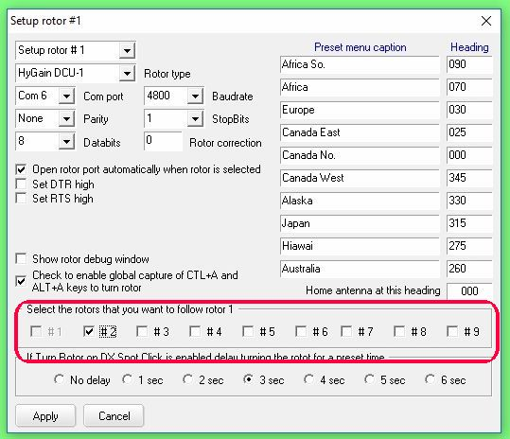

SAR\_4

### 3.2 Handshaking

The Set DTR high and Set RTS high check boxes are used to provide interface power on from the RTS/DTR lines. Some rotors may require these to be set high for handshaking.

### 3.3 Rotor Correction

It should be noted that Logger32 beam headings are calculated relative to True North.

The “Rotor correction” allows users to insert small offsets to the antenna-pointing angle for such things as magnetic variation and/or minor mast slippage. If the user used a magnetic compass to align their beam when it was installed, then this correction option will allow the user to compensate for the magnetic variation at their QTH. This will result in more accurate antenna pointing. However, if the magnetic variation was corrected when the antenna was aligned, then this should have a 0 (zero) for the compensation. If the user does not know the magnetic variation for their specific QTH, it can be determined from information available on the Internet. One such location is <http://www.geo-orbit.org/sizepgs/magmapsp.html>.

There is an on-line magnetic declination calculator at <http://www.ngdc.noaa.gov/geomag/geomag.shtml>. Click on the Declination Online Calculator link.

If the mast has slipped and the antenna is no longer aligned with the rotor indicator, Logger32 can compensate for this slippage using the same option. As an example, if your antenna has slipped 10 degrees CW, then the “Rotor compensation” box should reflect –10. If it has slipped 10 degrees CCW then the compensation should be 10.

### 3.4 HotKeys

The <**Ctrl+A**> and <**Alt+A**> key combinations can be set for Global capture. This will allow the rotor commands to be sent regardless of which window has focus.

**Note**: You need to use caution in selecting this option if you run other programs that use these hot keys. Selection for Global use will route the hot keys to rotor commands even if Logger32 is running in background.

### 3.5 Rotor Presets

The Rotor presets are configured by the user to allow for quick positioning the antenna heading to preset positions. Enter an appropriate label and heading. See [SAR\_4](#SAR_4) above for samples.

Pressing the Preset Rotor Headings button on the Toolbox accesses the presets.

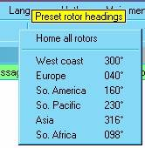

SAR\_17

When the focus is in the [Logbook Entry window](#_topic_LogbookEntryWindow), the user can position the antenna to a preset “HOME” position by entering the <**Ctrl+H**> key combination or by selecting “Home all rotors” from the "Preset rotor headings" button on the Logger32 Toolbar.

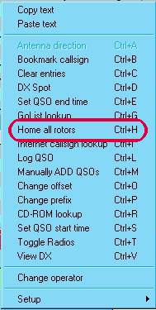

SAR\_16

When the “Home” command is selected, it will position all rotors to the designated Home position.

### 4. Rotor Debug Window

A check mark in the "Show rotor debug window" will open the Rotor Debug window when you close the setup window.

The Rotor Debug window can also be opened by a right-click on the [Rotor panel](#3.5_Rotor_Control_Status) in the [Lower Status bar](#3.0_LOWER_STATUS_BAR) and select the “Show rotor debug window” menu item.

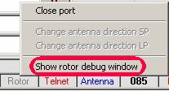

SAR\_14

The following are screen captures of the debug window showing the data exchange between the rotor controller and Logger32. Also shown is the [Tracking window](#_topic_TrackingWindow1) showing the rotor command line (red) and the rotor current position line (black). You can see the current position data changing as the updates are received from the rotor controller.

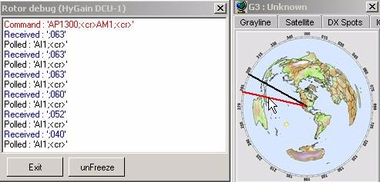

SAR\_1

HyGain DCU-1 Rotor Controller

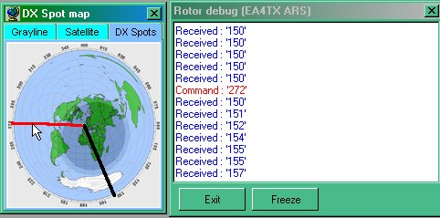

SAR\_2

EA4TX ARS Rotor Controller

## 5.0 OPENING AND CLOSING THE ROTOR PORT

This can also be accomplished by right-clicking on the [Rotor Status panel](#3.5_Rotor_Control_Status) on the [Lower Status bar](#3.0_LOWER_STATUS_BAR) and selecting "Close Port" or "Open Port" from the pop-up menu.

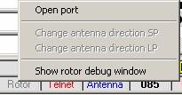

SAR\_6

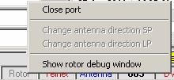

SAR\_7

### 5.1 Rotor Port Status

The status is displayed when the mouse is over the [Rotor Status panel](#3.5_Rotor_Control_Status) in the [Lower Status bar](#3.0_LOWER_STATUS_BAR).

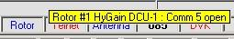

SAR\_5

## 6.0 METHODS OF ROTATING THE ANTENNA

The user can determine whether to use short or long path. This can be accomplished using [HotKeys](#_topic_HotKeys), the mouse cursor or [Macros](#_topic_MACROS)

### 6.1 Logbook Entry Window - HotKeys

When the focus is on the [Logbook Entry window](#_topic_LogbookEntryWindow) and a callsign has been entered into the Call field, the positioning information to the antenna controller can be sent by using the following hotkeys:

<**Ctrl+A**> will position the antenna using short path

<**Alt+A**> will position the antenna using long path

**Note**: The Hotkeys can be set to “Global” during rotor setup and they will work with the focus in any window.

### 6.2 Mouse Clicks

This method is available with the focus in any window.

Position the cursor over the [Rotor panel](#3.5_Rotor_Control_Status) of the [Lower Status bar](#3.0_LOWER_STATUS_BAR). When on the left side of the box you will see a tool tip box that displays "Click to turn Short Path". A left-click will then activate the rotor command.

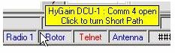

SAR\_8

When the cursor is over the right side of the box, you will see a tool tip box that displays "Click to turn Long Path". A left-click will then activate the rotor command.

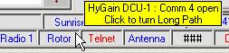

SAR\_9

You can also select the path by a right-click on the [Rotor panel](#3.5_Rotor_Control_Status) of the [Lower Status bar](#3.0_LOWER_STATUS_BAR) and click on the appropriate line to select the antenna direction using short (SP) or long (LP) path.



SAR\_7

### 6.3 Sound Card, CW Machine and Data Terminal Windows

When the focus is on the [Sound Card](#_topic_SoundCardDataWindow1), [CW Machine](#_topic_CWMachineWindow), or [Data Terminal](#_topic_DataTerminalWindow) windows, the antenna can be rotated by the use of a Macro command, once a callsign has been entered into the [Logbook Entry window](#_topic_LogbookEntryWindow) "Call" field. The callsign may be entered manually or by left-clicking on a callsign in the [Sound Card Data window](#_topic_SoundCardDataWindow1) received text.

The Macro command [$rotor$](#$rotor$) will rotate the antenna to the computed short path azimuth.

The Macro command [$rotorlp$](#$rotorlp$) will rotate the antenna to the computed long path azimuth.

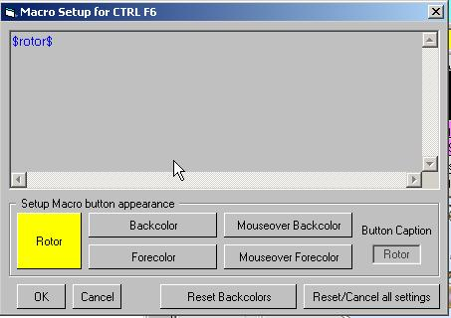

SAR\_10

### 6.4 Tracking Window

Some Rotator controllers provide current position data feedback. Logger32 receives this data via the RxD line of the RS-232 serial port. This real-time position data is displayed on the [Tracking map](#_topic_TrackingWindow1) when the display is set for "Azimuthal Equidistant Projection".

**Note**: The control/feedback info to/from the Rotator applies to all map tabs except the Satellite tracking

The Rotator can be controlled by mouse clicks while focus is in the [Tracking window](#_topic_TrackingWindow1) and the Tracking Window is set to Azimuthal Map display as described later in this section. Real-time position data will not appear if you do not have a Rotator installed and/or its support software running.

**Note**: In order for the Rotator position display to be accurate, the Tracking window must have the "Aspect Ratio locked".

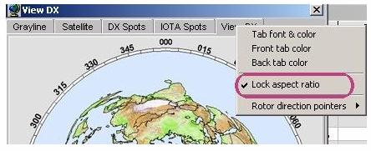

SAR\_12

There will appear a black line (default – color is user-definable) that indicates the antennas current azimuth position. This line will extend from the center of the map to the outer perimeter of the circle. This line will move to follow the antenna rotation. Logger32 polling the Rotator controller determines the antenna current position. The current position is returned to the program from the Rotator controller using the RXd line of the RS-232 Rotator control port

Moving the mouse cursor into the circular azimuthal map will create a red line extending from the center of the map through the mouse cursor to the periphery of the map. This line can be rotated around the map by changing the position of the mouse cursor within the confines of the circular map. When the position of the mouse results in the red line pointing in the direction you want your antenna to rotate to, click the left mouse button. The rotator will be commanded by Logger32 to point in that direction (the so-called “short path” direction to a target location). Alternatively, right-clicking will position the antenna 180 degrees away from the short path to the target, on the targets “long path” heading. The most accurate positioning will occur when clicking near the periphery of the circular map, with the red line passing through the target DX location or Spot.

**Note**: If the mouse cursor is positioned and clicked while on the DX Spot, the rotator action is inhibited and the DX spot info is entered into the [Logbook Entry window](#_topic_LogbookEntryWindow).

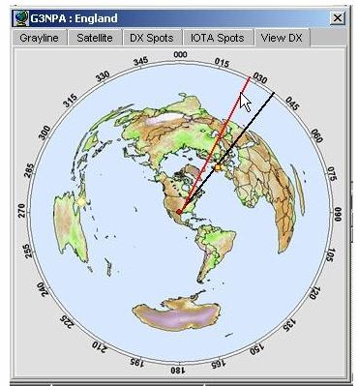

SAR\_11

The Rotator display includes a Beam width display wedge. This display can be adjusted to the anticipated Beam pattern.

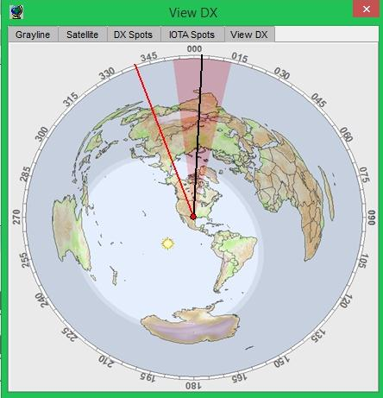

SAR\_18

The following reflects the Beam pattern for a Reversible SteppIR antenna.

**Note**: Say for example, you have setup a 40 degree wedge. SteppIR 180 will show a 60 degree wedge (150% of whatever is setup as normal) and the SteppIR Bi will show two 80 degree wedges (200% of whatever is setup as normal).

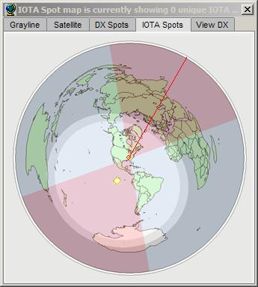

SAR\_19

The Rotator direction pointers can be configured by Right-Clicking on the header to the right of the "View DX" box.

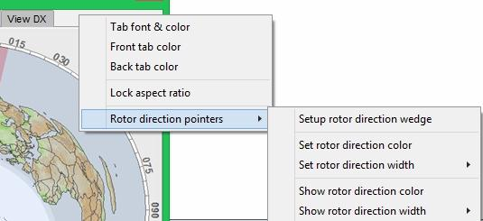

SAR\_20

The Rotator indicator wedge can be configured for color, Opacity and Beam width. If you have a bi-directional SteppIR antenna, you can check the box: Enable SteppIR Bi/180 wedge, if desired.

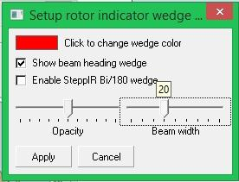

SAR\_21

### 6.5 Turn rotor on DX spot click

### 6.5.1 Enabling the Auto Point Option.

Selecting this option will setup the rotor to automatically rotate to the desired antenna heading based on the callsign in the [Logbook Entry CALL field](#_topic_LogbookEntryWindow). This function is activated by right clicking on the Rotor box in the lower stats bar and selecting “Turn rotor on DX Spot”

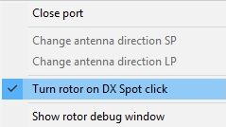

SAR\_22

This function is applied to the Active rotor based on the following selections:

* + 1. Manual entry in the [Logbook Entry CALL field](#_topic_LogbookEntryWindow) (When focus is toggled from the CALL field);
    2. Clicking on a DX spot in the [DX Spots window;](#_topic_DXSpotsWindow1)
    3. Clicking on a spot in the [Bandmap](#_topic_TheBandmap);
    4. Entering a callsign in the [CW Machine window](#_topic_CWMachineWindow); and,
    5. Clicking on a callsign in the Sound [Card Data window](#_topic_SoundCardDataWindow1).

### 6.5.2 Setting Rotor Delay.

Automatic Operation of the Antenna Rotor has a slight delay in heading information sent to the rotor. This delay allows Logger32 to refine the heading based on location information provided by QSO Mask and/or callsign lookup. The user can adjust the delay to compensate for individual callsign lookup time and heading refinement.

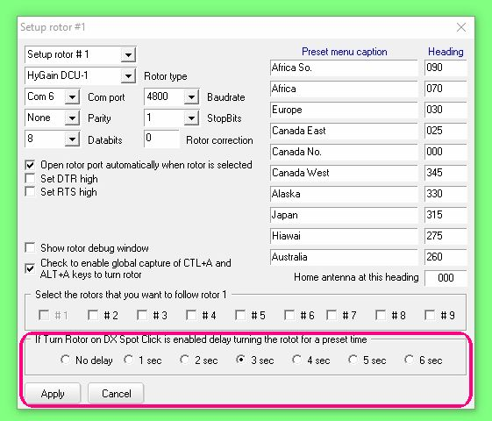

SAR\_28

### 6.6 Synchronizing two rotors:

A new feature has been added, in version 3.40.221, to allow a user to have two rotors, on different antenna systems, both can be used during a single Logger32 session. Each rotator control box must have an additional interface to attach to the computer running Logger32. This could be interfaces like the RotorEZ or several others which have been made available.

One new interface, which has the hardware to interface Logger32 to two rotators is the ERC-M from Easy Rotor Control in Germany <http://schmidt-alba.de/eshop/>.

A simple but successful configuration consists of the following:

* 1. ERC-M Interface card, available as an RS-232C or USB. It is offered as either a kit or ready-made. This device can be used as an azimuth- and elevation-rotator controller or a dual azimuth which would be the typical usage with Logger32. The website has copy of their manual at the link above and it explains many of the hook –up configurations available.
  2. Each of the two rotor control boxes requires a Rotorcard Kit for ERC-M. Note that, at this time these units are only available as a kit but it is a relatively easy kit to build. These two cards are cabled to the ERC-M interface card which is cabled via RS-232 cable to the computer.

To setup the ERC-M devices, click on [Setup | Rotor](#10.0_ROTOR_MENU_ITEM). Multiple rotators can be identified in the upper left box. Choose the rotor number you plan to use in this box. The example below for Rotor #1 shows the protocol selection for the ERC-M is GS232B AZ/AZ B.

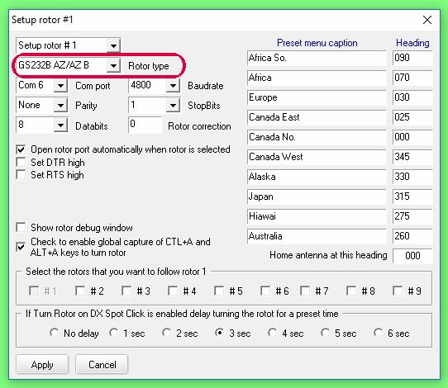

SAR\_23

Insert the Com port number you will use and add the baud rate and other information into the proper boxes. **Note:** the Rotor correction option is discussed in the heading [3.3 Rotor Correction](#3.3_Rotor_Correction) above.

The box for “Open rotor port automatically when rotor is selected” should be checked when using dual rotators.

To sync the rotators, note that the primary rotor will be currently in operation. When using the Azimuthal Equidistant Projection map, centered on your QTH, the wedge will be displaying the direction of that antenna. If you are using the new feature of the “Show digital heading” display of direction in numerals (explained below), it will be displaying the direction of the wedge and the primary rotor.

To sync the other rotor, click on the  icon to display this pull-down:

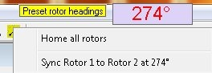

SAR\_24

Click on the message below “Home all rotors,” to perform the sync operation. In the example shown above, the primary rotor is pointed west. The wedge shows a westerly distribution of the RF (hopefully) and the digital position readout shows that it’s aimed at 274 degrees.

The other rotor is assumed aimed somewhere else and we don’t really care where it is. It can be CW of the primary rotor’s 274 degrees position or CCW. When you click the “Sync Rotor….” line, the secondary rotor will move to 274 degrees also to allow comparison of different antenna configurations.

**Note**: The object is to align two aerials on different rotors in the same direction. Remember that the direction pointer/wedge and the digital readout show the aerial direction and not necessarily the rotor direction. Logger32 will take into consideration any fixed offsets applied to the rotor setup.

6.7 Show Digital heading readout

This feature allows the user to know the exact direction to which the rotor has been aimed. It is the same type of window as the floating time panel found at [3.1 Logger32 Date and Time Panel](#2.5_The_Date_and_Time_Panel) in the [Status Panels](#_topic_StatusPanels) topic

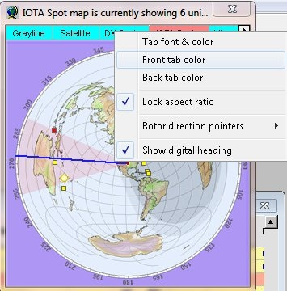

SAR\_25

This floating panel is reached by right-clicking on any of the tabs on the map and clicking on "Show digital heading."

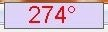

SAR\_26

Right-click on the floating direction panel to see the setup options available with the feature.

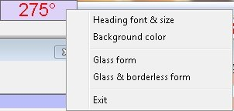

SAR\_27

*Created with the Personal Edition of HelpNDoc:* [*Create help files for the Qt Help Framework*](http://www.helpndoc.com/feature-tour/create-help-files-for-the-qt-help-framework)

**Hygain E-Z Rotator**

# Hal Miller KB1ZQ and Jim Hargrave W5IFP

## 1.0 GENERAL

This section describes the setup for the HyGain / Rotor-EZ Rotator control. Setup is reached by selecting the Logger32 [Main menu](#_topic_MainMenu) [Setup | Rotor](#10.0_ROTOR_MENU_ITEM) menu items. The Rotor Setup window will display.

**Note**: If Rotor-EZ is used, the control chip must be the version allowing RS-232C communications. Rotors without this option will not work with Logger32.

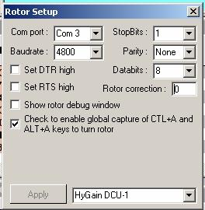

HRE\_1

## 2.0 SETUP

**Com Port** – Set to the serial port to which the rotor is connected.

**Baudrate** – Set to 4800 for Rotor-EZ.

**StopBits** – Set to 1

**Parity** – None

**Databits** – Set to 8

**Rotor Correction** - Enter azimuth correction. **Note**: These settings allow for a fixed offset where the antenna has slipped on the mast and is no longer aligned to true north or south,

## 3.0 ROTOR EMULATION

Choose HyGain DCU-1

## 4.0 OPERATION

To control the rotor a call sign must be entered in the [Logbook Entry window](#_topic_LogbookEntryWindow) then press the <**Ctrl+A**> key combination. The rotator will swing to the direction of the station in the [Logbook Entry window](#_topic_LogbookEntryWindow).

**Note**: The Rotor-EZ provides position feedback and will display on the tracking map if the map is set to Azimuthal Equidistant Projection. See [Tracking Window setup](#_topic_TrackingWindow1).

*Created with the Personal Edition of HelpNDoc:* [*What is a Help Authoring tool?*](http://www.helpauthoringsoftware.com)

**EA4TX ARS Support**

Geoff Anderson G3NPA

## 1.0 GENERAL

This section is designed to assist those using the EA4TX ARS system to interface with Logger32.

**Important Note**; In order for the full range of options described below to function correctly it is necessary that the version of ARSWIN in use must be Ver. 2.2a or later. In addition, at present it is not known if a required patch to the ARS.INI file is included in distribution copies so please make sure that the following is included in the ARS.INI file (found in the Windows directory).

**[Logger32]**

**Active=1** - Active =1, sends data to lpCaption program and =0, disables this option

**Refresh=1** - Timer value in seconds, for sending' the azimuth position. The default=1 second

**lpCaption=Logger32** - The name of the caption program, Logger32 by default Initially.

Open Logger32 and select the [Main menu](#_topic_MainMenu) [Setup | Rotor](#10.0_ROTOR_MENU_ITEM) menu items to open the Rotor Setup window.

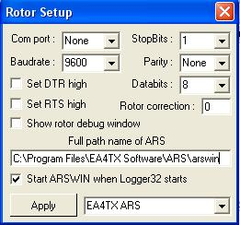

EAS\_1

Select the EA4TX rotor and enter the path name to the ARSWIN program. **Note** that the COM port settings in the table above are meaningless for the ARS system. If you want the ARSWIN program to start whenever you bring up Logger32, then check the "Start ARSWin when Logger32 starts" check box. **Note**: If you select the option for Logger32 to start the ARSWIN software, Logger32 will also close the ARSWIN software on exit. If you do not want this to happen, then do not check the start box.

You can load Logger32 and the EA4TX applications in any sequence. If you start Logger32 first, the [Rotor Panel](#3.5_Rotor_Control_Status) in the [Lower Status bar](#3.0_LOWER_STATUS_BAR) of Logger32 will change color from red to blue when the EA4TX software is started & vice versa when stopped.

If Logger32 sees the EA4TX application, then the ANTENNA DIRECTION menu item (right-click on [Logbook Entry window](#_topic_LogbookEntryWindow) data field) will be enabled, Use either of the two Antenna Direction hotkeys, <**Ctrl+A**> or <**Alt+A**>, to transfer the angle data to the EA4TX control panel and the antenna will rotate to the new position.

A right-click on [Rotor](#3.5_Rotor_Control_Status) on [Lower Status bar](#3.0_LOWER_STATUS_BAR) will enable the Rotor menu items. Placing the mouse over the Rotor box will also bring up two pop-up menu items. The left side of the box will bring up a short path menu and the right side of the box will bring up a long path menu. A left-click on either of these pop-up menu items will activate the antenna rotation to the specified path.

Alternatively, it is now possible to control the antenna from the [Tracking window](#_topic_TrackingWindow1). All maps (except for the Satellite tracking) when in their great circle projection (Azimuthal Equidistant projection) will also display one or two indicator lines as shown below:-

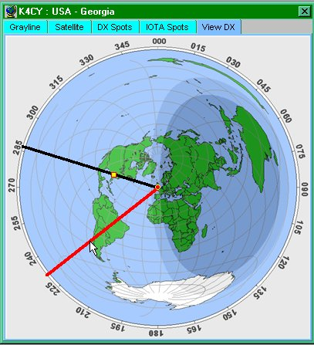

EAS\_2

In this example the black line represents the actual antenna position. The red line is always drawn between the cursor head and the center of the map and this line can be rotated around the full 360 degrees by simply moving the mouse and represents the required (or preset) pointing angle. Note that this line will ONLY appear when the cursor is inside the compass circle. Having selected the required angle a simple left-click on the mouse will drive the antenna to the short path direction. A right-click will make the antenna go to the same point via the long path.

Menu items to set the colors of the two lines and their widths can be found by right clicking on one of the 5 tabs.

You are strongly advised to lock the aspect ratio of the maps to preserve the 1:1 ratio of the azimuthal maps. If these are displayed elliptically, then the pointing angle will be incorrect.

The Macros [$rotor$](#$rotor$) (short path) and [$rotorlp$](#$rotorlp$) (long path) can also be used to rotate the antenna while focus is in the [Sound Card Data window](#_topic_SoundCardDataWindow1), [Data Terminal window](#_topic_DataTerminalWindow), or [CW Machine](#_topic_CWMachineWindow) if desired.

**Note**: If you do not currently own the EA4TX ARS hardware, then select the “demo” mode for RC1 (see menu item Pref.| Setup| RC1 Board) and it is possible to “play” with the system.

Copies of ARSWIN can be downloaded from <http://www.ea4tx.com>

*Created with the Personal Edition of HelpNDoc:* [*Create HTML Help, DOC, PDF and print manuals from 1 single source*](http://www.helpndoc.com/help-authoring-tool)

**TNCs**

*Created with the Personal Edition of HelpNDoc:* [*Create help files for the Qt Help Framework*](http://www.helpndoc.com/feature-tour/create-help-files-for-the-qt-help-framework)

**KAM Plus**

# Mike Mace VK3SU

## 1.0 GENERAL

This section provides information on setting up Logger32 to operate with the KAM+ TNC using KAM-8.0 or 8.2 firmware.

I run my KAM+ in its default setting with these personal preferences:

INTFACE TERMINAL

CWPTT ON

ECHO OFF

HEADERLN ON

USERS 5/5

With these settings, the KAM+ will operate in the following selected modes correctly:

AMTOR

ASCII

CW

G-TOR

PACKET

PACTOR

RTTY

These modes are selected from the KAM+ Terminal mode using the CONTROL\_C instruction. You must enter the CONTROL\_C (letter) in full and it must be in UPPER CASE. Do not use abbreviations like ctrl^(letter) as this will not work. All this will do is send a set of characters to the modem and it will reply with that lovely $ EH?

The KAM+ command set, however, is not case sensitive and commands may be entered in both upper and lower case. For example, "mycall" and "MYCALL" are both acceptable.

In the text descriptions and examples below, any text below that is bracketed by a "$" is a Macro command described in the section [MACROS topic](#_topic_MACROS).

## 2.0 AMTOR MODE

The AMTOR mode selection macros are:

CONTROL\_CX For command mode

echo on To see your transmitted text

AMTOR To go to AMTOR stand by mode

Or

CONTROL\_CX For command mode;

echo on To see your transmitted text

AMTOR [$call$](#$call$) To go to AMTOR calling the selected callsign

The following KAM+ AMTOR instructions can be used in Logger32:

CONTROL\_CA Abort link

CONTROL\_CD Break link and stay in standby

CONTROL\_CE Returns to standby after transmit buffer is sent. Also puts +? if linked

CONTROL\_CI Inverts MARK/SPACE

CONTROL\_CR Immediately returns to receive mode regardless of TX buffer

CONTROL\_CS Selects the next MARK/SPACE shift (Hz)

CONTROL\_CT Enters transmit mode

CONTROL\_CX Returns to command mode

CONTROL\_CW Sends the Who Are You inquiry

An example AMTOR macros is:

CONTROL\_CT Enter transmit mode

Hello [$call$](#$call$),[$name$](#$name$) from mike de: [$mycall$](#$mycall$) Send his call, name and mycall

You are 599-30-[$serialnum$](#$serialnum$) Send report, zone and serial number

CONTROL\_CE Return to standby

## 3.0 ASCII MODE

The ASCII mode selection macro is:

CONTROL\_CX For command mode;

echo on To see your transmitted text

ascii To set 110 baud ASCII (default)

The following KAM+ ASCII instructions can be used in Logger32:

CONTROL\_CE Returns to standby after transmit buffer is sent. Also puts +? if linked

CONTROL\_CI Inverts MARK/SPACE

CONTROL\_CR Immediately returns to receive mode regardless of TX buffer

CONTROL\_CS Selects the next MARK/SPACE shift (Hz)

CONTROL\_CT Enters transmit mode

CONTROL\_CX Returns to command mode

CONTROL\_Cn n = baud speed as per manual (0 – 9)

An example ASCII macro is:

CONTROL\_CT Enter transmit mode

[$call$](#$call$) de [$mycall$](#$mycall$) Send his call and my call

CONTROL\_CE Return to standby

To change baud rates, use the following instruction:

CONTROL\_Cn Where n = speed (baud )

1 = 45

2 = 50

3 = 57

4 = 75

5 = 100

6 = 110

7 = 150

8 = 200

9 = 300

0 = ascbaud

## 4.0 CW MODE

The CW mode selection macro is:

CONTROL\_C Return to command prompt

Echo on See your transmitted text

cw 15 CW speed of 15 wpm

The following KAM+ CW instructions can be used in Logger32:

CONTROL\_CE Returns to standby after transmit buffer is sent. Also puts +? if linked

CONTROL\_CL Locks transmit and receive speeds

CONTROL\_CR Immediately returns to receive mode regardless of TX buffer state

CONTROL\_CT Enters transmit mode, sending key strokes immediately

CONTROL\_CU Unlocks the speed to allow tracking

CONTROL\_CX Returns to command mode

CONTROL\_Cn n = CW speed as per manual (0 – 9)

An example macro to call CQ is:

CONTROL\_CT Enter transmit mode

cq cq cq de [$mycall$](#$mycall$) Call CQ 3 times followed by my call

cq cq cq de [$mycall$](#$mycall$) And again

cq cq cq de [$mycall$](#$mycall$) And again

CONTROL\_CE Return to standby

An example contest macro is:

CONTROL\_CT

[$call$](#$call$) ur 599 oc001 [$serialnum$](#$serialnum$) de [$mycall$](#$mycall$) +

CONTROL\_CE

Some TNCs require a short delay after issuing a CONTROL\_X instruction or TNC command. For example, the KAM+ TNC does not like a CONTROL\_CT instruction to put it in transmit mode immediately following a CW speed set command. The KAM+ instruction sequence:

CONTROL\_CX

CW $speed+$

CONTROL\_CT

does not work correctly. The TNC takes several milliseconds to set the TNC speed before it is ready to receive input so the CONTROL\_CT instruction must be delayed.

The Logger32 macro statement $delay$ inserts a 250-msec. delay before executing the next macro statement. The following macro correctly sets the CW speed for the KAM+:

CONTROL\_CX

CW 20

$delay$

CONTROL\_CT

To change CW speed, use the following instruction:

CONTROL\_Cn

Where n = speed (baud)

1 = 5

2 = 10

3 = 15

4 = 20

5 = 25

6 = 30

7 = 35

8 = 40

9 = 45

0 = 50

## 5.0 G-TOR MODE

The G-TOR mode selection macros are:

CONTROL\_CX Return to command prompt

echo on See your transmitted text

gtor Sets G-TOR Standby mode

or

CONTROL\_CX Return to command prompt

echo on See your transmitted text

gtor [$call$](#$call$) Sets G-TOR mode calling the specified station

The following KAM+ G-TOR instructions can be used in Logger32:

CONTROL\_CA Abort link

CONTROL\_CB Enter transparency mode {binary}

CONTROL\_CD Break link and stay in standby

CONTROL\_CE Returns to standby after transmit buffer is sent also puts +? If linked

CONTROL\_CR Immediately returns to receive mode regardless of TX buffer

CONTROL\_CS Selects the next MARK/SPACE shift (hz)

CONTROL\_CT Enters transmit mode

CONTROL\_CX Returns to command mode

CONTROL\_C0 Sets automatic baud rate

CONTROL\_C1 Forces 100baud (irs)

CONTROL\_C2 Forces 200baud (irs)

CONTROL\_C3 Forces 300baud (irs)

An example G-TOR CQ macro is:

CONTROL\_CT Enter transmit mode

CQ CQ CQ DE [$mycall$](#$mycall$) $mycall$ $mycall$ Send CQ followed by my call

PSE ARQ IN GTOR MODE ONLY Additional text transmitted

K K K Additional text transmitted

CONTROL\_CE Return to standby

## 6.0 PACKET MODE (AX25)

The Packet mode selection macros is

CONTROL\_CX Return to command prompt

echo off Do not view transmitted text

Packet is pretty straightforward to most people (said with tongue in cheek). This mode is the default mode of the Kam+. The Kam+ is dual port in this mode {default switch STREAMSW 7E/$7C (~/|)} which are the tiled and pipe keys.

Some commands will affect both ports and some will affect the VHF port only, so we do need to specify port paths for either connect requests or beacon traffic. HF is port 1, VHF is port 2.

As the default mode is packet, the CONTROL\_C instruction is not required in the macros. However, there does need to be a carriage return at the end of the last command to instruct the TNC to execute the macro statements.

Macros to switch between VHF and HF with the TNC using the default settings are:

~a HF streamswitch character $7e or what you have set for your switch

|a VHF streamswitch character $7c or what you have set for your switch

**Note**: The 'a' can be any letter down to 'j' that provides 10 user ports

An example macro to connect to a VHF DX cluster is:

|e

callsign of the cluster station

or if it is on HF

~c

callsign of the cluster station

The following may be looked at if you are in the situation where your network is shared by DX clusters, BBSs and APRS traffic.

The commands below are examples only and you will need to enter your own callsign and the calls of the high site digipeaters with appropriate pathing. The numbers 3748.33ST14520.11E, shown in the examples below, should be replaced with your Lat/Long coordinates, in the format "degmin.sec".

Remember, the KAM+ is dual port in packet mode and if your HF is purely used for voice I strongly suggest that when entering commands into the TNC that you use the following format:

command set /command example beacon /e 20

The following commands will program your beacon to transmit on VHF only every 20 minutes

Command HF port/VHF port

BEACON E 10/E 35

BTEXT :blna :HF gateway is active 10.149lsb ui with gate hf->vhf

blt 1 E 00:05:00/E 00:20:00

blt 2 E 00:12:00/E 00:30:00

blt 3 E 00:22:00/E 00:40:00

blt 4 E 00:10:00/E 00:50:00

lt 1 =3748.33ST14520.11E- Station description

lt 2 =3748.33ST14520.11E- Station description

lt 3 =3748.33ST14520.11E- Station description

lt 4 :blna :HF-gateway on 10.149lsb ui with gate hf->vhf only

ltp 1 aprs v MMM/APRS

ltp 2 aprs v echo,MMM/aprs v LLL

ltp 3 aprs v MMM,OOO/aprs V WIDE2-2,LLL

ltp 4 aprs v MMM/aprs v trace2-2,LLL

This is not covered very well in the Kam+ manual. I got these from the manual of the new Kantronics modem.

The above commands all correspond with each other:

blt2 – lt2 – ltp2 where:

blt is beacon times per port

lt2 is information that is to be beaconed

ltp2 is the port and path with digi-peater routes

## 7.0 PACTOR MODE

The PACTOR mode selection macros are:

CONTROL\_CX Return to command prompt

echo on View transmitted text

pactor PACTOR standby mode

CONTROL\_CX Return to command prompt

echo on View transmitted text

pactor $call$ PACTOR the specified callsign

CONTROL\_CX Return to command prompt

echo on View transmitted text

ptlisten PACTOR listening mode for FEC and ARQ

The following KAM+ PACTOR instructions can be used in Logger32:

CONTROL\_CA Abort link

CONTROL\_CD Break link and stay in standby

CONTROL\_CE Returns to standby after transmit buffer is sent. Aso puts +? if linked

CONTROL\_CR Immediately returns to receive mode regardless of TX buffer

CONTROL\_CS Selects the next MARK/SPACE shift (Hz)

CONTROL\_CT Enters transmit mode

CONTROL\_CX Returns to command mode

CONTROL\_C0 Sets automatic baud rate

CONTROL\_C1 Forces 100baud (irs)

CONTROL\_C2 Forces 200baud (irs)

An example CQ macro is:

CONTROL\_CT Enter transmit mode

CQ CQ CQ DE [$mycall$](#$mycall$) $mycall$ $mycall$ -- PTOR

PSE ARQ

K K K

CONTROL\_CE Return to standby

## 8.0 RTTY MODE

The RTTY mode selection macro is:

CONTROL\_CX Return to command prompt

echo on Display transmitted data

rtty 45 Enter RTTY mode at 45 baud

The following KAM+ RTTY instructions can be used in Logger32:

CONTROL\_CE Returns to standby after transmit buffer is sent. Also puts +? if linked

CONTROL\_CI Inverts MARK/SPACE

CONTROL\_CL Sends letters shift characters

CONTROL\_CN Sends numbers shift characters

CONTROL\_CR Immediately returns to receive mode regardless of TX buffer

CONTROL\_CS Selects the next MARK/SPACE shift (Hz)

CONTROL\_CT Enters transmit mode

CONTROL\_CX Returns to command mode

CONTROL\_Cn n = baud speed as per manual (0 – 9)

An example CQ macro is:

CONTROL\_CT Enter transmit mode

CQ CQ TEST DE $mycall$ $mycall$ $mycall$

CONTROL\_CE Return to standby

To change RTTY speed, use the following instruction:

CONTROL\_Cn Where n = speed (baud )

1 = 45

2 = 50

3 = 57

4 = 75

5 = 100

6 = 110

7 = 150

8 = 200

9 = 300

0 = ascbaud

*Created with the Personal Edition of HelpNDoc:* [*Write EPub books for the iPad*](http://www.helpndoc.com/create-epub-ebooks)

**PK232-HK232**

# Jim Hargrave W5IFP

## 1.0 GENERAL

This section will provide the basic setup and interface of the AEA PK-232 & Heathkit HK-232 with Logger32. These TNCs are electrically identical. The Heathkit HK-232 was built by AEA for Heathkit and only differs in the front panel configuration.

## 2.0 DATA TERMINAL WINDOW SETUP

Open the [Data Terminal window](#_topic_DataTerminalWindow) and select "Config | Port setup" This will open the Data Terminal Comport Setup dialog box.

Enter the terminal parameters for your unit. If you do not have the PK-232/HK-232 Terminal port parameters configured then you can insert the following default settings. These settings will also work if you do not use a battery backup. Once you have entered the Port parameters, close the window and turn on the PK-232/HK-232. The Autobaud routine will work using the "\*" <**Enter**> <**Shift+8**>. The separate keypad "\*" does not work for this function.

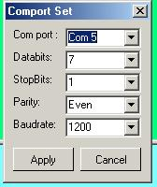

PK232\_1

## 3.0 MODE MACROS

Once you have the PK-232/HK-232 communicating with Logger32, you can setup the Mode Macros. Open the [Data Terminal window](#_topic_DataTerminalWindow) and select "Config | Mode macros"

You can enter the modes in your order of preference in the left-hand side of the chart. Click on the <**Show Macro**> button and type the desired commands in the right-hand space. Go to the next mode and repeat until you have all the modes covered.

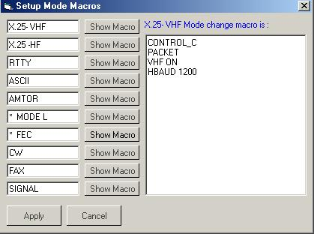

PK232\_2

The following is an excerpt from the DataTerminal.ini file for the PK-232/HK-232. You can copy/paste it into your own DataTerminal.ini file and the modes will already be set up for you.

----------- Excerpt - DataTerminal.ini------------

[Mode Menu]

Menu #1=X.25- VHF

Menu #2=X.25 -HF

Menu #3=RTTY

Menu #4=ASCII

Menu #5=AMTOR

Menu #6=\* MODE L

Menu #7=\* FEC

Menu #8=CW

Menu #9=FAX

Menu #10=SIGNAL

[Mode Macros]

Menu Macro #1=CONTROL\_C~PACKET~VHF ON~HBAUD 1200

Menu Macro #2=CONTROL\_C~PACKET~VHF OFF ~HBAUD 300

Menu Macro #3=CONTROL\_C~BAUDOT~RBAUD 45~WIDESHFT OFF

Menu Macro #4=CONTROL\_C~ASCII

Menu Macro #5=CONTROL\_C~AMTOR

Menu Macro #6=CONTROL\_C~AMTOR~AL

Menu Macro #7=CONTROL\_C~AMTOR~FEC

Menu Macro #8=CONTROL\_C~MORSE

Menu Macro #9=CONTROL\_C~FAX

Menu Macro #10=CONTROL\_C~SIGNAL

The following is a listing of normal terminal settings that work with Logger32. This is an actual "Display A" listing from a working HK/PK-232.

8BITCONV OFF

ACRDISP 80

AFILTER OFF

ALFDISP ON

AWLEN 7

BBSMSGS OFF

CASEDISP 0 (as is)

DCDCONN OFF

ECHO OFF

ESCAPE OFF

FLOW ON

ILFPACK ON

NUCR OFF

NULF OFF

NULLS 0

PARITY 3 (even)

TBAUD 1200

TRFLOW OFF

TXFLOW OFF

XFLOW ON

4.0 OPERATION:

For detailed explanation of the operating modes and appropriate TNC commands, please see your operating manual.

*Created with the Personal Edition of HelpNDoc:* [*Full-featured Kindle eBooks generator*](http://www.helpndoc.com/feature-tour/create-ebooks-for-amazon-kindle)

**AGW Packet Engine**

# Jose M. Valdes R. YV5LIX (SK)

## 1.0 GENERAL

The AGWpe interface found in the Logger32’s [Telnet Cluster window](#_topic_TelnetClusterWindow) allows you to connect to you local Packet Cluster over radio using your computer’s sound card, a KISS TNC, a Baycom MODEM, a DRSI Card, a USCC Baycom Cards, an OE5DXL 9600 G3RUH compatible MODEM, a YAM 1200/9600 modem, etc.

The requirement to use this very nice interface is a pre-installation of either the SV2AGW Packet Engine or the SV2AGW Packet Engine Professional, both available at <http://www.sv2agw.com/ham/agwpe.htm>

### 2.0 CONFIGURATION

Since the Packet Engine Professional Edition can be initially configured via a very easy to use Wizard, we will refer here to the AGW Packet Engine standard edition; but also applies to the post-installation configuration of the pro.

The first step is to install the packet engine (the Logger32 AGWpe terminal will not work without it).

Next we should configure the packet engine to work with your external TNC, Baycom or Yam modem, DRSI card or computer’s sound card.

### 2.1 TNC Configuration

Start the packet engine. In the Window’s System Tray you will see a new icon.

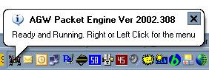

APE\_1

Right or left-click on this new icon to open the menu, and select Properties

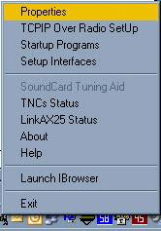

APE\_2

You will be presented with a port selection window. Click on New Port to create a new AGW port for the device you will use and configure.

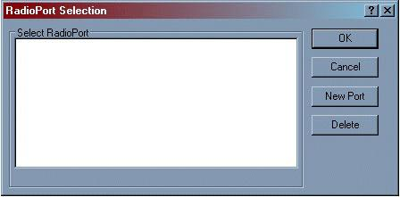

APE\_3

Now the Port Properties window will be displayed and you can select the device (TNC type) and configure it.

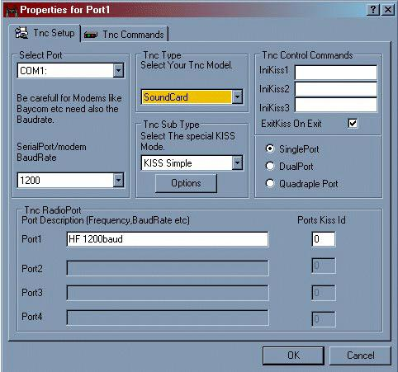

APE\_4

To start configuring AGW, select your TNC model choose the proper device and you will be presented with a long list that includes the most popular TNCs, packet modems, and other possible devices such as a sound card.

Once the device has been chosen select the serial port that the device is connected to; the next step is to. Select the COM port baud rate (the TNC – computer communication speed). Now, if applicable, you will be able to select the KISS type used by your TNC/Modem. Next write a friendly name to identify the port. AGW will automatically select the proper TNC commands according to your on the air speed (1200/9600). If you wish to use your own settings, click on the TNC Configuration tab to open a new window. You can then change the TNC’s configuration command that affects its on the air performance.

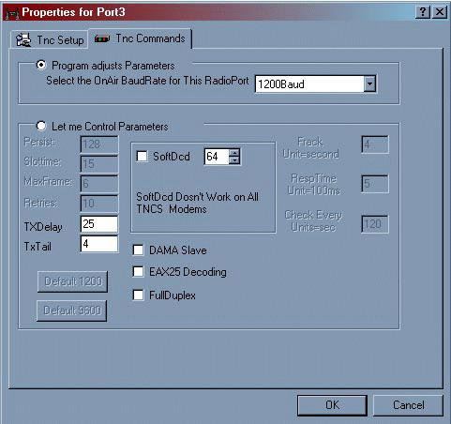

APE\_5

Once you have completed all the above steps, you must close the AGW Packet Engine for the changes to take effect.

Now re-start the Packet Engine and a second AGW icon will be shown in the system tray, this new icon takes the form of a TNC indicating that the port is active.

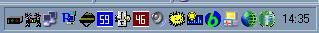

APE\_6

### 2.2 Using the Loger32 AGWpe Terminal

Add the AGW Packet Engine to the [Utilities menu](#7.0_UTILITIES_MENU_ITEM) in Logger32 by going to Tools, [Utility program setup](#Utility_Program_Setup) and add the AGWpe by browsing for the proper .EXE file (AGW Packet Engine.exe for the standard version or Packet Engine Pro.exe for the pro version)

To start using the AGWpe terminal open the Logger32 [Utilities menu](#7.0_UTILITIES_MENU_ITEM) and start the AGWpe, once the AGW Packet Engine is running (you will see its icon on the system tray) in the Logger32´s [Telnet Cluster window](#_topic_TelnetClusterWindow) select AGWpe, right-click

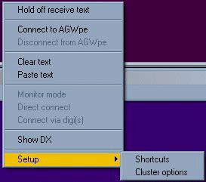

APE\_7

on the window to open the menu and at the bottom you will find setup. There click on Cluster options and fill the fields: your call, the call of the cluster you wish to connect to, if you connect via a Digi; the Digi call. Also check direct connect or connect via Digi or monitor mode to suit your operational preference.

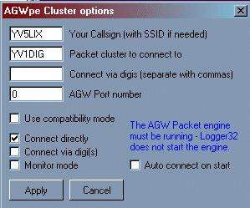

APE\_8

To connect to the cluster and start receiving spots click on Connect to AGWpe. Logger32 will automatically connect to the configured cluster.

If you connect to your cluster via a NODE, in the field “Packet cluster to connect to” enter the call of the NODE. Once connected to the NODE you will be presented with the NODES’s command line, where you will issue the command to connect to the cluster.

A word of caution, an AGW Radio Port is not a TNC, for instance, if you are using a dual-port TNC (KAM, PK-232) AGWpe will be configured as 2 Radio Ports and only one TNC icon will be displayed in the Window’s taskbar (sentry). The DRSI driver supports up to 8 channels (Radio Ports) and again only one icon will be shown in the Windows taskbar (systray)

### 2.3 Configuration Tips

In the property window you will find some options for configuring each port. This applies to both versions of AGW, Standard and Pro. This window will be used to change some of the configuration parameters of the AGW ports after they have been created in the Pro version and for both the initial configuration and future changes in the Standard version.

Pay special attention to the BAUDRATE configuration, here if you are using an external TNC you will enter the serial communication baud rate between your computer and the TNC, and if you are using the computer’s sound card you will enter here the on-air baud rate (1200/2400/9600). Also if you are using a 1200 bps Baycom modem you should select 1200.

If your computer has more than one sound card you also will be presented with a list of the cards available. Just choose the one you would like to use with AGWpe.

The non-professional version of the Packet Engine requires you to install the proper driver for your device (sound card, Baycom or Yam modem etc.) available as a zip file (Drivers.zip) containing all the drivers at http://www.raag.org/sv2agw/inst.htm. The Professional version does not require the installation of this driver.

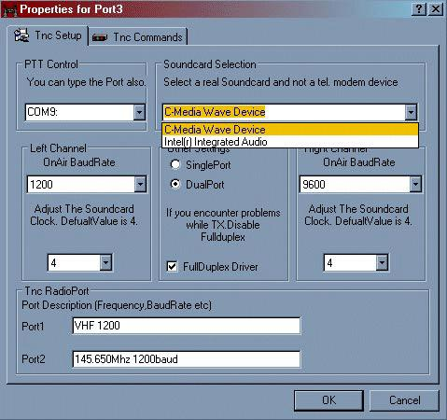

APE\_9

The TNC commands tab allows you to adjust the TNC on-air parameters, such as TX delay, to suit your needs and those of the network you will be operating. For most applications it is better to leave them with the default settings.

The sound card operation requires a PTT circuit similar to the one used by the Logger32 [Sound Card Data window](#_topic_SoundCardDataWindow1).

For the DRSI card you must use the Professional version for easy configuration.

In the AGW Packet Engine Pro configuration the wizard should select internal cards.

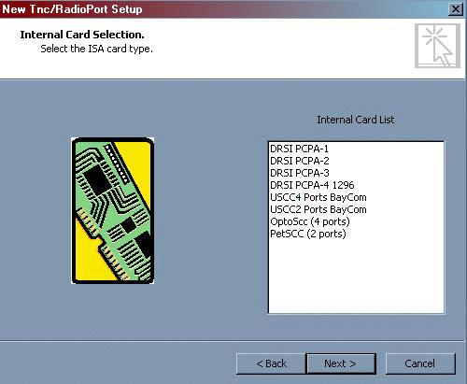

APE\_10

Select the DRSI card that you will be using.

* 1. Enter the base address and IRQ of your DRSI card
  2. Leave the serial port and baud rate as is.
  3. You should now see the dialog with the properties for your DRSI card
  4. Check if the baud rates are ( or rate is) correct for your card and also the base address and IRQ line.
  5. If you wish to use hardware clocking for external modems enter a value of 0.
  6. In the TNC Radio Port Description, write the friendly name for each Radio Port

Special note regarding 9600 baud operation with the computer’s sound card.

Not all sound cards operate correctly at 9600 baud. Also your radio must be capable of operating at such speed or a modification should be performed. Even after performing the required modifications some radios will operate very poorly at 9600 baud.

For other modems please refer to the AGW help files available at http://www.raag.org/sv2agw/inst.htm

*Created with the Personal Edition of HelpNDoc:* [*Full-featured multi-format Help generator*](http://www.helpndoc.com/help-authoring-tool)

**Radios**

*Created with the Personal Edition of HelpNDoc:* [*Free PDF documentation generator*](http://www.helpndoc.com)

**Configuring Push to Talk**

# Scott E. Thile K4SET and Jim Hargrave W5IFP

## 1.0 GENERAL

This topic covers transmit/receive (TX/RX) switching using PTT controlled by Logger32. If you want to set up PC control of your transceiver go to [Interfacing a Radio for PC Control](#_topic_InterfacingaRadioforPCControl) and if you need to interface your PC sound card to your transceiver go to [Interfacing a Radio to the PC Sound Card](#_topic_InterfacingaRadiotothePCSoundCar).

### 2.0 TRANSMITTER KEYING OPTIONS

You can perform transmit/receive switching in four ways:

* 1. Operate a push-to-talk (PTT) switch using a switched voltage RTS or DTR from a serial computer port, either the port used for serial communication with the radio, or a separate serial port;
  2. Use [$transmit$](#$transmit$) and [$receive$](#$receive$) macro commands sent to the radio over a serial (Com) port;
  3. Use VOX in your radio so it turns on when audio comes from the computer; and,
  4. Operate the radio transmit/receive manually.

## 3.0 KEY THE RADIO PTT LINE

In both cases of serial port keying, the PTT keying is accomplished by low/high voltage on pin 20 and pin 4 of a DB-25 connector (the DTR and RTS lines) connected to the serial port. The DB-9 equivalent pins are 7 and 4. To key the radio PTT line from DTR or RTS, a transistor interface circuit is required. This simple circuit will do the trick:

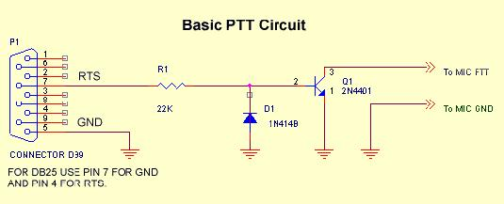

CPTT\_1

.

An excellent resource for PTT interface designs for the builder or purchaser is the site maintained by WM2U, <www.qsl.net/wm2u/interface.html>.

## 4.0 USING A SERIAL PORT

### 4.1 Software Setup to Operate PTT with a Com Port in Logger32

Here is how to switch the PTT line by using a Com port. This discussion assumes that you have built and connected an appropriate interface for the PTT line, as shown above. Select the appropriate PTT options. In the [Sound Card Data window](#_topic_SoundCardDataWindow1), select Settings, Radio PTT Options, which brings up the following dialog box. The selections displayed are the correct ones to set up the radio for sharing the same Com port for radio control and PTT functions:

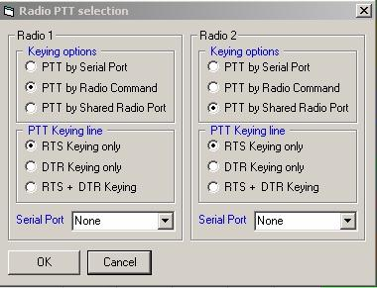

CPTT\_2

If you wish to use a separate Com port for PTT or you do not have radio control, the following steps will provide the correct setup:

* + Under Keying Options, select PTT by Serial Port.
  + Under Serial Port, select the Com port connected to your PTT interface.
  + Under PTT Keying line, select RTS for pin 4 (DB-25) or pin 7 (DB-9) operation (used by the circuit above). Select DTR for pin 20(DB-25) or 4(DB-9) operation. Selecting RTS and DTR will set both pins to high. Make sure that your PTT interface is connected to the appropriate pin for the method that you choose.

### 4.2 PTT Using a Shared Radio Port

You may choose to operate a PTT line directly from a pin on a Com port, as described directly above, and also have Logger32 communicate directly with the radio for frequency information and software command control on the same Com port. In the [Sound Card Data window](#_topic_SoundCardDataWindow1), select Settings, Radio PTT Options, and select PTT by Shared Radio Port. Logger32 will key DTR or RTS on the same Com port used for information exchange between the radio and Logger32.

CW and Sound Card operation may also be shared on the same port as the Radio Control. In the CW mode, PTT is automatically routed to the RTS line and CW data is automatically routed to the DTR line when in the CW mode.

To make this all work on the same serial port, you must select RTS as the PTT line in the PTT setup in the Sound Card settings. Open the "Radio PTT selection". Under keying options, select "PTT by shared radio port." Then select "RTS keying only". Your port is now configured to allow CW and Sound card PTT operation. For an appropriate CW data interface see the section on the CW Machine.

One Way to Keep From Having a Live Microphone During AFSK Operation

A number of modern radios, like the Kenwood TS-570D, when keyed by closing a certain PTT input on the back, only accept audio from the rear panel audio input. With these radios, you can operate the PTT using a direct line from a serial port to the rear panel PTT, and apply the AFSK signal to the rear audio input. You will never have a live microphone during AFSK operation, even if the microphone is left connected.

## 5.0 DIRECT COMMAND OF TX/RX USING A PC-RADIO INTERFACE

Certain models of Kenwood, Yaesu, Kachina, and Ten-Tec radios can be switched between transmit and receive when the software sends the appropriate command. At the present time, Icom radios support many commands (see Direct Control of Radios) but not the transmit/receive changeover. Ten-Tec uses the Icom command set, but includes a TX/RX changeover command. Since the following discussion tells how to configure the interface so you can talk to your radio, you may want to do this for your Icom, so that you can exchange mode, frequency, filter, and other information between the computer and the radio.

### 5.1 Radio Debug Window

You can monitor the commands sent between Logger32 and your radio. From the Logger32 [Main menu](#_topic_MainMenu), select the [Setup | Radio | Show Radio Debug Window](#5.0_RADIO_MENU_ITEM) menu items. Here is what you will see:

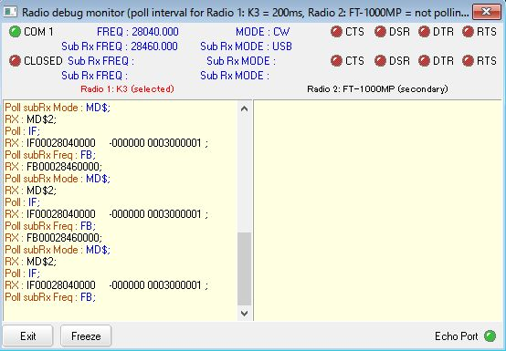

CPTT\_3

### 5.2 Notes About Radio Control of Transmit/Receive

* + With some radios (Yaesu FT1000MP, Kenwood), if you operate PTT by sending a command over the serial port, the microphone input remains active.
  + If you have a problem controlling TX/RX, try speeding up or slowing down polling. Specifically, try the values 500 ms. and 1000 ms. It is possible to be too slow or too fast.
  + If you continue to have problems, you can bring up the [Radio Debug window](#_topic_RadioDebugWindow) (Radio button) to look directly at the codes sent to and from your radio.
  + Once you activate transmit using a radio command, if the computer locks up or crashes, you may have difficulty taking the radio out of transmit mode. You should examine your radio and manual closely, and determine what steps you can take in this situation. For example, with a Ten-Tec Omni VI, if you are unable to send the software receive command, you must turn the radio off and back on.
  + If you use a Ten-Tec Omni VI (or VI Plus), remember that you must set the address to 04 under the Icom setup, then go to Ten-Tec and select the Omni VI.

## 6.0 VOX CONTROL OF TX/RX

An easy way to control Transmit/Receive is to use the VOX in the radio. Set the VOX sensitivity so that the input signal keys the VOX. If you use VOX, you may find that the radio does not turn off, but cycles on and off when you try to go to receive. You can stop this by bringing up the full set of Windows audio mixer controls and making sure that only the ones you need to transmit and receive are turned up or enabled.

## 7.0 MANUAL CONTROL OF TX/RX

Manual operation is, to be honest, a nuisance. It requires that you operate the PTT with an external switch and also tell Logger32 when you want to go to transmit and to receive. You will find that you sometimes forget to key the transmitter although you have already started transmitting audio out of the computer. This method should be used only for initial setup and testing purposes. One of the more automated methods should be instituted for regular operation.

## 8.0 ONE INPUT AT A TIME

When you key the radio, make sure that you are not sending one audio signal from the computer plus one from the microphone at the same time. On many radios the microphone input and the rear panel input are active at the same time. If this is the case, you should disconnect the microphone from the radio whenever you operate AFSK.

You may choose to use a device that connects to the microphone input and allows you to switch between a microphone and another input source. There are devices on the market that do this, and also have the interfaces and wiring for PTT, and for reducing and isolating the AFSK signal from the sound card. See Information on the WWW.

*Created with the Personal Edition of HelpNDoc:* [*Easily create EPub books*](http://www.helpndoc.com/feature-tour)

**Software Controlled Radios**

# Bob Furzer K4CY

The following software-controlled radios are now supported:

* 1. Pegasus - Using both TenTec and N4PY control software;
  2. Orion, Argonaut V, Elecraft K2, RX320, RX331, RX340, RX350 and the Jupiter - using N4PY control software; and,
  3. Software Defined Radios using the PowerSDR software.

In all cases the 'catch-all' radio type to be selected by the user is Pegasus.

In all cases, the communication between Logger32 and the radio control software is that Logger32 reads a file (created by the control software) called Pegasus.out. Logger32 writes when issuing commands to the radio (for Band/Mode change) to a file called Pegasus.in

The user must (when setting up the Pegasus radio type) specify the path where these files exist - the path only, not the file name.

Examples are:

**Example 1** : The control files are C:\PEGASUS\PEGASUS.IN and C:\PEGASUS\PEGASUS.OUT. The user enters C:\PEGASUS as the data file name in the Rig Control window, and selects radio type as TenTec Pegasus.

**Example 2** : The control files are

C:\PEGASUS\MYFAVORITERADIO\N4PY\PEGASUS.IN and :\PEGASUS\MYFAVORITERADIO\N4PY\PEGASUS.OUT.

The user enters C:\PEGASUS\MYFAVORITERADIO\N4PY as the data file name in the Rig Control window, and selects the radio type as TenTec Pegasus.

It is not necessary to configure the Com port in the Rig Control window. Serial port communication is NOT used. The Com port will default to NONE.

The [$command$](#$command$) and [$hexcommand$](#$hexcommand$) Macros do not work with/for PC controlled radios that use disc files for data transfer.

*Created with the Personal Edition of HelpNDoc:* [*Free help authoring tool*](http://www.helpndoc.com/help-authoring-tool)

**Interfacing Logger32 to a microHam Keyer and FT-1000MP**

Geoff Anderson G3NPA

1.0 GENERAL

These are basically notes about my own setup. They are presented here in the hope that they might help someone else in the complexities of setting up something similar. The user is encouraged to read and understand the facilities offered by the MicroHam MicroKEYER and possibly to use one of the many setup templates provided.

I stress that there are many ways to set up this combination of equipment. This is simply one way that works for me.. the way I like it.

From the setup described, I can:

* + Use PTT, foot switch or VOX-operated SSB;
  + Use PSK31 and/or (AFSK) RTTY from the [Sound Card Data window](#_topic_SoundCardDataWindow1);
  + Use PSK31 or FSK RTTY (with a very small change to the setup);
  + Operate CW from the built-in keyer in Logger32, supplemented by the WinKey keyer and paddles; and,
  + Set up for other operating modes using software other than Logger32.

## 2.0 SETUP

### 2.1 Basic Starting Point

Most decisions taken during the setting up of my arrangement rested on two main items:

* 1. The hardware (RS232) ports that I had available in my computer; and,
  2. How I wanted to operate RTTY (FSK or AFSK).

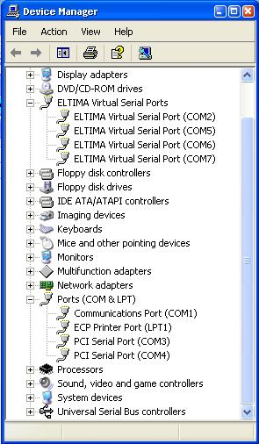

IAM\_1

**Station hardware**: My computer has one built-in RS232 port (COM1) plus a PCI card that gives me two more ports (Com 3 and Com 4). The virtual serial ports seen in the above table are all creations of the microKEYER USB support software. (see [USB Software](#2.4.3_USB_software) below).

I decided to try to run ALL of my system via just one USB port with the following port allocation. This is not a prerequisite at all – simply a personal desire as, in my case, this would leave me with 3 hard-wired COM ports for any other way I wanted to use them.

As for RTTY operation, I like to use AFSK. I do mention below, however, how to set up for FSK should that be your particular preference.

### 2.2 Connecting the Radio

Follow the instructions that come with the equipment. I bought the FT-1000MP interconnect cable and just plugged everything in.

### 2.3 Setting up the software

This is where the fun starts………

First, you must follow the instructions given in the microKEYER instructions on how to load the basic software including the drivers, etc.

You now need to establish which ports you are going to use for which function. I chose the following:

* + COM 2 – WinKey software (if needed);
  + COM 5 – Radio CAT interface;
  + COM 6 – CW keyer; and,
  + COM 7 – Soundcard PTT.

There is nothing hard and fast about these allocations. You can select what you wish but having made that selection I suggest you stick with it until you gain more experience with what is possible. Having made this decision, both Logger32 and the USB driver software need to be set up to match. In my case, COM ports 1, 3 and 4 are reserved for items such as a TNC, rotator control or anything else requiring a hard-wired COM port. (I actually use one as a loop back port so I can send DXspots type messages back to myself for test purposes)

### 2.4 Logger32 Software

### 2.4.1 The Radio (CAT) port

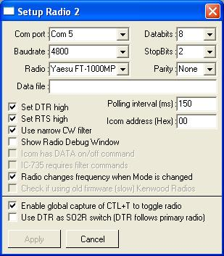

IAM\_2

Set the COM port to 5, baud rate to 4800, Data bits to 8 and the Stop bits to 2 with no parity. The FT-1000MP will respond to a fast poll rate so I have selected the fastest I can achieve with my rig that gives satisfactory results. In my case this is 110 ms.

### 2.4.2 The CW Keyer

Logger32 now supports WinKey and since the introduction of that support there have been two keyer setup windows. The first, shown below, is for the original software keyer

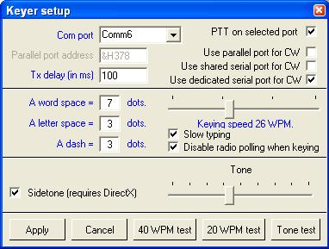

IAM\_3

Not much more to do apart from setting the COM port to 6 and check the “use dedicated serial port”.

The second is for the WinKey support

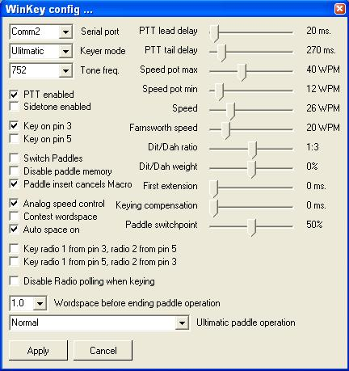

IAM\_4

Information on all of these settings can be obtained from the WinKey interface manual downloadable from <http://k1el.tripod.com/products.html>, and further information about the use of WinKey can be found in the [CW Machine](#_topic_CWMachineWindow) topic.

When Logger32 opens the WinKey serial port, Logger32 takes control over ALL functions of WinKey including PTT on pin 5. If you do not want PTT generation from WinKey when Logger32 is running you must uncheck the PTT checkbox in Logger32. Logger32 always has priority.

WinKey pin 5 is multi-functional pin. Logger32 can use this pin for various functions:

* + None;
  + PTT;
  + Side tone; or,
  + Second CW output

MicroKEYER allows only "none" and PTT, but Logger32 can control all functions. Inside the microKEYER is a jumper called SO1R/SO2R. It's a jumper for pin 5. If it is in the SO1R position then pin 5 is used for PTT. If it is in the SO2R position then pin 5 is disconnected from the PTT circuits and wired to the REMOTE mini DIN 6 connector (signal will be used in SO2R extension for microKEYER as second CW source).

### 2.4.2 The Sound Card Data window

For the Sound Card Data window there are two places that need to be set up.

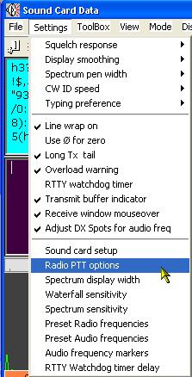

IAM\_5

First, select the Radio PTT options from the [Sound Card Data window](#_topic_SoundCardDataWindow1) Settings menu. Make sure you select the keying option as PTT by serial port (otherwise the FSK option will not become available as described later). Select RTS keying.



IAM\_6

and set the port to Com 7.

The above will set up the AFSK side of Logger32, i.e., PSK31 and/or RTTY using audio generated tones (commonly referred to as AFSK).

If you are happy to use AFSK for RTTY then you will need to ensure that under the RTTY Setup|Misc tab, (see below) the TX port should have the “sound” radio button marked. However, if you want to use FSK for the RTTY mode, then check the COM-TxD (FSK) radio button AND click on the USB port button and select “C”. Just note that it is as simple as this to change from AFSK to FSK keying and back again.

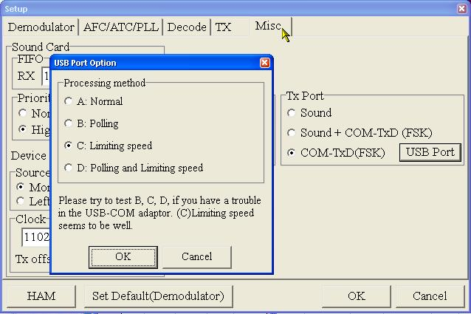

IAM\_7

This completes the setup of the Logger32 software.

**Note**: The Normal /Reverse button in the Communicating with RTTY section of Logger32 will invert the TX and RX data if you are using AFSK but it will NOT invert the transmitted data if using FSK.

### 2.4.3 USB software

The setup of the microHAM USB software follows: You must start by actually telling this software that you need 4 virtual ports. Select Virtual ports|Create and select ports 2, 5, 6,and 7 in turn and “OK” them.

Now select the Ports tab and set the table as below.

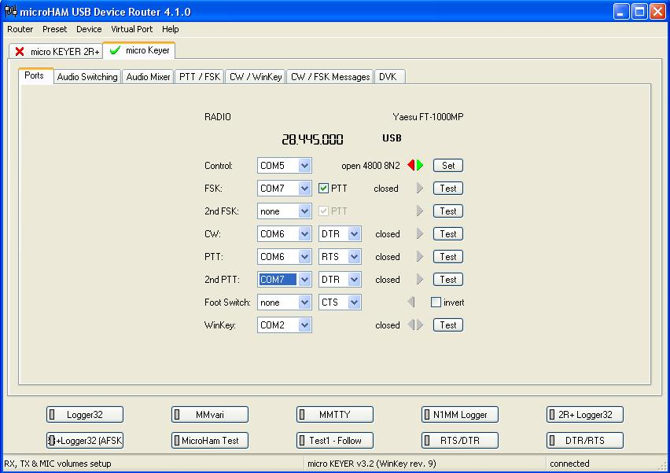

IAM\_8

**Notes**:

* + If you have any software that can use WinKey, then when setting up that software make sure it uses com port 2.
  + For Logger32 the PTT should be either RTS or CTS. Do NOT select RTS\* or CTS\*.
  + If using the FSK mode for the generation of RTTY from MMTTY module, then be sure that the FSK port in the router matches that for the PTT.

Make sure you have the correct radio set up in the router software. Click on the “Set” button for radio 1 control, to obtain the (part) window shown below. Select the radio type, baud rate and if necessary the CI-V address

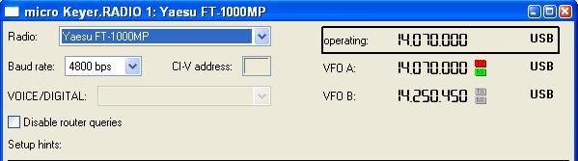

IAM\_9

Follow this with looking at all the other main tabs in turn. I show below my setup for the audio, PTT/FSK and CW/WinKey.

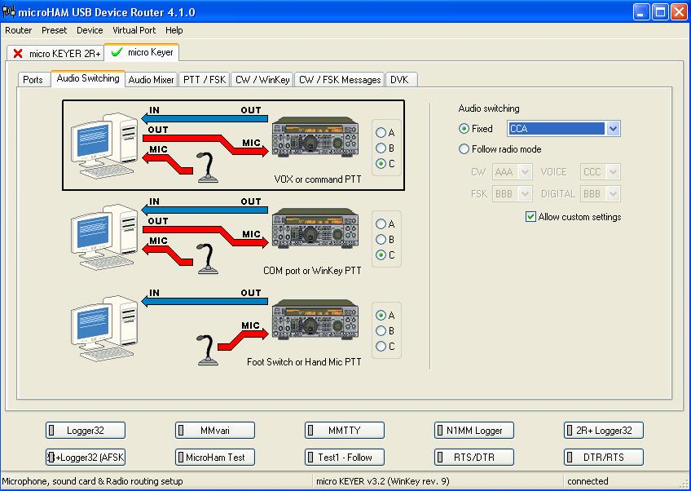

IAM\_10

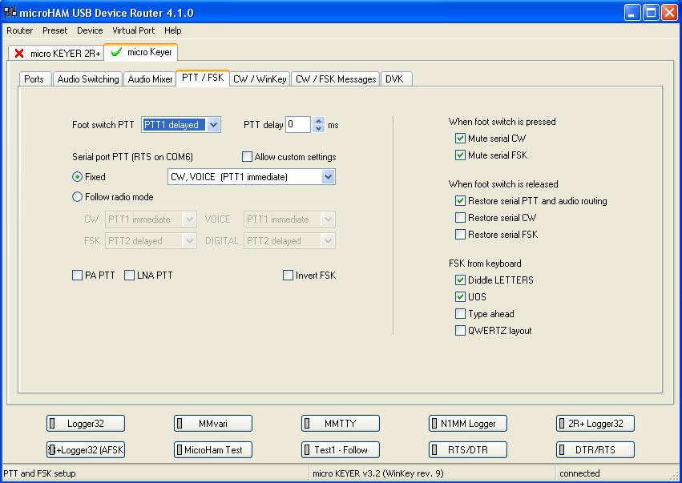

IAM\_11

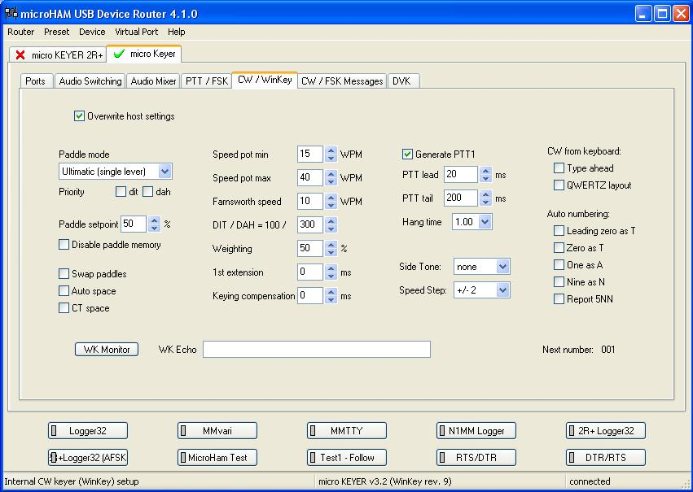

IAM\_12

I would like to make it clear once again that the setup shown above is one of many that will work. What this will do, however, is get you going so you can experiment further in the knowledge that you can return to something known should things not go according to plan!.

*Created with the Personal Edition of HelpNDoc:* [*Single source CHM, PDF, DOC and HTML Help creation*](http://www.helpndoc.com/help-authoring-tool)

**The Echo Port**

# Aki Yoshida JA1NLX

## 1.0 GENERAL

The echo port can be configured to echo radio data to an external device (amplifier, or antenna, or whatever) that 'listens' on the port and follows the frequency/band. The external device should use same CAT protocol as the radio.

## 2.0 ECHO PORT SETUP

To configure the Echo Port, from the [Logger32 Setup menu](#_topic_SetupMenu), select the [Radio | Echo port](#5.0_RADIO_MENU_ITEM) configuration menu items. ”The Echo port repeats data to/from the selected radio only. No data is received on this port” option should be always checked if you use Eco port. The Logger32 COM port parameters, including RTS and DTR, should be configured as required for the radio or device being connected to the Echo Port.

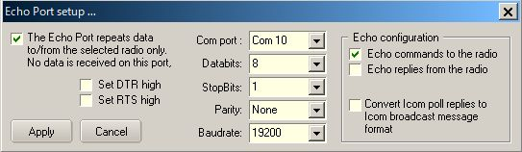

TEP\_1

The port is opened/closed by right clicking the Radio pane on the Lower Status bar or select the Logger 32 Setup menu [Radio | Open(Close) port-Echo](#5.0_RADIO_MENU_ITEM) menu items.

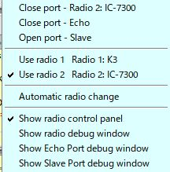

TEP\_3

The Echo Port state, open or closed, is shown on the Status bar of the [Radio Debug window](#_topic_RadioDebugWindow).

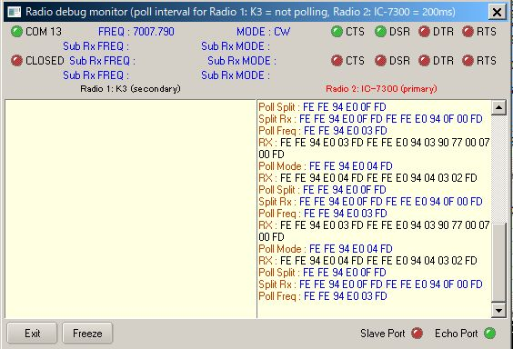

TEP\_4

You can see what command is sent to slave radio in Echo Port debug window.

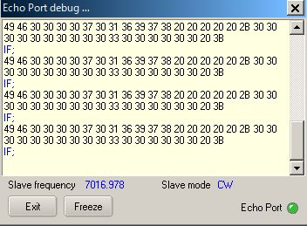

TEP\_5

## 3.0 EXAMPLES

For the examples below, a K3 is connected to Logger32 using Com 2 and a TS-590SG is connected to the Echo port on COM1.

**TS590SG is controlled by Echo replies from the radio (K3 in this case)**

Check the Echo replies from the radio check box in the Echo port setup dialog box ([TEP\_1](#TEP_1)).

The following Macros in the [Radio Control Panel](#_topic_RadioControlPanelRCP) will control the the TS590SG via Echo port;

* + - [$command FA;$](#$command$)   read current K3 VFO A frequency and control TS590SG to this frequency; and
    - $command MD;$  read current K3 mode and control TS590SG to this mode.

### TS590SG is controlled by Echo command to the radio

Check Echo commands to the radio in Echo port setup setup dialog box ([TEP\_1](#TEP_1)).

The following Macro in the Radio Control Panel will control both the K3 and TS590SG:

[$command FA00014040000;MD3;$](#$command$)  set K3 and TS590SG to 14040.0KHz CW

### K2 is controlled through Echo Port as second receiver of TS-590SG

When you click om a DX spot then both radios are tuned to that frequency. When you turn the TS-590SG VFO knob you must send specific command, FA; to TS590SG. K2 is tuned to same frequency as TS-590SG. This command is configured in one of function buttons in RCP.

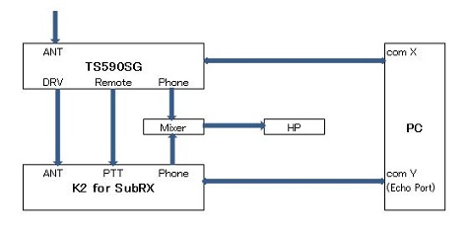

TEP\_6

### IC-7300 is controlled through Echo Port as second reciver of anothor IC-7300

IC-7300 #2 connected to Echo port follow anther IC-7300 #1 frequency and mode when DX Spot is clicked, frequency is typed in [Logbook Entry Window](#_topic_LogbookEntryWindow) or direct command to change frequecy and mode is trigerred.

In this case when you want to call rare station click DX spot or type his frequency. Both #1 and #2 IC-7300 are tuned to this frequency. While you listen to him on IC-7300 #2 look for clear frequenct to call him tuning IC-7300 #1 VFO. Just give a call on IC7300 #1.

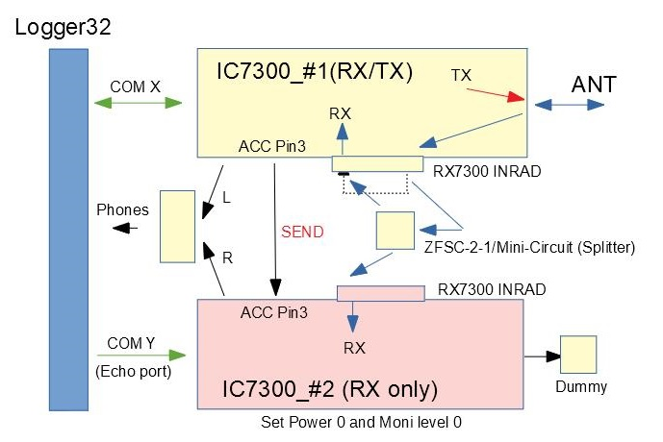

TEP\_6A

*Created with the Personal Edition of HelpNDoc:* [*Create HTML Help, DOC, PDF and print manuals from 1 single source*](http://www.helpndoc.com/help-authoring-tool)

**The Slave Port**

# Aki Yoshida JA1NLX and Rick Ellison N2AMG

## 1.0 GENERAL

The Slave Port was originally implemented in Logger32 version 3.50.358.

a)The Slave Port synchronizes a slave receiver/transceiver (of any type) with the main radio frequency and mode and,

b) if “Enable polling of the slave receiver/transceiver....” option is checked then main radio follow slave radio frequency and mode.

## 2.0 SLAVE PORT SETUP

To configure the Slave Port, from the Logger32 Setup menu, select the Radio | Slave port configuration menu items.

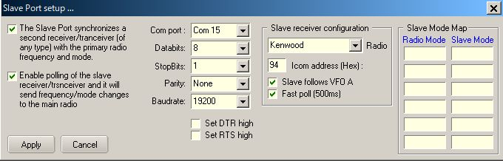

TSP\_1

If your transceiver reports both VFO A and VFO B frequency/mode in real time, you may uncheck “Slave follows VFO A” option.

If you prefer fast polling of slave receiver/transceiver, you may check “Fast poll (500ms)” option. If it is unchecked, polling interva is 1000ms.

The Slave port is opened/closed by right clicking the Radio pane on the Lower Status bar.

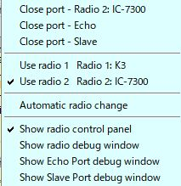

TSP\_2

The Slave Port state, open or closed, is shown on the Status bar of the Radio Debug window.

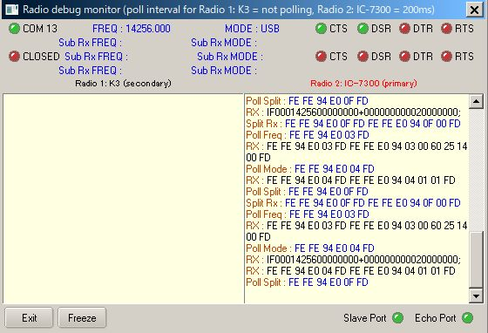

TSP\_3

You can see what command is sent to slave radio in Slave Port Debug window.

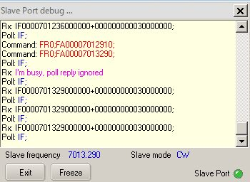

TSP\_4

## 3.0 HOW TO COMMAND THE SLAVE RECEIVER OR TRANSCEIVER

Some examples of Slave port settings for various combination of main/slave radios are described below.

IC-7300 as Main Radio and Another IC-7300 as Slave Radio

In this case slave IC-7300 is connected to COM10.  
  
Slave IC-7300 follow main IC-7300 frequency and mode when clicking DX Spot, changing frequency in Logbook Entry Window or sending direct command macro.   
  
Main IC-7300 follow slave IC-7300 frequency and mode.

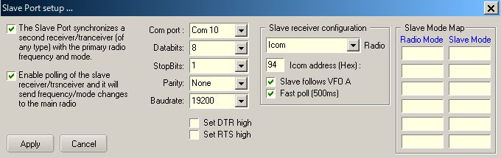

TSP\_5

## FT-920 as Main Radio and IC-735 as Slave Radio

In this case slave IC-735 is connected to COM5.

Slave IC-735 follow main FT-920 frequency and mode when clicking DX Spot, changing frequency in [Logbook Entry Window](#_topic_LogbookEntryWindow) or direct command macro.　Main FT-920 follow slave IC-735 frequency and Mode.

The right hand side shows the radio Mode conversion.

**Note**: The baud rate is shown as 1200 (factory default). The radio can be set to 9600 with a jumper change.

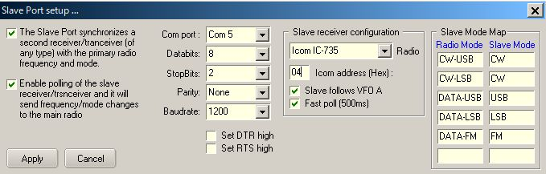

TSP\_6

## IC-7300 as Main Radio and K3 as Slave Radio

In this case slave K3 is connected to COM11.

Slave K3 follow main IC-7300 frequency and mode when clicking DX Spot, changing frequency in Logbook Entry Window or sending direct command macro. . Main IC-7300 follow slave K3 frequency and mode.

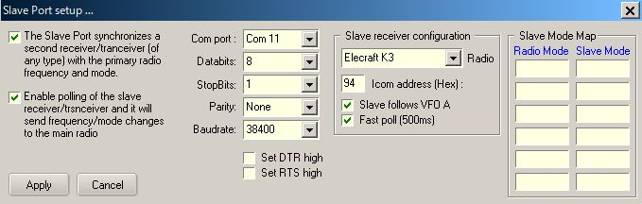

TSP\_6A

## 4.0 HOW TO USE “CHEAP” SDR RX AS PANADAPTOR

You will be able to add external Panadapter using “cheap” SDR RX and SDR application. These are controled via Slave Port.

We used SDRplay RSP1A as SDR RX, SDRplay SDRuno V1.22 and SDR-Radio SDR Console V3.B2 as SDR application for these testing. These applications can be downloaded at following page. <https://www.sdrplay.com/downloads/>

IC-7300 and IC-706MK2G do not report both VFO A and VFO B frequecy/mode in real time, howevwer Logger32 command RSp1A/SDRuno (or SDR Console) frequency and mode when:

a. Clicking DX spot

b. Entering frequency in Logbook Entry Window or changing frequency by mouse wheel

c. Rotating IC-7300 VFO knob (VFO A or VFO B)

d. Changing frequncy and mode in SDRuno (or SDR Console) command Logger32.

**Note**: Logger32 slave port does not command VFO B in SDRuno. Even if you select VFO B in SDRuno it is back to VFO A when you change frequency/mode in IC-7300

The basic setup using ICOM IC-7300 and IC706MK2G are explained below.

**Sample Configulation Diagram:**

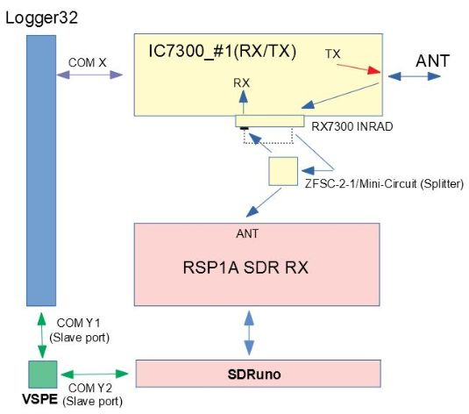

TSP\_7

Sharing Slave Port using VSPE  
  
You need to create “Pair” port to shaire Slave Port, one for Logger32 and another for SDRuno. COM 15 and COM 16 are used in the following examples.

Slave Port setup

Kenwood should be selected as Radio. Both “The Slave Port synchronize a slave receiver.....” and “Enable polling of the slave receiver.....” option should be checked.

You need to select correct COM port. In this example it is COM 15.

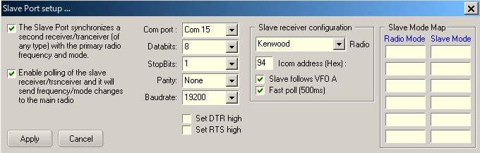

TSP\_8

### SDRuno setup

It will work with dafault setting except COM port. You need to select correct COM port for COM DEVICE. In this example it is COM 16. Details are explained in SDRuno User\_Manual.

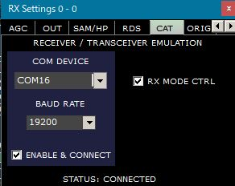

TSP\_9

Typical example of SDRuno display.

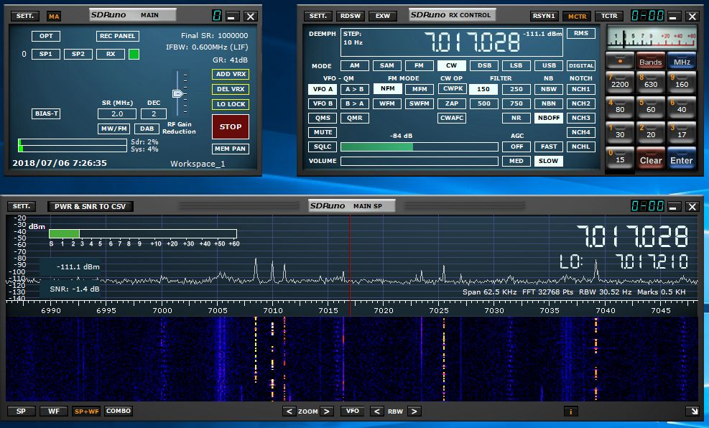

TSP\_10

### SDR Console setup

1. Open the SDRr Console program and Click on Tools.　Click on Options.

2. Click on the Controllers Folder and then select the CAT(Serial Port) folder

3. Scroll the window and find the second half of the Virtual serial port pair that you created earlier. Place

a check in the checkbox for that port and click Ok. (COM16 in this example)

4. On some systems you will need to restart SDR Console for things to work.

5. After opening the Echo Port in Logger32 you may open SDR Console and the radio setup in Logger32

should be able to control the frequency and mode in SDR Console. Clicking in the waterfall or scrolling the

frequency or scrolling in the waterfall will update the radio in Logger32.

One thing to note is the frequency will not be updated in Logger32 until the frequency updates in SDR Console. Ex. When scrolling in the waterfall the frequency will not update until you stop scrolling.

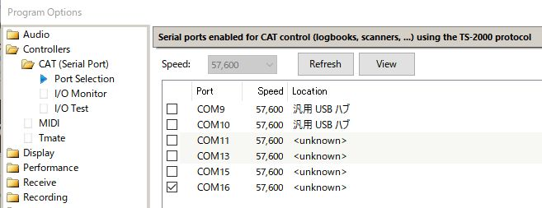

TSP\_11

Typical example of SDR Console display.

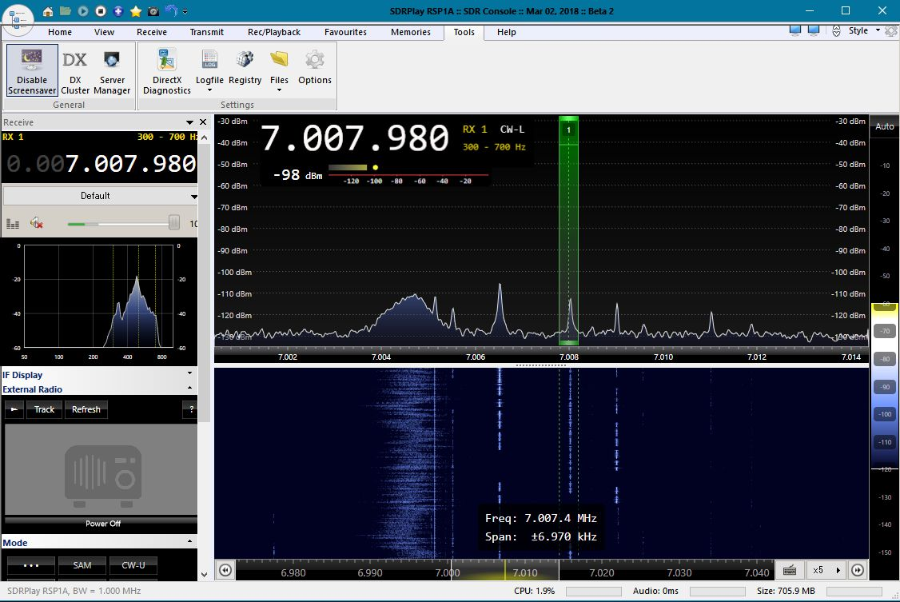

TSP\_12

*Created with the Personal Edition of HelpNDoc:* [*Free EBook and documentation generator*](http://www.helpndoc.com)

**Elecraft**

*Created with the Personal Edition of HelpNDoc:* [*Easily create iPhone documentation*](http://www.helpndoc.com/feature-tour/iphone-website-generation)

Elecraft K2 K3

# Aki Yoshida JA1NLX and Gary Hinson ZL2IFB

## 1. GENERAL

Logger32 can control Elecraft K2, K3 and KX3 radios through their serial ports (if fitted), for example logging the frequency automatically from VFO A or sending commands to QSY the rig to the frequency and mode of a DX Cluster or Reverse Beacon Network spot that you have clicked.

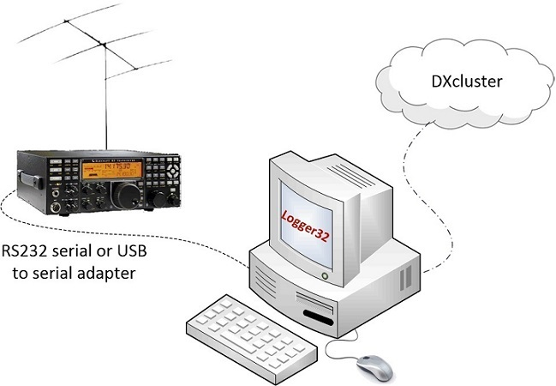

EK\_1

Elecraft radios use an extended version of the Kenwood radio command protocol. Logger32 supports all the basics and some of the extended commands directly, and can send command Macros if you need more sophisticated control see the [Radio Control Panel](#_topic_RadioControlPanelRCP) topic.

## 2.0 K2 SETUP

You need the optional KIO2 module installed in the K2 in order to connect it to your PC through 9-pin RS232 connector on the rear panel.

1. On the K2, turn PORT ON in the secondary menu. See the K2 manual for help with this.
2. Connect the K2 to the PC using an RS232 serial cable if your PC has a free RS232 port, or a USB to RS232 converter if it only has USB ports. See the KIO2 manual for wiring instructions.
3. Check the port number on the PC. In Windows, open Device Manager and click to expand the "Ports (COM & LPT)" section.

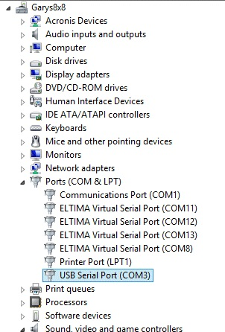

EK\_2

1. In this example on a PC running Windows 8, I have two serial ports (COM1 and COM3, the latter using a USB/serial adapter) plus 4 virtual ports (defined in software using the LP\_Bridge program). The radio is connected to one of the serial ports through a USB adapter. To find out whether it is COM1 or COM3, I simply unplugged the USB adapter from the PC and saw that COM3 disappeared from the list. When I plugged it back in, COM3 reappeared.

Sometimes Windows picks a high number for the COM port. Logger32 expects a COM port to be in the range 1 to 16 (inclusive). If Windows picks, say, COM17, you will need to tell it to use a lower number. In Device Manager, right-click the port and select "Properties".

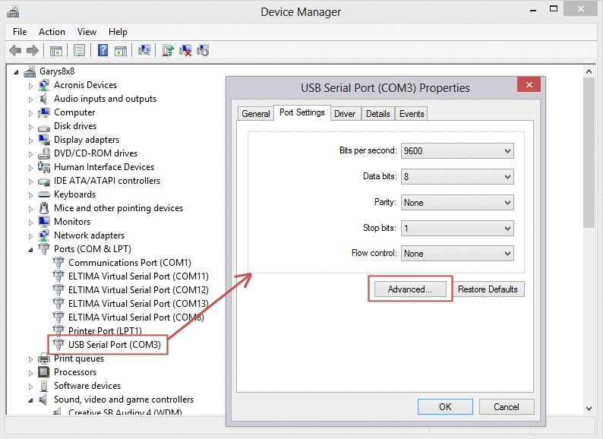

EK\_3

Now select the <**Advanced**> button and there you will find a pull-down box to select the COM port number. Pick a COM port between 1 and 16 that is not already “in use”.

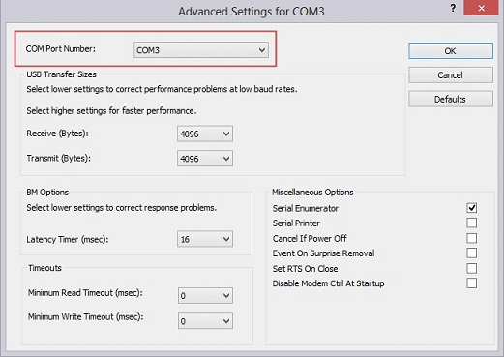

EK\_4

If all your COM ports between 1 and 16 are “in use”, you either have a lot of serial devices connected, or more likely Windows has reserved the ports for devices that may no longer be connected. You may be able to tell what devices they were reserved for by selecting "View | Show hidden devices" in Device Manager. You can delete unused ports, or pick the same COM port number to be used by the radio connection, ignoring the fact that it is “in use”. You may need to experiment with different port numbers.

1. In Logger32, using the [Setup menu](#_topic_SetupMenu), open the radio configuration menu using [Setup | Radio | Radio 1 or Radio 2 configuration](#5.0_RADIO_MENU_ITEM).

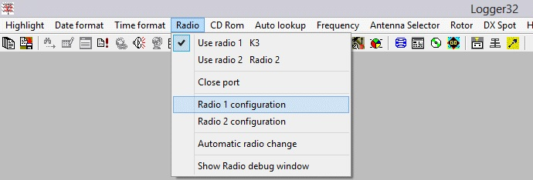

EK\_5

Logger32 can connect to and control up to two radios for [SO2R](#_topic_SingleOperatorTwoRadiosSO2RSuppo) (Single Operator 2 Radio) stations. Since each radio is configured independently on different COM ports, they need not be the same make or model of radio.

1. Configure Logger32’s parameters for the K2 in the Setup Radio window, then select the <**Apply**> button. Pick the appropriate COM port number. The baud rate for the K2 should be 4800 bps with 8 data bits, 2 stop bits and no parity.

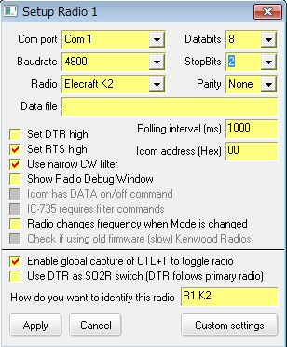

EK\_6

The "Polling interval (ms)" setting determines how often Logger32 checks the radio for any changes. A low value such as 250 milliseconds makes Logger32 respond more quickly if you QSY the radio, but loads the K2 more heavily. A higher value such as 1000 milliseconds is less responsive and less heavy on the K2. Experiment with this value to find one that works best for you.

1. Confirm that the K2 is turned on, plugged in and connected to Logger32.

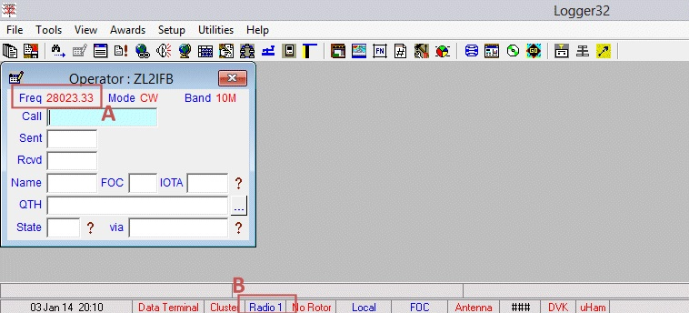

EK\_7

The current radio VFO frequency should be shown in the [Logbook Entry window](#_topic_LogbookEntryWindow) at point A, and Radio 1 should be shown in blue on the lower status bar at point B.

1. Your K2 can now be controlled through Logger32 on your PC.

## 3.0 K3 SETUP

1. Check the serial port speed on the K3 under the RS232 entry on the menu. The default speed is 38,400 baud which suits Logger32 just fine.
2. Connect the K3 to the PC using an RS232 serial cable if your PC has a free RS232 port, or a USB to RS232 converter if it only has USB ports. See the K3 operator manual for cable wiring instructions.
3. Check the port number on the PC (see [K2 setup step 4](#K2_Setup_Step_4) for details).
4. Configure Logger32’s parameters for the K3 in the Setup Radio window (see [step 5 in the K2 section](#K2_Setup_Step_5) above), then select the <**Apply**> button. Pick the appropriate COM port number. The baud rate for the K3 should be 38,400 baud with 8 data bits, 1 stop bit and no parity.

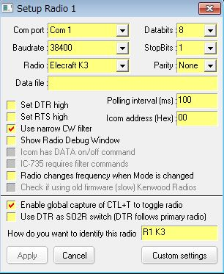

EK\_8

1. Confirm that the K3 is turned on, plugged in and connected to Logger32 (see [K2 setup step 7](#K2_Setup_Step_7)).
2. Setup is now complete

## 4.0 KX3 SETUP

### 4.1 Using the QRP KX3 without the KXPA100

1. Connect the PC serial port to the KX3’s ACC1 jack using Elecraft option cable (KXSER or KXUSB). Refer to KX3 Owners manual.
2. On the KX3, check that the RS232 is set to 38,400 baud in the menu.
3. Check the port number on the PC (see [K2 setup step 4](#K2_Setup_Step_4) for details).
4. In Logger32, configure the radio using the Setup Radio menu (see [K2 setup step 5](#K2_Setup_Step_5)) to the same baud rate, 8 data bits, 1 stop bit and no parity

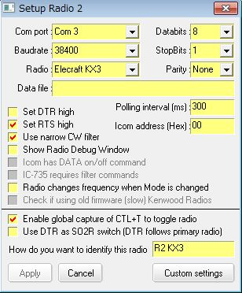

EK\_9

1. Confirm that the KX3 is turned on, plugged in and connected to Logger32 (see [K2 setup step 7](#K2_Setup_Step_7)).
2. You’re done.

### 4.2 Using the QRP KX3 with the KXPA100

1. Connect the PC serial port to the KXPA100’s RS232 jack using Elecraft option cable (KXSER or KXUSB). Refer to KXPA100 Owners manual.
2. Connect the KXPA100 to the KX3 using Elecraft option cable (KXPACBL).

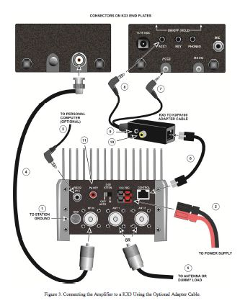

EK\_10

1. On the KX3 set following parameters in the menu.

- RS232 38400 (do not use other speeds)

- PA

- TUN PWR NOR

1. On the PC, check the COM port number (see [K2 setup step 4](#K2_Setup_Step_4))
2. In Logger32, configure the radio using the Configure radio menu (see [K2 setup step 5](#K2_Setup_Step_5)) to the same 38.400 baud rate, 8 data bits, 1 stop bit and no parity.
3. Confirm that the KX3 & KPA100 are turned on, plugged in and connected to Logger32 (see K2 setup step 7). If Logger32 fails to connect to the radio, try closing Logger32 and turning both the KX3 and the KXPA100 off. Turn the KX3 & KXPA100 on. Wait until the KXPA100 ATU mode LED is lit before starting Logger32.

## 5.0 K3 AND KX3 DATA SUB-MODE

1. The K3 normally stores and recalls the last-used data sub mode settings according to the band. If you click a digi mode DX Cluster Cluster spot for a different band, the rig will automatically change to the data sub mode you were using the last time you were on that band.
2. If you prefer, you can set the data sub mode to a default setting. Click "Custom" settings in the Setup radio window and edit your settings, entering the appropriate Elecraft commands (see the K3 Programmer’s Reference Guide for details). With effect from Logger32 version 3.48.133, you must use operating mode (not radio mode) in this panel.

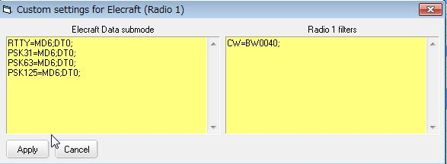

EK\_11

The settings are stored in Logger32.ini when you select the <**Apply**> button but will not take effect until you change band and/or mode through Logger32 (e.g. by clicking a DX Cluster spot).

1. **Note**: a new feature was added to Logger32 in version 3.48. Clicking a DX Cluster or Reverse Beacon Network spot while holding the Shift or Ctrl key puts the SubRX on the corresponding frequency and mode. If you use this feature, you must edit your settings in the "Custom settings" window.

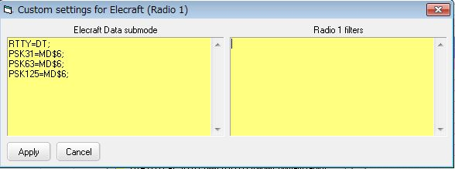

EK\_12

## 6.0 K3 AND KX3 FILTERS

The K2, K3 and KX3 normally store and recall the last-used filter settings (filters and bandwidths) according to the mode. If you click a DX Cluster spot for a different mode to the current setting, the rig will automatically return to the filter settings you were using the last time you were on that mode.

If you prefer, you can set the filter to a default setting for each mode, regardless of what you were last using. To edit your filter settings, from the Logger32 [Setup menu](#_topic_SetupMenu), select the [Setup | Radio | Radio 1 configuration](#5.0_RADIO_MENU_ITEM) menu items and select the <**Custom settings**> button:

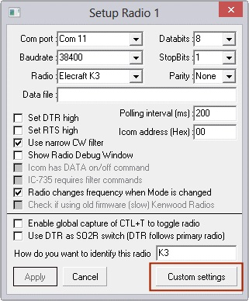

EK\_13

The settings will be stored in Logger32.ini when you select the <**Apply**> button but will not take effect until the radio changes band and/or mode.

### 6.1 K3:

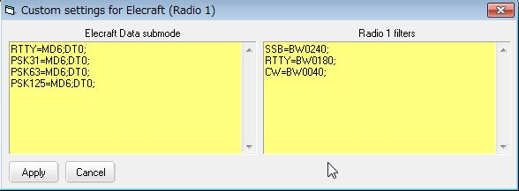

EK\_14

### 6.2 KX3:

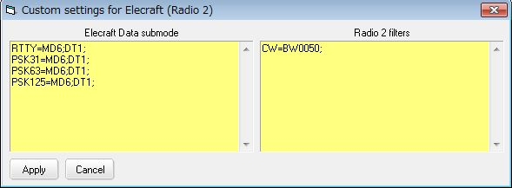

EK\_15

Data sub mode and filter settings are stored in Logger32.ini. As an example, the relevant part of Logger32.ini with a K3 configured as Radio 1 and KX3 configured as Radio 2 is shown below:

[Elecraft Data Submode 1]

RTTY=MD6;DT0;

PSK31=MD6;DT0;

PSK63=MD6;DT0;

PSK125=MD6;DT0;

[Elecraft Filter 1]

SSB=BW0280;

RTTY=BW0180;

CW=BW0040;

[Elecraft Data Submode 2]

RTTY=MD6;DT1;

PSK31=MD6;DT1;

PSK63=MD6;DT1;

PSK125=MD6;DT1;

[Elecraft Filter 2]

CW=BW0050;

**Note**: Elecraft holds the copyright on some of the images in this topic ( the K3 in ELE\_1 and all of ELE\_10). They are used with permission. Thanks Elecraft.

## 7.0 DIRECT CONTROL OF K3

Various macros which control the K3 can be used in [Radio Control Panel](#_topic_RadioControlPanelRCP), [CW Machine](#_topic_CWMachineWindow), [Soundcard Data Window](#_topic_SoundCardDataWindow1).

In the case of the Elecraft rigs, the string to set various functions is composed of the following sequence:

* + two alphabetical characters for Main RX
  + various parameters; and,
  + and a sem i-colon (;) terminator to indicate the end of the command.

The string to set various functions which control Sub RX is composed of the following sequence:

* + two alphabetical characters with additional “$”;
  + various parameters; and,
  + and a sem i-colon (;) terminator to indicate the end of the command.

Following are some basic and special macro examples.

### 7.1 Basic Macros

These macros control Main RX.

$command FA 00007000000;$ set VFO A frequency 7000KHz

$command BW0020;$ set Main RX IF Band Width 200Hz

$command BW0040;$ set Main RX IF Band Width 400Hz

$command NB1;$ set Main RX NB ON

$command NB0;$ set Main RX NB OFF

### 7.2 Special Macros

These macros control Sub RX. <24> is HEX code for “$”

$command BW<24>0020;$ set Sub RX IF Band Width 200Hz

$command BW<24>0040;$ set Sub RX IF Band Width 400Hz

$command NB<24>1;$ set Sub RX NB ON

$command NB<24>0;$ set Sub RX NB OFF

*Created with the Personal Edition of HelpNDoc:* [*Full-featured Help generator*](http://www.helpndoc.com/feature-tour)

**ICOM**

*Created with the Personal Edition of HelpNDoc:* [*Full-featured Documentation generator*](http://www.helpndoc.com)

ICOM General

# Joe Valdes YV5LIX (SK), Jim Hargrave W5IFP and Aki Yoshida JA1NLX

## 1.0 GENERAL

The following list details the Hex addresses for ICOM radios:

IC-1271 24

IC-1275 18

IC-127A/E 18

IC-271 20

IC-275A/E/H 10

IC-375A 12

IC-471 22

IC-475A/E/H 14

IC-575A/H 16

IC-7000 70

IC-703 68

IC-706 48

IC-706MKII 4E

IC-706MKIIG 58

IC-707 3E

IC-718 5E

IC-7200 76

IC-725 28

IC-726 30

IC-728 38

IC-729 3A

IC-735 04

IC-736 40

IC-737/A 3C

IC-738 44

IC-7400 66

IC-746 56

IC-746 PRO 66

IC-751 1C

IC-755 0A

IC-756 50

IC-756PRO 5C

IC-756PROII 64

IC-756PROIII 6E

IC-7600 7A

IC-761 1E

IC-765 2C

IC-775 46

IC-7700 74

IC-78 62

IC-7800 6A

IC-781 26

IC-820 42

IC-820H 42

IC-821 4C

IC-910 60

IC-970 2E

IC-970A/E/H 2E

IC-R10 52

IC-R20 6C

IC-R7000 08

IC-R7100 34

IC-R71 1A

IC-R72 32

IC-R75 5A

IC-R8500 4A

IC-R9000 2A

IC-R9500 72

IC-RX7 78

Paragon II 04 (Use IC-735 protocol)

**Note**: It is recommended that ICOM transceivers that support CI-V Transceive have this option turned OFF. This is to reduce data collisions caused by unsolicited messages from the radio every time you change the VFO frequency. If you have a linear amplifier that supports CI-V control from the radio then the CI-V Transceive function must be left on. There is a potential of data collisions under this setup, but it should function OK.

## 2.0 CW AND SSB WIDTH SETTINGS

If you have CW and SSB narrow filters installed you can tell Logger32 which filters to use for DX spots. The filter selections will automatically be applied based on the frequency of DX spots and your settings in the BandMode chart.

In the Radio Port Setup, you need to check the "Use Narrow Filters for CW" option and edit the Logger32.INI file.

To accomplish this:

If you have Logger32 running, close it, make a copy of your Logger32.INI file, and put it somewhere safe just in case something goes wrong.

Open your Logger32.INI file using your favorite text editor (Notepad will do).

Scroll down the page until you find a heading [Radio Port] or [Radio Port 2] and there should be 8 or so lines of text looking something like this:

[Radio Port]

Automatic Open=TRUE

Comport=COM5,9600,n,8,2

Radio Type=Icom (not IC-735)

Poll Interval=50

Icom Address=58

Set DTR High=0

Set RTS High=1

CW Filter=1

The software defaults to filter 01 for CW normal and filter 02 for CW narrow. If the defaults are inadequate (the user wants to use filters other than the default), then the following section(s) need to be added to the Logger32.ini file:

[Icom Filter n] n = 1 or 2 (for radio 1 or 2)

CW Normal=xx

CW Narrow=xx

SSB Filter=xx

**Note**: xx equals the filter command number 0`, 02 or 03. The following chart, from the CI-V specification, shows the relationship of the numbers to filter width:

Control Data IF Width

01 Width 1 (Wide)

02 Width 2 (Narrow)

03 Width 3 (More Narrow)

**Note**: If you have more than one CW filter, you need to consult your manual and experiment with the filter numbers. The SSB Filter line is only needed if your radio supports more than one SSB filter setting.

## 3.0 RADIO DATA MODES

Some ICOM radios have a DATA setting. This mode is used in conjunction with the AUX connector on the rear of the radio when receiving and transmitting digital information. When the DATA mode is set, the radio shifts the audio input and output to the rear AUX connector. This function usually mutes the microphone so it will not interfere with the TNC or Soundcard data during transmit and a constant audio output level is provided to the AUX connector.

If your radio has this feature, Logger32 can turn this mode on and off via CI-V radio control. In the port setup, place a check mark in the box for the line that reads "Icom as DATA on/off command".

The following is a typical setup for the ICOM IC-756ProIII.

**Note**: In the DTR/RTS setting in Radio setup table you may need to check either of “Set DTR high” or “Set RTS high” option. It depends on your radio and CAT interface.

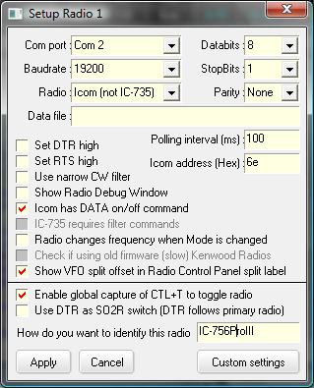

ICG\_1

*Created with the Personal Edition of HelpNDoc:* [*Easy EBook and documentation generator*](http://www.helpndoc.com)

ICOM IC-706 Mk II

# Geoff Andersen G3NPA

## 1.0 GENERAL

The IC-706 MkII radio comes with the following factory default settings. It is highly recommended that you set these as shown below.

**Note**: It is recommended that ICOM transceivers that support CI-V Transceive have this option turned OFF. This is to reduce data collisions caused by unsolicited messages from the radio every time you change the VFO frequency.

CI-V Hex address = 4EH. (Menu item 25) Leave as is

CI-V Baud rate = Auto. (Menu Item 26) Change to 19200

CI-V Transceive = On. (Menu Item 27) Change to OFF

The Rig control setup for the IC706 should be as follows. Obviously the Com port should be set to suit that which is actually being used. It has been found that the “Stop bit” value can be either 1 or 2 and this makes little difference to performance.

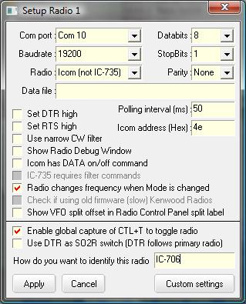

IC-706\_1

**Note**: Many commercial interface circuits use the computer RTS or DTR lines to power the interface circuitry. If you are using a radio control interface that derives power from the computer, you can set the DTR and/or RTS lines "HIGH" by placing a check mark in the box adjacent to them. If you set either of these lines High you will not be able to share the same Com port for CW operation. However, if your interface will run on power from the DTR line, you may still be able to share the RTS line for PTT operation of the [Sound Card Data window](#_topic_SoundCardDataWindow1).

## 2.0 CW AND SSB FILTER WIDTH SETTINGS

If you have CW and SSB narrow filters installed, you can tell Logger32 which filter to use. The [ICOM General](#_topic_ICOMGeneral) topic contains the procedure for editing the Logger32.ini file to automatically set the desired bandpass filter for DX spots depending on the mode of operation.

*Created with the Personal Edition of HelpNDoc:* [*Free help authoring tool*](http://www.helpndoc.com/help-authoring-tool)

ICOM IC-706

*Created with the Personal Edition of HelpNDoc:* [*Easily create Web Help sites*](http://www.helpndoc.com/feature-tour)

ICOM IC-735

# Jim Hargrave W5IFP

## 1.0 GENERAL

The IC-735 radio comes with the following factory default settings:

Hex address = 04

Baud rate = 1200

Transceive function = Enabled.

Whereas all other ICOM transceivers communicate using 5 byte parcels of data, the IC-735 stands alone by using only 4 bytes of data. This is why you will always see the IC-735 in a category by itself when setting up the CI-V communications with a computer. Logger32 identifies these in their "Radio # configuration" setup as a choice of "ICOM (IC-735 only)" or "ICOM (not IC-735)."

Although the default settings work very well with Logger32, it is suggested that you use "2 Stop Bits". It seems to work better.

If desired for faster performance, the baud rate can be changed to 9600 by moving jumper "D4" to position "D5" on J-22. J-22 is located inside the radio under the PA unit. To gain access you need to remove the top cover and the 4 screws attaching the PA unit. You can set aside the PA unit by disconnecting the power cable to the PA unit.

**Note**: Contrary to other ICOM series radios, the IC-735 will not communicate properly with Logger32 if you 'disable" the Transceive function. It must be left in the factory default position.

The following shows a Logger32 setup for the IC-735 using factory default settings:

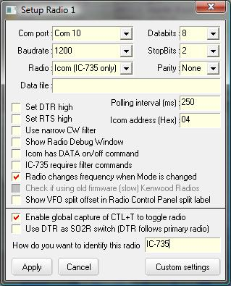

IC-735\_1

**Note**: DO NOT set the Polling Interval less than 250 ms as the IC-735 cannot respond to the Logger32 polling at an interval of less.

**Note**: Many commercial interface circuits use the computer RTS or DTR lines to power the interface circuitry. If you are using a radio control interface that derives power from the computer, you can set the DTR and/or RTS lines "HIGH" by placing a check mark in the box adjacent to them. If you set either of these lines High you will not be able to share the same Com port for CW operation. However, if your interface will run on power from the DTR line, you may still be able to share the RTS line for PTT operation of the Sound Card Data window.

*Created with the Personal Edition of HelpNDoc:* [*Free Kindle producer*](http://www.helpndoc.com/feature-tour/create-ebooks-for-amazon-kindle)

ICOM IC-746

# Hal Miller KB1ZQ

## 1.0 GENERAL

Radio IC-746 with ICOM OPC-662 interface cable\*

Sample Settings are as shown in the figure below:

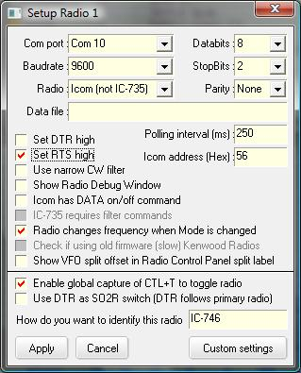

IC-746\_1

The COM port and Baudrate are user selectable, making sure that the radio is set to the same settings.

Radio is set to Icom (not IC-735)

Set RTS high must be checked as this powers the OPC 662 interface.

Databits must be set to 8

StopBits should be set to 2, will work intermittently with 1

Parity is set None

ICOM address (Hex) can be user defined, however the default for the IC-746 is 56. See the topic [ICOM General](#_topic_ICOMGeneral)" for a list of many ICOM addresses.

\*OPC-662 Interface and cable are part of the ICOM RS-746 Package

**Notes**:

The default values of 9600 baud for the COM port and 1000 ms (1 second) for the polling speed should be used as a starting point for your configuration. If your radio and computer can handle faster baud rates you should select the highest baud rate that provides reliable operation with your specific hardware. Reducing the value of the polling speed (increasing the rate of radio polling) will provide a faster and smoother display of all band, frequency and mode changes. It is also recommended that ICOM transceivers that support CI-V Transceive have this option turned OFF. This is to reduce data collisions caused by unsolicited messages from the radio every time you change the VFO frequency.

If you have CW and SSB narrow filters installed, you can tell Logger32 which filter to use. The [ICOM General](#_topic_ICOMGeneral) section contains the procedure for editing the Logger32.ini file to automatically set the desired bandpass filter for DX spots depending on the mode of operation.

*Created with the Personal Edition of HelpNDoc:* [*News and information about help authoring tools and software*](http://www.helpauthoringsoftware.com)

ICOM IC-7300

# Aki Yoshida JA1NLX

## 1.0 GENERAL

This radio provides both [CI-V](#CI-V) and [USB](#USB) interface for [CAT](#CAT). USB Audio CODEC is supported if USB interface is used. This section explains how to use USB interface.

## 2.0 SETUP

### 2.1 Using USB interface

Install correct driver and connect USB cable between PC USB jack and IC-7300 USB jack referring to ICOM manual.

Unplug USB cable and check sound/port device. This shows all devices except for IC-7300.

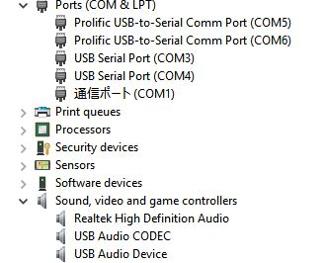

IC-7300\_1

Plug USB cable. Sound/port devices for IC-7300 appear. In this example, Silicon Labs CP210x USB to UART Bridge (COM9) and one of USB Audio CODEC are for IC-7300.

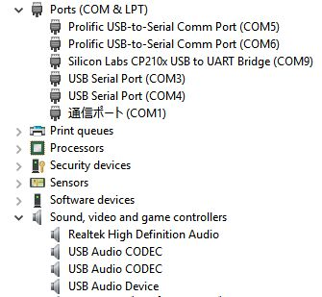

IC-7300\_1

## 2.2 Setup in IC-7300 menu items

Select Set/Connectors and set following items.

ACC/USB Output Select: AF

ACC/USB AF Output Level: 20%

ACC/USB AF SQL: OFF

ACC/USB AF Beep/Speech Output: OFF

USB MOD level: 50%

DATA OFF MOD: MIC

DATA MOD: USB

Select Set/Connectors/CI-V and set following items..

CI-V address: 94h

CI-V Transceive: OFF

CI-V USB->Remote Transceive address: 94h

CI-V Output (for ANT): OFF

CI-V USB Port: Unlink from [Remote]

CI-V USB Baud Rate: 115200

CI-V USB Echo Back: ON

## 2.3 Setup in Logger32

Set each parameter in Logger32 Radio setup table.

Com port number should be same as explained in [paragraph 2.1](#2.1_Using_USB_interface). Baudrate and Icom address should be same as IC-7300 menu explained in [paragraph 2.2](#2.2_Setup_in_IC-7300_menu_items).

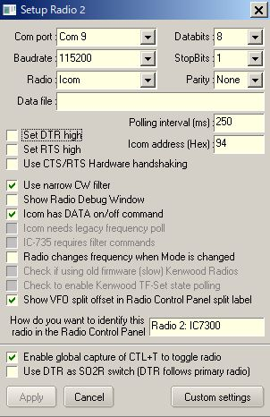

IC\_7300\_3

## 2.4 Setup JTDX/WSJT-X for FT8 operation

If you are interested in FT8 operation using IC-7300 then refer to following examples of Radio/Audio settings in JTDX program. This should work flawlessly. Carefully set each items, especially Rig, Serial port and Baud Rate.

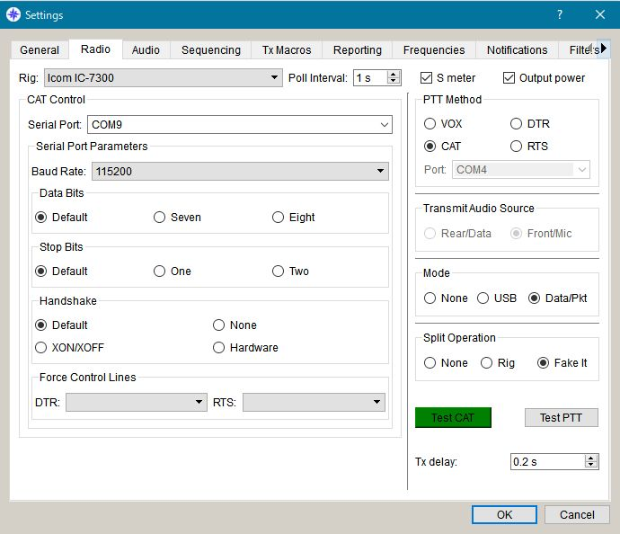

IC-7300\_4

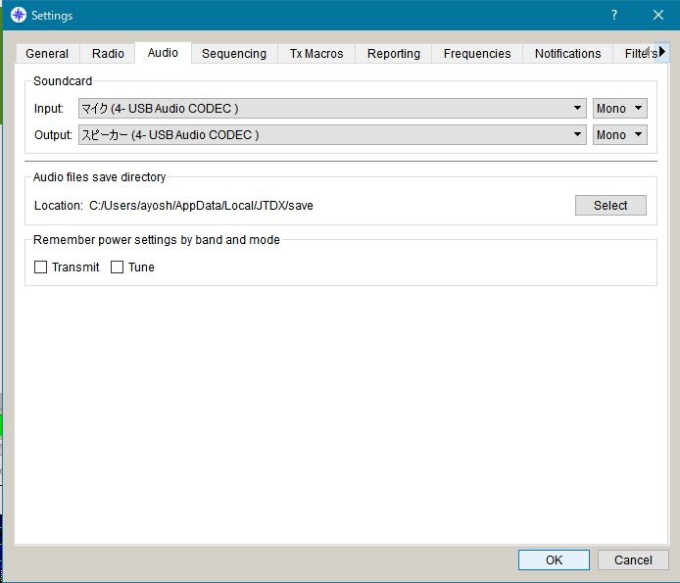

IC-7300\_5

*Created with the Personal Edition of HelpNDoc:* [*News and information about help authoring tools and software*](http://www.helpauthoringsoftware.com)

ICOM IC-7610

# Aki Yoshida JA1NLX and John Munton G7SSE

## 1.0 General

This topic describes the USB interface, IC-7610 setup, and Logger32 setup.

## 2.0 Setup

### 2.1 USB interface

I am assuming at this point you have installed the drivers and connected the radio. You will need to identify which of the two newly created com ports are which.

Open Device Manager in Windows;

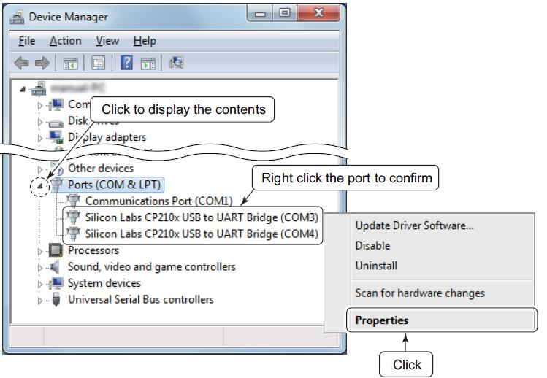

IC-7610

Click the 'Details" tab.

Click "Property" and select the "Device Instance Path" displayed in the drop-down list.

Check the contents displayed in "Value."

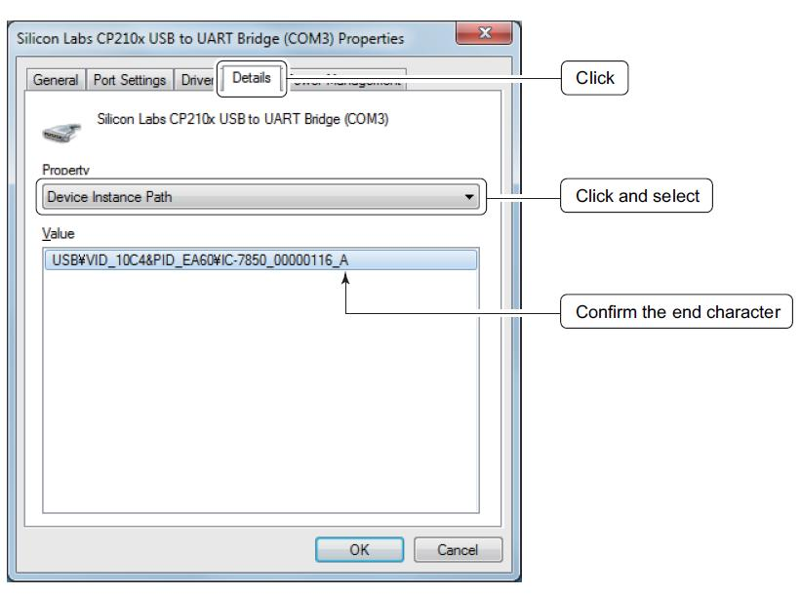

IC-7610\_2

In my set up the A port (COM3 in the above example) is the CAT port and the B port (COM4 above) is used in the radio’s USB Send/Keying menu for Digital Modes and CW keying, PTT etc.

### 2.2 Setup in IC-7610

My radio and Logger32 CAT settings are;

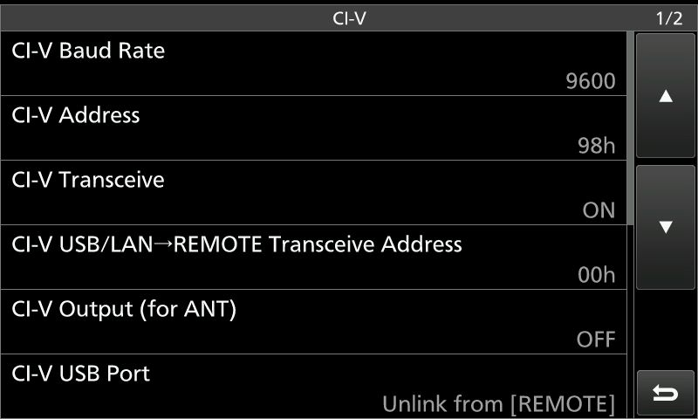

IC-7610\_3

CI-V USB Echo Back **MUST** be set to **ON** for Logger32 to track frequency / band

changes.

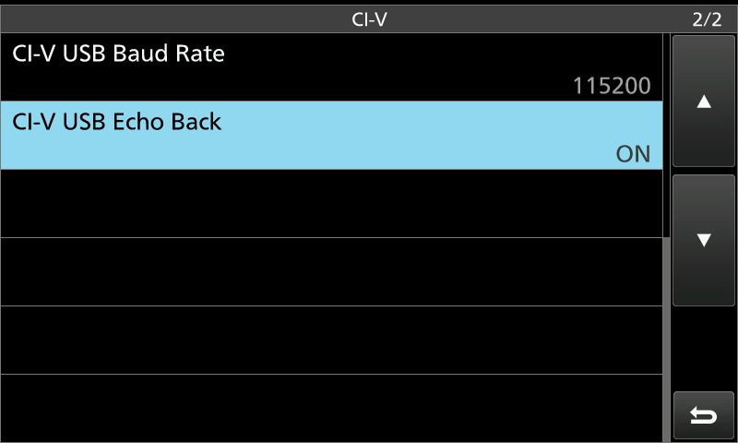

IC-7610\_4

My Radio menu for USB Send/Keying.

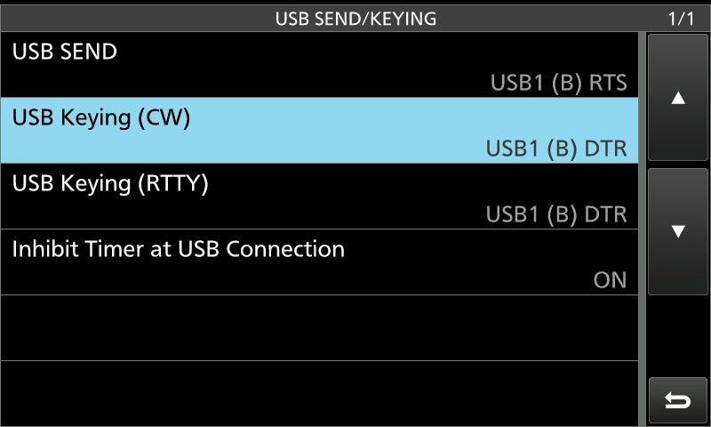

IC-7610\_5

### 2.3. Setup in Logger32

Settings in Logger32. Select COM3 ( “A” port) as COM port.

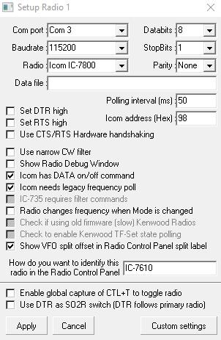

IC-7610\_6

The COM4 (“B” port) is used for Digital Mode / CW software for PTT, CW and FSK keying. Setup in USB SEND/KEYING menu. (IC-7610\_5)

*Created with the Personal Edition of HelpNDoc:* [*Easily create CHM Help documents*](http://www.helpndoc.com/feature-tour)

**JRC JST-245**

# Fabio Mantovani IZ4AFW

## 1.0 GENERAL

The procedure for connecting your PC to the JRC JST-245 is straightforward. You need a null modem serial cable, or a straight cable and a null modem adapter, if you prefer. Having connected the PC to the radio, you need to configure Logger32.

From the Logger32 [Setup Menu](#_topic_SetupMenu) select [Radio | Radio # configuration](#5.0_RADIO_MENU_ITEM) to display the Setup Radio # dialog box.

The JST-245 needs Baudrate - 4800 bps, Data bits - 8, Stop bits - 1, Parity - None (4800 8N1). Select the correct parameters and COM port from the drop-down menus.

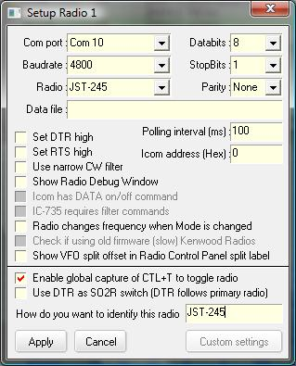

JST-245\_1

The “Set RTS high” and “Set DTR high” checkboxes are not needed, however, if you are experiencing problems communicating with the JST, experiment with these options.

The “Icom Address (Hex)” is not related to the JRC family of radios, so leave it at its default value. In the Radio box, choose JST-245.

The “Polling interval” value sets how often Logger32 will poll the radio to request its parameters (frequency, mode, filters selected, etc.). Use a value of at least 1000 ms (1 second); I have experimented with it and could not get polling faster than 400 ms without glitches in the frequency read by the PC. Your mileage may vary, but 1000 ms is surely a good starting point.

A note about JST-245 support in Logger32: At the moment, the “Use narrow filters for CW” option (under Setup/Radio) is not functional.

*Created with the Personal Edition of HelpNDoc:* [*Easy Qt Help documentation editor*](http://www.helpndoc.com)

**Kachina 505**

# Hew Lines VA7HU and John Torneby VE6MRT

## 1.0 GENERAL

No COM port is required for this radio. The Kachina writes data directly to a data file on your computer. Setting up Logger32 to control the Kachina 505 is very simple. From the Main menu, select the Setup menu. From the Logger32 [Setup Menu](#_topic_SetupMenu), select the [Radio | Radio # configuration](#5.0_RADIO_MENU_ITEM) menu item to display the RigControl Setup dialog box.

This configuration has been tested and works with:

Kachina control software version 4.41 and

Kachina radio firmware version 4.29.

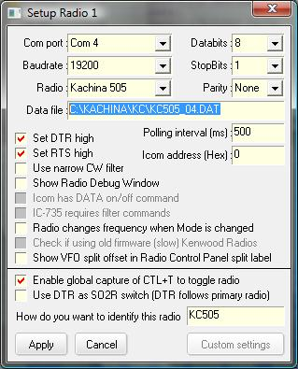

Kachina 505\_1

## 2.0 SETUP

Select "None" for the COM Port.

Enter the fully qualified filename for the Data File into edit box. This data file is created by the Kachina control software and the filename will be "C:\KACHINA\KC\KC505\_nn.DAT", where "nn" is the COM Port number used by the Kachina control software. For example "C:\KACHINA\KC\KC505\_04.DAT".

Accept all other defaults.

It is important that you have the interface to logging programs in the Kachina control software turned ON. In the Kachina software - click SPECIAL, then STATION SETTINGS, then INTERFACE TO OTHER LOGBOOKS, and make sure it is set to ON.

*Created with the Personal Edition of HelpNDoc:* [*Create cross-platform Qt Help files*](http://www.helpndoc.com/feature-tour/create-help-files-for-the-qt-help-framework)

**Kenwood**

*Created with the Personal Edition of HelpNDoc:* [*Free Web Help generator*](http://www.helpndoc.com)

Kenwood General

# Geoff Anderson G3NPA

## 1.0 CAT CONNECTION TYPES

There are three types of connections for using [CAT](#CAT) with Kenwood radios.

## 1.1 Type A

You need IC-10 kit installed in radio plus an external IF-232C interface box. A 6-pin DIN cable is required between the radio and the IF-232C, and a standard RS-232C cable is connected between the IF-232C interface box and the PC’s serial port.

Example radios: TS-440, TS-850, TS-940, etc.

## 1.2 Type B

Radio has RS-232C port. A standard RS-232C cable is connected between the radio’s RS-232C port and the PC’s serial port.

Example radios: TS-480, TS-570, etc.

### 1.3 Type C

Radio has both RS-232C port and USB port. You may use either of them.

To use the radio’s RS-232C port, connect a standard RS-232C cable between the radio’s RS-232C port and the PC’s serial port.

To use the radio’s USB port, connect a USB cable between radio’s USB port and the PC’s USB port. You must install a USB driver correctly.

Example radios: TS-590S, TS-590SG, TS-990 etc

**Note** for Type A and Type B radios (no USB port): If your PC has USB ports but no RS-232 ports, you will need a serial-to-USB adapter in line with your RS-232 cable. Users of many different logging programs have reported difficulties when using an adapter based on anything other than a genuine FTDI chip. The latest driver for your specific operating system can be found at [www.FTDIchip.com](http://www.FTDIchip.com) or obtained from the manufacturer of your adapter.

**2.0 BASIC CAT COMMAND PROTOCOL**

All Kenwoods use the same basic CAT command protocol; however, the available commands for a specific model may be expanded beyond the basic set. (A good example can be found in the added commands for the sub-receiver of the TS-950 series.) For details, check the CAT command programmer’s reference manual for your specific radio.

The Kenwood protocol is also used by Elecraft and in the latest Yaesu radios.

## 2.1 Some Basic Command Examples:

**Request**

IF;

**Reply**

Ifxxx....xxx; xxx is 35 byte data. It shows radio’s frequency, mode etc.

**Request**

FA;

**Reply**

FAxxx....xxx; xxx is 11 byte data. It shows radio’s VFO A frequency.

**Request**

MD;

**Reply**

MDx; x is 1 byte data. It shows radio’s mode parameter. 1=LSB, 2=USB, 3=CW etc

**Note:** There may be some differences in data structure for each radio.

**3.0 TF-SET CONTROL**

You can use [$TF-Set$](#$TF-Set$) and [$mouseTF-Set$](#$mouseTF-Set$) macro in [Radio Control Panel](#_topic_SetupRadioControl), [CW Machine](#_topic_CWMachineWindow) and [Soundcard Data Window](#_topic_SoundCardDataWindow1) for following Kenwood Radios.If $mouseTF-Set$ macro is defined in a function key then this function key works just like TF-SET button on radio’s panel.

TS-590

TS-990

You need to check corresponding option in Setup Radio table to enable this function.

**Note**: In the DTR/RTS setting in Radio setup table you may need to check either of “Set DTR high” or “Set RTS high” option. It depends on your radio and CAT interface.

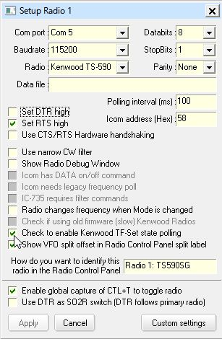

KG\_1

*Created with the Personal Edition of HelpNDoc:* [*Free Qt Help documentation generator*](http://www.helpndoc.com)

Kenwood TS-440

# Ben Antanaitis WB2RHM

The Kenwood TS-440S(/AT) was designed to allow for computer control by using a Kenwood IC-10 chip set, installed within the TS-440, and a Kenwood IF-232C external level converter box installed between the TS-440 and the RS-232 port of a computer.

The IC-10 accessory kit consists of two dual inline integrated circuit chips that are installed within the TS-440. You can either obtain an IC-10 kit or buy inexpensive equivalent ICs and install them following the instructions in the TS-440 manual. (IC-54 is a uPD-8251-AC aka 8251A; IC-55 is a CMOS TC-4040-BP aka TC4040BP)

With the IC-10 kit (or equivalent chips) installed, the TS-440 will provide an Asynchronous, ASCII, 4800BPS, 1-Start 8-Data 2-Stop bit TTL level 0.0->+5.0 volt only interface at the ACC-1 6 Pin DIN connector on the rear of the radio.

The IC-10 interface in the rig will not transmit data if it does not see/receive a TTL high signal (+5 volts) on its CTS pin (pin 4 in the DIN connector on the back of the radio). The IC-10 interface will generate a TTL high signal (+5 volts) at its RTS pin (pin 5 in the DIN connector) when the radio is able to accept data.

The Kenwood IF-232C external level converter box is a collection of optoisolators and level converters to interface the TS-440's ACC-1 DIN connection to a computer's RS-232C cable.

The TTL signals that come or go to the radio’s DIN connector go through optical isolators to protect the radio interface (TTL voltage) circuits from any over/under voltages that may appear on the RS-232C cable (EIA RS-232C +/- 11 volt voltages) from the computer. You cannot just connect RS-232C voltage levels into the TS-440... bad things can happen.

The Kenwood IF-232C only senses the signal levels from the computer RS-232C connector and the radio’s TTL DIN connector. It does not use any voltage or current seen on the interface for internal power. The IF-232C is powered from an external +13.8 volt power cube. This voltage is filtered and is used to generate a regulated +5 volts for internal use and to provide the TTL signals (0.0v and 5.0v) back to the radio. The filtered 13.8 v is also used to provide +11.5 and –11.5 volts for the RS-232 signal levels for the computer interface.

Because the IC-10 interface requires a TTL high (+5) at its CTS pin (coming from the IF-232C) before it will transmit data to your computer you have to set RTS ‘ON’ in your configuration by checking the box labeled "Set RTS high"..

Your RS-232 cable must hard-wire the computer’s RTS to the ‘modem’ side's CTS and vice-versa (one side's Request To Send data is seen as the OK or Clear To Send from the other side's point of view).

*Created with the Personal Edition of HelpNDoc:* [*Free help authoring environment*](http://www.helpndoc.com/help-authoring-tool)

Kenwood TS-570, TS-60, TS870 and TS-2000

# Hew Lines VA7HU and Grant Mitchell N4GM

## 1.0 GENERAL

The procedure for interfacing the Kenwood TS-570, TS-870, and TS-2000 transceivers to Logger32 is very simple, and almost identical for all three radios.

The COM connector on the rear panel of the transceiver allows you to directly connect your computer using a standard RS-232C cable. You can still use all transceiver controls while under computer control.

The RS-232 cable must be a standard "straight" cable terminated with a 9-pin female connector at the radio end. The computer end must be either a 9 or 25-pin female connector to match your computer serial port.

Radio Shack carries both cables #2608033 (DB-9 to DB-9) or #2618175 (DB-9 to DB-25). If you wish to build an interface cable, only the following signals (wires) are required:

### 1.1 9-Pin RS-232 Connector

Pin 2 – Transmit Data

Pin 3 – Receive Data

Pin 5 – Signal Ground

Pin 7 - Request to Send

Pin 8 - Clear to Send

### 1.2 25-Pin RS-232 Connector

Pin 2 – Transmit Data

Pin 3 – Receive Data

Pin 4 - Request to Send

Pin 5 - Clear to Send

Pin 7 – Signal Ground

## 2.0 SETTING UP THE RADIO

To use computer control with the radio you must set up the Communication Parameters section of the radios menu.

### 2.1 TS-570

From Menu Nr 35 (Computer Interface), select one of the eight options. The recommended option is the Kenwood default of 96-1, or 9600 bps with 1 stop bit.

### 2.2 TS-870

From Menu Nr 56 (COM.RATE), select one of the eight options. The recommended option is the Kenwood default of 96-1, or 9600 bps with 1 stop bit.

### 2.3 TS-2000

From Menu Nr 56 (COM CONNECTOR PARAMETERS), select one of the five options. The recommended option is the Kenwood default 9600 bps.

After selecting the desired menu item, the radio must be turned off then back on for the new parameters to take effect on the serial port.

## 3.0 SETTING UP LOGGER

The TS-570, TS-870 and TS-2000 all operate with No Parity and 8 Data Bits. Setting up Logger32 is very simple. From the Logger32 [Main Menu](#_topic_MainMenu), the [Setup | Radio | Radio #](#5.0_RADIO_MENU_ITEM) menu items to display the Setup Radio # dialog box.

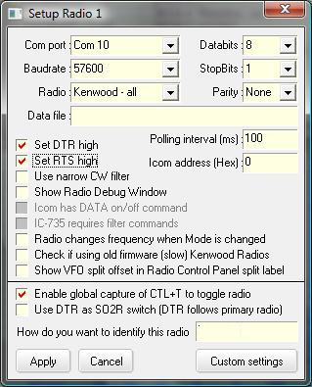

KW\_1

From the drop-down lists, select the following:

**Com port** – the serial port to be used on the computer;

**Baudrate** – the baud rate configured in the previous section (Setting up the Radio);

**Radio** – Kenwood – all;

**Databits** – 8;

**StopBits** – the number of stop bits configured in the previous section (Setting up the Radio);

**Parity** – None;

accept all other defaults.

Select the <**OK**> button.

**Note**: The default values of 9600 baud for the COM port and 1000 ms (1 second) for the Polling interval should be used as a starting point for your configuration. If your radio and computer can handle faster baud rates you should select the highest baud rate that provides reliable operation with your specific hardware. Reducing the value of the Polling interval (increasing the rate of radio polling) will provide a faster and smoother display of all band, frequency and mode changes.

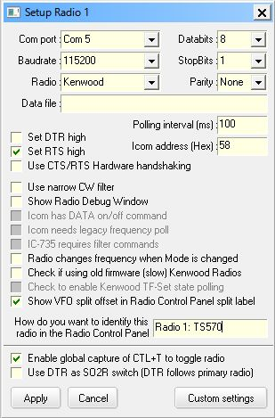

KW\_2

*Created with the Personal Edition of HelpNDoc:* [*Single source CHM, PDF, DOC and HTML Help creation*](http://www.helpndoc.com/help-authoring-tool)

Kenwood TS-50, TS-60, TS-840, TS-940, TS950SD and TS-950DX

# Bud Hippisley W2RU

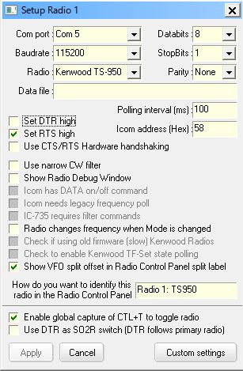

TS-950\_1

It may be necessary to click the box "Set RTS high" in your configuration and you may need to hard-wire the computer’s RTS to the ‘modem’ side's CTS and vice-versa (one sides Request To Send data is seen as the OK or Clear To Send from the other side's point of view).

There are two alternatives:

* + Use a three-wire interface (TxD, RxD and Gnd) with appropriate level converters and loop the CTS and RTS pins inside the radio plug, or
  + Use a FULL interface with level converters for TxD, RxD, CTS, RTS and Gnd, such as the Kenwood IF-232, and place a check-mark in the "Set RTS high" check box in the Logger32 "Radio 1 [or 2]" configuration drop-down window.

*Created with the Personal Edition of HelpNDoc:* [*Easily create HTML Help documents*](http://www.helpndoc.com/feature-tour)

Kenwood TS-480/TS-590

**Aki Yoshida JA1NLX and Mark Anderson WB2SMK**

**1.0 GENERAL**

Both radios basically use same [CAT](#CAT) command and have been widely used. This section will provide basic setup and useful information.

**Note**: In this section the TS-590SG is used as a example. The TS-590S and TS-480 series will work with the same settings as well.

## 2.0 SETUP

**2.1 Setup Radio Dialog Box**

This is a Setup Radio dialog box for the TS-590SG

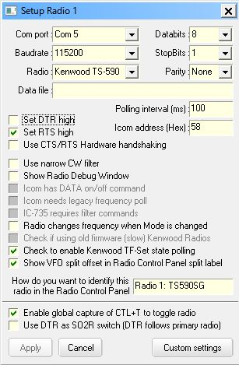

TS590\_1

**Note**: There are two options to connect a PC and the TS590S for CAT control. One is to use a serial port and another is to use a USB port. If you want to use a USB port then you need to install a driver properly. See the operating manual. Baudrate is selected separately for each port in the TS-590S menu.

You need to check “Set [DTR](#DTR) high” and/or “Set [RTS](#RTS) high” depending on your system.

If you want to use [$TF-Set$](#$TF-Set$) and/or [$mouseTF-Set$](#$mouseTF-Set$) macro then check “Check to enable Kenwood TF-Set state polling”.

**2.2 Setup in RCP (Radio Control Panel)**

**2.2.1 Macros configured in function buttons**

This is a sample macros configured in [RCP](#_topic_RadioControlPanelRCP) Main.

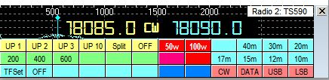

TS590\_2

**Macro for UP 1**

[$command](#$command$) FT0;FB#split+1#;FT1;$

[$ClearCallsignOnQSYOff$](#$ClearCallsignOnQSYOff$)

[$ClearQSYMarker$](#$ClearQSYMarker$)

**Macro for 200 (Band width 200Hz)**

[$command](#$command$) FW0200;$

**Macro for TF-SET**

[$command](#$command$) TS1;EX06600001;FL2;$

**Macro for OFF (TF-SET OFF)**

[$command](#$command$) TS0;EX06600000;FL1;$

[$command](#$command$) FB;$

**2.2.2 Setup DX Spot Macros**

This is a sample macros configured in Setup DX Spot Macros table.

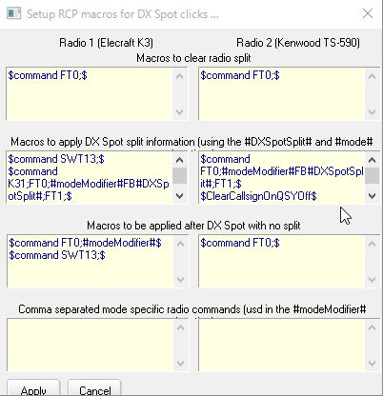

TS590\_3

Here are details in Macros to apply DX Spot split information... box as it does not show all macros.

[$command](#$command$) FT0;#modeModifier#FB#DXSpotSplit#;FT1;$

[$ClearCallsignOnQSYOff$](#$ClearCallsignOnQSYOff$)

[$ClearQSYMarker$](#$ClearQSYMarker$)

**3.0 FREQUENCY AND MODE DISPLAYED IN RCP MAIN**

In this example VFO A is set to 18085 KHz CW and VFO B is set to 18090 KHz CW. “Show VFO A and VFO B side by side” option is checked.

* + **Simplex mode and VFO A is in use**

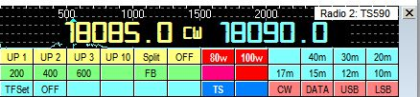

TS590\_4

**Note**: VFO B mode is not displayed. This is normal.

* + **Simplex mode and VFO B is in use**

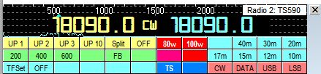

TS590\_5

**Note**: VFO B freq/mode is displayed in left area and VFO B freq is displayed in right area.

* + **Split mode and VFO A is in use (VFO A for RX VFO B for TX)**

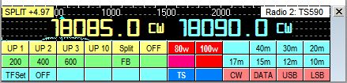

TS590\_6

**Note**: VFO A freq/mode is displayed in left area and VFO B freq/mode is displayed in right area.

* + **Split mode and VFO A is in use. Hold TF-SET button. (this swaps VFO A and B)**

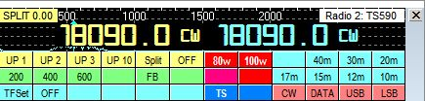

TS590\_7

**Note**: VFO B freq/mode is displayed in both left and right area.

**3.1 Frequency and mode displayed in RCP SO2R**

In this example K3 is configured as Radio 1 and TS-590SG is configured as Radio 2.

* + **Radio 1 is primary radio. Radio 2 is in simplex mode**.

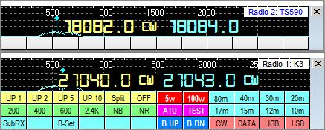

TS590\_10

**Note**: VFO B mode is not displayed in RCP SO2R. This is normal.

* + **Radio 1 is primary radio. Radio 2 is in split mode**.

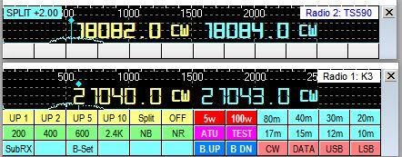

TS590\_11

**4.0 HOW TO ADD AN EXTERNAL SUB-RECEIVER**

The TS-590SG/TS-590S/TS-480 have no internal sub receiver. This is a weak point in this great transceiver, however you may add external sub receiver. This is a example to add Elecraft K2 as external sub receiver for TS-590SG. The main purpose is to find frequency and make a call with TS-590SG and listen to DX station with K2 at the same time. Both radios should be in simplex mode (not split mode).

**4.1 Using Echo port**

This is described in [Echo Port topic](#_topic_TheEchoPort).

**4.2 Using K2 as Radio 2**

When you click DX spot or you turn TS-590SG VFO knob you must send specific command to K2 to be tuned to same frequency as TS-590SG. This command is configured in one of function buttons in [RCP](#_topic_RadioControlPanelRCP).

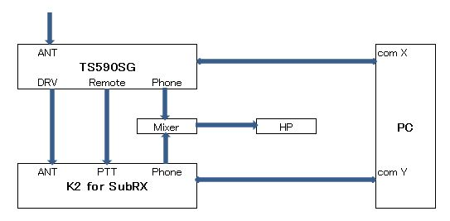

TS590\_8

**Note**: This method is applicable for all transceivers.

### 4.3 Logger32 setup

* + **TS-590SG Setup**

TS-590SG is configured as Radio 1.

* + **K2 Setup**

K2 is configured as Radio 2.　See the [Elecraft K2 K3](#_topic_ElecraftK2K3) topic for details.

* + **RCP setup**

When you click DX spot with split comment then both radios should not turn in split mode. For this purpose “Enable Set Split Macro when clicking on a DX Spot” option should be unchecked. See TS590\_11.

Following macro should be configured to send command to K2. This macro is to tune K2 to same frequency/mode as TS-590SG.

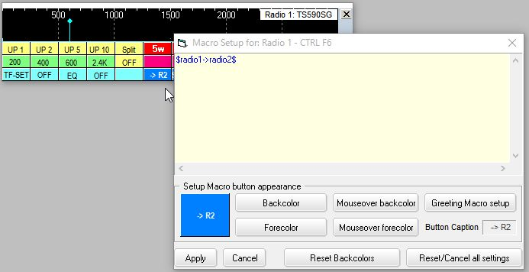

TS590\_9

Logging frequencies are written depending on checked option in the Logging frequency setup table located in the Radio Control Panel. In the following example primary radio VFO-A frequency is written as FREQ and secondary radio VFO-A frequency is written as FREQ\_RX in the Logbook.

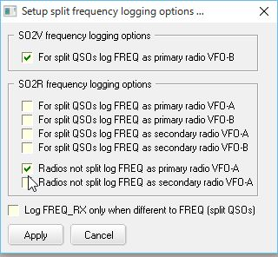

TS590\_9A

## 5.0 Using SDR with Kenwood TS-590SG as Panadapter/Second Receiver

### 5.1 Goals

To add SDR support to my TS-590SG and to allow other applications to also access & control the rig.

These instructions do not cover the download/installation of any of the tools, only the process for configuring them to work together.

### 5.2 My Setup

I currently have the following items set up in my shack:

* Kenwood TS-590SG
* Logger32
* HDSDR
* JT-65 HF HB9HQX Edition
* WSJT-X
* Nooelec dongle (RTL2832) + Nooelec Up-converter
* VSPE – Virtual Serial Port Emulator
* Omni-Rig
* Windows 10 PC

I do not know how to accomplish this on Linux or Mac's - sorry!

### 5.3 Display spectrum via HDSDR

This lets you:

* See the full ham (or other!) band to see where the activity is – or isn’t.
* Identify file-ups or open areas for calling CQ
* Look for particular types of activity, e.g. JT65 vs. SSB vs. CW.

### 5.4 Link Frequency & Mode

The system connects the various elements to share the frequency and mode. This allows the SDR to provide a panoramic display of the spectrum space in use and links the rig to the SDR as well as JT-65, FT-8, and my logging program so that frequency and mode track between them all.

### 5.5 Settings

Each of the various elements in this system will require their own unique settings. These settings were derived based on many resources found on-line supplemented with my own experimentation. While it is possible that other combinations will work and perhaps be ‘better’, this set has at least worked for me.

With the righ and the SDR dongle plugged in, the Device Manager will show the two items seen COM3 is for the TS-590SG rig and the RTL2838UHIDIR is the Nooelec SDR dongle.

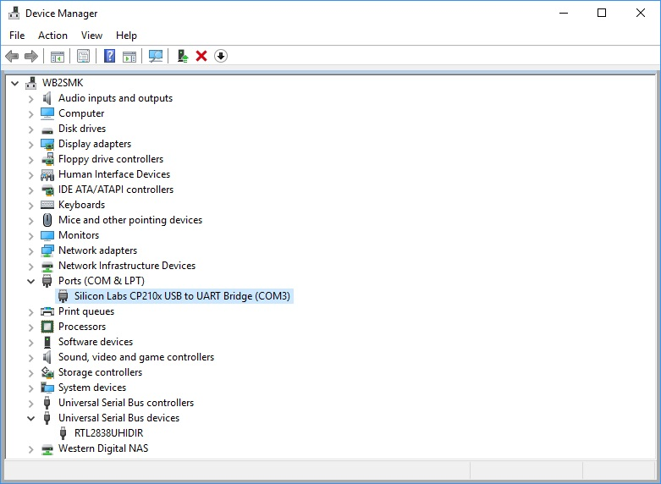

TS-590\_10

## Rig

All of this is easy to do because the TS-590SG supports an antenna output to drive a second receiver, which in this case is the SDR. On the rig, you must change Settings Menu 85 to set the DRV function to antenna. On other radios you would have to tap into the IF for a panoramic display or use a T/R switch to feed both the rig and the SDR in receive and feed the antenna directly to the rig for transmitting.

## VSPE

This package provides virtual serial ports and is currently a key component in this configuration. When starting up it will nag you to buy the 64 bit license but you do not need it. It will run fine in 32 bit (free) mode. Just click on “No” to the purchase offer then ok to the next window.

Create a “Splitter” to create a link to virtual port COM5 from physical port COM3. You may use / need to use other ports based on what's available in your PC.

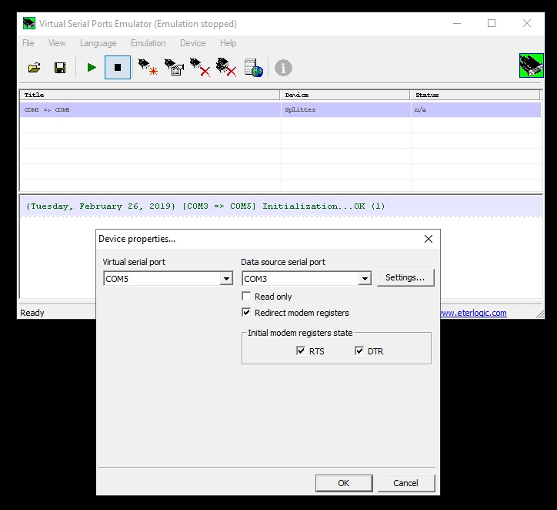

TS-590\_11

I found that I needed RTS/DTR to start in the "on" condition. Next, go into the Setting button and enter the settings in Figure 2 - Serial Port Settings to match your rig's settings.

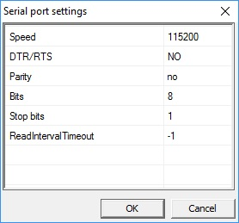

TS-590\_13

**Note:** that the settings **MUST** include no DRT/RTS. I did not find any other combination of settings that worked!

Once configured, be sure to "Run" the configuration using the green arrow button.

**Note:** that the virtual port COM5 does NOT show up in the Windows Device Manager port listing. Looking at the Hardware Manager reveals:

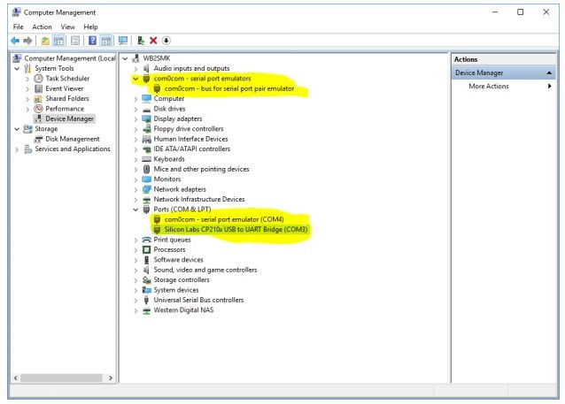

TS-590\_14

**Note:** the following highlighted items:

1. There is an entry called com0com. This does NOT appear when VSPE is not running or when it is running but nothing is activated. If TWO of these show up, try deleting one. If that fails to get things working, reboot;

2. The rig shows up as COM3 in the Ports section. This should always be there at the same com port number and must match the VSPE configuration; and,

3. A com0com emulated port shows up in the Ports section.

Again, the emulated port created by VSPE does NOT show up anywhere in this display!

**Note:** you will have to start VSPE and start the serial port emulation every time your PC reboots! If your programs aren't tracking, be sure to check this first. You can look at the serial port within VSPE using the information screen by clicking on the blue "i" button.

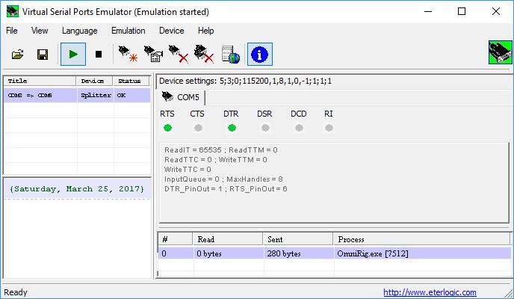

TS-590\_15

To make any configuration changes to the virtual serial port you must close all programs that might access the physical or virtual port, make the changes and then restart everything. Since I rarely reboot my PC, I have not found this to be a problem.

## HDSDR

This is one of the many available SDR programs that run with various SDR dongles. It supports the Nooelec dongle that I am using but the exact choice of dongle / SDR hardware should not matter. I preferred the user interface of HDSRD over the others and it works fine for me. Set the SDR software to use OMNI-RIG.

From Options menu choose “CAT to Radio (Omni-Rig)” then check the following items:

* 1. sync Rig1
  2. sync to Omni-Rig
  3. sync from Omni-Rig
  4. sync Tune frequency
  5. sync Modulation

If HDSDR “loses” the RTL dongle, ZADIG may need to be re-run to re-install the WinUSB driver instead of the default RTL driver. The ZADIG tool is fully explained in the installation instructions for HDSDR.

## OMNI-RIG

The following settings can be made directly in Omni-Rig or this dialog can be opened from within HDSDR.

Set OMNI-RIG to be on COM5 (the virtual port created using VSPE), port parameters to match rig’s settings. For my rig, this is: 115,200 baud / 8 bits / no parity / 1 stop bit. Polling interval 500ms, timeout 4000ms as shown in. If you run into performance issues on your PC or your rig, just lower the polling speeds. It only introduces a slight delay when it updates the frequency and mode but does not affect overall operation.

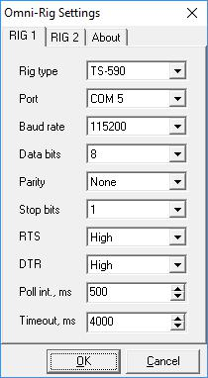

TS-590\_16

It appears that HDSDR uses the pmFreq definition from within the Omni-rig rig definition ini file while JT-65 requires that the pmFreqA ( or presumably pmFreqB) section be used. To resolve this conflict and to restore HDSDR’s ability to read/control the rig’s frequency, I modified the rig definition file. On my installation, this was found in: C:\Program Files (x86)\Afreet\OmniRig\Rigs\TS590.ini. I copied the entire file for a safe back up, then copied the commands from the pmFreqA section to the previously empty pmFreq section.

I have not made any other changes to this for the other programs that also work with this system.

Since I am not entirely clear on the inner details of Omni-Rig / HDSDR / JT-65 I am not sure exactly why this is needed nor, frankly, why it actually works!

## Logger32

Setup the rig to be on COM5 (the virtual port created using VSPE), port parameters to match rig’s settings. Again, for my rig, this is: 115,200 baud / 8 bits / no parity / 1 stop bit.

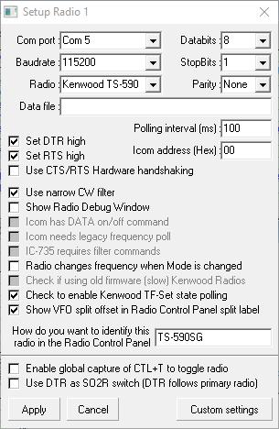

TS-590\_17

This JT-65 HB9HQX Edition supports an Omni-Rig connection. The Hamlib connection did not work when attempting to connect to the virtual com port.

The Omni-Rig configuration file dates back to 2011. Inside, it indicates that pmFreq is not supported and there are no commands configured! For this reason in JT-65 HB9HQX Edition, you must set the Omni-Rig’s Freq option to use pmFreqA so that it will use VFO A to control the rig’s frequency. Without that, JT-65 will properly display the rig’s frequency but is unable to set it. The other applications would still be able to change the rig’s frequency.

The Mode portion of the Omni-rig configuration may optionally be set to pmSSB\_U which will automatically force the rig to upper sideband as needed for the JT-65 mode. A side effect of this is that the TS-590SG will send the Morse code indicator for that mode change – every time!

Unfortunately, putting the rig into SSB mode is not enough! One must also put it into DATA mode to pass the audio via the USB connector. To facilitate this and to add no interfere with the normal operation of pmSSB\_U in case that’s ever needed, I modified the pmDATA\_U entry in the rig definition file by changing the default entry to:

;--------------

; Mark Anderson WB2SMK; Make digital mode use USB but turn on DATA mode. I don't currently use direct FSK on the rig

; I had placed these commands in my Logger32 control panel so why not use them here too!

;$command LK00;$ lock OFF the front panel to make changes possibly not needed

;$command MD2;$ turn on USB

;$command FW2500;$ set filter to wide

;$command DA1;$ turn on DATA mode

;$command LK10;$ lock the front panel to avoid accidents

;$command AG0000;$ turn audio down to 0

;$command PC030;$ low power at 30 watts

; for this I ONLY need the actual command, not the $command prefix nor the $comment after it

;------------------

[pmDIG\_U]

; personalized command string - more than just "mode"

Command=(LK00;MD2;FW2500;DA1;LK10;AG0000;PC030;)

ReplyLength=0

The overall configuration within JT65 can be seen in Figure 5 - JT65 Configuration. Note that this older version of Hamlib only has support for the TS-590S and not for the TS-590SG

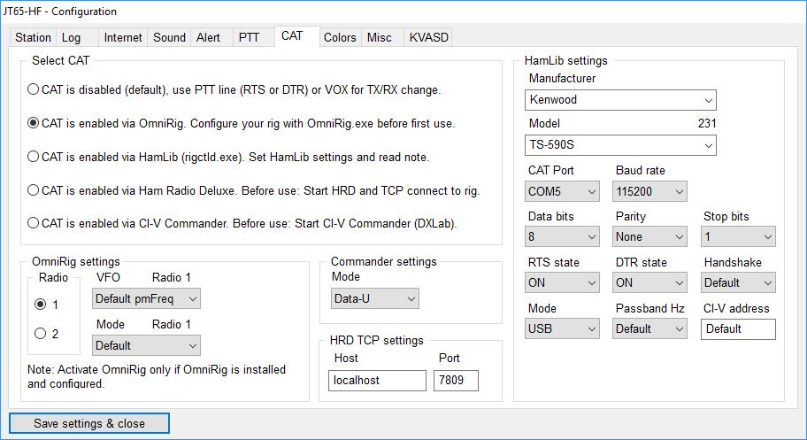

TS-590\_18

Selecting Omni-Rig provides the needed configuration page:

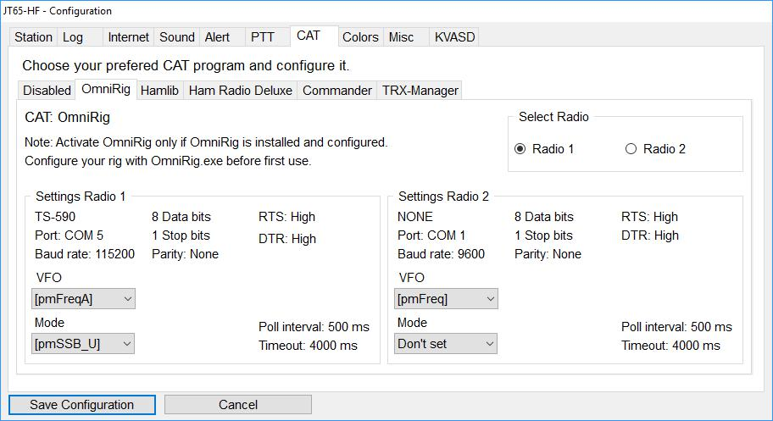

TS-590\_19

The PTT line must also be setup:

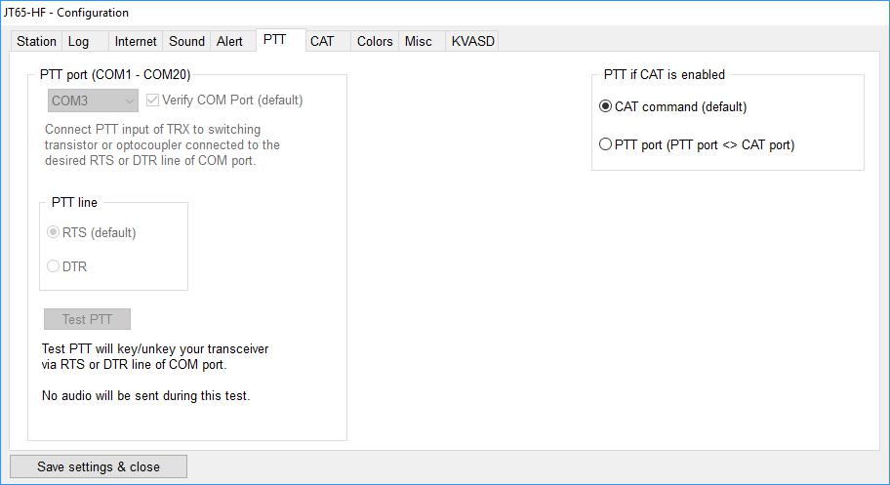

TS-590\_20

**Note:** this shows the manual edits to the rig definition file, e.g. Poll interval and Timeout.

## WSTJ-X

I have also added support for FT8 using the standard WSTJ-X package. Once the com port was set to also use COM5, the package was ready to go. Other packages are likely to have very similar configuration details.

## 5.6 Physical Connections

The physical connections among the various pieces of hardware is straightforward:

* + Ant -> rig -> DRV connector -> Up converter -> RTLSDR dongle -> PC USB port
  + Rig -> PC USB port as COM3

This can be seen in Figure 11 - Physical Connections.

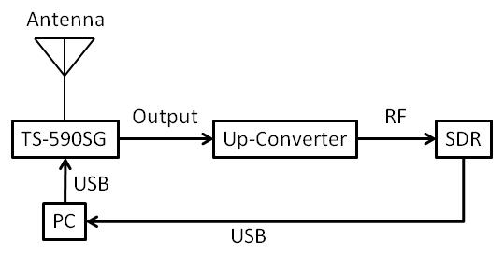

TS-590\_21

## 5.7 Resources

This working combination was achieved through the use of the following resources. My thanks to the various authors!

* <https://sites.google.com/site/g4zfqradio/installing-and-using-hdsdr>
* <http://www.crystalradio.us/projects/ts-590s-panadaptor.htm>
* <http://dxatlas.com/Download.asp>
* <http://www.hdsdr.de/>
* <http://www.eterlogic.com/Products.VSPE.html>
* [https://omniasdr.groups.io/g/main/topic/using\_cat\_with\_a\_logbook/2263174?p=,,,20,0,0,0::RecentPostDate%2FSticky,,,20,2,20,2263174](https://omniasdr.groups.io/g/main/topic/using_cat_with_a_logbook/2263174?p=)

*Created with the Personal Edition of HelpNDoc:* [*Single source CHM, PDF, DOC and HTML Help creation*](http://www.helpndoc.com/help-authoring-tool)

**Power SDR**

# Stan Engel WA2UET and Jim Hargrave W5IFP

## 1.0 GENERAL

This section contains a basic setup for interfacing Software Defined Radios to Logger32.

## 2.0 POWER SDR SETUP

The following setup screens depict a basic setup of Software Defined Radios using the PowerSDR software.

* 1. Open the N8VB VComConfigurator window and select the proper Virtual Port pair. The example shows COM 7 and 8.

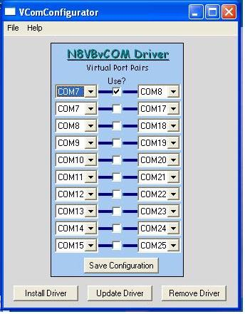

PSDR\_1

* 1. Open the PowerSDR Setup window and select the VAC tab. Set the following:

**Check** "Enable VAC"

**Input** = Virtual Cable 1

**Output** = Virtual Cable 2

**Buffer** = 2048

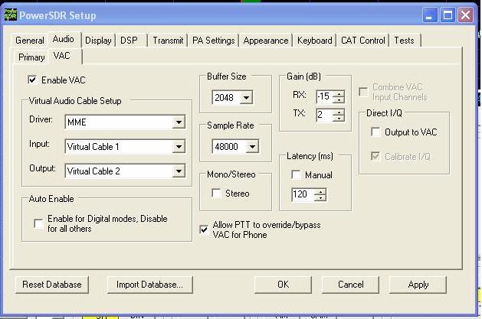

PSDR\_2

* 1. Open the PowerSDR Setup window. Select the "CAT Control" tab. Set the CAT to match the VCom settings.

**Check** "Enable CAT"

**Select** the PTT port

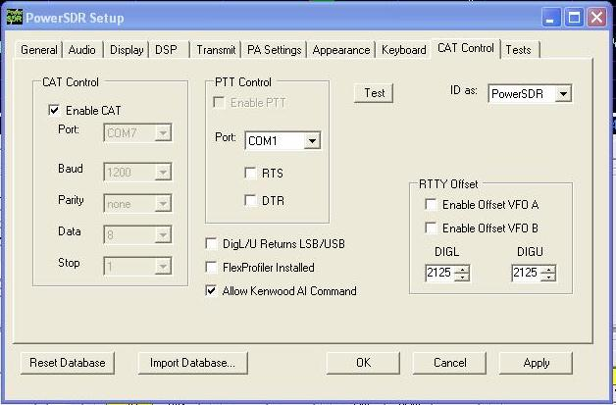

PSDR\_3

* 1. Open the Audio Cable Control Panel and set them according to the following chart.

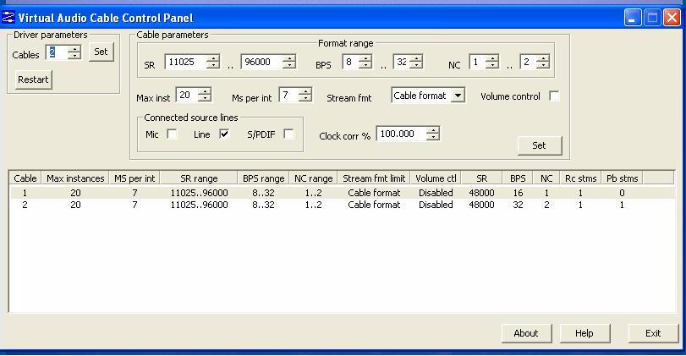

PSDR\_4

## 3.0 LOGGER32 SETUP

The following pictorials depict the Logger32 setup.

**3.1** Go to the Logger32 [Main menu](#_topic_MainMenu) and select the [Setup | Radio | Radio #1 Configuration](#5.0_RADIO_MENU_ITEM) menu items. Set the Com port to match the VCom settings. Under the Radio type, select "PowerSDR". The following is an example of the Flex-5000 port settings.

**Note**: If you are using the SmartSDR software, select PowerSDR for the radio type.

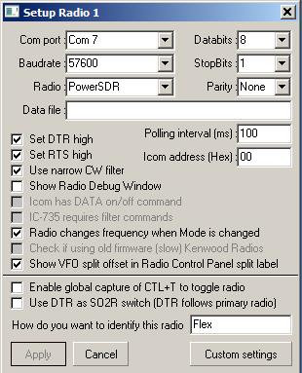

PSDR\_5

Clicking on the “Custom settings” will allow you to enter specialized Mode / filter commands.

**3.1.1**. The following are samples for a FLEX-1500, 3000 & 5000.

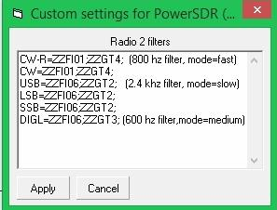

PSDR\_5A

**3.1.2**. The following is for a Flex-6300.

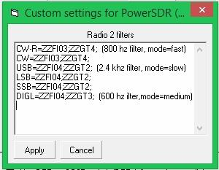

PSDR\_5B

**3.2** Open the [Sound Card Data window](#_topic_SoundCardDataWindow1) in the MMVARI mode. Open "Settings | Radio PTT options" and select the appropriate Keying options and Com port. These settings must match the PowerSDR software configuration.

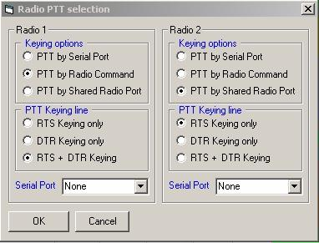

PSDR\_6

**3.3** Open the [Sound Card Data window](#_topic_SoundCardDataWindow1) in the MMVARI mode.

**Input** = Virtual Cable 2

**Output** = Virtual Cable 1

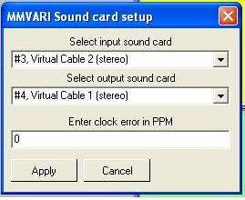

PSDR\_7

**3.4** Open the [Sound Card Data window](#_topic_SoundCardDataWindow1) in the MMTTY mode. Select the MMTTY setup and click on the "Sound Card" tab (MMTTY version 1.66g and later). Make the following selections for Sound Card input and output.

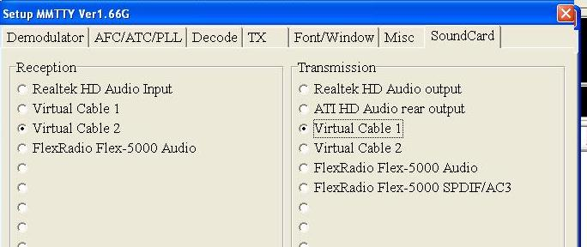

PSDR\_8

*Created with the Personal Edition of HelpNDoc:* [*Create cross-platform Qt Help files*](http://www.helpndoc.com/feature-tour/create-help-files-for-the-qt-help-framework)

**Yaesu**

*Created with the Personal Edition of HelpNDoc:* [*Produce online help for Qt applications*](http://www.helpndoc.com/feature-tour/create-help-files-for-the-qt-help-framework)

Yaesu General

# Geoff Anderson G3NPA and Aki Yoshida JA1NLX

## 1.0 CAT CONNECTION TYPES

There are three types of connections for using CAT with Yaesu radios.

**Note**: In the DTR/RTS setting in Radio setup table you may need to check either of “Set DTR high” or “Set RTS high” option. It depends on your radio and CAT interface.

### 1.1 Type A

Radio has 8 Pin DIN Mini jack for CAT. You need CT-62 cable (or equivalent) to connect to PC’s serial port.

Example radios: FT-857, FT-897, etc.

### 1.2 Type B

Radio has RS-232C port. A standard RS-232C cable is connected between the radio’s RS-232C port and the PC’s serial port.

Example radios: FT-1000MP, FT-2000D, FTDX-1200, FTDX-5000 etc.

### 1.3 Type C

Radio has both RS-232C port and USB port. You may use either of them.

To use the radio’s RS-232C port, connect a standard RS-232C cable between the radio’s RS-232C port and the PC’s serial port.

To use the radio’s USB port, connect a USB cable between radio’s USB port and the PC’s USB port. You must install a USB driver correctly.

Example radios: FTDX-3000, FT-991 etc

**Note for Type A and Type B radios** If your PC has USB ports but no RS-232 ports, you will need a USB-to-Serial adapter in line with your RS-232 cable. Users of many different logging programs have reported difficulties when using an adapter based on anything other than a genuine FTDI chip. The latest driver for your specific operating system can be found at www.FTDIchip.com or obtained from the manufacturer of your adapter.

## 2.0 BASIC CAT COMMAND PROTOCOL

There are 2 types of protocol. One was used in older radios and another is used in newer radios.

### 2.1 Protocol used in older radios

The protocol is original. Please read operation manual carefully. Example of basic request command and reply data used in FT-897.

Request

03 ‘request fequency and mode

Reply

02 11 75 00 01 ’21.175MHz USB

Request

02 11 75 00 01 ‘Set frequency 21.175MHz

Radio Debug Window shows request command and reply data for FT-1000MP. FT-1000MP is configured as Radio 2 in this case.

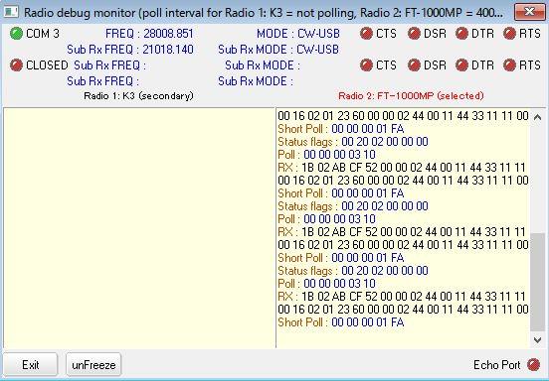

YG\_1

### 2.2 Protocol used in newer radios

The protocol is similar to Elecraft and Kenwood radios. Examples of basic request command and reply data below.

Request

IF;

Reply

Ifxxx....xxx; xxx is 28 byte data followed by terminator “;”. It shows radio’s frequency, mode etc.

Request

FA;

Reply

FAxxx....xxx; xxx is 8 byte data followed by terminator “;”. It shows radio’s VFO A frequency.

Request

MD;

Reply

MDxx; x is 2 byte data.followed by terminator “;”. It shows radio’s mode parameter.

**Note**: There may be some differences in data structure for each radio.

## 3.0 MEM MODE

When Logger32 polls radio for Frequency and Mode of VFO-A, it only reports the correct frequency and Mode if the radio is in VFO mode. If the radio is in MEM, M-TUNE or QMB, an error flag will pop up on the RCP spectrum and the bottom of the radio de-bug window. This flag advises the operator to turn off the MEM. M-TUNE or QMB as appropriate.

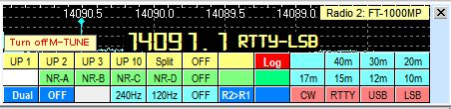

YG\_2

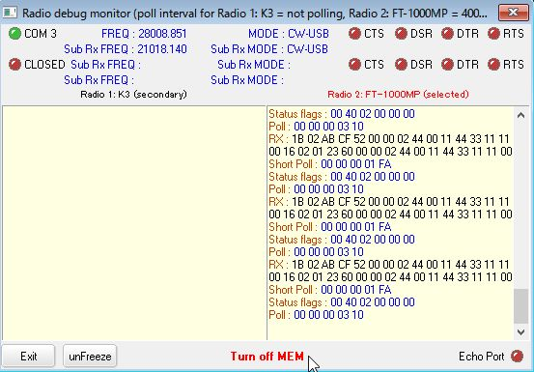

YG\_3

## 4.0 FILTER SELECTION

Some Yaesu sets will store selected filter setting for each mode with in the set. If you select a mode manually or by clicking a DX spot then the radio will use its stored filter settings.

Logger32 provides an alternative way to set the filters according to mode and this is achieved by adding details into the Filter Setup window. See details in the Port Setup section of Setup Radio Control.

Add the following commands:

CW=XXXXXX

USB=YYYYY

LSB=ZZZZZZ

Where X…X,Y….Y and Z…Z represents the command to set the filter.

An imaginary entry could be:

USB=00 00 90 41 75

LSB=00 00 90 41 75

CW=00 00 00 01 0C 00 00 00 00 8C

The operator is strongly advised to consult their user manual for the radio to gain the appropriate command codes.

*Created with the Personal Edition of HelpNDoc:* [*Full-featured EBook editor*](http://www.helpndoc.com/create-epub-ebooks)

Yaesu FT-100

# Barry Winch VA3WI

## 1.0 GENERAL

The procedure for interfacing the FT-100 is relatively straightforward, provided you have a level converter to interface the computer's RS-232 signals to the FT-100's TTL signals. There are two ways to achieve this; the first is to acquire the Yaesu CT-62 cable, the second is to build your own.

## 2.0 CAT INTERFACE

Below are details of a home-brew circuit using a minimum of components. If a MAX-233 is used instead of the MAX-232, then the capacitors are not required.

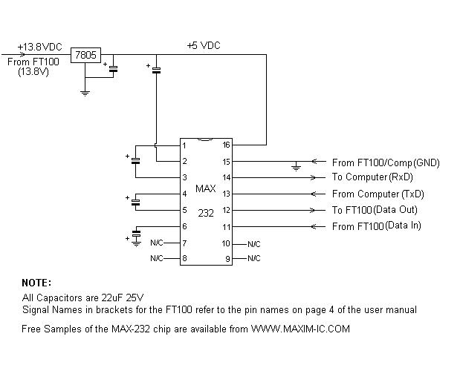

FT-100\_1

The 13.8 volts can be obtained from the pig-tail on the FT-100, however a word of caution; be very careful that the 13.8 v line is not shorted to ground, as there is no separate fuse on this line, and a short WILL disable the transmitter. I know - I've done it!! If you are not comfortable with this, then I suggest you use a separate 5 v supply. Should you manage to short out the 13.8 v line, drop me an e-mail at barry@winch.cc and I'll send you the repair instructions!!

### 2.1 8-Pin Mini DIN Connector

An 8-pin mini-DIN male connector is required to interface to the FT-100. The diagram below shows the pin connections FROM THE WIRING SIDE. The pin names correspond with the bracketed names on the circuit diagram above.

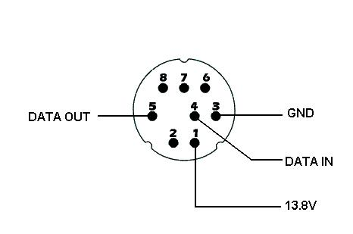

FT-100\_2

### 2.2 DB-9 Connector

A female DB-9 connector is required at the computer end of the cable. The diagram below shows the pin connections FROM THE WIRING SIDE. The pin names correspond with the bracketed names on the circuit diagram above.

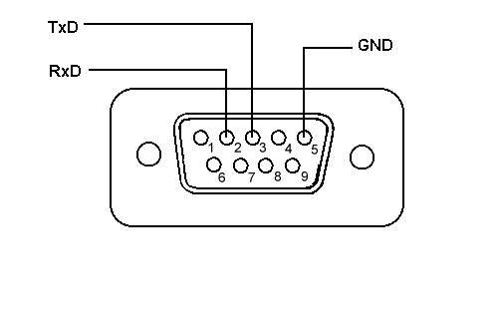

FT-100\_3

## 3.0 SETTING UP THE RADIO

No radio setup is required other than ensuring that the pig tail connector is at its default setting of CAT/TUNER. This is achieved by changing an internal hardware setting within the FT-100 (page 19 of the user manual).

## 4.0 SETTING UP LOGGER32

The FT-100 operates with No Parity, 8 Data Bits and 2 stop bits at a fixed baudrate of 4800. Setting up Logger32 to control FT-100 is very simple. From the Logger32 [Main Menu](#_topic_MainMenu), select the [Setup | Radio | Radio Port configuration](#5.0_RADIO_MENU_ITEM) menu items to display the "Setup Radio #" dialog box.

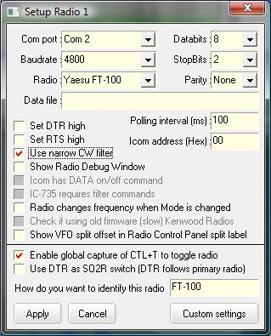

FT-100\_4

From the drop-down lists, select the following:

**Com Port** – the serial port to be used on the computer;

**Baudrate** – 4800;

**Radio** – Yaesu FT-100;

**Databits** – 8;

**StopBits** – 2

**Parity** – None;

accept all other defaults and select the <**Apply**> button.

**Note**: The default value of 1000 ms (1 second) for the polling interval should be used as a starting point for your configuration. Reducing the value of the polling interval (increasing the rate of radio polling) will provide a faster and smoother display of all band, frequency and mode changes.

*Created with the Personal Edition of HelpNDoc:* [*Free EPub and documentation generator*](http://www.helpndoc.com)

Yaesu FT-817

# Geoff Anderson G3NPA

The radio port configuration for the FT-817 should normally be set to:

· 9600 baud;

· 8 data bits;

· 2 stop bits;

· No parity;

· Polling Interval of 100 ms

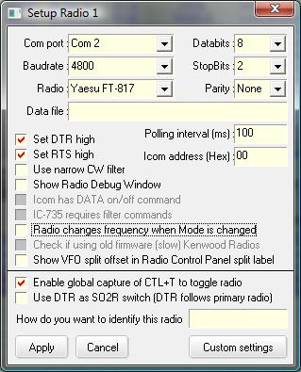

FT-817\_1

If the interface does not seem to work, then check that menu option 14 of the radio is also set to 9600. The best settings found during testing were 9600,8,2,n with a poll rate of 100 ms

If you wish to use the FT-817 for PSK modes it is suggested that you select the option of PSK-L in menu option 26 (Dig Mode). When in digital mode, the FT-817 selects the lower sideband and it does not signal to the outside world that the IF filter setting could be set to PSK-U which then puts the set into upper sideband. This means that in Logger32 the frequency ribbon in the [Sound Card Data window](#_topic_SoundCardDataWindow1) will be run backwards if the PSK-U option is set and the clicking Logger32 options such as “align” will not work correctly.

*Created with the Personal Edition of HelpNDoc:* [*Full-featured multi-format Help generator*](http://www.helpndoc.com/help-authoring-tool)

Yaesu FT-920

# Jim Hargrave W5IFP

## 1.0 GENERAL

The FT-920 has a built in RS-232 level converter for the CAT radio control system. However the user needs an interface to connect the RS-232 levels for PTT and CW data signals. The audio for the [Sound Card Data window](#_topic_SoundCardDataWindow1) operation can be connected direct via the rear data connector, however it is recommended that be accomplished using a 1:1 isolation transformer and some means of level control. Logger32 can be configured to connect the CAT, PTT and CW functions using a single serial port, or they can be wired using a different port for each function.

## 2.0 SETUP

### 2.1 CAT Setup

To setup the communication parameters in Logger32, From the Logger32 [Main menu](#_topic_MainMenu), select the [Setup | Radio | Radio # configuration](#5.0_RADIO_MENU_ITEM) menu items.

Select the Yaesu FT-920 and set the baud rate to 4800, 8 databits, 2 stopBits and parity to none. You can adjust the poll rate to your liking. A rate of 300 ms seems to work well with sound card functions. Leave the DTR and RTS boxes blank. You can ignore the ICOM address

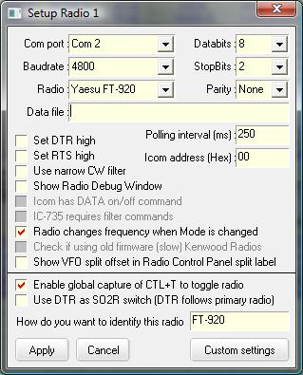

FT-920\_1

### 2.2 PTT Setup

In the [Sound Card Data window](#_topic_SoundCardDataWindow1), select "Settings" and click on "Radio PTT options. Set the parameters to the desired port. You can also select the shared port option, which will allow CAT and PTT on the same port. This is the most efficient and simplest setup, however if you already have a separate PTT interface, then you will need 2 ports. The following shows the shared port configuration.

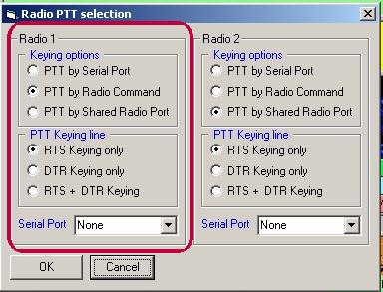

FT-920\_2

### 2.3 CW Setup

Open the [CW Machine](#_topic_CWMachineWindow), click on "Config" and select "Keyer setup". This setup provides the option of using a parallel or serial port. You must provide the address of the parallel or serial port you expect to use. If you have CAT capability, then it is suggested you use a serial port and configure it for shared port. In either case the interface needed will be the same. You can also share the PTT functions on the same port.

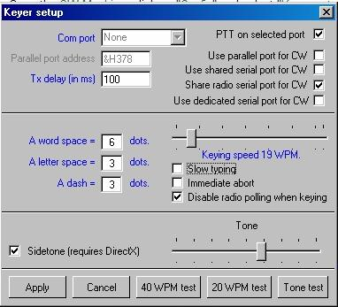

FT-920\_3

## 3.0 INTERFACES

### 3.1 Sound Card Interface

Any commercial sound card interface should work on the FT-920 with appropriate wiring. The following is a suggested interface that provides complete isolation between the computer and the radio. The potentiometers will provide external level adjustments so the sound card settings can be left in a compatible setting for all software.

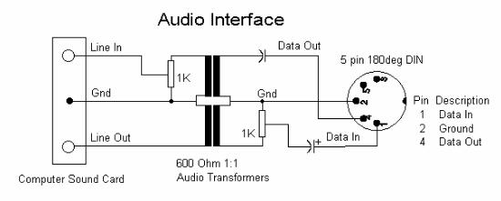

FT-920\_4

### 3.2 CAT, CW and PTT Interface

The CAT, CW and PTT functions can be combined into one single interface that will only use one serial port. If you use this configuration be sure and follow the ground rules for the [Shared Port Setup](#_topic_SharedSerialandParallelPorts) to make sure there is no conflict.

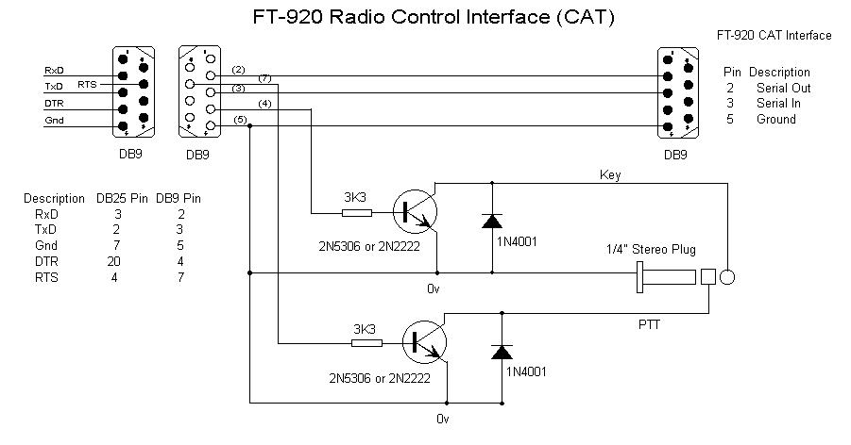

FT-920\_5

## 4.0 RADIO SETTINGS

### 4.1 Radio Settings for Sound Card Operation

The AFSK-FSK slide switch on the back of the radio should be in the "AFSK" position. Select the desired SSB mode (USB or LSB) and then press the "DATA" button. This will automatically disconnect the microphone and make the "DATA" connection active. Follow normal procedures for setting up your power levels and sound card levels. See the [Sound Card Data window](#_topic_SoundCardDataWindow1) setup section for details

### 4.2 Radio Settings for CW and PTT Operation

If you use the "KEY" connection on the back of the radio for CW and PTT, you must set two switches for operation.

The PDL-KEY switch on the rear of the radio should be set to "KEY" for PTT functions. This setting will make the PTT line active in all modes.

The "KEYER" switch on the front panel must be "ON" for CW operation.

### 4.3 Radio Settings for RTTY/FSK operation

The FT-920 can be set up to transmit FSK signals using the Logger32 [Sound Card Data window](#_topic_SoundCardDataWindow1) by selecting the MMTTY engine. Received RTTY signals will be decoded by the MMTTY software using the audio output from the radio. Transmissions will use the internal FSK tone generators in the FT-920. This requires the radio to utilize the data keying provided by the MMTTY engine in FSK transmit mode.

To accomplish this you must use a dedicated parallel or COM ports for FSK keying. You cannot operate FSK using the same COM port that is used for radio control. You will need the typical transistor interface circuit for FSK keying line. See the FT-920 manual for appropriate hook-up. Both transmit and receive signals and PTT can be connected to the DATA terminal on the back of the radio. The FSK transmitted data from the computer can be via a COM port or parallel port.

Suggested FT-920 settings that will work with the Logger32 [Sound Card Data window](#_topic_SoundCardDataWindow1) settings:

* + The AFSK-FSK slide switch on the back of the radio must be in the "FSK" position. You must have an FSK interface.
  + FT-920 MODE = DATA-LSB
  + RTTY FSK mode that configures the radio for internal FSK tone generation. This mode can be operated with LSB or USB tone injection.
  + Menu U-42 = HI 2125 L. This sets the HI tone to 2125 Hz with LSB injection. It is necessary to use this setting so the frequency scale in the sound card is compatible with the radio settings.
  + Menu U-43 = shift 170. Default RTTY shift
  + Menu U-44 = Normal. Used for LSB operation
  + Menu U-44 = Reverse. Reverses the Mark and Space keying - this will configure the FT-920 transmissions to be compatible with USB signals.

### 4.4 Sound Card Settings for RTTY/FSK Operation

EXTFSK.DLL is an MMTTY port driver for the FSK mode. A copy must be in the Logger32 directory. This driver allows you to select the port and data line for FSK keying. It also allows you to reverse the data keying depending on the type of interface in use.

For specific [Sound Card Data window](#_topic_SoundCardDataWindow1) settings for FSK operation, see the section [Transmitting RTTY](#_topic_CommunicatingwithRTTY) / Setting up RTTY for FSK Mode.

*Created with the Personal Edition of HelpNDoc:* [*Produce electronic books easily*](http://www.helpndoc.com/create-epub-ebooks)

Yaesu FT-990

# Jim Steel M0ZAK

The following base configuration should enable your FT-990 and Logger32 to ‘talk’ to each other via a CAT interface cable connection.

From the Logger32 Main menu select the Setup | Radio | Radio # Configuration menu items to ope the Setup Radio # dialog box.

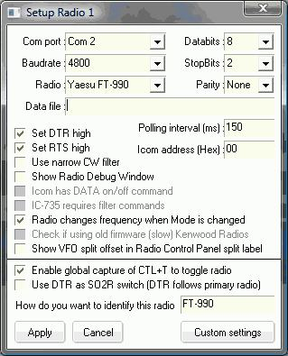

FT-990\_1

Com Port -> select a valid com port.

**Buadrate** -> set this to 4800.

**Radio** - > select Yaesu FT-990.

**Databits** -> 8

**Stopbits** -> 2

**Parity** -> None

**Datafile** -> Leave blank

**Polling interval** -> the lower the number (50 – 5000 ms) the faster the polling rate. A setting of less than 200 ms gives a continual CAT system light on the FT-990 display. Try different values to see which you prefer

**Icom address** -> leave blank (00)

**Use narrow CW filter** -> if you place a checkmark (tick) in this box, the 500 Hz CW filter will be selected every time a CW DX Spot is selected from the [DX Spots window](#_topic_DXSpotsWindow1).

**Show Radio Debug window** -> placing a checkmark (tick) in this box opens the [Radio Debug window](#_topic_RadioDebugWindow), which displays the information being exchanged between Logger32 and the FT-990, when you close the Radio Setup 1 window. It is recommended you leave this box blank.

**Set DTR / RTS High** -> if you are using an interface powered CAT interface you will have to check one of these boxes to assert the DTR or RTS line to high to provide power from the serial port of your computer or laptop to the FT-990. If on the other hand you are using Yaesu’s IF-232C CAT interface, or some other powered interface cable, then you need to leave these two boxes empty as power is provided via the IF-232C interface.

In the event there is no communication between your FT-990 and Logger32, check that all relevant software is installed, all cables are connected to the correct sockets and everything is switched on that needs to be switched on. Check also that you have a valid Com port selected and the Baudrate is set to 4800, as any other baud rate will not work.

The FT-990 should have a ROM version 1.3 or later to work properly with Logger32.

**Note**: One-way communications.

The radio will accept commands from Logger32 but does not respond back to Logger32.

Some interface units do not provide a data load on the transceiver data output line. The FT-990 has a source driver data output, which MUST be loaded for proper operation. This can be remedied by adding a load resistor to the CAT DIN plug.

Solder a 1.5k-ohm resistor between pin 1 (Gnd) and pin 2 (Serial Out) of the DIN6 CAT plug.

*Created with the Personal Edition of HelpNDoc:* [*iPhone web sites made easy*](http://www.helpndoc.com/feature-tour/iphone-website-generation)

Yaesu FT-1000MP

# Geoff Anderson G3NPA

The FT-1000MP has a built-in level converter, allowing direct connection from the rear panel CAT connector to the chosen serial port on your computer without the need for any external boxes.

**CAT setup**

To set up the communication parameters from the Logger32 Main menu, select the Setup | Radio | Radio # Configuration.

Select the Yaesu FT-1000MP and set the baud rate to 4800, 8 databits, 2 stopbits and parity to none. You can adjust the poll rate to your liking. A poll rate of 300 ms seems to work well but it is possible with some computers to run faster at 100 ms.

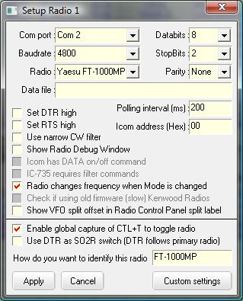

FT-1000MP\_1

*Created with the Personal Edition of HelpNDoc:* [*Free CHM Help documentation generator*](http://www.helpndoc.com)

Yaesu FTDX-5000

# Darren Collins G0TSM and Jim Hargrave W5IFP

## 1.0 GENERAL

The Yaesu FTDX5000 is supported using the Yaesu FT-5000 protocol.

## 2.0 SETUP

### 2.1 Radio Port setup

The following shows the recommended settings in the Logger32 radio port setup:

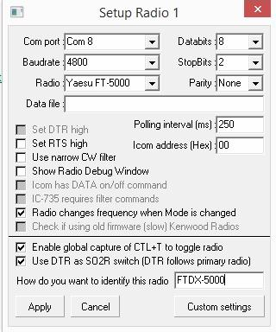

FTDX\_1

### 2.2 Filter Commands Setup

When the roofing filter is not set to 'auto' and a cluster spot is clicked the roofing filter will not change.

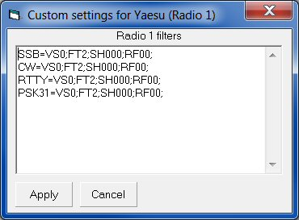

FTDX\_2

A lot of flexibility is available by adding various CAT commands in the filter section.

The following Filter commands allow you to click a CW spot and the roofing filter is changed to 'auto'. VFO 'A' is selected and the final command moves the 'TX' back to VFO A

CW=RF00;VS0;FT2;

USB=RF00;VS0;FT2;

LSB=RF00;VS0;FT2;

FSK=RF00;VS0;FT2;

PKT-USB=RF00;FT2;

**Note**: If the orange 'B' VFO is selected this moves it back to the red VFO 'A'. A full list of CAT commands is given in the Yaesu FTDX5000 CAT Operation Reference Book.

### 2.3. Data Modes Setup Examples

For the correct data mode filters to be selected the operating modes must first be defined. In the example listed below operation on RTTY uses the mode FSK-LSB and for PSK31 PKT-USB is used.

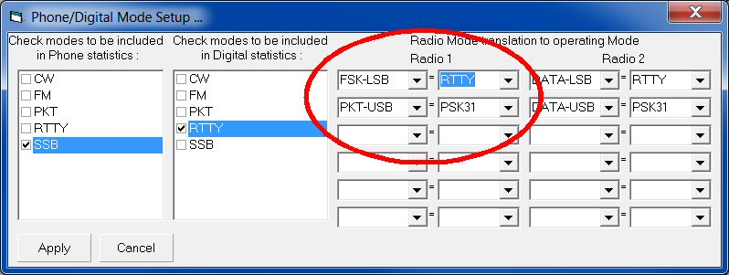

FTDX\_3

Clicking on a PSK31 spot will change the FTDX-5000 to PKT-USB and the RF00;VS0;FT2; CAT commands will be sent to the radio.

*Created with the Personal Edition of HelpNDoc:* [*Free PDF documentation generator*](http://www.helpndoc.com)

**TEN-TEC**

*Created with the Personal Edition of HelpNDoc:* [*Create HTML Help, DOC, PDF and print manuals from 1 single source*](http://www.helpndoc.com/help-authoring-tool)

TEN-TEC OMNI V, VI and VI+

# Rick Williams VE7TK

## 1.0 USING FSK WITH OLDER OMNI V, AND VI

The following applies ONLY to the FSK ( Mark-Space ) plug for the above radios.

Some older versions of the Omni will transmit in REVERSE (upside down) with the conventional keying circuits mentioned. There are 2 known methods that correct this problem. This fix applies ONLY to serial ports.

The usual circuit is through a 1000 to 4700 ohm resistor from TXD (pin 3 on a DB-9 connector, pin 2 on a DB-25) to the base of an NPN transistor. The emitter of the transistor is grounded and the collector connected to the FSK phono plug on the rear of the transceiver (Mark-Space).

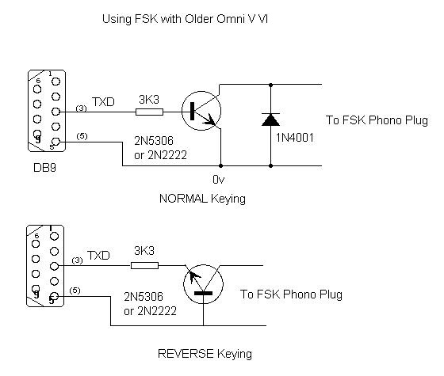

OMNI\_1

The solution to correct REVERSE keying is to reverse the emitter and base connections. Ground the BASE and connect the EMITTER of the NPN to the resistor. Keying will now be normal.

The other solution is to connect TXD directly to a 1000 to 10000 ohm resistor and feed that resistor directly to the FSK phone plug (Mark-Space) on the transistor. A value of 4700 ohms has been tested and works well.

BE SURE THERE IS A COMMON GROUND BETWEEN THE COMPUTER AND TRANSCEIVER.

A very neat setup, which will key both the PTT and FSK, is to build these circuits on a 5-pin connector, and then place both the circuits in a small prescription bottle. Be sure you push the serial port cable through the bottle BEFORE you begin wiring, and that you push the PTT and FSK through the top of the bottle BEFORE constructing the circuit.

## 2.0 USING THE TEN-TEC OMNI V.9

The Omni V.9 is a modified version of the Ten-Tec Omni V. It uses a replacement CPU with firmware developed by N4PY and emulates the CI-V interface protocol.

Setup info for the Omni V.9 is:

**Baud** 1200

**Radio** Ten-Tec Omni V.9

**Poll Interval** 500 ms

**ICOM Address** (Hex) 1E

*Created with the Personal Edition of HelpNDoc:* [*Free CHM Help documentation generator*](http://www.helpndoc.com)

TEN-TEC OMNI VII

# Jim Cox, K4JAF

**COM Port Configuration**

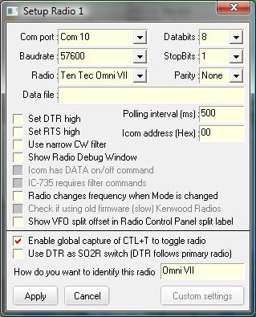

TTOVII\_1

**Customizing the .INI File**

The user can customize the Logger32.INI file to personalize the CW Normal, CW Narrow and FSK receiver bandwidths.

The basic filter defaults are:

CW (Normal) - 1000 Hz

CW (Narrow) - 500 Hz and

FSK - 1000 Hz

The user can modify any of these values by adding/editing the Logger32.INI [Radio Port 1] or [Radio Port 2] sections to include the following:

OmniVII CW Filter Normal=xx

OmniVII CW Filter Narrow=xx

Omni FSK Filter=xx

Where xx is the filter width as outlined in the TEN-TEC Programmers Reference Manual. This manual can be found at <www.rfsquared.com/updates/588/588>.

For example:

[Radio Port 2]

OmniVII CW Filter Narrow=36

would set the Narrow CW filter for Radio 2 to 250 Hz.

**Special adaptation of the $command$ macro for use with the Omni VII**

The OmniVII command structure uses a combination of ASCII characters and hex numbers. It has been necessary, therefore, to make an alteration to the [$command$](#$command$) macro to allow for the sending of hex numbers to the radio. This is achieved by surrounding the hex number(s) ith the “<” and the “>” characters:

$command ASCII <hex number>$

Here's an example: Put the radio on 3505.0 KHz.

First, convert the frequency to Hz 3.550 \* 1000 = 3505000

Now convert the frequency to a hex number - Hex(3505000) = 357b68

Add leading 0s until the string is 8 characters long = 00357b68

Now, enter a Macro like this $command \*A<00><35><7b><68>$. This will send the \*A ASCII command to set the radio frequency followed by a 4 byte hex number representing the frequency.

Similarly, to change mode use $command \*Mxy$ where x denotes the mode for VFO A and y the mode for VFO B (as an ASCII number in the range 1 to 6). As the numbers here are ASCII the “<” and “>” symbols are not required.

**Note**: The Ten-Tec OMNI VII cannot activate transmit using a radio command

*Created with the Personal Edition of HelpNDoc:* [*Full-featured Help generator*](http://www.helpndoc.com/feature-tour)

TEN-TEC ORION

# Randolf Schmitz, DL6KAI

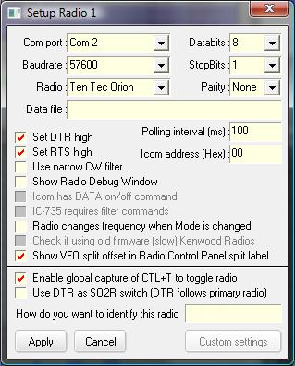

ORION\_1

**Customizing the .INI File**

The user can customize the Logger32 .INI file to personalize the CW Normal, CW Narrow and FSK receiver bandwidths and the TX and RX bandwidth for SSB.

The .INI entries that must be added must be placed in the [Radio Port] section of the .INI file and are:

[Radio Port]

Orion Narrow CW=\*RMF150

Orion Normal CW=\*RMF750

Orion FSK=\*RMF750

Using the syntax above the syntax must be followed EXACTLY. The only spaces are after the word Orion and before the word CW. When Logger32 switches the Orion to FSK, the receiver bandwidth would be set to 750 Hz.

For the SSB settings:

[Radio Port]

Orion SSB RX Filter=2100

Orion SSB TX Filter=2100

The value 2100 is for example only. Values greater than 2400 will be ignored.

**Notes**:

1. If you use the mode “CW” in the Band/mode table, then the Orion will select LCW on 160, 80, 40 and 30m UCW on 20. 17, 15, 12, & 10m with a 500 Hz filter.
2. If “Use narrow filter CW filter" is set, then the CW bandwidth will become 250 Hz.
3. When Logger32 switches the radio to LSB or USB both the TX and RX filter widths are set to 2.4 kHz (unless otherwise modified as above).
4. There are no special settings for the radio itself.
5. PTT by radio command does not work on the Orion for CW, but it should be OK for PSK, AFSK, etc.

*Created with the Personal Edition of HelpNDoc:* [*Free EBook and documentation generator*](http://www.helpndoc.com)

TEN-TEC Paragon 585

# Alec Otulak SP2EWQ

Radio settings for the Paragon 585 are:

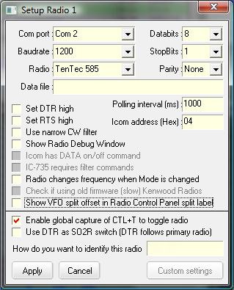

Ten-Tec Paragon\_1

*Created with the Personal Edition of HelpNDoc:* [*Free help authoring tool*](http://www.helpndoc.com/help-authoring-tool)

TEN-TEC Paragon II

# Jim Hargrave W5IFP and Alec Otulka SP2EWQ

If your Paragon has been updated to use the N4PY chip that uses the ICOM CI-V protocol and is configured for the ICOM IC-735 control codes, you must use the ICOM (IC-735 only) radio port setup.

**Port Setup**

See the [IC-735 radio topic](#_topic_ICOMIC735) for specific Logger32 setup.

The following is a typical Paragon (with N4PY chip) port setup:

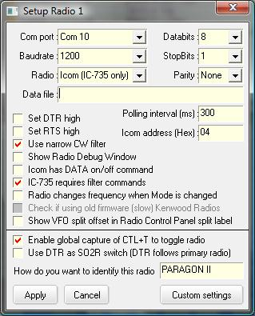

PII\_1

A detailed description of the bandwidth filter selection method for the different radio modes is explained in the [ICOM General](#_topic_ICOMGeneral) topic. The filter selections must be entered into the Logger32.ini file. The normal default for SSB is 01 and the default for CW is 02. These need to be changed for the Paragon.

The following filter selections are available in the Paragon II:

Control code Bandwidth

01 USB 6 khz

02 USB 2.4 khz

03 USB 1.8 khz

04 CW 0.5 khz

05 CW 0.25 khz

Enter the desired bandwidth control code in the Normal and Narrow lines that you add to the Logger32.ini.

Below is an excerpt from Logger32.ini file that has the Filter lines added.

[Radio Port] (see note below)

Automatic Open=True

ComPort=COM1,1200,n,8,1

Radio Type=Icom (IC-735 only)

Poll Interval=300

Set DTR High=0

Set RTS High=0

CW Filter=1

Icom Filter Normal=04

Icom Filter Narrow=05

Icom Address=04

Old Kenwood=0

IC-735 with Filters=1

**Note**: The port section Title can be [Radio Port] or [Radio Port 2] depending on which port (Radio 1 or Radio 2) is configured for the Paragon radio.

*Created with the Personal Edition of HelpNDoc:* [*Create iPhone web-based documentation*](http://www.helpndoc.com/feature-tour/iphone-website-generation)

**Alpha 87A Linear**

# Geoff Anderson G3NPA and Bud Hippisley W2RU

## 1.0 GENERAL

Access to the Alpha 87A window is via the icon on the Tool bar.

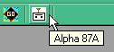

The Alpha 87A amplifier includes provisions for external monitoring and control of some of its functions via its built-in RS-232 serial port. In addition to monitoring Forward & Reflected output power from the 87A, Logger32 provides remote control and monitoring of the following amplifier conditions:

* + Power On/Off
  + Standby/Operate
  + High/Low Power
  + AlphaMax On/Off

AlphaMax is firmware in late model or updated 87A amplifiers that dynamically fine-tunes the settings of the TUNE and LOAD capacitors during key down periods, as described in Section 7 of Revision 2.0 of the Alpha 87A User Manual.

A totally different function, "Auto track frequency" (which the user can turn on or off with a checkmark at the bottom of Logger32's 87A Config menu dropdown list), when turned on causes Logger32 to automatically supply the active radio's active VFO frequency to the amplifier, which uses that information to change bands and select settings for its TUNE and LOAD capacitors from user- or factory-preset values stored in internal 87A memory for each of five band segments on each band covered by the amplifier. Although the 87A is capable of changing bands automatically on its own by sensing the frequency of RF drive power from the transceiver connected to it, quicker band- and segment-changes that put less stress on the internal PIN-diode QSK system of the 87A and eliminate the loss of the first dash or dots on cw (while the amplifier takes itself off-line and retunes in response to sensing the newly selected operating frequency from input RF) are made possible by having Logger32 supply the transceiver's new frequency across the serial interface.

## 1.1 ALPHA 87A - BASIC WINDOW - AMPLIFIER OFF

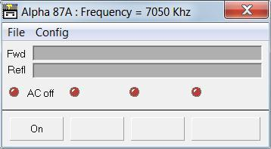

A8L\_1

There is nothing to configure other than the serial port and/or whether the user wants the Alpha 87A to auto track the radio frequency. Click on the Alpha icon, then click on the "Config" menu item and select the port number (Com 1 to 16) required. Click the "Config" menu item again and open the selected port. To set the autotracking facility then simply click on the menu item to place a check mark against the item.

If/when there is communications with the amplifier, the caption of the window will reflect the frequency to which the amplifier is tuned and all buttons will reflect the state of the amplifier - as shown below.

## 1.2 ALPHA 87A POWER ON, 3-MINUTE WARM-UP PERIOD IN PROGRESS

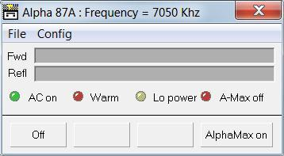

A8L\_2

## 1.3 ALPHA 87A POWER ON AND RECEIVING, i.e., in 'STANDBY' mode, with "AlphaMax " (auto tune) OFF

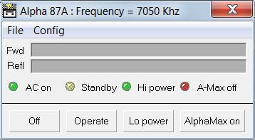

A8L\_3

Alpha 87A power ON and receiving, i.e., in 'STANDBY' mode, with "AlphaMax " (auto tune) activated

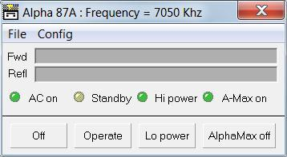

A8L\_4

## 1.4 ALPHA 87A POWER ON AND CAPABLE OF TRANSMITTING, .i.e., in 'OPERATE' mode, with "AlphaMax" (auto tune) ON

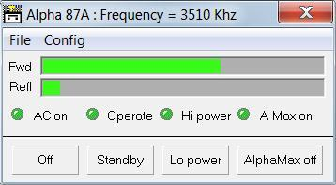

A8L\_5

Alpha 87A power ON and capable of transmitting, .i.e., in 'OPERATE' mode, with "AlphaMax" (auto tune) OFF, i.e., disabled or not present

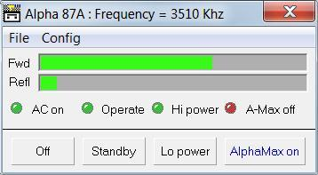

A8L\_6

## 1.5 ALPHA 87A POWER ON AND IN 'OPERATE' mode with 'Lo power mode (capable of transmitting at up to 1 KW limit)' ON, and "AlphaMax" (auto tune) OFF, i.e., disabled or not present

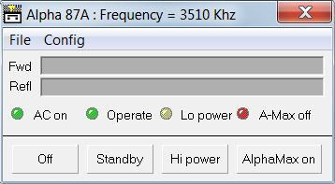

A8L\_7

**Note 1**: Attention is drawn to the Communication Link section in the Alpha 87A user manual where the RS232 interconnection details are given. It should be noted that Alpha uses some of the data pins for setting the default com's baud rate which it does by pulling the pin(s) down to zero volts. The user should be aware that the standard default com rate for the Alpha 87A is 4800 baud and this is what Logger32 expects. The operator must make sure that any cabling between the computer and the amplifier includes the signaling wires TXD (2), RXD (3), CTS (5), RTS (4) and Gnd (7) and that the computer does NOT change the state of any of the pins numbered 9, 12, 13, 14 or 22 on this connector.

**Note 2**: If "Auto track frequency" (at the bottom of the Alpha 87A Config dropdown menu) has a check next to it, the 87A will change bands and segments in response to frequency information provided to it by Logger32, which normally supplies the frequency reported by the ACTIVE radio (Radio1 or Radio2). If the active radio is NOT the radio feeding RF to the 87A, "Auto track frequency" may possibly put the 87A on the wrong band. Of course, if the serial port from the active radio is no longer Open, frequency information previously provided by Logger32 to the amplifier may not be current and "Auto track frequency" will not be active, even if checked in the Alpha 87A Config menu. A quick check to be sure everything is functioning as you expected is to change bands on the radio that is supplying RF to the 87A and make sure the amplifier follows the radio to the proper bands and tuning segments, as indicated by its front-panel LEDs and the audible "growl" of its internal motors.

Logger32 supports the standard 4800 baud Com rate for the Alpha 87A. If the Alpha 87A is set to 9600 baud, it can be selected in Logger32 by the Config pulldown menu.

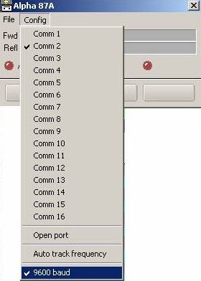

A8L\_8

*Created with the Personal Edition of HelpNDoc:* [*Free EPub and documentation generator*](http://www.helpndoc.com)

**Using Transverters with Logger32**

# Geoff Anderson, G3NPA

## 1.0 GENERAL

Logger32 derives its frequency information from a CAT controlled radio and the frequency displayed reflects the set up of the radio in question. If, however, that radio is used as a tunable IF to a fixed frequency shift up or down converter, then Logger32 will record only the tunable IF freq and not the final operating frequency.

From Logger32 ver 3.19.0 onwards this problem has been rectified and it is now possible to add (or subtract) a fixed offset frequency to that obtained from the CAT controlled radio. As Logger32 can control up to two radios, provision is made to allow the addition of different offsets depending on which radio is “active” at the time (see the [SO2R](#_topic_SingleOperatorTwoRadiosSO2RSuppo) topic).

The option will work alongside all other frequency related features of Logger32 such as the [DX Spots window](#_topic_DXSpotsWindow1), [$QSY$](#$qsy(nn)nnn.(nn)$) Macro, etc.

## 2.0 SETUP

The offset frequency is setup as follows:

Click on the [Logbook Entry window](#_topic_LogbookEntryWindow) somewhere on the line containing the words Freq /Mode/Band to bring up the BandMode selection window. Towards the bottom of the window are two panes that will accommodate the offset frequencies for both radio #1 and#2. The offset for radio #1 will be applied when radio #1 is active and likewise for radio#2. Enter the frequency offset (either positive or negative) in kHz and place a check mark for the radios as appropriate to tell Logger32 to activate the offset(s).

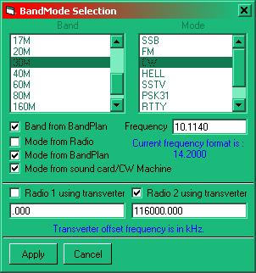

UT\_1

Select the <**Apply**> button to save the new settings.

In the example given above for radio #2 it is assumed that 28MHz will be used to derive a 2M signal using a transverter with an offset of 116.00MHz.

*Created with the Personal Edition of HelpNDoc:* [*Free EBook and documentation generator*](http://www.helpndoc.com)

**Support for microHam Control Commands**

# Geoff Anderson G3NPA

## 1.0 GENERAL

The support for the microHAM control interface has been expanded. Previously a microHAM DVK interface was provided. With release version 3.48.121 full support of the control port is provided. There is a new menu on the [Radio Control Panel](#_topic_RadioControlPanelRCP) to set up the microHAM port and a new [$uHam xx$](#$uham_xx$) Macro has been added.

Amongst other things Logger32 can automatically command the uHam Radio1 port (the 4 wire BCD coded TTL level) in the MK2R+ for antenna switching. This is enabled/disabled in the Antenna Selector Window. Using the $uham xx$ macro the Radio2 port can also be controlled.

It should be noted that while Logger32 meets the requirement for the port control, the microHAM output is ONLY at TTL levels and if there is to be any antenna switching driven from these signals then some form of interface will be required between the MK2R+ and any antenna relays etc.

## 2.0 SETTING UP LOGGER32

The passing of control information to the MK2R requires a serial port number and this may be set using the RCP menu. With the RCP panel showing right click on the side bar to produce the menu as below.

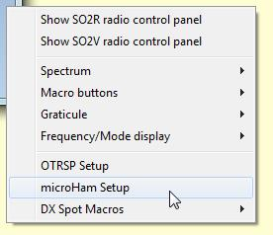

MCC\_1

select microHAM Setup

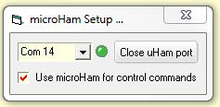

MCC\_2

and set the port number, open/close the port and select the "use microHAM for control commands" option. In this example port 14 has be used.

A new panel has been introduced in the [Lower Status bar](#3.0_LOWER_STATUS_BAR) at the bottom of the main screen.

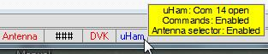

MCC\_3

Should it be that the user wishes to use the microHAM 4 bit port in preference to that provided in Logger32 BUT still maintain the logger32 antenna selection within Logger32 then set the option to do so as shown below.

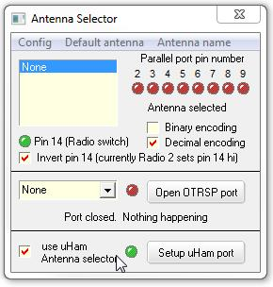

MCC\_4

## 3.0 SETTING UP THE MK2R+

### 3.1 Virtual Port

Need to set up a virtual port in the microHAM router software ? See the MK2R+ manual. In the example given com14 was used as the control port.

### 3.2 Set Control Port

On the microHAM router ports tab set the control port

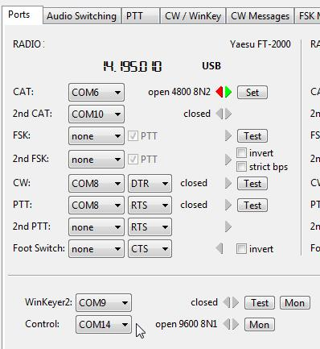

MCC\_5

### 3.3 SO2R

on the microHAM SO2R tab set the computer auto control as shown below.

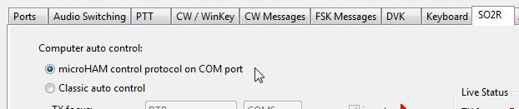

MCC\_6

### 3.4 ACC Tab

On the ACC tab it is possible to observe the status of the 4 bit ports (Pins 6,7,8 and 9) and (pins 10,11,12 and 13) but note that these must be set to be controlled by the microHAM control.

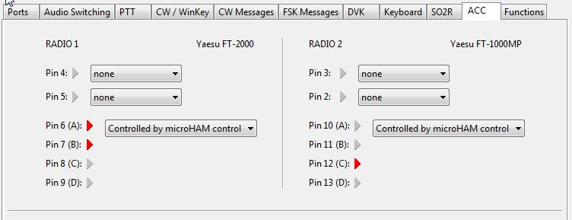

MCC\_7

## 4.0 BASIC MACRO AND EXAMPLES

### 4.1 New MACRO

A new Macro

[$uham xx$](#$uham_xx$)

has been added to [Radio Control Panel](#_topic_RadioControlPanelRCP) where xx is the appropriate uHam op code without the need for the <CR> as detailed in the MK2R user manual - Appendix B.

### 4.2 Example Macros

For these Macro commands to be understood fully the user is recommended to read the MK2R+ manual - Appendix B

$uham SA1$ - select function F1

$uham SA2$ - select function F2

$uham FT1$ - set TX focus to radio #1

$uham FT2$ - set TX focus to radio #2

if controlling the MK2 DVK via the control port then:

$uHam MPm$ - playback message (m) playback where m is a number between 1 and 9

To control the 4 bit outputs from the ACC socket

$uHam AS204$ - set R2 outputs to the binary value of 4 (pins 10,11,12 and 13)

or

$uham AM10001000000000000$ set R1 outputs to the binary value of 3 (pins 6,7 8 and 9)

*Created with the Personal Edition of HelpNDoc:* [*Easily create CHM Help documents*](http://www.helpndoc.com/feature-tour)

**Open Two Radio Switching Protocol (OTRSP)**

# Prasad Rajagopal VU2PTT

## 1.0 GENERAL

We have added OTRSP control Macros to the [Radio Control Panel](#_topic_RadioControlPanelRCP), the [Sound Card Data window](#_topic_SoundCardDataWindow1) and the [CW Machine](#_topic_CWMachineWindow). New features have been added to support switching of Transmit and Receive focus when toggling radios using the <**Ctrl+T**> key combination or the [$toggleradios$](#$toggleradios$) Macro.

A further addition is the use of the <**Grave**> accent key (the key to the left of the 1 key on most keyboards) to toggle between two OTRSP commands – this key is used for [SO2R](#_topic_SingleOperatorTwoRadiosSO2RSuppo) in contest logging software like N1MM to toggle between active radio audio in both ears of the headphones and the other position of having left radio on left ear and the right radio on the right ear.

**Note**: These commands will work only when the Antenna Selector panel has the OTRSP port configured and the port is opened.

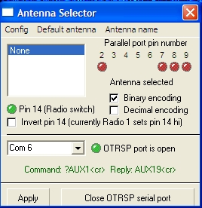

OTRSP\_1

## 2.0 OTRSP MACRO COMMAND FORMAT

Two formats of the OTRSP Macro commands have been developed.

### 2.1 $OTRSP xxx|yyy$

This is the main OTRSP macro command which can be used to send one or many commands to the OTRSP port. An example of this macro can be as follows:

$OTRSP TX1|RX1$

This example macro sends an OTRSP command to the SO2R interface to shift Transmit and Receive focus to Radio 1.

### 2.2 $onRxOTRSP xxx|yyy$

This is a special macro to be used in [CW Machine](#_topic_CWMachineWindow) and [Sound Card Data window](#_topic_SoundCardDataWindow1). A typical command is as follows:

$OTRSP TX1|RX2$

CQ CQ DE K4CY K4CY

$onRxOTRSP TX1|RX1$

This may also be written as $OTRSP TX1|RX2$ CQ CQ DE K4CY K4CY $onRxOTRSP TX1|RX1$

This script entered in one of the CW Machine or Sound Card Data window buttons will do the following:

* + Ensure the transmit focus is on Radio 1 and switch headphones to listen to Radio2;
  + Send the CQ on Radio 1; and,
  + At the end of transmission switch the receive audio back to Radio 1 to listen for replies to the CQ.

## 3.0 OTRSP COMMAND EXAMPLES

As many commands as required can be strung together in one Macro. The character between each command is the Pipe symbol which is usually the <**Shift + Back Slash**> key combination. Do not add the <**CR**> at the end of the OTRSP command. The software will do that for you.

These Macros have been tested to be working OK on the YCCC SO2R+ Interface box for SO2R. See K1XM’s page at <http://www.k1xm.org/SO2R/index.html>.

The following are some of the common OTRSP commands that can be sent to the SO2R interface through the OTRSP port.

### 3.1 OTRSP TX Commands

* + **TX1** - Switch TX focus to Radio 1.
  + **TX2** - Switch TX focus to Radio 2.

### 3.2 OTRSP RX Commands

* + **RX1** - Connect radio 1 to both headphones.
  + **RX2** - Connect radio 2 to both headphones.
  + **RX1S** - Connect radio 1 to the left headphone and radio 2 to the right headphone (stereo). If stereo is not possible connect radio 1 to both headphones.
  + **RX2S** - Connect radio 1 to the left headphone and radio 2 to the right headphone (stereo). If stereo is not possible connect radio 2 to both headphones.
  + **RX1R** - Connect radio 1 to the right headphone and radio 2 to the left headphone (reverse stereo). If reverse stereo is not possible connect radio 1 to the left headphone and radio 2 to the right headphone (stereo). If stereo is not possible connect radio 1 to both headphones.
  + **OTRSP RX2R** - Connect radio 1 to the right headphone and radio 2 to the left headphone (reverse stereo). If reverse stereo is not possible connect radio 1 to the left headphone and radio 2 to the right headphone (stereo). If stereo is not possible connect radio 2 to both headphones

## 4.0 CTRL-T AND GRAVE KEY SWITCHING

We now have the ability to change radios and also change Tx/Rx focus on OTRSP supported SO2R devices at the same time. The <**CtrlL-T**> key combination command used for toggling between 2 radios has additional programmable parameters to enable this. The <**Grave**> accent key is now a hotkey which has two parameters that can be toggled by striking the <**Grave**> key.

The commands for these two features have to be set in the right-click menu of the [Radio Control Panel](#_topic_RadioControlPanelRCP) as shown below, similar to the DX Spot Macros menu.

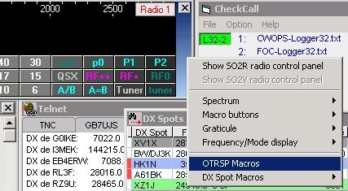

OTSRP\_2

On selecting the OTRSP Macros menu option in the menu, the following screen appears to input your preferred OTRSP parameters for each radio when toggling radios and when using the <**Grave**> accent key to toggle commands.

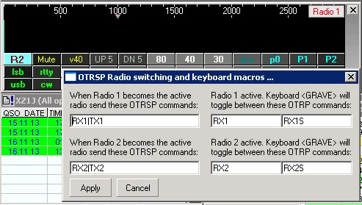

OTRSP\_3

In the example shown in the image above, the following commands are entered.

|  |  |  |
| --- | --- | --- |
| **Function** | **OTRSP Command String** | **Description** |
| TOGGLE RADIOS: When Radio 1 becomes active | RX1|TX1 | Ensures receive and transmit focus in the SO2R box is on Radio 1 when that radio is made active |
| TOGGLE RADIOS: When Radio 2 becomes active | RX2|TX2 | Ensures receive and transmit focus in the SO2R box is on Radio 2 when that radio is made active |
| <**Grave**> key toggle when Radio 1 active | RX1 RX1S | Toggles between Radio 1 on both ears and stereo receive with Radio1 on one ear and Radio2 on the other ear |
| <**Grave**> key toggle when Radio 2 active | RX2 RX2S | Toggles between Radio 2 on both ears and stereo receive with Radio1 on one ear and Radio2 on the other ear |

These commands are configured once the <**Apply**> button is clicked and will now work when the [Radio Control Panel](#_topic_RadioControlPanelRCP) is kept open or is closed.

*Created with the Personal Edition of HelpNDoc:* [*Free PDF documentation generator*](http://www.helpndoc.com)

**Tips, Tricks and Troubleshooting**

*Created with the Personal Edition of HelpNDoc:* [*Free EBook and documentation generator*](http://www.helpndoc.com)

**Tips, Tricks and Troubleshooting**

# B. Charles Sutton W1MCP, Geoff Anderson G3NPA, Jim Hargrave W5IFP and Aki Yoshida JA1NLX

The following Table of Contents provides a series of "Quick Links" to take you to specific topics:

## [1.0 GLOBAL](#1.0_GLOBAL)

[1.1 Error During Installation](#1.1_Error_During_Installation)

[1.2 Printing QSL Labels/Cards](#1.2_Printing_QSL_Labels/Cards)

[1.3 Run time error 6 Overflow and Logger32 hangs after loading about xx%](#1.3_Run_time_error_6_Overflow)

[1.4 Run time error 13 Type Mismatch](#1.4_Run_time_error_13_Type_Mismatch)

[1.5 COM Ports](#1.5_COM__Ports)

[1.5.1 Failure to Open COM Port Error](#1.5.1_Failure_to_Open_COM_Port_Error)

[1.5.2 Turn Off Power Save Mode](#1.5.2_Turn_Off_Power_Save_Mode)

[1.5.3 Logger32 uses Microsoft COM port control MSComCtl32.ocx](#1.5.3_Logger32_uses_Microsoft_COM_port_control_MSComCtl32.ocx)

[1.5.4 The following is a procedure for re-defining COM port numbers in the system](#1.5.4_The_following_is_a_procedure_for_re-defining_COM_port_numbers_in_the_system.)

[1.6 Snap](#1.6_Snap)

[1.7 Right-click Menus](#1.7_Right-click_Menus)

[1.8 Sharing Datsbase Files](#1.8_Sharing_Database_Files)

[1.9 Scroll wheel on Mouse Isn't Working](#1.9_Scroll_Wheel_on_Mouse_Isn't_Working)

[1.10 Need to See a Calendar Quickly?](#1.10_Need_to_See_a_Calendar_Quickly)

[1.11 Logger32 offers several Date Options, but you wany to use a different one](#1.11_Logger32_offers_several_Date_Options)

[1.12 You are Unable to Open or Access the Helpfile](#1.12_Helpfile)

[1.13 First Time Submittal of LoTW and eQSL records](#1.13_First_Time_Submittal_of_LoTW_and_eQSL_records)

## [2.0 CLUSTER / DX SPOTS WINDOW / BANDMAP](#2.0_CLUSTER_/_DX_SPOTS_WINDOW_/_BANDMAP:_)

[2.1 How can I setup a Bandmap to show all HF spots?](#2.1_How_can_I_setup_a_Bandmap_to_show_all_HF_spots)

[2.2 Stop Scrolling: (DX Spots Window)](#2.2_Stop_Scrolling:_(DX_Spots_Window))

[2.3 Stop Scrolling: (Telnet Cluster Window)](#2.3_Stop_Scrolling:_(Telnet_Cluster_Window))

[2.4 Instant Prefix Identification](#2.4_Instant_Prefix_Identification)

[2.5 WWV Update](#2.5_WWV_Update)

[2.6 Multiple Input](#2.6_Multiple_Input)

[2.7 Grid Colors](#2.7_Grid_Colors)

[2.8 Num Lock LED blinks with DX Spots](#2.8_Num_Lock_LED_blinks_with_DX_Spots)

[2.9 Can't remember what portion of the band a frequency falls into?](#2.9_Can't_remember_what_portion_of_the_band_a_frequency_falls_into)

[2.10 Computer crashes while attempting a Telnet connection](#2.10:__Computer_crashes_while_attempting_a_Telnet_connection)

[**3.0 PREFIX DATABASE MAINTENANCE WINDOW**](#3.0_PREFIX_DATABASE_MAINTENANCE_WINDOW)

[3.1 Can't remember the prefix you wish to edit?](#3.1_Can't_remember_the_prefix_you_wish_to_edit)

[**4. TRACKING WINDOW**](#4._TRACKING_WINDOW:_)

[4.1 Map](#4.1_Map)

[4.2 Problem with the grayline map not displaying correctly](#4.2_Problem_with_the_grayline_map_not_displaying_correctly)

[5.0 LOGBOOK PAGE WINDOW](#5.0_LOGBOOK_PAGE_WINDOW:)

[5.1 I receive a Runtime Error 13 - type mismatch](#5.1_I_receive_a_Runtime_Error_13_-_type_mismatch)

[5.2 Logbook Import: (Multiple Operators)](#5.2_Logbook_Import:_(Multiple_Operators))

[5.3 Logbook Import: (SPEED)](#5.3_Logbook_Import:_(SPEED))

[5.4 I sorted the logbook and my data is gone](#5.4_I_sorted_the_logbook_and_my_data_is_gone)

[5.5 I loaded an ADIF file with some QSOs that had DXCC equal to 0 (zero), and Logger32 changed those callsigns to \*\*CA1LL. Why?](#5.5_I_loaded_an_ADIF_file_with_some_QSOs_that_had_DXCC_equal_to_0)

[5.6 Deleting old or Unwanted logbook(s)](#5.6_Deleting_old_or_unwanted_logbook(s))

[5.7 The QSO number column has just the letter N for every contact](#5.7_The_QSO_number_column_has_just_the_letter_N_for_every_contact)

[5.8 QSO Number does not advance](#5.8_QSO_Number_does_not_advance)

[**6. STATS WINDOW**](#6._STATS_WINDOW)

[6.1 Logbook Usage Gauge](#6.1_Logbook_Usage_Gauge)

[**7. IMPORTING/EXPORTING LOGS**](#7.0_IMPORTING/EXPORTING_LOGS)

[7.1 Changes to the Country ADIF field in Logger32 version 3.x and up](#7.1_Changes_to_the_Country_ADIF_field_in_Logger32_version_3.x_and_up)

[7.2 Changes to the CNTY field in Logger32 version 3.x and up](#7.2_Changes_to_the_CNTY_field_in_Logger32_version_3.x_and_up)

[7.3 Changes to the STATE field in Logger32 version 3.x and up](#7.3_Changes_to_the_STATE_field_in_Logger32_version_3.x_and_up)

[8.0 LOGBOOK ENTRY WINDOW](#8.0_LOGBOOK_ENTRY_WINDOW)

[8.1 My QRZ.com autolookup isn't working](#8.1_My_QRZ.com_autolookup_isn't_working)

[8.2 If you use Logger32 to control your radio and are manually changing the VFO, you may see a popup warning window: The band had no entries that match a frequency of .00 Mhz. The Band and Mode have not been changed](#8.2_If_you_use_Logger32_to_control_your_radio_and_are_manually_changing_the_VFO,_you_may_see_a_popup_warning_window)

[8.3 Can't access the Lookup Tables](#8.3_Can't_access_the_Lookup_Tables)

[8.4 I want to prevent Logger32 from assigning a DXCC to a specific callsign](#8.4_I_want_to_prevent_Logger32_from_assigning_a_DXCC_to_a_specific_callsign)

[8.5 Want to change your frequency quickly?](#8.5_Want_to_change_your_frequency_quickly?)

[9.0 SOUND CARD DATA WINDOW](#9.0_SOUND_CARD_DATA_WINDOW)

[9.1 Is there a simple method of copying a Macro in one mode to another mode?](#9.1_Is_there_a_simple_method_of_copying_a_macro_in_one_mode_to_another_mode?)

[9.2 How can I add a new MODE to Logger32?](#9.2_How_can_I_add_a_new_MODE_to_Logger32?)

[9.3 How do I copy my BPSK macros from the PSKCore engine (which was removed in version 3.4.0) to the MMVARI engine?](#9.3_How_do_I_copy_my_BPSK_Macros)

[10.0 SYNCHRONIZE LOGGER32 ON MULTIPLE COMPUTERS](#10._SYNCHRONIZE_LOGGER32_ON_MULTIPLE_COMPUTERS)

[10.1 It is possible to synchronize your logbook across two or more computers and here are a few suggestions](#10.1_It_is_possible_to_synchronize_your_logbook_across_two_or_more_computers)

[10.2 If you want to truly network one log between multiple computers, give this a try](#10.2_If_you_want_to_truly_network_one_log_between_multiple_computers,_give_this_a_try)

[11. CW Machine](#11.0_CW_MACHINE:)

[11.1 CW Keying](#11.1_CW_Keying)

[12. DVK](#12.0_DVK:)

[12.1 Is there any way to select a different sound card for the DVK?](#12.1_Is_there_any_way_to_select_a_different_sound_card_for_the_DVK?)

[13. RADIO CONTROL](#13.0_RADIO_CONTROL:)

[13.1 Popup Window Error: The Bandplan has no entries that match a frequency of nn](#13.1_Popup_Window_Error)

[14.0 OPERATING SYSTEM OR HARDWARE LIMITATIONS](#14.0_OPERATING_SYSTEM_OR_HARDWARE_LIMITATIONS)

[14.1 16 Color vs. 256 Color](#14.1_16_Color_vs._256_Color)

[14.2 Setup Menu Flags](#14.2_Setup_Menu_Flags)

[14.3 Stats window chopped off on bottom](#14.3_Stats_window_chopped_off_on_bottom)

[14.4 The file - MSIMG32 is missing](#14.4_The_file_-_MSIMG32_is_missing)

[14.5 Help window closes shortly after opening](#14.5_Help_window_closes_shortly_after_opening)

[14.6 Cannot print DXCC stats to Excel](#14.6_Cannot_print_DXCC_stats_to_Excel)

[14.7 Windows XP Computer can't Connect to Club Log](#14.6_Cannot_print_DXCC_stats_to_Excel)

[15.SYSTEM RELATED](#15.0_SYSTEM_RELATED)

[15.1 It is recommended that the latest version of Internet Explorer be installed](#15.1_It_is_recommended_that_the_latest_version_of_Internet_Explorer_be_installed.)

[15.2 Files that may need to be updated to run Logger 32](#15.2_Files_that_may_need_to_be_updated_to_run_Logger_32:)

================================================================================

1.0 GLOBAL:

1.1 Error During Installation: During installation you may receive an error message similar to: "Cannot find the source file “C:\temp\@IOTAIsland23.isd to install” –OR - "Cannot continue installation because the following is not found: c:\temp\logger32\\@mmtty.exe”. The path and filename are NOT critical and will change from user to user. The critical point is that the missing file is prefixed by the “@” sign. This results from previously failed installation attempt in which Windows incorrectly uncompressed files into the Windows directory. Search your Windows directory and delete any files with the Logger32 name and then try the install again.

1.2 Printing QSL Labels/Cards: Logger32 does NOT contain ANY print routines. You must use an external means to print QSL labels or cards. You could use LogPrint or you could modify the WORD masks that come with Logger32. Logger32 only keeps track of those QSOs that need to be printed. See the help file topic [Using External Print Programs](#_topic_UsingExternalPrintPrograms) - where all is explained.

1.3 Run time error 6 Overflow and Logger32 hangs after loading about xx%: This normally happens when a user “cleans up” Windows or removes several unused programs – OR – moves their Logger32.ini file from one computer to another. It is usually caused by a missing font and Logger32 is unable to load it. Check your Logger32.ini file for all fonts listed and make sure they exist in the Windows\Font directory.

1.4 Run time error 13 Type Mismatch: This error is usually brought about by an error in the LOGBOOK file. Open up a NEW logbook (File -> Change Logbook) and retry the function you were doing when the error occurred. If you do not receive the run time error 13, then something is corrupt in your logbook. Close Logger32 and replace the four logbook files from your last backup – or - delete the four logbook files, restart Logger32, create a new logbook file and import your recent ADIF backup file. You did do a backup recently right?

## 1.5 COM Ports

1.5.1 Failure to Open COM Port Error: You may get this error when you open the [Sound Card Data window](#_topic_SoundCardDataWindow1) in [MMTTY](#MMTTY) mode and the program seems to be operating properly. This usually is a result of opening MMTTY in Standalone mode within the Logger32 directory and [configuring Radio control](#_topic_SetupRadioControl) ([CAT](#CAT)). To correct this error, close Logger32 and from the Logger32 directory open MMTTY in standalone mode. Go to “Options | Setup MMTTY” and click on the “TX” tab. In the PTT section, select “NONE” for the port. Next click on the “Radio Command” button and select “None” for the port. Save this configuration and click OK to back out of the setup window. If you desire to operate MMTTY in the standalone mode and use Radio control, then you must run MMTTY from another directory other than the Logger32 directory. The PTT and CAT are functions of Logger32 when MMTTY is operated under the sound Card.

This error also occurs with USB to Serial converters. USB ports typically have a default power saving mode in the system. If the port is not used for some time, the system shuts it down. The shutdown of the individual USB port can be avoided by setting the ports to never go to sleep or hibernate. Procedures for several Operating Systems are listed below.

**Caution for laptop users**, this will increase your power usage and decrease your battery life

If you do not feel comfortable making this type of system change and the port that is going to sleep controls your rotor, you can try to keep the port alive by generating data. If your rotor controller has capability to report position information back to the Logger32, you can open the [Tracking window](#_topic_TrackingWindow1) and set the map to Azimuthal Equidistance projection so the rotor position will be displayed. Logger32 will then poll the rotor on a frequent basis. This will keep the USB adapter alive and you should not have any more trouble with the rotor port going to sleep.

If you're using the serial port to control your radio, increase the polling speed as much as you can until the serial port remains active.

1.5.2 Turn Off Power Save Mode: In Windows XP (and probably 2000), you can turn off power save mode on your USB ports by doing the following:

Right click My Computer on your desktop (or start menu, if you use the XP menu) and select Properties

Go to the tab Hardware and click Device Manager

Expand Universal Serial Bus Controllers by clicking the + in front of it

There are probably one or more USB root hubs. Double click the first root hub and go to the tab Power Management

Uncheck "Allow the computer to turn off this device to save power" and click OK.

Repeat the last step for all USB root hubs listed.

In Windows 7, Vista, 8 & 10 turn off power save mode by the following steps:

* 1. Open Control Panel and select “Power Options”;
  2. Select “Change when the computer sleeps”;
  3. Put the computer to sleep, set to “Never”;
  4. Select “Change advanced power settings”;
  5. Select “Sleep | Sleep after” set to “Never”;
  6. Select “USB settings | USB selective suspend setting” Set this to “Disable” and click <OK>

1.5.3 Logger32 uses Microsoft COM port control MSComCtl32.ocx.

This limits the Logger32 serial port functions to COM ports 1 thru 16. Many times USB to Serial adapters are assigned COM numbers greater than 16. You can configure Logger32 to a use one of your lower numbered ports. Otherwise, You must re-configure the existing serial port(s) to a lower unused port number.

1.5.4 The following is a procedure for re-defining COM port numbers in the system.

**Note**: This procedure is written for Windows XP. Other OS may have a slightly different step by step process.

Make sure all your serial ports/adapters etc are plugged in where you want them.

* + 1. Open Control panel
    2. Select "SYSTEM"
    3. Click on "Hardware" tab
    4. Click on "Device manager"
    5. Expand "Ports (Com & LPT)"
    6. Right click one of the ports and select "Properties"
    7. Click on "Port settings" Tab.
    8. Select "Advanced"
    9. Select desired port (1-16) ( Must be an unused port number))
    10. Click "OK",
    11. Click "OK"
    12. Repeat steps 5-11 on each of the other ports you need to re-configure.

Be sure and write down the new port numbers so you can properly configure the serial ports in Logger32.

1.6 Snap: There are 8 child windows that can be opened inside the main window. Once you have positioned and sized them, as you like, click the SNAP button on the toolbar to fine-tune their alignment. You can then enable the "Lock child windows" option on the View menu to prevent them from changing.

1.7 Right-click Menus: All of the windows have menus that are accessed by right-clicking in them. Even small items, like the clock within the lower left hand corner, have a right-click menu with options you can try.

1.8 Sharing Database Files: It was common practice among users of Logger16 to share their database files. This is still possible with Logger32 but due to indexing restrictions, it is absolutely imperative that ALL the files be kept and shared together. These files include the Country, Offset and Alias files. They must ALWAYS be distributed as a COMPLETE set (of 12 files) and must NEVER be broken up. NOTE: If you use this group of files from another user, you must run a recalculate on your logbook! The reason is that the stats info is actually hidden in the Countries database files.

1.9 Scroll Wheel on Mouse Isn't Working: Be sure the correct drivers were installed with your mouse, and if so, check with the manufacturer for updated drivers.

1.10 Need to See a Calendar Quickly? Right-click in the [Logbook Page window](#_topic_LogbookPageWindow), select Add QSO and right-click on the arrow next to the date. This will pop-up a calendar (be sure to click exit when you are finished so as not to add a bad QSO record).

1.11 Logger32 offers several Date Options, but you want to use a different one: Open the Logger32.ini file in Notepad and look for the existing date format. If you haven't chosen one yet it won't be there until you do, so be sure you have selected something from the setup Date menu item. The string is something like: Date Format=mmm/dd/yy. Change it to read: Date Format=yy/mm/dd (or similar) and the log will display the date as you like. Windows stores dates as a Julian number so today might be 37707. Any Windows program then will convert that number to a format we recognize as a date. Because of this, you can "make up" your own to some degree. Please note, that regardless of the format you choose, Logger32 will use the ADIF standard when exporting an ADIF file.

1.12 Helpfile: After updating Logger32, I can no longer open the Helpfile, or when I click on a subject I receive the message " The page cannot be displayed. The page you are looking for is currently unavailable. The Web site might be experiencing technical difficulties, or you may need to adjust your browser settings." You can correct this problem by browsing to the Logger32 directory and right click on the .chm file. Select properties and uncheck the message at the bottom of that screen saying "this file was downloaded from another computer and may be blocked."

1.13 First Time Submittal of LoTW and eQSL records:

This is a simple process that will set up Logger32 for easy submittal in the future. The same basic process can be followed for LoTW and/or eQSL updating.

* 1. Open Logger32 and export your logbook to an ADIF file,
  2. After you have made the logbook ADIF export, close Logger32 and open Windows Explorer. Navigate to the Logger32 directory and move the four Logbook32 files to another directory for safekeeping. (Logbook.ISD, ISF, ISL and ISM),  
       
     **Note**: If your logbook is named something else, then move those files. Example: W5IFP.ISD, ISF, ISL, ISM.
  3. Open Logger32 and you will have a blank logbook.
  4. Right-click on the [Logbook Entry window](#_topic_LogbookEntryWindow) and select "SETUP | QSLing". Place a check mark on the "Flag QSOs for LoTW". You can also check the eQSL line if you use that service. Now you are setup for any new QSO(s) to automatically be flagged for LoTW/eQSL.
  5. Open "FILE | IMPORT Logs | ADIF" tell it the filename of the ADIF logbook file you exported in the procedure above. CHECK the “Rebuilding the logbook…” option and Click "OPEN".
  6. On the import window that pops up, place a check mark in the line(s): "Flag QSO for LoTW export file" and "Flag QSO for eQSL export file" and any other lines you feel appropriate. Click START.
  7. After the import, look at your logbook and make sure it's intact.
  8. Select "FILE | EXPORT FILES | Export LoTW file"
  9. Following the LoTW export file, you will be given an option to mark the QSOs as having been sent to LoTW. Tell it YES. This will completely update your entire logbook for LoTW status.
  10. Certify this LoTW export file for submittal to the ARRL/LoTW.

Following the above initial process, the next time all you need to do is periodically export a LoTW file and certify/submit it.

2.0 CLUSTER / DX SPOTS WINDOW / BANDMAP:

2.1 How can I setup a Bandmap to show all HF spots? With the introduction of the monitor bandmaps you can set up one of the windows to watch all the HF bands at once.

* 1. Open up your ADIFBands.txt file in a text editor and edit in a new line at the bottom to read GEN (for General)
  2. In your bandmode table make an entry to cover the full range of your radio (I set the lower freq to 0.003 and the upper freq to 30.0) and give the line a band name of GEN.
  3. Select the band GEN in the bandmap and it will show all the spots as they come in.

You can also use the ZOOM facility in this bandmap (see the [Bandmap topic](#_topic_TheBandmap)) and just show (say) 40m to 15m if you so wish.

2.2 Stop Scrolling: (DX Spots Window): Having trouble scrolling back to a previous spot? New spots coming in so quickly you can't get back to an older one? Right-click in the [DX Spots window](#_topic_DXSpotsWindow1) and choose HOLD OFF DX SPOTS. This will prevent new spots from being written to the DX Spots grid and refocusing you to the bottom. After you are finished with the older spot, uncheck the HOLD OFF DX SPOTS and the spots that came in while it was on hold will populate the grid. You won't lose any! NOTE: While in 'freeze mode', the colored background of the title bar will flash to alert you that it is frozen.

2.3 Stop Scrolling: (Telnet Cluster Window): The same feature for pausing the scrolling of the [DX Spots window](#_topic_DXSpotsWindow1) is available here. Simply right-click and choose HOLD OFF RECEIVED TEXT.

2.4 Instant Prefix Identification: See a callsign in the [DX Spots window](#_topic_DXSpotsWindow1) and you don't recognize the prefix? Hold your mouse over the callsign and a tool tip will pop up with the country name. It will also tell you if or where that prefix is needed.

2.5 WWV Update: WWV Updates are sent every 3 hours, and most clusters transmit them. When Logger32 sees the WWV report it writes the data to the [Lower Status bar](#3.0_LOWER_STATUS_BAR) at the bottom of the screen. If you don't want to wait for the next report, send a request to your cluster: (SH/WWV) or add it to your logon script.

2.6 Multiple Input: Logger32 allows you to send data to the [DX Spots window](#_topic_DXSpotsWindow1) from both the Telnet and VHF Cluster windows. By choosing a different font color for VHF and telnet spots you will be able to determine the spot origin when it's displayed in the DX Spots window.

2.7 Grid Colors: If using alternate background colors, and a spot comes in that does not require a color code, it will retain the color of the grid. This can be confusing; it is not a bug, but something to keep in mind.

2.8 Num Lock LED blinks with DX Spots: You may notice the Num lock LED blinks when clicking on a spot. (Note: The Num Lock LED must be ON to see this). This is not a bug, but a limitation in Visual Basic: To navigate between the numerous windows and fields within windows, Logger32 uses the VB code SendKeys "{TAB}", 1. This causes the NumLock LED to blink. VB does not provide a NoNumLockBlink function.

2.9 Can't remember what portion of the band a frequency falls into? Enter the frequency and a call sign in the [Logbook Entry window](#_topic_LogbookEntryWindow) (either manually or by clicking a spot), then look at the [Worked/Confirmed window](#_topic_WorkedConfirmedWindow). You will see the band and mode highlighted (you must have "show complex info" turned on).

2.10: Computer crashes while attempting a Telnet connection. Some users have reported problems with Telnet auto-connect crashing your PC if an IP address is used instead of a host name. This sometimes happens If the user sets telnet to "Login on Program Start", then Logger32 hangs during start up. It hangs at the point where Logger32 is trying to connect to the telnet cluster. This does not appear to be a Logger32 problem, rather a problem with the configuration of the WINSOCK.DLL on your PC.

In order to clear the hang-up, re-boot the computer.

Open the Logger32.ini file using a text editor and change the following line:

autologin=True Change to read: autologin=False.

Save the file.

This will get Logger32 back up and running.

At your own risk, Try running a utility called WINSOCKFIX which is available at http://www.snapfiles.com/get/winsockxpfix.html.

There are no guarantees, but it worked flawlessly here and has solved the Telnet crash problem for at least some users. And a reminder ... The developers/testers of Logger32 consider it beyond the scope of the Logger32 support contract to maintain the users PC. Your Logger32 maintenance contract (which is included in the price of the user License) is for Logger32 issues ONLY.

3.0 PREFIX DATABASE MAINTENANCE WINDOW:

3.1 Can't remember the prefix you wish to edit? Do you know the country name but can't remember the Prefix? Click on any column heading to re-sort the database.

## 4. TRACKING WINDOW:

4.1 Map: Logger32 comes with a generic map for use in the tracking window. For those of you who like to play, take a look at www.satscape.co.uk/ under Maps. These maps can be used in place of the default map. See the [Tracking Window](#_topic_TrackingWindow1) topic.

Other maps may also be used, but the middle of the map must be centered over Greenwich, England. The size of the map can be resized considerably without image quality degradation, and may also improve program speed by using fewer resources.

4.2 Problem with the Grayline Map not Displaying Correctly, usually not showing any color difference between day and night: This seems to be a video problem linked with Windows on some computers. Right-click on your desktop and choose settings. Find the area for Hardware acceleration (it's in different areas depending on the Windows version you're running). Try dropping this down one notch.

## 5.0 LOGBOOK PAGE WINDOW:

5.1 I receive a Runtime Error 13 - type mismatch: This error is usually associated with an error in the Logbook data. To correct the problem, try thr following:

1. Backup your original logbook files (there are four) and they are in the Logger32 directory, named mylog.isd, isf, .isl and .ism.

2. Start Logger32.

3. Export your entire logbook in .ADI format.

4. Close Logger32.

5. Delete the four logbook files mentioned above.

6. Start Logger32 and Import the exported .ADI file saved in step 3.

5.2 Logbook Import: (Multiple Operators): When importing an ADIF file, Logger32 checks for an Operator field. If it is blank, Logger32 will import the log and assign the CURRENT operator call to all imported entries. If you have held more than one callsign, you can export your current log in sections based on the dates you held a callsign. Before importing your log entries, change the operator callsign to reflect the call you had, then import it. Then change the operator to your current call and import the rest. Your operator field will now reflect the correct callsign you held when you made the contact.

5.3 Logbook Import: (SPEED): Logger32 imports ADIF files rather quickly considering all the details it must analyze for each QSO. If you have a very large file to import, you can increase the speed by having the grayline map in the foreground rather than the satellite tracking window, or by even closing the tracking window altogether.

5.4 I sorted the logbook and my data is gone: When clicking on the header cell of an individual column to sort your logbook, keep in mind it will only display entries with matching data. If you sort by a column in which there is no data in that column, you will see a blank logbook. To see all your data again, simply re-sort by another column, such as the QSO# or DATE column header.

5.5 I loaded an ADIF file with some QSOs that had DXCC equal to 0 (zero), and Logger32 changed those callsigns to \*\*CA1LL. Why? Some programs export ADIF files with the DXCC field set to 0 (zero) to indicate "not accepted for DXCC". When Logger32 encounters those records it will add them to the logbook with DXCC set to 0 and will also prepend '\*\*' to the front of the call. The two asterisks preceding the call tell Logger32 that this QSO is not accepted for DXCC and will not be included in the DXCC statistics.

5.6 Deleting old or unwanted logbook(s): If you have any old or un-wanted logbooks that you wish to delete, you must first open Logger32 and then open a logbook you wish to keep and close Logger32. Open Windows Explorer, browse to the Logger32 directory and manually delete the 24 files associated with the logbook that you wish to delete. The 24 files have the extensions .isd, .isf, .isl and .ism. Note that if you close Logger32 with the logbook that you want to delete in the open or active state, Logger32 will re-create that logbook automatically the next time you start the program. The default file names are:

logbook32.admin.isd, isf, isl, ism

logbook32.credit.isd, isf, isl, ism

logbook32.extension.isd, isf, isl, ism

logbook32.isd, isf, isl, ism

logbook32.stats.isd, isf, isl, ism

logbook32.year.isd, isf, isl, ism

If you use another name, then the “logbook32” name will be replaced with the new name. Such as:

W5IFP.admin.isd, isf. Isl, ism

Etc…

**Note** that if you close Logger32 with the logbook that you want to delete in the open or active state, Logger32 will re-create that logbook automatically the next time you start the program.

5.7 The QSO number column has just the letter N for every contact: This is one of those mystery bugs ... but there is a work around. Open the Setup meny from the Logbook Page window, find an ADIF field that you DON'T use (10-10 or maybe SAT-RX), and MOVE this field to become the first field in the list (i.e. top left) and in fromt of QSO#. Having done that, switch the column OFF by removing the check mark. This now adds a dummy first column to the log which is not shown on the screen. Click Ok and you will find your numbers will return.

5.8 QSO Number does not advance: Your logbook database has a broken index. To recover, you must:

1. Make backups of your logs (using the two left buttons on the toolbar) - just in case;

2. Export your Logbook in ADIF format;

3. Stop Logger32;

4. Delete your Logbook;

5. Run Logger32; and,

6. Import your logbook using the ADIF file from step 2 -- IMPORTANT NOTE WHEN THE IMPORT WINDOW SHOWS, MAKE SURE YOU CHECK THE “REBUILDING LOGBOOK” option.

6. STATS WINDOW:

6.1 Logbook Usage Gauge: Logger32 calculates your total usage of the available space in the logbook based on cluster usage. Disk space is grabbed in blocks (one at a time as needed), up to a maximum of 16,380 blocks at which time the logbook is considered full. Keep in mind that the logbook is dynamic which means that the more fields you store data in for a single QSO, the more room it uses in the logbook. This is more efficient than a fixed format, which would allocate the same amount of space for each QSO without regard for the amount of actual data you store.

## 7.0 IMPORTING/EXPORTING LOGS:

7.1 Changes to the Country ADIF field in Logger32 version 3.x and up: Prior to the adoption of ADIF version 2, when you asked Logger32 to export the full country name, Logger32 would add an additional field named APP\_LOGGER32\_COUNTRY. ADIF version 2 now allows for a full country name field, "COUNTRY", and Logger32 will now export the full country name into that field.

Please be aware that if you have other software, such as a log printing program, that is expecting to find the APP\_LOGGER32\_COUNTRY field, you will need to change it to COUNTRY.

7.2 Changes to the CNTY field in Logger32 version 3.x and up: Logger32 allows the user considerable flexibility in Setup/usage of the Primary/Secondary Admin Subdivisions. For ADIF 2.x compatibility, ADIF export/import of the CNTY field will apply to countries that have ADIF defined Secondary Admin Subdivisions. Countries that have no ADIF defined Secondary Admin Subdivisions will be exported/imported as APP\_LOGGER32\_CNTY.

7.3 Changes to the STATE field in Logger32 version 3.x and up: STATE fields that are defined by ADIF (Primary Admin Subdivision) are exported/imported as <STATE:x> others are exported/imported as APP\_LOGGER32\_STATE:x>.

8.0 LOGBOOK ENTRY WINDOW:

8.1 My QRZ.com autolookup isn't working. For a long period QRZ.com supported Logger32 users by providing a direct access to their callsign database. This facility has now been withdrawn and the site has become more demanding of subscriptions. As a result the routines to access QRZ.com directly have been removed. However the Logger32 external interface has been enhanced to allow third party software to interface better with Logger and this has given the opportunity for others to write plug-ins.

Not for the same reasons but Hamcall.net access has also been withdrawn from Logger32.

N2AMG has produced some plug-ins for Logger which will effectively replace these lookups and you are advised to check out his site which can be found at: <www.n2amg.com/>

8.2 If you use Logger32 to control your radio and are manually changing the VFO, you may see a popup warning window: The band had no entries that match a frequency of .00 Mhz. The Band and Mode have not been changed. To resolve this issue, make a 'catch all' entry at the bottom of your Band Plan covering the frequency range .0000 to 100.000 (or higher).

For example: 10M,USB,.000000,100.000000,,LSB,,N,,,

As an alternate, you can uncheck the "Enable out of band messages" option on the View menu.

8.3 Can't access the Lookup Tables: Only the user-defined fields #2, 3, 5, 6, & 7 can be set to show a "?" icon next to the field. If, for example, you are setting up the IOTA field, be sure to use one of the field numbers listed above and activate the 'Show Help Button' option.

8.4 I want to prevent Logger32 from assigning a DXCC to a specific callsign: An example of this type of situation would be W1MCP/MM. To prevent Logger32 from assigning a DXCC entry, place two asterisks in front of the callsign such as \*\*W1MCP/MM. Logger32 will then register this entry as: "Not accepted for DXCC." Another option is to log the call as W1MCP/MM and then manually edit the DXCC field in the [Logbook Page window](#_topic_LogbookPageWindow).

8.5 Want to change your frequency quickly?: In the "Call" pane of the [Logbook Entry window](#_topic_LogbookEntryWindow), simply enter the frequency (in kHz) and then press <**TAB**> or <**Enter**>. For those without a CAT interface, this frequency will transfer to the "Freq" field of the Logbook Entry window. For those with a CAT interface, the frequency entered will be sent to the radio as determined by your Bandplan. (This function is determined by the state of the COM port. A CLOSED COM port means no CAT interface.

## 9.0 SOUND CARD DATA WINDOW

9.1 Is there a simple method of copying a Macro in one mode to another mode? Yes, you can copy INDIVIDUAL Macros from button to button. Example - set up the top left-hand macro button <**F1**> in (say) the MMTTY PSK31 mode and <**Apply**> it. Re-open the Macro so you can see the Macro setup window and with this window open change the MODE to the one you want to copy to (say) RTTY\_U - and then hit the <**Apply**> button again. You will find the Macro is now copied from PSK31 to RTTY\_U. Note that this copy ONLY copies to the same button position and you can only do one at a time.

9.2 How can I add a new MODE to Logger32? Open the file ADIFmodes.txt in Notepad or similar ASCII editor. Add the new mode(s) required one per line.

Close and restart Logger32.

Open the Bands & Modes table (Tools -> [Setup Bands & Modes](#_topic_SetupBandsandModes)) and add entries in the correct band listing the new mode in the Mode column. If you want the new mode(s) to be included in your statistics open the Digital Mode Setup window (Tools -> Database Maintenance -> Setup Phone Digital Modes) and check the appropriate modes.

### 9.3 How do I copy my BPSK Macros from the PSKCore engine (which was removed in version 3.4.0) to the MMVARI engine?

With the release of Logger32 version 3.4.0, the PSKCore data engine was removed from the [Sound Card Data window](#_topic_SoundCardDataWindow1) options. The MMVARI engine is still included and offers BPSK 31, BPSK 63 and BPSK 125, as well as RTTY and MFSK modes.

**Note**: The PSKCore engine used the same set of MACROs for all BPSK31 modes. The MMVARI engine stores a complete set of Macros for each mode.

To copy your Macros from the PSKCore engine to the MMVARI engine:

Open the SoundCardMacros.ini file in a text editor such as Notepad or Wordpad. You will need to copy any entries between the [Macro] heading and the next heading identified by square brackets (such as [RTTY Macro]. Do not include the headings when copying.

Open the MMVARISoundCardMacros.ini file in a text editor such as Notepad or Wordpad. Paste the copied text under the [MMVARI BPSK 31] heading. If the heading does not exist, you can create it.

If you wish to use the same Macros for BPSK 63, then also copy your Macros after the [MMVARI BPSK 63] heading.

If you wish to use the same Macros for BPSK 125, then also copy your Macros after the [MMVARI BPSK 125] heading.

You can also copy/paste the [MMTY Macro] section into the MMVARI RTTY modes.

The following is a list of all the MMVARI Mode headings used in Logger32. "MMVARISoundCardMacros.ini:"

[MMVARI BPSK 31]

[MMVARI BPSK 63]

[MMVARI BPSK 125]

[MMVARI RTTY-U]

[MMVARI RTTY-L]

[MMVARI MFSK-L 4]

[MMVARI MFSK-L 8]

[MMVARI MFSK-L 11

[MMVARI MFSK-L 16]

[MMVARI MFSK-L 22]

[MMVARI MFSK-L 32]

[MMVARI MFSK-L 64]

[MMVARI MFSK-U 4]

[MMVARI MFSK-U 8]

[MMVARI MFSK-U11]

[MMVARI MFSK-U 16]

[MMVARI MFSK-U 22]

[MMVARI MFSK-U 32]

[MMVARI MFSK-U 64]

[MMVARI QPSK-L 31]

[MMVARI QPSK-L 63]

[MMVARI QPSK-L 125]

[MMVARI QPSK-U 31]

[MMVARI QPSK-U 63]

[MMVARI QPSK-U 125]

10. SYNCHRONIZE LOGGER32 ON MULTIPLE COMPUTERS:

### 10.1 It is possible to synchronize your logbook across two or more computers and here are a few suggestions:

* 1. Network connected: The easiest way is to copy the log files (all 8 of them) between the computers. Remember, it is important to copy the 4 logbook files AS WELL AS the 4 stats files. This can be automated by creating a batch file on each computer, to automatically copy these files. All versions of Windows allow the use of batch files.
  2. No Network Connection: You could use the ZIP Logbook utility and then just copy the zip file to a floppy, Zip disk, CD-Rom, etc., then unzip the Zip file on the second computer.
  3. You could output the log in ADIF format, transfer it to the second computer, and load it into the second. Logger32 will reject any duplicates so only the new, non-matching records will be accepted onto the second machine.
  4. If you have a CD Writer with R/W ability on all computers, copy the whole directory to a RW CD-ROM. Logger32 can be run entirely from a CD R/W. I would STRONGLY recommend that you keep an up-to-date backup on the hard drive of at least one computer in the event the CD-ROM gets damaged.

10.2 If you want to truly network one log between multiple computers, give this a try:

Each machine needs to have Logger32 installed on it (don't just copy the files). For ease in explaining this I will refer to the two computers as the Primary and the Secondary. The Primary machine will hold the logbook files (whatever you decide to call them). In Windows, you also have to share the drive Logger32 is on (I didn't try sharing just the directory, but it should work as well). On the Secondary machine, using Windows Explorer, browse to the drive where Logger32 resides on the Primary machine and map that drive (make note of the letter you use, in my case it was E:). Next, on the Secondary machine, open Logger32, select "Change Logbook" (File Menu) and browse to the mapped drive of your primary machine and navigate to the Logger32 directory. Choose the logbook that you're using on the Primary machine and select "Apply". You should now see your logbook. Please note, you CANNOT have Logger32 running on both machines at the same time with both trying to access the same logbook. Also note, this is for sharing logbook data ONLY. Any setting changes on one machine will have no effect on the other.

For this test I setup my Primary on a Win XP machine. I tapped into it with 3 Secondary machines. The first is my laptop running Win98, the second was my wife's running Win98 (now she wants to know why there's a new icon on her desktop) and the third machine is a Windows NT box, twelve miles away, connected through a VPN. Running the stats/awards from the NT box took a few extra seconds, but all looked as expected.

## 11.0 CW MACHINE:

11.1 CW Keying: If you are experiencing a problem with the radio keying in the CW mode during and following the computer boot up, you can make a simple change to the keying circuit.

When windows initializes, it leaves some of the parallel port lines in a high state. If your radio is turned on, this condition could activate the CW keying circuit if you are using parallel port keying with a transistor and using a common ground return. To prevent this occurrence, you can use the "STROBE" line (pin #1) as a ground return to the keying circuit. This pin is normally set high when windows boots up. When you open Logger32, the program will set this pin to a low state making it available for the CW keying circuit ground return. For additional information on CW keying go to the [CW Machine](#_topic_CWMachineWindow) topic.

## 12.0 DVK:

12.1 Is there any way to select a different sound card for the DVK? Yes, you can choose a different sound card to send DVK messages to the radio. Open the DVK window and select the Microsoft Sound Recorder from the File menu. Set the playback in the Audio Properties to the sound card of your choice.

## 13.0 RADIO CONTROL:

13.1 Popup Window Error: The Bandplan has no entries that match a frequency of nn. The band has not been changed. Several things cause this error, but the bottom line is that Logger32 wasn't able to read the frequency response from the radio correctly. If this happens often, the popup window can become a nuisance.

To prevent the popup message, there are three options:

* 1. Got to "VIEW" in the main menu and uncheck the "Enable out of band messages"
  2. Make sure "Transceive" is turned "OFF" in the radio CAT options
  3. Create a catch-all frequency range in your Bandplan with the range of 0 - 30MHz (or higher). You may wish to also open up the file called ADIFBands.TXT and ADD to the bottom of the list the word "Gen" (for General). You can then use GEN as the BAND in the bandplan and it will show up in the log input window. NOTE: By using this tip, it is possible to log a contact that falls into this gray area. Logger32 will log the file with a band of GEN. If you then export the ADIF file for use elsewhere, the entry will not be compliant. If all of your operating frequencies are defined in your Bandplan, this shouldn't be a problem as the only way the GEN band could enter your log would be by operating outside your operating frequency.

As an alternate, you can uncheck the "Enable out of band messages" option in the View menu.

Using DTR or RTS to power a radio interface. Many commercial interface circuits use the computer RTS or DTR lines to power the interface circuitry. If you are using a Radio Control interface that derives power from the computer, you can set the DTR and/or RTS lines "HIGH" by placing a check mark in the box adjacent to them. If you set either of these lines High you will not be able to share the same COM port for CW operation. However, if your Interface will run on power from the DTR line, you may still be able to share the RTS line for PTT operation of the [Sound Card Data window](#_topic_SoundCardDataWindow1).

## 14.0 OPERATING SYSTEM OR HARDWARE LIMITATIONS:

14.1 16 Color vs. 256 Color: Running Logger32 in 16 color mode has not been tested, 256 or above is recommended.

14.2 Setup Menu Flags: Windows XP Limitation: There are several drop-down menus located on the Setup Menu that display your current settings. These menus are the Date Format, Time Format, CD-ROM, Frequency and DX Spot. If you are using Windows XP and select one of these menus you may not see the check mark next to the setting you have chosen. To refresh the menu and display the checkmark, simply drag your mouse cursor down the list. When you pass the setting you had previously selected, the check mark will re-appear. The check mark will remain until Logger32 is shut down and restarted.

14.3 Stats window chopped off on bottom: This problem has only been observed when running Logger32 on XP. To fix this, open the screen display properties for XP, then select Appearance and then Advanced. Click on the Title Bar or select Active Title bar under item: and change the font size to 8, then OK or accept the change. It seems they changed the font size in the title bar to a 10-point font in XP while others used an 8-point font.

14.4 The file - MSIMG32 is missing: Microsoft did not include MSIMG32.dll with its Windows 95 or NT versions, and does not support it within these operating systems. However, several users of Logger32 have successfully copied the file from a Windows 98 computer.

14.5 Help window closes shortly after opening: This can happen when clicking on "Help" from within Logger32 or when clicking on the Help File through Windows Explorer. We haven't determined the cause, but it seems to affect only certain users running Windows XP who have installed SP2, which upgrades the HHCTRL.OCX file to version 5.2.3790.2453. The file can be found in the Windows\System32 directory and you can check the version by right-clicking on it from within Windows Explorer and choosing "Properties", then selecting the "Version" tab. Several users have corrected the problem by rolling the HHCTRL.OCX back to version 5.2.3790.1194. The older version can be found on many XP systems in the Windows\$NtUninstallKB890175$ directory. Before overwriting your current version, I suggest you save it someplace safe (or rename it) just in case it affects another help file and you need to restore it.

14.6 Cannot print DXCC stats to Excel : The menu option “Print DXCC Stats to Excel” is grayed out on the stats chart.

Many new Win 7 & 8 computers are preloaded with a trial version of Microsoft Office. These trial versions are not always fully functional. The solution is to install a full featured, registered copy or purchase the trial version and obtain an activation key. Once activated, the utilities are then fully operational.

Logger32 looks for the existence of Excel during the loading process. This may produce an error message. If the computer does not have Excel, this test can be bypassed by adding the following statement to the Globals section of the Logger32.ini file:

[Globals]

Check for Excel=No

14.7 Windows XP computer can't connect to Club Log: If you're using Windows XP, you may not be able to use Club Log's server code (API) features.

In line with accepted best practice, Club Log uses HTTPS encryption for all traffic.

API features are used, for example, by logging software which connects to Club Log to integrate with uploads, real-time logging, and other features like downloading Club Log's exceptions files.

The Windows XP operating system does not have support for modern encryption ciphers. Older technologies that Windows XP does support are no longer in use on the internet, as they have been superseded or contain vulnerabilities. When your logging software tries to connect to Club Log, it is using operating system features to do this. Windows XP cannot successfully interact with Club Log because of the outdated encryption libraries.

Club Log's web server supports all modern web browsers, so even on Windows XP you can normally browse to https://clublog.org using Firefox, Google Chrome etc. However, you will be unable to use applications that make use of API features connecting via the operating system to Club Log. There is no workaround for this problem, as Windows XP is long out of support (it was retired from support by Microsoft in 2014). If Club Log integration is important to you, it is recommended to upgrade to a later version of Windows.

For Club Log Frequent Asked Questions/responses see: <http://clublog.freshdesk.com/support/solutions/59695>

15.0 SYSTEM RELATED:

### 15.1 It is recommended that the latest version of Internet Explorer be installed.

### 15.2 Files that may need to be updated to run Logger 32:

COMDLG32.OCX - Windows\System32 - v 6.0.84.18

MSCOMM32.OCX - Windows\System32 - v 6.0.81.69

MSIMG32.DLL - Windows\System32 - v 2.0.2600.0

MSWINSCK.OCX - Windows\System32 - v 6.0.89.88

RICHTX32.OCX - Windows\System32 - v 6.0.88.4

SIZERONE.OCX - Windows\System32 - v 7.0.0.4

ARBUTTON.OCX - L32 Dir - v 1.10 or Later

VBIS5032.DLL - L32 Dir - v 50.32.3.3

WINLO.DLL - L32 Dir - v N/A - File created 3/17/2001

WINLO.SYS - L32 Dir - v N/A - File created 7/4/2000

*Created with the Personal Edition of HelpNDoc:* [*Free EBook and documentation generator*](http://www.helpndoc.com)

**Frequently Asked Questions (FAQs)**

# B. Charles Sutton W1MCP

Please note that many of the answers here will not contain detailed information that is covered elsewhere in this help file, but serves as a guide to get you going in the correct direction.

**Q. I receive a "Runtime Error 13 - type mismatch" when loading or running Logger32, how do I fix this?**

A. This error is usually associated with an error in the Logbook data. To correct the problem try the following:

* 1. Backup your original logbook files (there are four), they are in the Logger32 directory and named mylog.isd, .isf, .isl and .ism - where 'mylog' is the name of your actual logbook file.
  2. Start Logger32.
  3. Export your entire logbook in .adif format.
  4. Close Logger32.
  5. Delete the four logbook files mentioned above.
  6. Start Logger32 and import the exported ADIF file created in step 3.

**Q. After upgrading to ver 3.x, I have found several errors in my BAD.ADI file. What should I do?**

A. Most of the errors found in the bad.adi file after upgrading to version 3.x are related to the major changes in the State & County fields as related to the Primary/Secondary subdivisions. Some of these take a little detective work, for example: <Note unrelated fields removed for ease of display>

Error in the STATE field: <CALL:5>KL7QW <CNTY:9>MO,Camden <CONT:2>NA <CQZ:1>4 <DXCC:1>6 <ITUZ:1>1 <MODE:3>SSB <PFX:3>KL7 <QSL\_SENT:1>Y <QSO\_DATE:8:D>20001118 <RST\_RCVD:2>57 <RST\_SENT:2>56 <STATE:2>MO <EOR>

The error here is not actually in the STATE field itself. This record is showing a contact with KL7QW. The prefix would identify the call as originating from Alaska, DXCC country code 6. However, this operator actually lives in Camden, MO - so the DXCC Country code of 6 needs to be changed to 291. An ADIF field has three parts, the field name, the length of the data and the data itself. In this case, both the data length and the data needs to be changed, once corrected the QSO record will import properly. The full correction is: Change <DXCC:1>6 to read <DXCC:3>291

**Q. I just loaded my log and I have NO prefixes, why?**

A. First, your ADIF file doesn’t contain the field, and secondly, you didn’t tell Logger32 to calculate them for you. On the option window for loading your ADIF file check the box for “Ignore PFX field”. This tells Logger32 to ignore the data in the prefix field (if present) and do the calculations itself. This option can also be used to correct ADIF files with incorrect PFX data. We ran across a few programs, which used this field for the DXCC prefix, and by ADIF standards, it should show the WPX prefix. If you have already loaded your ADIF file then you need to export it as an ADIF file, delete your 4 logbook files, and import the new ADIF file with the calculate PFX selected. See the help file section on Importing Logs for more information.

**Q. Some of my prefixes are wrong, why?**

A. Are you sure? The prefix column is not, as many think, used for the DXCC prefix. The ADIF standards use this field for the WPX prefixes and they do differ from DXCC. Check their website for more information.

There have been changes to the WPX prefix rules and effective with Logger32 version 3.14 code changes have been made to reflect these changes.

For example: AA6AA/7 is now AA7. Previously, AA6AA/7 translated to W7. There is no cutoff date for this change so previous WPX prefix detyerminations made by Logger32 could now be incorrect.

The following procedure to update/correct logs is recommended:

* 1. Backup your logbook
  2. Export your logbook in ADIF format
  3. Shutdown Logger32
  4. Delete yoour logbook (all four files)
  5. Restart Logger32 - yoour logbook will be recreated
  6. Import the ADIF file saved earlier with the "Ignore PFX" option selecter
  7. Recalculate statistics

**Q. I have been trying to display the map for the IOTA locations but could not.**

A. There are several lookup tables included in Logger32, including the IOTA. To access them, you must assign them to any user-defined field in the [Logbook Entry window](#_topic_LogbookEntryWindow) that has the “?” icon.

**Q. Are there any shortcuts to clear the Logbook Entry Window?**

A. Yes, there are three. Right-Click and choose clear entries, or from the keyboard, type CTL-C or ALT-W.

**Q. How can I add a new band to Logger32?**

A. If the band is new, like the recent addition of 60M, you must first edit the ADIFbands.txt file located in the Logger32 directory using a text editor such as Notepad. You can then add the new band, modes and frequencies to your bandplan.

**Q. I don’t like the look of the highlight coloring in my Logbook, how do I change it?**

**Q. Many of my QSOs in the Logbook are RED, how can I change them?**

A. In the Main menu, click Setup then highlight color.

**Q. I imported my ADIF file from Logger 16 (V 8.xx) and all my Notes are gone, how can I get them back?**

A. Did you run the ConvertNotesToLogger32.exe program located in the Logger32 directory?

**Q. How do I change the columns in the Worked/Confirmed window?**

A. Modify your bandplan. Bands and Modes that have the stats column set to “Y” will be displayed, and those with an “N” will not.

**Q. In the Telnet window setup, I have entered a script but it is not saved.**

A. After entering your script, right-click and choose Save.

**Q. I’ve imported my log but the Logbook Page doesn’t show any of my QSOs. Where did they go?**

A. The number one cause for this is sorting. Several columns in Logger32 can be sorted by clicking on the header label. This also acts as a filter, i.e., if the column you have sorted on has no data then the Logbook will appear empty. Simply click on a mandatory column header label (such as the QSO number field or the date field) and they should all return.

**Q. If I add user fields to my Logbook Entry window, it covers up the country, distance, bearing info, etc. How can I still have this information AND add more user fields?**

A. If it’s not already displayed, turn on the [Upper Status bar](#2.0_UPPER_STATUS_BAR). This will show as the second bar from the bottom and will contain all this information.

**Q. How do I include comments in my DX spots?**

A. In the Main menu, click Setup then DX Spot.

**Q. I have noticed that the fonts in the Logbook Page window and the Previous QSOs window do not correctly show the lower portion of lower case letters correctly (y looks like v, q and g look the same). Can anyone tell me how I can fix this?**

A. The font you are using is too large for the row height you have chosen. Either choose a smaller font or increase the row height in your grids.

**Q. My bandplan is all wrong. Why?**

A. Logger32 included a generic bandplan as an example. You must edit the bandplan to suit your individual needs and to reflect your region of the world.

**Q. I loaded my ADIF log into Logger32 and it reported that I had a few bad records that are in the BAD.ADI file, how do I read this file?**

A. You can open and edit the file using any program, which supports ASCII files, such as Notepad.

**Q. When I load my Logger 16 log ADIF file, the prefixes are missing and not showing in the Logger32 prefix column.**

A. When you choose to import an ADIF file there is a check box option to have Logger32 calculate the PFX from the callsign. You will need to export your logs, delete the logbook files (all four) and import them again using this option. Also note, the PFX is not the DXCC prefix but rather the WPX prefix.

**Q. The map in the tracking window doesn’t look like the map in the help files or in the screen shots on Logger32’s website**.

A. That’s because many of us changed ours, and you can too. See [Tips, Tricks & Troubleshooting](#_topic_TipsTricksandTroubleshooting1) for ideas.

**Q. I can’t edit the DXCC field in the Logbook Page. Why?**

A. You didn’t read the whole error message that popped up did you? You can, but you need to right-click in the cell and choose from the list.

**Q. How do I change the width of the columns in my grids (Logbook page, Previous QSOs, etc.)?**

A. Move your mouse over the line directly between two column headers. The cursor will change into a double-headed arrow, now click and hold while moving the cursor left or right and release it at your desired width.

**Q. Something funny happened that has not happened before.**

A. Please try the following, in order. Give each step time to work.

* 1. Look over the rest of the FAQs
  2. Go to the Help Section that discusses this functionality
  3. Shut down the function and invoke it again
  4. Shut down Logger32 and re-start it
  5. Shut down Windows and re-start it
  6. Review the archives of the Hamlogger reflector
  7. Ask for help on the Hamlogger reflector

**Q. I received an error message during Logger32 installation**

A. Try the following

Try installing Logger32 again. Make CERTAIN that you close all programs before beginning the installation. Be especially cautious to close any serial and modem connections.

Logger32 requires the use of many DLL files and provides them as part of the installation package. These may be older or newer than those on your system. The Windows recommendation is to keep the newer DLL.

**Q. I try to start Logger32 from an icon and I receive a message that one or more files did not load, and the program fails to run**

A. Check to make sure that you have ONLY ONE COPY each of DWSPYDLL.DLL and SBC.VBX on the C:/ drive, and that they are located in the Logger32 directory.

**Q. Logger32 prints everything except the figure zero (0)**

A. Go to Settings on the Start Menu and change the way the figure zero prints to the screen.

**Q. How can I "copy" and "paste" from the Telnet, Data Terminal and other windows ?**

A. If you need to capture anything from any of the text windows, then click, hold and drag the cursor to highlight the required text and then release the mouse button. The highlight will then disappear but the text will have been stored on the Windows clipboard and can be pasted where desired.

*Created with the Personal Edition of HelpNDoc:* [*Generate EPub eBooks with ease*](http://www.helpndoc.com/create-epub-ebooks)

**Appendices**

*Created with the Personal Edition of HelpNDoc:* [*Easy to use tool to create HTML Help files and Help web sites*](http://www.helpndoc.com/help-authoring-tool)

**Abbreviations**

# Hew Lines VA7HU

## AC

Alternating Current

## ADIF

Amateur Data Interchange Format

## AFC

Automatic Frequency Control

## AFSK

Audio Frequency Shift Keying

## AGC

Automatic Gain Control

## ALC

Automatic Level Control

## AM

Amplitude Modulation

## AMTOR

Amateur Teleprinting Over Radio

## AOS

Acquisition Of Signal

## ARQ

Automatic Repeat Request

## ASCII

American National Standard Code for Information Interchange

## BCD

Binary Coded Decimal

## BPF

Bandpass Filter

## bps

The number of binary digits transferred per second on a serial link

## BPSK31/63/125

Binary Phase-Shift Keying

## C

Celsius

## CAT

Computer Assisted Transceiver

## CI-V

ICOM Computer Interface 5

## CNTY

County

## COM

Computer Serial communications port

## CQZ

CQ Zone number

## CSV

A standard data file format where fields of a data record are separated by commas

## CW

Continuous Wave - as in Morse code

Clockwise

## CTS

Clear To Send - an RS-232 hardware handshaking signal.

## CW-R

CW Reverse sideband

## DATA-LSB

Data transmission using LSB

## DATA-USB

Data transmission using USB

## dB

decibel

## DIG

Digital

## DLL

Microsoft Dynamically Linked Library

## DOK

German Administrative District

## DSP

Digital Signal Processing

## DSR

Data Set Ready

## DST

Daylight Savings Time

## DTR

Data Terminal Ready - an RS-232 hardware handshaking signal

## DVK

Digital Voice Keyer

## DXCC

DX Century Club award

## eQSL

An electronic QSL facility using the Internet

## F

Fahrenheit

## FEC

Forward Error Detection

## FFT

Fast Fourier Transform

## FIR

Finite Impulse Response FiIter

## FM

Frequency Modulation

## FSK

Frequency Shift Keying

## GMSK

Gaussian Minimum Shift Keying

## GMT

Greenwich Mean Time (see [UTC](#UTC))

## G-TOR

Golay-Teletype Over Radio

## HELL

Hellschreiber

## HF

High Frequency

## Hz

Hertz

## IMD

Intermodulation Distortion

## IOTA

Islands On The Air

## ITUZ

ITU Zone number

## JCC

Japan Century Cities

## JCG

Japan Century Gunn

## KEPS

Keplerian Elements

## KHz

Kilohertz

## Km

Kilometers

## LCID

Microsoft Locale ID

## LOS

Loss Of Signal

## LoTW

Logbook of The World, an ARRL project - see <http://www.arrl.org/lotw/>

## LSB

Lower Sideband

## Mb

Megabyte

## MBCS

Multibyte Character Set

## MFSK

Multi-Frequency Shift Keying

## MHz

Megahertz

## MMTTY

[RTTY](#RTTY) Encoding and Decoding engine written by Makoto Mori JH3HHT that supports [RTTY](#RTTY)

## MMVARI

Digital encoding and decoding engine written by Makoto Mori JH3HHT that supports [PSK](#PSK31/63/125) and [RTTY](#RTTY)

## ms

Millisecond

## MT63

Multi-Tone frequency shift keying

## NCDXF

Northern California DX Foundation Inc

## NM

Nautical Miles

## OQRS

Online QSL Request Service

## OS

Operating System

## OTRSP

Open Two Radio Switching Protocol.

## PACTOR

Digital communication mode that dynamically adapts to conditions. PACTOR can accept a series of imperfect or incomplete data segments and "intelligently" attempt to reassemble them into a solid group.

## Pfx

Prefix

## PKT

Packet

## PKT-LSB

Packet using LSB

## PKT-USB

Packet using USB

## PUP

Potentially Unsafe Programs

## PSK31/63/125

Digital modes of communication using Phase Shift Keying

## PTT

Push To Talk

## QPSK

Quadrature phase-shift keying

## RF

Radio Frequency

## RIT

Receiver Incremental Tuning

## RSGB

The Radio Society of Great Britain

## RTS

Request To Send - an RS-232 hardware handshaking signal

## RTTY

Radioteletype

## RTTY-LSB

Radioteletype using LSB

## RTTY-USB

Radioteletype using USB

## RX

Receive

## SDR

Software Defined Radios

## SFI

Solar Flare Index

## SSB

Single Sideband

## SO2R

Single Operator, Two Radios

## SSTV

Slow Scan Television

## TNC

Terminal Node Controller

## TX

Transmit

## UAC

User Account Control

## UHF

Ultra High Frequency

## UOS

Unshift on Space

## UQF

Universal QSL Format - A weird logging format no longer used by modern logging programs. It is available as an option with Logger32 when exporting logs for those who still have needs for this format.

## URL

Universal Resource Locator, also known as a web address.

## USB

Upper Sideband

Universal Serial Bus

## UTC

Coordinated Universal Time (See [GMT](#GMT))

## VFO

Variable Frequency Oscillator

## VHF

Very High Frequency

## WPM

Words Per Minute

## WPX

Worked All Prefixes award

## XML

Extensible Markup Language

*Created with the Personal Edition of HelpNDoc:* [*Full-featured Help generator*](http://www.helpndoc.com/feature-tour)

**Glossary**

# Hew Lines VA7HU

## A index

Daily geomagnetic conditions are summarized in an A index that corresponds to daily K index values.

## American National Standard Code for Information Interchange (ASCII)

The ASCII character set is used in data processing and communications systems. It uses seven bits to represent letters, figures and control characters.

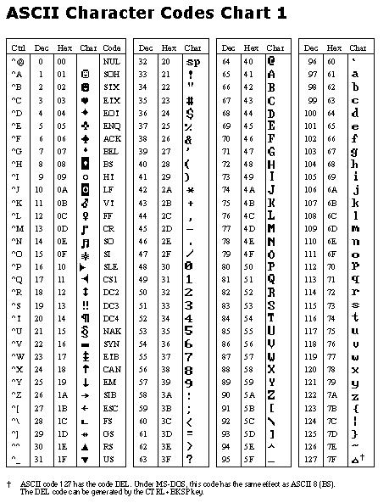

G\_1

## AMTOR

A digital communications protocol using time diversity.

## Baud

A measure of how fast individual signal elements could be transmitted serially through a system. Note: It is not the same as Bits per Second bps.

## Coordinated Universal Time

Time zone of the Zero (0) or Greenwich meridian. Sometimes referred to as GMT or Zulu.

## DB-9

A nine-pin connector used to connect to computer Serial (COM) ports.

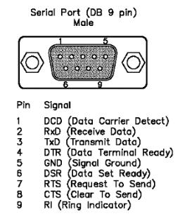

G\_2

## DB-25

A 25-pin connector used to connect to computer Serial (COM) and Parallel (LPT) ports.

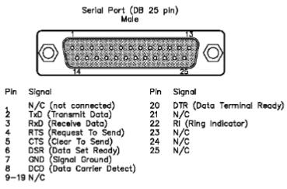

G\_3

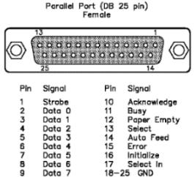

G\_4

## Finite Impulse Response Filter

The most basic architecture for digital signal processing. It periodically samples the input data stream, multiplies the sample data by specific coefficients, and sums the results to make the output.

## Gaussian Minimum Shift Keying

A type of continuous phase frequency-shift keying. The baseband modulation is generated by starting with a bit stream 0/1 and a bit-clock giving a time slice for each bit.

## Greenwich Mean Time

A standard time zone that corresponds to UTC and ZULU times.

## Grid Squares

Grid Squares are used as an indication of a location based on the "Maidenhead" system of identifying a location within a "square on the earth's surface" based on Latitude and Longitude and identified by six characters (two capital letters, two digits, and another two lower case letters). The first two letters Identify a 20 degree by 10 degree "field", followed by two digits designating a 2 degree by 1 degree "square" within that field. The last two characters are normally not always used. This location methodology is used in almost all VHF contacts and contests.

## G-TOR

A digital communications protocol that provides an improved communication capability for the HF bands and increased throughput.

## Hellschreiber

Digital communication mode invented by Dr. Rudolf Hell in 1929.

## Islands on the Air Award

An award issued by the Radio Society of Great Britain in recognition of confirmed contacts with the required number of islands/countries since 1 Dec, 1964. Contact the RSGB for further details.

## K Index

The K index provides an indication of magnetic activity during the previous three hours on a finite scale of 0-9. Very quiet conditions are reported as 0 or 1, while geomagnetic storm levels begin at 4. Also see the A Index.

## Keplerian Elements

A set of six orbital element numbers used to define and compute satellite orbital motions. Complete details can be found in the ARRL Handbook. One source of this data is <www.celestrak.com/NORAD/elements/amateur.txt>

## MACRO

A set of commands that can be used, along with plain text, to create limited routines or shortcuts assigned to the programmable buttons of the Sound Card Data window, Data Terminal window and CW Machine.

## MT63

Multi-Tone digital communication mode developed by SP9VRC. It is intended as a conversational mode between two or more hams. It uses 64 tones spaced 15.625 Hz apart, in the 1 kHz bandwidth and uses FEC error correction.

## Multibyte Character Set

Multibyte character sets are an alternative to Unicode for supporting character sets, like Japanese and Chinese, which cannot be represented in a single byte.

## Prop\_Mode

VHF Propagation Mode used in ADIF file format.

## RS-232

The EIA-232-D (commonly referred to as RS-232) standard defines a system used to send data over relatively long distances. It is commonly used to send data anywhere from a few feet to 50 feet or more. The standard specifies the physical connection and signal lines.

## Solar Flare Index

A measure of solar flare activity on the surface of the sun.

## Terminator

The terminator is the boundary between day and night. Its position changes during the day (it makes a complete circuit around the Earth in one day), and it also changes during the year. Daylight is longer in the northern hemisphere than in the southern hemisphere from about March 21 to September 21, and daylight is longer in the southern than in the northern hemisphere during the rest of the year. The terminator, more or less, divides the Earth into halves; facing the sun and facing away from the sun. Logger32 also displays the Twilight Terminator, defining a Twilight Zone. These terminators are displayed in three different modes.

## Zakanaka

A digital mode decoding and terminal program that uses no terminal unit, terminal node controller, or multimode hardware. It does all of its decoding using the sound card inside the computer, and it can interface with a radio using a [COM](#COM) port. Zakanaka is an extremely cost-effective way of operating [PSK31](#PSK31/63/125) and [RTTY](#RTTY).

*Created with the Personal Edition of HelpNDoc:* [*Easy EPub and documentation editor*](http://www.helpndoc.com)